**Project Workflow: Steps to Implement ETL Process**

1. **Load Source Data**
   * Import the CSV files as source definitions into Informatica.
   * Ensure the source definitions are correctly configured to reflect the structure of the input files.
2. **Stage the Data**
   * Load the data from the source files into staging tables in the MSSQL database.
   * Create staging tables in the database, mirroring the structure of the source files, including primary and foreign key constraints for data integrity.
3. **Design Dimensional Target Tables**
   * Define and create dimensional target tables in the SQL database.
   * Ensure the dimensional tables align with the required schema for analytical purposes, including necessary primary and foreign key relationships.
4. **Map and Develop Workflows**
   * Create workflows in Informatica for each staging source table to populate the corresponding dimensional tables.
   * Implement the required transformation logic in mappings, such as:
     + **Slowly Changing Dimensions (SCD) Type 1:** Overwrite updates.
     + **SCD Type 2:** Maintain historical data.
     + **Insert-Only Logic:** For simple data addition.
5. **Integrate with the Fact Table**
   * Develop a final mapping to populate the **FACT_SALES** table.
   * Use lookups on all dimensional tables to ensure accurate integration of data into the fact table.

**Output :**

1. Loading data to staging tables

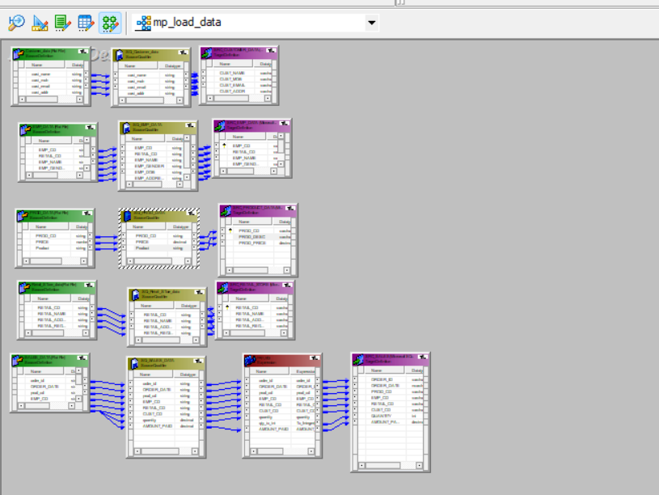

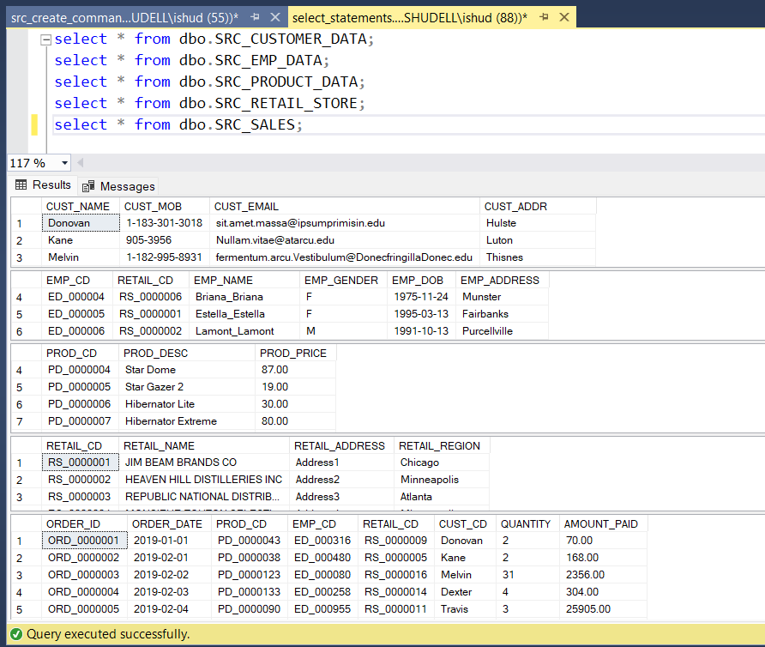

1. Customer data table

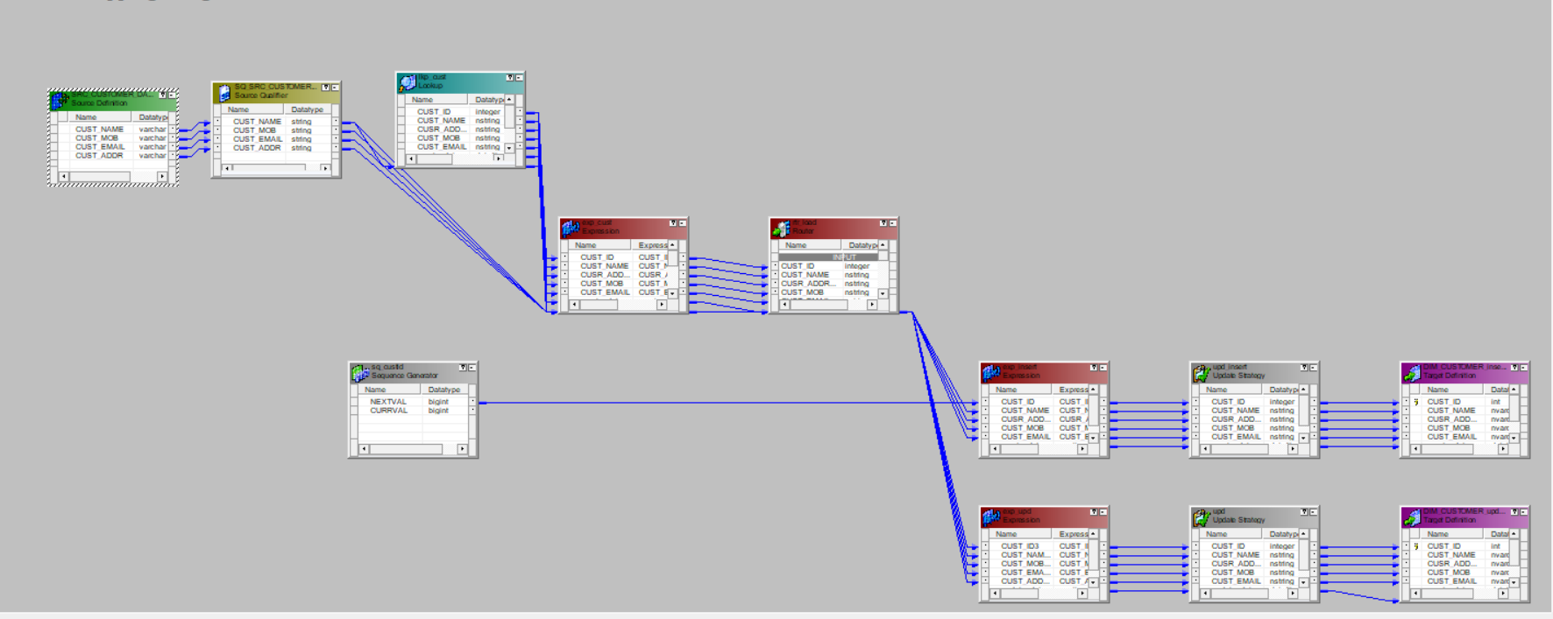

1. Employee data table

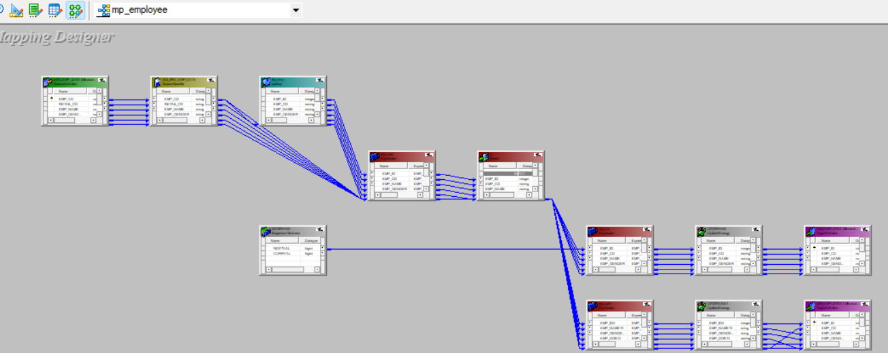

1. Date table

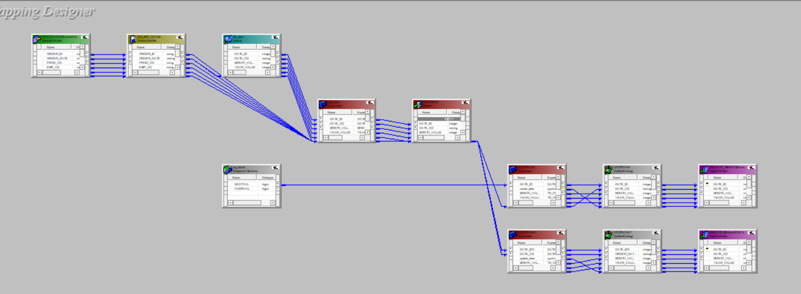

1. Order table

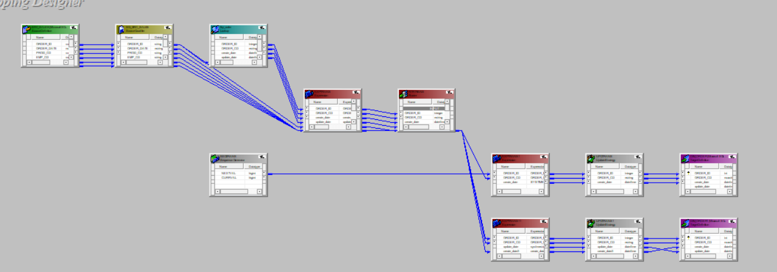

1. Product table

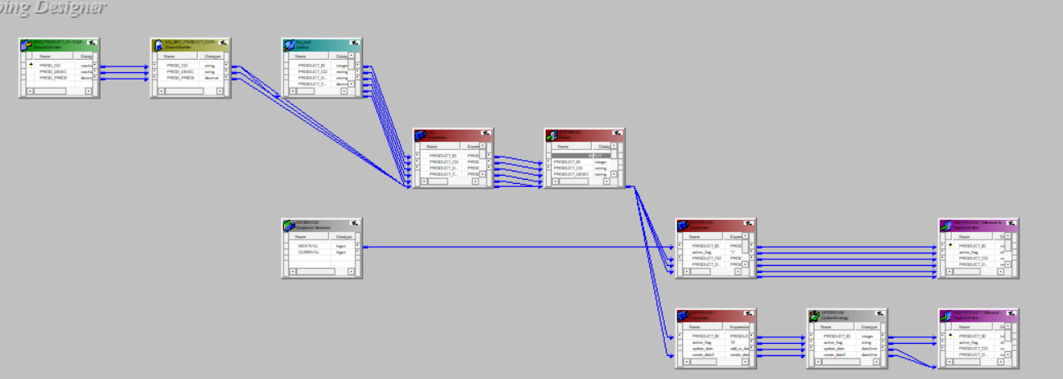

1. Region table

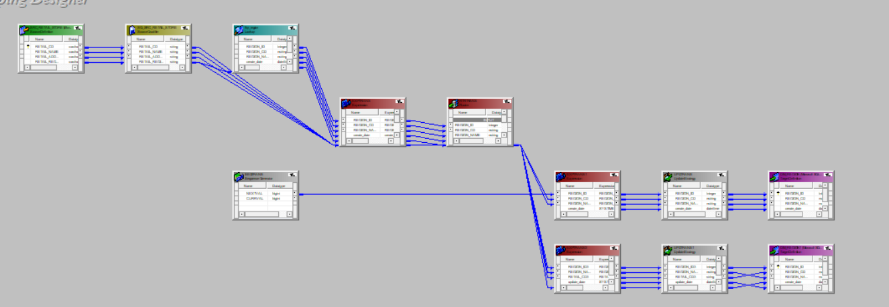

1. Retailer table

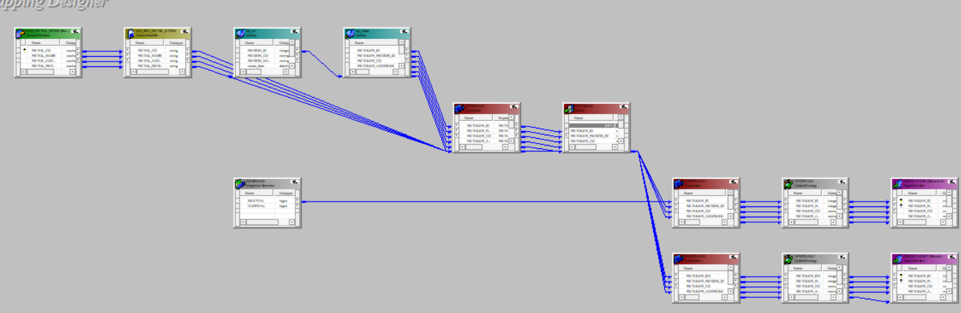

1. Fact table