|  |  |
| --- | --- |
| Name | MOHAMMADISTIYAK SHAIKH |
| Email ID | Shaikhistiyak9824@gmail.com |
| Country | United Kingdom |
| College | London Metropolitan University |
| Specialization | Data Science |
| Project | Persistency of a drug |

Contents

Week-7 3

Problem description 3

Business understanding 3

Project lifecycle along with deadline 3

Week-8 4

Type of data have got for analysis 4

Problems in the data 4

Approaches will be trying to apply on the dataset to overcome problems 4

# Week-7

# Problem description

**ABC Pharma** wants to understand patient **drug persistency**—whether patients continue to take their medications as prescribed by physicians. The goal is to build a **machine learning model** that predicts persistency using patient demographics, clinical history, risk factors, and treatment behavior. Automating this process will help physicians and the pharma company improve adherence strategies and personalize patient interventions.

# Business understanding

The business objective of this project is to improve drug adherence by identifying patients who are at risk of non-persistence. This initiative aims to reduce costs associated with non-adherence, enhance patient health outcomes, and enable more effective targeting of patient support programs. Key stakeholders include the pharmaceutical company ABC Pharma, the data science team, and healthcare providers. The success of the project will be measured by the development of a predictive model that demonstrates high recall and precision in identifying non-persistent patients, along with sufficient model explainability to support actionable clinical and programmatic interventions.

# Project lifecycle along with deadline

|  |  |
| --- | --- |
| Phase | Task |
| Week 8 | EDA, cleaning, preprocessing |
| Week 9 | Feature engineering, modeling |
| Week 10 | Model tuning, evaluation |
| Week 11 | Deployment |
| Week 12 | reporting |

# Week-8

# Type of data have got for analysis

The dataset consists primarily of **categorical and binary features** collected from patients, along with one key numerical column:

* **Categorical features** include demographic information such as Gender, Race, Ethnicity, Region, Age_Bucket, and clinical details like Ntm_Speciality, Ntm_Specialist_Flag, and bucketed scores.
* **Binary features** (e.g., risk factors, comorbidities) are represented by "Y"/"N" values and indicate presence or absence of certain medical conditions or risk factors.
* **Numerical features** are minimal; a key example is Count_Of_Risks, which is an actual integer count.
* The target variable is Persistency_Flag, which is binary and classifies patients as Persistent or Non-Persistent with their medications.

|  |  |
| --- | --- |
| Property | Value |
| Number of Rows | 3424 |
| Number of Columns | 69 |
| Number of Numeric Columns | 2 |
| Number of Categorical Columns | 67 |
| List of Numeric Columns | [Dexa_Freq_During_Rx, Count_Of_Risks] |
| List of Categorical Columns | [Ptid, Persistency_Flag, Gender, Race, Ethnici... |
| Missing Values (Total) | 0 |
| Missing Values (Per Column) | {'Ptid': 0, 'Persistency_Flag': 0, 'Gender': 0... |

# Problems in the data

**Missing Values (NA):**  
Upon inspection, the dataset does **not contain any missing values** (nulls). This is ideal and suggests a pre-cleaned or high-quality data source.

**Outliers:**  
While most columns are categorical or binary (where outliers do not apply), numeric features like Count_Of_Risks and Change_T_Score may contain **extreme values**.  
These outliers can disproportionately influence models like logistic regression or linear models, so identifying and treating them is important.

**Skewed Features:**  
Some categorical features may be **highly imbalanced**. For example, certain regions, age groups, or risk factors may dominate the data, potentially leading to biased model performance. Also, the target variable Persistency_Flag should be checked for balance.

|  |  |  |  |
| --- | --- | --- | --- |
| **Column** | **Skewness** | **Interpretation** | **Suggestion** |
| Persistency_Flag | 0.51 | Mild right skew (more 0s) | Leave as is (if binary) |
| Dexa_Freq_During_Rx | 6.81 | Strong right skew | Transform or clip outliers |
| Count_Of_Risks | 0.88 | Moderate right skew | Optional transform |

Figure :Log transformation

**Best Strategy: Log Transformation**

The variable is **strongly right-skewed** → it can dominate distance-based models or linear relationships.

Log transformation **reduces skew**, improves **model performance**, and **preserves all data points**.

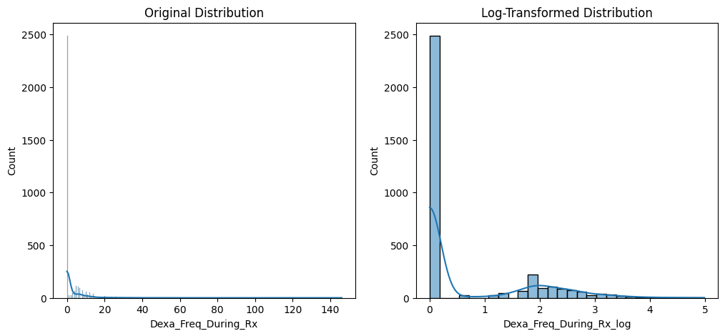It's interpretable in the medical context (e.g., frequency on a log scale is still meaningful to analysts or physicians).

# Approaches will be trying to apply on the dataset to overcome problems

Since the dataset does not have NA values, the focus shifts to cleaning and transforming the data for model readiness:

* **Text Cleaning:**  
  Strip whitespaces and fix inconsistencies in text-based columns to avoid incorrect grouping or misclassification during encoding.
* **Binary Encoding of Y/N Columns:**  
  All Y/N columns were converted to 1 and 0, making them suitable for modeling without introducing artificial ordinal relationships.
* **Label Encoding of Categorical Columns:**  
  Non-ordinal categorical variables (e.g., Gender, Race, Region) are label encoded. This keeps the dataset compact for models that can handle categorical codes.
* **Outlier Treatment:**  
  Numerical columns like Count_Of_Risks are treated using the **IQR (Interquartile Range) method**. This helps cap extreme values without completely removing data, preserving data integrity while limiting influence on model performance.

Outlier Count per Numeric Column (IQR Method):

Persistency_Flag: 0 outliers

Dexa_Freq_During_Rx: 460 outliers

Count_Of_Risks: 8 outliers

|  |  |  |
| --- | --- | --- |
| **Column** | **Outlier Count** | **Interpretation** |
| Persistency_Flag | 0 | Expected — it's a binary target variable (0 or 1). |
| Dexa_Freq_During_Rx | 460 | **Significant outliers** — heavy right skew. |
| Count_Of_Risks | 8 | Minor outliers — could be genuine high-risk patients. |

After the applying the log transformation on the column name Dexa_Freq_During_Rx, and relaced with the transformed column name, Dexa_Freq_During_Rx_log. Now in the dataset outlier condition mentioned below:

|  |  |
| --- | --- |
| **Column** | **Outlier Count** |
| Persistency_Flag | 0 |
| Dexa_Freq_During_Rx_log | 460 |

**Class distribution check for imbalance**

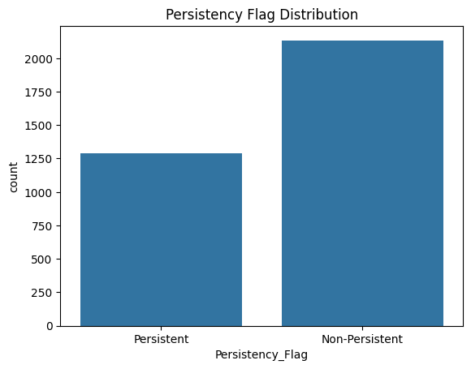

Figure : Target variable distribution

|  |
| --- |
| Target Variable Distribution:  Persistency_Flag  Non-Persistent 2135  Persistent 1289 |

* **Feature Scaling:**  
  Applied **StandardScaler** to scale numeric features. This is important for algorithms like logistic regression, SVM, and gradient boosting that are sensitive to feature magnitudes.
* **Train-Test Split and Model Pipeline:**  
  The data is split into training and test sets to prevent data leakage and allow reliable performance evaluation. A gradient boosting model is used as the final classifier, supported by explainable models like logistic regression and random forests for comparison.

After applying encoding final dataset, we got:

We performed.

1. Identify Y/N columns (binary risk factors) and convert it from “Y”, “N” to 1,2
2. Apply label encoding to non-ordinal categorical columns

|  |  |  |  |  |  |  |
| --- | --- | --- | --- | --- | --- | --- |
| **Ptid** | **Persistency_Flag** | **Gender** | **Race** | ….. | **Count_Of_Risks** | **Dexa_Freq_During_Rx_log** |
| P1 | 1 | 1 | 2 |  | 0 | 0.0 |
| P2 | 0 | 1 | 1 |  | 0 | 0.0 |
| P3 | 0 | 0 | 3 |  | 2 | 0.0 |
| …… |  |  |  |  | .. | …. |
| P3424 | 0 | 0 |  |  | 1 | 0.0 |