#### logo-color-1

#### Assignment 4(a)

##### Artificial Intellingence (Prolog)

Name- AMIT KUMAR

Roll no.-137

PRN- 0120180479

PS:- **Build Fact, Rule, goal for family relationships and arithmetic operations using Prolog.**

**Family relationships operations :**

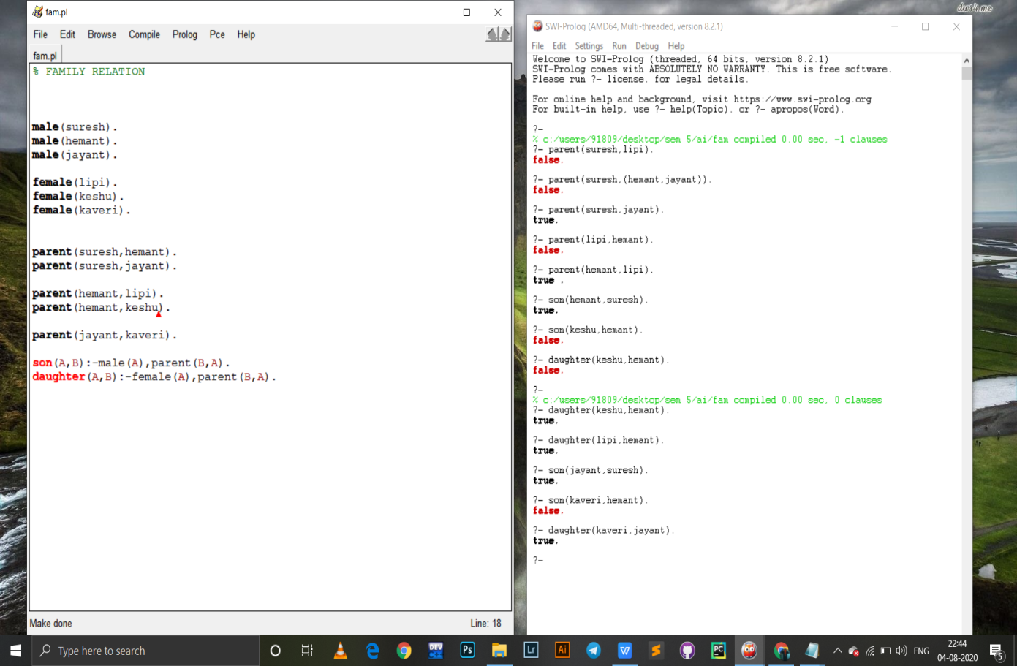

**Arithmetic operations :-**



