KANTIPUR ENGINEERING COLLEGE

Dhapakhel,Lalitpur

Report on 64 bit Processor

Submitted to : Submitted by :

Prof.Dr. Surbarna Shakya Iza K.C.

kan077bct039

Table of contents

1. Introduction to 64 bit processor
2. Internal architecture of 64 bit processor
3. Comparison of 32 bit and 64 bit processor
4. Limitations

Introduction to 64 bit processors

A 64 bit processor refers to a processor that can process data and instruction in chunks of 64 bit. Every microprocessor handles two key criteria: memory addressing and the corresponding data or instruction present at each memory address. Microprocessors are tied to memory where applications and data are executed, and the number of bits available on a processor define the memory size and space that a processor can handle per unit of time.

A 64 bit processor uses internal registers that are temporary storage locations within the processor that are 64 bit wide. This corresponds to an address bus and data bus that are also 64 bit. The address bus is the pathway of electrical signals used to determine the device or memory address that the processor is attempting to access. The data bus is the pathway used to exchange data with the intended address. Processors also include signaling for a third control bus, but this bus is typically a unique collection of discrete, or individual, digital signals and does not operate like an address or data bus.

Intel 64 bit Architecture (IA64)

As applications began to demand larger address spaces and RAM prices began to drop, Intel and AMD started to pursue 64-bit architectures. Intel developed the brand-new *IA64* RISC architecture. Intel 64 architecture increases the linear address space for software to 64 bits and supports physical address space up to 46 bits. It operates in one of two sub-modes: compatibility mode enables a 64-bit operating system to run most legacy 32-bit software unmodified and 64-bit mode enables a 64-bit operating system to run applications written to access 64-bit address space.

Features

* 64-bit flat linear addressing
* 8 additional general-purpose registers (GPRs)
* 8 additional registers for streaming SIMD extensions (SSE, SSE2, SSE3 and SSSE3)
* 64-bit-wide GPRs and instruction pointers
* uniform byte-register addressing
* fast interrupt-prioritization mechanism
* a new instruction-pointer relative-addressing mode

Internal Architecture

1. Compatibility mode

Compatibility mode permits most legacy 16-bit and

32-bit applications to run without re-compilation under a 64-bit operating system.Compatibility mode is similar to 32-bit protected mode. Applications access only the first 4 GByte of linear- address space. Compatibility mode uses 16-bit and 32-bit address and operand sizes. Like protected mode, this mode allows applications to access physical memory greater than 4 GByte using PAE (Physical Address Extensions).

1. 64-bit mode

This mode enables a 64-bit operating system to run applications written to access 64-bit linear address space.64-bit mode extends the number of general purpose registers and SIMD extension registers from 8 to 16.General purpose registers are widened to 64 bits. The mode also introduces a new opcode prefix (REX) to access the register extensions. See Section 3.2.1 for a detailed description.

64-bit mode is enabled by the operating system on a code-segment basis. Its default address size is 64 bits and its default operand size is 32 bits. The default operand size can be overridden on an instruction-by-instruction basis using a REX opcode prefix in conjunction with an operand size override prefix.

REX prefixes allow a 64-bit operand to be specified when operating in 64-bit mode. By using this mechanism,many existing instructions have been promoted to allow the use of 64-bit registers and 64-bit addresses.

Basic execution environment

The basic execution environment is used jointly by applications and the operating system or executive running on the processor.

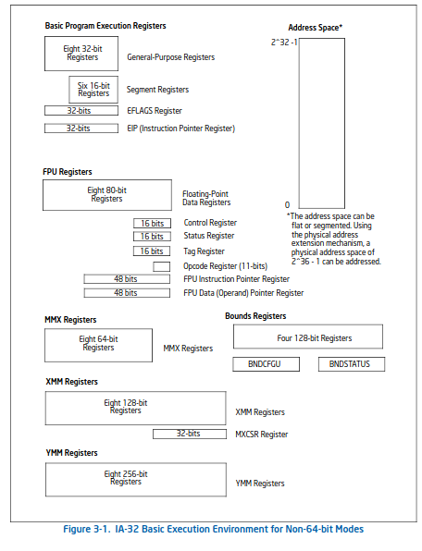

Fig: compatible mode execution environment

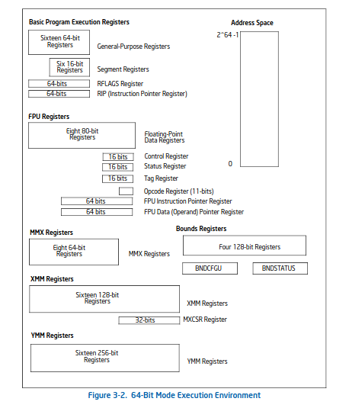

fig : 64-bit execution mode environment.

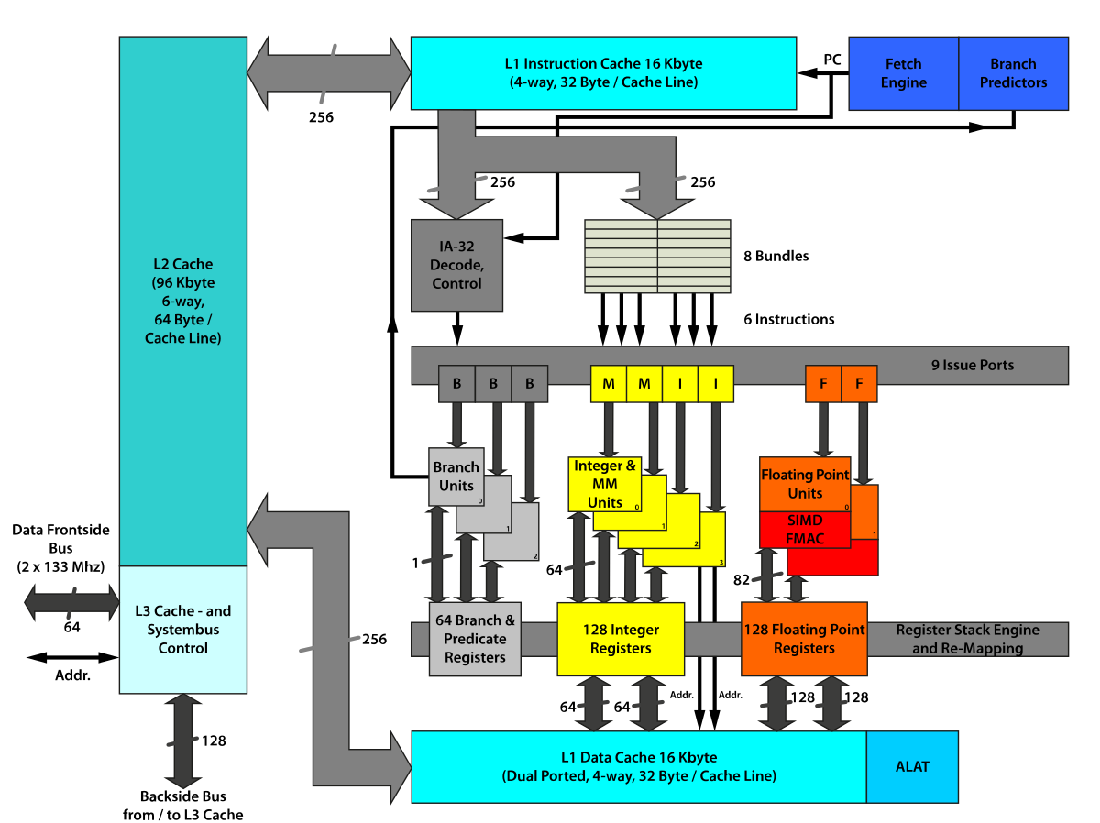

Fig : general 64-bit internal architecture

Comparison of 32-bit and 64-bit processor (Bigelow)

* The 32-bit general-purpose registers (EAX, EBX, etc.) have been extended to 64-bit and are called RAX, RBX, and so on.
* 32-bit processors are older,slower and less secure whereas 64-bit processors are newer, faster and more secure
* The addressable space in 32-bit is 4GB and 64-bit is 16GB
* 64-bit programs won't work on 32-bit processor but 64-bit processor allows operation of programs and applications written for 32-bit processor through legacy compatible mode
* 64-bit processors are ideal for multitasking
* All editions of Windows 7,Windows 8, Windows XP, Linux and Windows 10 all work on both the processor

Limitations

1.Industry catch-up.

In practical terms, today's 64-bit processors cannot access all of the potential memory space that 64 bits offer. When 64-bit processors were first released, the practical memory limit was about 8 terabytes (TB) because of early 64-bit OSes and other hardware limits. Today, OSes and supporting hardware have advanced, and 64-bit processors are typically limited to about 256 TB -- just 48 bits -- of memory space because of current OS and remaining limitations of memory design. The problem is not that the 64-bit processor cannot use all 64 bits, but rather the rest of the computer industry is still catching up and evolving to grow into that enormous capacity. So, this issue should disappear in the coming years.

2. Memory waste

64-bit computing offers backward compatibility with 32-bit computing. However, the translation from 32-bit to 64-bit computing environments can lead to wasted memory capacity, depending on the ways that data is formatted and stored. For example, some 32-bit applications and data sets may need to add padding -- basically null data -- to occupy the additional 32 bits at every address. It works, but it is not an effective use of the additional capacity when using older 32-bit software or data. This issue should also disappear over time as older 32-bit legacy software is updated and replaced by equivalent 64-bit programs.

Reference

Bigelow, Stephen J. “What is a 64-Bit Processor (64-Bit Computing)?” *TechTarget*, https://www.techtarget.com/searchdatacenter/definition/64-bit-processor. Accessed 13 June 2023.

Enrico Perla, Massimiliano Oldani, in [A Guide to Kernel Exploitation](https://www.sciencedirect.com/book/9781597494861/a-guide-to-kernel-exploitation), 2011

“Intel® 64 and IA-32 Architectures Software Developer's Manual, Volume 1: Basic Architecture.”*cs.Princeton*,https://www.cs.princeton.edu/courses/archive/spr18/cos217/reading/x86-64-1.pdf. Accessed 13 June 2023.