
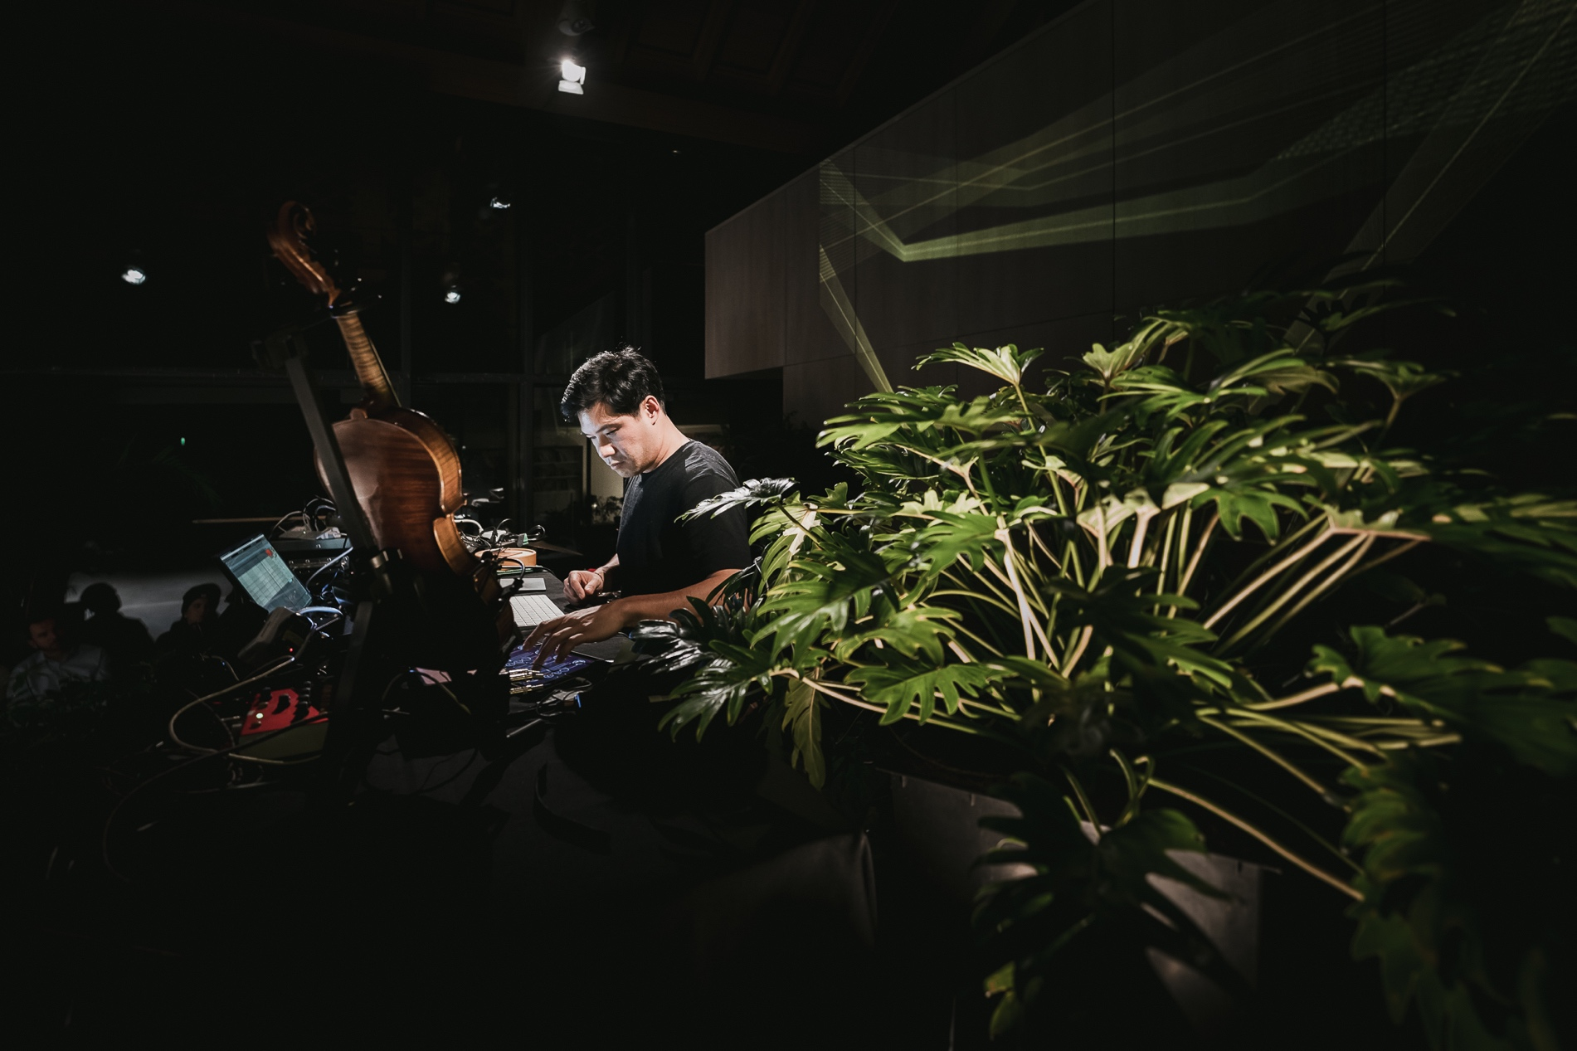

EPK
H E A D L I N E

Dive into the Enchanting Fusion of Bio Sounds, Experimental Jazz, Electronics & Strings in an Immersive Audiovisual Interdisciplinary Performance Inspired by Nature.

B I O G R A P H Y

J3ZZ is a visionary artist and multi-instrumentalist from Reunion Island. With a passion for exploring the boundaries of music and sound, J3ZZ's artistic journey is characterized by a fusion of genres and a commitment to creative experimentation. Drawing inspiration from free jazz, electronic ambient, and the traditional rhythms of Maloya, J3ZZ creates immersive and captivating sonic experiences that transport listeners to new realms of imagination.

"I see myself as a protean author artist, as much as a performer, violinist, composer, producer and sound designer as in the themes of my work, where the themes of gathering and legitimacy constantly intersect with those of dialogue and code sharing. This permeability is also part of the artist and engineer in me, bringing a know-how acquired through multiple experiences around the world.

I develop artistic, technological and social projects that transmit, in a roundabout way, knowledge and values, which raise questions about our environment. My creative process is part of a social, cultural and artistic approach. My desire is to develop actions accessible to all, documented, rich and synonymous with discovery and dialogue.

I believe that arts, culture, education and science are the best way to grow and live in society. My artistic research consists of creating a bridge between humans and Nature, experimenting and playing through various mediums such as conferences, online tools, workshops, installations in festivals and cities to give a chance to see and to consciously appreciate our environment as a society and to inspire self-change first in our daily lives and then in our political and economic environments."

-- Jérôme Li-Thiao-Té (a.k.a. J3ZZ)

H I G H L I G H T S

- Composer, producer, and sound designer extraordinaire
- Masterful violinist, known for his expressive and emotive playing style
- Founder of Watcha Studios, an artistic hub promoting collaboration and celebrating cultural diversity
- Pioneer in the field of biosonification, transforming plant vibrations into mesmerizing musical compositions
- Renowned for pushing artistic boundaries and creating unique fusion experiences

D I S C O G R A P H Y

"Ex Nihilo 3" (2021) – single
"Ex Nihilo 2" (2021) – single
"Ex Nihilo 1" (2021) – single
"Stereo Woods" (2020) – single

"A Drop in the Ocean" (2020) – album

N O T A B L E P E R F O R M A N C E S

“J3ZZ feat. Grecsó Zoltán & Bujdosó Anna", Lóvasut, Budapest, Hungary, 2020
“IRIS at Lighthouse: O N / light art exhibiton” Debrecen, Hungary, 2020
"J3ZZ x Szabihíd", Budapest, Hungary, 2019

C O L L A B O R A T I O N S

J3ZZ's collaborations with other artists:

Indigo Theory:
Collaboration as composer and violinist on the single "Rainy Day" (2017)
Buddha Bar Budapest:

Resident live musician at Buddha Bar Budapest for 5 years (2013-2017)

Talking heArts:
Collaboration with various young music, media, and dance artists as part of the Talking heArts project, funded by the Youth in Action programme of the European Union (2012)

Eutropia:
Collaboration as violinist, composer, and producer for the Eutropia project, involving multidisciplinary shows and performances across Europe (2 years)
Resident violinist during Eutropia residency in Lille, France (2012)

Iparkutya:
Collaboration as violinist with Iparkutya, a Balkan free jazz band (2010-2012)

Willany Léo:
Collaboration as an improviser musician with Willany Léo Improvisation Dance Theatre, directed by Zoltán Grecsó (since 2009)

Azalai:
Collaboration as a violinist with African and European artists in the Azalai project, involving residencies, concerts, and tours (2 years) with Aly Keita (Mali-Germany), Dimitri Grechi Espinoza (Italy), Ebou Gaye Mada (Gambia-Netherlands), Hilaire Penda (Cameroon-France), Istvan Cik (Serbia), Kandia Kora (Guinea-France), Károly Féher (Hungary), Minyeshu (Ethiopia-Netherlands), Moh! Kouyaté (Guinea-France), Pasquale Mirra (Italy),Said Tichiti (Morocco-Hungary) …

Jamie Winchester (Ireland-Hungary): as a violinist

C O N T A C T I N F O R M A T I O N

Website: https://vibrotanica.j3zz.com/en
Email: contact@j3zz.com
Phone: +33698845571
Social Media: @iamj3zz (Instagram, Facebook, Twitter)

H I G H R E S P H O T O S

https://drive.google.com/file/d/1QvVXxc37JjxcHRS9SXt9khr5TWAdxbSD

M U S I C S A M P L E S

https://open.spotify.com/artist/0gsGZAcqRcoDmr6RuaKwze

V I D E O H I G H L I G H T S

Ex Nihilo 2 - https://www.youtube.com/watch?v=Jc6lOe_jvCQ
Stereo Woods - https://www.youtube.com/watch?v=-DyZlkGGLiE
Vibrotanica - https://www.youtube.com/watch?v=sl-GYb-_PM0

