Audit Management Dashboard

Training Guide
A quick-start guide to what the Audit Management Dashboard is, who uses it, and the four audit workflows it supports. Use this document to onboard new auditors before their first live audit.
Chrome Extension | Trax Group Inc. | Operations Analytics
Internal training material — for authorized Trax employees only

1. What is the Audit Management Dashboard?
The Audit Management Dashboard is a Google Chrome extension used by the Trax Group Operations Analytics and Audit teams. It opens as a side panel inside Chrome — a vertical pane that sits next to whatever tab you are working in — so you can complete audit forms while you review the underlying system, without switching windows or copying data back and forth.
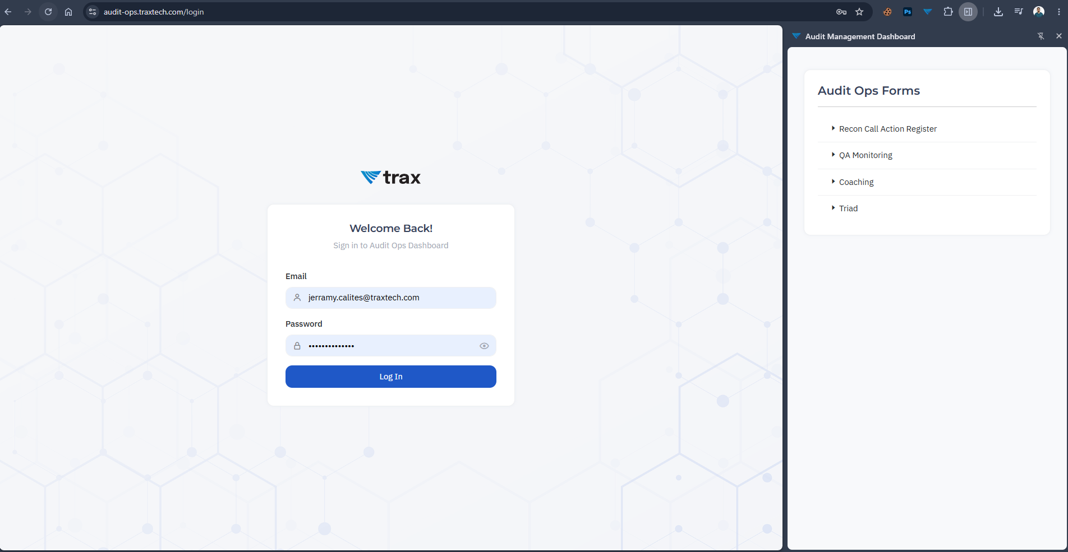
All forms and reference data are loaded from, and submitted back to, the Trax audit platform (audit-ops.traxtech.com). You sign in once with your Trax Microsoft 365 account, and the panel shows the audit workflows you are authorized to use.
In one sentence: a secure side panel where authorized Trax auditors fill in and submit QA, coaching, reconciliation, and triad audits.

Screenshot: the side panel open next to a browser tab, showing the main menu
2. Who it is for and what you need
- Audience: Trax auditors, QA analysts, and team leads who complete audits.
- Account: a valid Trax Microsoft 365 (Azure AD) work account. Personal or non-Trax accounts cannot sign in.
- Browser: Google Chrome (desktop), with the Audit Management Dashboard extension installed.
- Network: access to audit-ops.traxtech.com and Microsoft sign-in (login.microsoftonline.com).
If you cannot sign in or do not see a form you expect, it is almost always an access/permission matter rather than a bug. See the FAQ and contact your team lead for access.

3. Signing in
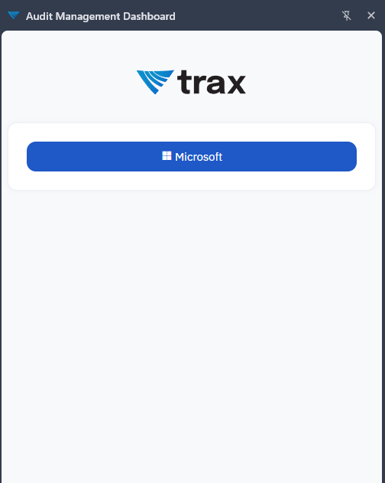
Click the extension icon in the Chrome toolbar to open the panel, then click Login. A Microsoft sign-in window appears. Sign in with your Trax email and password (and approve multi-factor authentication if prompted). After sign-in you land on the main menu.
Your session is kept only for as long as you are working. If it expires, the panel returns you to the Login screen — simply sign in again.

Screenshot: Microsoft sign-in prompt / the login button in the panel

4. The four audit workflows
From the main menu you can open any of the following. Each opens its own form inside the panel.
QA Monitoring
A full quality-assurance review. The form is organized into sections — Verification, Process Compliance, Engagement, and Business Analytics. As you select outcomes, the panel calculates each section's score and an overall score automatically, so you can see the result before you submit.
- Verification acts as a gate: the overall score only counts the other sections when verification is complete.
- Audit dates default to today; the auditor's email is filled in automatically.
Coaching
Records a coaching session tied to a specific audit reference, using the SMART (Specific, Measurable, Achievable, Relevant, Time-bound) and GROW (Goal, Reality, Options, Way forward) frameworks. You pick the coaching reference and type, then complete both framework sections.
Reconciliation Call
Logs the outcome of a reconciliation call: the call date, client and carrier codes, region, an action-item summary and details, status, and a linked ticket reference. The carrier list updates based on the client you choose.
Triad Audit
A triad review scored across criteria such as body language, clear mind, questioning, summarizing/recap, subject-matter adherence, and root-cause analysis. Each criterion takes a note and a score, linked to a coaching reference.
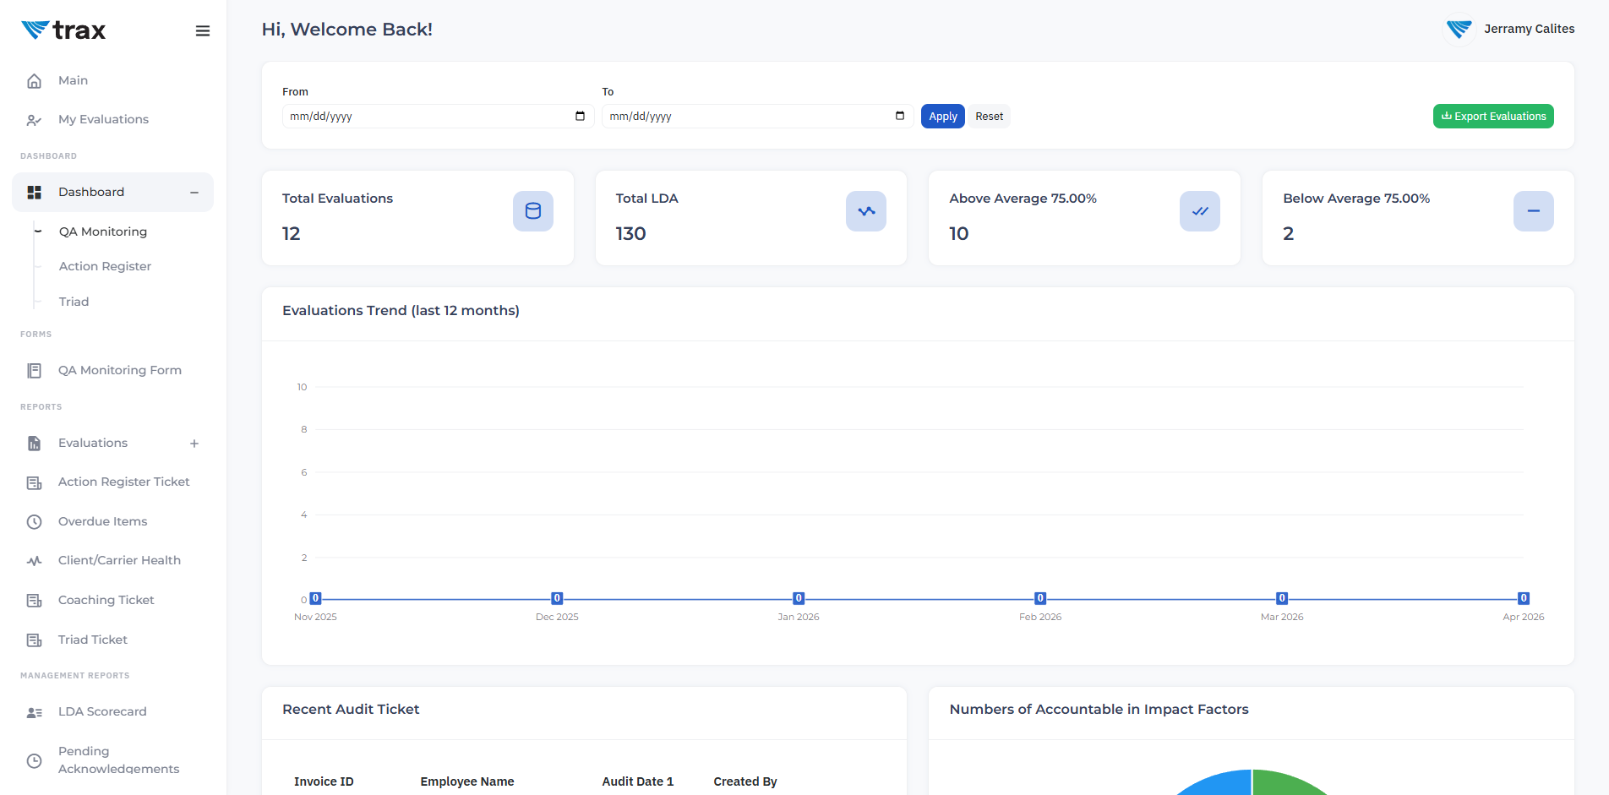
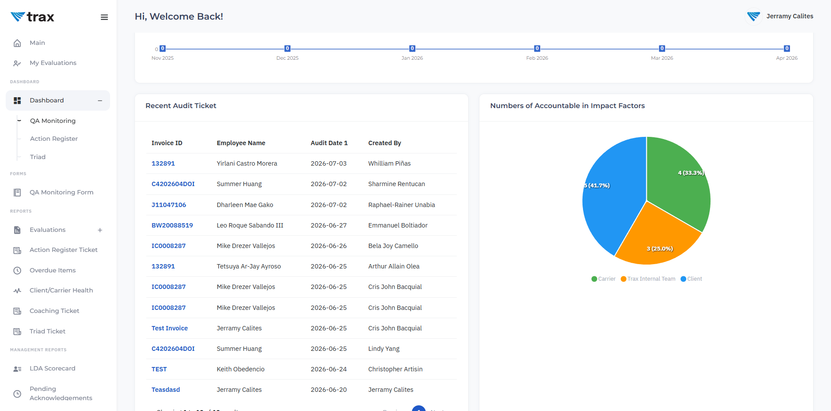
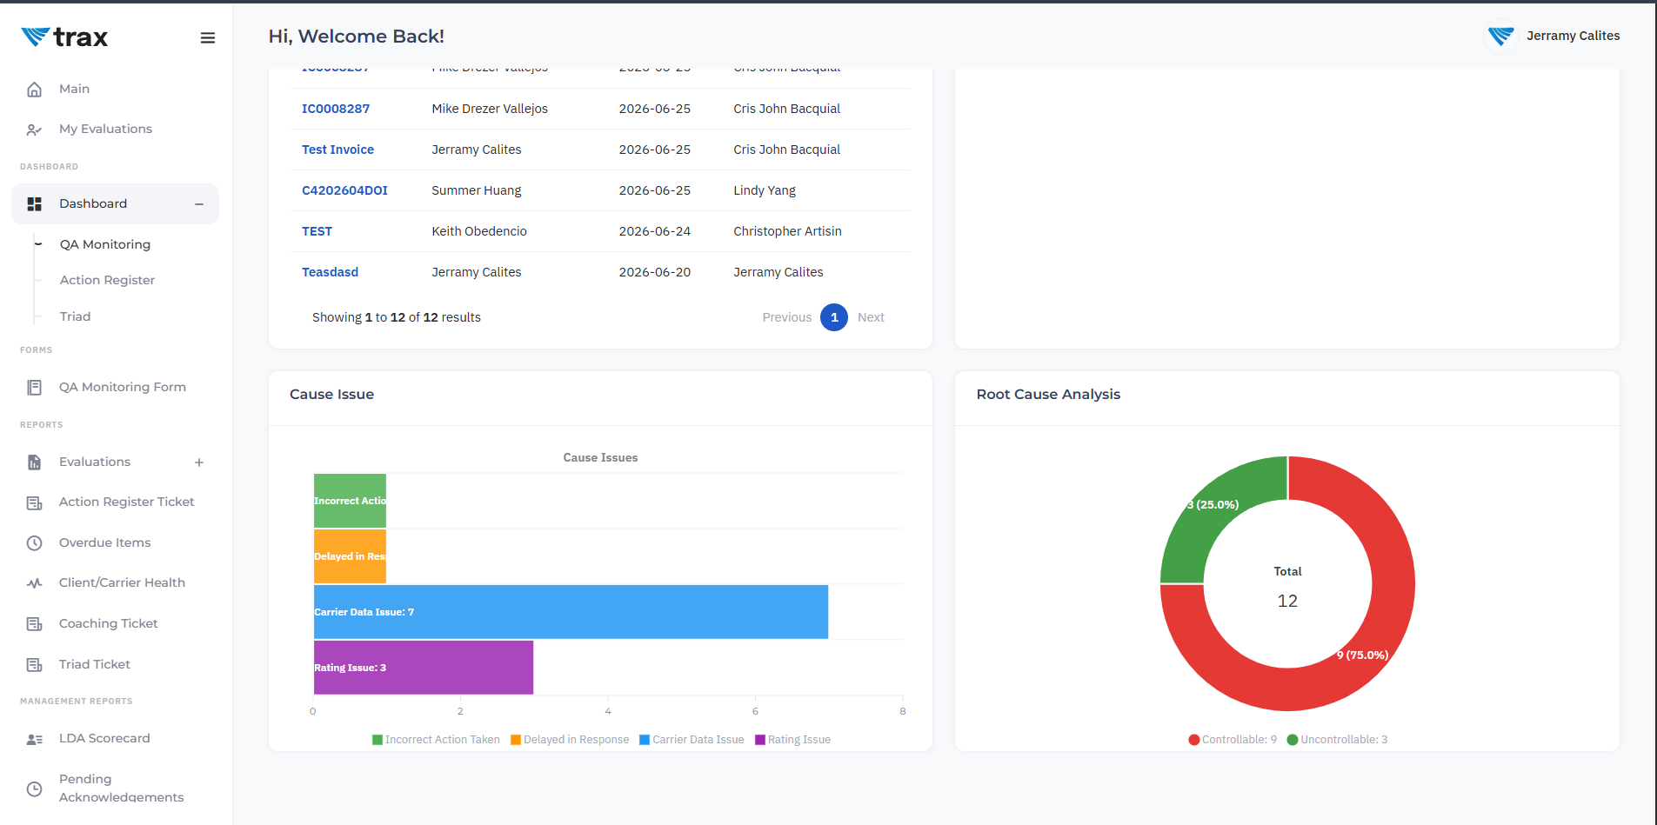

Screenshot: a QA Monitoring form with the live score bars visible
5. Good habits
- Complete required fields before submitting — the form highlights anything missing.
- Wait for the confirmation message after you submit; the form then resets for the next audit.
- Pick client, carrier, and reference values from the dropdowns rather than typing, so they match the platform.
- If a spinner does not clear or a dropdown stays empty, refresh the panel and try again, then check the FAQ.

Next: see the Walkthrough for click-by-click steps, and the FAQ for common questions and troubleshooting. For support, contact Trax Group Inc. at 1-800-755-0110 or jerramy.calites@traxtech.com.

