Audit Management Dashboard

Walkthrough (Step-by-Step)
Click-by-click instructions for installing the extension, signing in, and completing each of the four audit forms. Screenshot placeholders mark where to add images.
Chrome Extension | Trax Group Inc. | Operations Analytics
Internal training material — for authorized Trax employees only

Part 1 - Install the extension
From the Chrome Web Store (once published)
- Open the Audit Management Dashboard listing on the Chrome Web Store.
  - Chrome Webstore Link
2. Click Add to Chrome, then Add extension to confirm.
3. Pin the extension: click the puzzle-piece icon in the toolbar and click the pin next to Audit Management Dashboard.
Part 2 - Open the panel and sign in
1. Click the Audit Management Dashboard icon in the Chrome toolbar. The side panel opens on the right.
2. Click the Login button.
3. In the Microsoft window, enter your Trax email and password.
4. Approve multi-factor authentication if prompted.
5. You are returned to the panel's main menu, signed in.
If the Login button is greyed out, the panel could not reach the Trax platform. Check your connection/VPN and reload the panel. See the FAQ.

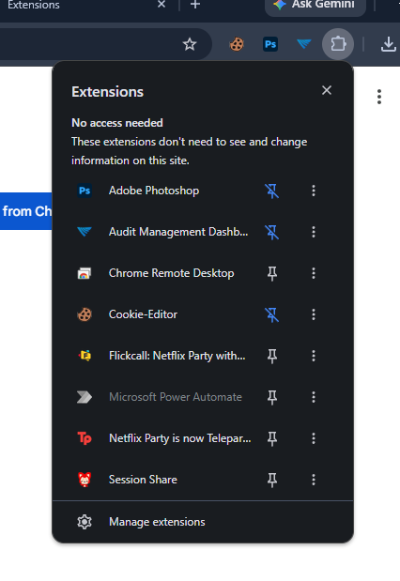
Screenshot: the panel Login button, and the Microsoft sign-in window
Part 3 - Complete a QA Monitoring audit
1. From the main menu, click QA Monitoring.
2. Confirm the audit dates (they default to today) and that your email shows in Audited by.
3. Select the LDA / auditor and enter invoice, carrier, and exception details.
4. Work through the Verification, Process Compliance, Engagement, and Business Analytics sections, choosing an outcome for each item.
5. Watch the section score bars and the Overall Score update automatically as you go.
6. Click Submit. Wait for the success message; the form then resets for the next audit.
Verification is a gate. If verification is not fully complete, the overall score shows 0% until it is.

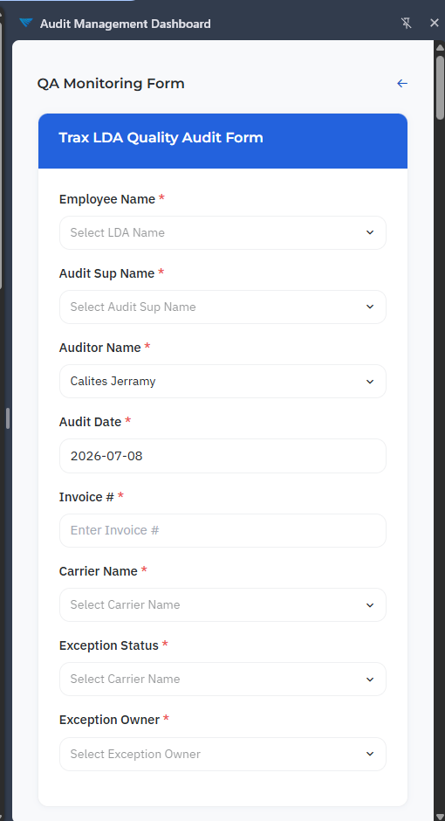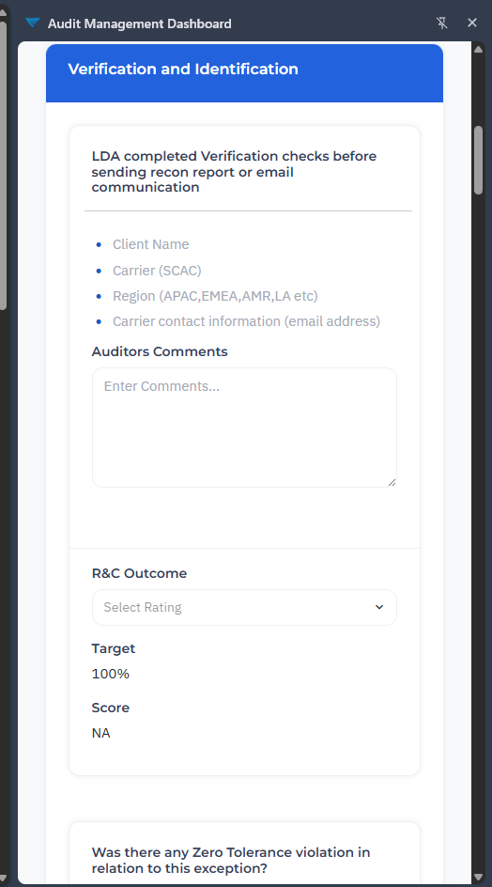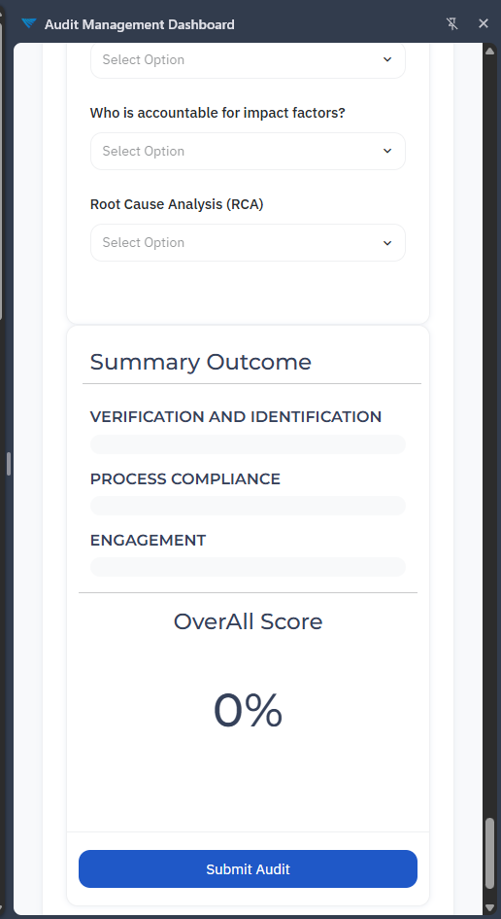

Screenshot: completed QA Monitoring form showing score bars and Overall Score

Part 4 - Log a Coaching session
1. From the main menu, click Coaching.
2. Choose the LDA, then the Coaching Reference (the reference list loads after you pick the LDA).
3. Select the Coaching Type.
4. Complete the SMART fields (Specific, Measurable, Achievable, Relevant, Time-bound).
5. Complete the GROW fields (Goal, Reality, Options, Way forward) with input and comments.
6. Click Submit and wait for the confirmation message.
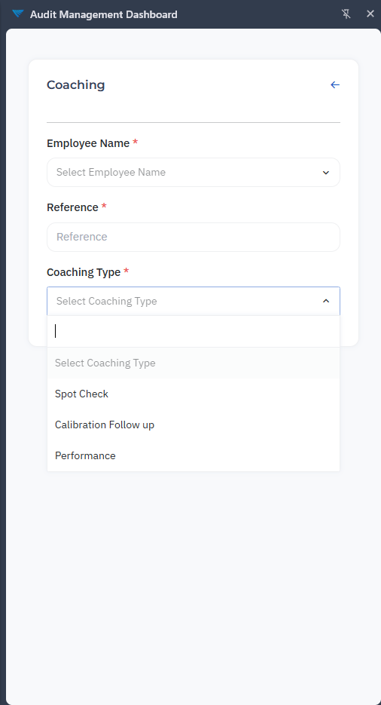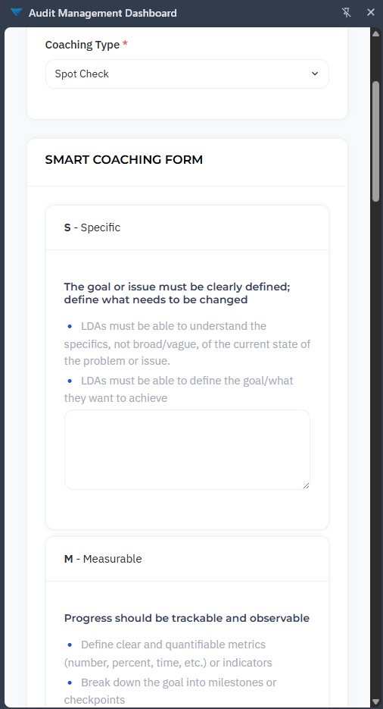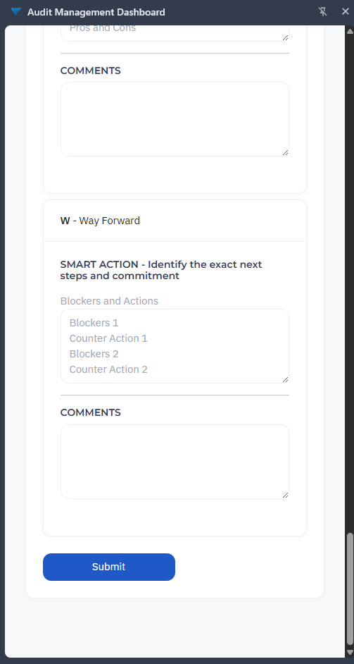

Screenshot: the Coaching form with SMART and GROW sections

Part 5 - Record a Reconciliation Call
1. From the main menu, click Reconciliation Call.
2. Your email pre-fills in the LDA email field.
3. Pick the Client Code; the Carrier Code list updates to match that client.
4. Set the call date, region, action-item summary and details, status, and the linked ticket.
5. Click Submit. A success alert confirms the call was saved.
All fields except the pre-filled email are required. The form will not submit until each one is completed.
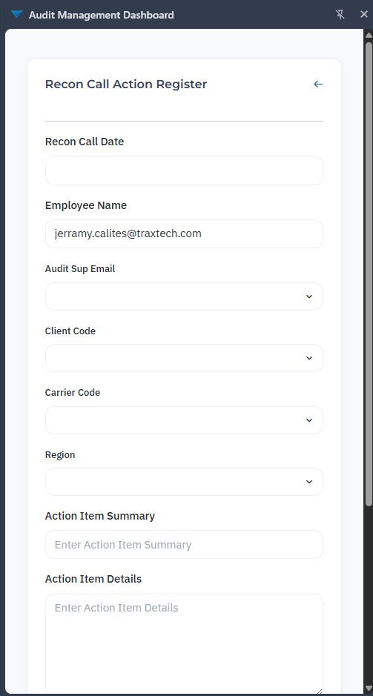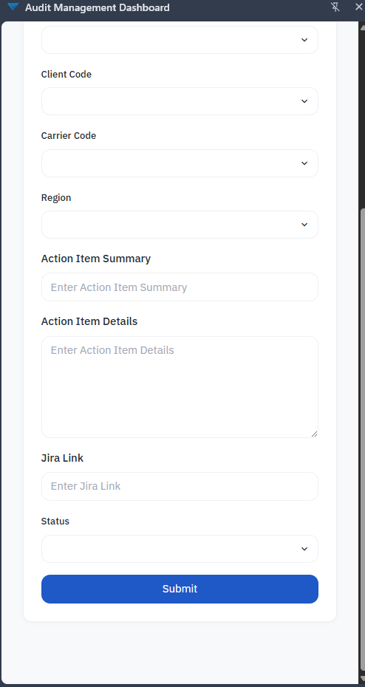

Screenshot: the Reconciliation Call form

Part 6 - Complete a Triad audit
1. From the main menu, click Triad.
2. Select the LDA and the coaching reference.
3. For each criterion (body language, clear mind, questioning, recap/summary, SME adherence, root-cause analysis, and the others), enter a note and a score.
4. Click Submit and wait for the confirmation message.
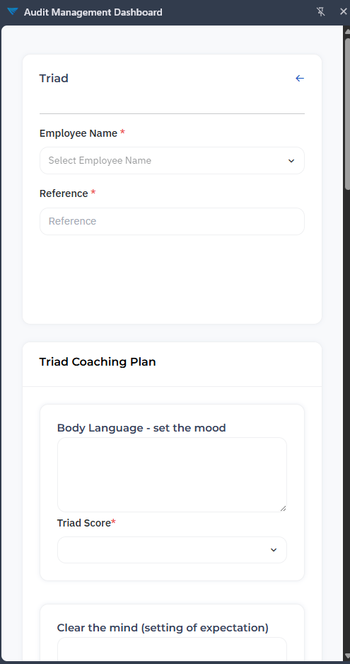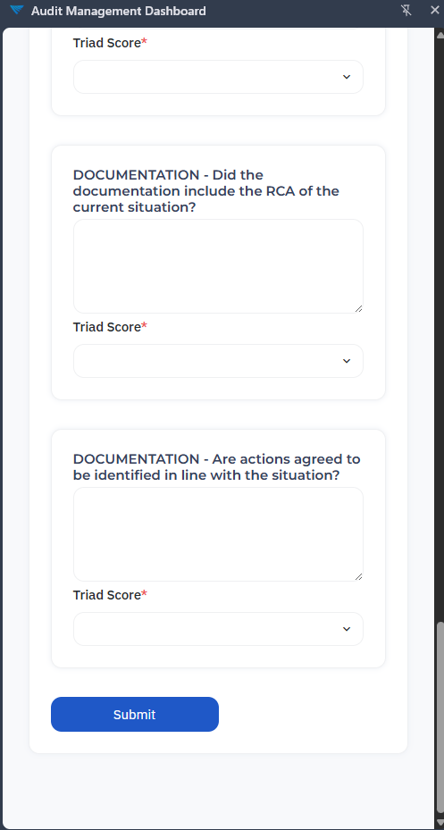
Screenshot: the Triad form with scored criteria

Stuck on any step? See the FAQ for troubleshooting, or contact Trax Group Inc. at 1-800-755-0110 or jerramy.calites@traxtech.com.

