TO-DO APP DOCUMENTATION

- Project Setup
- Initialise Directories
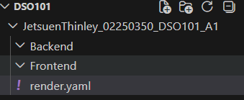
- Push to github
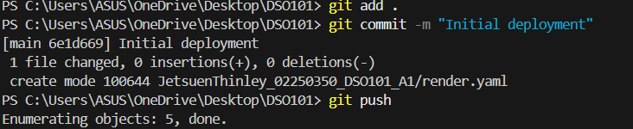
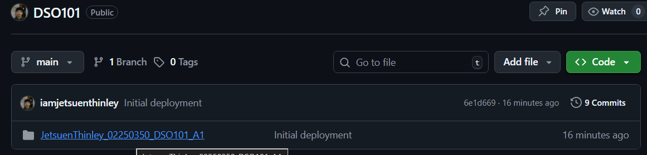

- Frontend Development
A simple user interface was created using:
- HTML
- CSS
- JavaScript
Using Environment Variables
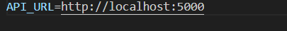
Dockerizing the Frontend
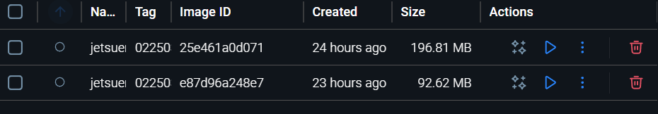
My final frontend files:
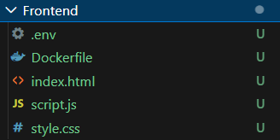

- Backend Development
A backend server was created using
- Node.js
- Express
Features implemented:
- Create task
- Read tasks
- Delete tasks

Using Environment Variables
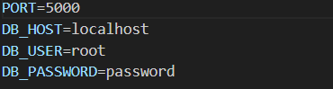
Dockerising the Backend
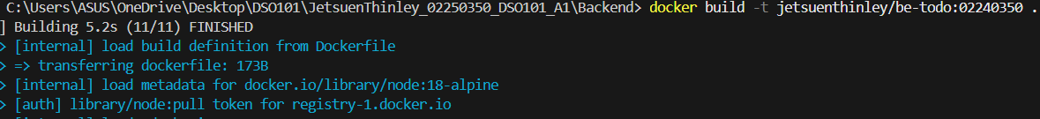
My final backend files:
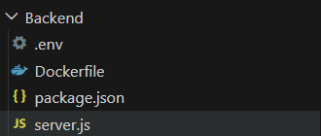

Deployed Frontend and Backend files to github
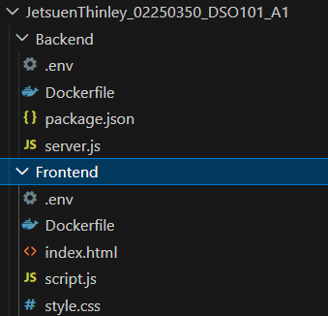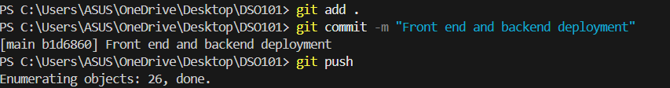

- Pushing Docker Images to Docker Hub
Enter “docker login” in the reminal.
Then pushed the images to docker hub.
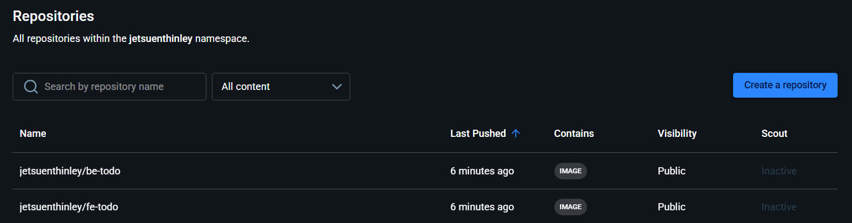
- Connecting GitHub to Render (CI/CD)Go to render.com
Created a new webservise
Connected to my github repository for both backend and frontend
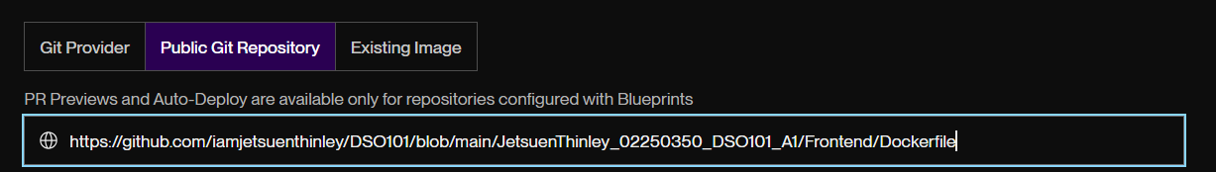
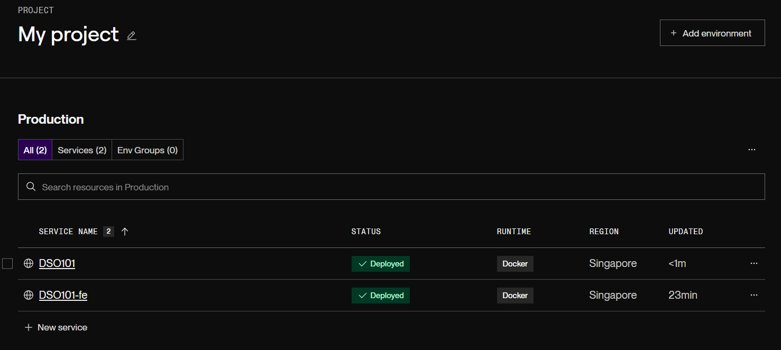

- Continuous Deployment
Henseforth if I were to make changes to the code and pushed to GitHub.
git add .
git commit -m "Test CI/CD deployment"
git push
Render automatically rebuilds and redeploys the application.
This demonstrates Continuous Integration and Continuous Deployment.

- Final Deployment

