


འབྲུག་རྒྱལ་འཛིན་གཙུག་ལག་སློབ་སྡེ།།

College of Science and Technology
Rinchending: Bhutan

WEB101
Web Application Fundamentals
(SS2026)

Practical 3 Report

Submitted By;
Name: Jetsuen Thinley
Student No.: 02250350
Programme: BE 1SWE
Date: 19/4/2026

RUB Wheel of Academic Law: Academic Dishonesty
Section H2 of the Royal University of Bhutan’s Wheel of Academic Law provides the following definition of academic dishonesty:

Academic dishonesty may be defined as any attempt by a student to gain an unfair advantage in any assessment. It may be demonstrated by one of the following:
- Collusion: the representation of a piece of unauthorised group work as the work of a single candidate.
- Commissioning: submitting an assignment done by another person as the student’s own work.
- Duplication: the inclusion in coursework of material identical or substantially similar to material which has already been submitted for any other assessment within the University.
- False declaration: making a false declaration to receive special consideration by an Examination Board or to obtain extensions to deadlines or exemption from work.
- Falsification of data: presentation of data in laboratory reports, projects, etc., based on work purported to have been carried out by the student, which has been invented, altered or copied by the student.
- Plagiarism: the unacknowledged use of another’s work as if it were one’s own.
Examples are:
• verbatim copying of another’s work without acknowledgement.
• paraphrasing of another’s work by simply changing a few words or altering the order of presentation, without acknowledgement.
• ideas or intellectual data in any form presented as one’s own without acknowledging the source(s).
• making significant use of unattributed digital images such as graphs, tables, photographs, etc., taken from test books, articles, films, plays, handouts, the internet, or any other source, whether published or unpublished.
• submission of a piece of work which has previously been assessed for a different award or module or at a different institution as if it were new work.
• use of any material without prior permission of copyright from the appropriate authority or owner of the materials used”.

Aim

To design and implement a file upload system using Next.js that allows users to upload files to a server with validation and progress tracking.

Background Information (Theory)
File upload is an important feature in modern web applications that allows users to send files such as images, documents, or videos from the client side to a server. This is commonly used in applications like social media platforms, cloud storage systems, and online forms.

In web development, file uploads are usually handled using HTTP POST requests with a special encoding type called multipart/form-data. This encoding allows both text and binary data (files) to be sent together in a single request. On the frontend, JavaScript is used to collect the selected file and send it to the backend using tools like FormData and libraries such as Axios.

On the backend, the server processes the uploaded file, performs validation, and stores it in a specific location. In this practical, the Next.js framework is used because it supports both frontend and backend in a single project. The backend API route is created to handle file uploads using the formidable library, which helps parse incoming file data.
File validation is an important part of the process to ensure that only allowed files are uploaded. This includes checking file size and file type to prevent misuse or security issues. Additionally, tracking upload progress improves user experience by showing how much of the file has been uploaded.

Overall, file upload systems demonstrate how client-server communication works in real-world applications and highlight the importance of handling user data securely and efficiently.

Implementation Steps

- Step 1: Create Project

- Step 2: Install Dependencies
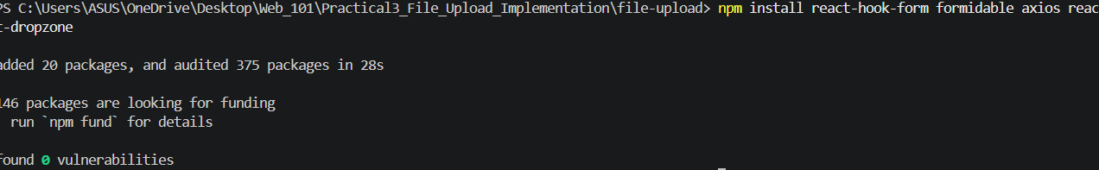

Step 3: Create File Upload Form (Frontend)
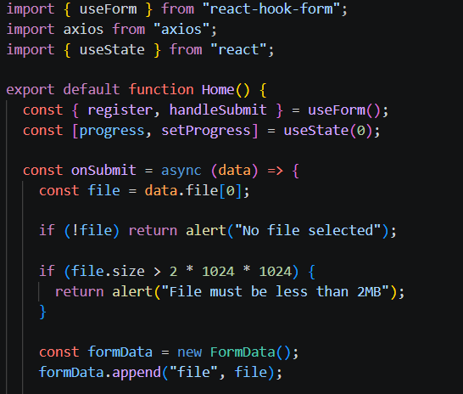
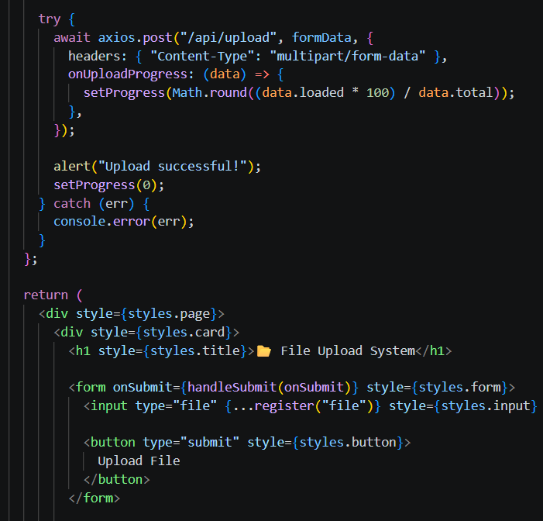
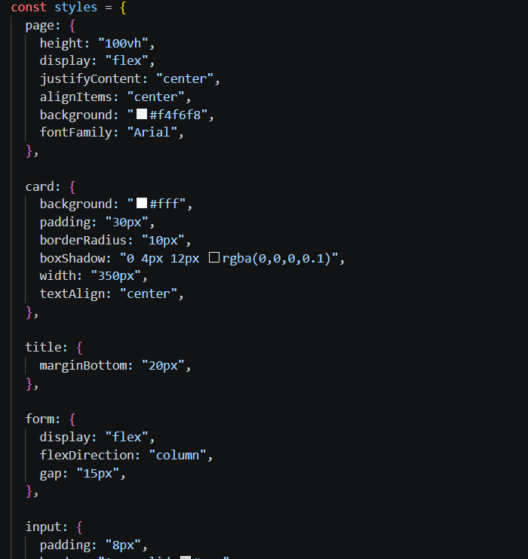

Step 4: Create API for File Upload (Backend)
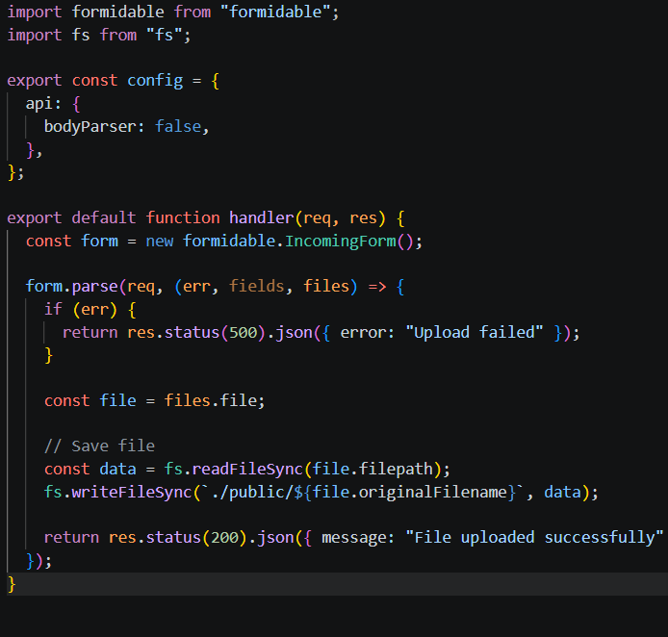

Step 5: Run the Project
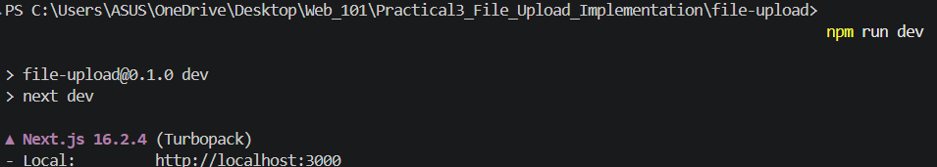
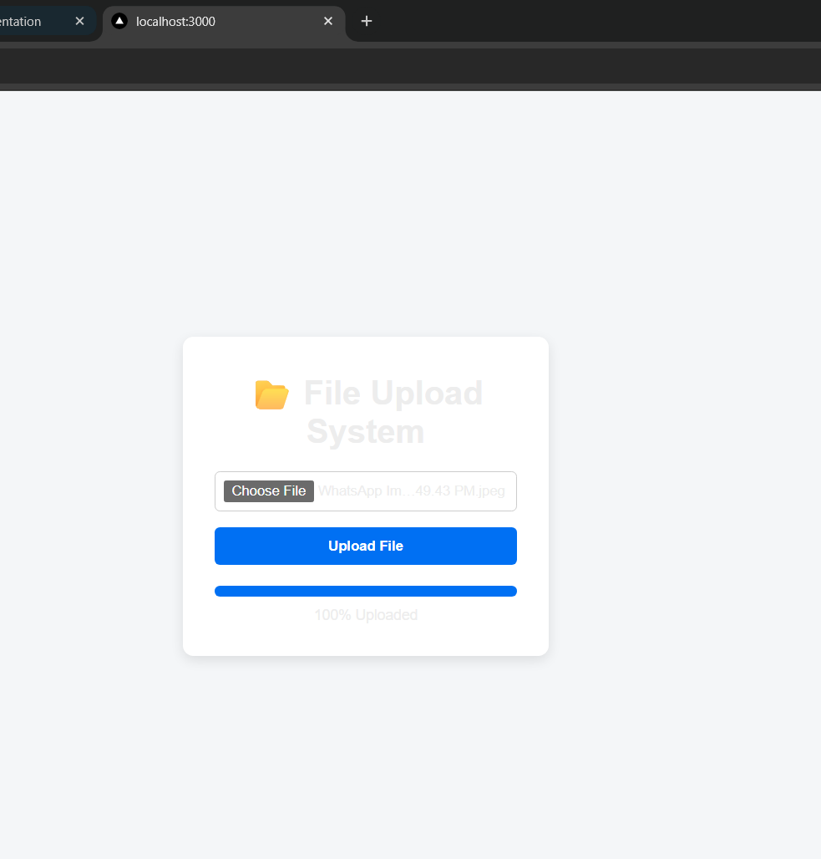

Conclusion
In this practical, a file upload system was successfully developed using Next.js. The application allows users to select and upload files to the server with proper validation and progress tracking. The use of API routes and external libraries simplified the process of handling file data. This practical helped in understanding how file uploads work in web applications and the importance of validation and user feedback during the upload process.

Reference
- Next.js Documentation: https://nextjs.org/docs
- React Hook Form Documentation: https://react-hook-form.com
- Axios Documentation: https://axios-http.com
- Formidable Documentation: https://www.npmjs.com/package/formidable
- MDN Web Docs (File Upload): https://developer.mozilla.org

