1. Project Proposal
1.1 Background the problem
With the increasing demand for transparency, accuracy, and efficiency in financial auditing, audit firms are under growing pressure to manage projects, assignments, and reports in a structured and timely manner. Traditional audit management processes often rely on spreadsheets, emails, and manual documentation, which leads to inefficiencies such as poor task tracking, data duplication, lack of accountability, and delays in report approval. Communication gaps between CEOs, Managers, and Auditors further complicate project coordination and decision-making.
In many audit firms, it is difficult to track which auditor is assigned to which task, the status of ongoing projects, and the progress of submitted reports. Manual systems also make it challenging to maintain a clear audit trail for compliance and internal review purposes. Additionally, report reviews and approvals are often delayed due to the absence of a centralized platform, resulting in slower project completion and reduced service quality for clients.
To overcome these challenges, an integrated Audit Firm Management System (AFMS) is required. This system will provide centralized access to users based on their roles (CEO, Manager, and Auditor), enable efficient project and assignment management, support structured report submission and approval workflows, and improve visibility across all audit activities. By digitizing audit operations, the system aims to enhance operational efficiency, ensure accountability, reduce manual workload, and support better management decisions within the audit firm.

1.2 Selection of Process Model
For this project, the Scrum process model has been selected as the most suitable software development approach. Scrum is an Agile development model that emphasizes iterative development through short, time-boxed cycles known as sprints. Each sprint delivers a working increment of the system, allowing continuous improvement and early validation of system functionality.
The Audit Firm Management System involves evolving requirements such as user role management, project workflows, assignment allocation, and report approval processes. These requirements are likely to change based on user feedback from CEOs, Managers, and Auditors during development. Scrum supports this flexibility by maintaining a prioritized product backlog and enabling frequent reviews and refinements after each sprint.

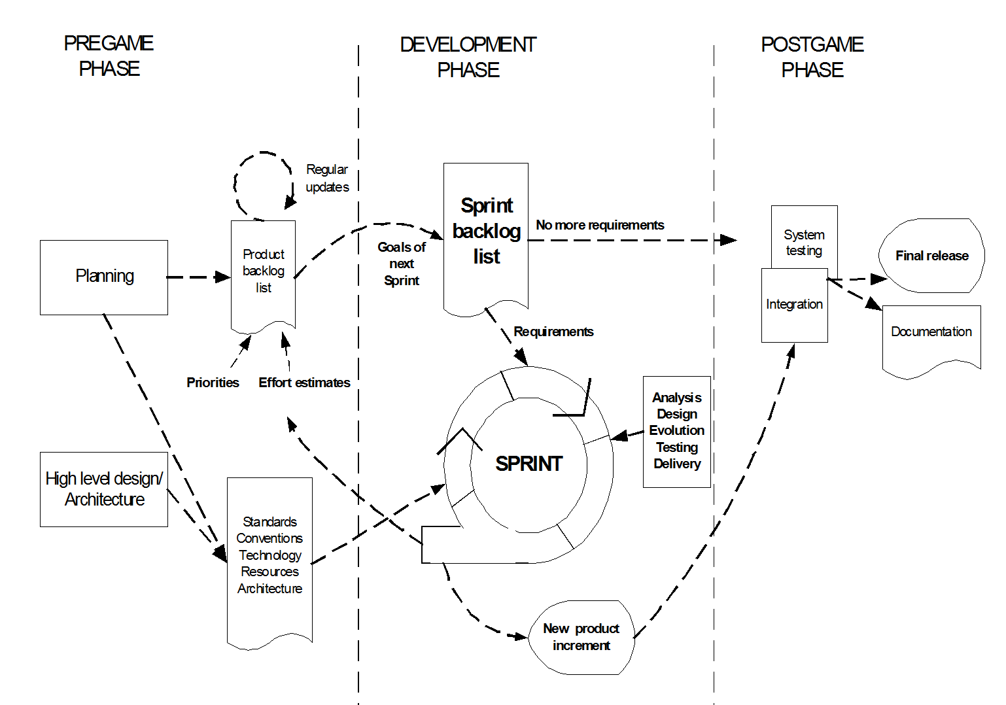

Using Scrum, core features such as authentication, dashboards, project creation, and assignment management can be developed in early sprints, while advanced workflows like report feedback, audit trail generation, and performance dashboards can be added in later sprints. Continuous testing and stakeholder feedback ensure that the system remains aligned with real audit firm operations. Therefore, the Scrum process model is well-suited for delivering a reliable, scalable, and user-centered Audit Firm Management System efficiently.

