Name : Abdul kalam
Roll NO : 23P-0622
section : BS-CS-6A
Lab task : local searches

TASK 01 — N-QUEENS WITH HILL CLIMBING

output screen shot
Bar chart comparing steepest , first choice and random restart in which random restart gives us 100% of result
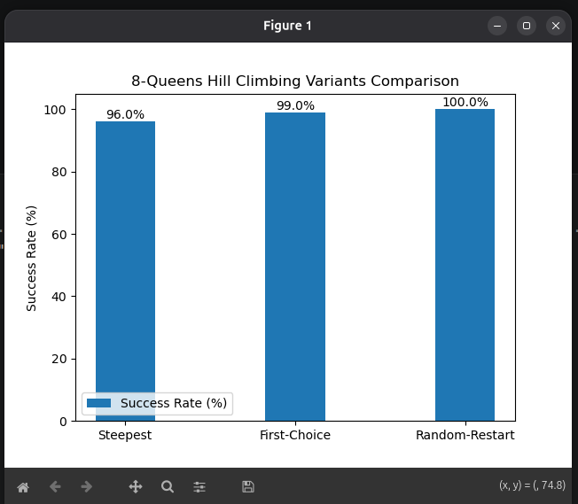
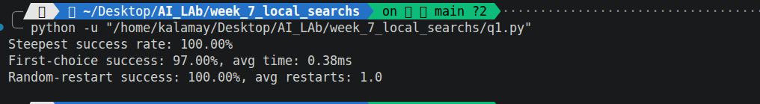

TASK 02 — TSP WITH SIMULATED ANNEALING

output screen shot
result :
Geometric cooling with T0=10000 and alpha=0.995 performs best. It allows initial exploration with high T and gradual exploitation. Linear cools too quickly, risking local optima. Logarithmic cools too slowly, wasting computation.
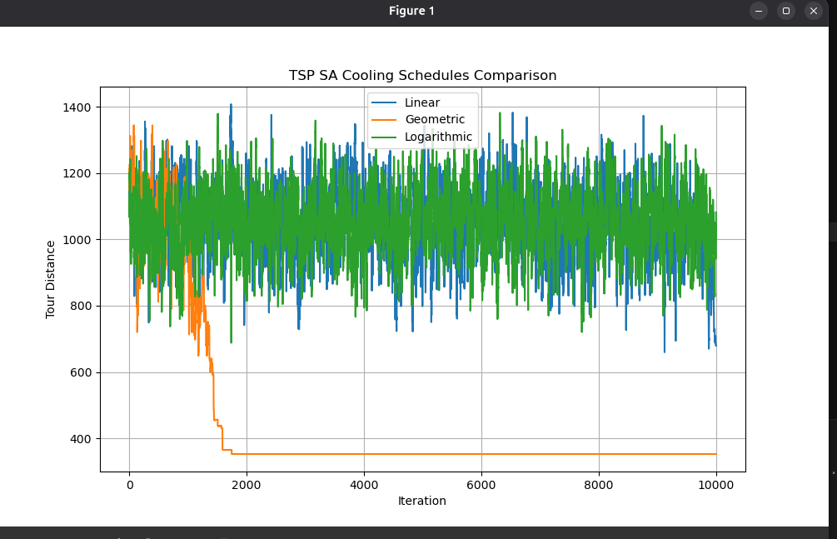

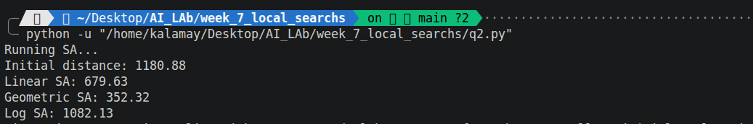

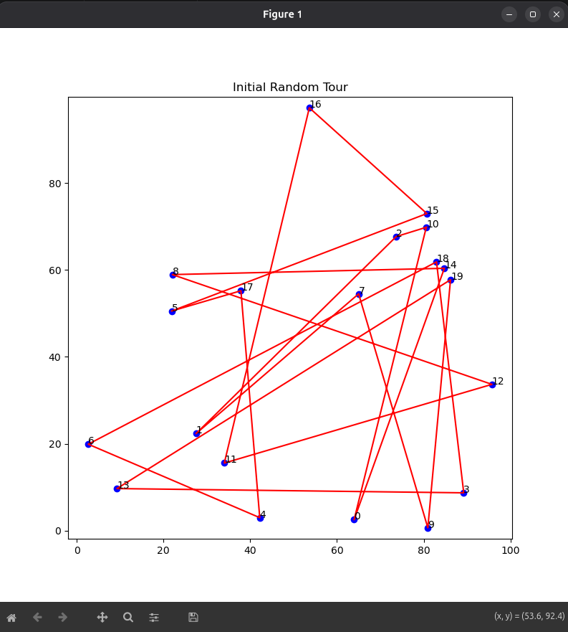
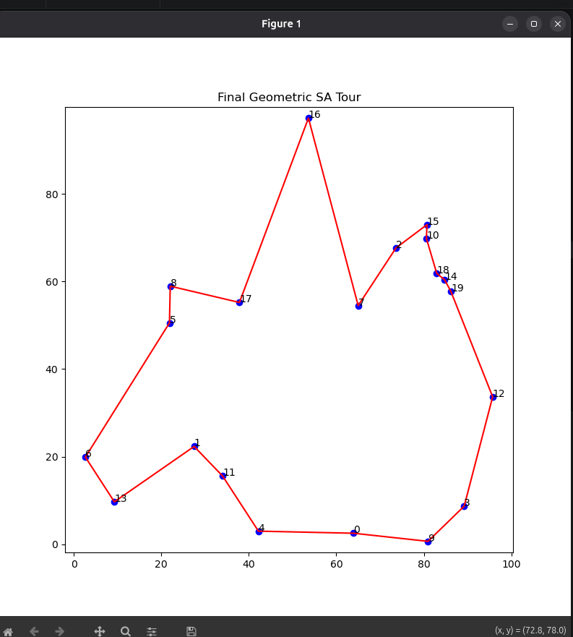

TASK 03 — ACKLEY FUNCTION WITH BEAM SEARCH
output screenshot
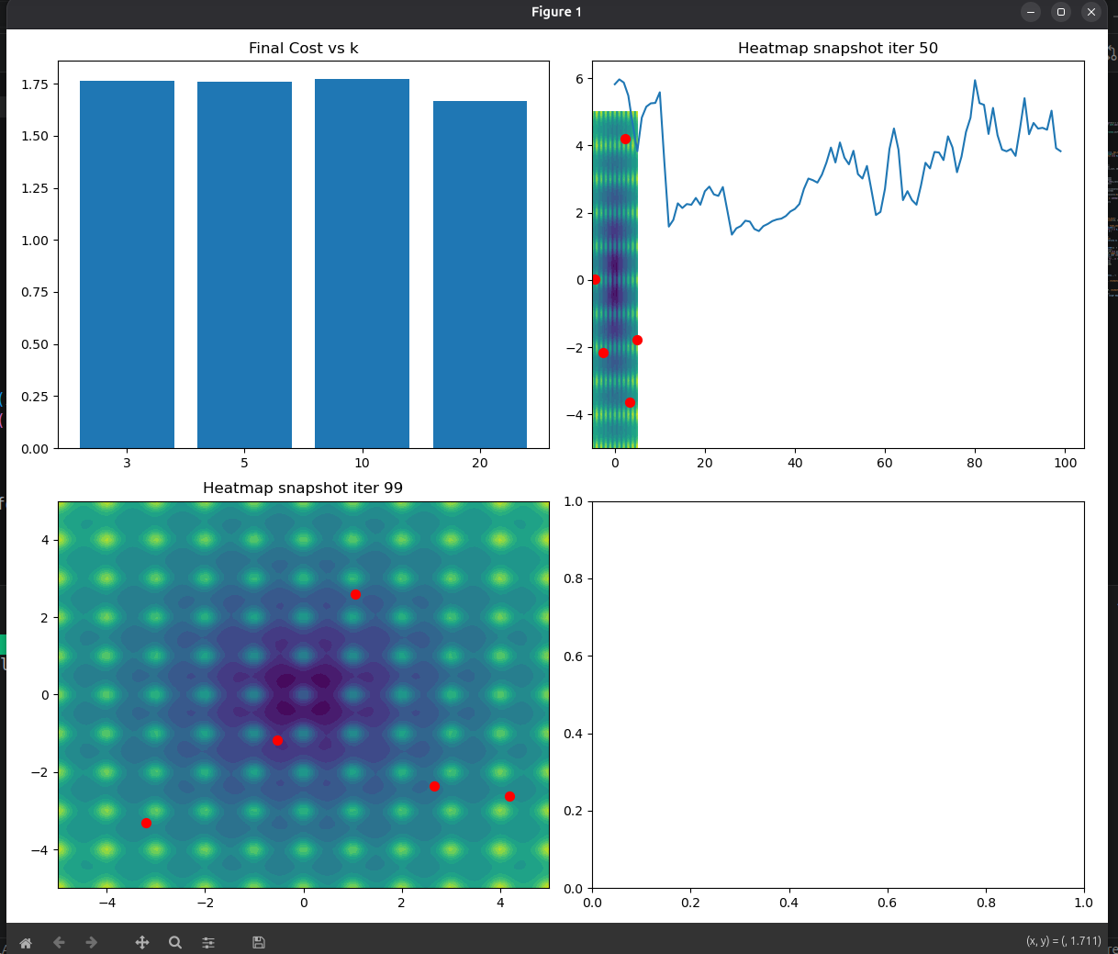
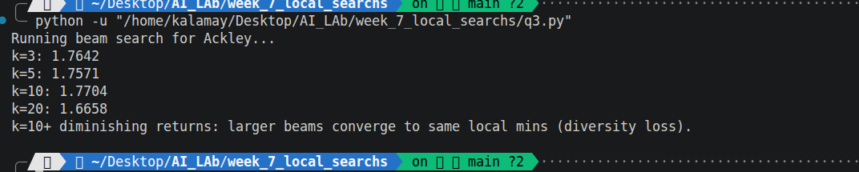

TASK 04 — JOB SCHEDULING WITH TABU SEARCH

output screen shot
result:
Random: 20.0
Best schedule Gantt:
Aspiration allows escaping tabu traps when improving global best. Triggered in runs with longer tenure.
