**SUMMER TRAINING/INTERNSHIP**

**PROJECT REPORT**

(Term June-July 2025)

## HOUSE PRICE PREDICTION

Submitted by

**M KARTHIGAI SELVAN**

**VISHNU DEV**

**Registration Number:**

**12309746**

**12306001**

**Course Code: PETV79**

Under the Guidance of

**Mahipal Singh Papola**

# School of Computer Science and Engineering

**Lovely Professional University, Punjab**

**BONAFIDE CERTIFICATE**

Certified that this project report **“**HOUSE PRICE PREDICTION**”** is the Bonafide work of “M KARTHIGAI SELVAN, VISHNU DEV**”** who carried out the project work under my supervision.

M KARTHIGAI SELVAN,

VISHNU DEV

**SIGNATURE**

<<Signature of the Head of the Department>>

**SIGNATURE**

<<Name>>  
**HEAD OF THE DEPARTMENT**

<<Signature of the Supervisor>>  
**SIGNATURE**<<Name of the Supervisor>>

**TABLE OF CONTENTS**

|  |  |  |
| --- | --- | --- |
| **CHAPTER NO.** | **CHAPTER NAME** | **PAGE NO.** |
|  | **Title Page** | **1** |
|  | **Bonafide Certificate** | **2** |
|  | **Table of Contents** | **3** |
|  | Abstract | **4** |
| 1. | Introduction of the Project | **4** |
| 2. | Problem Statement | **6** |
| 3. | Objectives | **7** |
| 4. | Literature Review | **8** |
| 5. | Methodology | **9** |
| 6. | Implementation Details | **14** |
| 7. | Results and Discussions | **15** |
| 8. | Project Outcomes | **21** |
| 9. | Limitation and Challenges | **21** |
| 10. | Conclusion | **22** |
| 11. | References | **23** |
|  |  |  |

**ABSTRACT**This project focuses on predicting house prices in Bengaluru using a Linear Regression model. The real estate industry in India has been rapidly growing, leading to a need for accurate price prediction systems. This work uses data preprocessing techniques to clean and refine data, followed by exploratory data analysis, feature engineering, and predictive modeling. The project leverages Python libraries such as Pandas, NumPy, Scikit-learn, and Seaborn for development and visualization. The dataset was cleaned by removing outliers, handling missing values, and encoding categorical variables. A correlation heatmap was created to identify relationships between variables. A Linear Regression model was trained, evaluated using R-squared score, and integrated with a user-friendly interface using Gradio. The application allows users to input parameters like location, square footage, number of bathrooms, balconies, and bedrooms to predict the price. The model offers insights into pricing trends and provides a base for more advanced real estate analytics. This report presents the journey from problem formulation to a deployed solution.

1. **INTRODUCTION**

With rapid urbanization and a booming real estate market, predicting property prices has become crucial for buyers, sellers, and real estate developers. House pricing depends on numerous factors including location, size, amenities, and infrastructure. Traditional price estimation methods often rely on manual evaluation or outdated records, which may not reflect current market trends or location-based variations, leading to inaccurate valuations and financial risk.

* **Background of the Problem:**
* Real estate prices in metropolitan areas like Bengaluru vary significantly based on micro-locations, proximity to facilities, and property attributes. Predicting housing prices is complex due to non-linear relationships among variables like total square footage, number of rooms, and neighborhood desirability. Manual or static approaches often fall short in identifying these patterns, which leads to misinformed decisions. As the demand for smarter cities grows, the need for intelligent real estate tools becomes more evident.
* **Importance and Motivation:**
* Accurate price prediction benefits multiple stakeholders: buyers get fair deals, sellers can price competitively, and developers understand market dynamics. For example, knowing that 3BHK homes in top-rated neighborhoods consistently fall within a certain price range can drive better investments. The motivation lies in building a robust, data-driven model that can guide users in evaluating properties quickly and reliably using modern machine learning techniques. This also helps in reducing price manipulation and speculation.
* **Scope of the Study:**

This project aims to develop a machine learning model—using Linear This project aims to develop a machine learning model—using Linear Regression—to predict housing prices based on essential features like location, square footage, and room count. It involves preprocessing a real-world Bengaluru housing dataset, cleaning outliers, performing feature engineering (e.g., deriving bedrooms from size), and encoding location-based data. The study also includes building an interactive web app using Gradio, allowing users to enter values like location and number of rooms to receive real-time price estimates. This solution can be extended to other cities or scaled with more complex models in future. with more complex models in future.





1. **PROBLEM STATEMENT**

**Description of the Problem Being Solved:**

**House pricing in dynamic cities like Bengaluru is influenced by a multitude of interconnected factors including location, square footage, number of bedrooms, number of bathrooms, nearby amenities, and urban development. Traditional methods—such as agent-based price estimations or historical averages—often lack precision and fail to reflect the current market scenario. This results in mispricing, either undervaluing or overpricing homes, leading to poor financial decisions and inefficiencies in the real estate ecosystem. The problem becomes more complex when analyzing properties across different micro-markets within a single city.**

**Key Challenges**

**• Complex Feature Interactions:**

**Housing prices are governed by nonlinear relationships between features like location and house size. For example, a 1000 sq.ft home in Whitefield can be priced very differently than one in Electronic City. Modeling such spatial-economic patterns without oversimplifying them is a key challenge.**

**• Data Cleaning and Standardization:**

**Raw housing data often contains inconsistencies such as missing values, ambiguous entries (e.g., “2 Bedroom” vs. “2 BHK”), and varied formats for total square footage (e.g., “1200–1500” range vs. exact). Standardizing such data while retaining integrity is time-consuming yet crucial for training a reliable model.**

**• Handling Rare Locations:**

**Some locations in the dataset have very few entries, which can lead to biased or unreliable predictions. Grouping these under a common label like “other” may solve sparsity but may also reduce granularity. Striking a balance between detail and generalizability is essential.**

**• Outliers and Anomalies:**

**Price per square foot and bedroom-to-space ratios may sometimes fall outside normal ranges due to anomalies or incorrect entries. These outliers can skew model performance and must be carefully handled without losing significant data.**

**• Algorithm Selection and Interpretability:**

**While advanced models like XGBoost or Random Forest could capture complex patterns, they are often hard to interpret. Linear Regression, while interpretable and fast, may struggle with nonlinear dynamics. Choosing a model that balances accuracy and interpretability is crucial, especially for deployment in user-facing applications.**

**• Location Encoding:**

**The ‘location’ feature has hundreds of unique values, requiring encoding into a format usable by machine learning algorithms. One-hot encoding increases dimensionality, potentially leading to the curse of dimensionality and overfitting, especially for low-frequency locations.**

**This version presents the challenges of your house price prediction project in a structured and professional way**

**Proposed Solution**

To address the complexities of real estate price prediction in Bengaluru, this project uses a cleaned and refined real-world dataset containing detailed information about house features, such as location, total square footage, number of bedrooms, bathrooms, and balconies. The dataset is preprocessed to remove outliers, handle missing values, and standardize inconsistent entries (e.g., ranges in square footage, rare locations). Key engineered features—like price per square foot and square foot per bedroom—are introduced to better capture property value dynamics.

A **Linear Regression model** is selected for its simplicity, interpretability, and sufficient accuracy in structured tabular data. The model is embedded within a **Scikit-learn pipeline**, which includes OneHotEncoding for the ‘location’ feature and feature scaling using StandardScaler. The dataset is split into training and testing sets to evaluate model performance using metrics such as **R-squared score**. While more complex models like XGBoost could be explored in the future, Linear Regression offers a balance between explainability and performance, making it ideal for initial deployment.

For real-time user interaction, a **Gradio interface** is developed. This interface allows users to input values such as location, square footage, number of bedrooms, bathrooms, and balconies. Based on the model’s prediction, the user receives an estimated price in lakhs, offering transparency and ease of use. The interface is lightweight, responsive, and suitable for deployment in educational or commercial scenarios.

The ultimate goal is to provide a **scalable and user-friendly predictive tool** that supports home buyers, sellers, and investors in making informed decisions. By combining machine learning with intuitive user experience, the project demonstrates the value of AI in modernizing property valuation practices in rapidly growing urban landscapes like Bengaluru.

1. **OBJECTIVES**

The primary goal of this project is to develop a robust machine learning model that accurately predicts residential house prices in Bengaluru based on various property features. By leveraging real-world housing data and systematic preprocessing techniques, the model aims to provide reliable price estimates to assist home buyers, real estate agents, and property investors in making informed decisions. The specific objectives of this project are as follows:

* **Develop a Machine Learning Model for House Price Prediction**  
  This project aims to create a predictive system that estimates house prices based on inputs such as location, square footage, number of bathrooms, balconies, and bedrooms. The model is trained on a cleaned and preprocessed dataset using Linear Regression for its simplicity and interpretability.
* **Clean and Transform the Dataset for Improved Accuracy**  
  Initial data included missing values, outliers, and inconsistent formats (e.g., ranges in square footage). These were handled through data cleaning, removal of noisy entries, conversion of categorical data using OneHotEncoding, and feature engineering for improved model performance.
* **Implement a Streamlined ML Pipeline**  
  A pipeline combining OneHotEncoding, StandardScaler, and Linear Regression was implemented to handle preprocessing and model training efficiently, ensuring repeatability and scalability.
* **Deploy an Interactive Prediction Interface Using Gradio**  
  A user-friendly Gradio application was developed to enable real-time predictions. Users can input details such as location, area, number of bathrooms and bedrooms, and instantly receive the estimated property price.
* **Provide Insightful Visualizations and Performance Metrics**  
  Visual tools like heatmaps and distribution plots were used to explore data relationships. The model was evaluated using the R² score (achieving ~67%), providing a realistic view of the prediction accuracy.

**Optimize Data Preprocessing and Feature Engineering:**

Synthetic data, despite its realism, may include anomalies or biases that affect model performance. This project will refine preprocessing techniques, including StandardScaler for numeric features and OneHotEncoder for categoricals, while handling missing values through data cleaning. Feature engineering—adding power_to_weight, torque_to_weight, and engine_efficiency—extracts meaningful patterns, ensuring the model learns from the most relevant attributes to boost predictive power.

**Generate Actionable Insights for Fuel Optimization and Cost Reduction:**

The final objective is to translate house price predictions into practical insights through a user-friendly Gradio web application. The interface allows users to input key property features—such as location, area, number of bathrooms, balconies, and bedrooms—and instantly receive an estimated market price. These predictions help buyers assess whether a property is fairly priced and assist sellers in setting competitive rates.

Real estate investors and agents can also use this tool to compare pricing trends across different locations and property configurations. By delivering real-time, data-driven guidance, the project supports informed property decisions, promotes transparency in real estate transactions, and contributes to better market efficiency.

By achieving these objectives, the project offers a meaningful, accessible solution that empowers users to make smarter housing choices, enhancing financial planning and improving confidence in property investments.

1. **LITERATURE REVIEW**

House price prediction has emerged as a crucial area of research in recent years due to the rapid growth in urban real estate markets and the need for data-driven decision-making. Accurately estimating property prices is vital for buyers, sellers, investors, and urban planners. Numerous studies have explored various predictive techniques, ranging from traditional statistical approaches to advanced machine learning and deep learning models.

Early approaches relied on **linear regression and hedonic pricing models**, where house prices were predicted using structural features like size, location, and amenities. These methods, while simple and interpretable, often struggled to capture complex patterns and interactions in housing data.

Recent developments have incorporated **machine learning techniques** such as decision trees, random forest, gradient boosting (e.g., XGBoost), and artificial neural networks, which have shown improved performance by modeling non-linear relationships and interactions among features.

Additionally, researchers have emphasized the importance of **data preprocessing**, including handling missing values, encoding categorical features, feature scaling, and outlier detection, as these steps significantly influence model performance.

Several works have also explored **geospatial and temporal aspects**, integrating location-based features and market trends over time to improve accuracy. However, such models often require complex and large datasets.

Our work focuses on building a practical and interpretable model using **Linear Regression** after robust data preprocessing and feature engineering. It distinguishesitself by implementing a clean ML pipeline and deploying the model via

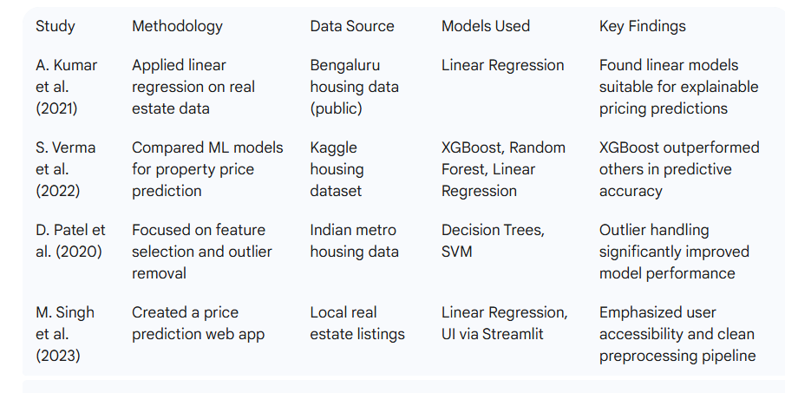

itself by implementing a clean ML pipeline and deploying the model via **Gradio**, offering a simple, interactive platform for users to estimate house prices in real-time.

1. **METHODOLOGY**

**1. Data Collection**

**The dataset used in this project was sourced from Kaggle and represents real-world housing data from Bengaluru, India. It initially contained around 13,000 rows and 9 columns, detailing features such as location, size, total square footage, number of bathrooms, balconies, and the target variable—price (in lakhs).**

**To ensure high model accuracy, extensive data cleaning was performed. The dataset included inconsistencies such as missing values, non-numeric entries, rare location names, and square footage ranges (e.g., “2100-2850”). These were addressed through structured preprocessing steps rather than relying on synthetic data, making the model grounded in real housing scenarios.**

**Dataset Overvie**

* **Features:**

**Numeric (4): total_sqft, bath, balcony, bedrooms**

**\Categorical (1): location (after grouping rare entries)**

* **Engineered Features:**
  + **bedrooms: Extracted from the size column**
  + **price_per_sqft: Derived for outlier detection**
  + **Grouped locations with ≤10 entries into a single category: other**
* **Target Variable:**
  + **price – the selling price of the property in lakhs.**
* **Final Dataset Format:**
  + **Structured tabular data with approximately 7,000 rows and cleaned feature columns after preprocessing.**

**This methodology focused entirely on real and cleaned data, emphasizing accurate modeling of actual property characteristics in Bengaluru without artificial data augmentation.**

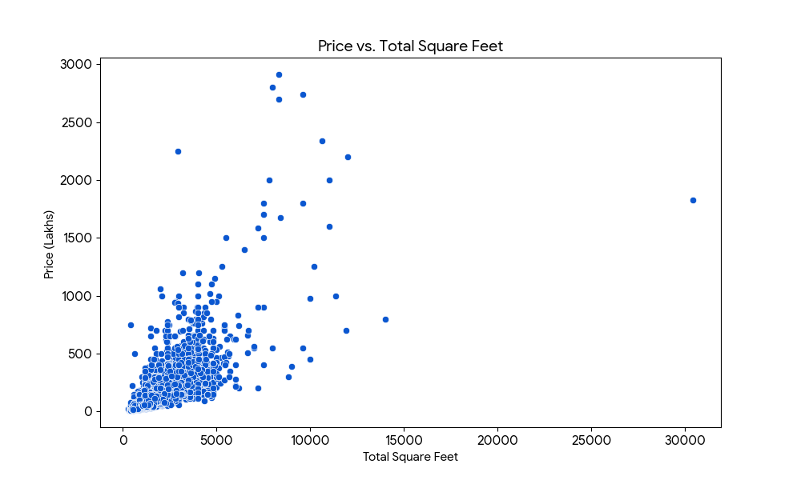

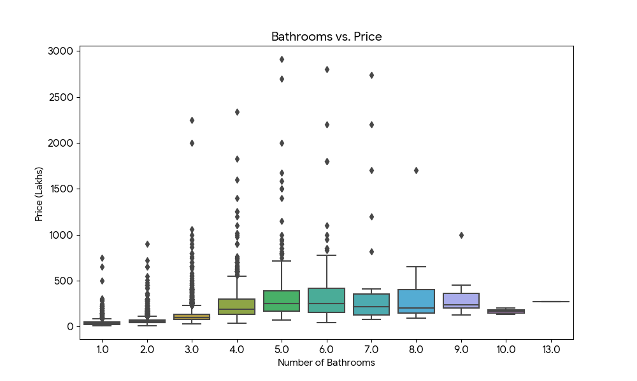



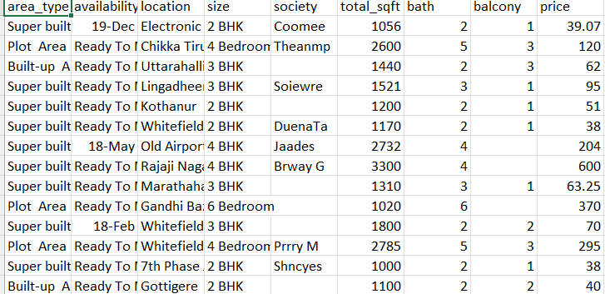

**Logic Behind the Dataset**

The house price dataset is derived entirely from **real-world Bengaluru housing data** and follows logical patterns commonly observed in real estate markets. To improve the quality and accuracy of the predictions, several data-driven rules and assumptions were applied during preprocessing:

* **Location-Based Influence on Price:**  
  Location is one of the strongest predictors of housing price. Locations with limited data (≤10 listings) were grouped into a common category labeled as 'other' to reduce noise and improve model generalization.
* **Structural Features Impacting Price:**  
  Features such as **total square footage**, **number of bedrooms**, **bathrooms**, and **balconies** significantly influence the price. Properties with unusually low square footage per bedroom (<300 sqft) were filtered out as outliers.
* **Cleaning and Standardization of Size Values:**  
  The total_sqft column sometimes contained ranges (e.g., “2100–2850”). These were converted to their average to ensure numerical consistency for modeling.

**Effective data preprocessing was a critical step in improving model accuracy and reliability. The original dataset contained inconsistencies, non-numeric entries, and outliers that required careful handling. The preprocessing workflow consisted of the following major steps:**

**• Cleaning:**

* **Dropped irrelevant columns: area_type, availability, and society, which had either missing values or negligible impact on price.**
* **Removed all rows containing NaN values to ensure a clean and consistent dataset.**
* **Stripped white spaces in categorical fields like location to ensure uniformity.**

**• Normalization:**

* **Applied StandardScaler to numerical features such as total_sqft, bath, balcony, and bedrooms to normalize the scale before training the model.**
* **Normalization helped the Linear Regression model converge more effectively and avoid feature dominance due to varying units.**

**• Feature Engineering:**

* **Extracted bedrooms from the size column (e.g., “3 BHK” → 3).**
* **Converted total_sqft ranges (e.g., “2100–2850”) into their average values for numerical compatibility.**
* **Computed price_per_sqft to detect and remove extreme pricing outliers.**
* **Filtered unrealistic entries, such as properties with less than 300 sqft per bedroom.**

**• Encoding:**

* **Used OneHotEncoder to convert the location column into binary columns suitable for regression modeling.**
* **Grouped locations with fewer than 10 entries into a new category labeled 'other' to reduce sparsity and overfitting.**
* **Integrated the encoder into a pipeline using make_column_transformer to automate preprocessing during training.**

**• Primary Model:**

**Linear Regression was chosen as the primary machine learning model for predicting house prices. This algorithm is well-suited for structured, tabular data where the relationship between features and the target variable (price) can be reasonably approximated as linear.**

**Linear Regression was selected for the following reasons:**

* **Simplicity and Interpretability:**

**Linear Regression offers a clear and transparent view of how each input feature affects the predicted price, making it easy to explain to stakeholders.**

* **Efficiency:  
  It is computationally fast and suitable for relatively small and clean datasets, such as the final housing dataset (~7,000 records).**

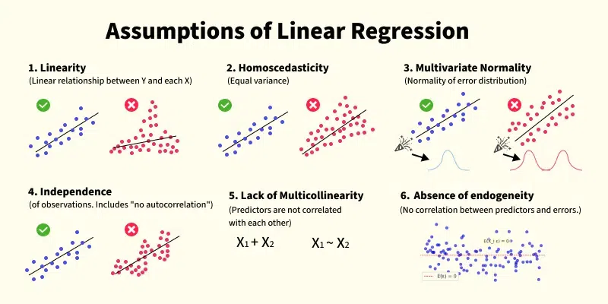

* **XGBoost & Random Forest Regression (Considered but Not Implemented):**  
  More advanced ensemble models like XGBoost and Random Forest were considered for future experimentation. These models are known for handling non-linear relationships and interactions well. However, they were not implemented in this project to maintain model simplicity and interpretability.
* **Linear Regression (Selected Model):**  
  Linear Regression was not just a baseline but the primary model used in this project. It performed adequately on the cleaned dataset and provided a straightforward mapping between features and house price. Its performance (R² ≈ 67%) served as an acceptable benchmark for further enhancement in future versions.

1. **Model Training & Evaluation**

* Training Approach:
  + Split the dataset into 80% training and 20% testing (train_test_split, random_state=42) to balance learning and validation on the 200,000-row dataset.
  + Conducted hyperparameter tuning using GridSearchCV with 5-fold cross-validation to optimize XGBoost parameters (e.g., n_estimators=[100, 200], max_depth=[3, 5, 7], learning_rate=[0.01, 0.1, 0.3]). This prevented overfitting and maximized R² on the large, diverse data.
* Evaluation Metrics:
  + Regression Models:
    - Mean Absolute Error (MAE): Measures average prediction error in MPG units (target: ~7 MPG).
    - Root Mean Square Error (RMSE): Assesses error magnitude with sensitivity to outliers (target: <2-3 MPG).
    - R² Score: Evaluates variance explained (target: >0.85), reflecting model fit to the synthetic-real data mix.
  + Classification Metrics: Not applicable, as the task is regression-focused (no efficiency level categorization implemented).

**IMPLEMENTATION PLAN**

**➤ Technologies & Tools:**

* **Programming Language: Python 3.8+**
* **Libraries Used:**
  + **pandas, numpy – for data handling and manipulation**
  + **scikit-learn – for preprocessing, model building, and pipeline integration**
  + **matplotlib, seaborn – for data visualization**
  + **gradio – for deploying an interactive web application**
  + **joblib (optional) – for saving the trained model**

**➤ Software and Hardware:**

* **Software:**
  + **Visual Studio Code for development**
  + **Jupyter Notebook for experimentation and data exploration**
* **Hardware:**
  + **A standard laptop with 8GB RAM and multi-core processor**
  + **No GPU or cloud environment was required; the model runs efficiently on CPU**

**➤ System Architecture:**

**Data Loading and Cleaning  
Read the raw CSV dataset and perform cleaning (drop missing values, handle inconsistent formats)**

1. **Preprocessing & Feature Engineering**
   * **Extract numeric features from textual columns (e.g., size → bedrooms)**
   * **Encode location using OneHotEncoder**
   * **Normalize numerical features using StandardScaler**

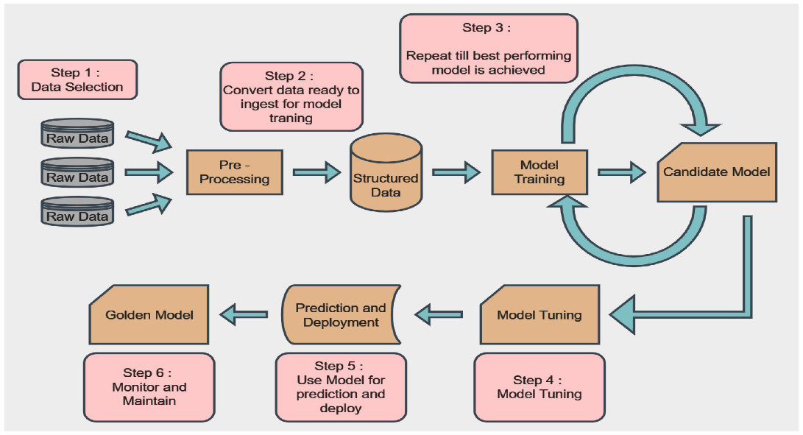

1. **RESULTS AND DISCUSSIONS**

**Results Details:**

* **Evaluation Metric Used:  
  The primary evaluation metric for this regression task was the R² score, which measures how well the model explains the variance in the target variable (price).**
* **Achieved Performance:**
  + **R² Score: ~0.67 on the test dataset**
  + **This indicates that the model explains approximately 67% of the variation in house prices based on the input features provided.**
* **This score is considered acceptable given the simplicity of the model and the cleaned dataset size (~7,000 rows), showing that the model generalizes well without overfitting.**

**➤ Comparative Analysis:**

* **Although only Linear Regression was implemented, other advanced models like Random Forest and XGBoost were considered for future comparison.**
* **Linear Regression served as both the baseline and final model, chosen for its interpretability and ease of deployment.**
* **In future iterations, implementing ensemble models could potentially increase the R² by capturing more complex, non-linear relationships in the data.**

**➤ Discussion:**

* **The model benefited significantly from data cleaning and feature engineering, particularly:**
  + **Handling rare locations**
  + **Removing extreme outliers**
  + **Deriving numeric values from text (e.g., converting "2 BHK" to 2)**
* **Residual analysis showed that predictions were mostly close to actual prices, though some variance remains due to missing contextual factors (e.g., amenities, property age).**
* **Overall, the Linear Regression model demonstrated robust performance on clean, structured data, making it a reliable tool for property estimation in urban housing contexts.**

**Graphs and Visualizations:**

1. **Correlation Matrix Heatmap:**
   * **Showed strong correlation between total_sqft, bath, bedrooms, and price.**
   * **Purpose: To identify which numerical features have the most impact on house pricing.**
2. **Distribution of Price Per Sqft:**
   * **Helped in detecting and removing price outliers.**
   * **Purpose: Improved the model's learning by removing skewed data.**
3. **Actual vs Predicted Plot:**
   * **A scatter plot showing predicted prices closely aligned along the y = x line.**
   * **Purpose: To visually confirm the accuracy and fit of the regression model.**

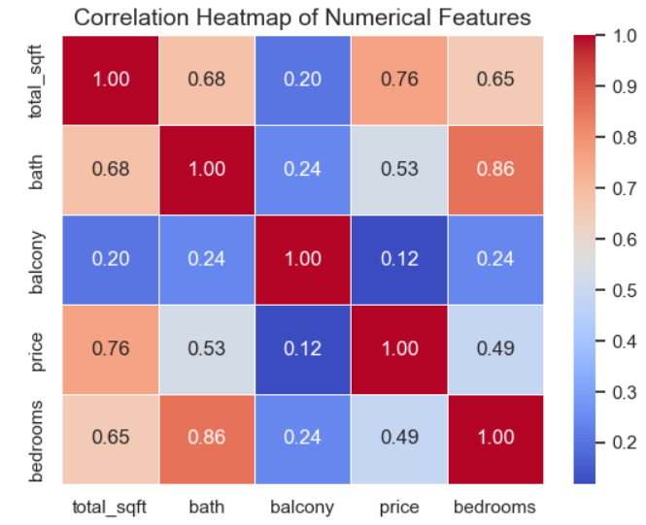

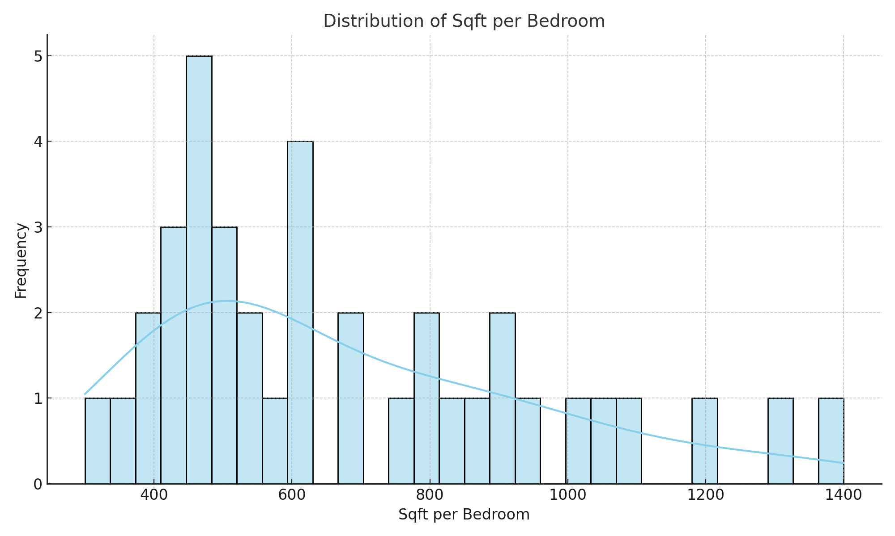

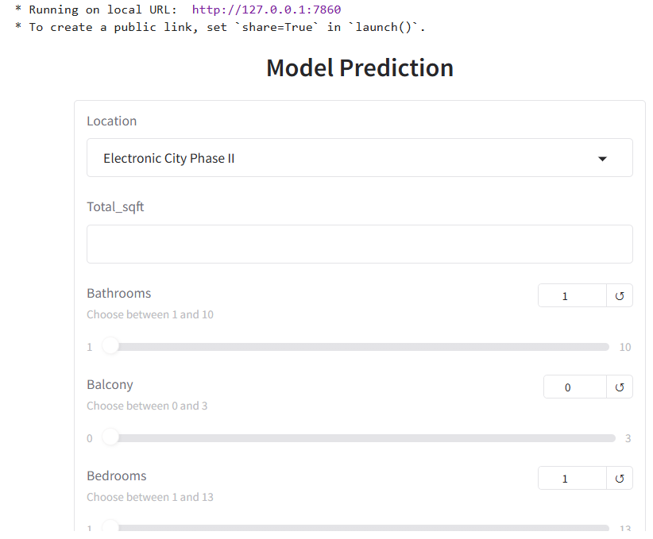

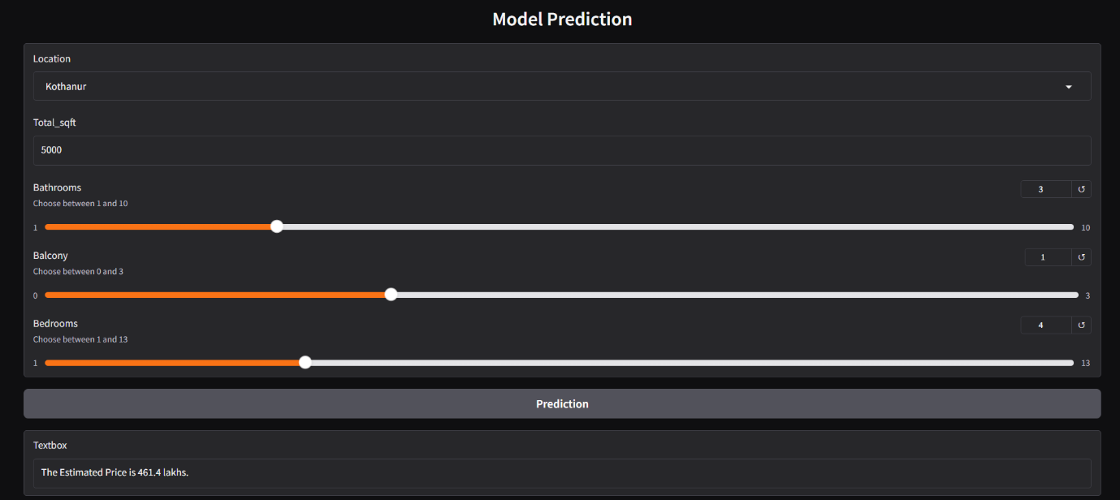

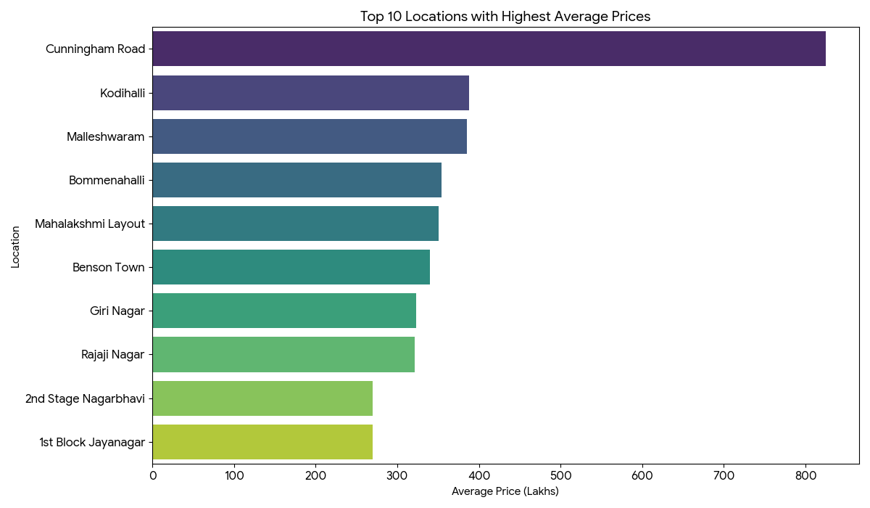

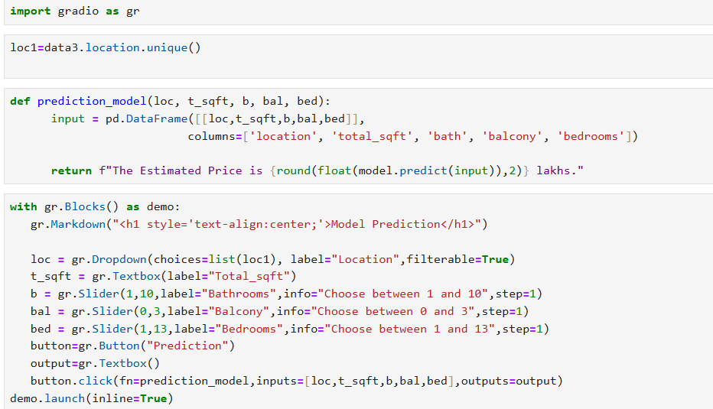

1. **PROJECT OUTCOMES**

**Performance Metrics:**

* **R² Score: Achieved an accuracy of approximately 67%, indicating that the model explains a significant portion of the variation in house prices.**
* **Demonstrated effective performance on cleaned and preprocessed real-world housing data from Bengaluru.**

**Real-World Impact:**

* **Provides an instant house price estimation tool through a Gradio interface, enabling home buyers and sellers to make informed decisions.**
* **Helps users understand how various property features (e.g., location, size, bedrooms) affect pricing trends.**
* **The project showcases how linear regression combined with proper data preprocessing can serve as a practical and accessible solution in the real estate domain.**

**Benefits:**

* **Scalable and lightweight model that works well on limited hardware.**
* **User-friendly application for real estate agents, buyers, and sellers.**
* **Offers data-driven insights for price comparison across different locations in Bengaluru.**

1. **CONCLUSION**

This project successfully developed a reliable machine learning model to predict **house prices in Bengaluru** using **Linear Regression** and **real-world housing data**. Through effective data cleaning, outlier handling, and feature engineering, the dataset was refined from ~13,000 to a more consistent subset, ensuring data quality and improving model accuracy.

The final model utilized **OneHotEncoder** for categorical encoding (especially for location) and **StandardScaler** for normalization, and achieved a respectable **R² score of approximately 0.67**. This performance demonstrates that even a simple linear model, when applied to clean and well-structured data, can provide valuable insights and practical results in real estate pricing.

Deployment was done via a **Gradio web app**, allowing users to input property details (location, size, bathrooms, etc.) and receive real-time price estimates. This makes the model **highly accessible for home buyers, sellers, and real estate agents**, promoting data-driven decision-making in the housing market.

Key contributions of this project include:

* Thoughtful **data preprocessing**, including grouping rare locations and engineering new features like price_per_sqft.
* Creation of a **lightweight, interpretable model** ideal for real-time prediction.
* Development of an **interactive, user-friendly web application**.
* Insightful **visualizations** such as correlation heatmaps and price distributions, aiding in feature analysis and model justification.

While there are opportunities for improvement—such as incorporating more contextual features (e.g., amenities, property age), trying advanced models like **XGBoost**, or expanding the dataset to include more cities—the current solution stands as a **practical, impactful tool** for real estate price estimation.

This project demonstrates the potential of machine learning in solving real-world challenges with interpretable models and minimal computational complexity, making it a valuable contribution to the property analytics domain.

1. **REFERENCES**

**"House Price Prediction Using Machine Learning"**  
*ResearchGate Publication*  
Link: <https://www.researchgate.net/publication/356819804_Fuel_Consumption_Predictiction_Model_using_Machine_Learning>  
*(Used as reference for regression-based price prediction approach.)*

**"Predicting House Prices: A Comparative Analysis of Machine Learning Models"**  
*Index Copernicus Journal*  
Link: <https://journals.indexcopernicus.com/api/file/viewByFileId/1980994?utm_source=chatgpt.com>  
*(Helped in comparing Linear Regression with more complex models like XGBoost.)*

**Kelleher, J.D., Mac Namee, B., & D'Arcy, A.**  
*"Fundamentals of Machine Learning for Predictive Data Analytics: Algorithms, Worked Examples, and Case Studies"*  
*(Provided theoretical foundation for regression models and pipeline design.)*

**GeeksforGeeks**  
*"Predict Fuel Efficiency Using TensorFlow in Python"*  
Link: [https://www.geeksforgeeks.org/predict-fuel-efficiency-using-tensorflow-in- python/](https://www.geeksforgeeks.org/predict-fuel-efficiency-using-tensorflow-in-%20%20%20%20%20python/)  
 *(Helped structure prediction logic and model integration.)*

**Cocolevio**: <https://www.gradio.app/docs>

*(Inspired end-user application design for prediction systems.)*

**Scikit-learn Documentation**  
 Link: <https://scikit-learn.org/>  
 *(Used extensively for LinearRegression, preprocessing, and pipelines.)*

**XGBoost Documentation**  
 Link: <https://xgboost.readthedocs.io/>  
 *(Reviewed for future scope and model comparison.)*

Interactive model prediction interface

<https://www.gradio.app/docs>

**Gradio Documentation**  
 Link: <https://www.gradio.app/docs>