NJATH (Not Just Another Treasure Hunt)
Official Question Bank & Complete Answer Key (Levels 1 to 6 - 48 Questions)

Summary Answer Key Table (1 - 48)
Level | Order | Question Title | Official Answer
Level 1 | Q1 | The Dragon's Files | dragon ball
Level 1 | Q2 | The Brand Ambassador | shahrukh khan
Level 1 | Q3 | Operation Vanilla | diana
Level 1 | Q4 | Curiosity and the Fall | icarus
Level 1 | Q5 | Bard of Bengal | rabindranath tagore
Level 1 | Q6 | Patliputra to the Board | praggnanandhaa
Level 1 | Q7 | Deep Blue Victory | ibm
Level 1 | Q8 | 255 + 1 = 0 | pac-man
Level 2 | Q1 | The Spider's Responsibility | bonesaw
Level 2 | Q2 | The Golden Milestone | milliarium aureum
Level 2 | Q3 | The Primeval Atom | georges lemaitre
Level 2 | Q4 | My Drug Is My Baby | reputation
Level 2 | Q5 | The Demon's Tape | the conjuring 2
Level 2 | Q6 | Triumph of Liberty | red phrygian cap
Level 2 | Q7 | Scent of Eternity | senetnay
Level 2 | Q8 | Cosmic Shift | doppler effect
Level 3 | Q1 | Be Rational | 227
Level 3 | Q2 | Gates of Fire | thermopylae
Level 3 | Q3 | Gleipnir's Bonds | gleipnir
Level 3 | Q4 | The Winged Stallion | pegasus
Level 3 | Q5 | What If the Cards Played You? | khurasan
Level 3 | Q6 | Error 404 | georgedavidson
Level 3 | Q7 | Shape of the Adriatic | heart
Level 3 | Q8 | Apex Ceyane | apexceyane
Level 4 | Q1 | The Dwarf Catalogue | the hobbit
Level 4 | Q2 | European Hexcode | acbbad
Level 4 | Q3 | Tanabata Evening | oyasumi punpun
Level 4 | Q4 | Diwali Deck | dogecoin
Level 4 | Q5 | Four Dimensions of Fear | cowardlydog
Level 4 | Q6 | The Forbidden Forest | forbiddenforest
Level 4 | Q7 | The Legendary Uchiha | uchihamadara
Level 4 | Q8 | Living Image of Aten | tutankhamun
Level 5 | Q1 | Father of Acoustics | marin mersenne
Level 5 | Q2 | The Cryptic Crossword | crossword
Level 5 | Q3 | Lying in the Depths | kaori
Level 5 | Q4 | Dancing Men of 221B | jamesmoriarty
Level 5 | Q5 | The Leper King | baldwin
Level 5 | Q6 | The Infamous Equation | dojoquest
Level 5 | Q7 | The Rotated Overlap | 904
Level 5 | Q8 | Pigpen Cube Hex | fbaeae
Level 6 | Q1 | Numbers in a Relationship | number system
Level 6 | Q2 | The Printing Architect | 3d printing
Level 6 | Q3 | Reflections of the Glass | reflection
Level 6 | Q4 | The Enigma Breaker | alan turing
Level 6 | Q5 | The Three Idiots Formula | chetan bhagat
Level 6 | Q6 | The First Bug of Harvard | moth
Level 6 | Q7 | The Great Chain of Being | scala naturae
Level 6 | Q8 | The Final Key: NJATH Champion | not just another treasure hunt

LEVEL 1

Level 1 - Question 1: The Dragon's Files
Description: Follow the timestamps to find the truth: File#0143 (https://youtu.be/AvGvKjqZfew?si=JsgCjF-i8WAURGLa), File#0304 (https://youtu.be/5M0SQu71VA0?si=SvQfr0yRSZNd-Qco), File#0345 (https://youtu.be/zMYy67B0gDA?si=Xlaqy8dUqBsO9SqU)
Hint: Aired on Cartoon Network in Hindi; one of the Big 4 anime.
Answer: dragon ball
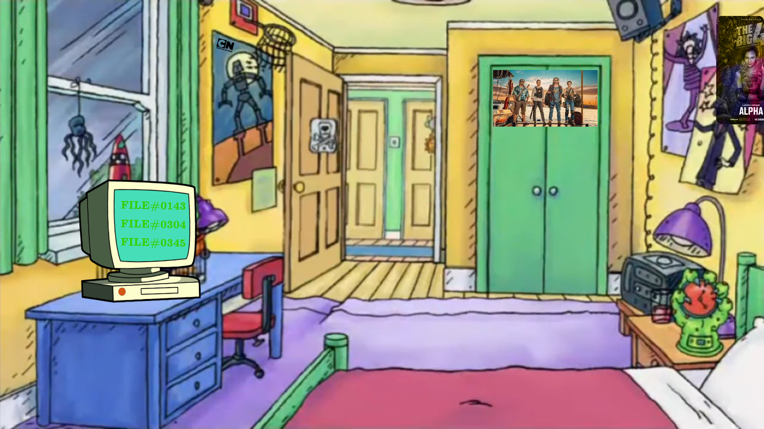

Level 1 - Question 2: The Brand Ambassador
Description: What do Dish TV, Kent RO, Dubai Tourism, BigBasket, and Hyundai share in common?
Hint: ककककक... King of Bollywood.
Answer: shahrukh khan
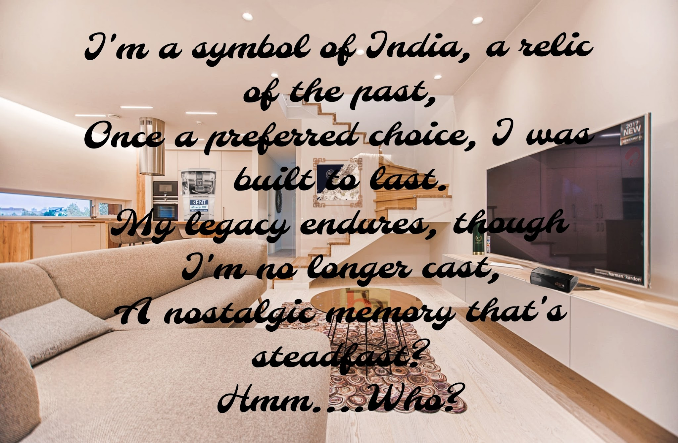

Level 1 - Question 3: Operation Vanilla
Description: A disaster relief mission executed by the Indian Navy in Madagascar in 2020.
Hint: Tropical Cyclone named after a Princess.
Answer: diana

Level 1 - Question 4: Curiosity and the Fall
Description: He flew too close to the sun with wings made of feathers and wax. His father built the labyrinth.
Hint: The maze where his father trapped the Minotaur.
Answer: icarus

Level 1 - Question 5: Bard of Bengal
Description: Resided at Jorasanko Thakurbari. Promoted domestic production through advertisements and wrote national anthems.
Hint: First non-European Nobel laureate in Literature.
Answer: rabindranath tagore

Level 1 - Question 6: Patliputra to the Board
Description: Indian grandmasters from Patliputra origins of Chaturanga to the silver medalist in the 2023 FIDE World Cup.
Hint: Pragg vs Magnus Carlsen in the World Cup final.
Answer: praggnanandhaa

Level 1 - Question 7: Deep Blue Victory
Description: Defeated world champion Garry Kasparov in chess and built the guidance computers for the Apollo moon landing.
Hint: Big Blue tech giant.
Answer: ibm

Level 1 - Question 8: 255 + 1 = 0
Description: An 8-bit integer overflow leads to the split-screen level 256. Cherries, ghosts, and dots in a dark maze.
Hint: Classic arcade game created by Toru Iwatani.
Answer: pac-man

LEVEL 2

Level 2 - Question 1: The Spider's Responsibility
Description: With great power comes great responsibility. X is nothing without a ___
Hint: Uncle Ben to Peter Parker. 'Bonesaw is ready!'
Answer: bonesaw
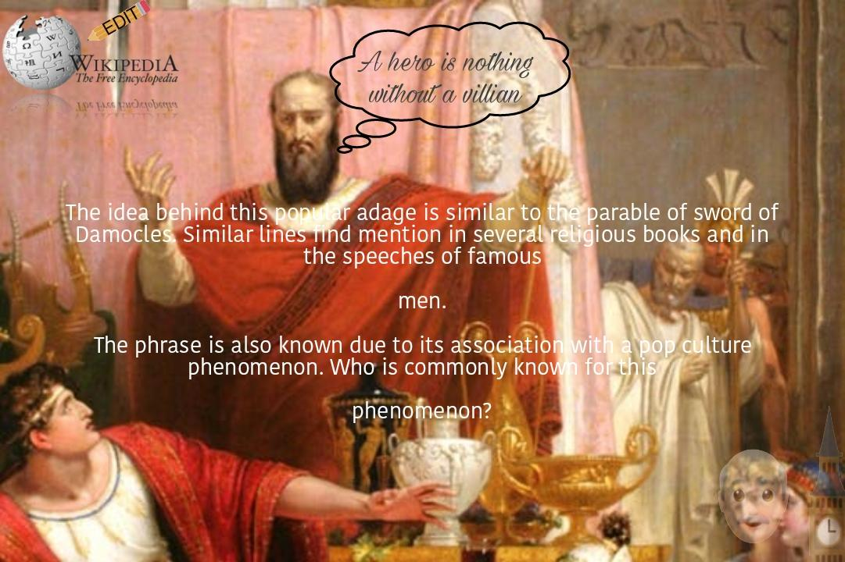

Level 2 - Question 2: The Golden Milestone
Description: All roads lead to Rome. A monument erected by Emperor Augustus marked the origin of all distances.
Hint: Coordinates in Roman Numerals. Also known as the Golden Milestone.
Answer: milliarium aureum

Level 2 - Question 3: The Primeval Atom
Description: Ordained priest and civil engineer who first proposed the expanding universe hypothesis.
Hint: Father of the Big Bang Theory.
Answer: georges lemaitre

Level 2 - Question 4: My Drug Is My Baby
Description: End Game, snake rings, blurred cover art, and the squad of cats.
Hint: Sixth studio album by Taylor Swift.
Answer: reputation

Level 2 - Question 5: The Demon's Tape
Description: Never imagined 'nrita' can be train. Combine the two recorded cassettes to decode what Bill Wilkins wanted to reveal.
Hint: Horror sequel directed by James Wan about the Enfield poltergeist.
Answer: the conjuring 2

Level 2 - Question 6: Triumph of Liberty
Description: I am not Santa Claus though thou can't ignore me. In my honour bronze was melted down thanks to Roy. Worn after storming the Bastille.
Hint: Red soft conical cap of liberty.
Answer: red phrygian cap

Level 2 - Question 7: Scent of Eternity
Description: In September 2023, scientists analyzed the mummification balms of an ancient Egyptian noblewoman to recreate the scent of eternity.
Hint: Royal nurse of Tutankhamun's father.
Answer: senetnay

Level 2 - Question 8: Cosmic Shift
Description: Amidst stars' dance, celestial delight, nebulas swirl in the vast night. Change in frequency of a wave in relation to an observer.
Hint: Christian Doppler's astronomical principle.
Answer: doppler effect

LEVEL 3

Level 3 - Question 1: Be Rational
Description: Be rational while solving this. What is the most famous rational approximation of the circle constant?
Hint: Fraction: 22/7.
Answer: 227

Level 3 - Question 2: Gates of Fire
Description: O ye men who dwell in the streets of broad Lacedaemon! Mourn for the loss of a king, descendant of great Heracles. A battle against the Persian empire.
Hint: The narrow pass defended by King Leonidas and the 300 Spartans.
Answer: thermopylae

Level 3 - Question 3: Gleipnir's Bonds
Description: Made from the sound of a cat's footfall, beard of a woman, roots of a mountain, sinews of a bear, breath of a fish, and spittle of a bird.
Hint: Norse magical chain forged by dwarves to bind the great wolf Fenrir.
Answer: gleipnir

Level 3 - Question 4: The Winged Stallion
Description: Born from Medusa when Perseus struck her neck. Look closely at the Commonwealth of Australia constellation.
Hint: Winged horse of Greek mythology.
Answer: pegasus

Level 3 - Question 5: What If the Cards Played You?
Description: Some kings are jokers in this ancient Persian province known for saffron and turquoise.
Hint: Historical region in north-eastern Persia.
Answer: khurasan

Level 3 - Question 6: Error 404
Description: Famous Minecraft gamer and content creator whose skin is 404 Not Found.
Hint: George NotFound's real name.
Answer: georgedavidson

Level 3 - Question 7: Shape of the Adriatic
Description: Coordinates 43°58′42″N, 15°23′01″E on the Adriatic coast near Croatia reveal an iconic natural shape.
Hint: Galesnjak island is naturally shaped like a...
Answer: heart

Level 3 - Question 8: Apex Ceyane
Description: Cryptic ancient constellation flight path and celestial speed.
Hint: Look into the Latin astronomical cipher apexceyane.
Answer: apexceyane

LEVEL 4

Level 4 - Question 1: The Dwarf Catalogue
Description: Almost all names of the dwarves and Gandalf are taken from the Voluspa Dvergatal. Key cipher: rd sharma subtracted from juxrhgrun (mod 27) yields 'try again'.
Hint: Classic fantasy quest by J.R.R. Tolkien.
Answer: the hobbit

Level 4 - Question 2: European Hexcode
Description: Six points marked on European football capitals: Dublin City F.C. to Ankara Demirspor. Trace right to left to get the hex password #ACBBAD.
Hint: Hexadecimal color code.
Answer: acbbad

Level 4 - Question 3: Tanabata Evening
Description: I won't see the Milky Way this year, and it will also be cloudy on the 7th forever. The Evening of the Seventh in Japanese lore.
Hint: Critically acclaimed manga by Inio Asano.
Answer: oyasumi punpun

Level 4 - Question 4: Diwali Deck
Description: K, 1, 8, K, 9, J, 8, 2, 1 mapped to 13, 1, 8, 13, 9, 11, 8, 2, 1 at 0.69. You might want to practice for your Diwali night.
Hint: Meme cryptocurrency featuring a Shiba Inu.
Answer: dogecoin

Level 4 - Question 5: Four Dimensions of Fear
Description: Courage reversed to Degaruoc -> ASCII decimal 74107109103120123117105 -> Why don't you equally store four in 4 dimensions?
Hint: The cowardly dog who lives in Nowhere, Kansas.
Answer: cowardlydog

Level 4 - Question 6: The Forbidden Forest
Description: Upon entering the forest of four houses: enter 'Password', then 'Incorrect', then 'Again' to hear the tune of Hogwarts.
Hint: The dark forest on the borders of Hogwarts.
Answer: forbiddenforest

Level 4 - Question 7: The Legendary Uchiha
Description: Ghost of the Uchiha who awakened the Rinnegan and orchestrated the Infinite Tsukuyomi.
Hint: Rival of Hashirama Senju.
Answer: uchihamadara

Level 4 - Question 8: Living Image of Aten
Description: I am the living image of Aten and despise Amarna. Boy king of the 18th Dynasty whose tomb was discovered intact in 1922.
Hint: King Tut.
Answer: tutankhamun

LEVEL 5

Level 5 - Question 1: Father of Acoustics
Description: Let the Catholic priest guide you as 'le pere de l'acoustique'. French Polymath who studied prime numbers and vibrating strings.
Hint: Mersenne primes are named after him.
Answer: marin mersenne

Level 5 - Question 2: The Cryptic Crossword
Description: ACROSS: London landmark an Aussie might tell you to visit; poetic form of 14 lines; DOWN: Ancestor to DVD player; Inventor Whitney.
Hint: Word puzzle where every clue is a riddle.
Answer: crossword

Level 5 - Question 3: Lying in the Depths
Description: Song visualizer: Lying in the depths of the dark lays the one who made my heart her mark. Melodious violinist of April.
Hint: Your Lie in April female protagonist.
Answer: kaori

Level 5 - Question 4: Dancing Men of 221B
Description: A theoretical physicist failed in college and a neuroscientist had a PhD in hand. 'Did you miss me?' in dancing men cipher.
Hint: Sherlock Holmes' archenemy, the Napoleon of Crime.
Answer: jamesmoriarty

Level 5 - Question 5: The Leper King
Description: King of Jerusalem from 1174 to 1185, celebrated for his courage and military prowess against Saladin despite battling leprosy.
Hint: Baldwin IV of Jerusalem.
Answer: baldwin

Level 5 - Question 6: The Infamous Equation
Description: | r = 0.0069 { 30 <= theta <= 330 } |= x/sqrt(3). An infamous maximal equation that turns an evil character good by the power of Love.
Hint: Dojo Quest arcade game equation.
Answer: dojoquest

Level 5 - Question 7: The Rotated Overlap
Description: Rotate the image, remove the background, and overlap them together to reveal a 3-digit number.
Hint: Three digits: 9, 0, 4.
Answer: 904

Level 5 - Question 8: Pigpen Cube Hex
Description: Six cubes with hex codes: FBAEAE, ACEDAF, CCFFEC, CDEFAA, EFBEAC, ECAAAE in form of pigpen ciphers.
Hint: Freemason cipher decoded.
Answer: fbaeae

LEVEL 6

Level 6 - Question 1: Numbers in a Relationship
Description: Are the digits single or in a relationship? (4,1), (1,1), (6,2), (5,2), (4,2)... Multiple number systems combined.
Hint: Character encoding mapping pairs to letters.
Answer: number system

Level 6 - Question 2: The Printing Architect
Description: You may not know what this is, but there was a man who did. Chuck Hull invented stereolithography.
Hint: Additive manufacturing / 3D printing.
Answer: 3d printing

Level 6 - Question 3: Reflections of the Glass
Description: Specular reflection on rgb(247, 247, 247). An inverted perspective through optical mirrors.
Hint: Optical reflection.
Answer: reflection

Level 6 - Question 4: The Enigma Breaker
Description: Cracked the German Lorenz and Enigma ciphers using the Bombe at Bletchley Park and pioneered artificial intelligence.
Hint: The Turing Test was named in his honour.
Answer: alan turing

Level 6 - Question 5: The Three Idiots Formula
Description: A novel about five friends in IIT that became a cinematic masterpiece on questioning rote education.
Hint: Author of Five Point Someone.
Answer: chetan bhagat

Level 6 - Question 6: The First Bug of Harvard
Description: On September 9, 1947, Grace Hopper recorded the first actual computer bug taped into the Mark II logbook.
Hint: A moth trapped in relay number 70.
Answer: moth

Level 6 - Question 7: The Great Chain of Being
Description: Scala naturae: a strict hierarchical structure of all matter and life, thought in medieval Christianity to have been decreed by God.
Hint: Latin term: Scala Naturae.
Answer: scala naturae

Level 6 - Question 8: The Final Key: NJATH Champion
Description: You have traversed all 6 levels and solved every riddle across history, cryptography, science, and pop-culture. What does NJATH stand for?
Hint: Not Just Another...
Answer: not just another treasure hunt

