HEART DISEASE PREDICTION
An End-to-End MLOps Implementation

AIMLCZG523 — MLOps Assignment 01
Reproducible machine learning, experiment tracking,
API serving, containerization, CI/CD and monitoring

Repository: https://github.com/iamkeerthy7/heart-disease-mlops
Prepared: 19 October 2026

Abstract
This project implements a reproducible machine-learning workflow for binary classification using the UCI Cleveland Heart Disease dataset. It covers data inspection and exploratory analysis, preprocessing, model comparison, cross-validation, MLflow experiment tracking, automated tests, a FastAPI prediction service, Docker packaging, Kubernetes deployment configuration, and request monitoring. Logistic Regression was selected using mean five-fold cross-validation ROC-AUC. The final test-set results are reported from the project's saved evaluation output. The system is an educational demonstration and is not validated for clinical decision-making.

1. Objectives and scope
The goal is to demonstrate the complete lifecycle of a machine-learning application rather than only fit a classifier. The implementation separates data processing, training, inference, testing and deployment configuration. It records experiments, persists a reusable preprocessing-and-model pipeline, exposes predictions through HTTP, and provides operational metrics.
The principal deliverables are Python source code, a cleaned dataset, EDA figures, model artifacts, MLflow records, tests, a CI workflow, a Dockerfile, Kubernetes manifests, evidence screenshots, and this report.

2. Dataset and target definition
The project uses the Cleveland heart-disease dataset with 303 observations and 14 columns in the supplied heart.csv file. Thirteen input features are used: age, sex, cp, trestbps, chol, fbs, restecg, thalach, exang, oldpeak, slope, ca and thal. The original target num is converted to a binary target: num > 0 indicates the positive class; num = 0 indicates the negative class.
The project records missing values in ca (4 observations) and thal (2 observations). Imputation is performed within the preprocessing pipeline to keep the transformation reproducible and to avoid fitting imputers on the held-out test data.
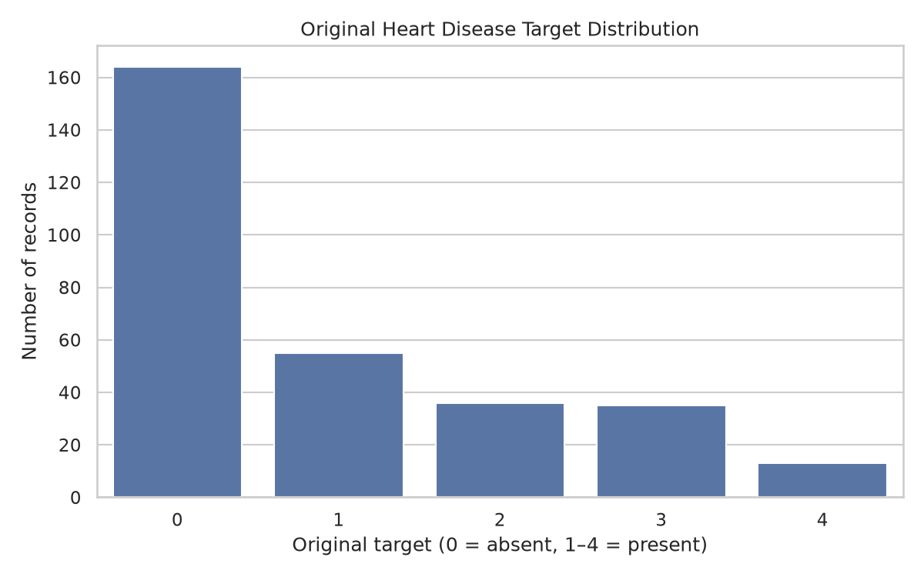
Figure 1. Distribution of the original target values.
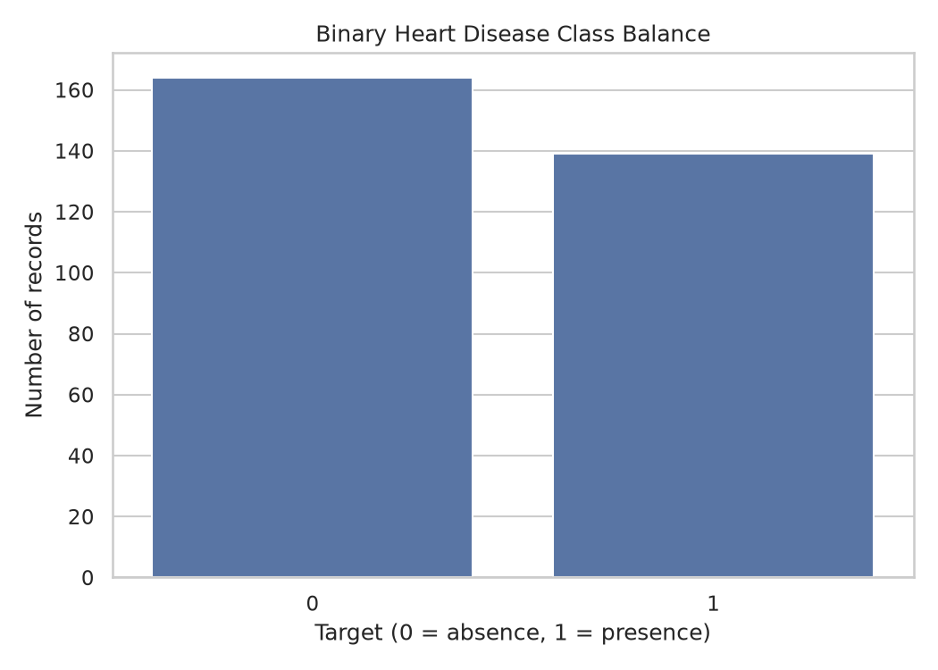
Figure 2. Class balance after binary target conversion.

3. Exploratory data analysis
EDA artifacts include target distributions, feature histograms, categorical distributions, a correlation heatmap and model confusion matrices. These visualizations support inspection of class balance, feature ranges, relationships between numeric variables and the structure of categorical features. Correlation is descriptive and does not establish causality.
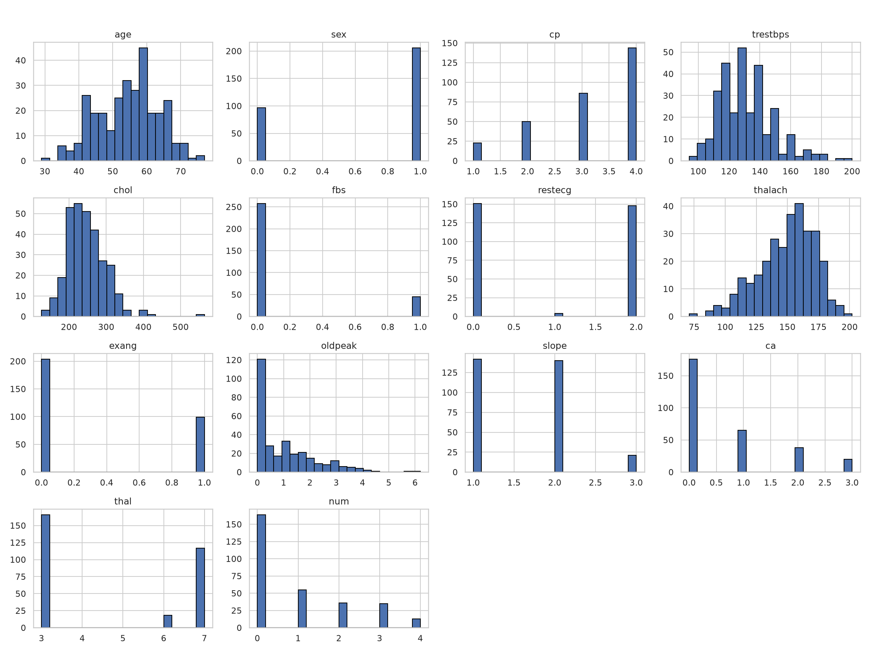
Figure 3. Histograms of numeric feature distributions.
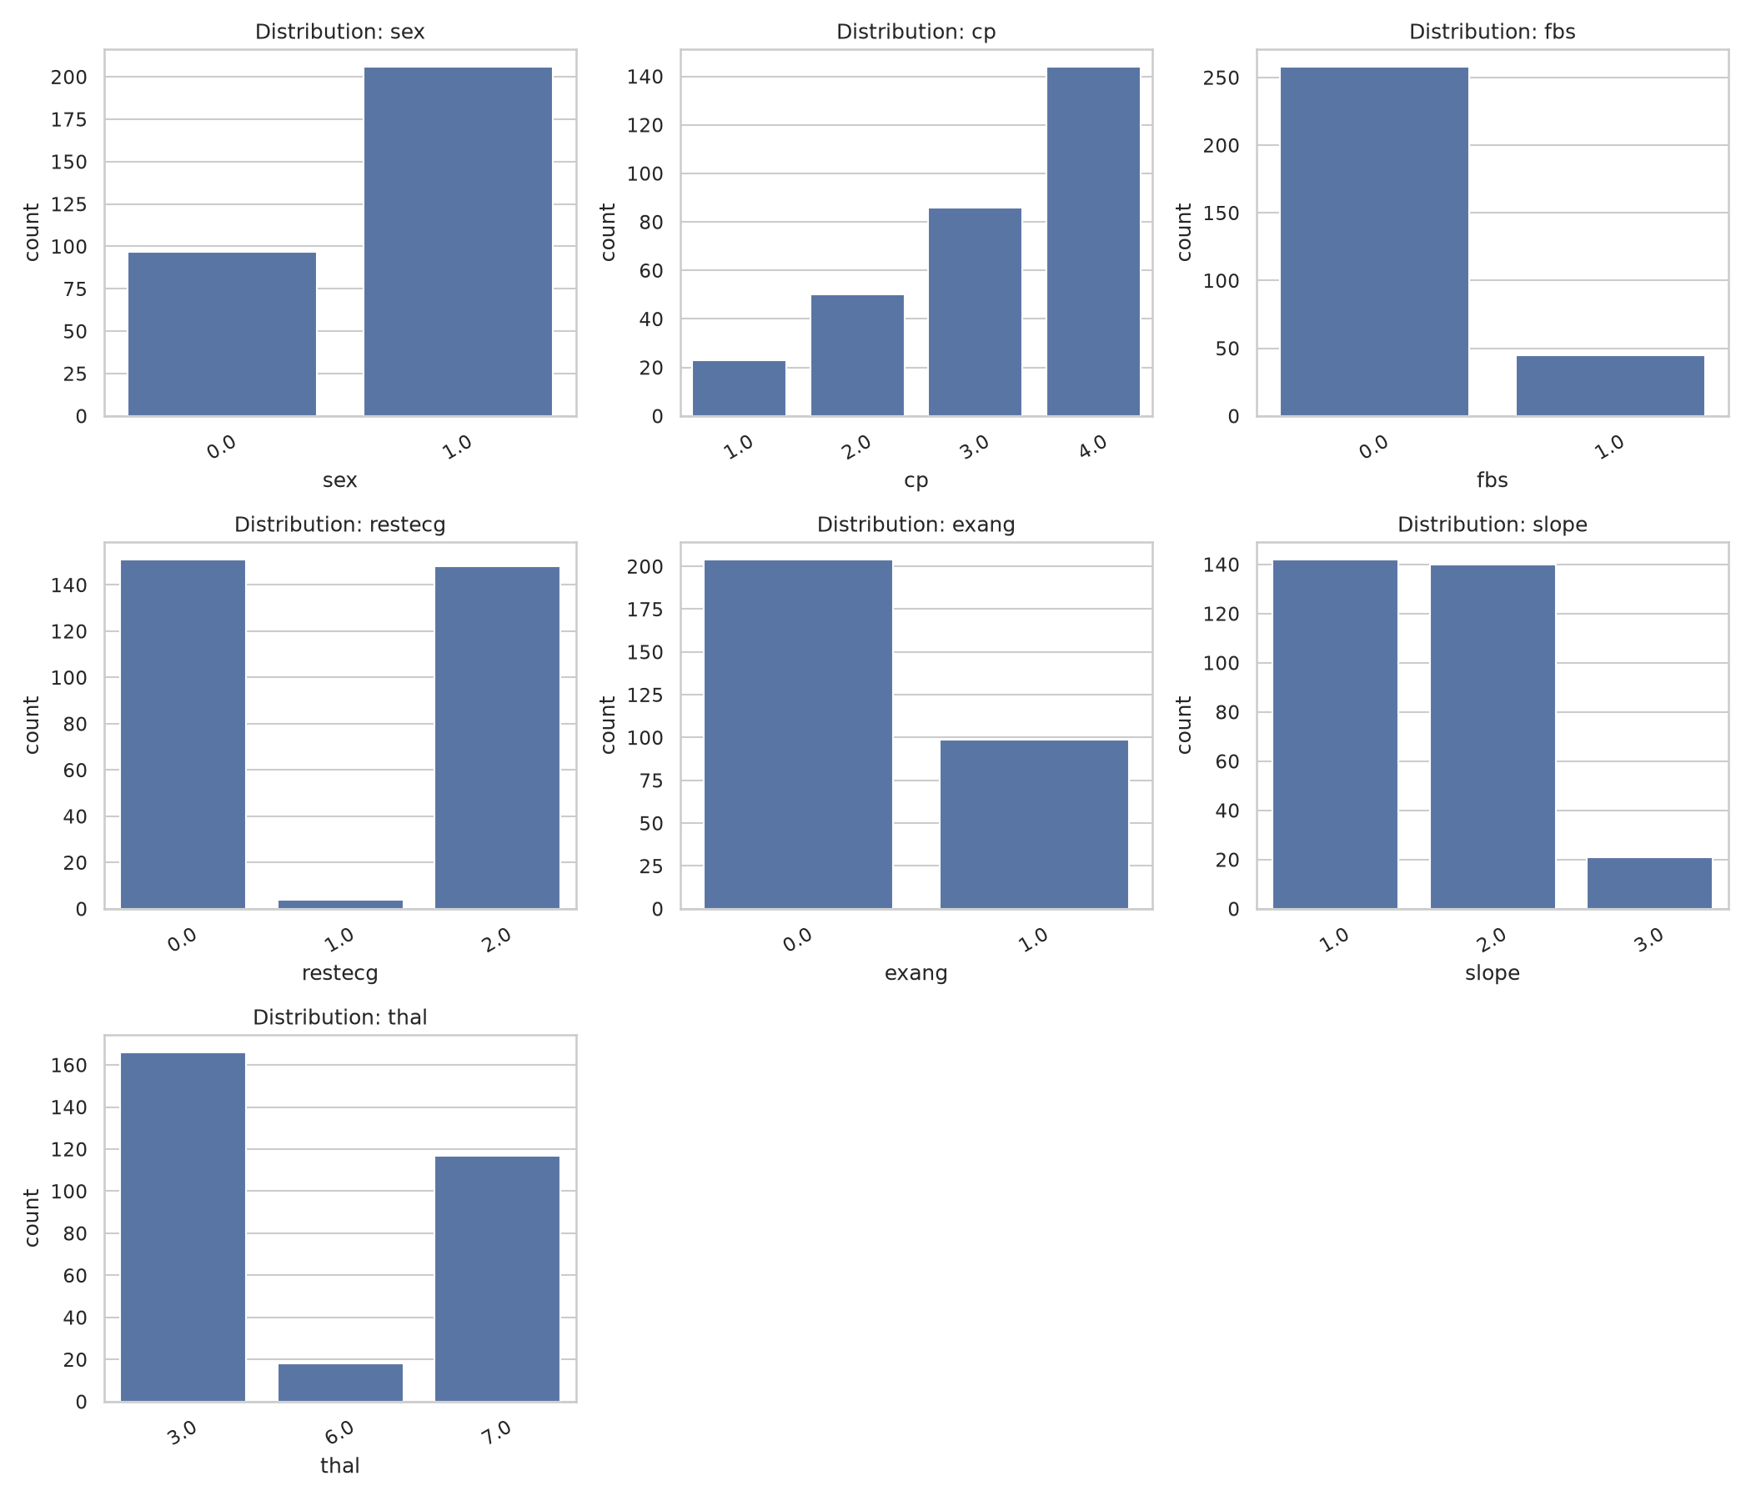
Figure 4. Distributions of categorical features.
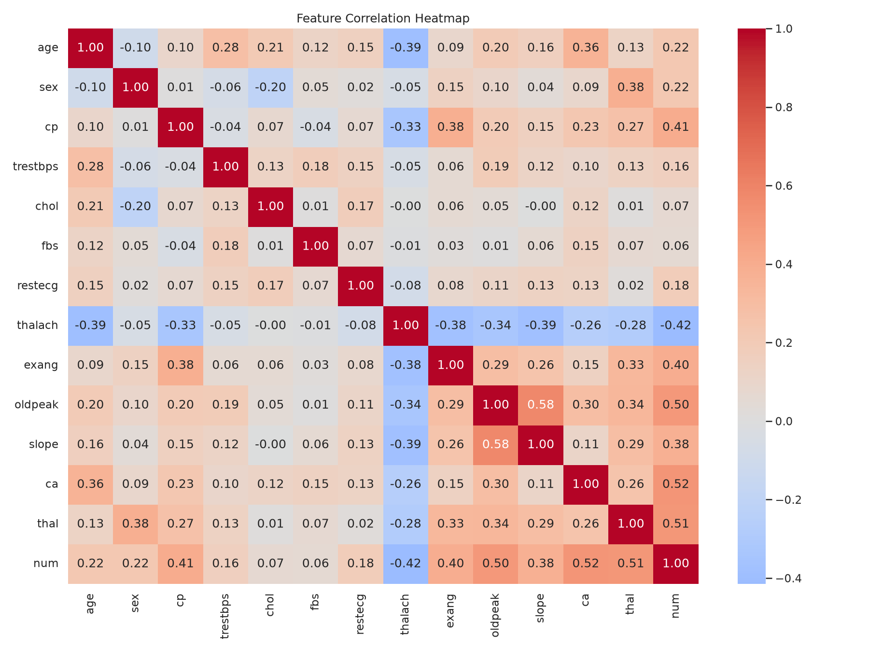
Figure 5. Correlation heatmap for the dataset.

4. Preprocessing and model development
The preprocessing pipeline uses a ColumnTransformer. Numeric columns are imputed with the median and scaled. Categorical columns are imputed using the most frequent value and one-hot encoded. This pipeline is bundled with the estimator so training and inference apply the same transformations.
Two classifiers were evaluated: Logistic Regression and Random Forest. GridSearchCV with stratified five-fold cross-validation was used for hyperparameter selection. The comparison records accuracy, precision, recall and ROC-AUC, along with cross-validation means and standard deviations.
The saved model metadata identifies Logistic Regression as the selected model because it achieved the higher mean cross-validation ROC-AUC. The selected configuration records C = 1.0. The Random Forest search selected 200 estimators, maximum depth 5 and minimum leaf size 1.

5. Evaluation results
Metric | Logistic Regression | Random Forest
Test accuracy | 88.52% | 88.52%
Test precision | 83.87% | 83.87%
Test recall | 92.86% | 92.86%
Test ROC-AUC | 0.9665 | 0.9513
Mean CV ROC-AUC | 0.9025 | 0.9020
CV ROC-AUC standard deviation | 0.0144 | 0.0247

Both models achieved 88.52% test accuracy, 83.87% precision and 92.86% recall on this split. Logistic Regression achieved test ROC-AUC 0.9665 versus 0.9513 for Random Forest. Its mean cross-validation ROC-AUC was 0.9025 versus 0.9020. The cross-validation difference is small, so the selection should not be interpreted as proof of general superiority.
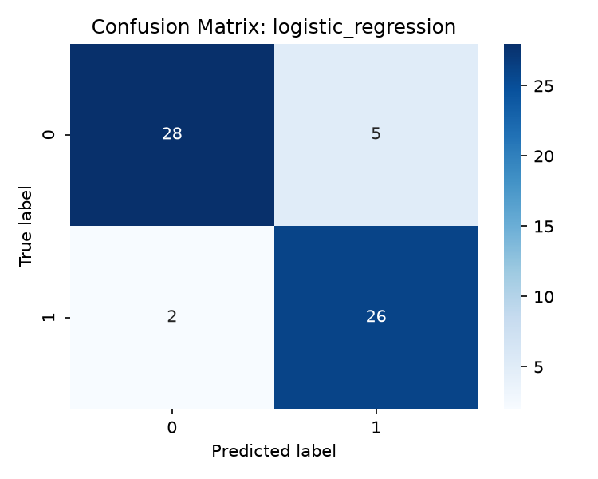
Figure 6. Confusion matrix for Logistic Regression.
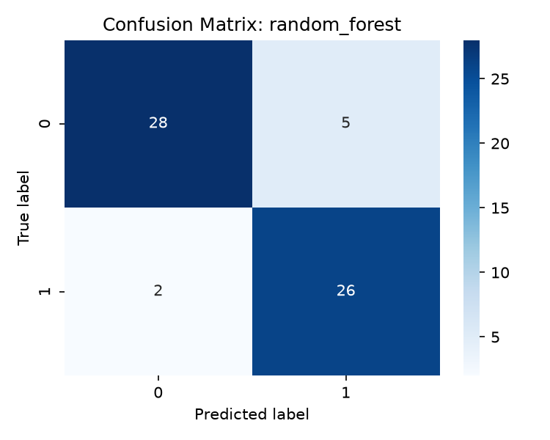
Figure 7. Confusion matrix for Random Forest.

6. Experiment tracking with MLflow
MLflow is used to track model parameters, evaluation metrics and artifacts for the training runs. The project stores tracking data locally in the MLflow database and artifact directory. This makes model comparisons inspectable and supports repeatable experiments. Screenshots below provide visual evidence of recorded runs and a run-detail view.
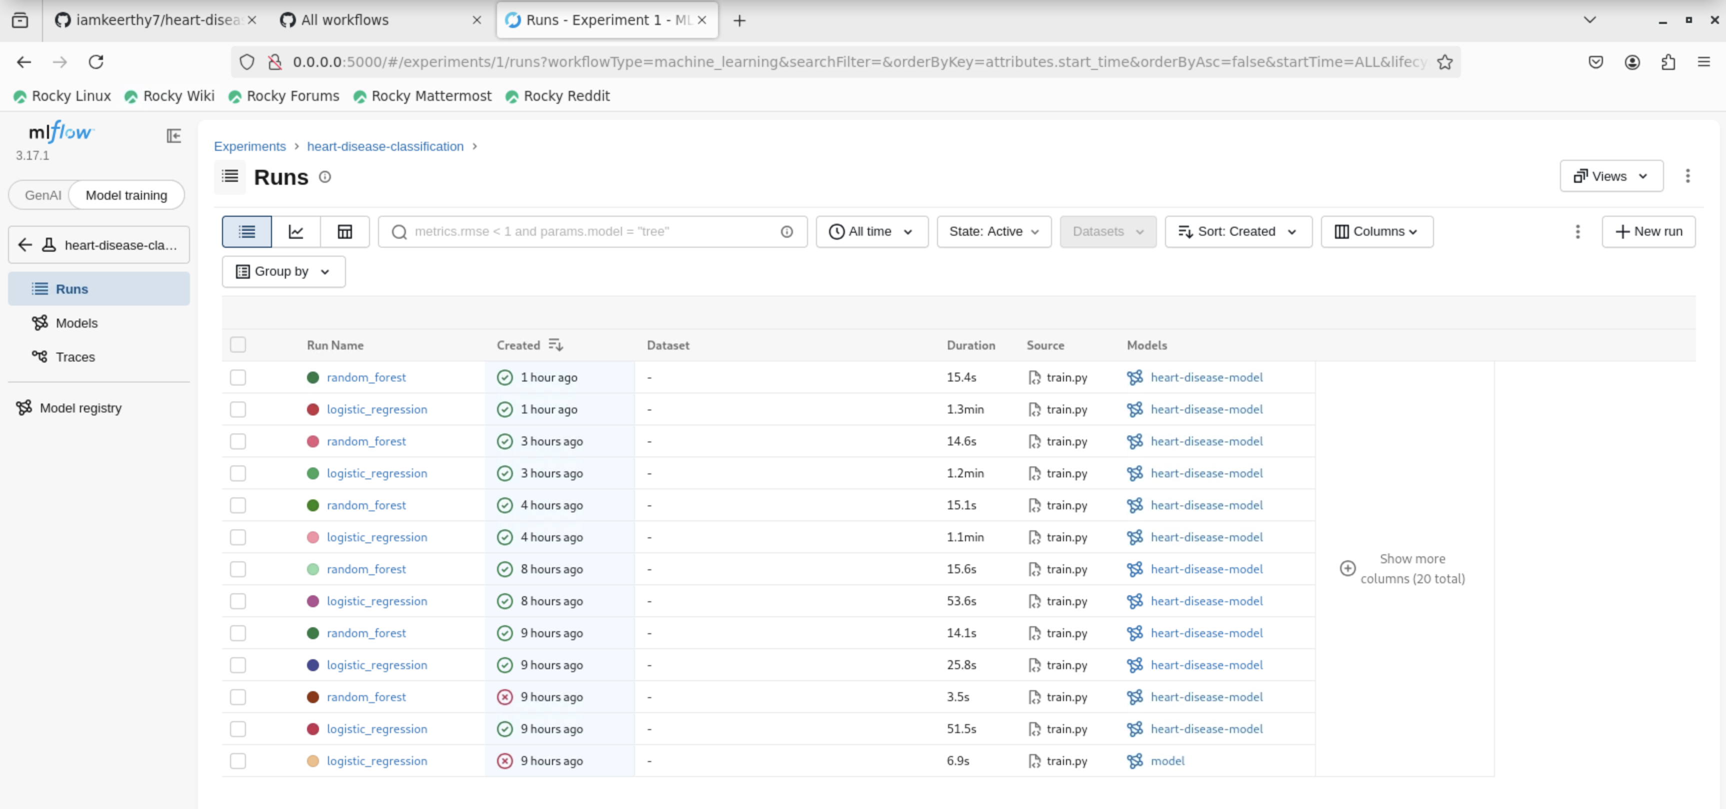
Figure 8. MLflow experiment runs.
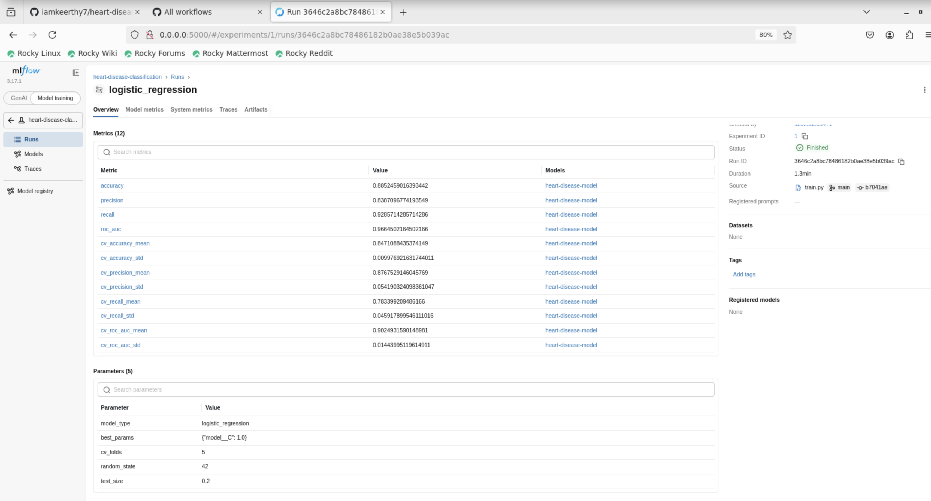
Figure 9. MLflow run details and logged values.

7. Model persistence and API
The selected fitted pipeline is persisted as models/best_model.joblib, with model selection details in models/model_metadata.json. The FastAPI application provides a health endpoint, a JSON prediction endpoint, Prometheus metrics and a monitoring dashboard. The prediction response contains the predicted class, a human-readable label, confidence, class probabilities and an educational-use disclaimer.
Input validation rejects malformed or incomplete requests. The reusable pipeline ensures imputation, scaling and categorical encoding are applied at inference time using the fitted training transformations.
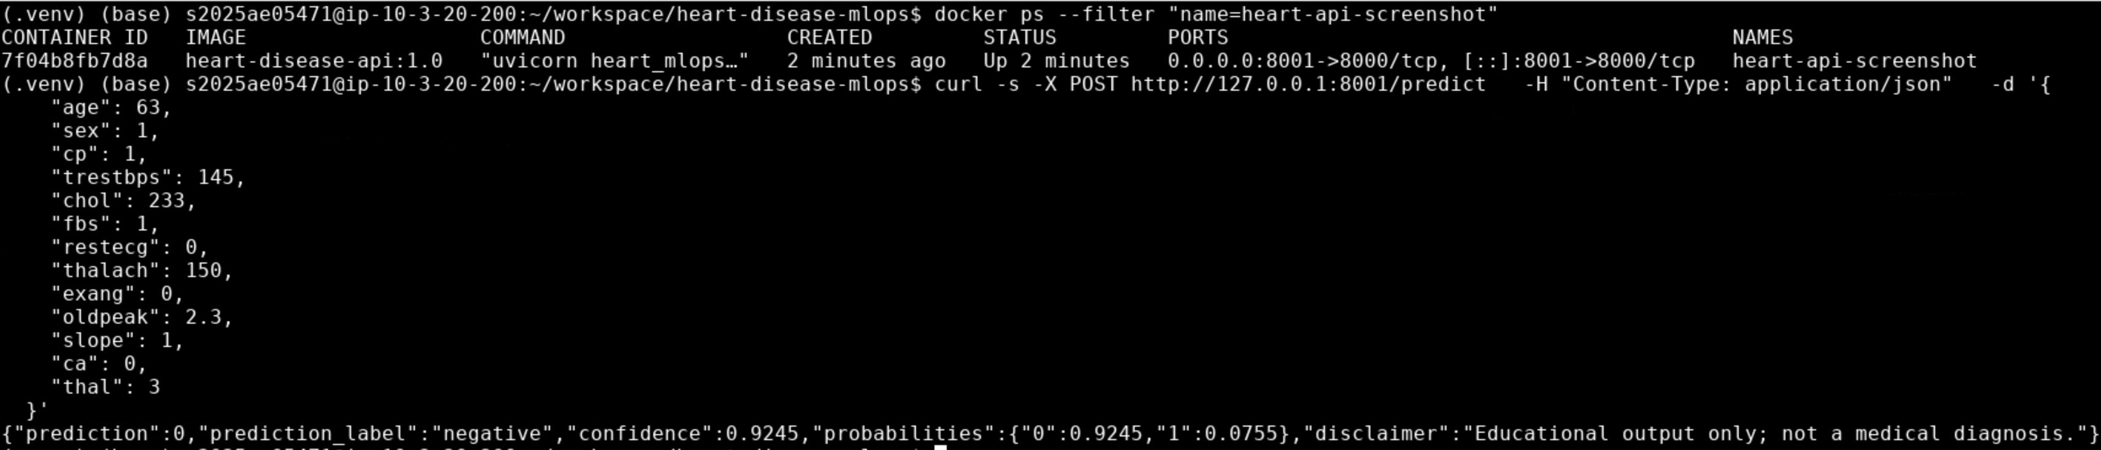
Figure 10. Example prediction response from the containerized API.
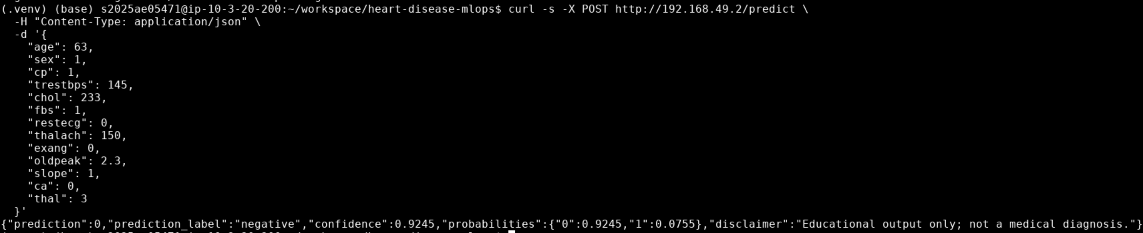
Figure 11. Example prediction response through Kubernetes ingress.

8. Automated testing and CI
The project includes tests for API health, valid prediction requests, invalid input, missing features, metrics and the dashboard. Preprocessing tests cover finite transformed values, missing values, unseen categories and feature partitioning. The recorded verification was 10 passing tests. Ruff linting and Python compilation checks were also run.
The GitHub Actions workflow installs dependencies, runs linting and compilation, executes the test suite, trains the model and uploads generated artifacts. A failing validation command causes the workflow to fail, making errors visible rather than silently ignored.
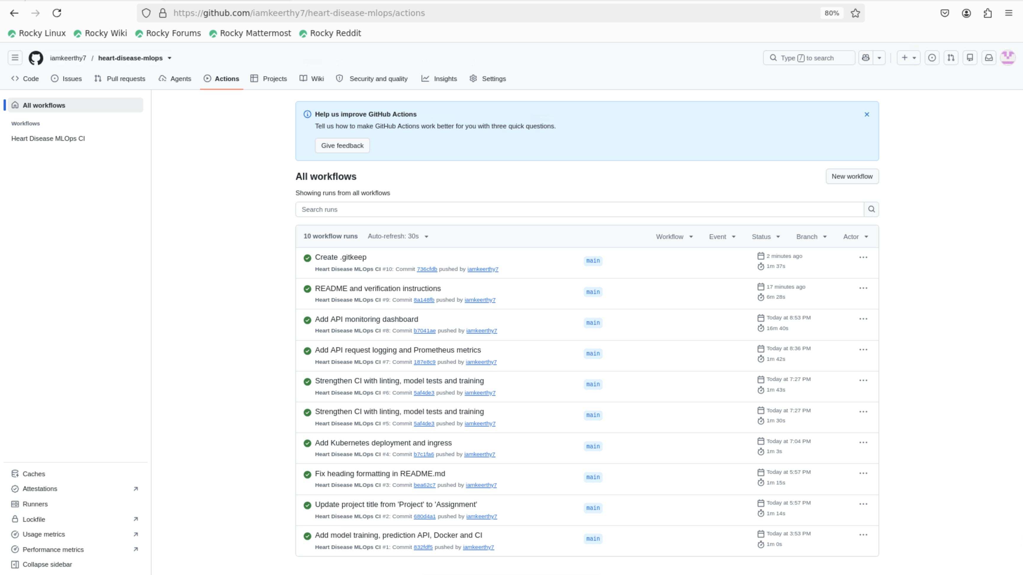
Figure 12. GitHub Actions workflow evidence.

9. Docker and Kubernetes deployment
The Docker image packages the Python application and model for consistent execution. The image exposes port 8000. The local container was tested using host port 8001 because port 8000 was already occupied on the host.
Figure 13. Docker image build evidence.
Kubernetes manifests define the API Deployment, a LoadBalancer Service and an NGINX Ingress. The local Minikube deployment reached one ready replica, and ingress requests to health, prediction, metrics and dashboard routes were tested. In local Minikube, a LoadBalancer external IP may remain pending; the ingress address is local and is not a public URL.
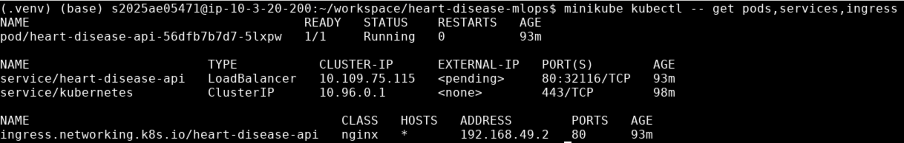
Figure 14. Kubernetes resources and deployment status.

10. Monitoring and request logging
The API middleware records request method, route, response status and duration. Prometheus metrics include HTTP request counters, latency histograms and prediction outcome counters. A dashboard summarizes request volume, successful predictions, errors, latency and status.
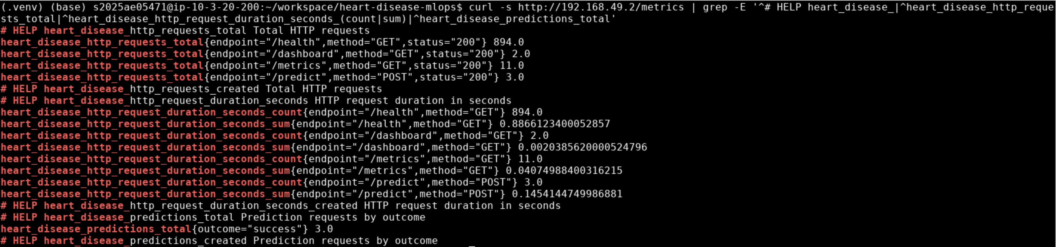
Figure 15. Prometheus metrics exposed by the API.
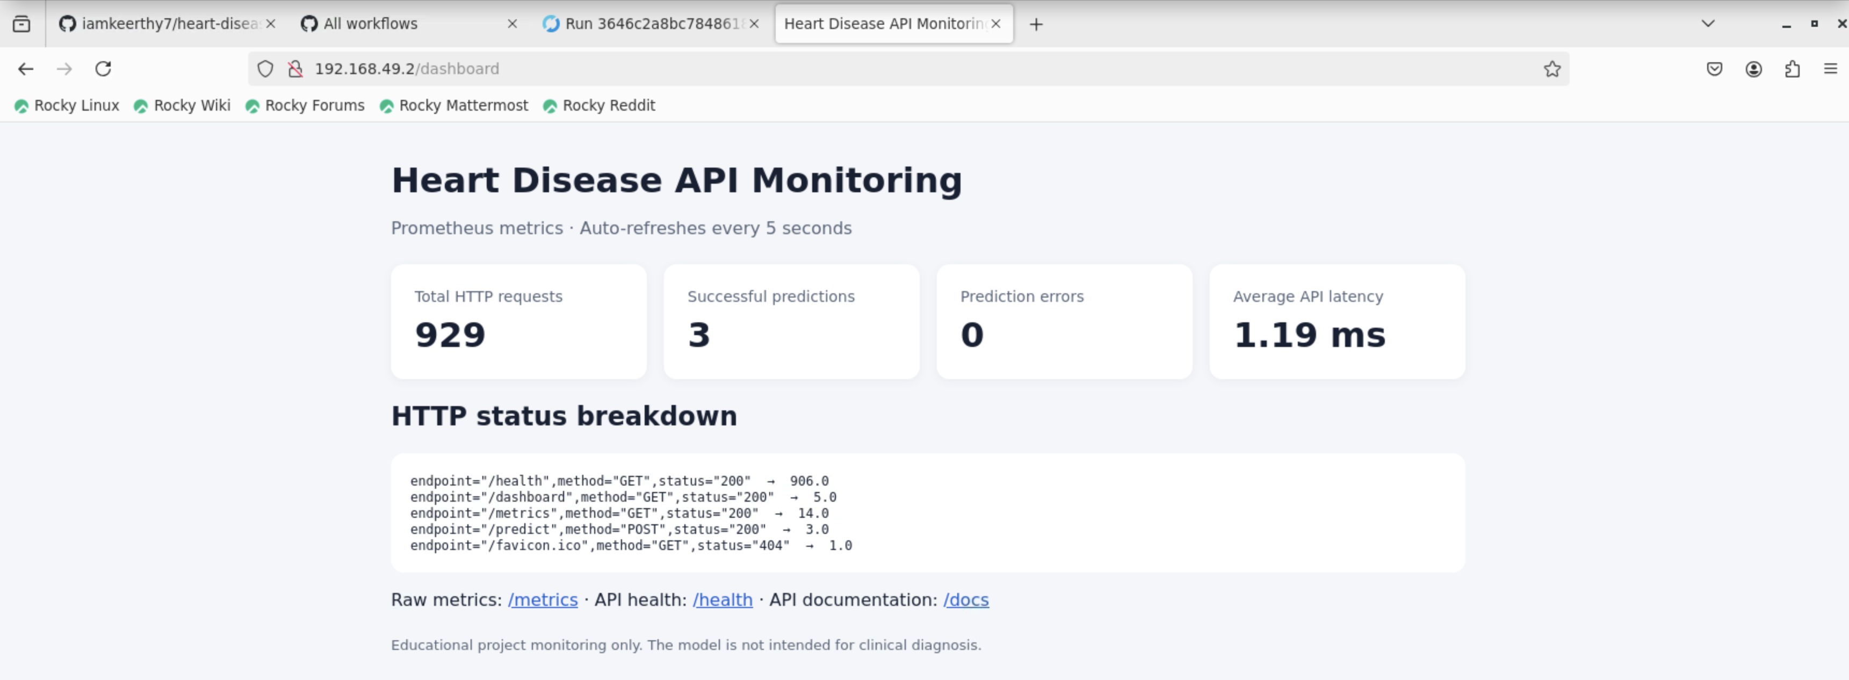
Figure 16. Application monitoring dashboard.

11. Reproducibility and repository layout
The repository separates source code, data, model artifacts, reports, tests, deployment configuration and screenshots. The main setup path is to create a Python 3.12 environment, install requirements.txt, inspect the dataset, run the training command, execute pytest and Ruff, and then start the FastAPI application. Docker and Kubernetes deployment instructions are documented in the repository README.
Key paths include data/heart.csv, src/heart_mlops/, tests/, models/, reports/figures/, deployment/k8s/, .github/workflows/ and screenshots/. MLflow tracking files and trained artifacts should be preserved when reproducing the recorded experiment history.

12. Limitations, risks and future work
This dataset contains only 303 observations and represents a historical dataset rather than a representative modern clinical population. A single held-out split and cross-validation cannot establish clinical utility, calibration, fairness or generalization to other hospitals or populations. The prediction endpoint is a software demonstration, not medical advice.
Future improvements include external validation, confidence calibration, threshold analysis based on explicit use-case costs, drift monitoring, stronger API authentication and rate limiting, dependency and image scanning, centralized secrets management, and deployment to a secured cloud Kubernetes cluster with a publicly accessible endpoint.

Conclusion
The project demonstrates a complete educational MLOps path from data inspection through model evaluation, experiment tracking, automated testing, containerization, local Kubernetes deployment and monitoring. The selected Logistic Regression pipeline is reproducible and served by an API. The recorded results are promising for the supplied dataset but must not be interpreted as evidence of clinical readiness.

Repository and evidence
Source repository: https://github.com/iamkeerthy7/heart-disease-mlops
The screenshots referenced in this report are maintained under the repository's screenshots/ directory. The EDA and confusion-matrix figures are maintained under reports/figures/. Consult README.md for exact commands, configuration, and local deployment instructions.

