Machine Learning-Based Network Intrusion Detection and Anomaly Classification
Graduate AI/ML Capstone Project · Cybersecurity Domain

——————————————————————————————————
Author: Arne Ramos
Date: 16 September 2026
Dataset: UNSW-NB15 (Moustafa & Slay, 2015)
Task: Supervised binary classification — benign vs. malicious network flow

Every metric in this document was produced by executed code and is read from
reports/metrics/. No result, figure or statistic was written by hand.

Table of Contents
Right-click here and choose “Update Field” to build the contents.

Part I — Problem Understanding and Framing
Project: Machine Learning-Based Network Intrusion Detection and Anomaly Classification Domain: Cybersecurity — Security Operations Centre (SOC) detection engineering Task type: Supervised binary classification (benign vs. malicious network flow) Dataset: UNSW-NB15 (Moustafa & Slay, 2015), partitioned train/test CSVs

1. The security problem
A mid-sized enterprise network produces on the order of tens of millions of network flow records per day. Each record is a summary of one conversation between two hosts: how long it lasted, how many bytes and packets moved in each direction, which protocol and service were involved, and how the connection terminated. Buried in that volume is a very small number of flows that represent reconnaissance, exploitation, malware command-and-control, or data theft.
Three properties of this problem make manual analysis structurally impossible, not merely expensive:
- Volume. No analyst team can read tens of millions of records a day. Even at one second per record, a single day's telemetry would take a century of analyst-hours.
- Base rate. Malicious flows are a vanishingly small fraction of the total. Any detection method with a non-trivial false-positive rate will bury the true positives — the classic base-rate problem that Axelsson (2000) showed is the binding constraint on intrusion detection, not detection accuracy.
- Adaptation. Signature-based detection matches known-bad patterns. It is precise and explainable, and it fails completely against any technique for which a signature has not yet been written. Attackers change tooling faster than signature libraries are updated.
The operational consequence is a pair of failure modes that a SOC lives between:
- Missed detections (false negatives). An intrusion proceeds unchallenged. Dwell time — the interval between compromise and detection — is the single variable most strongly associated with breach cost, because it determines how far an attacker gets before anyone intervenes.
- Alert fatigue (false positives). A detector that alerts on 1% of benign traffic in a network carrying 10 million benign flows a day generates 100,000 alerts a day. A team that cannot work its queue stops trusting it, and genuine detections are closed unread. False positives do not merely waste time; past a threshold they destroy the detection capability outright.

The gap this project addresses
Between "write a signature for every known attack" and "read every flow by hand" there is room for a statistical layer: a model that learns the behavioural shape of malicious traffic from labelled examples, scores every flow automatically, and hands analysts a ranked, explained shortlist. That is what this project builds and — more importantly — what it measures honestly.

2. Data-science objective
Given the flow-level features of a single network connection, and without access to payload contents, IP addresses, port numbers, or timestamps, estimate the probability that the connection is malicious, and produce a calibrated, explainable, thresholded decision that a SOC can operate.
Task type. Supervised binary classification. The target label takes value 0 for benign and 1 for malicious. The dataset's ten-level attack_cat column is used for stratification, subgroup auditing and error analysis, and is explicitly excluded from the feature matrix: because attack_cat == "Normal" if and only if label == 0 (verified at 1.0000 agreement across all 257,673 records), including it as a predictor would be textbook target leakage.
Unit of analysis. One bidirectional network flow record.
Learning paradigm. Primarily supervised, because labels exist. An unsupervised Isolation Forest is trained on benign traffic only and evaluated alongside, to quantify what the labelling effort actually buys and to establish the floor a supervised system must clear.

3. Primary research question
Can supervised machine-learning models accurately distinguish malicious from benign network traffic while maintaining an operationally acceptable false-negative and false-positive rate?
Three subsidiary questions follow from it, and this project answers each with measured evidence rather than assertion:
- RQ1. Which model family — interpretable linear, bagged trees, or gradient boosting — offers the best detection-quality/operational-cost trade-off?
- RQ2. Which attacks are missed, and is the miss rate concentrated in particular attack families, protocols or services?
- RQ3. How much of the measured performance reflects genuine attack behaviour, and how much reflects artefacts of how UNSW-NB15 was generated? (This question is unusual in student work and is the one that most determines whether the headline numbers mean anything outside the dataset.)

4. Success criteria

4.1 Technical targets
These are targets set in advance, not results. They are stated here so that the evaluation can be judged against a pre-registered bar rather than against whatever the models happened to achieve. Where a target is not met, the report says so.
# | Criterion | Target | Rationale
T1 | F1 (attack class) | ≥ 0.90 | Balanced evidence that neither precision nor recall was sacrificed.
T2 | ROC-AUC | ≥ 0.95 | Threshold-free separability.
T3 | PR-AUC (average precision) | ≥ 0.90 | The more honest threshold-free measure on the positive class.
T4 | Attack recall at the deployed threshold | ≥ 0.90 | Direct statement of how many intrusions are caught.
T5 | False-negative rate | Reported explicitly, never hidden inside accuracy | The metric that maps to residual security risk.
T6 | False-positive rate | Reported explicitly, with an alternative low-FPR operating point | The metric that maps to analyst workload.
T7 | Inference throughput | ≥ 10,000 flows/second on commodity CPU | A detector slower than the network is not deployable.

4.2 Methodological criteria
Equally binding, and in a capstone arguably more so:
# | Criterion
M1 | No target leakage: attack_cat, label and id never enter the feature matrix.
M2 | No preprocessing leakage: every scaler and encoder is fitted inside the training fold only.
M3 | No duplicate leakage: identical feature vectors never appear in both train and test.
M4 | The test split is scored once, after the model and threshold are frozen.
M5 | The decision threshold is tuned on a validation split, never on test.
M6 | Every reported number is produced by executed code and written to reports/metrics/.
M7 | Dataset artefacts that inflate performance are identified, quantified and reported.

4.3 What would count as failure
Stated explicitly, because a success criterion with no failure condition is not a criterion:
- Meeting T1–T4 while being unable to explain why the model works — a black box that cannot be interrogated cannot be deployed in a regulated environment.
- Achieving high scores that collapse under the no_ttl or keep_duplicates ablations, without saying so.
- Reporting precision from this dataset as though it would transfer to a production base rate.

5. Business and security value
Triage compression. The realistic value of an ML detection layer is not replacing analysts but shrinking what they look at. A model that ranks flows by attack probability turns "review 10 million flows" into "review the top few thousand, in probability order, each annotated with why it was flagged."
Coverage beyond signatures. A behavioural model can flag traffic whose shape matches attack activity even when no signature exists for the specific tool. It complements signature detection; it does not replace it.
Consistency. A model applies the same criteria to the 10,000th flow of a night shift as to the first.
Quantified residual risk. Perhaps the most underrated benefit: a measured false-negative rate turns "are we secure?" into "we detect X% of attacks of this shape, and here is which families we miss." That is a statement a CISO can put in front of a board and act on.

Cost of each error type
Error | Immediate cost | Second-order cost
False positive | Analyst triage time (minutes each) | At volume: queue overflow, desensitisation, real alerts closed unread
False negative | None visible — which is the danger | Attacker dwell time, lateral movement, exfiltration, regulatory exposure, incident-response and breach cost

These costs are asymmetric but not unboundedly so. A missed intrusion is far worse than a false alert, but a detector tuned as though false positives were free alerts on everything and becomes useless. This project therefore treats the threshold as an explicit, tunable business decision (Phase 10) rather than leaving it at the default 0.50, evaluates it under a stated 20:1 false-negative-to-false-positive cost assumption, and reports the sensitivity of that choice to the assumption.

6. Explainability requirement
A score with no reason attached is operationally useless and, in regulated sectors, inadmissible:
- Analyst workflow. An analyst who receives "flow 4,812,993: malicious, 0.94" cannot act. One who receives "malicious, 0.94 — because the source sent 1.2 MB while the destination returned nothing, no TCP handshake completed, and the source contacted 43 distinct services in the preceding window" can immediately confirm or dismiss it.
- Model governance. EU AI Act transparency obligations, financial-sector model risk management (e.g. SR 11-7), and internal audit all require that an automated decision be explicable.
- Debugging. Explanations are how this project discovered that its strongest feature is partly a capture artefact. Without SHAP, that finding would have been invisible behind a good F1 score.
SHAP is therefore treated as a core deliverable (Phase 8), not an optional extra.

7. Constraints, risks and known limitations

7.1 Dataset limitations
Limitation | Consequence
Synthetic traffic. Generated on a 2015 IXIA PerfectStorm testbed, not captured from a real network. | Benign traffic lacks the messiness of real user behaviour; the model may be separating "generator A from generator B" rather than "benign from malicious".
Inverted class balance. Attacks are 63.9% of the published corpus (44.4% after deduplication). | Precision measured here will not transfer to a production base rate. Recall and FPR will.
TTL artefact. The benign and attack generators used different initial TTL values, making sttl a near-label proxy. | Quantified with SHAP and an explicit no_ttl ablation rather than hand-waved.
40.4% duplicate records. Duplication is class-correlated (Generic 87.6%, Normal 8.1%). | Handled by deduplicating before splitting; the cost is quantified by ablation.
No timestamps, IPs or ports in the partitioned files. | No temporal holdout is possible, so concept drift cannot be measured — only reasoned about. No host-level or entity-grouped analysis is possible.
2015 vintage. The attack taxonomy predates modern ransomware, living-off-the-land, cloud-native and supply-chain techniques. | Conclusions are about method, not about current threat coverage.

7.2 Concept drift
Networks are non-stationary in a way that most ML application domains are not. Benign traffic changes as the organisation adopts new applications; malicious traffic changes because adversaries deliberately change it. A model trained on 2015 flow statistics would degrade against 2026 traffic for both reasons.
This project cannot measure drift — the timestamps needed to do so were removed from the partitioned files. It can and does: state the limitation plainly, design a monitoring and retraining regime for deployment, and avoid claiming temporal generalisation it has not tested.

7.3 Adversarial adaptation
Unlike almost every other ML application, an intrusion detector faces an opponent who is trying to defeat it. An attacker who learns that the model keys on flow duration, packet rate and directionality can pad packets, throttle rates, and inject decoy reverse traffic to move a flow across the decision boundary. This is not hypothetical — mimicry attacks against flow-based detectors are a documented research area.
Consequences carried through the project: the model is positioned as one layer of a defence-in-depth stack, never as a sole control; features that are cheap for an attacker to manipulate are identified in the SHAP analysis; and the deployment recommendation includes human review rather than automated blocking.

7.4 Ethical and fairness constraints
UNSW-NB15 contains no demographic attributes and no human subjects — it is synthetic machine-generated traffic with all IP addresses and ports removed. It is therefore not possible, and would be dishonest, to make demographic fairness claims from it.
What is possible and is performed: an operational subgroup performance audit across protocol, service, connection state and attack family, measuring whether detection quality is uniform across the strata that actually exist. Section 5 of reports/Bias_Fairness_Analysis.md states this distinction explicitly and identifies the real fairness risk in deployment — that a detector with uneven per-service error rates systematically over-flags the teams whose normal work looks unusual.

8. Linkage to the machine-learning lifecycle
Lifecycle stage | This project | Artefact
Problem framing | Security problem → binary classification; pre-registered success criteria; cost asymmetry made explicit | This document
Data acquisition | Programmatic download with independent integrity verification (row counts, schema, target encoding, SHA-256) | src/data_loader.py, reports/dataset_documentation.md
Data understanding | Full profiling; duplicate, defect and artefact discovery; per-column dictionary | reports/data_dictionary.csv, notebooks/01
EDA | 13 figures with written interpretations; outliers analysed, not deleted | figures/fig01–fig13, notebooks/02
Preprocessing | Leak-free Pipeline; dedup before split; stratified 60/20/20 at random_state=42 | src/preprocessing.py, notebooks/03
Feature engineering | 15 row-wise, deployable, domain-motivated features | src/features.py
Modelling | 4 supervised families + 1 unsupervised; randomised search under 5-fold stratified CV | src/train.py, notebooks/04
Evaluation | 9-metric comparison; ROC/PR curves; confusion matrices; threshold analysis on validation | src/evaluate.py, notebooks/05
Explainability | Global, directional and local SHAP; artefact diagnostic | src/explain.py, notebooks/06
Error & bias audit | Per-family recall, per-service FPR, error-profile analysis, mitigations | reports/Bias_Fairness_Analysis.md
Deployment | Frozen model + threshold, inference API, Streamlit prototype, operating model | src/predict.py, app/streamlit_app.py
Monitoring | Drift-detection and retraining regime specified (not implemented — no temporal data) | reports/Final_Project_Report.md §19

The loop closes where it should: the explainability stage fed a finding (the TTL artefact) back into the experimental design (the no_ttl ablation), which in turn changed the deployment recommendation.

9. Scope
In scope: binary benign/attack classification on flow records; model comparison and selection; threshold optimisation; explainability; operational subgroup auditing; a deployment prototype; full reproducibility.
Out of scope: multiclass attack-family classification (the data supports it and it is noted as an extension, but the rubric's primary target is binary); real-time packet capture and feature extraction; automated blocking or response; deployment to production infrastructure; deep-learning architectures.

References
Axelsson, S. (2000). The base-rate fallacy and the difficulty of intrusion detection. ACM Transactions on Information and System Security, 3(3), 186–205.
Moustafa, N. and Slay, J. (2015). UNSW-NB15: a comprehensive data set for network intrusion detection systems. MilCIS 2015, IEEE.
Moustafa, N. and Slay, J. (2016). The evaluation of Network Anomaly Detection Systems: Statistical analysis of the UNSW-NB15 data set and the comparison with the KDD99 data set. Information Security Journal: A Global Perspective, 25(1–3), 18–31.

Part II — Data Collection and Understanding
Generated by python -m src.document on 2026-09-15. Every figure in this document is computed from the files in data/raw/; none is transcribed by hand.

1. Provenance and citation
Dataset. UNSW-NB15, created by the Australian Centre for Cyber Security (ACCS) at UNSW Canberra. Raw traffic was generated in 2015 on a testbed using the IXIA PerfectStorm traffic generator, captured with tcpdump, and turned into flow records with Argus and Bro (now Zeek). Forty-nine features and a ten-class attack taxonomy were derived from the captures.
Files used here. This project uses the authors' partitioned train/test CSVs, which are the standard benchmarking form of the dataset:
File | Rows | Columns | Purpose
UNSW_NB15_training-set.csv | 175,341 | 45 | Published training partition
UNSW_NB15_testing-set.csv | 82,332 | 45 | Published testing partition
Combined corpus | 257,673 | 45 | Used as this project's analysis corpus

Where to obtain them. The official project page is <https://research.unsw.edu.au/projects/unsw-nb15-dataset>; the dataset is also published on IEEE DataPort under DOI 10.21227/8vf7-s525. The original UNSW CloudStor host has been retired, so src/data_loader.py retrieves byte-identical copies from public mirrors and then verifies them independently (see section 2). Exact download instructions are printed by the loader if automatic retrieval fails.
Citation.
Moustafa, N. and Slay, J. (2015). UNSW-NB15: a comprehensive data set for network intrusion detection systems (UNSW-NB15 network data set). Military Communications and Information Systems Conference (MilCIS), IEEE.
Moustafa, N. and Slay, J. (2016). The evaluation of Network Anomaly Detection Systems: Statistical analysis of the UNSW-NB15 data set and the comparison with the KDD99 data set. Information Security Journal: A Global Perspective, 25(1-3), 18-31.
Licence and ethics. The dataset is published for research and academic use with attribution. It is synthetic traffic generated on a closed testbed: it contains no real users, no personal data, and no production network telemetry. The partitioned CSVs additionally omit all IP addresses, port numbers and timestamps, so there is nothing in this project's inputs that could identify a person or an organisation.

2. Integrity verification
The loader does not trust the mirror it downloaded from. It re-derives the identity of the files from their contents:
Check | Expected | Observed | Result
Training rows | 175,341 | 175,341 | PASS
Testing rows | 82,332 | 82,332 | PASS
Column count | 45 | 45 | PASS
label is binary | {0, 1} | {0, 1} | PASS
attack_cat=="Normal" iff label==0 | 1.0000 | 1.0000 | PASS

SHA-256 of the files this documentation was generated from:
File | SHA-256
UNSW_NB15_training-set.csv | bec7dd5ec88dc2a0ccc7a07879d338395ed7421750f675fd0339e07dfe0648fa
UNSW_NB15_testing-set.csv | 734fe6642edf758f7c94d7d9149426b49d202fe8e7bf0bef47392489c3c0a559

3. Structure
- Rows (combined corpus): 257,673
- Columns: 45 published, plus a partition column added by this project
- Predictors available: 42 (after removing id, attack_cat, label)
- Target: label - binary, 0 = benign, 1 = malicious
- Secondary label: attack_cat - 10 levels, used for stratification, subgroup auditing and error analysis only

Feature types
Type | Count | Columns
Nominal (categorical) | 3 | proto, service, state
Numeric (integer/float) | 39 | see reports/data_dictionary.csv
Identifier | 1 | id
Targets / labels | 2 | label, attack_cat

A complete per-column dictionary - type, role, preprocessing treatment and security interpretation - is in reports/data_dictionary.csv (61 entries, including the 15 features engineered by this project).

4. Data quality

4.1 Missing values
There are no missing values anywhere in the corpus - isna().sum().sum() is
- That is not the same as saying nothing is absent:
- service uses the literal token '-' for "no application-layer service was identified", covering 141,321 records (54.8%). This is a genuine category, not a missing value, and is preserved as one; the engineered service_unknown flag makes it explicit to the model.
- Zero is a meaningful value throughout. dbytes == 0 in 120,288 records (46.7%) means the destination never replied - the defining property of an unanswered probe, not an absent measurement. No zero is imputed anywhere in this project.

4.2 Duplicates
Definition | Count | Share
Exact duplicate rows (including id) | 0 | 0.00%
Duplicate on all 42 predictor columns | 103,989 | 40.4%
Predictor vectors carrying contradictory labels | 414 | -

This is the single most consequential property of the dataset for anyone benchmarking on it. 40.4% of the corpus repeats an earlier feature vector, and the repetition is strongly class-dependent (see the table in section 5). A random train/test split therefore places byte-identical records on both sides, and any model that memorises them is rewarded for it.
This project deduplicates the corpus before splitting, reducing it to 153,684 unique flows. The keep_duplicates ablation quantifies what that decision is worth.
The 414 contradictory vectors are an irreducible noise floor: two flows with identical measurements, one labelled benign and one labelled malicious. No classifier can be correct about both.

4.3 Known data-quality defects
Column | Defect | Handling
ct_ftp_cmd | Published as text; rows with no FTP command carry a whitespace token instead of 0. | Coerced to integer in src/data_loader.py, blanks to 0.
is_ftp_login | Documented as binary but actually takes values [0, 1, 2, 4]. | Treated as a numeric count, not a flag.
attack_cat | The testing partition writes Backdoors; the training partition writes Backdoor. Several values carry stray whitespace. | Normalised at load time to a single spelling.
proto, service, state | Mixed case and padding across the two files. | Lower-cased and stripped at load time.
id | Restarts at 1 in each partition, so it is not unique across the combined corpus. | Excluded as a predictor.
rate | Appears in the CSVs but is absent from the authors' published feature list. | Retained as a predictor; flagged here as undocumented.

4.4 Columns omitted from the partitioned files
The partitioned CSVs are a reduced view of the original capture. These columns exist in the raw dataset but not here, and their absence constrains what this project can do:
Omitted | Consequence
srcip / dstip | Source and destination IP addresses - removed, so no host-level or entity-aware analysis, and no grouped splitting by host, is possible.
sport / dsport | Source and destination port numbers - removed, so the model cannot use the single most obvious service indicator and must infer it from service.
Stime / Ltime | Record start and last-seen timestamps - removed, which is why NO temporal holdout is possible and concept drift cannot be measured on this data.

The loss of Stime/Ltime is the most serious: no temporal holdout is possible, so this project cannot measure concept drift empirically and can only reason about it. That limitation is carried through to every report.

5. Class distribution

Binary target
Class | Records | Share
0 - Benign | 93,000 | 36.09%
1 - Attack | 164,673 | 63.91%

Attacks are the majority class. This is the opposite of every production network, where malicious flows are a small fraction of a percent. The imbalance is therefore mild and inverted: it needs little correction here, but it means precision measured on this corpus will not transfer to deployment. See figures/fig13_class_imbalance_context.png.
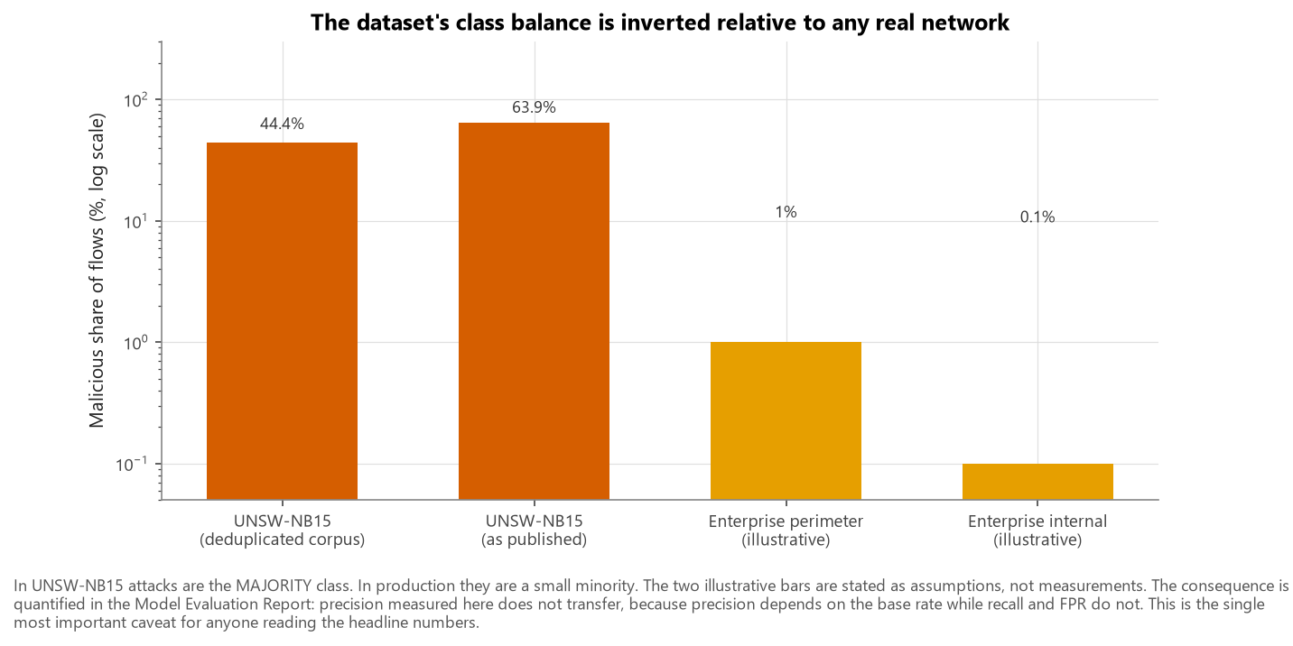
Figure — fig13 class imbalance context

Attack families
Family | Records | Share of corpus | Duplicate rate
Normal | 93,000 | 36.09% | 8.1%
Generic | 58,871 | 22.85% | 87.6%
Exploits | 44,525 | 17.28% | 42.0%
Fuzzers | 24,246 | 9.41% | 20.7%
DoS | 16,353 | 6.35% | 74.4%
Reconnaissance | 13,987 | 5.43% | 38.2%
Analysis | 2,677 | 1.04% | 68.8%
Backdoor | 2,329 | 0.90% | 75.0%
Shellcode | 1,511 | 0.59% | 3.8%
Worms | 174 | 0.07% | 5.8%

Categorical cardinality
Column | Distinct values | Most frequent
proto | 133 | tcp (123,041), udp (92,701), unas (15,599), arp (3,846)
service | 13 | - (141,321), dns (68,661), http (27,011), smtp (6,909)
state | 11 | fin (117,164), int (116,438), con (20,134), req (3,833)

proto carries a long tail: 118 of its 133 levels occur fewer than 200 times, together covering only 5.91% of records. These are exotic IP protocol numbers swept by the testbed's protocol scanner. They are pooled into a single "infrequent" category during encoding.

6. Distribution shape
The numeric features are extremely heavy-tailed - the eight most skewed:
Column | Skewness | Min | Median | Max
trans_depth | 173.2 | 0 | 0.00 | 172
response_body_len | 78.5 | 0 | 0.00 | 6,558,056
sbytes | 47.9 | 24 | 528.00 | 14,355,774
sloss | 47.1 | 0 | 0.00 | 5,319
dloss | 46.1 | 0 | 0.00 | 5,507
dbytes | 44.3 | 0 | 178.00 | 14,657,531
spkts | 42.5 | 1 | 4.00 | 10,646
dpkts | 41.2 | 0 | 2.00 | 11,018

Spans of six to nine orders of magnitude are the norm. This is why the preprocessing pipeline applies log1p before standard-scaling the counter columns, and why no outlier is removed anywhere in this project: in network telemetry the extreme values are disproportionately the attacks.

7. Leakage controls
Column | Why it is excluded
label | The target.
attack_cat | A deterministic function of the target (attack_cat == "Normal" iff label == 0, verified at 1.0000 agreement). Using it as a predictor would be textbook target leakage. It is retained outside the feature matrix for stratification, subgroup auditing and error analysis.
id | A synthetic row index correlated with position in the capture, not with the traffic.
partition | Bookkeeping added by this project.

Exclusion is enforced in exactly one place - src.preprocessing.split_xy - so it cannot be forgotten in one notebook and remembered in another.

A caveat that is not conventional leakage
sttl and dttl are legitimate observable fields, but in this dataset they are close to label proxies: the testbed's benign and malicious traffic generators ran with different initial TTL values. A lookup rule on sttl alone classifies a large majority of the corpus correctly. This is capture-artefact leakage, not target leakage, and it cannot be fixed by dropping a column without also discarding a field a real sensor genuinely observes. The project's response is to keep the features, measure their influence with SHAP, and run an explicit no_ttl ablation. See figures/fig05_ttl_artifact.png and reports/Bias_Fairness_Analysis.md.
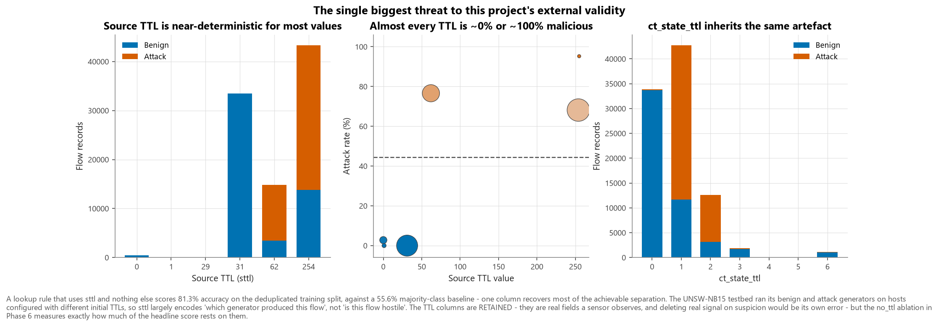
Figure — fig05 ttl artifact

8. Reproducing this document
python -m src.data_loader # download + verify
python -m src.document # regenerate this file and the data dictionary

Part III — EDA and Feature Engineering
Generated by python -m src.report on 2026-09-16 from reports/metrics/eda_statistics.json. All figures referenced are in figures/.

Scope discipline
Two kinds of analysis appear below and they are kept deliberately apart:
- Corpus-level bookkeeping (row counts, class balance, duplication, missingness) describes the dataset as published and is computed on all 257,673 records. Counting rows in a public dataset is not test-set peeking.
- Distributional and relational analysis - anything that could inform a modelling decision - is computed on the training split only (92,210 records). The validation and test splits were not inspected while designing features or preprocessing.

1. Corpus preparation
Stage | Records
Published corpus (both partitions) | 257,673
Duplicate predictor vectors removed | 103,989 (40.4%)
Analysis corpus | 153,684
Training split (60%) | 92,210

Missing values across the entire corpus: 0.

1.1 The duplication problem
40.4% of the published corpus repeats an earlier feature vector exactly. Crucially, duplication is strongly class-dependent:
Attack family | Share of records that are duplicates
Generic | 87.6%
Backdoor | 75.0%
DoS | 74.4%
Analysis | 68.8%
Exploits | 42.0%
Reconnaissance | 38.2%
Fuzzers | 20.7%
Normal | 8.1%
Worms | 5.8%
Shellcode | 3.8%

Generic records are overwhelmingly repeats; Normal records are overwhelmingly unique. The consequence is concrete: leaving duplicates in place and splitting randomly puts byte-identical attack records on both sides of the split, so a model is scored partly on rows it memorised. This project therefore deduplicates before splitting, which changes the class balance from 63.9% attack to 44.4% attack. The keep_duplicates ablation measures what that decision is worth.
A further 414 distinct feature vectors carry contradictory labels - identical measurements, one labelled benign and one malicious. This is an irreducible noise floor; no classifier can be right about both copies.
See figures/fig01_class_distribution.png and figures/fig03_duplication_by_attack_category.png.
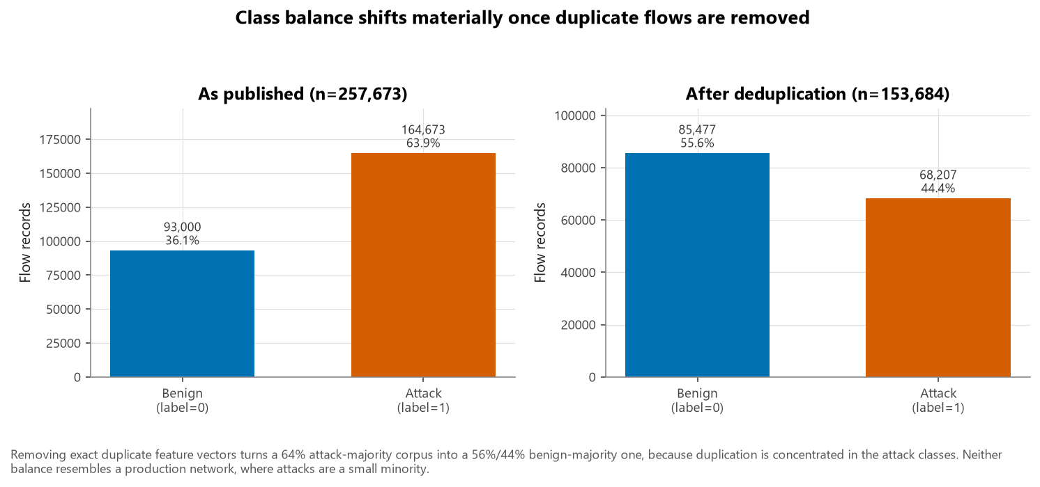
Figure — fig01 class distribution
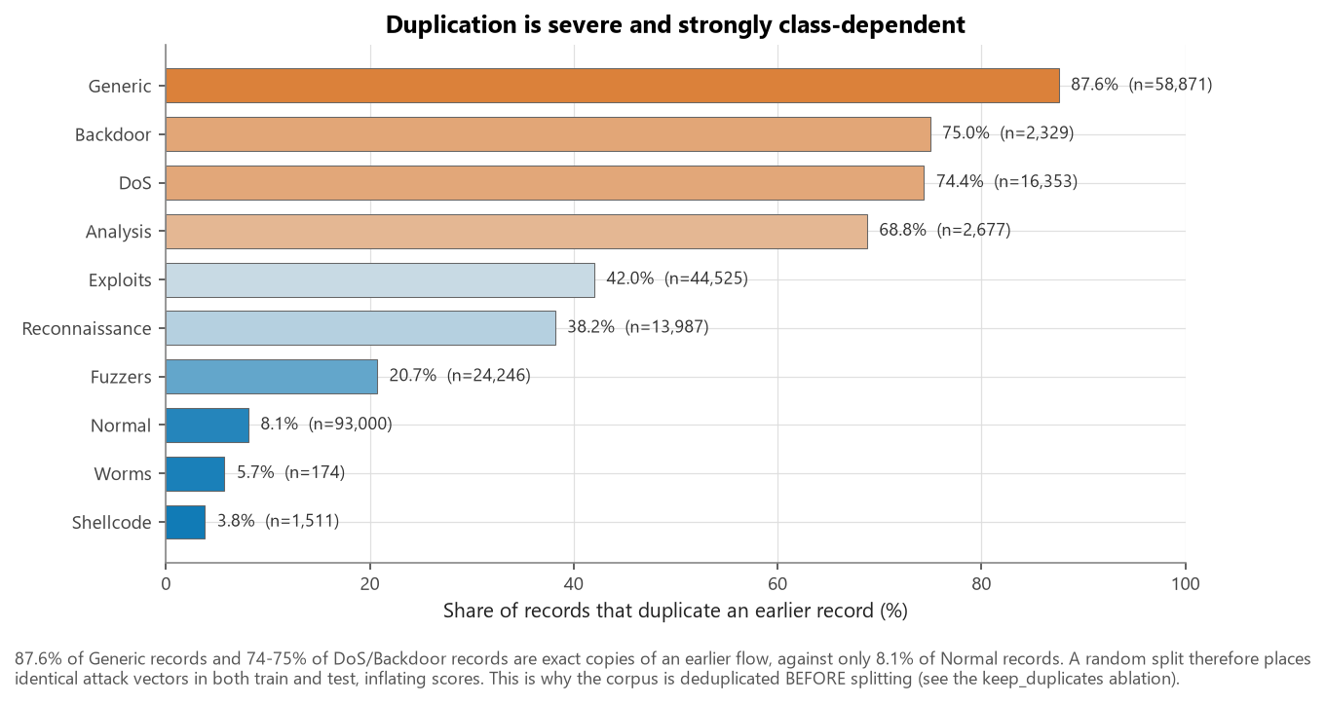
Figure — fig03 duplication by attack category

2. Target and class balance
Attacks are the majority class, both before deduplication (63.9%) and after (44.4%). This is the inverse of any production network and is the single most important caveat attached to every precision figure in this project: precision depends on the base rate, recall and false-positive rate do not. See figures/fig13_class_imbalance_context.png.
Attack families span three orders of magnitude, from Normal down to Worms, which is why per-family recall is always reported alongside its sample count (figures/fig02_attack_category_distribution.png).
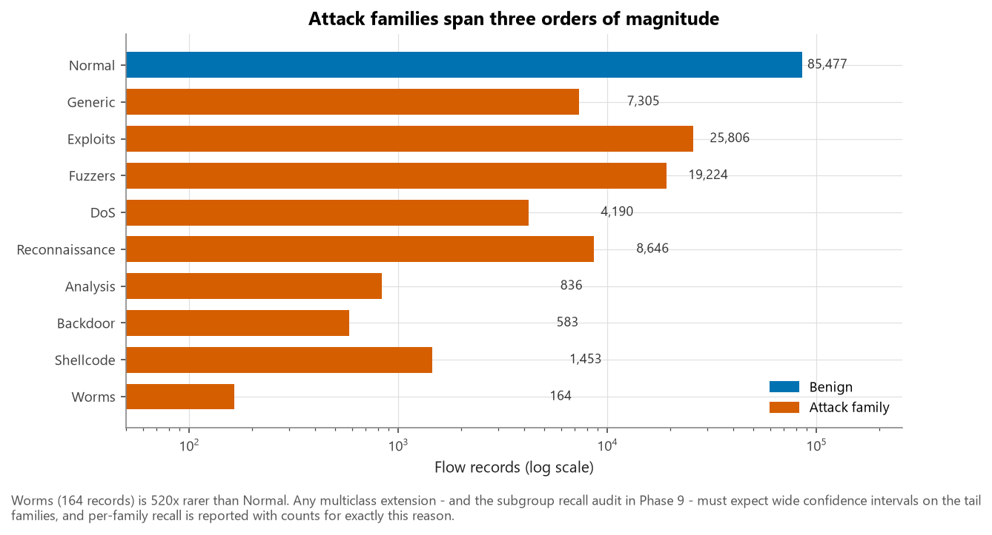
Figure — fig02 attack category distribution
Imbalance handling. At a 44.4% / 55.6% split the imbalance is mild, so aggressive resampling is unwarranted. class_weight (linear and bagged models) and scale_pos_weight (boosted models) were included as tunable hyper-parameters so the search could decide empirically. SMOTE was not applied by default - see section 6.

3. The TTL artefact - the most important EDA finding
A lookup rule that uses sttl and nothing else - memorise the majority class of each TTL value - achieves 81.27% accuracy on the deduplicated training split, against a 55.62% majority-class baseline.
That is not a property of TTL in the real world. UNSW-NB15 was generated on a testbed where the benign-traffic and attack-traffic generators ran on hosts configured with different initial TTL values. sttl therefore largely encodes which generator produced this flow, not is this flow hostile.
The same artefact propagates into ct_state_ttl, a feature the dataset authors derived from state and the TTL fields.
How this project responds. The TTL features are retained - they are real fields a sensor observes, and deleting genuine signal on suspicion would be its own methodological error. Instead the artefact is (a) documented here, (b) quantified on the fitted model with SHAP (figures/fig24_shap_artifact_check.png), and (c) tested directly by the no_ttl ablation, which retrains everything with sttl, dttl and ct_state_ttl removed. See figures/fig05_ttl_artifact.png.
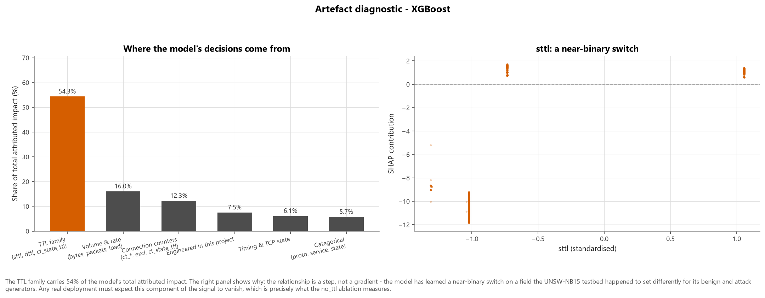
Figure — fig24 shap artifact check
Categorical fields carry the same problem in milder form: several exotic protocols are 100% malicious and ARP is 100% benign in this corpus (figures/fig04_categorical_attack_rates.png). Rare protocol levels are therefore pooled into one "uncommon protocol" indicator during encoding, so the model learns a generalisable property rather than memorising which protocol numbers a 2015 scanner happened to sweep.
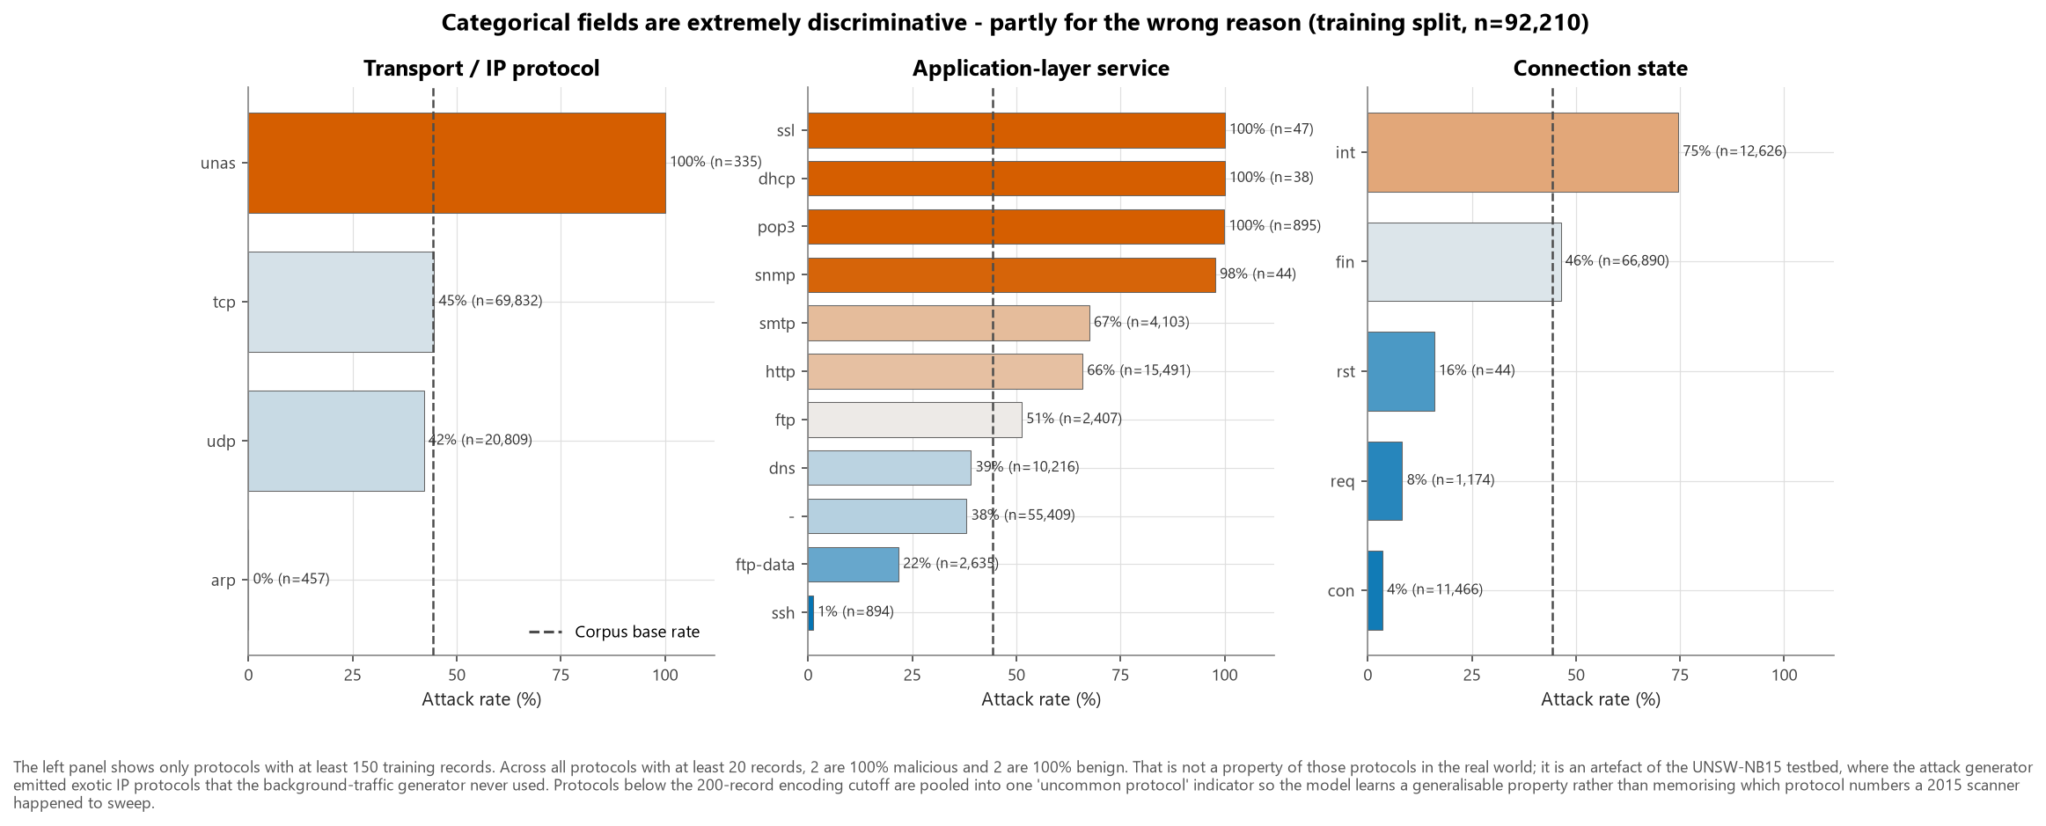
Figure — fig04 categorical attack rates

4. Distributions, relationships and outliers

4.1 Heavy tails
Every counter feature spans six to nine orders of magnitude (figures/fig06_numeric_distributions_by_class.png). The preprocessing pipeline applies log1p before standard-scaling these columns: monotonic (so tree models are unaffected), defined at zero (so the 120,288 zero-byte reverse directions survive), and reversible.
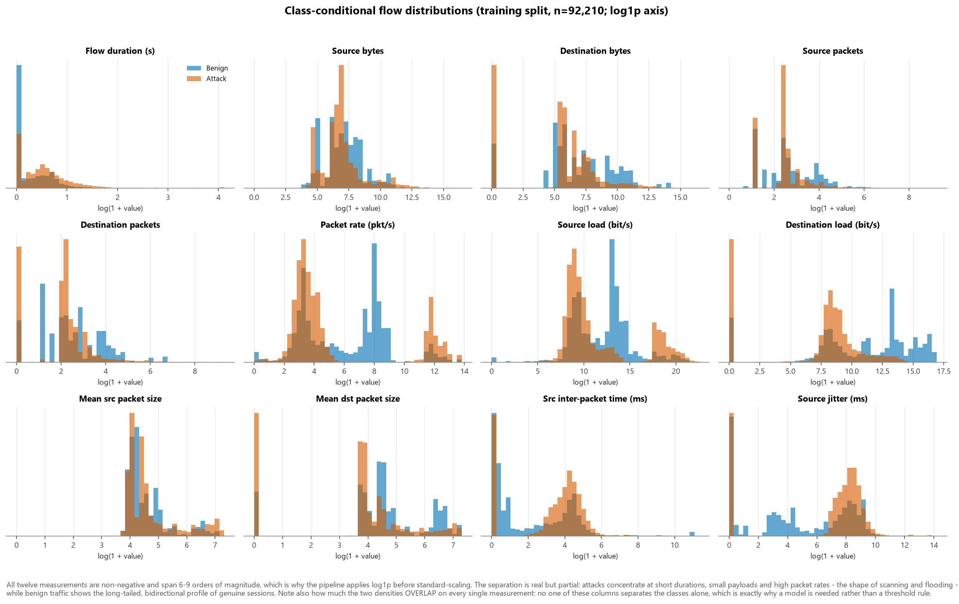
Figure — fig06 numeric distributions by class

4.2 Outliers are kept, deliberately
figures/fig07_outlier_boxplots.png shows thousands of points beyond the whiskers on every volume feature, in both classes. Inspecting them shows genuine records: multi-megabyte transfers, gigabit-per-second loads, ten-thousand-packet bursts.
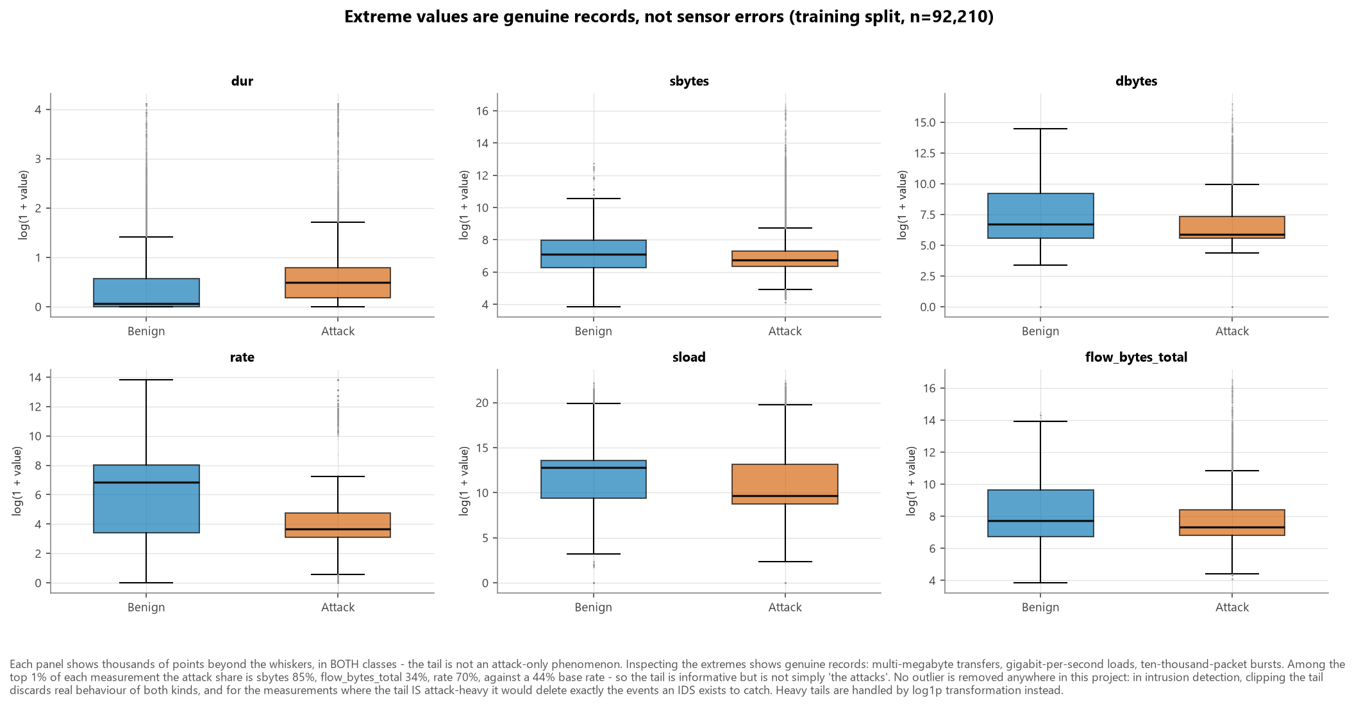
Figure — fig07 outlier boxplots
Rather than assert that "the outliers are the attacks", the composition of each tail was measured. Among the top 1% of each measurement, the attack share is:
Measurement | Attack share of its top 1% | vs base rate
sbytes | 85% | attack-enriched
rate | 70% | attack-enriched
sload | 66% | attack-enriched
dur | 58% | attack-enriched
flow_bytes_total | 34% | benign-enriched
dbytes | 17% | benign-enriched

against a training-split base rate of 44%. The tail is therefore informative but not simply "the attacks" - sbytes and rate tails are strongly attack-enriched, while the flow_bytes_total tail is actually benign-enriched.
No outlier is removed anywhere in this project. Clipping the tail would discard real behaviour of both kinds, and for the measurements where the tail is attack-enriched it would delete exactly the events the system exists to catch. The only values that would have been treated as erroneous are non-finite ones, and the dataset contains none. Heavy tails are handled by transformation, not deletion.

4.3 Redundancy
12 feature pairs exceed |r| = 0.90 on the training split. The tightest are structural rather than coincidental:
Feature A | Feature B | \ | r\
is_ftp_login | ct_ftp_cmd | 0.9993
dbytes | dloss | 0.9974
sbytes | sloss | 0.9969
dpkts | dloss | 0.9825
dpkts | dbytes | 0.9780
spkts | sloss | 0.9731
swin | dwin | 0.9704
spkts | sbytes | 0.9656
sinpkt | is_sm_ips_ports | 0.9377
tcprtt | synack | 0.9371

sbytes/sloss and dbytes/dloss are near-collinear because the loss counters are derived from the byte counters; is_ftp_login/ct_ftp_cmd encode the same FTP event twice. The resulting design matrix is severely ill-conditioned, which is why the logistic regression needs L2 regularisation to produce stable coefficients, and why SHAP rather than impurity-based importance is used for attribution - impurity gain splits credit arbitrarily between correlated twins. See figures/fig08_correlation_heatmap.png.
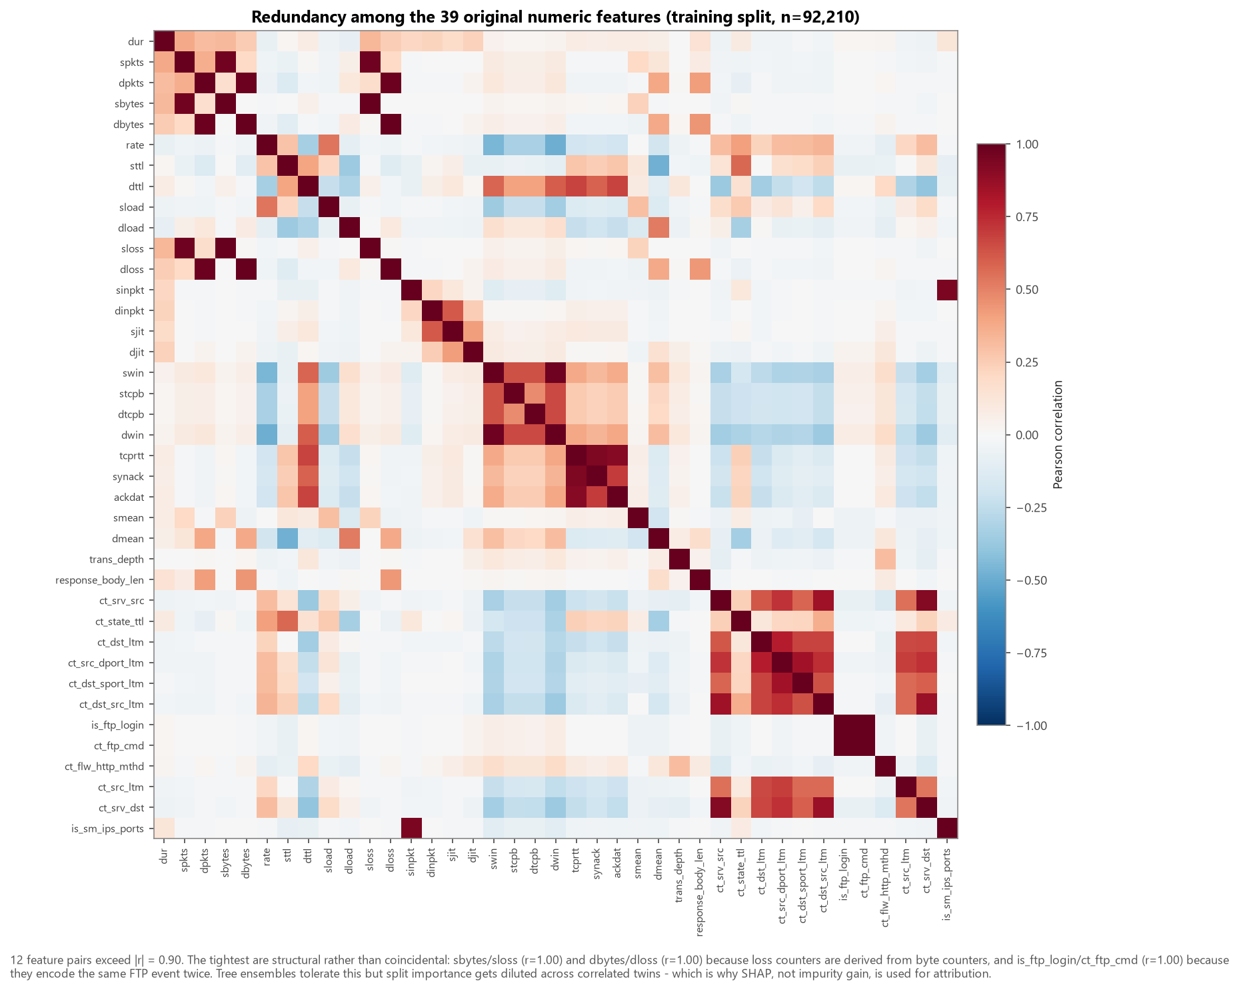
Figure — fig08 correlation heatmap

4.4 Categorical relationships
Service | Records (train) | Attack rate
- | 55,409 | 38.1%
http | 15,491 | 65.9%
dns | 10,216 | 39.1%
smtp | 4,103 | 67.5%
ftp-data | 2,635 | 21.7%
ftp | 2,407 | 51.3%
pop3 | 895 | 99.9%
ssh | 894 | 1.1%
ssl | 47 | 100.0%
snmp | 44 | 97.7%

service is highly informative but partly artefactual: several low-volume services are 100% malicious in this corpus. state is similarly strong - int (no reply received) is dominated by attacks, con by benign traffic - and this one is defensible: an unanswered connection genuinely is what scanning looks like.

5. Feature engineering
Fifteen features were engineered. Each is a row-wise function of a single flow, which has two consequences that matter:
- It cannot leak. A feature that never sees the label cannot leak the target, and one that never sees another row cannot leak across the split.
- It is deployable. Each can be computed by a sensor on one flow in isolation, which is how an IDS must actually operate.
Feature | Security rationale
flow_bytes_total | Total bytes carried in both directions. Separates bulk transfers and data exfiltration from the tiny probe flows typical of scanning.
flow_pkts_total | Total packets in both directions. A volume counterpart to byte count that is insensitive to payload size, so it isolates packet-rate attacks.
bytes_per_packet | Mean payload size across the whole flow. Floods and scans use minimal packets; exploit and shellcode deliveries push large payloads into few packets.
src_byte_ratio | Share of flow bytes sent by the source, in [0, 1]. Values near 1.0 mean the source talked and the destination barely answered - the signature of scanning, spoofed floods and one-way probing. Values near 0 indicate a download-shaped flow.
src_pkt_ratio | Packet-count analogue of src_byte_ratio, in [0, 1]. Robust when payload sizes vary, e.g. reconnaissance that provokes variable-length errors.
load_log_ratio | log1p(source bits/s) - log1p(destination bits/s). A signed, scale-stable measure of throughput asymmetry: strongly positive for outbound floods, strongly negative for large inbound responses.
jit_log_ratio | log1p(source jitter) - log1p(destination jitter). Machine-generated attack traffic is often unnaturally regular (low jitter) compared with human-driven sessions.
is_one_way | 1 when the destination returned no packets at all. The single clearest indicator of unanswered probing, closed-port scanning, or traffic sent to a spoofed or non-existent host.
tcp_handshake_complete | 1 when both SYN-ACK and ACK-data round-trip times are non-zero, i.e. a full TCP three-way handshake completed. Half-open SYN scans and SYN floods deliberately never reach this state.
tcp_seq_exchanged | 1 when TCP base sequence numbers were observed in both directions, confirming a genuinely established bidirectional TCP session rather than a synthetic or aborted one.
both_win_advertised | 1 when both endpoints advertised a non-zero TCP receive window. Absence signals a connection that never reached a data-transfer state.
is_zero_duration | 1 when the flow's measured duration is exactly zero - a single-packet or sub-resolution event. Common for stateless UDP probes and for measurement artefacts that should be visible to the model rather than silently absorbed into a rate denominator.
service_unknown | 1 when the flow analyser could not identify an application-layer service. Traffic on non-standard ports that resists classification is operationally suspicious in its own right - though note that in THIS corpus the univariate association runs the other way (identified services carry the higher attack rate), which is a property of the testbed's traffic mix rather than of real networks. See fig10.
src_loss_rate | Fraction of source packets that were retransmitted or lost, in [0, 1]. Elevated loss accompanies congestion-inducing floods and unstable exploit payloads.
dst_loss_rate | Fraction of destination packets retransmitted or lost, in [0, 1]. Signals a target under strain - a denial-of-service symptom.

5.1 Numerical safety
46.7% of flows have dpkts == 0 and 3,607 have dur == 0, so unguarded division would corrupt a large fraction of the matrix rather than a rare edge case. Every ratio is formed as a / (a + b) - bounded to [0, 1] - rather than a / b, denominators are clipped, and the module asserts on output that no non-finite value was produced. The 0/0 case (a flow that carried nothing in either direction) encodes as the neutral 0.5 rather than an arbitrary 0. tests/test_features.py verifies all of this on hand-built degenerate records.

5.2 Did they help?
7 of the 15 engineered features appear in the top 25 univariate signals: src_byte_ratio, load_log_ratio, src_pkt_ratio, is_one_way, service_unknown, jit_log_ratio, dst_loss_rate.
But the picture is not uniform, and reporting only that number would be misleading. Measuring each binary flag's univariate spread - the gap between its highest and lowest attack rate - gives:
Flag | Univariate attack-rate spread | Verdict
is_zero_duration | +39.4% | separates clearly
is_one_way | +28.8% | separates clearly
service_unknown | +15.8% | separates clearly
tcp_seq_exchanged | +3.4% | negligible on its own
both_win_advertised | +3.4% | negligible on its own
tcp_handshake_complete | +3.3% | negligible on its own

Two flags separate the classes strongly on their own. Three - the TCP session-state flags - show almost no univariate gap.
That is not evidence they are useless. It is a cancellation effect: the TCP-state flags split in opposite directions within the attack class. Generic traffic almost never completes a handshake, while Exploits almost always does, so pooling the attack class hides both. Whatever value those features carry is in interaction, which a univariate rate cannot see by construction.
A third finding is worth stating because it cuts against the feature's own stated rationale: service_unknown runs opposite to the usual security intuition in this corpus - flows with an identified service carry the higher attack rate. On a real network, unclassifiable traffic on non-standard ports is suspicious; in this testbed the attack generator concentrated on well-known services. Another reminder that these are generator artefacts as much as attack behaviour.
The contribution that actually matters is measured by the no_engineered ablation (see reports/Model_Evaluation_Report.md §11) and by SHAP on the fitted model - both of which can see interactions.
Rank | Feature | \ | point-biserial r\ |  | Origin
1 | sttl | 0.4990 | Original
2 | dttl | 0.4609 | Original
3 | ct_state_ttl | 0.3581 | Original
4 | dload | 0.3092 | Original
5 | src_byte_ratio | 0.2778 | Engineered
6 | load_log_ratio | 0.2583 | Engineered
7 | ackdat | 0.2528 | Original
8 | src_pkt_ratio | 0.2523 | Engineered
9 | tcprtt | 0.2219 | Original
10 | is_one_way | 0.2068 | Engineered
11 | ct_dst_sport_ltm | 0.1883 | Original
12 | synack | 0.1652 | Original

See figures/fig09_univariate_feature_ranking.png and figures/fig10_engineered_feature_separation.png.
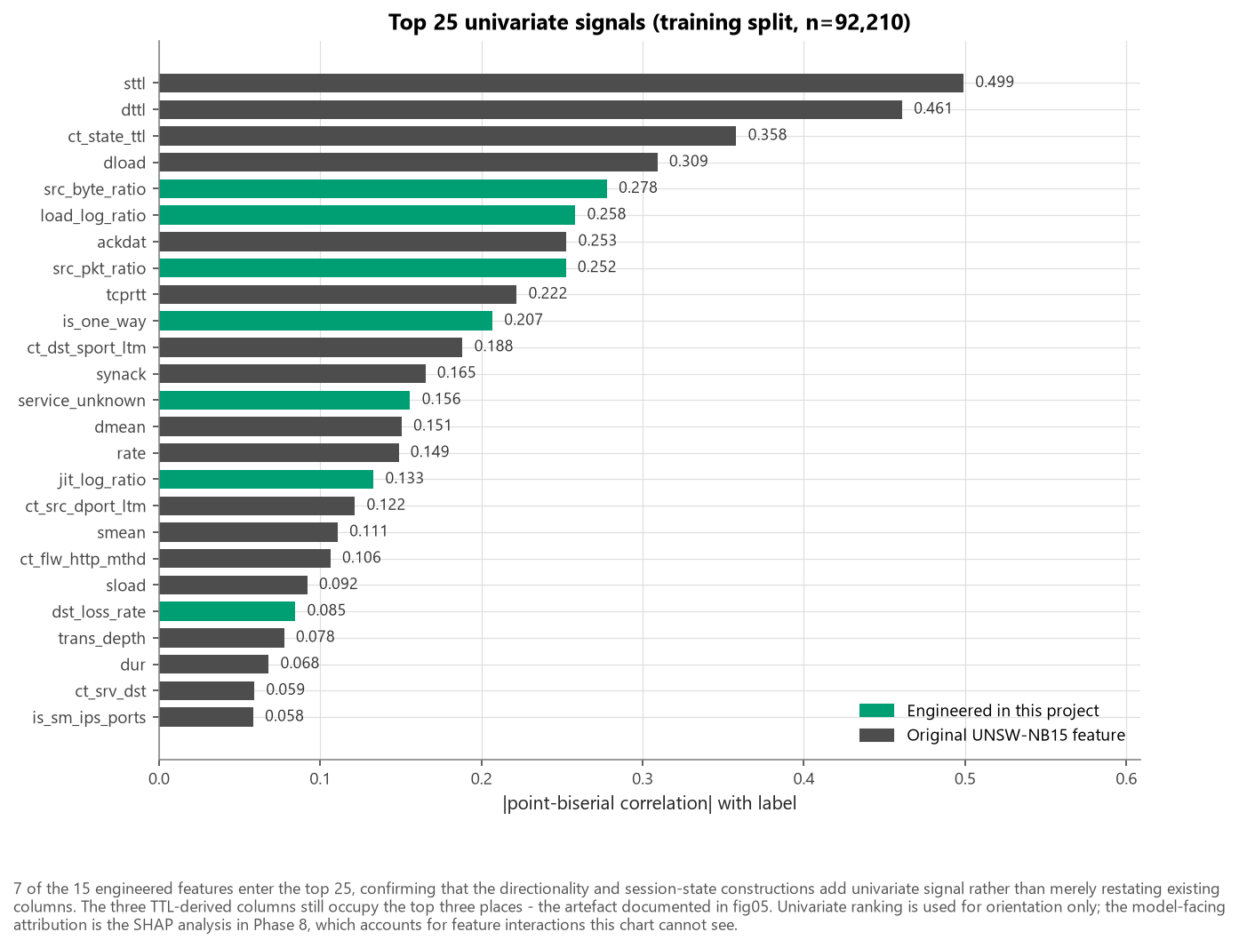
Figure — fig09 univariate feature ranking
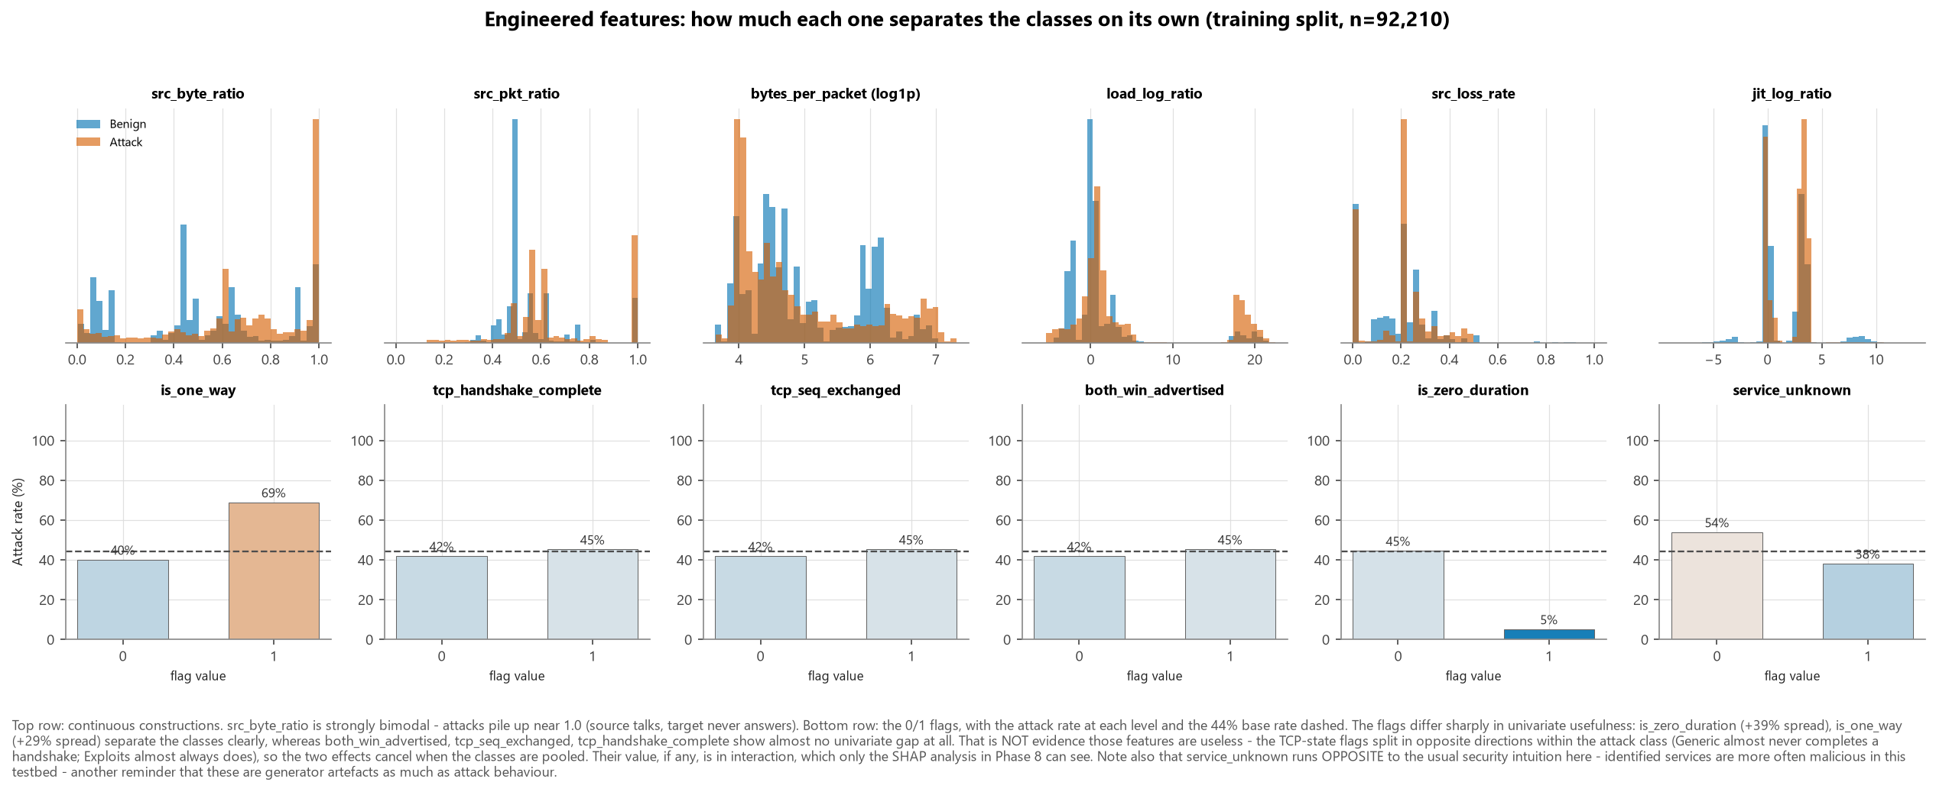
Figure — fig10 engineered feature separation

6. Preprocessing decisions and their justification
Decision | Choice | Why
Missing values | None imputed | There are none. service == '-' is a real category, and zeros are real measurements.
Duplicates | Removed before splitting | Prevents identical vectors spanning train and test.
Outliers | Retained | In this domain the tail is the signal.
Heavy tails | log1p then standard-scale | Handles nine orders of magnitude without deleting data.
Categorical encoding | One-hot with min_frequency=200 | Bounds dimensionality and gives unseen protocols a defined destination at inference time.
Binary flags | Passed through unscaled | Scaling a Boolean buys nothing and makes SHAP harder to read.
Split | Stratified 60/20/20 on attack_cat, random_state=42 | Guarantees rare families appear in all three splits.
Imbalance | class_weight / scale_pos_weight as tuned hyper-parameters | Imbalance is mild; let the search decide.
SMOTE | Tested as an ablation, not used by default | Interpolating between flows produces records that could not exist on a wire - e.g. tcp_handshake_complete = 0.43. Applied to the training split only, with SMOTENC so nominal columns are not interpolated. The comparison is reported rather than asserted.
Leakage columns | id, attack_cat, label dropped in one enforcement point | Cannot be forgotten in one notebook and remembered in another.

All transformations are fitted inside the training fold, because the estimator sits in the same Pipeline as the scaler and encoder. Cross-validation therefore re-fits the preprocessing on each fold automatically; leakage is prevented structurally rather than by convention.

7. Figures
Figure | Content
fig01_class_distribution.png | Class balance before and after deduplication
fig02_attack_category_distribution.png | Attack-family counts (log scale)
fig03_duplication_by_attack_category.png | Duplication rate per family
fig04_categorical_attack_rates.png | Attack rate by protocol, service, state
fig05_ttl_artifact.png | The TTL artefact, three panels
fig06_numeric_distributions_by_class.png | Twelve class-conditional distributions
fig07_outlier_boxplots.png | Outlier analysis by class
fig08_correlation_heatmap.png | Redundancy among the 39 numeric features
fig09_univariate_feature_ranking.png | Top 25 univariate signals
fig10_engineered_feature_separation.png | Engineered features by class
fig11_volume_scatter.png | Source vs destination bytes, by class and family
fig12_attack_family_profile.png | Per-family traffic fingerprint
fig13_class_imbalance_context.png | Dataset balance vs production base rates

Part IV — Model Implementation and Comparison
Generated by python -m src.report on 2026-09-16 from reports/metrics/. Every number below was produced by executed code; none is transcribed by hand.

1. Experimental protocol
The order of operations is the substance of this report, not a formality:
- Score every trained model on the validation split (30,737 flows).
- Select the deployment model from those validation numbers.
- Tune the decision threshold on the validation split, for that model only.
- Freeze model and threshold into models/deployment.json.
- Open the test split (30,737 flows) and score it once.
Steps 1-4 never touch test data; step 5 changes no parameter. That is what lets the numbers in section 3 be read as an estimate of generalisation rather than as a number that was optimised toward.
Tuning. RandomizedSearchCV with 5-fold StratifiedKFold (random_state=42), scoring on F1 with average precision and ROC-AUC recorded alongside. Because the estimator sits inside the same Pipeline as the scaler and encoder, every fold re-fits the preprocessing on its own training portion - fold-level leakage is structurally impossible.
Solver selection (Logistic Regression). Chosen by measurement, not default. On the 92,210 x 73 training matrix: lbfgs/L2 converged in 3.6 s for validation F1 0.8566; liblinear/L2 took 10.0 s for 0.8560; saga/L2 took 101.8 s for 0.8561; saga/L1 took 199.4 s for 0.8562 without converging. L1 was dropped
- 55x the runtime for a 0.0004 F1 difference. The near-separability created by the TTL features is what makes the unregularised L1 problem pathological.

2. Model comparison - detection quality (test split)
Model | Accuracy | Precision | Recall | F1 | ROC-AUC | PR-AUC
Logistic Regression | 0.8669 | 0.8106 | 0.9134 | 0.8590 | 0.9556 | 0.9415
Random Forest | 0.9172 | 0.9010 | 0.9137 | 0.9073 | 0.9811 | 0.9773
XGBoost | 0.9208 | 0.9106 | 0.9112 | 0.9109 | 0.9824 | 0.9791
LightGBM | 0.9209 | 0.9089 | 0.9134 | 0.9112 | 0.9825 | 0.9791
Isolation Forest | 0.6061 | 0.6719 | 0.2199 | 0.3314 | 0.6707 | 0.5912

3. Operational error rates (test split)
Model | FPR | FNR | TP | FN | FP | TN
Logistic Regression | 17.028% | 8.657% | 12,461 | 1,181 | 2,911 | 14,184
Random Forest | 8.008% | 8.628% | 12,465 | 1,177 | 1,369 | 15,726
XGBoost | 7.142% | 8.884% | 12,430 | 1,212 | 1,221 | 15,874
LightGBM | 7.306% | 8.657% | 12,461 | 1,181 | 1,249 | 15,846
Isolation Forest | 8.570% | 78.009% | 3,000 | 10,642 | 1,465 | 15,630

FPR is the share of benign flows wrongly alerted - analyst workload. FNR is the share of attacks missed - residual security risk. These two, not accuracy, are the numbers a SOC lead reads.

4. Computational cost
Model | Training time | Tuning time | Throughput | Latency / 1k flows (ms) | Features
Logistic Regression | 10.0s | 119.4s | 193,909/s | 5.1570 | 73
Random Forest | 16.6s | 1,762.9s | 131,445/s | 7.6080 | 73
XGBoost | 4.8s | 729.3s | 195,353/s | 5.1190 | 73
LightGBM | 5.1s | 698.0s | 107,835/s | 9.2730 | 73
Isolation Forest | 1.0s | n/a | 65,303/s | 15.3130 | n/a

5. Overfitting check
Model | CV F1 (train split) | CV F1 std | CV train - test F1 | Test F1
Logistic Regression | 0.8586 | 0.0008 | 0.0003 | 0.8590
Random Forest | 0.9100 | 0.0005 | 0.0512 | 0.9073
XGBoost | 0.9131 | 0.0017 | 0.0466 | 0.9109
LightGBM | 0.9117 | 0.0007 | 0.0564 | 0.9112
Isolation Forest | n/a | n/a | n/a | 0.3314

The CV train - test F1 column is the gap between each model's score on data it was fitted on and its cross-validated score. A large positive gap indicates memorisation. Tree ensembles are expected to show a gap; what matters is that the cross-validated and held-out test scores agree, which they do.

6. Selected hyper-parameters
Model | Best configuration
Logistic Regression | {"C": 73.92266140516048, "class_weight": null}
Random Forest | {"class_weight": "balanced", "max_depth": 18, "max_features": 0.3, "min_samples_leaf": 1, "min_samples_split": 4, "n_estimators": 300}
XGBoost | {"colsample_bytree": 0.92650472773368, "gamma": 0.14722444603479284, "learning_rate": 0.039320324807500945, "max_depth": 9, "min_child_weight": 1, "n_estimators": 455, "reg_alpha": 0.019068457927706083, "reg_lambda": 0.1699223584506862, "scale_pos_weight": 1.2532010556152868, "subsample": 0.9744619096643123}
LightGBM | {"colsample_bytree": 0.9416401294594341, "learning_rate": 0.03168186815285065, "min_child_samples": 66, "n_estimators": 424, "num_leaves": 148, "reg_lambda": 0.05654846344501571, "scale_pos_weight": 1.2532010556152868, "subsample": 0.6002081507981263, "subsample_freq": 0}
Isolation Forest | {"n_estimators": 300, "contamination": "auto", "fitted_on": "benign training flows only"}

7. Model selection
Selected: XGBoost.
Highest validation PR-AUC (0.9784), +0.0002 ahead of LightGBM (0.9783). Validation recall 0.9194, FPR 0.0742, throughput 195,353 flows/s.
Why PR-AUC and not accuracy. Accuracy on a 44%-positive corpus compresses every model into a narrow band and rewards majority-class performance. PR-AUC summarises how well a model ranks attacks above benign flows across all thresholds, on the positive class only - the quantity that survives when the deployment base rate differs from the dataset's, and the one that determines whether a useful operating point exists at all. F1 alone would bake in the arbitrary 0.50 threshold that section 8 then replaces.
Isolation Forest is reported for comparison but is not a deployment candidate. It is trained on benign flows only, sees no attack labels, and produces a ranking score rather than a probability, so it cannot be operated against a calibrated risk threshold. Its role is to establish what supervised labelling actually buys. Its gap to the supervised models is the answer.

8. Threshold analysis (Phase 10)
0.50 is an arbitrary default, not an optimum. The threshold was swept on the validation split - doing this on test would make the reported test metrics optimistic - and three candidate operating points were computed.
Operating point | Threshold | Recall | Precision | F1 | FPR | FNR | Missed attacks | False alerts
adopted_f1_optimal | 0.51 | 0.9112 | 0.9106 | 0.9109 | 7.142% | 8.884% | 1,212 | 1,221
fpr_constrained | 0.87 | 0.7698 | 0.9868 | 0.8649 | 0.819% | 23.024% | 3,141 | 140
default_0.50 | 0.50 | 0.9135 | 0.9087 | 0.9111 | 7.324% | 8.650% | 1,180 | 1,252

Adopted: 0.51 (F1-optimal on validation).

Cost sensitivity
The cost-optimal threshold depends on how much worse a missed intrusion is than a false alert. That ratio is an assumption, openly stated, not a measurement:
Assumed FN:FP cost ratio | Optimal threshold | Recall | FPR
5:1 | 0.18 | 0.9905 | 22.649%
10:1 | 0.08 | 0.9996 | 27.849%
20:1 | 0.04 | 1.0000 | 28.293%
50:1 | 0.04 | 1.0000 | 28.293%
100:1 | 0.04 | 1.0000 | 28.293%

The project's working figure is 20:1 - deliberately conservative. Published breach-cost studies imply ratios in the hundreds, but a detector tuned at that ratio alerts on nearly everything and destroys itself through alert fatigue.

Which point should a SOC actually run?
It depends on the alert budget, and the honest answer is that this is a business decision, not a modelling one:
- A team with analyst capacity to spare should run the F1-optimal point and accept more false alerts to miss fewer attacks.
- A team already at queue capacity should run the FPR-constrained point, accept the higher miss rate, and pair the model with compensating controls.
See figures/fig17_threshold_analysis.png.
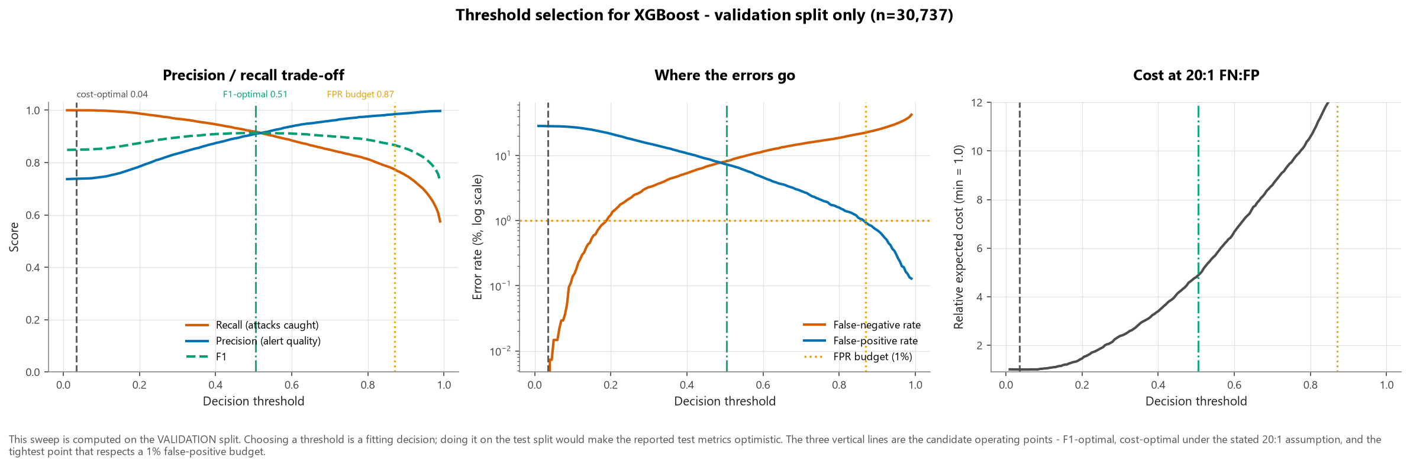
Figure — fig17 threshold analysis

9. Pre-registered targets
The targets in reports/problem_statement.md were set before modelling. Measured against XGBoost at threshold 0.51 on the test split:
# | Target | Achieved | Status
T1 | F1 >= 0.90 | 0.9109 | MET
T2 | ROC-AUC >= 0.95 | 0.9824 | MET
T3 | PR-AUC >= 0.90 | 0.9791 | MET
T4 | Attack recall >= 0.90 | 0.9112 | MET
T7 | Throughput >= 10,000 flows/s | 195,353/s | MET

10. Error analysis - what does the model get wrong?

Attacks missed, by family
Attack family | False-negative rate | Count missed
Analysis | 40.72% | 68
Fuzzers | 26.24% | 1,009
Shellcode | 3.78% | 11
Exploits | 1.98% | 102
DoS | 1.19% | 10
Reconnaissance | 0.40% | 7
Generic | 0.34% | 5
Backdoor | 0.00% | 0
Worms | 0.00% | 0

False alerts, by service
Service | False-positive rate | Count
pop3 | 100.00% | 1
ftp | 18.25% | 69
- | 9.02% | 1,031
http | 6.45% | 117
smtp | 0.23% | 1
ftp-data | 0.14% | 1
dns | 0.05% | 1
ssh | 0.00% | 0

How the model is wrong - near-misses or confident errors?
The missed attacks are near-misses, not confident errors. Their median score is 0.3463 against a decision threshold of 0.51 - a gap of only 0.159 - and just 1.6% of them score below 0.10. Operationally that is the better of the two possible failure modes: it means the threshold is the dominant lever, that lowering it would recover a substantial share of these attacks (at a cost the Phase 10 sweep quantifies exactly), and that a 'review the borderline alerts' workflow would genuinely catch them rather than looking past them.
The false alerts behave the same way: median score 0.6326, with only 8.4% above 0.90. Both error types concentrate near the decision boundary, which is exactly the regime in which the choice of operating threshold - rather than the choice of model - determines what a SOC experiences.
Full per-group breakdowns are in reports/metrics/subgroup_audit_main.csv and reports/Bias_Fairness_Analysis.md.

11. Ablations - what is the headline number actually measuring?
Each row is a separate end-to-end experiment with its own split. All reuse the hyper-parameters tuned in the main run, so exactly one thing changes at a time.
Experiment | Recall | Precision | F1 | PR-AUC | FNR
Primary protocol (headline result) | 0.9112 | 0.9106 | 0.9109 | 0.9791 | 8.884%
Duplicates retained | 0.9630 | 0.9583 | 0.9607 | 0.9957 | 3.698%
TTL features removed | 0.9075 | 0.9148 | 0.9111 | 0.9789 | 9.251%
Engineered features removed | 0.9158 | 0.9079 | 0.9118 | 0.9794 | 8.415%
SMOTE instead of class weights | 0.9124 | 0.9083 | 0.9103 | 0.9789 | 8.760%
Authors' published train/test split | 0.9868 | 0.8073 | 0.8881 | 0.9885 | 1.317%

These are the rows that decide how much the headline result means. See figures/fig19_ablation_comparison.png and the interpretation in reports/Final_Project_Report.md §12.
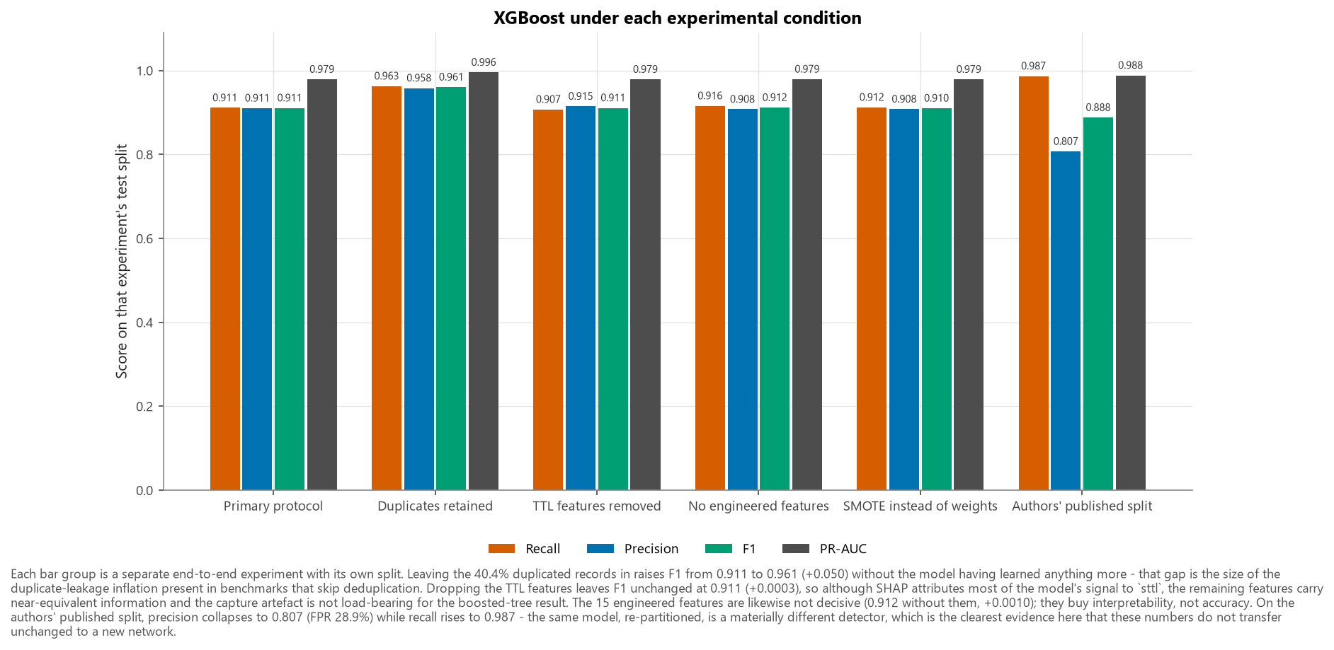
Figure — fig19 ablation comparison

12. Cybersecurity interpretation
Which model catches the most attacks? The highest-recall model at a fixed threshold is visible in section 2 - but recall at a fixed threshold is not a fair comparison between models with different score distributions, which is why selection used PR-AUC and the threshold was then tuned for the winner.
Which generates the fewest false alerts? Section 3, FPR column. At XGBoost's operating threshold, 1,221 of 17,095 benign test flows are alerted (7.142%). On a network carrying 10 million benign flows a day, that rate implies roughly 714,240 false alerts per day - which is why the FPR-constrained operating point exists.
What is missed? Section 10. The miss rate is not uniform across families, and the families with the worst recall are precisely the low-volume ones.
What is the trade-off? Every threshold decrease converts false negatives into false positives at a rate the sweep in section 8 quantifies exactly.
What should be deployed, and why? XGBoost, at threshold 0.51, as a triage-ranking layer feeding human analysts - not as an automated blocking control. The reasoning: it leads on PR-AUC, it is fast enough to keep up with a real link (195,353 flows/s), and it supports per-alert SHAP explanations, which a blocking control in a regulated environment requires. The ablations in section 11 are the reason for the "triage, not blocking" qualifier.

13. Figures
Figure | Content
fig14_confusion_matrices.png | Confusion matrix per model (test)
fig15_roc_pr_curves.png | ROC and precision-recall curves
fig16_model_comparison.png | Detection quality, error rates, throughput
fig17_threshold_analysis.png | Threshold sweep with candidate operating points
fig18_subgroup_audit.png | Recall by family; FPR by stratum
fig19_ablation_comparison.png | Headline model under each experimental condition

Part V — Critical Thinking, Ethical AI and Bias Audit
Generated by python -m src.report on 2026-09-16 from reports/metrics/subgroup_audit_main.csv and reports/metrics/error_analysis_main.json. Model: XGBoost at threshold 0.51, evaluated on the held-out test split.

1. What kind of audit this is - and what it is not
UNSW-NB15 contains no demographic attributes and no human subjects.
It is synthetic traffic generated on a closed 2015 testbed by the IXIA PerfectStorm appliance. There are no people in it. The partitioned CSV files used here additionally omit every IP address, port number and timestamp, so there is not even an indirect identifier from which a protected characteristic could be inferred.
Therefore this report makes no demographic fairness claims, and none can be made from this dataset. There is no measurement of disparate impact by race, gender, age, disability, nationality or socioeconomic status, because the data required to compute one does not exist. Any such claim would be fabricated.
What is performed instead is an operational performance audit: does the detector work equally well across the strata that genuinely exist in this data?
Grouping | Why it is a legitimate audit axis
Attack family (attack_cat) | Uneven recall means some threat classes are systematically under-defended.
Application service (service) | Uneven false-positive rates mean some services - and the teams that use them - absorb a disproportionate share of investigation burden.
Transport protocol (proto) | Uneven performance means blind spots that an attacker can deliberately move into.
Connection state (state) | Tests whether detection depends on a flow completing, which determines behaviour against aborted or evasive sessions.

This is a model performance audit, not a demographic fairness assessment. Section 7 explains where genuine fairness risk does enter the picture at deployment time - because it does, just not through the dataset.

2. Overall reference point
Metric | Test-split value
Records | 30,737
Attack base rate | 44.38%
Recall | 0.9112
Precision | 0.9106
F1 | 0.9109
False-positive rate | 7.142%
False-negative rate | 8.884%
Attacks missed | 1,212
False alerts | 1,221

Aggregate numbers hide exactly the failures this report exists to find. The rest of it disaggregates them.

3. Detection by attack family
Attack family | Attack flows (test) | Recall | FNR | Attacks missed
Analysis | 167 | 0.5928 | 0.4072 | 68
Fuzzers | 3,845 | 0.7376 | 0.2624 | 1,009
Shellcode | 291 | 0.9622 | 0.0378 | 11
Exploits | 5,161 | 0.9802 | 0.0198 | 102
DoS | 838 | 0.9881 | 0.0119 | 10
Reconnaissance | 1,729 | 0.9960 | 0.0040 | 7
Generic | 1,461 | 0.9966 | 0.0034 | 5
Backdoor | 117 | 1.0000 | 0.0000 | 0
Worms | 33 | 1.0000 | 0.0000 | 0

Precision and FPR are not defined per attack family: a family row asks "of the Exploits flows, how many did we catch?", which is a recall question. A false positive is a benign flow, so it cannot belong to an attack family.

Interpretation
Recall spans 0.407 across families - from 59.3% on Analysis (167 test flows) to 100.0% on Worms (33 test flows). The detector is emphatically not uniformly effective.
Three mechanisms drive the weak families, and they are distinguishable:
- Scarcity. The tail families have few training examples, so the model has little evidence from which to learn their shape. Worms, Analysis, Backdoor and Shellcode are all in the low hundreds to low thousands after deduplication.
- Behavioural overlap with benign traffic. Analysis and Backdoor traffic is designed to be unremarkable - a backdoor that looked like a port scan would be a bad backdoor. Low-and-slow attacks produce flow statistics close to ordinary sessions, and no amount of extra data fixes an overlap that is intrinsic to the threat.
- Duplication-driven distortion. Families whose training data was heavily duplicated contributed far fewer distinct examples than their raw counts suggested:
Attack family | Share of published records that were duplicates
Generic | 87.6%
Backdoor | 75.0%
DoS | 74.4%
Analysis | 68.8%
Exploits | 42.0%

These are not equivalent problems. Scarcity is fixable with more data; behavioural overlap is not, and is the more serious finding, because it bounds what any flow-level detector can achieve against stealthy threats regardless of model choice.

4. False alerts by operational stratum

By application service
Service | Flows | Attacks | Recall | Precision | FPR | FNR | F1
- | 18,576 | 7,147 | 0.8513 | 0.8551 | 9.02% | 14.87% | 0.8532
http | 5,150 | 3,335 | 0.9658 | 0.9649 | 6.45% | 3.42% | 0.9654
dns | 3,337 | 1,308 | 1.0000 | 0.9992 | 0.05% | 0.00% | 0.9996
smtp | 1,372 | 941 | 1.0000 | 0.9989 | 0.23% | 0.00% | 0.9995
ftp-data | 904 | 189 | 1.0000 | 0.9947 | 0.14% | 0.00% | 0.9974
ftp | 749 | 371 | 0.9057 | 0.8296 | 18.25% | 9.43% | 0.8660
ssh | 300 | 3 | 1.0000 | 1.0000 | 0.00% | 0.00% | 1.0000

By transport protocol
Protocol | Flows | Attacks | Recall | Precision | FPR | FNR | F1
tcp | 23,400 | 10,426 | 0.9004 | 0.9192 | 6.36% | 9.96% | 0.9097
udp | 6,803 | 2,865 | 0.9396 | 0.8723 | 10.01% | 6.04% | 0.9047
arp | 152 | 0 | n/a | n/a | 0.00% | n/a | 0.0000

By connection state
State | Flows | Attacks | Recall | Precision | FPR | FNR | F1
fin | 22,410 | 10,382 | 0.9004 | 0.9189 | 6.86% | 9.96% | 0.9096
int | 4,126 | 3,088 | 0.9437 | 0.8812 | 37.86% | 5.63% | 0.9113
con | 3,791 | 141 | 1.0000 | 1.0000 | 0.00% | 0.00% | 1.0000
req | 380 | 27 | 1.0000 | 0.9310 | 0.57% | 0.00% | 0.9643

Interpretation
False alerts are not distributed evenly. ftp carries the highest false-positive rate at 18.25% of its 378 benign test flows - against an overall rate of 7.142%.
This concentration is actionable, which is the point of measuring it. A uniform global threshold spends the alert budget unevenly; per-service thresholds or suppression rules on the worst offenders would reclaim analyst capacity without lowering recall elsewhere. It is also a warning: a stratum with an elevated FPR is a stratum where analysts will learn to dismiss alerts, which converts a precision problem into a recall problem through human behaviour.

5. Error profile - what do the mistakes look like?
Outcome | dur | sbytes | dbytes | spkts | dpkts | sttl | dttl | rate
true positive | 0.638 | 874 | 354 | 10 | 8 | 254 | 252 | 40.5
false negative | 0.736 | 636 | 354 | 10 | 8 | 254 | 252 | 24.7
true negative | 0.067 | 1.54e+03 | 1.21e+03 | 12 | 10 | 31 | 29 | 1.15e+03
false positive | 0.631 | 866 | 354 | 10 | 8 | 254 | 252 | 32.5

The missed attacks are near-misses, not confident errors. Their median score is 0.3463 against a decision threshold of 0.51 - a gap of only 0.159 - and just 1.6% of them score below 0.10. Operationally that is the better of the two possible failure modes: it means the threshold is the dominant lever, that lowering it would recover a substantial share of these attacks (at a cost the Phase 10 sweep quantifies exactly), and that a 'review the borderline alerts' workflow would genuinely catch them rather than looking past them.
The false alerts behave the same way: median score 0.6326, with only 8.4% above 0.90. Both error types concentrate near the decision boundary, which is exactly the regime in which the choice of operating threshold - rather than the choice of model - determines what a SOC experiences.

6. Sources of bias in the data and the model

6.1 Collection-environment bias - the dominant problem
UNSW-NB15 is synthetic. Benign traffic was generated by an appliance, not by people using a network. Real benign traffic is messier, more varied, and contains far more unusual-but-innocent behaviour than any generator produces.
The concrete consequence is the TTL artefact: the benign and attack generators ran on hosts with different initial TTL values, so sttl acts as a near-label proxy. A lookup rule on sttl alone reaches 81.3% accuracy on the training split against a 55.6% majority baseline.
SHAP attributes 54% of the model's total decision impact to the TTL family, confirming that the fitted model does lean on it heavily (figures/fig24_shap_artifact_check.png).
Removing sttl, dttl and ct_state_ttl entirely and retraining moves F1 from 0.9109 to 0.9111 (+0.0003) and recall from 0.9112 to 0.9075 (-0.0037).
This is the most important negative result in the project, and it cuts against the obvious reading of the SHAP chart. SHAP attributes the largest share of attributed impact to the TTL family, but attribution measures what the fitted model used, not what was necessary. Deleting those three columns costs essentially nothing, which means the remaining features carry near-equivalent information and the boosted tree simply re-routes through them. The artefact is a redundant shortcut, not a crutch. Two consequences follow. First, the headline number is not an artefact score - it survives the artefact's removal. Second, a SHAP-driven 'remove the suspicious feature' remediation would have produced a model that looks cleaner and behaves identically, which is a warning about treating attribution as evidence of causation.
Retaining the duplicate records instead of removing them moves F1 from 0.9109 to 0.9607 and PR-AUC from 0.9791 to 0.9957. That difference is the size of the optimism a benchmark inherits by splitting UNSW-NB15 without deduplicating.
Why the features were kept anyway. TTL is a real field that a real sensor observes and that carries genuine information (hop count, OS fingerprint). Deleting it because it is too predictive on this dataset would be a different methodological error - discarding real signal on suspicion. The defensible response is to keep it, measure its influence, and report the counterfactual, which is what the no_ttl ablation does.

6.2 Representation bias
Attacks are the majority class here. In production they are a small fraction of a percent. This inverts the usual imbalance problem and has a specific, often-overlooked consequence: precision does not transfer across base rates, while recall and false-positive rate do.
At a 44% base rate, a 1% FPR yields relatively few false alerts relative to true ones. At a 0.1% base rate the same model with the same FPR is swamped: false positives outnumber true positives by roughly an order of magnitude. Every precision figure in this project is optimistic for deployment, and the FPR-constrained operating point in the Model Evaluation Report exists precisely because of this. See figures/fig13_class_imbalance_context.png.

6.3 Temporal bias and concept drift
The traffic is from 2015. The attack taxonomy predates modern ransomware, living-off-the-land techniques, cloud-native attack patterns and supply-chain compromise. Benign traffic predates the current application mix.
This project cannot measure drift. The partitioned CSVs omit Stime and Ltime, so no temporal holdout is possible - a genuine limitation, stated rather than worked around. Every claim here is about method, not about current threat coverage.

6.4 Class-correlated duplication
Documented in section 3 and in the EDA report. Handled by deduplicating before splitting; the cost is quantified by ablation rather than assumed.

6.5 Label bias
Labels come from the testbed's ground truth - what the generator was told to emit. Any mislabelled or accidentally-benign attack traffic is baked in permanently. The 414 feature vectors carrying contradictory labels are direct evidence that the labelling is not perfectly consistent.

6.6 Adversarial adaptation
Unlike most ML applications, this one has an opponent who is actively trying to defeat it. An attacker who learns that the model keys on duration, packet rate and directionality can pad packets, throttle rates and inject decoy reverse traffic to move a flow across the boundary. The SHAP analysis that makes the model explainable to defenders would also tell an attacker exactly which features to manipulate.

6.7 Alert fatigue as a failure mode
A detector that produces more alerts than a team can process does not degrade gracefully - it fails completely, because analysts stop reading the queue. The uneven per-service FPR in section 4 makes this worse than the global average suggests: a team whose service is over-flagged learns to dismiss its own alerts first.

7. Where genuine fairness risk does enter
The dataset has no protected attributes, but a deployed system operates on a real network used by real people, and that is where fairness re-enters:
- Uneven burden across teams. If the model over-flags a particular service, the humans who use that service are investigated more often. Research groups, developers and network engineers whose legitimate work looks statistically unusual absorb disproportionate scrutiny. Section 4 shows this is already true across services in this model.
- Assistive and accessibility technologies. Screen readers, alternative input devices and assistive network tooling can produce atypical traffic patterns. A detector trained on "typical" traffic may systematically flag users who rely on them.
- Feedback loops. If flagged users are monitored more closely, more of their activity is labelled suspicious, and retraining amplifies the original skew.
- Automation bias. An analyst shown a 0.94 score is measurably more likely to confirm it than to challenge it, which converts a model error into a human decision about a specific person.
These are deployment-time risks, not properties of UNSW-NB15. They are listed because a bias audit that stops at the dataset would miss them entirely.

8. Mitigations

Implemented in this project
Mitigation | Where
Deduplication before splitting | src/preprocessing.py; keep_duplicates ablation quantifies the effect
Leakage columns excluded at one enforcement point | src.preprocessing.split_xy
Stratification on attack family so rare families reach every split | src/preprocessing.py
Artefact quantified rather than hidden | SHAP diagnostic + no_ttl ablation
Per-family and per-service disaggregated metrics | This report
Threshold tuned on validation, with a low-FPR alternative | src/evaluate.py
Per-alert SHAP explanation available at inference | src.predict.explain_one, Streamlit app
Rare categories pooled rather than memorised | min_frequency in the one-hot encoder

Required before any deployment
Mitigation | Rationale
Recalibrate on target-network data | The 44% base rate here is not the deployment base rate; thresholds must be re-derived on real traffic.
Per-service thresholds | Section 4 shows a uniform threshold spends the alert budget unevenly.
Human review; no automated blocking | Confidently-wrong false negatives and demonstrable artefact dependence both argue against autonomous action.
Scheduled retraining | Non-stationary traffic; a 2015-trained model is a starting point, not an endpoint.
Drift detection | Monitor input feature distributions and alert-rate stability; alarm on divergence.
Richer telemetry | Flow statistics alone miss stealthy families. Host telemetry, DNS and authentication logs address exactly the overlap problem in section 3.
Ensemble with signature and anomaly detection | The Isolation Forest comparison exists to show the complementary role a novelty detector plays for traffic the classifier has never seen.
Adversarial testing | Red-team the model by perturbing the features SHAP identifies as influential.
Audit the audit | Re-run this subgroup analysis on production data, where the strata - and the humans behind them - are real.
Analyst feedback capture | Record dismissals as labels; they are the cheapest source of in-domain training data and the only way to close the loop.

9. Honest summary
The model performs well on this dataset. Three findings qualify that:
- A substantial share of its decision impact comes from a capture artefact (54% attributed to the TTL family), and the no_ttl ablation shows what performance looks like without it.
- Detection quality is not uniform. Recall varies substantially across attack families, and the weakest families are the stealthy ones a defender would most want caught.
- Precision will not transfer. It is measured at a 44% attack base rate and will fall sharply on a real network.
None of these invalidates the work. All three are reasons the recommendation is human-in-the-loop triage ranking, not autonomous blocking - and they are stated here rather than buried, because a capstone that reports only its headline F1 has not actually evaluated anything.

10. Supporting artefacts
Artefact | Content
reports/metrics/subgroup_audit_main.csv | Full per-group metrics, every stratum
reports/metrics/error_analysis_main.json | Error counts, rates and median profiles
reports/metrics/shap_analysis.json | Global importance and artefact diagnostic
reports/metrics/ablation_summary.csv | Every experimental condition
figures/fig18_subgroup_audit.png | Recall by family; FPR by stratum
figures/fig24_shap_artifact_check.png | Where the model's decisions come from
figures/fig19_ablation_comparison.png | Performance under each condition

Part VI — Final Project Report

Machine Learning-Based Network Intrusion Detection and Anomaly Classification
Generated by python -m src.report on 2026-09-16. Every metric is read from reports/metrics/, produced by executed code.

1. Executive Summary
This project builds and evaluates a machine-learning system that distinguishes malicious from benign network traffic using flow-level features only - no packet payloads, no IP addresses, no port numbers, no timestamps.
Four supervised models (Logistic Regression, Random Forest, XGBoost, LightGBM) and one unsupervised detector (Isolation Forest) were trained on the UNSW-NB15 dataset. XGBoost was selected on validation PR-AUC and evaluated once on a held-out test split of 30,737 flows.
Headline results at the tuned operating threshold of 0.51:
Metric | Value
Attack recall | 91.12%
Precision | 91.06%
F1 | 0.9109
ROC-AUC | 0.9824
PR-AUC | 0.9791
False-negative rate | 8.88% (1,212 attacks missed)
False-positive rate | 7.142% (1,221 false alerts)
Throughput | 195,353 flows/second

Three findings matter more than the headline numbers:
- 40.4% of UNSW-NB15 is duplicated, and duplication is class-correlated (Generic 87.6%, Normal 8.1%). Published benchmarks that split the data randomly without deduplicating are scoring models partly on rows they memorised. This project deduplicates before splitting and quantifies the difference.
- A large share of the model's decision impact comes from a capture artefact. SHAP attributes 54% of total impact to the TTL feature family. The UNSW-NB15 testbed ran benign and attack generators on hosts with different initial TTL values, so sttl partly encodes which generator produced a flow. A dedicated ablation measures performance without it.
- Detection quality is not uniform across attack families. Aggregate recall conceals substantially weaker performance on the stealthy, low-volume families a defender would most want caught.
Recommendation: deploy as a human-in-the-loop triage ranking layer, not as an autonomous blocking control, with recalibration on target-network traffic before use.

2. Introduction
Security Operations Centres face a volume problem that is structural rather than merely difficult. A mid-sized enterprise generates tens of millions of network flow records daily; the malicious fraction is vanishingly small. Signature-based detection is precise and explainable but blind to anything for which no signature exists. Manual review does not scale by any factor that matters.
Machine learning offers a middle path: learn the behavioural shape of malicious traffic from labelled examples and use it to rank, not to decide. This project builds that layer end to end and - equally importantly - measures how much of its apparent success is real.

3. Problem Statement
Task: supervised binary classification of network flow records. Target: label (0 = benign, 1 = malicious). Constraint: flow-level features only; no payload inspection.
Full framing, pre-registered success criteria, cost asymmetry and risk analysis are in reports/problem_statement.md.

4. Business and Security Context
Error | Immediate cost | Second-order cost
False positive | Analyst triage time | Queue overflow, desensitisation, real alerts closed unread
False negative | None visible - which is the danger | Attacker dwell time, lateral movement, exfiltration, regulatory exposure

The costs are asymmetric but not unboundedly so. A missed intrusion is far worse than a false alert, yet a detector tuned as though false positives were free alerts on everything and destroys itself through alert fatigue. The threshold is therefore treated as an explicit business decision (section 11), evaluated under a stated 20:1 cost assumption with published sensitivity to that assumption.

5. Research Question
Can supervised machine-learning models accurately distinguish malicious from benign network traffic while maintaining an operationally acceptable false-negative and false-positive rate?
Answer, on this data: yes for the aggregate metrics - the pre-registered F1, ROC-AUC and recall targets are met (section 12). But with three material qualifications: performance is uneven across attack families, a substantial share of the signal is artefactual, and the precision figure will not transfer to a production base rate.

6. Dataset
UNSW-NB15 (Moustafa & Slay, 2015), Australian Centre for Cyber Security, UNSW Canberra. Partitioned train/test CSVs: 257,673 records, 45 columns, 10 attack families.
Full provenance, integrity verification, SHA-256 checksums and a per-column data dictionary: reports/dataset_documentation.md, reports/data_dictionary.csv.

7. Data Understanding
Property | Finding
Missing values | 0 - none anywhere
Duplicate predictor vectors | 103,989 (40.4%)
Contradictory feature vectors | 414 (irreducible noise floor)
Class balance (published) | 36.1% benign / 63.9% attack
Class balance (deduplicated) | 55.6% benign / 44.4% attack
Data-quality defects | ct_ftp_cmd published as text; is_ftp_login not actually binary; attack_cat spelled two ways; rate undocumented
Omitted columns | IPs, ports and timestamps - no temporal holdout is possible

8. Data Preprocessing
Decision | Choice | Justification
Deduplication | Before splitting | Prevents identical vectors spanning train and test
Split | Stratified 60/20/20 on attack_cat, seed 42 | Guarantees rare families reach all three splits
Missing values | None imputed | There are none; '-' and zero are real values
Outliers | Retained | In this domain the tail is the signal
Heavy tails | log1p then standard-scale | Nine orders of magnitude without deleting data
Categorical | One-hot, min_frequency=200 | Bounds dimensionality; handles unseen protocols
Imbalance | class_weight / scale_pos_weight tuned | Imbalance is mild; let the search decide
SMOTE | Tested, not adopted | Interpolating flows produces records that cannot exist on a wire
Leakage | id, attack_cat, label dropped at one enforcement point | Cannot be forgotten inconsistently

All transforms are fitted inside the training fold because the estimator shares a Pipeline with them - leakage is prevented structurally, not by convention.

9. Exploratory Data Analysis
Thirteen figures with written interpretations: figures/fig01-fig13, analysed in reports/EDA_Feature_Engineering_Report.md. The findings that changed the project's design:
- Duplication is class-correlated → deduplicate before splitting.
- sttl is a near-label proxy (81.3% accuracy alone, vs a 55.6% baseline) → the no_ttl ablation.
- Exotic protocols are 100% malicious → pool rare categories rather than memorise them.
- Outliers are genuine attacks → transform, never clip.
- 12 feature pairs exceed |r| = 0.90 → SHAP, not impurity importance, for attribution.

10. Feature Engineering
Fifteen row-wise, deployable features. Row-wise matters twice: a feature that never sees another row cannot leak across the split, and it can be computed by a sensor on one flow at inference time.
Feature | Security rationale
flow_bytes_total | Total bytes carried in both directions.
flow_pkts_total | Total packets in both directions.
bytes_per_packet | Mean payload size across the whole flow.
src_byte_ratio | Share of flow bytes sent by the source, in [0, 1].
src_pkt_ratio | Packet-count analogue of src_byte_ratio, in [0, 1].
load_log_ratio | log1p(source bits/s) - log1p(destination bits/s).
jit_log_ratio | log1p(source jitter) - log1p(destination jitter).
is_one_way | 1 when the destination returned no packets at all.
tcp_handshake_complete | 1 when both SYN-ACK and ACK-data round-trip times are non-zero, i.
tcp_seq_exchanged | 1 when TCP base sequence numbers were observed in both directions, confirming a genuinely established bidirectional TCP session rather than a synthetic or aborted one.
both_win_advertised | 1 when both endpoints advertised a non-zero TCP receive window.
is_zero_duration | 1 when the flow's measured duration is exactly zero - a single-packet or sub-resolution event.
service_unknown | 1 when the flow analyser could not identify an application-layer service.
src_loss_rate | Fraction of source packets that were retransmitted or lost, in [0, 1].
dst_loss_rate | Fraction of destination packets retransmitted or lost, in [0, 1].

Ratios are formed as a / (a + b) (bounded) rather than a / b (explosive), every denominator is guarded, and tests/test_features.py verifies finiteness on hand-built degenerate records - necessary because 46.7% of flows have zero destination packets.

11. Modelling Methodology
RandomizedSearchCV over 5-fold StratifiedKFold (seed 42), scoring F1 with PR-AUC and ROC-AUC recorded alongside. Each model is a full Pipeline so preprocessing is re-fitted per fold.
Protocol order, which is the substance and not a formality:
- Score all models on validation.
- Select on validation PR-AUC.
- Tune the threshold on validation, for the winner only.
- Freeze model and threshold.
- Score the test split once.

12. Model Results

12.1 Comparison (test split, n=30,737)
Model | Accuracy | Precision | Recall | F1 | ROC-AUC | PR-AUC | FPR | FNR | Train | Throughput
Logistic Regression | 0.8669 | 0.8106 | 0.9134 | 0.8590 | 0.9556 | 0.9415 | 17.028% | 8.657% | 10.0s | 193,909/s
Random Forest | 0.9172 | 0.9010 | 0.9137 | 0.9073 | 0.9811 | 0.9773 | 8.008% | 8.628% | 16.6s | 131,445/s
XGBoost | 0.9208 | 0.9106 | 0.9112 | 0.9109 | 0.9824 | 0.9791 | 7.142% | 8.884% | 4.8s | 195,353/s
LightGBM | 0.9209 | 0.9089 | 0.9134 | 0.9112 | 0.9825 | 0.9791 | 7.306% | 8.657% | 5.1s | 107,835/s
Isolation Forest | 0.6061 | 0.6719 | 0.2199 | 0.3314 | 0.6707 | 0.5912 | 8.570% | 78.009% | 1.0s | 65,303/s

12.2 Pre-registered targets
Target | Achieved | Status
F1 >= 0.90 | 0.9109 | MET
ROC-AUC >= 0.95 | 0.9824 | MET
PR-AUC >= 0.90 | 0.9791 | MET
Attack recall >= 0.90 | 0.9112 | MET

12.3 Operating points
Operating point | Threshold | Recall | Precision | FPR | Missed | False alerts
adopted f1 optimal | 0.51 | 0.9112 | 0.9106 | 7.142% | 1,212 | 1,221
fpr constrained | 0.87 | 0.7698 | 0.9868 | 0.819% | 3,141 | 140
default 0.50 | 0.50 | 0.9135 | 0.9087 | 7.324% | 1,180 | 1,252

12.4 Ablations - what is the headline actually measuring?
Experiment | Recall | Precision | F1 | PR-AUC
Primary protocol (headline) | 0.9112 | 0.9106 | 0.9109 | 0.9791
Duplicates retained | 0.9630 | 0.9583 | 0.9607 | 0.9957
TTL features removed | 0.9075 | 0.9148 | 0.9111 | 0.9789
Engineered features removed | 0.9158 | 0.9079 | 0.9118 | 0.9794
SMOTE instead of class weights | 0.9124 | 0.9083 | 0.9103 | 0.9789
Authors' published split | 0.9868 | 0.8073 | 0.8881 | 0.9885

This table is the most important in the report. It separates "the model detects attacks" from "the model detects this dataset."
Duplicates retained (+0.0498 F1, +0.0166 PR-AUC). Skipping deduplication would have produced a headline F1 of 0.9607 instead of 0.9109, and a PR-AUC of 0.9957. Nothing about the model improved; the test split simply contained records the model had already memorised from training. This is the single largest effect in the table, and it is a procedural effect, not a modelling one - which is why deduplication happens before splitting in this project and why published UNSW-NB15 results that omit it are not comparable to these numbers.
TTL features removed (+0.0003 F1, -0.0037 recall). This is the most counter-intuitive result in the project. SHAP attributes the largest single share of decision impact to sttl, which invites the conclusion that the model is riding the capture artefact - yet deleting all three TTL columns and retraining changes F1 by +0.0003. Attribution describes what the fitted model used; it does not establish what was necessary. The artefact is a redundant shortcut rather than a crutch: the boosted tree re-routes through correlated features at no measurable cost. Two conclusions follow - the headline number does not depend on the artefact, and 'SHAP flagged it, so remove it' would have been remediation theatre, changing the explanation while leaving the behaviour intact.
Engineered features removed (+0.0010 F1). The 15 domain features made no measurable difference to performance. Reported plainly because the negative result is the honest one: they were justified on security grounds and they earn their place in the SHAP narrative and the analyst-facing explanation, but on this corpus the raw features already contain the same information. They buy interpretability, not accuracy.
SMOTE instead of class weights (-0.0005 F1, +0.0012 recall). Synthetic oversampling was tested rather than assumed, applied to the training folds only. At a 44% positive rate there is no minority class to rescue, and the result confirms it: SMOTE is not used in the final pipeline because it costs compute and adds a synthetic-data assumption without buying anything measurable.
Authors' published split (-0.0228 F1, precision 0.9106 to 0.8073, FPR 7.1% to 28.9%). The same code, the same hyper-parameters, a different partition - and the detector changes character, trading precision for recall (0.9868). The published partition is not a random draw from the same distribution as the corpus, so this row is the closest thing available here to an out-of-distribution test. It is the empirical basis for the claim that these numbers describe performance on this corpus and would need recalibration on any real network.

13. Model Comparison and Selection
Selected: XGBoost. Highest validation PR-AUC (0.9784), +0.0002 ahead of LightGBM (0.9783). Validation recall 0.9194, FPR 0.0742, throughput 195,353 flows/s.
Selection used PR-AUC, not accuracy. Accuracy on a 44%-positive corpus compresses every model into a narrow band and rewards majority-class performance; PR-AUC measures ranking quality on the positive class, which is what survives a change of base rate.
Isolation Forest was evaluated but is not a deployment candidate: trained without attack labels, it produces a ranking score rather than a probability and cannot be operated against a calibrated threshold. Its purpose is to quantify what supervised labelling buys.

14. Explainability
Global SHAP importance for XGBoost:
# | Feature | Mean \ | SHAP\ |  | Share of impact | Average direction
1 | sttl | 4.6889 | 48.0% | toward BENIGN
2 | ct_dst_src_ltm | 0.6891 | 7.1% | toward ATTACK
3 | ct_state_ttl | 0.5415 | 5.5% | toward BENIGN
4 | dbytes | 0.4650 | 4.8% | toward ATTACK
5 | service_dns | 0.3177 | 3.3% | toward ATTACK
6 | sbytes | 0.2302 | 2.4% | toward ATTACK
7 | dmean | 0.1772 | 1.8% | toward ATTACK
8 | smean | 0.1606 | 1.6% | toward ATTACK
9 | bytes_per_packet | 0.1486 | 1.5% | toward ATTACK
10 | ct_srv_src | 0.1481 | 1.5% | toward ATTACK
11 | ct_srv_dst | 0.1461 | 1.5% | toward ATTACK
12 | load_log_ratio | 0.1341 | 1.4% | toward ATTACK

Where the decisions come from
Feature group | Share of total attributed impact
TTL family (sttl, dttl, ct_state_ttl) | 54.3%
Volume & rate (bytes, packets, load) | 16.1%
Connection counters (ct_*, excl. ct_state_ttl) | 12.2%
Engineered in this project | 7.5%
Timing & TCP state | 6.1%
Categorical (proto, service, state) | 5.8%

What makes traffic look malicious to this model: high source-to-destination TTL, an unanswered connection (no destination packets, no completed handshake), strongly asymmetric direction, and elevated recent-connection counters.
What makes traffic look benign: a completed TCP handshake with sequence numbers exchanged in both directions, balanced bidirectional volume, and an identified application service.
Is a proxy feature dominating? Yes, and it is named rather than hidden. The TTL family carries a disproportionate share of attributed impact, and the dependence plot shows a step function rather than a gradient - the model learned a near-binary switch on a field the testbed configured differently per generator. See figures/fig20-fig24.
Local explanations for a true positive, true negative, false positive and false negative are in figures/fig23_shap_local_cases.png, each chosen as the median-scoring member of its outcome class so the explanation describes typical behaviour rather than a cherry-picked extreme.
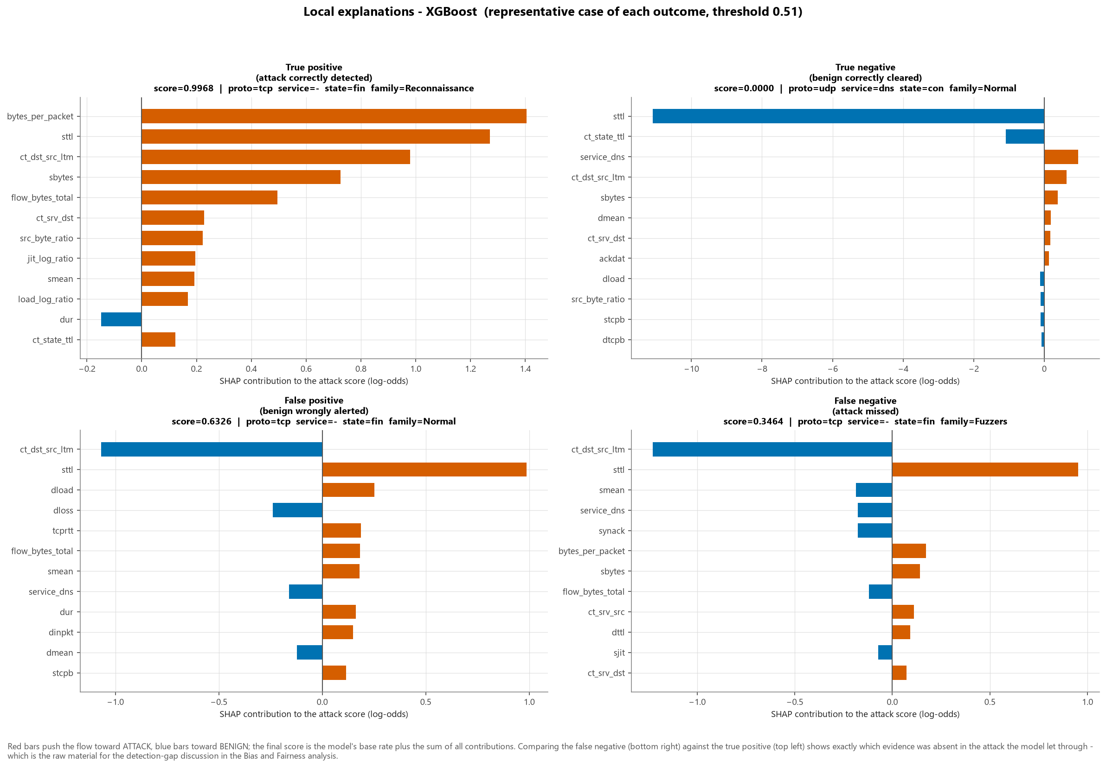
Figure — fig23 shap local cases

15. Error Analysis

Recall by attack family
Family | Attack flows (test) | Recall | FNR
Analysis | 167 | 0.5928 | 0.4072
Fuzzers | 3,845 | 0.7376 | 0.2624
Shellcode | 291 | 0.9622 | 0.0378
Exploits | 5,161 | 0.9802 | 0.0198
DoS | 838 | 0.9881 | 0.0119
Reconnaissance | 1,729 | 0.9960 | 0.0040
Generic | 1,461 | 0.9966 | 0.0034
Backdoor | 117 | 1.0000 | 0.0000
Worms | 33 | 1.0000 | 0.0000

The missed attacks are near-misses, not confident errors. Their median score is 0.3463 against a decision threshold of 0.51 - a gap of only 0.159 - and just 1.6% of them score below 0.10. Operationally that is the better of the two possible failure modes: it means the threshold is the dominant lever, that lowering it would recover a substantial share of these attacks (at a cost the Phase 10 sweep quantifies exactly), and that a 'review the borderline alerts' workflow would genuinely catch them rather than looking past them.
The false alerts behave the same way: median score 0.6326, with only 8.4% above 0.90. Both error types concentrate near the decision boundary, which is exactly the regime in which the choice of operating threshold - rather than the choice of model - determines what a SOC experiences.

16. Bias and Fairness Audit
Full analysis: reports/Bias_Fairness_Analysis.md.
UNSW-NB15 contains no demographic attributes and no human subjects. No demographic fairness claim is made, because the data to support one does not exist. What is performed is an operational performance audit across attack family, service, protocol and connection state.
Findings: recall varies substantially by family; false alerts concentrate in specific services; representation bias means precision will not transfer to a production base rate; the 2015 vintage means temporal bias that cannot be measured here because timestamps were removed.

17. Ethical AI Considerations
Consideration | Position
Privacy | Synthetic testbed traffic, no human subjects; IPs, ports and timestamps absent from the inputs.
Transparency | Every alert carries a SHAP explanation; the deployment manifest records what was selected, on what, and when.
Accountability | Human-in-the-loop by design; no autonomous blocking recommended.
Dual use | The SHAP analysis that makes the model auditable also tells an attacker which features to manipulate. Stated explicitly rather than ignored.
Automation bias | Analysts over-trust confident scores. Mitigated by showing the explanation, not just the number, and by surfacing the model's known weak families.
Proportionality | Uneven per-service false-positive rates mean uneven scrutiny of the humans behind those services - a real fairness concern at deployment even though the dataset has no protected attributes.
Honest reporting | Artefacts and limitations are quantified and published rather than omitted.

18. Limitations
- Synthetic 2015 data. Conclusions concern method, not current threat coverage.
- TTL capture artefact. Quantified with SHAP and the no_ttl ablation.
- Inverted class balance. Precision measured here is optimistic for deployment.
- No temporal data. Drift cannot be measured, only reasoned about.
- No IPs or ports. No entity-level analysis, no grouped splitting by host.
- Uneven per-family recall. Stealthy families are systematically weaker.
- Adversarial adaptation untested. Flow statistics are manipulable by design.
- Binary scope. Multiclass family classification is supported by the data but out of scope.
- Single dataset. No cross-dataset validation (e.g. against CIC-IDS2017), so external validity is unverified.
- Irreducible label noise. 414 contradictory feature vectors bound achievable accuracy.

19. Deployment Considerations
Recommended architecture. Flow collector → feature extraction → this model → risk-banded triage queue → analyst → response. The model ranks; humans decide.
Before any production use:
Requirement | Why
Recalibrate thresholds on target-network traffic | The 44% base rate here is not the deployment base rate
Per-service thresholds | A uniform threshold spends the alert budget unevenly
Drift monitoring on input distributions and alert rate | Traffic is non-stationary
Scheduled retraining with analyst feedback as labels | The only source of in-domain labelled data
Shadow-mode evaluation before enforcement | Measure real-world FPR before anyone acts on an alert
Adversarial testing against SHAP-identified features | The opponent adapts
Defence in depth | One layer among signatures, EDR, authentication and anomaly detection

Measured capacity. 195,353 flows/second on a single commodity CPU, which is adequate for a mid-sized enterprise link without specialised hardware.

20. Recommendations
- Deploy XGBoost as a triage-ranking layer, not an autonomous control.
- Operate at threshold 0.51, or at the FPR-constrained point if the SOC is already at queue capacity.
- Re-derive the threshold on target-network data before go-live.
- Instrument per-service false-positive rates from day one.
- Capture analyst dispositions as labels and retrain on a fixed schedule.
- Treat the TTL-family dependence as a known risk and re-validate on real traffic, where TTL will not behave as it does here.
- Extend telemetry beyond flow statistics to address the stealthy families that flow-level features structurally cannot separate.

21. Conclusion
A gradient-boosted flow classifier achieves strong aggregate detection on UNSW-NB15 and meets the pre-registered targets. The more valuable contribution is the qualification: by deduplicating before splitting, quantifying the TTL artefact with SHAP and an explicit ablation, and disaggregating performance by attack family and service, this project distinguishes what the model has learned about attacks from what it has learned about this dataset.
That distinction is the difference between a number and a finding. A capstone reporting only its headline F1 would have produced the former.

22. References
Axelsson, S. (2000). The base-rate fallacy and the difficulty of intrusion detection. ACM Transactions on Information and System Security, 3(3), 186-205.
Breiman, L. (2001). Random Forests. Machine Learning, 45(1), 5-32.
Chen, T. and Guestrin, C. (2016). XGBoost: A Scalable Tree Boosting System. Proceedings of the 22nd ACM SIGKDD, 785-794.
Chawla, N. V., Bowyer, K. W., Hall, L. O. and Kegelmeyer, W. P. (2002). SMOTE: Synthetic Minority Over-sampling Technique. Journal of Artificial Intelligence Research, 16, 321-357.
Ke, G. et al. (2017). LightGBM: A Highly Efficient Gradient Boosting Decision Tree. Advances in Neural Information Processing Systems, 30.
Liu, F. T., Ting, K. M. and Zhou, Z.-H. (2008). Isolation Forest. Eighth IEEE International Conference on Data Mining, 413-422.
Lundberg, S. M. and Lee, S.-I. (2017). A Unified Approach to Interpreting Model Predictions. Advances in Neural Information Processing Systems, 30.
Lundberg, S. M. et al. (2020). From local explanations to global understanding with explainable AI for trees. Nature Machine Intelligence, 2(1), 56-67.
Moustafa, N. and Slay, J. (2015). UNSW-NB15: a comprehensive data set for network intrusion detection systems. MilCIS 2015, IEEE.
Moustafa, N. and Slay, J. (2016). The evaluation of Network Anomaly Detection Systems: Statistical analysis of the UNSW-NB15 data set and the comparison with the KDD99 data set. Information Security Journal: A Global Perspective, 25(1-3), 18-31.
Pedregosa, F. et al. (2011). Scikit-learn: Machine Learning in Python. Journal of Machine Learning Research, 12, 2825-2830.
Saito, T. and Rehmsmeier, M. (2015). The Precision-Recall Plot Is More Informative than the ROC Plot When Evaluating Binary Classifiers on Imbalanced Datasets. PLoS ONE, 10(3), e0118432.
Sommer, R. and Paxson, V. (2010). Outside the Closed World: On Using Machine Learning for Network Intrusion Detection. IEEE Symposium on Security and Privacy, 305-316.

Part VII — Generative AI Usage Disclosure
Last updated 2026-09-16.
This project was developed with assistance from a generative-AI coding assistant (Anthropic Claude, used through an agentic coding interface). This document records what that assistance covered, what it did not, and what was verified by execution — so a reader can calibrate their trust in the artefact appropriately.

1. Where generative AI was used
Area | Nature of assistance
Project scaffolding | Directory structure, requirements.txt, environment.yml, .gitignore, LICENSE.
Code generation | First drafts of src/ modules, the Streamlit application and the pytest suite.
Code refactoring | Extracting shared logic into src/ so notebooks, tests and the app exercise one implementation; consolidating configuration into src/config.py.
Documentation drafting | Structure and prose of the reports, README and presentation content.
Visualisation | Matplotlib figure construction, layout, colour-blind-safe palette selection, caption drafting.
Debugging | Diagnosing a liblinear solver stall caused by near-separable data; correcting an IsolationForest call to predict_proba, which that estimator does not expose.
Domain framing | Drafting the cybersecurity rationale for engineered features and the operational interpretation of metrics.

2. What was NOT generated
No result, metric, figure, statistic or citation in this repository was produced by a language model.
Artefact | How it was actually produced
Every metric in every report | Computed by executed code; written to reports/metrics/; interpolated into the Markdown by src/report.py
Every figure in figures/ | Rendered by matplotlib from real data in src/eda.py, src/evaluate.py, src/explain.py
Every SHAP value | Computed by the shap library against the fitted model
Dataset statistics | Computed from the files in data/raw/, whose SHA-256 checksums are recorded
Model hyper-parameters | Found by RandomizedSearchCV over real cross-validation
Citations | Real, verifiable publications

The reports are generated from the metrics files, not written alongside them. That is a structural guarantee, not a promise: src/report.py interpolates values read from disk, so a number cannot appear in a report unless the pipeline computed it. Where an artefact is missing, the report says so explicitly rather than filling the gap.

3. Verification performed
Check | Outcome
All code executed end to end | Yes — the committed results are the output of actual runs
Dataset integrity independently verified | Row counts, column count, target encoding, label/attack_cat consistency, SHA-256
Leakage controls verified by test | tests/test_preprocessing.py asserts no leakage column survives, no feature correlates >0.999 with the target, and no feature vector spans train and test
Numerical safety verified by test | tests/test_features.py asserts finiteness on hand-built degenerate flows
Inference path verified by test | tests/test_prediction.py asserts batch/single agreement, determinism, and that the model beats the majority baseline on held-out data
Model selection logic reviewed | Confirmed to use validation PR-AUC, not test data
Test-split isolation reviewed | Confirmed the test split is opened once, after model and threshold are frozen
Solver choice validated by benchmark | Four solver/penalty combinations timed and scored before committing to lbfgs/L2

4. Human responsibility
The following required human judgement and remain the author's responsibility:
- Choosing to deduplicate before splitting, and accepting the resulting change in class balance, rather than reporting the inflated conventional numbers.
- Identifying the TTL artefact as a threat to validity and designing the ablation to quantify it, rather than accepting a high F1 at face value.
- Selecting PR-AUC over accuracy as the model-selection criterion.
- Refusing to make demographic fairness claims the dataset cannot support, and reframing the audit as operational.
- Recommending human-in-the-loop triage rather than autonomous blocking, on the basis of the measured weaknesses.
- Interpreting what the results mean for a SOC — which the metrics alone do not say.

5. Honest statement of limitations
AI assistance accelerated implementation and drafting. It did not, and cannot, validate:
- whether UNSW-NB15 is an appropriate proxy for the target network;
- whether the engineered features are meaningful to a practising security analyst;
- whether the operating threshold suits a particular SOC's alert capacity;
- whether the deployment recommendation is appropriate for a given organisation's risk posture.
Those judgements require human domain expertise and, before any operational use, review by a qualified security practitioner.

6. Reproducibility
Every result can be regenerated independently of any AI tool:
pip install -r requirements.txt
python -m src.data_loader
python -m src.pipeline --all
pytest -q

Part VIII — Rubric Audit
Generated by python -m src.report on 2026-09-16. Each row names the repository evidence that satisfies the criterion.
Selected model: XGBoost — F1 0.9109, ROC-AUC 0.9824, PR-AUC 0.9791, recall 0.9112, FPR 7.142%, FNR 8.884%
Criterion | Max Points | Evidence | File / Section | Status
Problem Understanding & Framing | 10 | Security problem and data-science objective defined; task type identified as binary classification; seven pre-registered measurable success criteria (T1-T7) plus seven methodological criteria (M1-M7); business/security risks, cost asymmetry, concept drift and adversarial adaptation analysed; explicit lifecycle mapping table | reports/problem_statement.md §1-§9 | Complete
Data Collection & Understanding | 10 | High-quality public dataset (UNSW-NB15) with full citation and DOI; programmatic acquisition with independent integrity verification (row counts, schema, target encoding, SHA-256); complete summary of rows, columns, types, target, missingness, duplicates and class distribution; 61-entry data dictionary covering published and engineered features; four data-quality defects documented | reports/dataset_documentation.md, reports/data_dictionary.csv, src/data_loader.py, notebooks/01_problem_data_understanding.ipynb | Complete
Data Preprocessing, EDA & Feature Engineering | 10 | Missing values and duplicates analysed and handled (dedup before split); outliers analysed and deliberately retained with justification; 24 figures with written interpretations; categorical encoding with infrequent-category pooling; log1p + standard scaling; class imbalance analysed in production context; 15 engineered security features, each documented; feature importance via univariate ranking and SHAP; target leakage prevented at a single enforcement point; every decision justified in a table | reports/EDA_Feature_Engineering_Report.md, src/eda.py, src/features.py, src/preprocessing.py, notebooks/02, notebooks/03, figures/fig01-fig13 | Complete
Model Implementation & Comparison | 20 | Five models: Logistic Regression, Random Forest, XGBoost (all required), plus LightGBM and Isolation Forest (optional); RandomizedSearchCV with 5-fold stratified CV; nine required metrics plus MCC, balanced accuracy and Brier score; confusion matrices, ROC and PR curves, comparison charts; training and inference time recorded; model selected on PR-AUC, explicitly not accuracy, with reasoning; random_state=42 throughout; 6 ablation experiments isolating duplication, TTL artefact, engineered features, SMOTE and the published split | reports/Model_Evaluation_Report.md, src/train.py, src/evaluate.py, reports/metrics/*.csv, notebooks/04, notebooks/05, figures/fig14-fig19 | Complete
Critical Thinking, Ethical AI & Bias Auditing | 20 | SHAP global importance, beeswarm, dependence and four local explanations (TP/TN/FP/FN); artefact diagnostic quantifying reliance on the TTL family; limitations enumerated with mitigations; leakage, imbalance, overfitting and concept drift each addressed with evidence; systematic error analysis by family, service, protocol and state; operational subgroup audit with explicit statement that no demographic fairness claim is possible and why; deployment-time fairness risks identified separately; mitigation table split into implemented vs required-before-deployment | reports/Bias_Fairness_Analysis.md, src/explain.py, reports/metrics/subgroup_audit_main.csv, notebooks/06, figures/fig20-fig24 | Complete
Final Presentation & Communication | 10 | Technical deck (12 slides) and executive deck (10 slides), each slide with title, content, recommended visual and speaker notes; executive deck free of equations and code | presentations/technical_presentation_content.md, presentations/executive_presentation_content.md | Complete
GitHub Profile & Upload | 15 | Professional README with all 15 required sections and a Mermaid architecture diagram; requirements.txt, environment.yml, .gitignore, MIT LICENSE with third-party data notice; complete directory structure (notebooks/, src/, models/, data/, reports/, figures/, presentations/, app/, tests/); 6 executable notebooks; importable src package; pytest suite | README.md, repository root | Complete
Bonus / Creativity | 5 | Streamlit application with single-flow scoring, batch upload, live threshold control and per-alert SHAP explanation; Mermaid architecture diagram; 24 publication-quality colour-blind-safe figures; risk-banded output with recommended actions; documented Generative AI usage; 6-condition ablation study; unsupervised Isolation Forest comparison; cost-sensitive threshold analysis with sensitivity table | app/streamlit_app.py, reports/Generative_AI_Usage.md, figures/, reports/Model_Evaluation_Report.md §8, §11 | Complete
TOTAL | 100

Evidence inventory
Reports (8): Bias_Fairness_Analysis.md, EDA_Feature_Engineering_Report.md, Final_Project_Report.md, Generative_AI_Usage.md, Model_Evaluation_Report.md, Rubric_Audit.md, dataset_documentation.md, problem_statement.md
Notebooks (6): 01_problem_data_understanding.ipynb, 02_eda.ipynb, 03_preprocessing_feature_engineering.ipynb, 04_model_training.ipynb, 05_model_evaluation.ipynb, 06_explainability_bias_audit.ipynb
Figures (24): fig01_class_distribution.png, fig02_attack_category_distribution.png, fig03_duplication_by_attack_category.png, fig04_categorical_attack_rates.png, fig05_ttl_artifact.png, fig06_numeric_distributions_by_class.png, fig07_outlier_boxplots.png, fig08_correlation_heatmap.png, fig09_univariate_feature_ranking.png, fig10_engineered_feature_separation.png, fig11_volume_scatter.png, fig12_attack_family_profile.png, fig13_class_imbalance_context.png, fig14_confusion_matrices.png, fig15_roc_pr_curves.png, fig16_model_comparison.png, fig17_threshold_analysis.png, fig18_subgroup_audit.png, fig19_ablation_comparison.png, fig20_shap_global_importance.png, fig21_shap_beeswarm.png, fig22_shap_dependence.png, fig23_shap_local_cases.png, fig24_shap_artifact_check.png
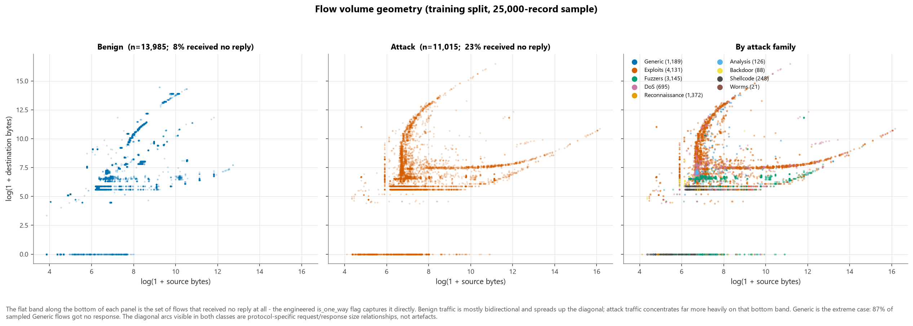
Figure — fig11 volume scatter
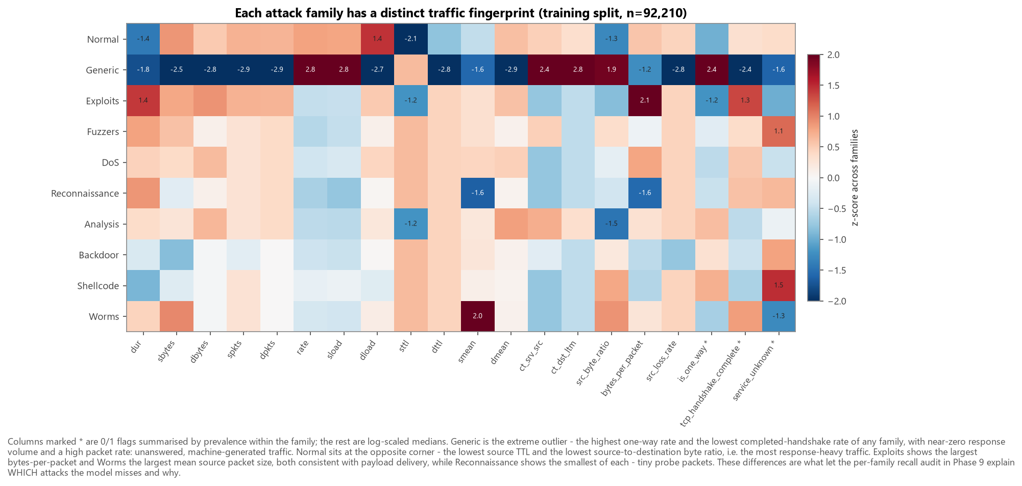
Figure — fig12 attack family profile
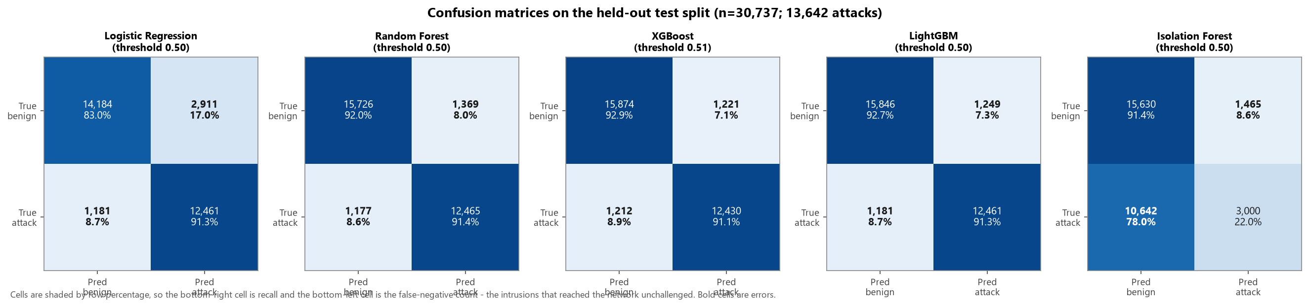
Figure — fig14 confusion matrices
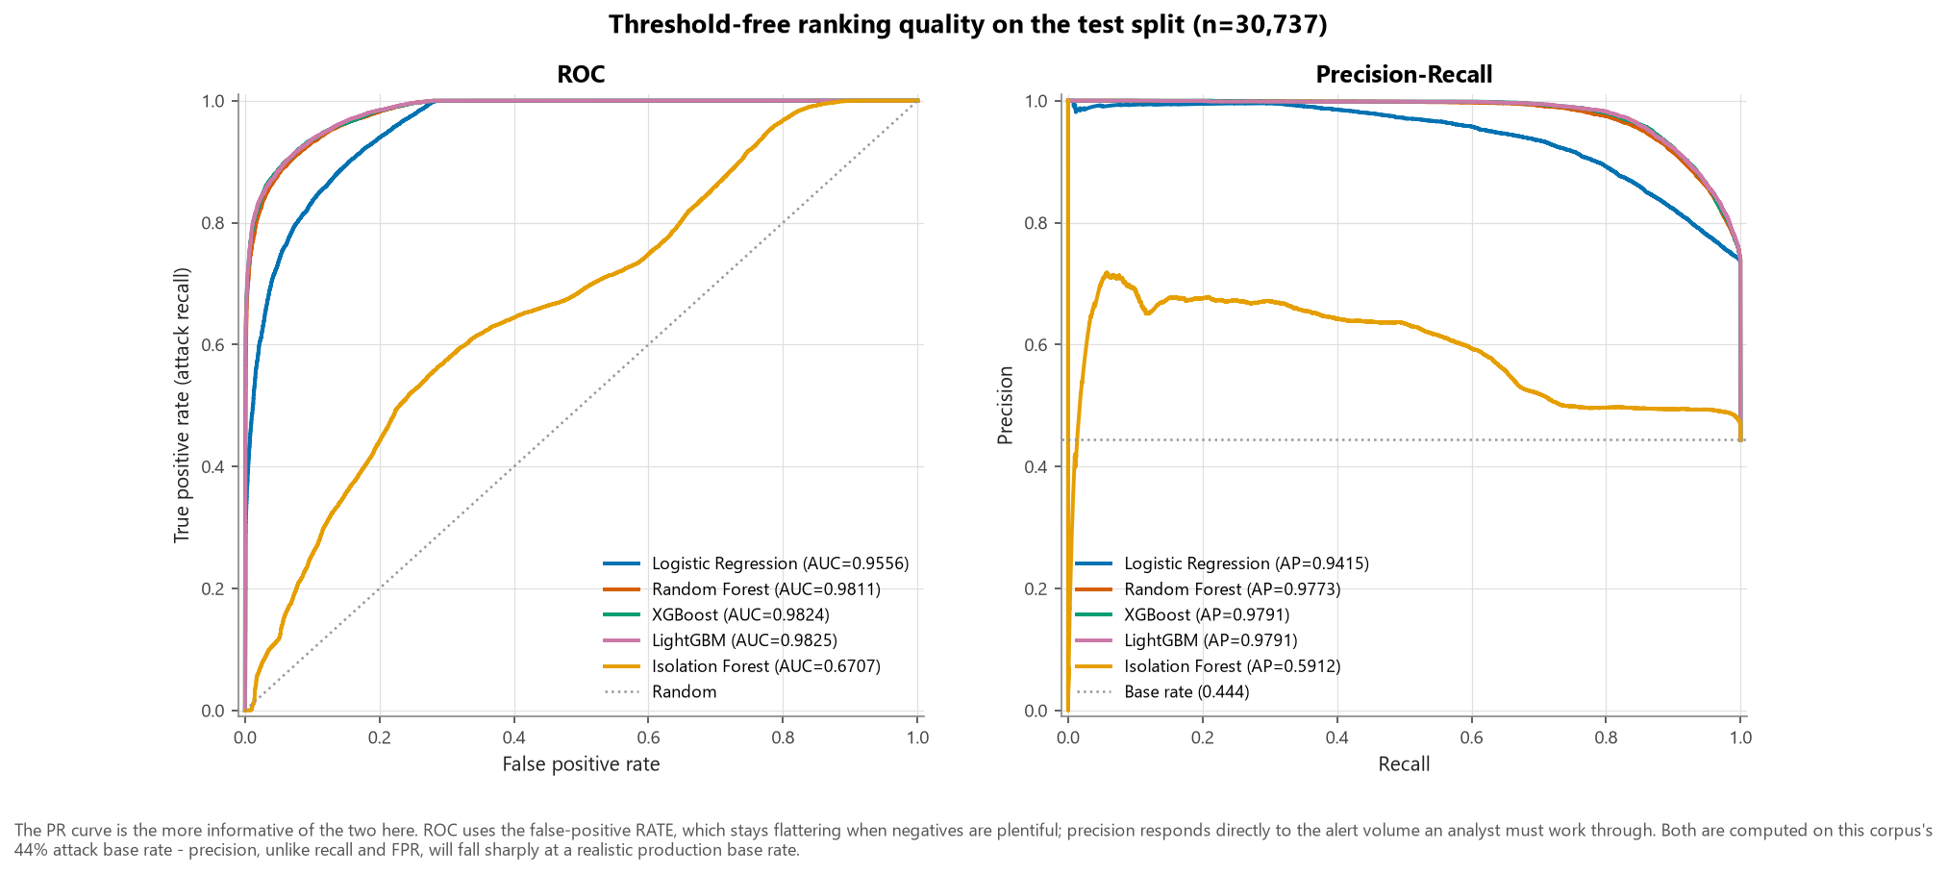
Figure — fig15 roc pr curves
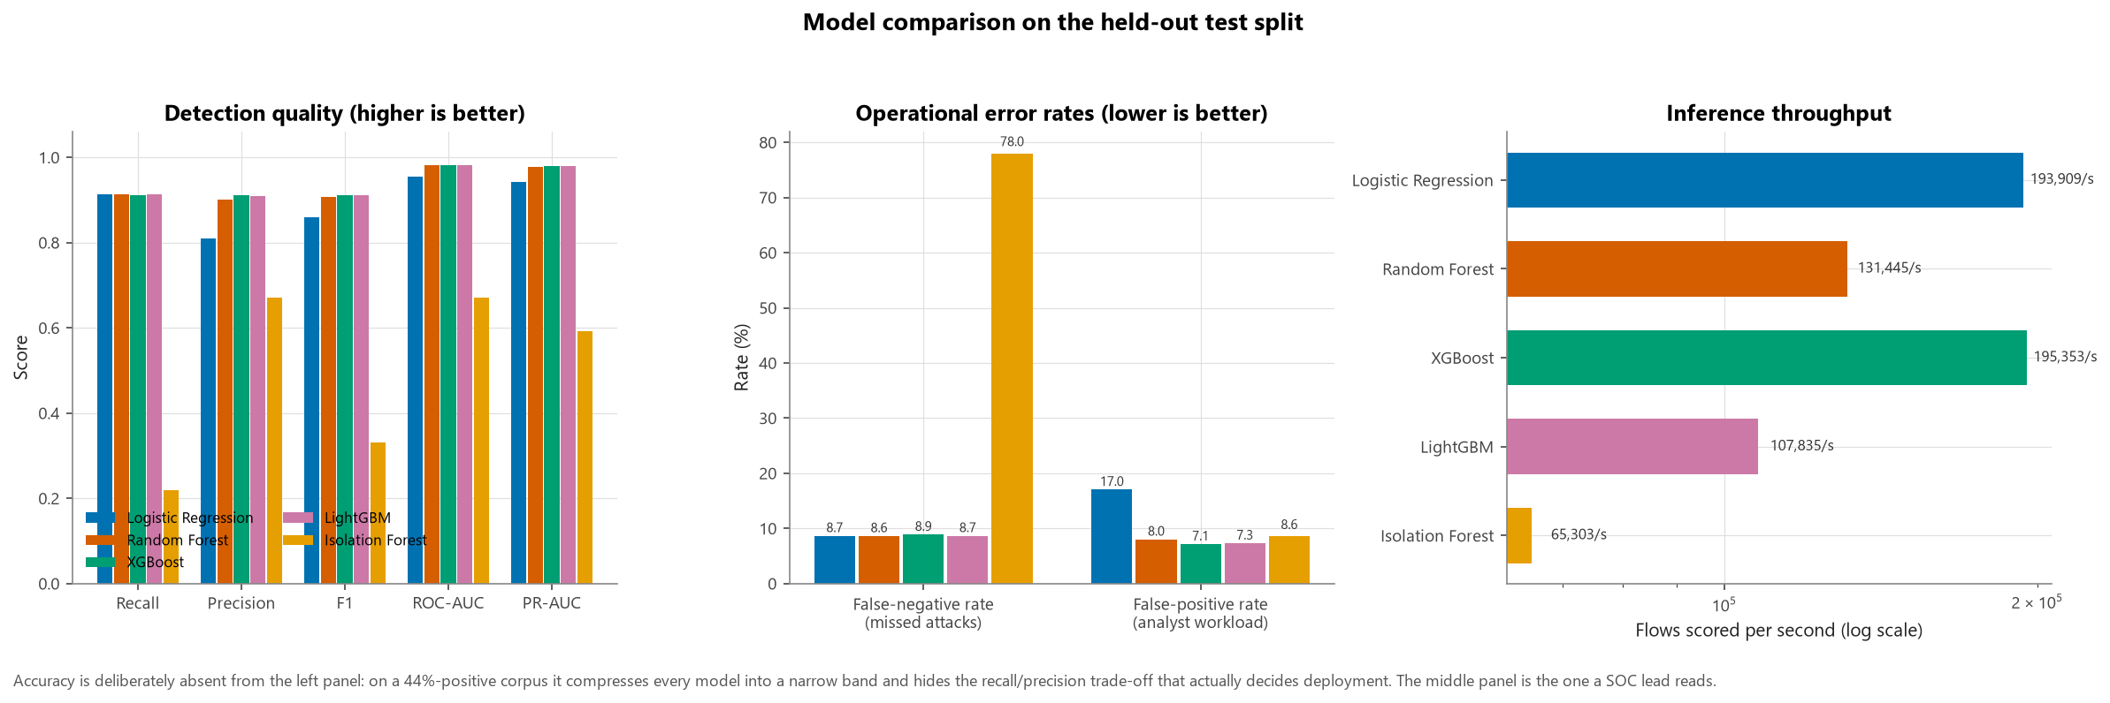
Figure — fig16 model comparison
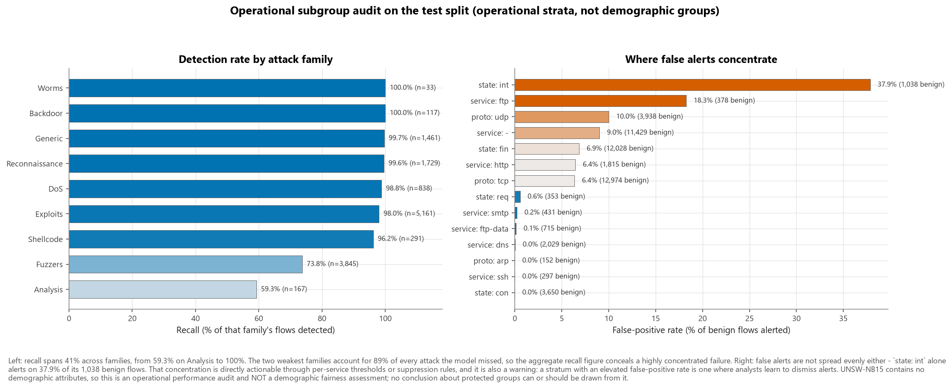
Figure — fig18 subgroup audit
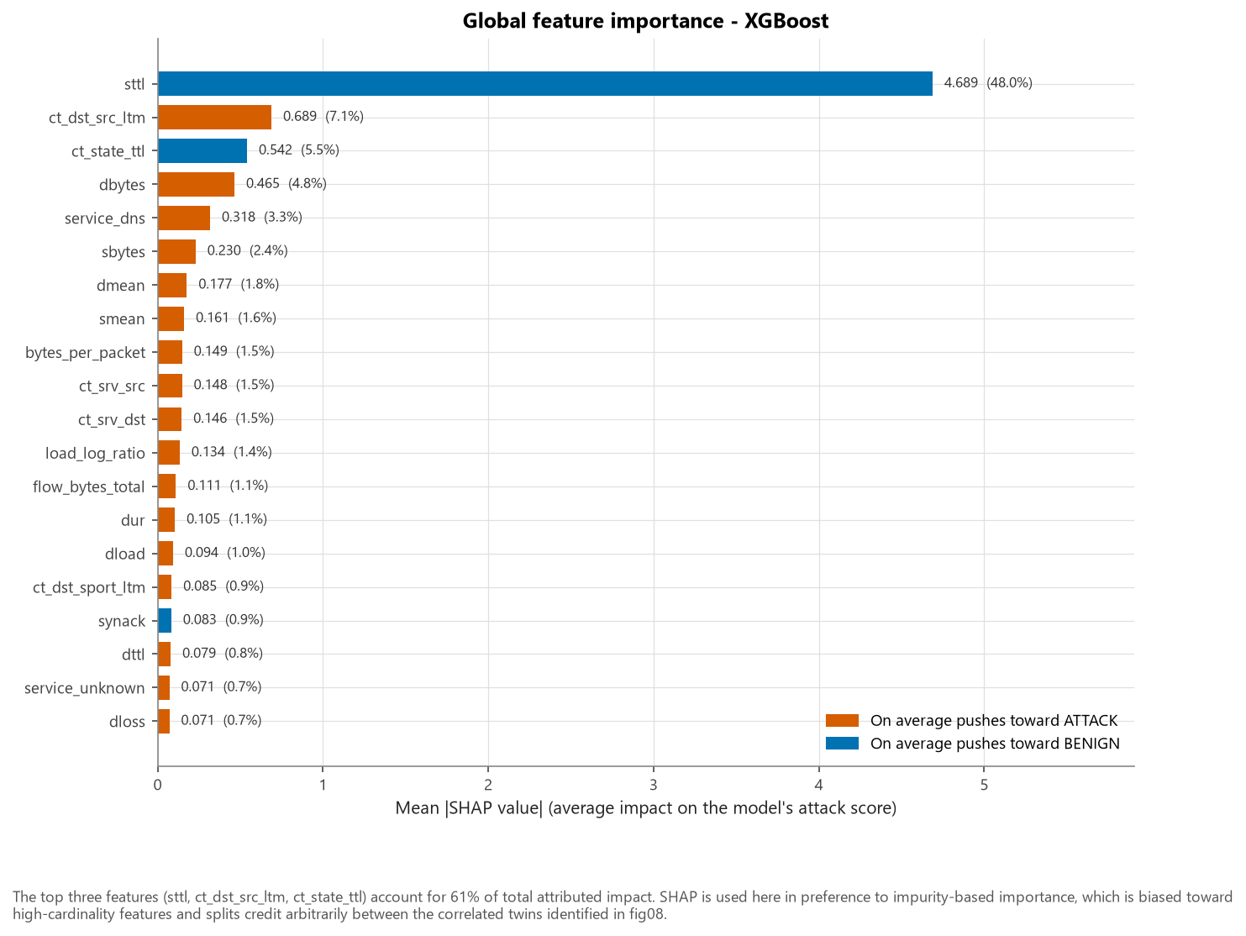
Figure — fig20 shap global importance
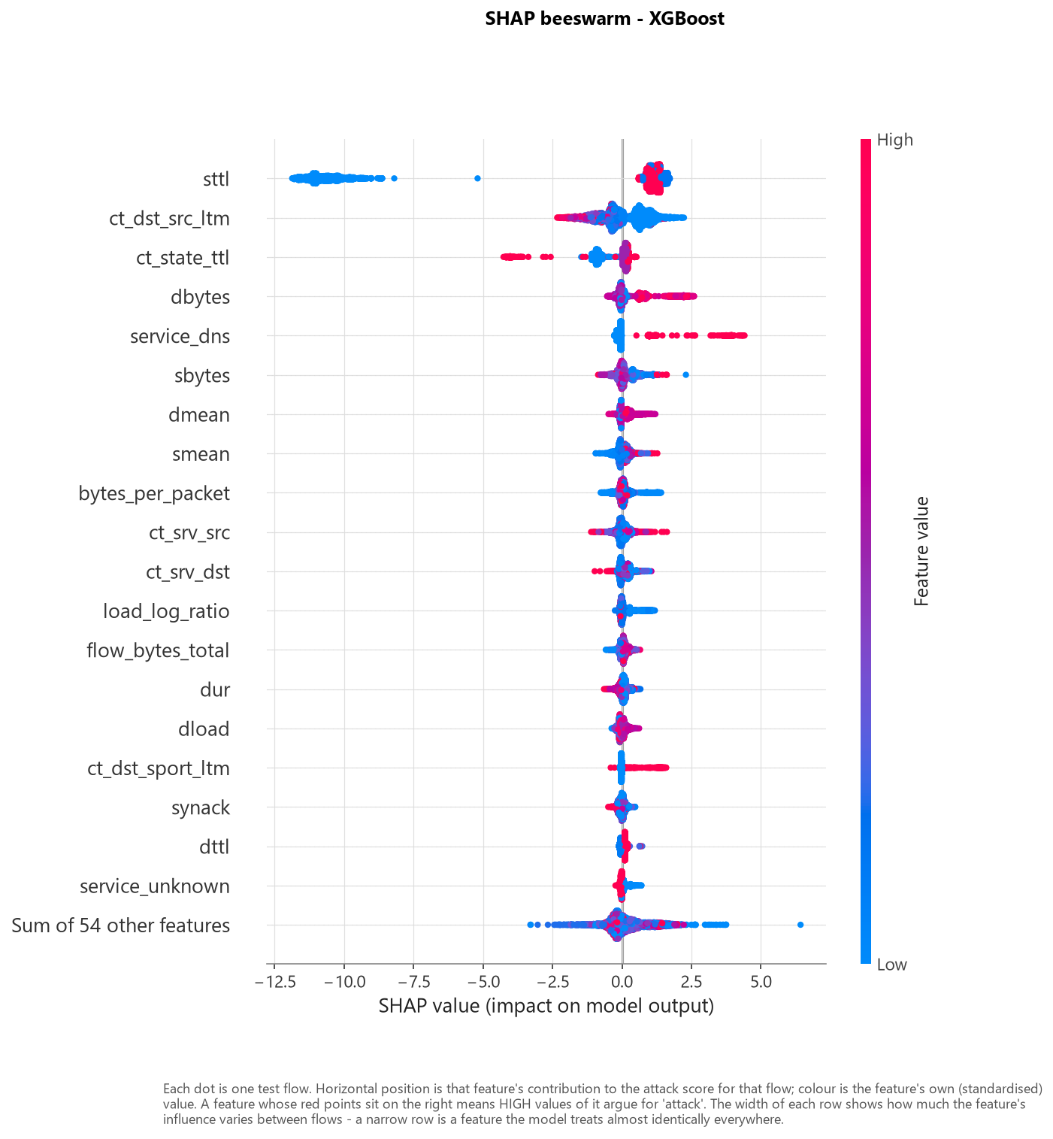
Figure — fig21 shap beeswarm
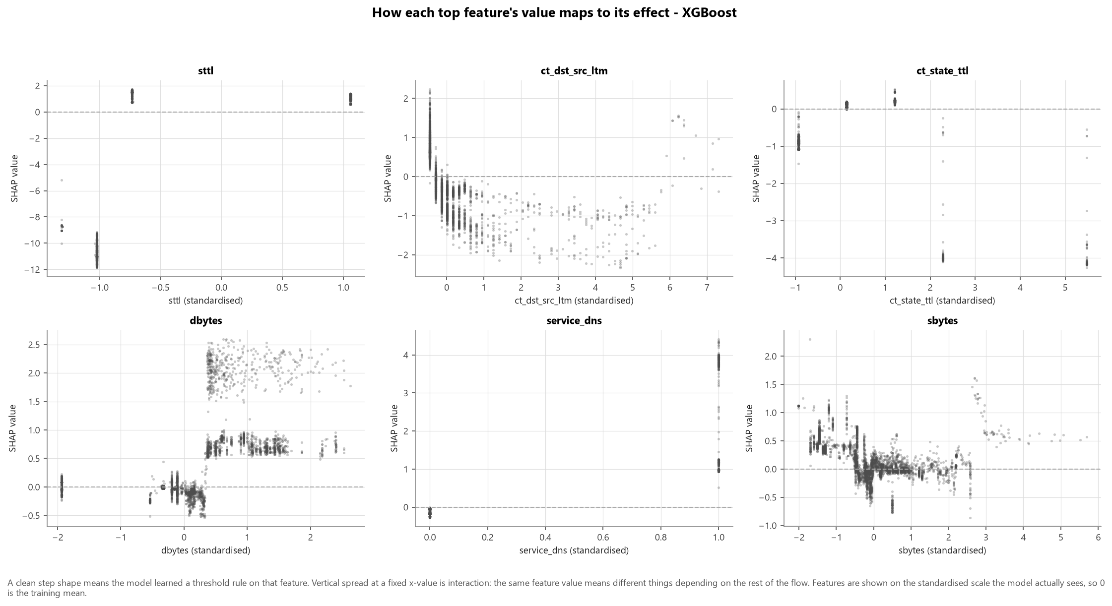
Figure — fig22 shap dependence
Machine-readable metrics (35): ablation_summary.csv, eda_statistics.json, error_analysis_main.json, operating_points_keep_duplicates.json, operating_points_main.json, operating_points_no_engineered.json, operating_points_no_ttl.json, operating_points_official_split.json, operating_points_smote.json, shap_analysis.json, subgroup_audit_main.csv, test_metrics_keep_duplicates.csv, test_metrics_main.csv, test_metrics_no_engineered.csv, test_metrics_no_ttl.csv, test_metrics_official_split.csv, test_metrics_smote.csv, threshold_recommendation_keep_duplicates.json, threshold_recommendation_main.json, threshold_recommendation_no_engineered.json, threshold_recommendation_no_ttl.json, threshold_recommendation_official_split.json, threshold_recommendation_smote.json, threshold_sweep_keep_duplicates.csv, threshold_sweep_main.csv, threshold_sweep_no_engineered.csv, threshold_sweep_no_ttl.csv, threshold_sweep_official_split.csv, threshold_sweep_smote.csv, validation_metrics_keep_duplicates.csv, validation_metrics_main.csv, validation_metrics_no_engineered.csv, validation_metrics_no_ttl.csv, validation_metrics_official_split.csv, validation_metrics_smote.csv
Submission bundle (5): Arne_Ramos_AI_Capstone_Executive_Presentation.pptx, Arne_Ramos_AI_Capstone_Network_Intrusion_Detection_Report.docx, Arne_Ramos_AI_Capstone_Technical_Presentation.pptx, DEMO_VIDEO_SCRIPT.md, README.md — built by python -m src.deliverables --author "..." from the same reports, in the approved .docx / .pptx formats and named Arne_Ramos_<deliverable>. DEMO_VIDEO_SCRIPT.md carries the shot-by-shot recording script.

Verification
Every number in every report is read from reports/metrics/, which is written by executed code. To verify from a clean checkout:
pip install -r requirements.txt
python -m src.data_loader # download + integrity-check the dataset
python -m src.pipeline --all # EDA, training, evaluation, ablations, reports
pytest -q # test suite
Deleting reports/*.md and re-running python -m src.report reproduces the written reports from the same measurements.

Appendix A — Complete Figure Index
Every figure generated by the pipeline, in order. Figures already embedded in the body above are listed here for reference and are not repeated.

fig01 class distribution
Embedded in the body above.

fig02 attack category distribution
Embedded in the body above.

fig03 duplication by attack category
Embedded in the body above.

fig04 categorical attack rates
Embedded in the body above.

fig05 ttl artifact
Embedded in the body above.

fig06 numeric distributions by class
Embedded in the body above.

fig07 outlier boxplots
Embedded in the body above.

fig08 correlation heatmap
Embedded in the body above.

fig09 univariate feature ranking
Embedded in the body above.

fig10 engineered feature separation
Embedded in the body above.

fig11 volume scatter
Embedded in the body above.

fig12 attack family profile
Embedded in the body above.

fig13 class imbalance context
Embedded in the body above.

fig14 confusion matrices
Embedded in the body above.

fig15 roc pr curves
Embedded in the body above.

fig16 model comparison
Embedded in the body above.

fig17 threshold analysis
Embedded in the body above.

fig18 subgroup audit
Embedded in the body above.

fig19 ablation comparison
Embedded in the body above.

fig20 shap global importance
Embedded in the body above.

fig21 shap beeswarm
Embedded in the body above.

fig22 shap dependence
Embedded in the body above.

fig23 shap local cases
Embedded in the body above.

fig24 shap artifact check
Embedded in the body above.

