BENCH-BENCH
Final results and development retrospective
A 52-week benchmark of long-horizon coaching under time, money, recovery, and household scarcity
Run: Public seeds 100–109 · five models · 50 completed episodes
Protocol: Three standardized tests at weeks 44, 48, and 52 after a fixed three-day taper
Engine/config: sha256:fdbd829339622163df8a27d64fe6467e353c1b2bd8ff289b25e36783e8d2e9a1
Prepared: 12 August 2026
Bottom line
Claude Opus 5 led the live models at 100.06 kg, followed closely by Grok 4.5 at 99.19 kg and Muse Spark 1.2 at 98.62 kg. The scripted-expert reference remained higher at 102.89 kg. Every live episode stayed within the pain constraint and completed without structural invalidation; Kimi K3 is the important operational exception, with 702 transport failures recorded separately from its 5.76% rejected-output repair rate.

1. What the benchmark measures
Bench-bench asks an agent to act as Dave’s coach for one simulated year. Dave is a returning lifter with a full-time job, a full-time working partner, a six-month-old baby at the start, a commercial gym membership, no home equipment, and a constrained discretionary budget. Each week the agent plans training and allocates time and money across meals, childcare, chores, partner coverage, giveback, sleep protection, and purchases. Seeded interruptions then test whether the plan survives contact with ordinary life.
The score is not the noisy weekly 1RM estimate. It is the arithmetic mean of three read-only standardized-test projections at weeks 44, 48, and 52, each after a fixed three-day taper. A score is counted only when pain days are at most 14 and the episode has no structural invalidation. Household strain and sleep debt are reported diagnostics; they are not hidden score penalties.
The live evaluation used temperature 1.0, medium effort wherever exposed, direct provider endpoints, one repair attempt, incremental JSONL transcripts, and resumable execution. Every transcript carries the same engine/config hash; the 50-transcript audit passed.

2. Final leaderboard
The live model leaderboard ranks mean counted score over the ten matched public seeds. Because every live episode had pain days 0 and a null invalid reason, raw and counted scores are identical for all five models.
Rank | Model | Mean kg | SD | Range | Counted | Pain | Repairs | Transport | $ / ep
1 | Claude Opus 5 | 100.06 | 2.25 | 94.88–102.15 | 10/10 | 0 | 130/677 (19.20%) | 0 | $5.9503
2 | Grok 4.5 | 99.19 | 2.09 | 94.91–101.80 | 10/10 | 0 | 57/677 (8.42%) | 0 | $0.9225
3 | Muse Spark 1.2 | 98.62 | 1.33 | 97.34–101.51 | 10/10 | 0 | 30/677 (4.43%) | 0 | $1.0753
4 | GPT-5.6 Sol | 93.86 | 1.23 | 91.80–95.44 | 10/10 | 0 | 15/677 (2.22%) | 0 | $2.8056
5 | Kimi K3 | 90.48 | 6.22 | 84.62–99.79 | 10/10 | 0 | 39/677 (5.76%) | 702 | $2.0095

Interpretation: the top three are close relative to ten-seed uncertainty. Opus exceeds Grok by 0.87 kg on average, but the paired 95% interval is [−1.12, 2.87] kg; that is not a robust separation at this sample size. Muse is clearly above GPT on matched seeds, while GPT versus Kimi is not cleanly separated because Kimi’s seed variance is large.
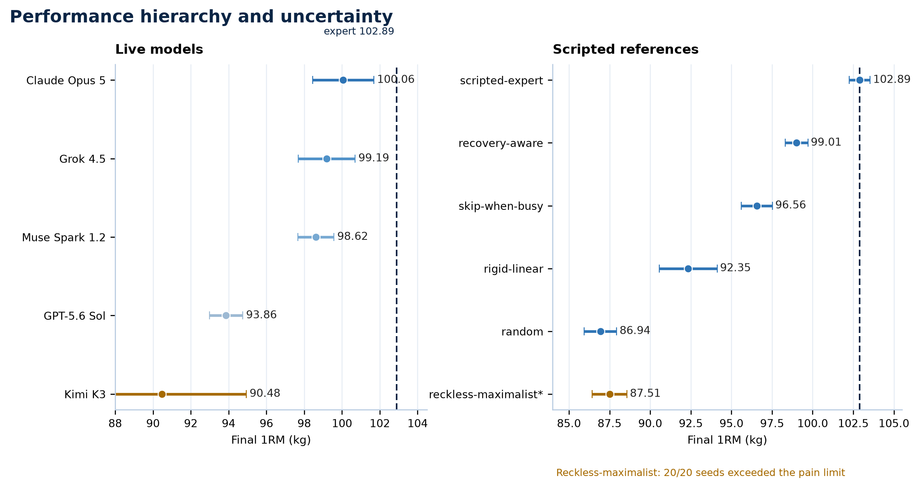
Figure 1. The live-model means cluster below the scripted expert; the reference hierarchy is much wider than the live top-three differences. Live whiskers show 95% intervals for the ten-seed mean; scripted whiskers show seed standard deviation.

3. Scripted reference baselines
The six fixed policies are calibration references, not competing model entries. Their role is to show that the simulator preserves the intended hierarchy and that reckless behavior loses endogenously rather than winning through a lucky final test.
Reference policy | Raw mean kg | Seed SD | Counted mean | Counted | Violations
scripted-expert | 102.89 | 0.65 | 102.89 | 20/20 | 0
recovery-aware | 99.01 | 0.70 | 99.01 | 20/20 | 0
skip-when-busy | 96.56 | 0.96 | 96.56 | 20/20 | 0
rigid-linear | 92.35 | 1.77 | 92.35 | 20/20 | 0
reckless-maximalist | 87.51 | 1.07 | — | 0/20 | 20
random | 86.94 | 1.00 | 86.94 | 20/20 | 0

Final reference ordering: scripted-expert (102.89) > recovery-aware (99.01) > skip-when-busy (96.56) > rigid-linear (92.35) > reckless-maximalist (87.51 raw) > random (86.94). Reckless-maximalist violated pain days on all 20 burned development seeds, so its counted mean is unavailable even though its raw diagnostic mean remains visible. The expert–random gap is 15.95 kg, equal to 18.92 pooled seed standard deviations; the 52-week gate passed, including the 65% adjacent-order criterion and endogenous reckless loss.

4. Statistical comparison of the live models
The table below reports paired differences over the same ten public seeds. A positive value means the model in the first column scored higher. Intervals are two-sided 95% paired t intervals with nine degrees of freedom and no multiplicity correction; they are uncertainty summaries, not claims of a formal multi-comparison hypothesis test.
A | B | Mean A−B kg | 95% paired CI kg
Claude Opus 5 | Grok 4.5 | 0.87 | [-1.12, 2.87]
Claude Opus 5 | Muse Spark 1.2 | 1.45 | [-0.12, 3.01]
Claude Opus 5 | GPT-5.6 Sol | 6.20 | [4.62, 7.78]
Claude Opus 5 | Kimi K3 | 9.58 | [5.05, 14.12]
Grok 4.5 | Muse Spark 1.2 | 0.57 | [-0.99, 2.14]
Grok 4.5 | GPT-5.6 Sol | 5.33 | [3.69, 6.97]
Grok 4.5 | Kimi K3 | 8.71 | [4.71, 12.71]
Muse Spark 1.2 | GPT-5.6 Sol | 4.75 | [3.91, 5.60]
Muse Spark 1.2 | Kimi K3 | 8.13 | [3.56, 12.71]
GPT-5.6 Sol | Kimi K3 | 3.38 | [-0.82, 7.58]

The practical picture is a three-tier top cluster rather than five crisply separated ranks: Opus, Grok, and Muse are within roughly 1.45 kg of each other in mean score, and their adjacent confidence intervals include zero. GPT is about 4.75 kg below Muse with a wholly positive interval. Kimi’s mean is lowest and its spread is much larger than every other model, so a ten-seed average is particularly unstable for that provider.
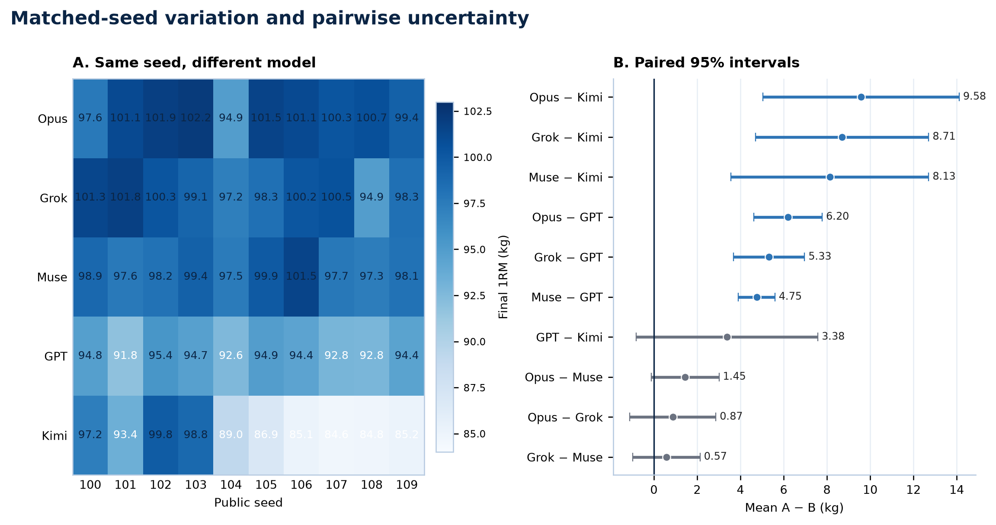
Figure 2. The matched-seed heatmap shows common difficulty variation across models, while the paired intervals show that the Opus–Grok, Opus–Muse, and Grok–Muse gaps are not cleanly separated with ten seeds.

5. Operational behavior and cost
Each model produced 677 decisions: 520 weekly plans plus 157 reactive interrupt decisions. Repairs count rejected model outputs only; transport failures are a separate metric. This distinction mattered in the Kimi run, where provider rate-limit/transport behavior was substantial but should not be mislabeled as model-format failure.
Model | Repairs | Transport | Total cost | $ / ep | Effort | Endpoint
Claude Opus 5 | 130/677 (19.20%) | 0 | $59.50 | $5.9503 | medium | api.anthropic.com/v1/messages
Grok 4.5 | 57/677 (8.42%) | 0 | $9.22 | $0.9225 | medium | api.x.ai/v1/chat/completions
Muse Spark 1.2 | 30/677 (4.43%) | 0 | $10.75 | $1.0753 | medium | api.meta.ai/v1/chat/completions
GPT-5.6 Sol | 15/677 (2.22%) | 0 | $28.06 | $2.8056 | medium | api.openai.com/v1/chat/completions
Kimi K3 | 39/677 (5.76%) | 702 | $20.10 | $2.0095 | not exposed | api.moonshot.ai/v1/chat/completions

Total live spend was $127.63. All provider cost ceilings were respected. Token accounting was recorded as input, visible output, and thinking tokens where available; provider semantics differ, so raw token totals should be used for cost auditing rather than as a direct measure of reasoning quality.
Model | Input M | Visible output M | Thinking M | Total M
Claude Opus 5 | 7.86 | 0.71 | 0.10 | 8.67
Grok 4.5 | 4.12 | 0.00 | 0.85 | 5.34
Muse Spark 1.2 | 3.29 | 0.30 | 1.38 | 4.98
GPT-5.6 Sol | 2.85 | 0.20 | 0.27 | 3.32
Kimi K3 | 2.14 | 0.24 | 0.83 | 3.22

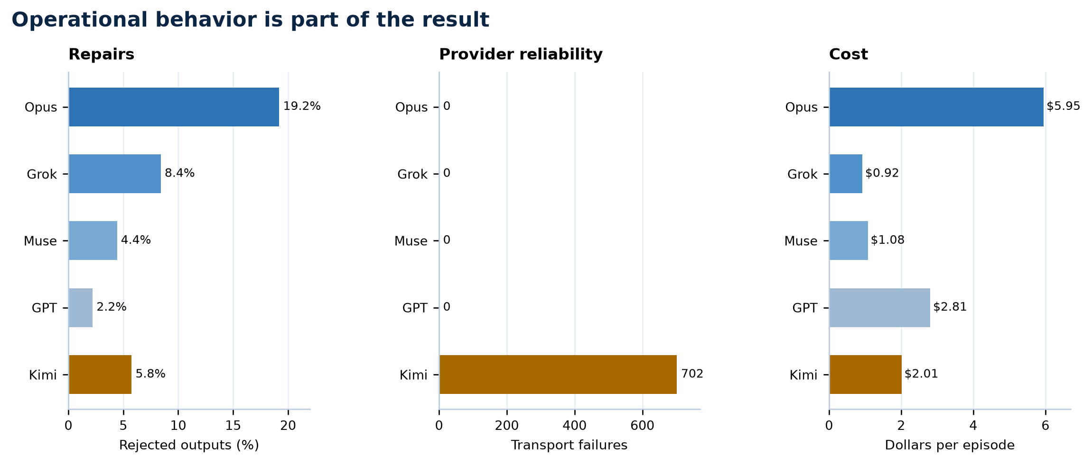
Figure 3. Output discipline, provider transport reliability, and cost are distinct dimensions: Opus required the most repairs, Kimi had the only substantial transport-failure burden, and cost varied by more than sixfold per episode.

6. What the results say

6.1 The benchmark rewards sustained operational judgment
The live ordering is not a simple intelligence ranking detached from the simulator. The task rewards keeping a plan feasible under a 900-minute weekly ledger, protecting recovery without starving training, reacting to shocks, and avoiding the temptation to spend the whole budget on a nominally optimal week. The gap between the scripted expert and the lowest-variance model results is a useful reference point, but the close Opus/Grok/Muse cluster shows that ten seeds are better at identifying broad tiers than precise rank order.

6.2 Kimi’s variance is an operational finding, not just a score
Kimi K3’s 6.22 kg seed SD is roughly three times Grok’s and five times GPT’s. The run also logged 702 transport failures, while the other four models logged none. That co-occurrence is suggestive that provider reliability contributed to the spread, but it is not causal proof: transport failures change the action path through retries and fallbacks, and the benchmark intentionally exposes the full system’s ability to continue. Kimi should therefore be reported with the transport caveat attached, not silently treated as an ordinary low-scoring model.

6.3 Format discipline mattered, especially for Opus and early Grok turns
Opus had the highest rejected-output repair rate at 19.20%, even after the prompt fixes, while GPT was 2.22%, Muse 4.43%, Grok 8.42%, and Kimi 5.76%. The main recurring errors were not physiology failures: they were schema nesting, shared-ledger feasibility, and constraints that had been enforced before being explicitly documented. Grok’s first-week failures flattened the nested life allocation into the weekly action; that finding is logged as a v0.2 prompt-clarity issue. The lesson is methodological: a long-horizon benchmark must make its output contract as explicit as its simulator contract, and must report repairs without confusing them with transport noise.

6.4 Zero pain days means the hard constraint did not fire
All 50 live episodes ended with pain_days=0. In benchmark terms this means no episode accumulated any recorded pain days and therefore none was voided by the pain-days rule. It does not establish that the model is safe for real training, that no soreness or discomfort occurred outside the metric, or that the benchmark validates medical advice. The score remains a simulation result, not a health claim.

7. How the benchmark was built
The development process was deliberately adversarial. Each stage started with a concrete question, was tested with a diagnostic, ablation, adversarial policy, or live run, and ended with a decision that changed either the simulator, the protocol, the runner, or the evidence standard. The sequence below is the process review that led from the initial plan to the frozen public results.
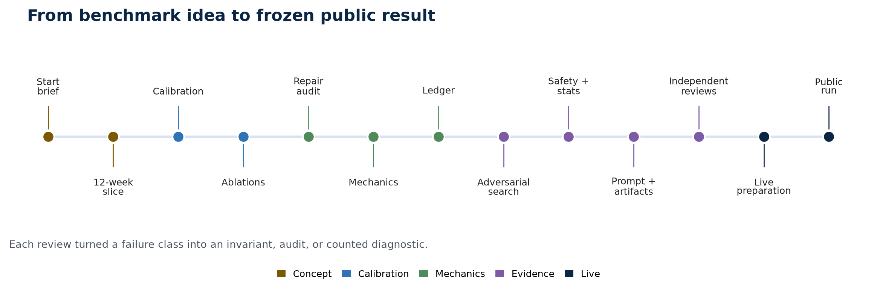
Figure 4. The benchmark moved from concept to calibration, mechanics hardening, evidence review, provider preparation, and finally a frozen public run.
Sequence | Question / test | What we found | Iteration / decision
Start / brief | Can a benchmark test long-horizon coaching rather than isolated workout advice? | A weekly plan has to coordinate training, work, money, sleep, childcare, chores, and a working partner; future interruptions must remain hidden. | Defined Dave, the model-only track, weekly actions plus reactive turns, delayed consequences, and the question: how much can Dave bench without letting the rest of life collapse?
Phase 1 / slice | Can the schemas, runner, replay, repair, and fallback path operate end to end? | The 12-week vertical slice made the mechanics observable, but short-horizon adjacent policies were too close to discriminate reliably. | Kept 12 weeks as development diagnostics and made 52 simulated weeks the release horizon.
Calibration | Does the engine preserve an interpretable baseline hierarchy? | Early calibration exposed questions about expert trajectory, returning-lifter gain, fixed bodyweight, nutrition, hidden tests, and whether the score was noisy or standardized. | Retuned delayed adaptation, repaired unused technique and mass pathways, and defined the final score as tests at weeks 44, 48, and 52 after a fixed taper.
Ablations | Which parts of the world model actually change decisions and scores? | The home rack, gym logistics, events, recovery, technique, adherence, and household reciprocity were not all equally active; home equipment could dominate and seven open days made life too easy. | Moved difficulty into logistics: 900 minutes of conserved weekly time, gym commute cost, realistic open days, reciprocity degradation, and consistency drift of 0.10 kg after a productive streak.
Repair audit | Are model failures telling us about reasoning or about an unclear interface? | The interrupt mechanic was effectively disabled by automatic fallback; weekly and reactive schemas were being conflated, and repairs often lacked the correct schema. | Separated turn-appropriate prompts, supplied the correct repair schema, counted rejected outputs separately from transport failures, and recorded every attempt and fallback.
Mechanics review 1 | Can a legal policy win by stacking volume or declaring compressed fallback work? | 8×4 and related high-volume programs showed that stimulus was too close to linear in sets × reps; zero-load declarations could earn real credit; silent clipping hid infeasible intent. | Added the Brzycki-style load/reps ceiling, rep-rate coupling for every focus, fallback caps, no zero-load stimulus, a diminishing weekly cap, and validation-time rejection instead of silent clipping.
Ledger review | Can the agent create free time or free resources by allocating aggressively? | The 8×4 strategy needed more than a full-time worker and infant household could supply; physiology tuning did not solve the root problem. | Unified training, commute, meals, childcare, chores, partner coverage, and giveback under one finite ledger; delegation and reactive childcare consume cash; expert became ledger-aware.
Adversarial search | Can automated search find a better legal policy, including reviewer-written policies? | The initial exploit scripts were too narrow; hand-written low-intensity/high-volume policies beat the search and showed that beating expert alone is not proof of abuse. | Widened the genome to mixed focus, per-week structure, zero loads, purchase ordering, and reviewer regressions; separated abuse signatures from the +5 kg human-review flag.
Safety + statistics | Can a bad episode or survivor bias produce a wrong leaderboard? | Pain metrics initially did not fire; missing fields could default to zero; survivor means favored policies that failed on hard seeds; invalidation needed to be real and automatic. | Made pain days ≤14 the only behavioral hard constraint, failed closed on missing fields, implemented invalid_reason, excluded invalid episodes, and required 100% counted-seed coverage for aggregates.
Prompt + artifact review | Does the model know the objective, and can the audit see every correction? | The system prompt lacked the objective and later risked leaking strategy; notebooks restated plans; transformations such as clipping, coercion, and reactive collapse were not consistently surfaced. | Rewrote the coach prompt, kept reactive prompting separate, made notebook entries observation-focused, audited the full silent-correction class, embedded hashes, and removed stale claims from the release path.
Independent reviews | What survives outside the author’s assumptions? | Two independent reviews converged on volume stacking, ledger accounting, zero-load credit, private-field auditing, shock reserves, stimulus constants, survivor bias, and search coverage. | Turned each convergence point into an invariant, regression, or explicit reporting rule. Burned seeds 0–19 for calibration and reserved public 100–109 plus private out-of-band seeds.
Live preparation | Can five direct providers run overnight without losing provenance or silently changing the experiment? | Adapters differed on structured output, effort, thinking-token accounting, pricing, rate limits, and endpoint shape; Kimi was slow and transport-sensitive. | Used direct endpoints, per-provider pricing, medium effort where exposed, temperature 1.0, resumable transcripts, retry/backoff, cost ceilings, a 100-decision repair guard, and separate transport metrics.
Public run | What happens when the frozen benchmark meets real model outputs? | All 50 episodes completed. Opus led at 100.06 kg; Grok and Muse formed a close top cluster; Kimi showed high variance and 702 transport failures; no live episode violated pain or structural validity. | Freeze the v0.1 results as a post-run record. Treat the next work as v0.2 prompt/documentation/artifact hygiene, not post hoc simulator retuning.

The most important pattern in the process was that the hard problems were not isolated bugs. They were classes of failure: free stimulus, free time, silent correction, survivor bias, undocumented constraints, and artifacts that could claim PASS without proving the underlying condition. The benchmark became stronger when each class was turned into an explicit invariant, an audit, or a counted diagnostic.

8. Limitations and recommended next step
The public live set has ten seeds per model, which is enough to expose gross ordering and provider failures but not enough to make close model ranks stable. The benchmark also remains a stylized simulator: the physiology is deliberately coarse, household behavior is represented by designed mechanics, and the standardized test is not a clinical or competitive lifting protocol. Provider output and transport semantics differ, especially for thinking tokens and structured output support.
The recommended next step is a narrow v0.2 hygiene pass before making comparative claims: add a complete nested weekly-action example to the prompt, document every enforced output limit (including notebook and fallback ceilings), update the benchmark card and release manifest to point to one post-run authoritative leaderboard, and rerun the artifact/hash/private-seed audits. Keep the current live results as the frozen v0.1 record; do not retune the simulator in response to this leaderboard unless a separately preregistered calibration change is approved.

Appendix A. Per-seed scores
Model | 100 | 101 | 102 | 103 | 104 | 105 | 106 | 107 | 108 | 109
Claude Opus 5 | 97.61 | 101.13 | 101.88 | 102.15 | 94.88 | 101.52 | 101.09 | 100.31 | 100.65 | 99.42
Grok 4.5 | 101.35 | 101.80 | 100.27 | 99.07 | 97.21 | 98.26 | 100.23 | 100.50 | 94.91 | 98.31
Muse Spark 1.2 | 98.90 | 97.63 | 98.17 | 99.40 | 97.45 | 99.92 | 101.51 | 97.70 | 97.34 | 98.14
GPT-5.6 Sol | 94.75 | 91.80 | 95.44 | 94.68 | 92.58 | 94.91 | 94.37 | 92.85 | 92.82 | 94.44
Kimi K3 | 97.25 | 93.36 | 99.79 | 98.78 | 89.05 | 86.88 | 85.14 | 84.62 | 84.79 | 85.17

Appendix B. Endpoint and sampling provenance
Provider track | Exact model string | Adapter | Endpoint | Effort | Temp
Claude Opus 5 | claude-opus-5 | anthropic-messages | api.anthropic.com/v1/messages | medium | 1.0
Grok 4.5 | grok-4.5 | openai-compatible | api.x.ai/v1/chat/completions | medium | 1.0
Muse Spark 1.2 | muse-spark-1.2 | openai-compatible | api.meta.ai/v1/chat/completions | medium | 1.0
GPT-5.6 Sol | gpt-5.6-sol | openai-compatible | api.openai.com/v1/chat/completions | medium | 1.0
Kimi K3 | kimi-k3 | openai-compatible | api.moonshot.ai/v1/chat/completions | not exposed | 1.0

All endpoint identities above are sanitized URL metadata from transcript start records. No API key or credential material is included in the transcripts, reports, or this document.

Appendix C. Reproduction and provenance
The deterministic baseline source is reports/current_baseline_gate.json. The four-model live transcripts are under runs/live-full-20260808/; the Grok transcripts are under runs/live-grok-4.5-full-20260811/. The engine/config hash is sha256:fdbd829339622163df8a27d64fe6467e353c1b2bd8ff289b25e36783e8d2e9a1. A repository test run passed 100% (pytest -q: 79 tests). All 50 live transcript start records matched the same hash.
The leaderboard’s counted-seed rule is intentionally strict: an aggregate is reportable only when every expected seed counts. A pain-violating or structurally invalid episode remains visible with its raw score, but it cannot be averaged into a leaderboard mean. Transport failures are not relabeled as repairs; they are reported as a separate operational metric.

