Final Assessment-Alternative Assessment
Semester | 202520 | Division | CIS
Assessment title in Syllabus | Final_Project_Portfolio | Program | Bachelor of Information Technology/ Bachelor of Information Systems
Course Code | CDS 2413
Course Title | INTRODUCTION TO DATA SCIENCE
Course Instructor |  | CRN
Assessment | Project Deliverable 1 – Data Analysis Report | Submission Date | Week 6
Student Declaration:
Academic Integrity Statement
In accordance with the HCT Academic Integrity Policy
• Students are required to refrain from all forms of academic integrity breaches as defined and explained by HCT.
• A student found guilty of having committed acts of academic integrity breach(es) will be subject to the relevant sanctions as outlined by HCT.
إفادة النزاهة الأكاديمية
وفقًا لسياسة كليات التقنية العليا للنزاهة الأكاديمية
• على الطلبة الإلتزام بلوائح وقواعد النزاهة الأكاديمية، كما هو مبيّن وموضح في السياسات والإجراءات الخاصة بكليات التقنية العليا.
• في حالة ارتكاب الطالب أي شكل من أشكال الإخلال بالنزاهة الأكاديمية، سيتعرض الى العقوبات الموضحة في السياسات ذات الصلة.
This assignment is entirely my/our own work except where I have duly acknowledged other sources in the text and listed those sources at the end of the assignment. I have not previously submitted this work to the HCT, or any other entity. I understand that I may be orally examined on my submission.

Student HCT ID(s): | H00500577 | H00494696
Student Name(s): | Khadija Maktoom | Maryam Ali
Student Signature
Chatbot (e.g. ChatGPT) statement
This submission allows you to use AI generated tools, but the prompt used must be stated and the response must be in red font. Include References to ChatGPT.

Instructions

Remove instructions and hints from the template before submitting the final report to BBLearn.

CLO1: Introduction and Data Wrangling (5 Points)

Purpose of Data Analysis (1 point)
The purpose of this data analysis is to study patient health data to understand diabetes risk.

By analyzing variables such as age, BMI, glucose level, and blood pressure, we can identify patterns and relationships in the dataset.
This analysis is also used to predict the diabetes risk score and classify patients into different risk categories.
This helps us better understand the data and supports better healthcare decisions.

Type of Programming (1 point)
Python programming is used in this project.
Python is chosen because it helps with data analysis, data cleaning, visualization, and machine learning.
Libraries such as Pandas and NumPy make data processing easier and faster.

Type and Purpose of ML algorithm (1 point)

Regression:
Used to predict numerical values.
Example: Predicting the diabetes risk score.
Classification:
Used to predict categories.
Example: Classifying patients into risk categories.
Clustering:
Used to group similar observations.
Example: Grouping patients based on health characteristics.

Identify the Varaibles (1 point)

Dependent Variable:
diabetes_risk_score
This variable is selected because it represents the outcome to be predicted.

Independent Variables:
Variables such as age, BMI, glucose level, and blood pressure.
These variables are chosen because they influence diabetes risk.

These are the features that influence the diabetes risk score, such as:
- BMI – higher BMI is often associated with higher diabetes risk
- Age – older age may increase the risk level
- Glucose level – high glucose is a strong indicator of diabetes
- Blood pressure – abnormal blood pressure may affect risk
- Insulin level – can reflect how the body processes sugar
- Family history (if available) – genetic factors may increase risk
- Lifestyle factors (if available) – such as physical activity or smoking

Sampling (1 point)
Sampling is performed to select a smaller subset of the dataset for analysis.
Sampling helps reduce analysis time and computational effort while maintaining a representative portion of the data.
This project applies:
- Random Sampling
- Systematic Sampling

This allows us to compare different groups.

CLO2: Descriptive, Exploratory and Statistical Analysis (10 Points)

Purpose of Descriptive Analysis (1 point)
Descriptive analysis is used to summarize and understand the dataset.
It helps describe the main characteristics of the data by calculating important values such as the mean, minimum, maximum, and standard deviation.
This step is important because it gives a clear overview of the data before applying machine learning models.

Script for Descriptive Analysis (1 point)
This script calculates descriptive statistics for the dependent variable (diabetes risk score).
It shows mean, standard deviation, min, max, and quartiles.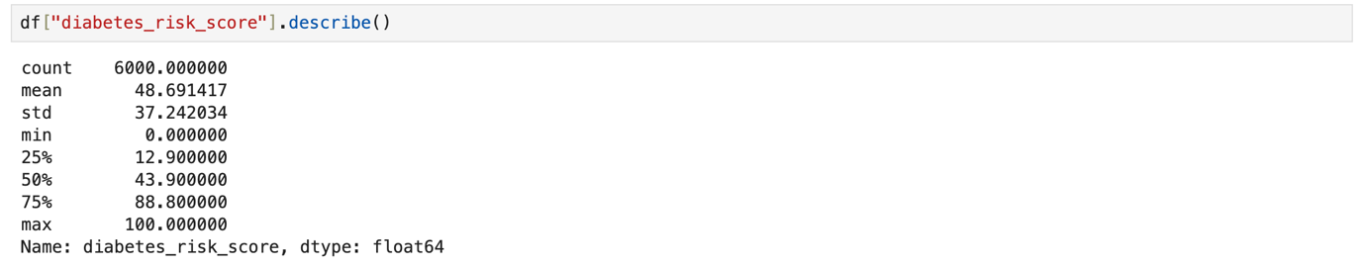
The mean value represents the average diabetes risk score in the dataset.
The standard deviation shows how much the risk scores vary among individuals.
The minimum and maximum values help identify the range of the data.

Random Sampling (1 point)
We selected 150 records so analysis becomes faster but still fair (no bias).
Then we calculated descriptive statistics for the dependent variable from the sample.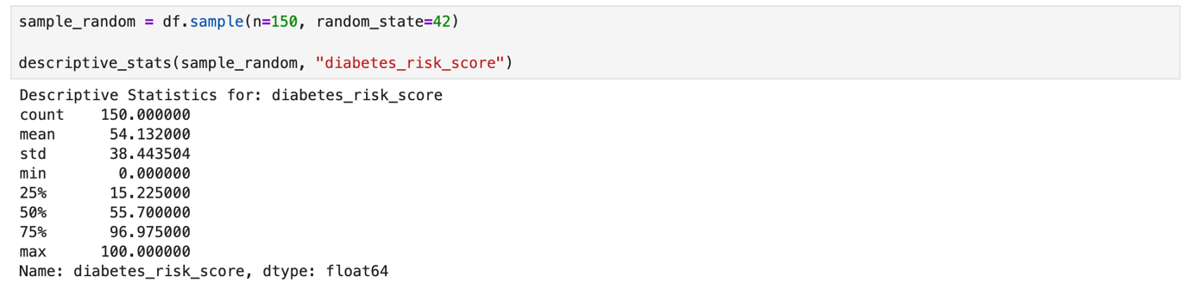

Systematic Sampling (1 point)
Systematic sampling selects records using a clear condition.
Here, we selected patients with BMI ≥ 30 to focus on higher BMI group.
Then we calculated descriptive statistics for the dependent variable.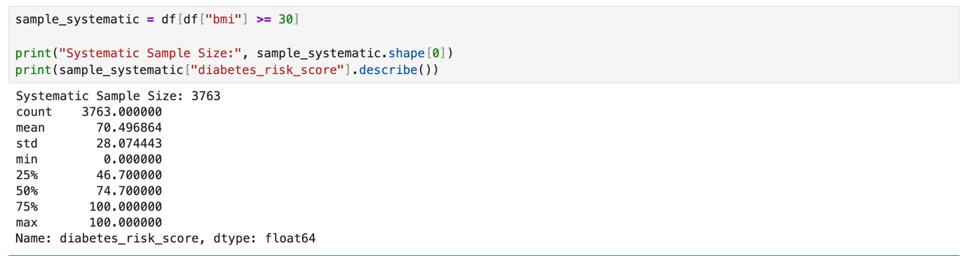

Descriptive Statistical Report (1 point)
The descriptive statistics show the overall diabetes risk score in the dataset.
The mean shows the average risk level.
The standard deviation shows how spread out the values are.
The minimum and maximum show the full range of risk scores.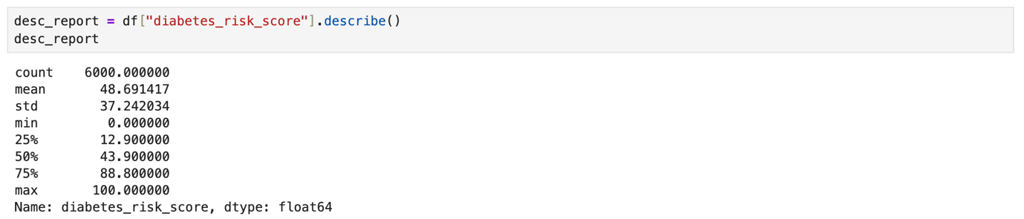

Visualisation through Various Charts (2 points)

Scatter Plot
The scatter plot shows the relationship between BMI (independent) and diabetes risk score (dependent).
If points go up, it means higher BMI may relate to higher risk.
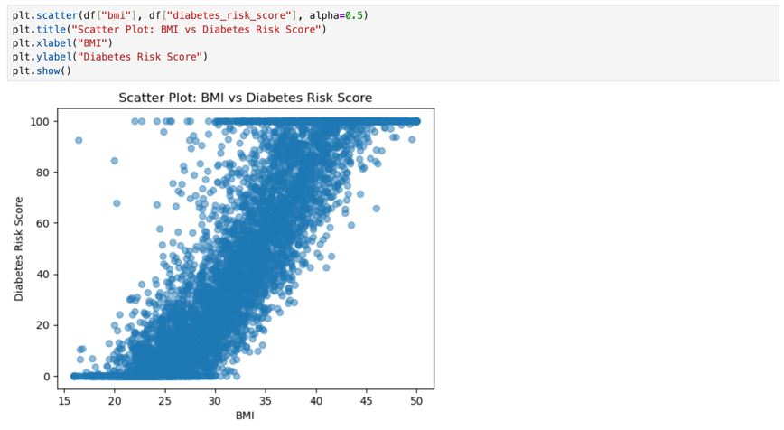

Box Plot
The box plot shows the spread of the diabetes risk score and helps detect outliers.
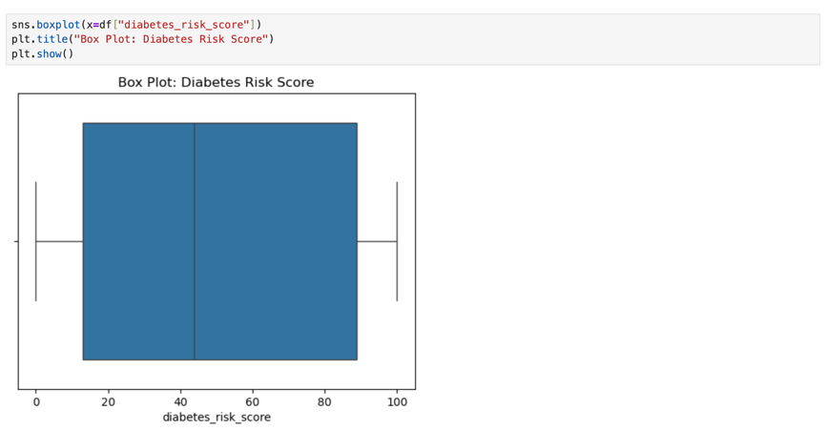

Histogram
The histogram shows how the diabetes risk scores are distributed.
It helps us see if the data is normal, skewed, or has unusual values.
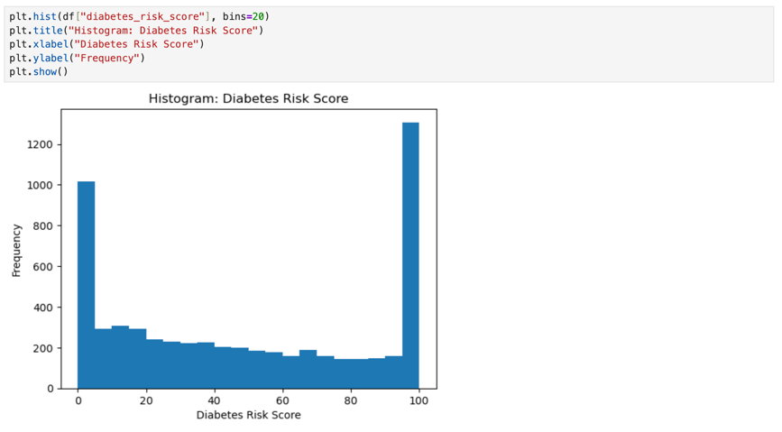

Heat Map
The heatmap shows correlations between numerical variables.
Stronger color means stronger relationship.

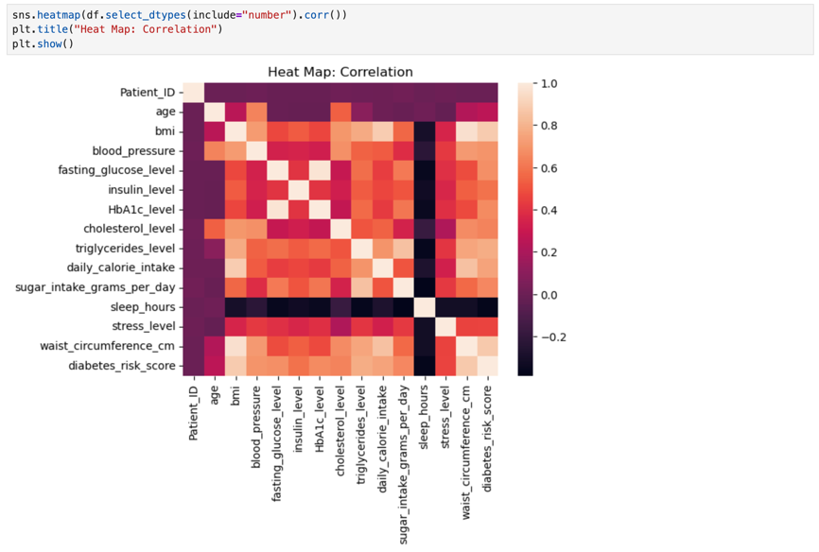

Hypothesis Test (1 point)
A Pearson correlation test was performed to examine the relationship between BMI and diabetes risk score.
Null Hypothesis (H₀):
There is no correlation between BMI and diabetes risk score.
Alternative Hypothesis (H₁):
There is a correlation between BMI and diabetes risk score.
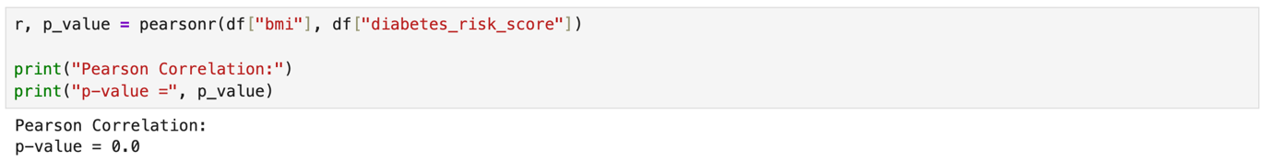
Decision Rule
If p-value < 0.05 → Reject H₀
If p-value ≥ 0.05 → Fail to reject H₀
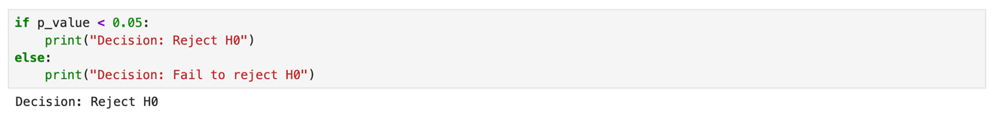
Interpretation
Since the p-value is less than 0.05, we reject the null hypothesis.
This indicates that there is a statistically significant correlation between BMI and diabetes risk score.

One Sample T-test (2 points)

A one-sample t-test was performed to compare the sample mean with the population mean.
Null Hypothesis (H₀):
The sample mean is equal to the population mean.
Alternative Hypothesis (H₁):
The sample mean is different from the population mean.

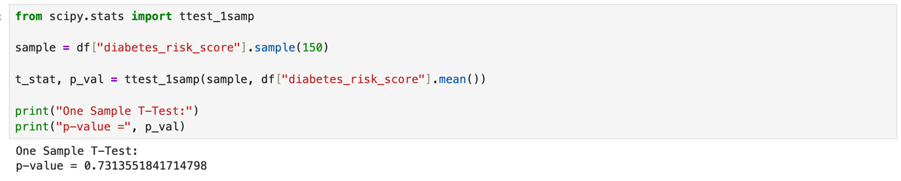
Decision Rule
If p-value < 0.05 → Reject H0
If p-value ≥ 0.05 → Fail to reject H0
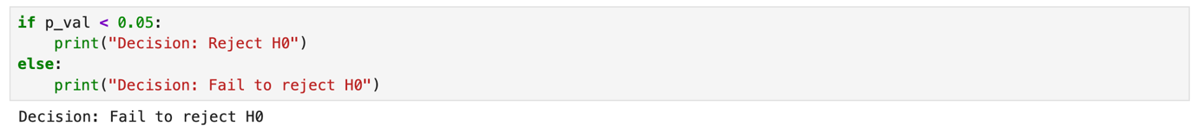
Interpretation
If the p-value is greater than 0.05, we fail to reject the null hypothesis.
This means that the sample mean is similar to the population mean.

