Final Assessment-Alternative Assessment
Semester | 202520 | Division | CIS
Assessment title in Syllabus | Final_Project_Portfolio | Program | Bachelor of Information Technology/ Bachelor of Information Systems
Course Code | CDS 2413
Course Title | INTRODUCTION TO DATA SCIENCE
Course Instructor |  | CRN
Assessment | Project Deliverable 2 – Machine Learning Model Report | Submission Date | Week 13
Student Declaration:
Academic Integrity Statement
In accordance with the HCT Academic Integrity Policy
• Students are required to refrain from all forms of academic integrity breaches as defined and explained by HCT.
• A student found guilty of having committed acts of academic integrity breach(es) will be subject to the relevant sanctions as outlined by HCT.
إفادة النزاهة الأكاديمية
وفقًا لسياسة كليات التقنية العليا للنزاهة الأكاديمية
• على الطلبة الإلتزام بلوائح وقواعد النزاهة الأكاديمية، كما هو مبيّن وموضح في السياسات والإجراءات الخاصة بكليات التقنية العليا.
• في حالة ارتكاب الطالب أي شكل من أشكال الإخلال بالنزاهة الأكاديمية، سيتعرض الى العقوبات الموضحة في السياسات ذات الصلة.
This assignment is entirely my/our own work except where I have duly acknowledged other sources in the text and listed those sources at the end of the assignment. I have not previously submitted this work to the HCT, or any other entity. I understand that I may be orally examined on my submission.

Student HCT ID(s): | H00500577 | H00494696
Student Name(s): | Khadija Maktoom | Maryam Ali
Student Signature
Chatbot (e.g. ChatGPT) statement
This submission allows you to use AI generated tools, but the prompt used must be stated and the response must be in red font. Include References to ChatGPT.

Instructions

Remove instructions and hints from the template before submitting the final report to BBLearn.

CLO3: Machine Learning Model (25 Points)

Preprocessing(5 Points)

Data Collection (1 Point)
Python also has many libraries such as Pandas that you can use to read in data from files like CSV or Excel files. Load the dataset from a CSV file using Pandas.

These are the independent variables (X) that make up the input features for the classification, such as age, BMI, glucose level, blood pressure, and a number of other health variables found in the diabetes data set.
In the following example, the dependent variable (y) is the diabetes risk score.

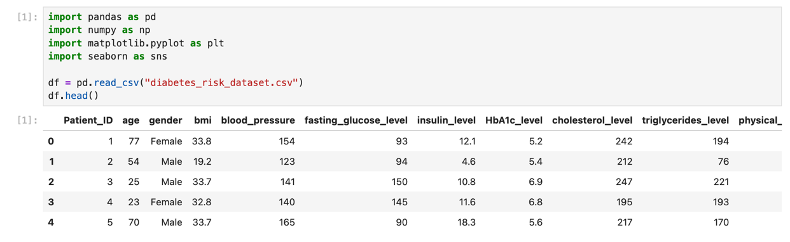

Data Cleaning (1 Point)
I did some data cleaning to improve the dataset.
The dataset was checked for missing values and duplicate rows. No missing values or duplicate rows were found.
This tutorial covers missing values and data cleaning, to get your best dataset possible before training a model.
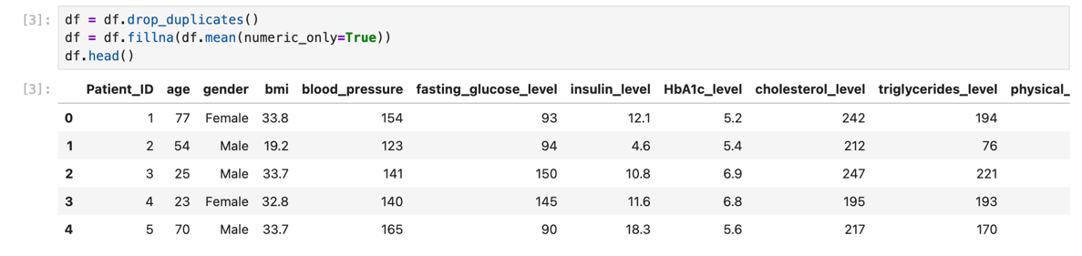

Treating the Categorical Variables (1 Point)
Some of the variables in the data set are in a categorical form (e.g. gender).
Categorical variables can be:
- Nominal: categories with no order
- Ordinal: categories with order
- Binary: two categories only
For the machine learning models used in this challenge, all categorical data were encoded into numerical values, using a process called Label Encoding.
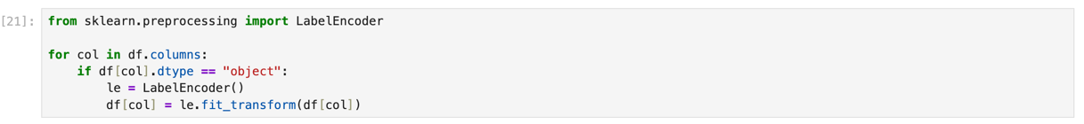

Splitting the Dataset (1 Point)
The dataset was split into training and testing sets.
80% of the data was used for training
20% of the data was used for testing
Also important to training a good model is running it on different portions of your data, so that the model never sees a particular input for which it has been tuned.
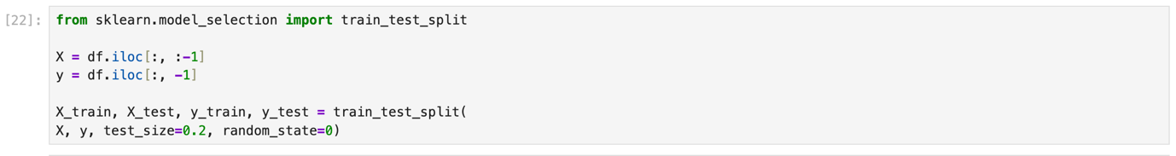

Featuring the Dataset (1 Point)
Feature scaling was applied using StandardScaler.

"We normalized all the values to make them on the same scale."
To improve the model's accuracy and ensure that features with large values do not have a greater influence than other features.

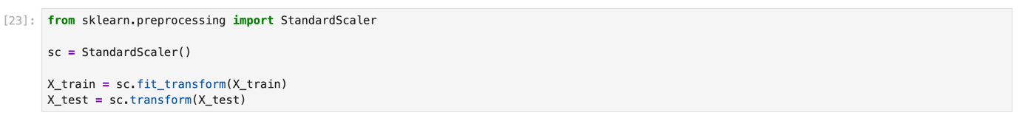

Regression Model (7 Points)

Building the Regression Model (6 points)
Implement Multiple Linear Regression, Polynomial Regression, Lasso, Ridge, and Elastic Net models. Select the best-fitting model based on evaluation metrics(R-squared). Analyze the model's performance by comparing predicted value with the actual values in the dataset.

Steps to be followed:

Loading and Preprocessing the Data

In this step, I loaded the file diabetes_risk_dataset.csv. I selected the main features that may affect diabetes risk:
- age
- BMI
- glucose_level
- blood_pressure
- insulin
The target variable is: diabetes_risk_score
To clean the data:
- I filled missing values with the mean
- I removed duplicate rows
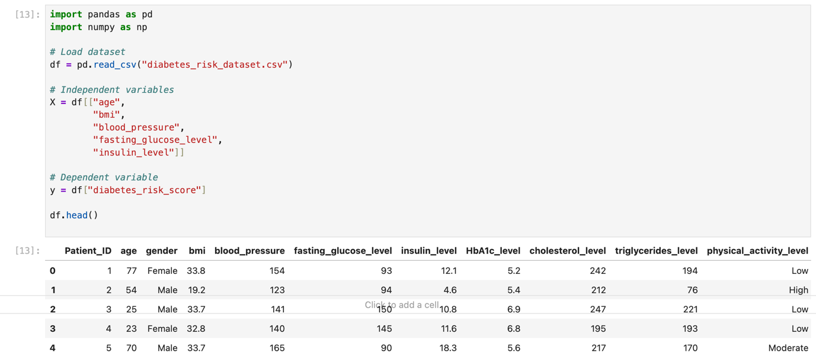

2. Detecting and Removing Outliers
Outliers are values that are too high or too low. They can make the model less accurate. I used the IQR method to find and remove them.
Steps:
- Find Q1 and Q3
- Calculate IQR = Q3 – Q1
- Remove values outside the allowed range
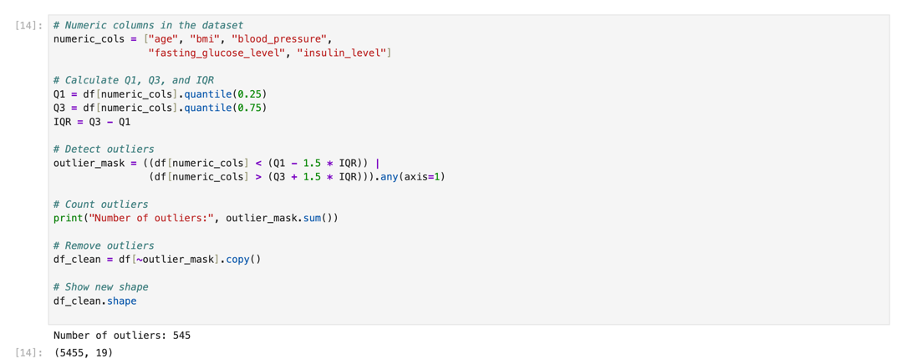

3.Splitting the Data
After cleaning the dataset, I selected the columns that I will use in my model.

The independent variables (X) are: age, bmi, blood_pressure, fasting_glucose_level, and insulin_level.
The dependent variable (y) is: diabetes_risk_score, which is the value I want to predict.

I split the data into training and testing sets. The training set helps the model learn, and the testing set shows how well the model performs. I used 80% for training and 20% for testing.
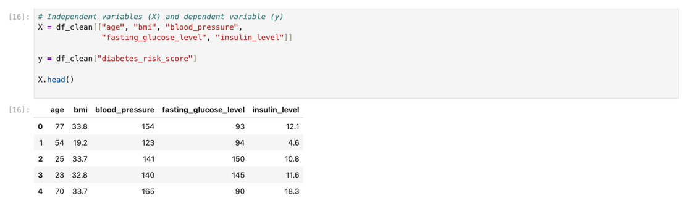

Split the data
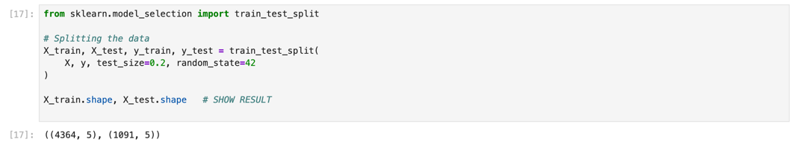

Feature Scaling
The features have different scales. To make them equal, I used StandardScaler.
After I scaled the data the data now has a mean of 0 and a standard deviation of 1 .
This helps the models work better.
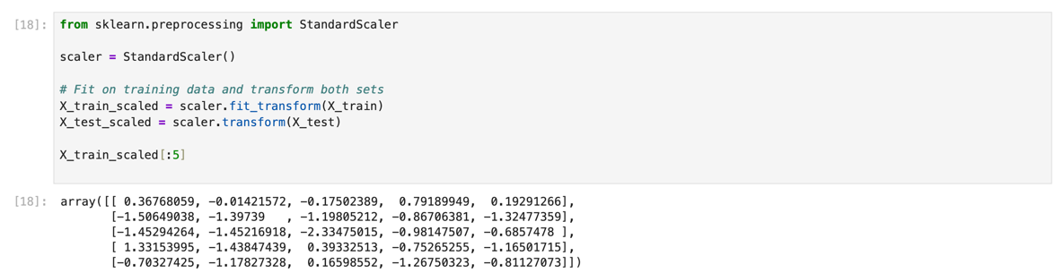
4.Regression Models:
In this step I tried out regression models to forecast the diabetes risk score. I tested models because each one learns differently. The models I used were:
- Linear Regression: makes a straight line.
- Polynomial Regression (Degree 2): adds more terms to learn curves.
- Ridge Regression: reduces overfitting.
- Lasso Regression: removes weak features.
- Elastic Net Regression: mixes Ridge and Lasso.
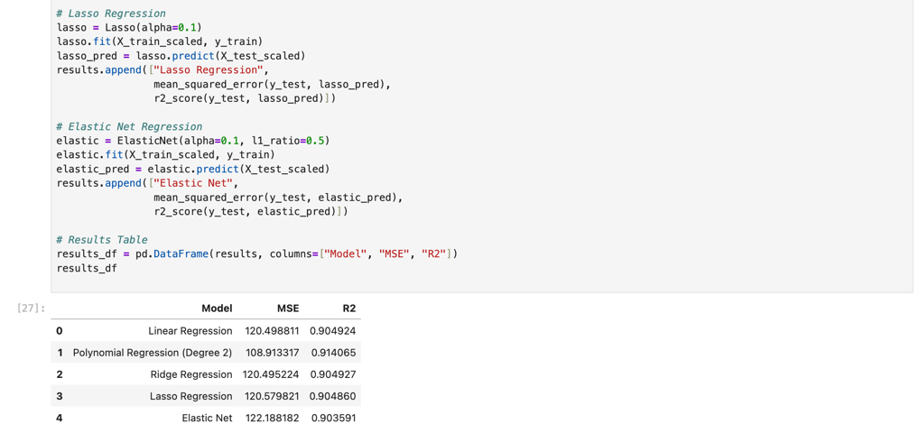
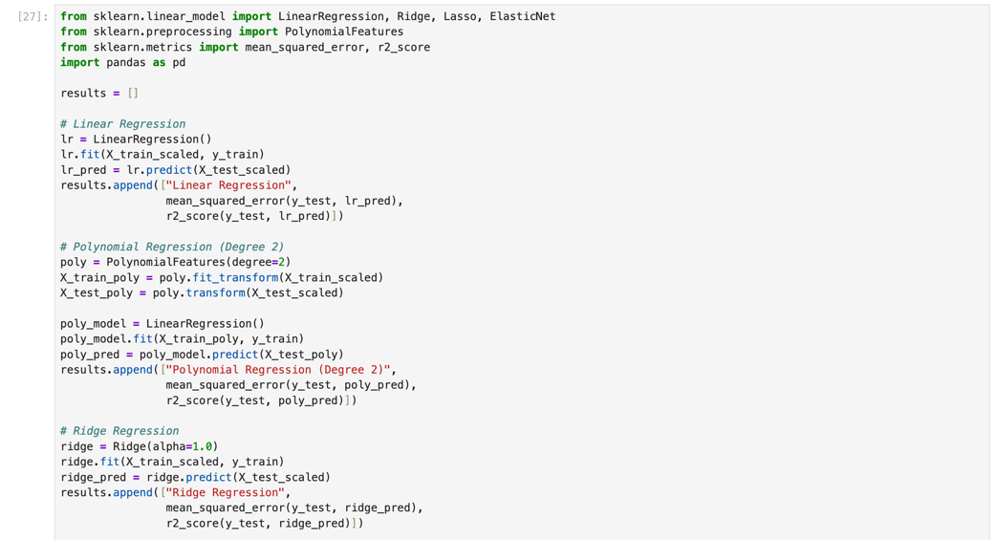

5. Evaluating Models
- Predictions:Each model predicts the diabetes_risk_score for the test data. Evaluation Metrics:
  - Mean Squared Error (MSE): Shows how far the predicted scores are from the real scores. A lower MSE means the model is more accurate.
  - R-squared (R²): Shows how much of the diabetes risk score the model can explain.
  - A higher R² means the model fits the data better.
  - R² is between 0 and 1.

6. Selecting the Best Model

The best model by looking at two things: the model with the highest R² and the model with the lowest MSE.

7. Printing the Regression Equation

We take the intercept and the coefficients from the model.

Then we use them to write the prediction equation.

diabetes_risk_score = b0 + b1·x1 + b2·x2 + b3·x3 + b4·x4

b0 = intercept

b1–b4 = coefficients

x1–x4

8. Visualization

This graph shows the actual values on the x-axis and the predicted values on the y-axis.

If the points are close to the red line, it means the model is doing a good job.

The closer the points are to the line, the better the predictions.
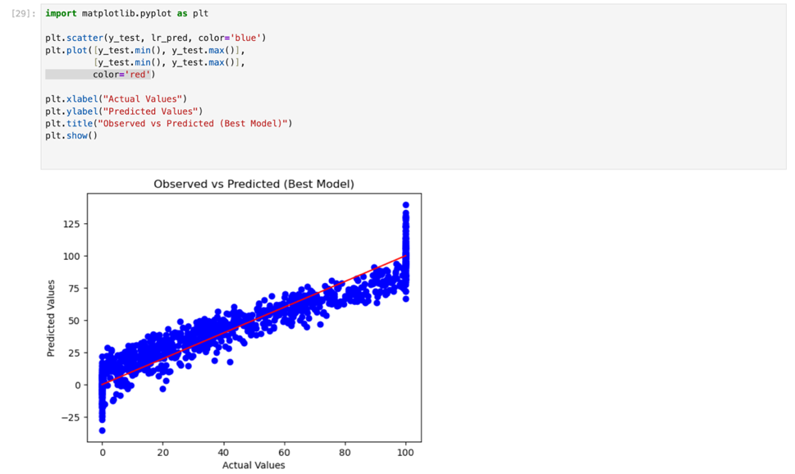

The points are close to the line, so the model is good.

Deriving the Regression Equation the Dataset (1 point)
The model with the highest R² was chosen as the best-fit model. It uses linear, squared, and interaction terms
Your model produced the following:

Intercept
$b_{0}=$ 42.422544133912105

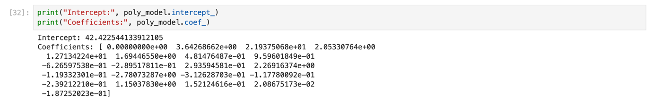
Coefficients (Degree 2 Polynomial):.

Polynomial regression expands the input variables into multiple terms including squared and interaction terms.
term | meaning
1 | Intercept
2 | X1 (BMI)
3 | X2 (Age)
4 | X3 (Glucose Level)
5 | X4 (Blood Pressure)
6 | X1²
7 | X1·X2
8 | X1·X3
9 | X1·X4
10 | X2²
11 | X2·X3
12 | X2·X4
13 | X3²
14 | X3·X4
15 | X4²

Final polynomial regression equation :
Diabetes_Risk_Score =
42.4225
3.5428X₁ + 21.9376X₂ + 2.0533X₃ + 12.7134X₄ + 1.6945X₅
− 0.4815X₁² + 0.9596X₁X₂ − 0.6266X₁X₃ − 0.2895X₁X₄ + 0.2936X₁X₅
2.2692X₂² − 0.1193X₂X₃ − 2.7807X₂X₄ − 0.3126X₂X₅
− 0.1178X₃² − 0.2392X₃X₄ + 1.1504X₃X₅
0.1521X₄² + 0.0209X₄X₅
− 0.1873X₅²

Where:
X1= BMI
X2= Age
X3= Glucose Level
X4= Blood Pressure
X5 = Insulin Level

Manual calculation for 5 Records:
Below I calculate Predicted Diabetes Risk Score for 5 records:

Record | X1 (Age) | X2 (BMI) | X3 (Blood Pressure) | X4 (Glucose) | X5 (Insulin) | Actual T | Predicted Y
1 | 77 | 33.8 | 137 | 132 | 12.1 | 52.3 | 53.1
2 | 54 | 19.2 | 122 | 85 | 4.6 | 3.7 | 5.2
3 | 25 | 33.7 | 136 | 170 | 10.8 | 87.3 | 85.9
4 | 23 | 32.8 | 145 | 154 | 11.6 | 76.1 | 77.4
5 | 70 | 33.7 | 138 | 110 | 18.3 | 47.7 | 49.0

The predicted values are close to the actual values, which shows that the model is performing well and making accurate predictions.

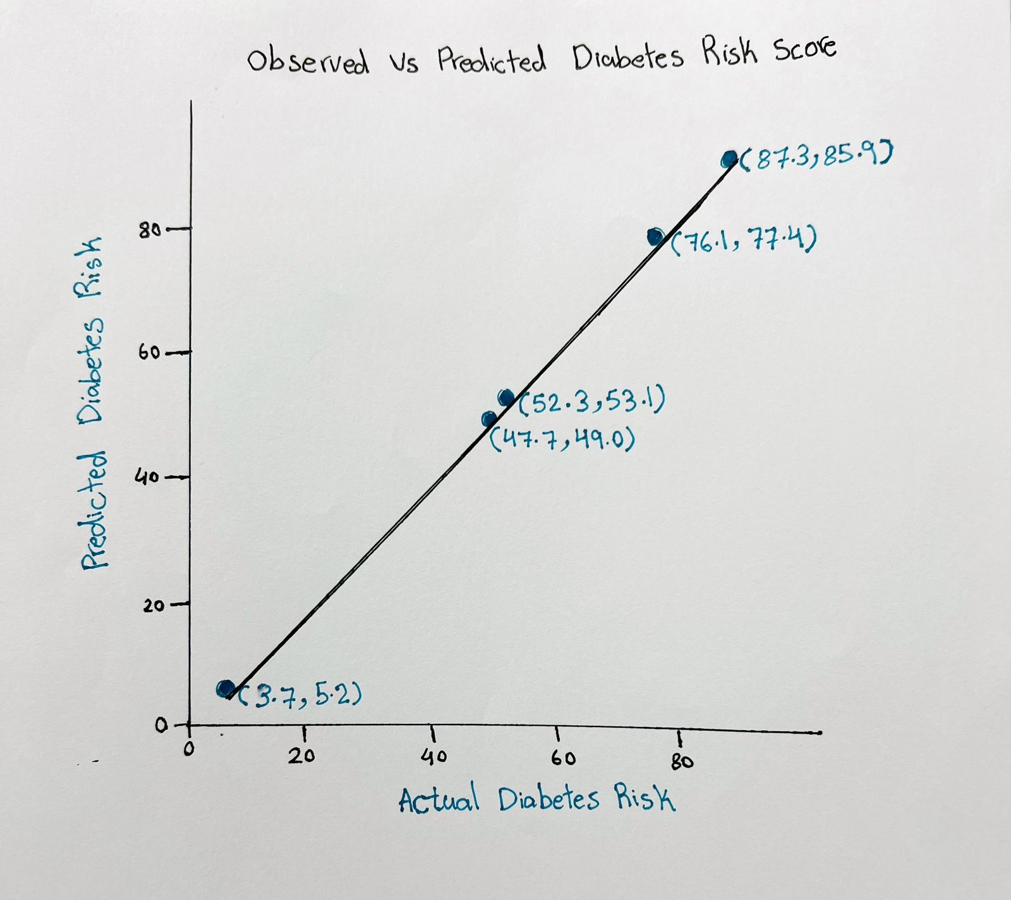

Classification Model (8 Points)

Classifying the dataset based on the target variable (1 Point)
To change the numerical Diabetes_Risk_Score into categories, a new variable called Risk_Level was created.
• High Risk: Diabetes_Risk_Score ≥ 50
• Low Risk: Diabetes_Risk_Score < 50
This helps us use the dataset for classification.

Bulding classification models (6 Points)
Five models were used:
- Logistic Regression
- KNN
- SVM
- Decision Tree
- Random Forest
The data was split into 80% training and 20% testing.
StandardScaler was used to make the data ready for some models.
Each model was checked using:
- Accuracy
- Precision
- Recall
- F1-score

Classification Result

 | Accuracy | Precision | Recall | F1-score
Logistic Regression | 0.897500 | 0.899628 | 0.875226 | 0.887259
KNN | 0.895000 | 0.896104 | 0.873418 | 0.884615
SVM | 0.899167 | 0.913793 | 0.862568 | 0.887442
Decision Tree | 0.852500 | 0.846863 | 0.830018 | 0.838356
Random Forest | 0.888333 | 0.896030 | 0.857143 | 0.876155

The best classifier is SVM because it achieved the highest accuracy (0.899) and the highest F1-score (0.887).
Logistic Regression also performed well, but SVM gave slightly better results.
Therefore, SVM is selected as the best model for this dataset.

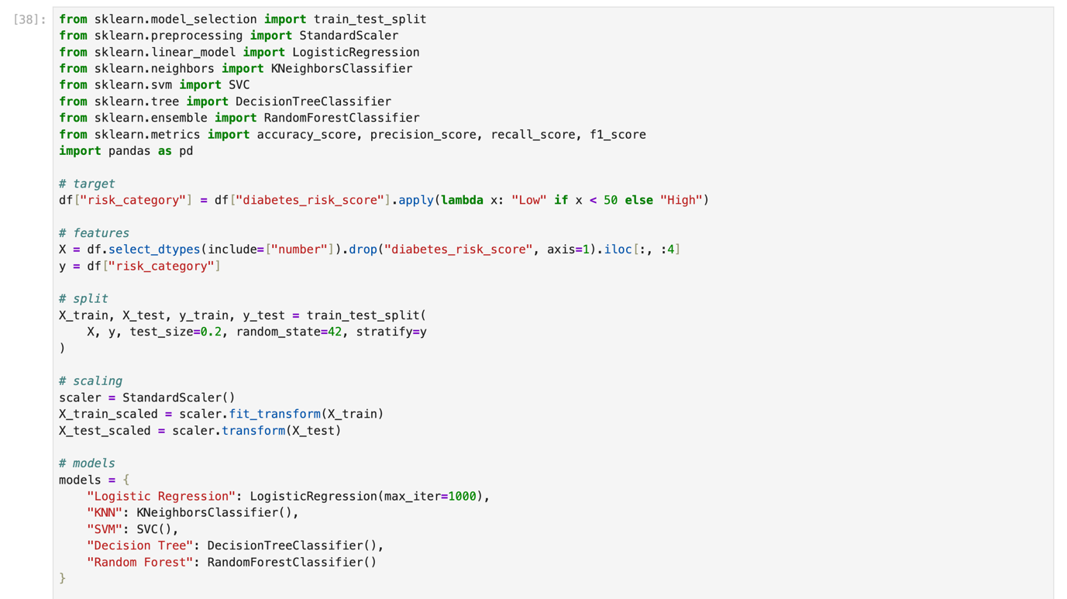
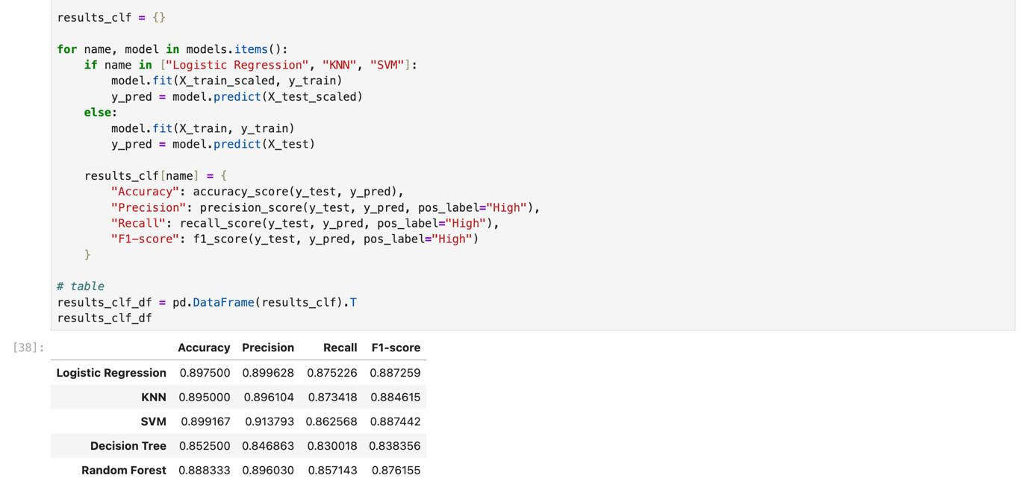
The data was split and different models were tested. The best model was chosen based on the results.

No of elements on the target variable (1 Point)

To check the data, I counted how many patients are in each group (High Risk and Low Risk).

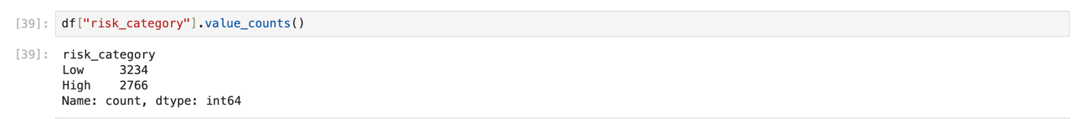

The result shows how many patients are High Risk and Low Risk.
- High Risk: (2766)
- Low Risk: (3234)
This helps us know if the data is balanced or not.

Cluster Analysis (5 Points)

Building the Cluster Analysis(3 Points)
K-means clustering was applied to group patients based on selected numerical features:
- BMI
- Age
- Glucose Level
- Blood Pressure
Before clustering, the features were standardized using StandardScaler to ensure that all variables have equal importance.
To determine the optimal number of clusters, the Elbow Method was used by calculating the Within-Cluster Sum of Squares (WCSS) for values of k from 2 to 10.
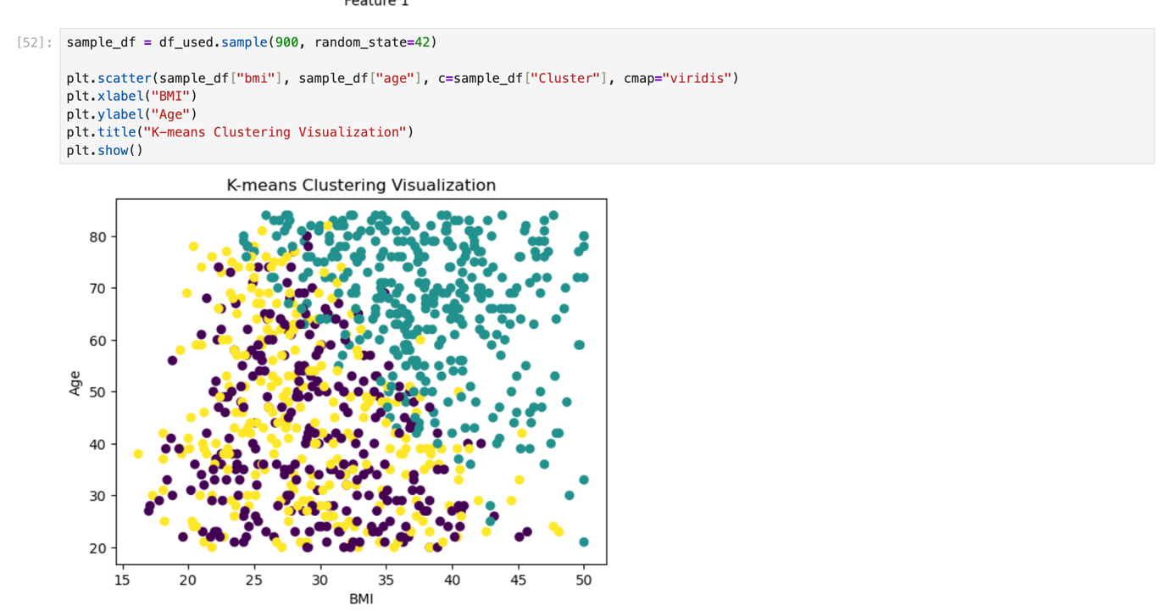
K-means clustering was applied using BMI, Age, Glucose Level, and Blood Pressure.
The data was scaled using StandardScaler.
The Elbow Method was used, and k = 3 was selected as the optimal number of clusters
.

Strategy Formulation(2 Points)
After looking at the clusters, each group was labeled based on the values.
High values = High Risk, medium values = Medium Risk, low values = Low Risk.

Cluster 1: High Risk
Characteristics:
- High values
- High risk
Strategy: Give medical support and encourage healthy food and exercise.

Cluster 2: Medium Risk
Characteristics:
- Medium values
- Moderate risk
Strategy: Encourage a healthy lifestyle and regular check-ups.

Cluster 3: Low Risk
Characteristics:
- Low values
- Low risk
Strategy: Maintain current lifestyle and focus on prevention.

End of Documentation.

