

**ADipIT02 – Object Oriented Design and Programming**

**TOPIC:** Continous Assessment - i

**Group Name:** Jyango

**Submitted date:** 2019/12/10

**Submitted to:** Er. Raj Prasad Shrestha

Contents

College Assignment System 1

Features: 1

Application: 1

Methodology 2

i. SDLC process models 2

a. Classical Waterfall Model 2

b. Incremental Process Model 3

c. Agile Scrum process model 4

ii. Use Case Diagram 6

iii. Class Diagram 7

iv. Activity Diagram for Database Administrator 8

v. Swimlane activity diagram for registering user 12

vi. Activity Diagram 13

vii. Software Architecture 14

# College Assignment System

College Assignment System is a web application that will help teachers to easily assign assignments or any course related materials to the students through the app.

## Features:

In the app, Teachers and Students will have their own individual account respectively. Teachers account will have the option of submitting assignment by two different ways, via uploading a file and then writing a description about the assignment or by giving multiple-choice question. Where the correct choice will be saved in the database system. Furthermore, they will have the ability to post a notice and upload course materials with description through their account.

Also, Students account will have their home page showing a list of course that they have enrolled in. After clicking the course, they will be able to view assignments or any course related posts. For uploaded assignments they can view the file and download it, whereas for multiple choice questions assignments, they will be able to choose the correct answers. After the completion, their grades or marks will be published as soon as they finish multiple choice questions where marks will also be saved in the database system.

All the user accounts of both students and teachers will be managed and registered by database administrator. All the files, user privileges and other data will be saved in the system. The administrator will have the ability to change any data or user details and privilege as necessary.

## Application:

Through this app, teachers will not have to go through the hassle of reminding every students of their assignment work or any course related materials. They can simply upload all the course related materials including assignments, recommendations, links, lecture slides and even important suggestions and notices through the app.

This will also help students as they will have access to all course related materials at any time or place through the internet. This will save time for both teachers and students. All in all, this app will be a very important and efficient tool for a college as a part of communication between Teachers and Students.

# Methodology

## i. SDLC process models

### a. Classical Waterfall Model

It is the basic software development life cycle model. It is not used nowadays but it was popular before. It is very important because all the other software development life cycle models are based on the classical waterfall model.  
It divides the life cycle into a set of phases. This model considers that one phase can be started after completion of the previous phase by which the output of one phase becomes the input to the next phase. The development process can be considered as a sequential flow in the waterfall.

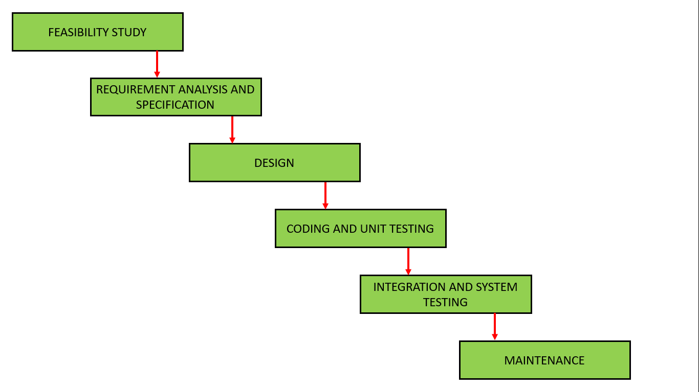

* **Feasibility Study**

In this phase it is determined whether it would be financially and technically feasible to develop the software. The feasibility study involves understanding the problem and then determine the various possible strategies to solve the problem.

* **Analysis**

The aim of the requirement analysis and specification phase is to understand the exact requirements of the customer and document them properly. This phase consists of two different activities: Requirement analysis and requirement specification.

* **Design**

In this phase of design, transformation of the requirements specified in the above phase is changed into a structure that is suitable for implementation in some programming language.

* **Coding and Unite testing**

In this phase, software design done in above phase is converted into source code using any suitable programming language. The aim of the unit testing phase is to check whether each module is working properly or not.

* **Integration and System Testing**

Integration of different modules are done after they have been coded and unit tested. Integration of various modules is carried out incrementally over a number of steps. Finally, after all the modules have been successfully integrated and tested, the full working system is obtained and system testing is carried out on this. System testing consists three different kinds of testing activities: Alpha testing, Beta testing, Acceptance testing.

* **Maintenance**

Maintenance is the most important phase of a software life cycle. The effort spent on maintenance is the 60% of the total effort spent to develop a full software. There are basically three types of maintenance: Corrective Maintenance, Perfective Maintenance and Adaptive Maintenance.

**Advantages**

* This model is very simple and is easy to understand.
* Phases in this model are processed one at a time.
* Each stage in the model is clearly defined.

Disadvantages

* **Backtracking is hard.**
* **Difficult to accommodate change request.**
* **No overlapping of phases.**

(Pal)

### b. Incremental Process Model

It is also known as Successive version model. First, a simple working system with few basic features is built and then that is delivered to the customer. After that, many successive iterations/ versions are implemented and delivered to the customer until the desired system is released.

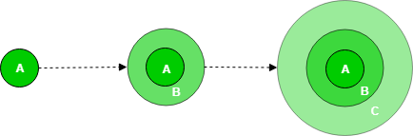

Here: A, B and C are software product that are incrementally developed and delivered.

In this model, the requirements of software are first broken down into several modules that can be incrementally constructed and delivered. Planning is done just for the next increment and not for any kind of long-term plans which makes it is easier to modify the version as per the need of the customer.

After the main features are fully developed, then they are refined to increase levels of capabilities by adding new functions in successive versions. Iterative waterfall model of development is used to develop each incremental version. The feedback of the Customer is taken after the successive versions are delivered. Each version of the software has more additional features over the previous ones.

There are two types of incremental development model:

Staged Development Model in which development of only one part of the project is done.

**Parallel Development Model in which different subsystems are developed at the same time. It can decrease the time needed for development.**

Advantages

* Error Reduction.
* Uses divide and conquer for breakdown of tasks.
* Lowers initial delivery cost.

Disadvantages

* Requires good planning and design.
* Total cost is not lower.
* Well defined module interfaces are required.

(Freak)

### c. Agile Scrum process model

Scrum is the Agile System sort. It is a system within which individuals will solve dynamic adaptation challenges while ensuring brand quality and innovation are at the highest possible values. Scrum follows the method of replication.

Silent features of Scrum

* Scrum is light-weighted framework
* Scrum emphasizes self-organization
* Scrum is simple to understand
* Scrum framework help the team to work together

**Lifecycle of Scrum:**

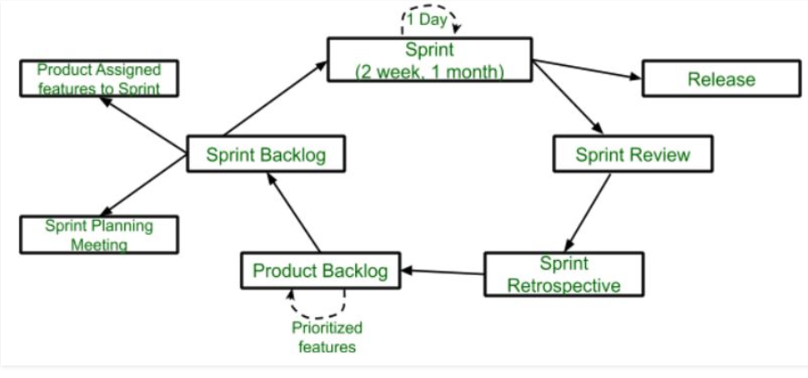

**Sprint:** A Sprint is a one month or less period package. A new Sprint will begin immediately after the previous Sprint has been finished.

**Release:** When the product is done, it will go to the launch stage.

**Sprint Review:** If the product still has some non-realizable functionality, it will be tested at this point and the item will be moved to the retrospective phase of Sprint.

**Sprint Retrospective:** Quality or product status is checked at this stage.

**Product Backlog:** The product is structured according to the prioritization functionality.

**Sprint Backlog:** Sprint Backlog is split into two sections Sprint and Sprint planning meetings are delegated to the product features.

**Advantage of using Scrum framework:**

* Scrum framework is fast moving and efficient in terms of money.
* Through splitting the broad object into small sub-products, the Scrum model functions. It's like a tactic of divide and conquer.
* Customer satisfaction is very critical to Scrum.
* By fact, Scrum is versatile because it has a fast sprint.

**Disadvantage of using Scrum framework:**

* Scrum frame does not permit changes to your sprint.
* The design is not fully described as the Scrum system. You need to fill in the structure with your own information, such as Extreme Programming (XP), Kanban, DSDM, if you want to follow it.
* Planning, structuring and coordinating a plan that lacks a clear description can be challenging for the Scrum.

## ii. Use Case Diagram

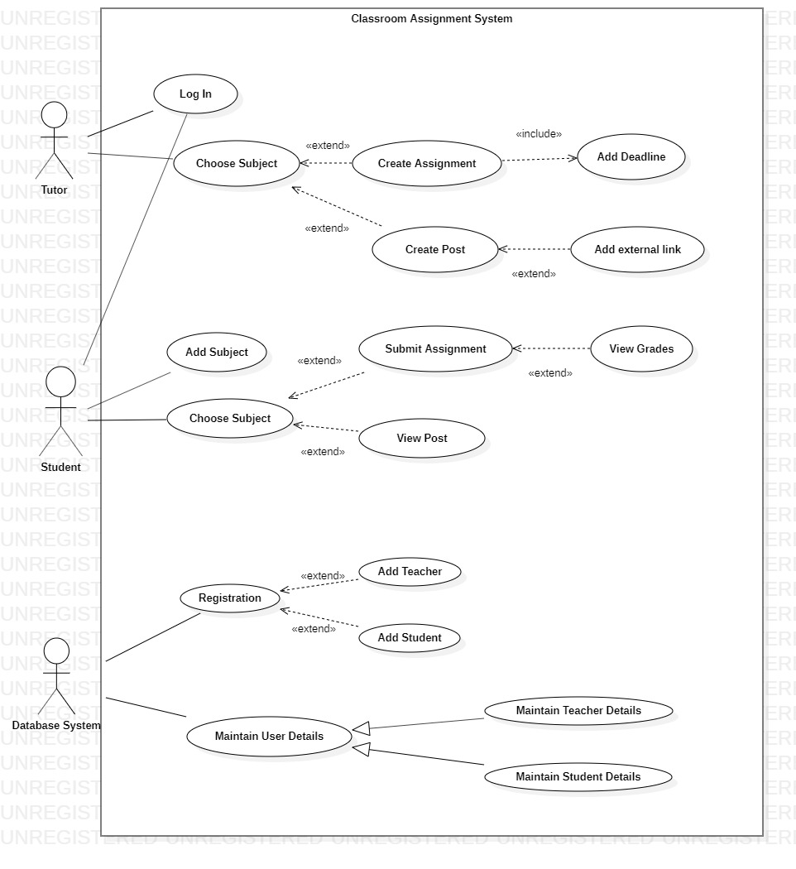

## iii. Class Diagram

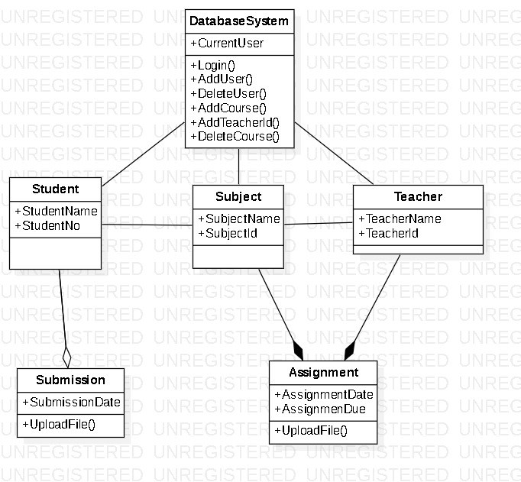

## iv. Activity Diagram for Database Administrator

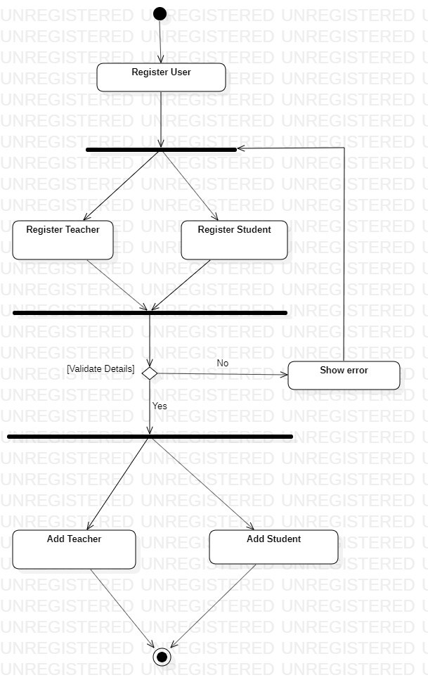

While registering user, Database administrator will choose either to add a Teacher(Tutor) or a Student. While filling up the details, the format and form must be filled according to the requirement or else there will be shown error that the form is not validated. In case of any error, page will be redirected to choosing either adding teacher or student account.

In case of validity, the process will be connected to adding a teacher account or a student account according to the function called.

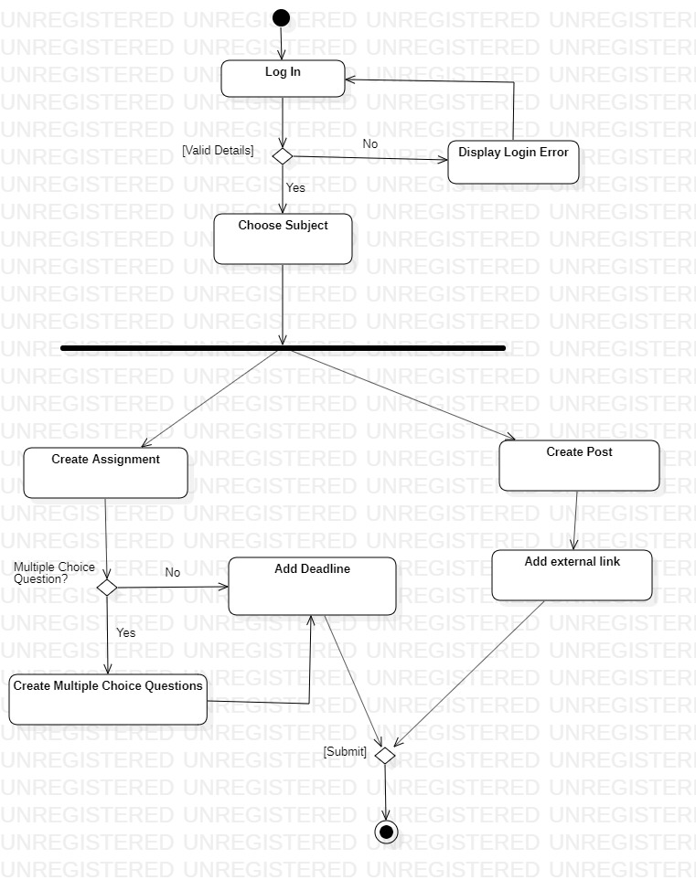

When a teacher(tutor) uses the application, s/he will be directed to log in with their specific login details. If it matches to the information in our database, s/he will be directed to their home page where they will have the option to either create assignment or create a post where they can share any course related materials by adding external link optionally. While creating assignment, they can either choose to create a multiple-choice questions assignment or just write the description of the assignment followed by adding a submission date or deadline for the assignment. After submitting, the use case will be closed.

## v. Swimlane activity diagram for registering user

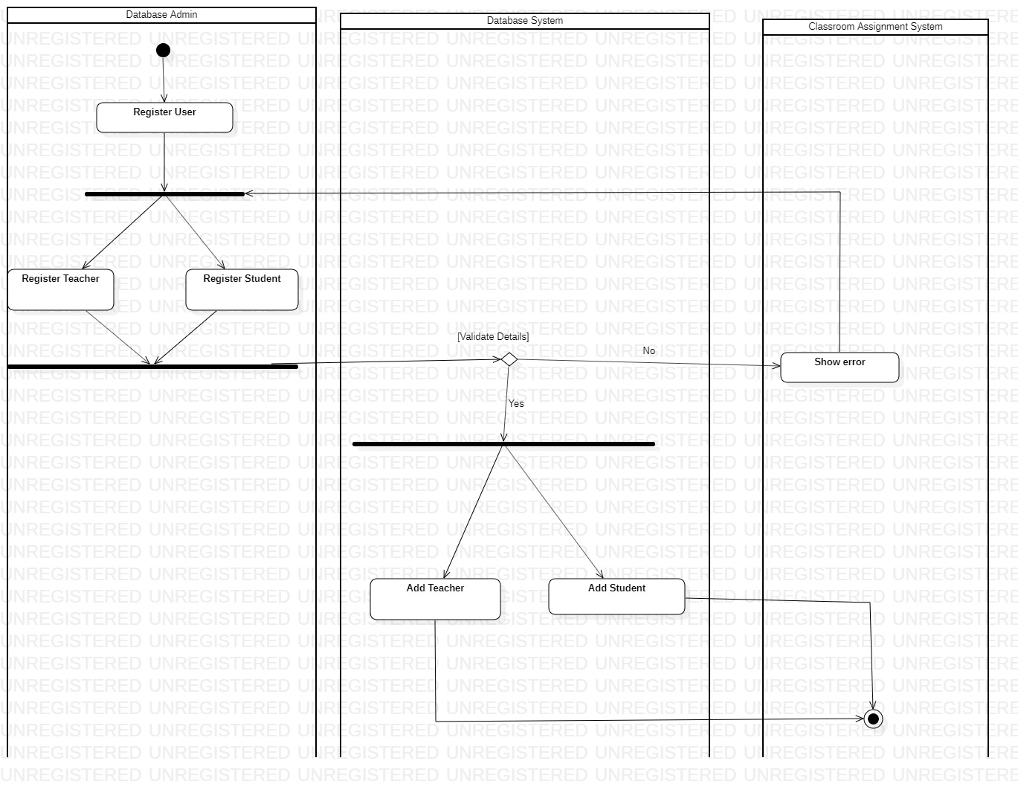

## vi. Activity Diagram

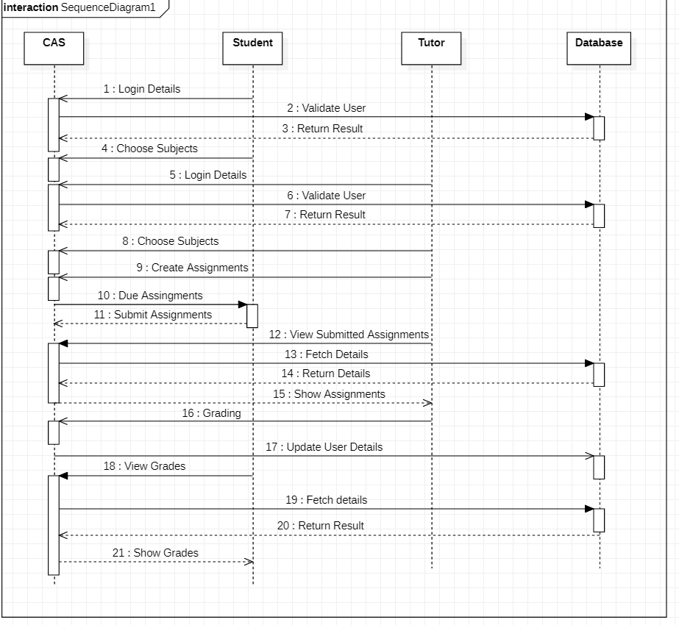

## vii. Software Architecture

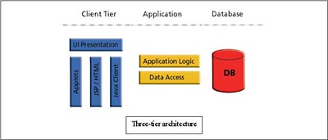

We are using 3 layers software architecture because our application will consist of Presentation or client tier, Application tier which is Django and python and Data tier which will be our database system. According to the demand of our application, these three tiers will be sufficient to provide a fully functional classroom assignment system.

Our app will work through presentation layer with either database system or application layer(logic) only where there is no need of any other type of tier to run the app in a reliable manner.

We will not be using any other external layers because for example for e-commerce web application, making payments or confirming payments, would have required different layers for the application to work efficiently and reliably, which would have required ‘N’ layer software architecture. Therefore, since there is no need of any other layer required for our application architecture, we will be using 3-layer software architecture.

Advantages of 3 tier application:

The benefits of using a 3-layer architecture include improved horizontal scalability, which is the ability to increase capacity by connecting multiple hardware or software entities. performance and availability. With three tiers, each part can be developed concurrently by different team of programmers coding in different languages from the other tier developers. Because the programming for a tier can be changed or relocated without affecting the other tiers, the 3-tier model makes it easier for an enterprise or software packager to continually evolve an application as new needs and opportunities arise. Existing applications or critical parts can be permanently or temporarily retained and encapsulated within the new tier of which it becomes a component.

3-Tier Architecture

A 3-tier architecture is a form of software architecture that consists of three logical computing "tiers" or "layers." These are often used as a particular type of client-server system in applications. Through modularizing the user interface, business logic and data storage levels, 3-tier architectures provide many advantages for production and development environments. It allows development teams to be more agile by enabling them to upgrade a particular part of a specification independently of the other parts. This added flexibility can improve overall time-to-market and reduce cycle times for development by giving development teams the ability to replace or upgrade independent levels without affecting the other parts of the system. (JReport, n.d.)

Advantages

* Maintainability - Since each tier is independent of the other levels, updates or modifications can be made without affecting the application as a whole.
* Scalability - Since tiers are dependent on layer implementation, it is reasonably straightforward to scale out an application.
* Flexibility - As each tier can be individually controlled or scaled, versatility is improved.
* Availability - Using easily scalable components, applications can exploit the modular architecture of enabling systems, which increases availability.
* Reusability - Components can be used again
* Faster development - Since web designer division is doing layout, software engineering is doing theory, DB admin is doing data model.

Disadvantages

* High cost of construction.
* The layout is more complicated than the architectures of 1 & 2 tiers.
* To implement even small part of application it will consume lots of time

(Mayekar, n.d.)