**Individual Contribution Report**

My Contribution:

Use Case Diagram

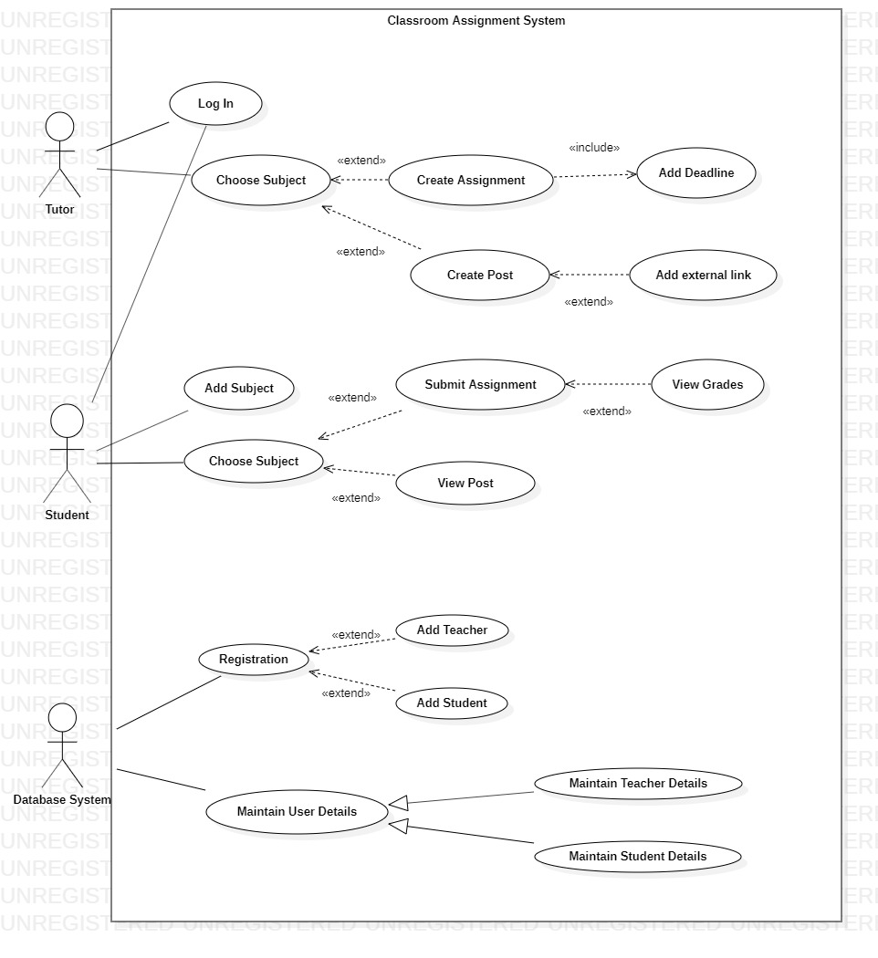

# College Assignment System

College Assignment System is a web application that will help teachers to easily assign assignments or any course related materials to the students through the app.

## Features:

In the app, Teachers and Students will have their own individual account respectively. Teachers account will have the option of submitting assignment by two different ways, via uploading a file and then writing a description about the assignment or by giving multiple-choice question. Where the correct choice will be saved in the database system. Furthermore, they will have the ability to post a notice and upload course materials with description through their account.

Also, Students account will have their home page showing a list of course that they have enrolled in. After clicking the course, they will be able to view assignments or any course related posts. For uploaded assignments they can view the file and download it, whereas for multiple choice questions assignments, they will be able to choose the correct answers. After the completion, their grades or marks will be published as soon as they finish multiple choice questions where marks will also be saved in the database system.

All the user accounts of both students and teachers will be managed and registered by database administrator. All the files, user privileges and other data will be saved in the system. The administrator will have the ability to change any data or user details and privilege as necessary.

## Application:

Through this app, teachers will not have to go through the hassle of reminding every students of their assignment work or any course related materials. They can simply upload all the course related materials including assignments, recommendations, links, lecture slides and even important suggestions and notices through the app.

This will also help students as they will have access to all course related materials at any time or place through the internet. This will save time for both teachers and students. All in all, this app will be a very important and efficient tool for a college as a part of communication between Teachers and Students.

**Report**

For this continuous assessment, I researched on how a college assignment system could be managed through an app. While making use case diagram, I got overview of what the functions and responsibility of each class is going to be in the app and by help of Django and database, how we could manage the data that we will need to run this app.

I learned about features of Django like Django administration that could help us easily manage data that will be used in this app. I learned briefly about the frameworks of Django that is MVT and MVC. Furthermore, I learned about the types of Software Development Life Cycle (SDLC), their features and advantages.

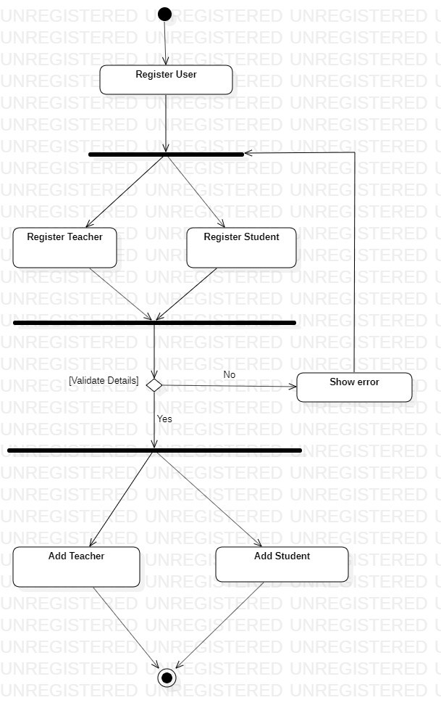

While registering user, Database administrator will choose either to add a Teacher(Tutor) or a Student. While filling up the details, the format and form must be filled according to the requirement or else there will be shown error that the form is not validated. In case of any error, page will be redirected to choosing either adding teacher or student account.

In case of validity, the process will be connected to adding a teacher account or a student account according to the function called.

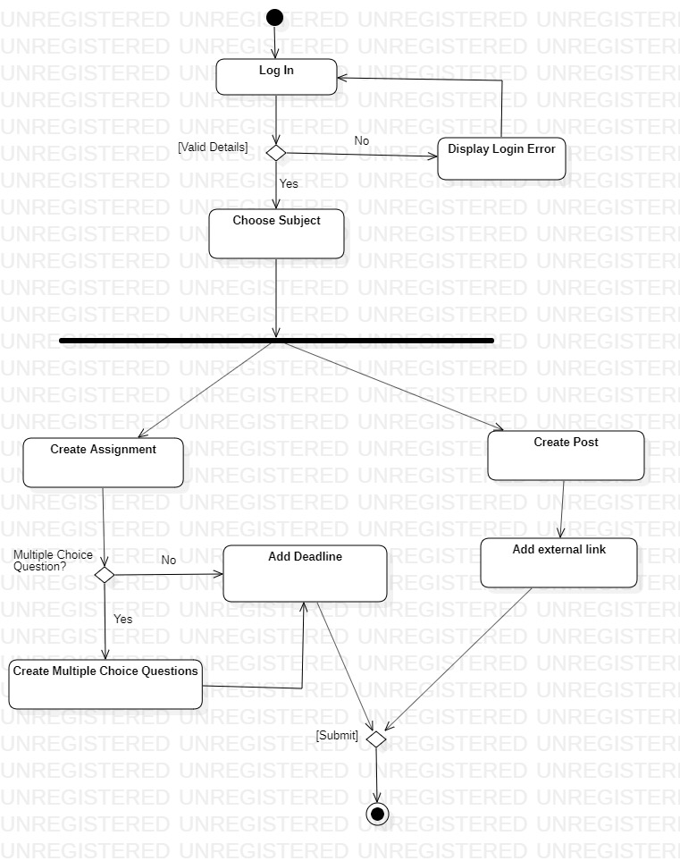

When a teacher(tutor) uses the application, s/he will be directed to log in with their specific login details. If it matches to the information in our database, s/he will be directed to their home page where they will have the option to either create assignment or create a post where they can share any course related materials by adding external link optionally. While creating assignment, they can either choose to create a multiple-choice questions assignment or just write the description of the assignment followed by adding a submission date or deadline for the assignment. After submitting, the use case will be closed.

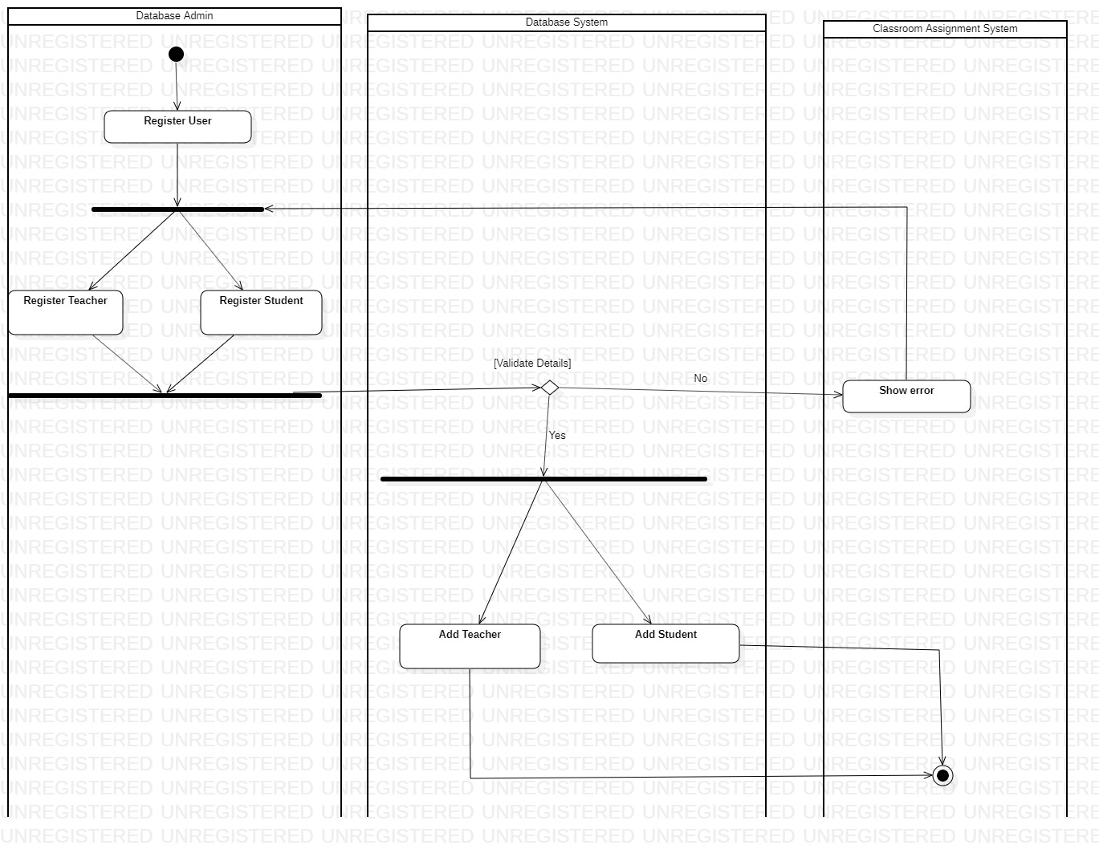

## vii. Software Architecture

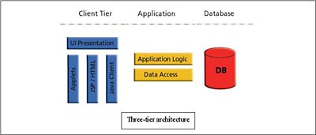

We are using 3 layers software architecture because our application will consist of Presentation or client tier, Application tier which is Django and python and Data tier which will be our database system. According to the demand of our application, these three tiers will be sufficient to provide a fully functional classroom assignment system.

Our app will work through presentation layer with either database system or application layer(logic) only where there is no need of any other type of tier to run the app in a reliable manner.

We will not be using any other external layers because for example for e-commerce web application, making payments or confirming payments, would have required different layers for the application to work efficiently and reliably, which would have required ‘N’ layer software architecture. Therefore, since there is no need of any other layer required for our application architecture, we will be using 3-layer software architecture.

Advantages of 3 tier application:

The benefits of using a 3-layer architecture include improved horizontal scalability, which is the ability to increase capacity by connecting multiple hardware or software entities. performance and availability. With three tiers, each part can be developed concurrently by different team of programmers coding in different languages from the other tier developers. Because the programming for a tier can be changed or relocated without affecting the other tiers, the 3-tier model makes it easier for an enterprise or software packager to continually evolve an application as new needs and opportunities arise. Existing applications or critical parts can be permanently or temporarily retained and encapsulated within the new tier of which it becomes a component.