CCP Context Aware → IMO Lexicals
High-Level System Design & Proposed Approaches
POC Scope: Diabetes Domain

1. Objective
Build a context-aware clinical NLP system that extracts medical conditions from unstructured clinical notes and maps them to IMO lexical codes. The POC is scoped to the diabetes domain.

Core Hypothesis: Sentence-level NER alone produces vague or non-codable results. Adding cross-sentence context enrichment (via Knowledge Graph traversal or LLM reasoning) produces more specific, accurate IMO lexical matches.
Output Target: IMO lexicals only. ICD-10-CM and SNOMED CT mappings are out of scope for this POC.

2. Background
Clinical notes contain rich diagnostic information spread across multiple sentences. A single sentence may mention "type 2 diabetes" while another references "hyperglycemia" and a third notes "long-term insulin use." Individually, these produce generic codes. Combined with document-level context, they map to the highly specific IMO lexical: "Type 2 diabetes mellitus with hyperglycemia, with long-term current use of insulin" (IMO 64855341).

The challenge is building a system that performs this cross-sentence reasoning reliably, explainably, and at scale. This POC evaluates seven different approaches to determine which combination of components achieves the best results.

3. Seven Proposed Approaches
The approaches are organized into three groups: NER-based (1-3) which use explicit biomedical NER as the first step, No Explicit NER (4-6) which bypass dedicated NER models but still perform implicit extraction, and End-to-End (7) where a single LLM handles the entire pipeline.

# | Group | Extraction | Enrichment | Resolution | Output | Notes
1 | NER-Based | NER | — | Semantic | IMO Lexicals | Baseline, sentence-level
2 | NER-Based | NER | KG | Semantic | IMO Lexicals | Explainable reasoning
3 | NER-Based | NER | LLM | Semantic | IMO Lexicals | Flexible, hallucination risk
4 | No Explicit NER | — | — | Semantic | IMO Lexicals | Direct matching
5 | No Explicit NER | — | KG | Semantic | IMO Lexicals | KG with implicit extraction
6 | No Explicit NER | — | LLM | Semantic | IMO Lexicals | LLM with implicit extraction
7 | End-to-End | LLM | LLM | LLM | IMO Lexicals | Single LLM does everything

Approach 1: NER → Semantic (Baseline)
Biomedical NER models extract clinical entities at the sentence level. Each entity is independently resolved to IMO lexicals via embedding similarity. No cross-sentence context is used. This is the simplest pipeline and serves as the baseline to measure how much value enrichment adds. Expected to produce generic, less specific codes (e.g., unspecified diabetes rather than diabetes with complications).

Approach 2: NER → KG → Semantic
NER extracts discrete entities, then a Knowledge Graph traverses relationships between those entities to infer richer clinical concepts. For example, NER finds "type 2 diabetes", "hyperglycemia", and "insulin" as separate entities. The KG recognizes the clinical relationship between them and produces an enriched concept combining all three. The enriched concept is then resolved to IMO lexicals via semantic matching. Produces explainable reasoning trails through graph edges.

Approach 3: NER → LLM → Semantic
NER extracts entities first, then an LLM receives both the extracted entities and the full clinical note. The LLM enriches the entities with cross-sentence context, inferring severity, complications, laterality, and other clinical modifiers. The enriched entities are then resolved to IMO lexicals via embedding similarity. More flexible than KG enrichment but introduces hallucination risk and non-determinism.

Approach 4: Direct Semantic (No Explicit NER)
Clinical note sentences are directly embedded and matched against IMO lexical embeddings without any explicit entity extraction step. This tests whether semantic similarity alone can identify the right IMO lexicals from raw text. Expected to produce noisy matches since a full sentence embedding conflates multiple clinical concepts into a single vector. Useful as a baseline to demonstrate why structured extraction matters.

Approach 5: KG → Semantic (No Explicit NER)
The Knowledge Graph performs implicit entity recognition by matching clinical text against graph node labels, then traverses relationships to enrich the matched concepts. Bypasses dedicated NER models but still requires some form of concept identification to seed the graph traversal. Tests whether the KG can handle both extraction and enrichment in a unified step.

Approach 6: LLM → Semantic (No Explicit NER)
An LLM reads the full clinical note and performs both extraction and enrichment in a single pass, outputting enriched clinical concepts. These concepts are then resolved to IMO lexicals via embedding similarity using the Semantic Resolver. The LLM replaces the NER step entirely but the final resolution still uses embedding models, not the LLM. Tests whether LLM-based extraction outperforms dedicated biomedical NER models.

Approach 7: Pure LLM (End-to-End)
A single LLM handles the entire pipeline: extraction, enrichment, and resolution in one pass. The LLM is prompted with a reference list of valid IMO lexicals for the diabetes domain and reads the full clinical note to directly output matched IMO lexical codes with reasoning.
Variant 7a (Prompt-only): IMO lexical list is included directly in the system prompt. Works if the diabetes domain lexical list fits within context window.
Variant 7b (RAG-assisted): LLM extracts enriched concepts first, those concepts retrieve candidate IMO lexicals from a vector store, then the LLM picks the best match from candidates.
Validation: Output IMO codes are checked against the terminology to ensure they exist. This is a simple lookup, not a semantic resolver.

Tradeoffs: Simplest pipeline, fastest to build. No embedding models or FAISS needed. However, hallucination risk is highest (LLM may output non-existent IMO codes), evidence spans are harder to trace, and debugging is limited. Serves as a ceiling/floor baseline for comparison.
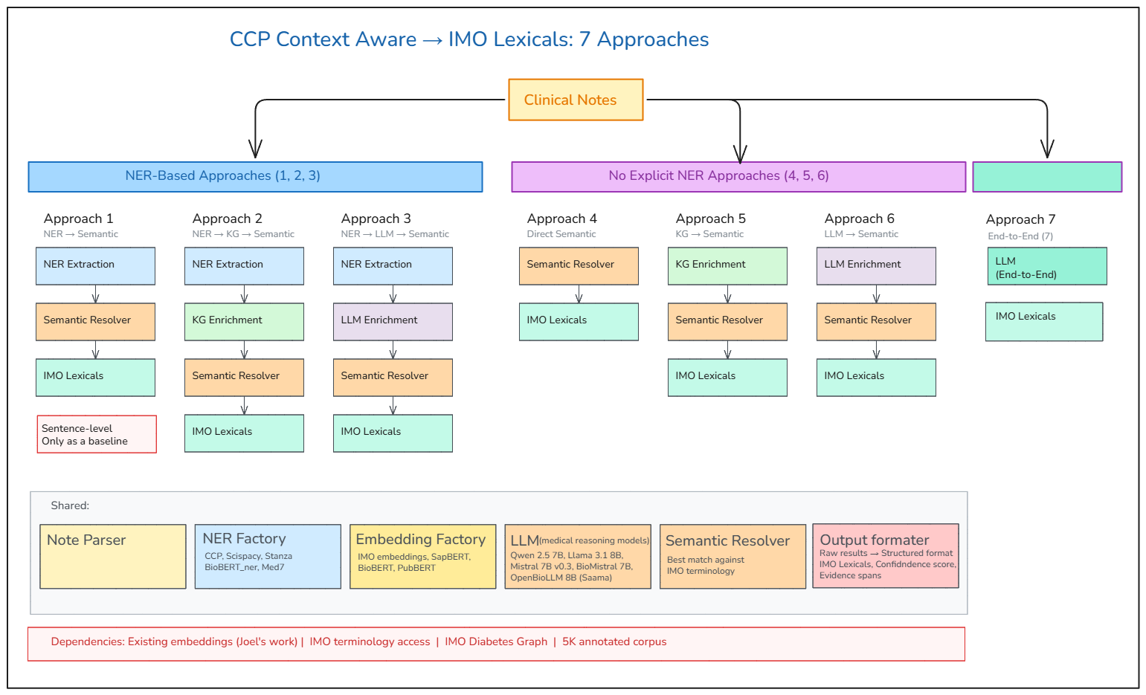

4. Pipeline Stages
All approaches share a common pipeline abstraction with six stages. The difference between approaches is which stages are active, what component handles each stage, and whether stages are explicit or implicit.

Stage | Name | Description | Used By
1 | Evidence Extraction | Extract entities + modifiers from clinical note using NER models, LLM, or direct embedding | Explicit: 1, 2, 3 (NER); Implicit: 5, 6, 7 (KG/LLM); Skipped: 4
2 | Mention-Level Entity Linking | Link extracted mentions to candidate IMO lexicals via embedding similarity, KG traversal, or LLM reasoning | Approaches 1-6; Approach 7 does this via LLM
3 | Filter to Domain | Filter candidate IMO lexicals to diabetes domain using IMO Diabetes Knowledge Graph | All approaches; Approach 7 via prompt constraint
4 | Document-Level Entity Inference | Cross-sentence context resolution. Combine mention-level entities into document-level clinical concepts | All approaches; Approach 7 does this natively
5 | Relevance Scoring | Rank and score candidate IMO lexicals with confidence scores, evidence spans, and review flags | All approaches
6 | Mapping (Out of Scope) | IMO Lexical → ICD-10-CM / SNOMED CT. Not part of current POC | Future scope

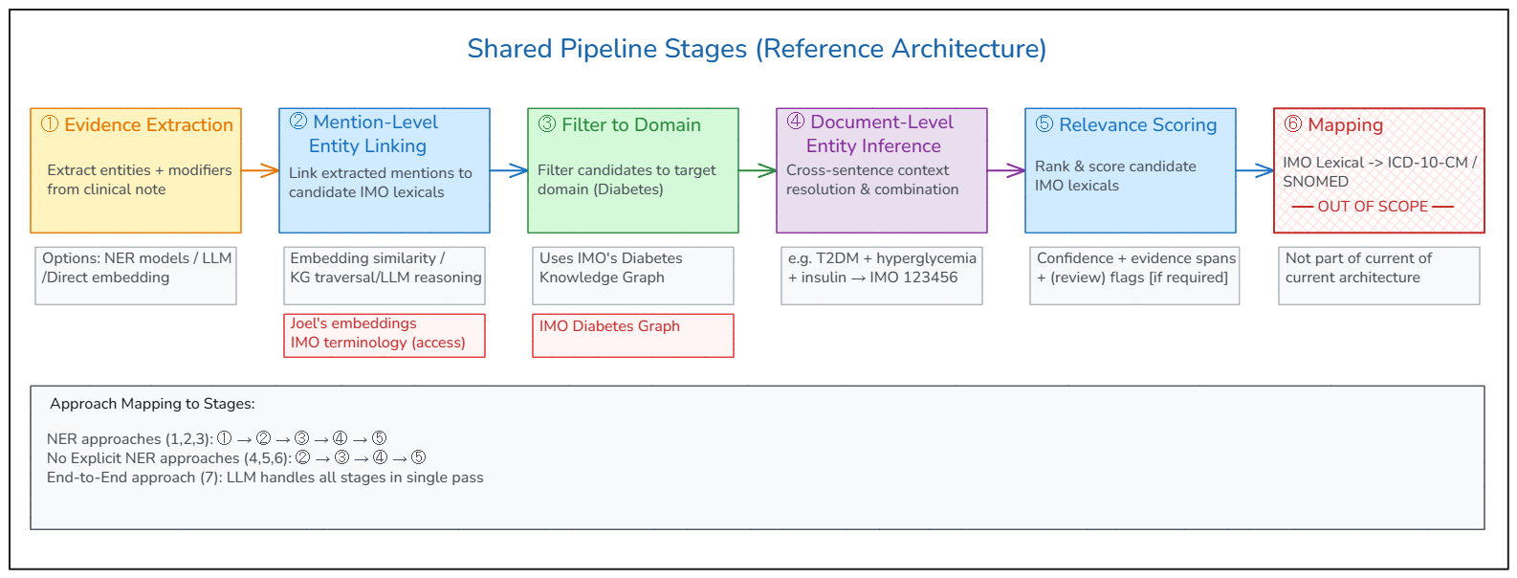

5. Shared Components
All approaches share common components built behind a factory pattern, enabling swappable models for benchmarking. Approach 7 bypasses most shared components, using a single LLM instead.

Component | Purpose | Options
Note Parser | Parse clinical notes into sections with character offsets | Custom parser
NER Factory | Extract clinical entities from text | CCP, ScispaCy, Stanza, BioBERT_ner, Med7
Embedding Factory | Generate vector representations of clinical text for similarity matching | IMO embeddings (Joel), SapBERT, BioBERT, PubBERT
Semantic Resolver | Find best match against IMO terminology using embeddings from the Embedding Factory | FAISS / cosine similarity + reranker
LLM Factory | Provide configurable LLM access for enrichment (Approaches 3, 6) and end-to-end (Approach 7) | Qwen 2.5 7B, Llama 3.1 8B, BioMistral 7B, Claude (Bedrock)
Output Formatter | Structure raw results into standardized format: IMO lexicals, confidence scores, evidence spans | Pydantic models + table renderer

6. Experiment Plan
Experiments are sequenced in three phases, ordered by dependency availability. Approach 7 runs alongside Phase 1 as a baseline.

Phase 1: Baselines (No Dependencies)
- Experiment 1: Approach 1 (NER → Semantic) — sentence-level NER with public embeddings
- Experiment 2: Approach 4 (Direct Semantic) — no NER, direct sentence embedding against IMO lexicals
- Experiment 3: Approach 7 (Pure LLM) — end-to-end LLM baseline, extraction + enrichment + resolution in single pass
Key Questions: Does NER extraction improve over direct semantic matching? How does the pure LLM baseline compare?

Phase 2: LLM Enrichment (No Dependencies)
- Experiment 4: Approach 3 (NER → LLM → Semantic) — NER extraction with LLM context enrichment
- Experiment 5: Approach 6 (LLM → Semantic) — LLM reads full note, produces enriched entities for semantic resolution
Key Question: Does LLM context enrichment improve specificity of IMO lexical matching?

Phase 3: KG Enrichment
- Experiment 6: Approach 2 (NER → KG → Semantic) — NER extraction with Knowledge Graph enrichment
- Experiment 7: Approach 5 (KG → Semantic) — Knowledge Graph enrichment with implicit extraction
Key Question: Does structured KG enrichment outperform LLM enrichment?
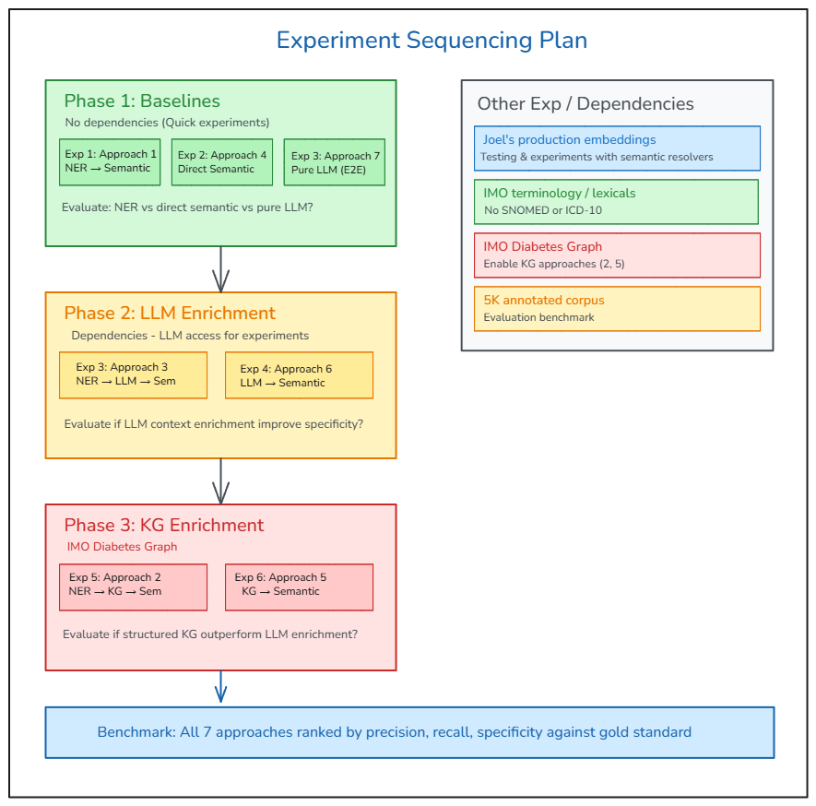

7. Evaluation Framework
All approaches produce identical output format via the Output Formatter, enabling direct comparison across the following metrics:

Metric | Description
Precision | Of the IMO lexicals returned, how many are correct?
Recall | Of all correct IMO lexicals, how many were found?
Specificity | How specific are the matched lexicals? (e.g., E11.65 vs E11.9 equivalent)
Code Coverage | Percentage of clinical concepts in the note that received an IMO lexical match
Latency | Processing time per clinical note
Explainability | Can the system provide traceable evidence spans and reasoning for each match?

Gold Standard: 5,000-note annotated corpus with sentence-level clinical expert annotations (to be obtained).

8. Dependencies
Dependency | Impact | Affects
Joel's production embeddings | Swap into all semantic resolvers for improved matching quality | Approaches 1-6
IMO terminology access | Required as the target terminology for semantic resolution and LLM prompting | All approaches
IMO Diabetes Graph | Enable KG-based enrichment and domain filtering | Approaches 2, 5
5K annotated corpus | Establish evaluation benchmark and gold standard | All approaches

9. Tech Stack
Component | Technology
Language | Python 3.11+
API | FastAPI
NER Models | CCP, ScispaCy, Stanza, BioBERT_ner, Med7
Embedding Models | SapBERT, BioBERT, PubBERT, IMO embeddings (Joel)
LLM (Local) | Qwen 2.5 7B, Llama 3.1 8B, BioMistral 7B (via Ollama)
LLM (Cloud) | Claude via AWS Bedrock
Vector Search | FAISS
Knowledge Graph | IMO Diabetes Graph (when available)

10. Key Suggested Steps
- Connect with Joel on production embeddings and integrate into semantic resolvers
- Integrate IMO terminology once access is available
- Build Diabetes Knowledge Graph and run Phase 3 experiments
- Establish evaluation benchmark with 5K annotated corpus
- Final benchmark: all 7 approaches ranked by precision, recall, specificity, and explainability

