Enterprise Architecture Deliverables
Price Assurance Contract-Invoice Reconciliation
July 06, 2026

Contents
Enterprise Architecture Deliverables 4
1. Document Control 4
2. Executive Summary 4
3. Enterprise Architecture 4
3.1 Enterprise Context 4
3.2 Enterprise Capabilities 4
3.3 Enterprise Principles 5
4. Solution Architecture 5
4.1 Logical Architecture 5
4.2 Solution Components 6
4.3 Key Design Decision 6
5. Medallion Architecture 6
5.1 Layer Overview 6
5.2 Bronze Layer 7
5.3 Silver Layer 7
5.4 Gold Layer 8
6. Ontology Architecture 8
6.1 What Is The Ontology Layer? 8
6.2 Ontology Storage Model 8
6.3 Core Ontology Objects 9
6.4 Core Ontology Relationships 9
6.5 How Ontology Helps Reconciliation 9
7. Data Flow 9
7.1 End-to-End Data Flow 9
7.2 Data Movement Detail 10
8. Processing Flow 10
8.1 Batch Processing Flow 10
8.2 Invoice Line Reconciliation Flow 10
8.3 Rule Processing Flow 11
9. Component Diagram 11
10. Deployment Diagram 12
10.1 Deployment Units 12
11. Unity Catalog Design 12
11.1 Catalog Strategy 12
11.2 Schema Strategy 13
11.3 Naming Convention 13
11.4 Securable Object Design 13
11.5 Managed vs External Storage 13
11.6 Access Control Model 14
11.7 Recommended Groups 14
11.8 Table Classification And Tags 14
11.9 Lineage And Audit 14
11.10 Retention Guidance 14
12. Non-Functional Architecture 15
13. Interfaces 15
13.1 Batch Interfaces 15
13.2 API Interfaces 15
14. Risks And Mitigations 15
15. Implementation Roadmap 16
16. Reference Implementation Files 16
17. External References 16
Solution Schematic Architecture Diagrams 17
1. Enterprise Architecture 18
2. Medallion Architecture 19
3. Ontology Architecture 20
4. Logical Data Model 21
5. Physical Data Model 22
6. Entity Relationship Diagram 23
7. Data Flow Diagram 24
8. Pipeline Dependency Diagram 25
9. Workflow Diagram 26
10. Unity Catalog Hierarchy 27
11. Security Architecture 28
12. Lakeflow Pipeline Flow 29
13. Matching Engine Architecture 30
14. Validation Engine Architecture 31
15. Gold Analytics Architecture 32
16. Monitoring & Observability 33

Enterprise Architecture Deliverables

1. Document Control
Attribute | Value
Solution | Price Assurance Contract-Invoice Reconciliation
Domain | Supply Chain / GPO / AP Price Assurance
Platform | Databricks Lakehouse with Unity Catalog
Architecture Pattern | Medallion Delta Architecture + Ontology Graph Layer
Data Assumption | Contract and invoice data are already structured and parsed
Runtime Scope | Batch reconciliation, API reconciliation, analyst exception workflow
Primary Consumers | AP analysts, sourcing teams, finance operations, contract managers, BI users

2. Executive Summary
The proposed solution is an enterprise-grade Price Assurance platform that reconciles structured invoice lines against structured contract terms. It uses Databricks as the governed backend, Delta tables for Medallion-layer data management, Unity Catalog for security and lineage, and an ontology graph layer for semantic relationships and explainable matching.
The architecture is intentionally split into:
- Bronze for raw structured source payloads.
- Silver for conformed, deduplicated, normalized business entities.
- Ontology for semantic graph relationships, rule metadata, matching policy, and explainability.
- Gold for business-ready compliance facts, leakage summaries, dispute workflow, and exception queues.
- Serving/API for application, dashboard, and workflow consumption.
The ontology layer does not replace Medallion architecture. It sits over curated Silver entities and Gold outputs to power graph-based reconciliation and application semantics.

3. Enterprise Architecture

3.1 Enterprise Context
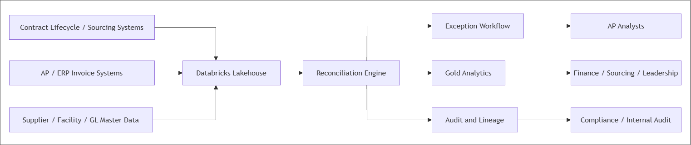
Figure 1: Enterprise Architecture

3.2 Enterprise Capabilities
Capability | Description
Contract price validation | Validate invoice line pricing against active contract and amendment terms
Contract availability validation | Detect suppliers/invoices with no contract on file
Facility scope validation | Confirm contract applies to invoicing facility
GL/category alignment | Compare invoice spend category and GL coding to supplier/contract classification
UOM normalization | Convert invoice UOM to contract UOM before price comparison
Exception detection | Detect rate above contract, unmatched charge, excluded charge, expedite fee, insufficient data
Dispute workflow | Manage disputes, disputed lines, supplier messages, and resolution
Supplier exposure analytics | Summarize overpayment, prepaid exceptions, in-dispute amount, AP spend
Auditability | Persist rule-level validation, findings, graph evidence, and user actions
Governance | Use Unity Catalog grants, lineage, audit logs, and tags

3.3 Enterprise Principles
Principle | Design Implication
Raw data must be retained | Bronze stores raw structured payloads with source metadata
Business entities must be conformed | Silver owns canonical contracts, invoices, suppliers, facilities, GL, categories
Results must be explainable | Each finding links to validation rules, contract terms, graph edges, and evidence
Financial validation must be deterministic | Price and quantity validators remain rule-based and reproducible
Semantic reasoning should be explicit | Ontology graph stores domain relationships used by matching and workflow
Gold is for business consumption | Gold tables serve dashboards, queues, scorecards, and AP workflow
Governance is first-class | Unity Catalog controls permissions, lineage, discovery, and audit

4. Solution Architecture

4.1 Logical Architecture
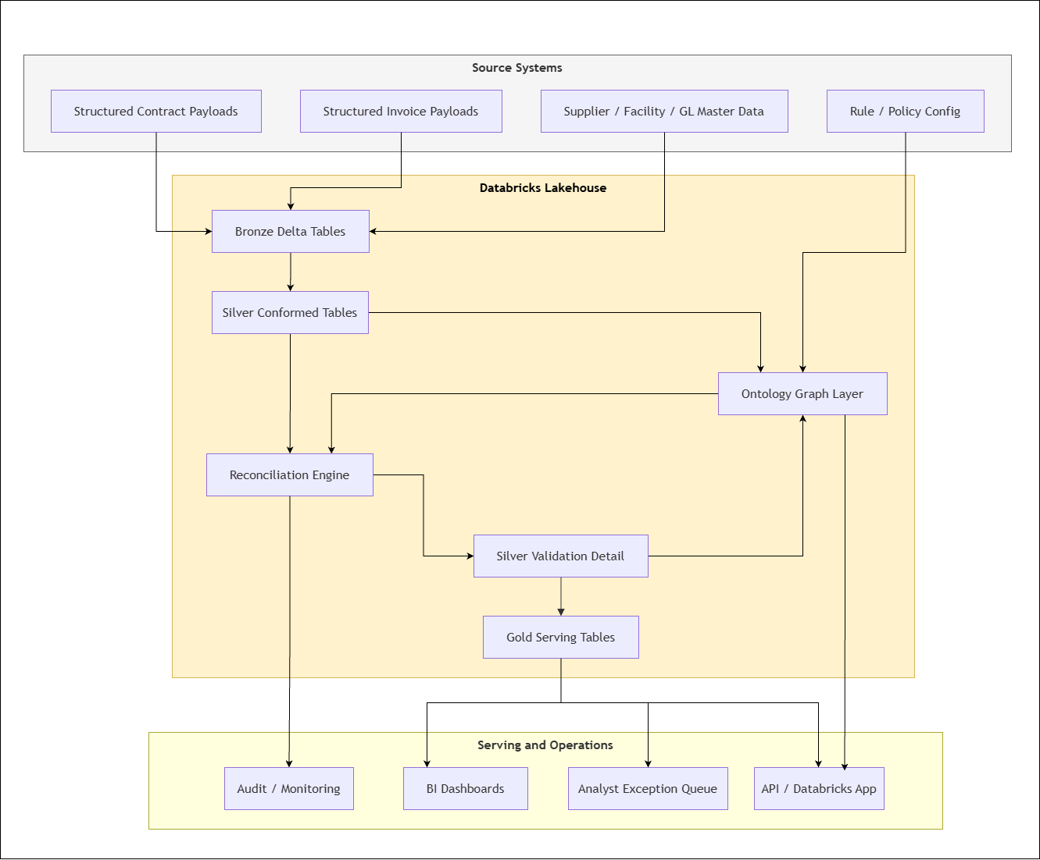
Figure 2: Solution Architecture

4.2 Solution Components
Component | Responsibility | Primary Storage
Source ingestion adapter | Receives structured contract, invoice, supplier, rule, dispute payloads | Bronze
Silver normalization jobs | Clean, deduplicate, type cast, standardize keys, conform master data | Silver
Amendment resolver | Builds active/effective contract term intervals | Silver
Ontology graph builder | Creates nodes, edges, bindings, triples from Silver/Gold objects | Ontology
Matching engine | Retrieves and scores candidate contract terms | Silver + Ontology
Validator registry | Runs deterministic validation rules | Ontology rule catalog + Silver outputs
Findings generator | Converts rule failures into business findings | Silver finding
Gold publisher | Creates facts, summaries, exception queues, supplier scorecards | Gold
API/app layer | Serves reconciliation, findings, ontology relationships, overrides | Gold + Ontology
Observability/audit | Stores run metrics, events, lineage references | Ops + Ontology

4.3 Key Design Decision
The ontology layer should be used todrive reconciliation, not only to describe Gold results.
Reason: Matching needs semantic relationships before Gold exists:
- Contract scoped to facility.
- Supplier known aliases.
- Contract line supported by clause.
- Invoice line matched to contract line.
- Rule violated by finding.
- Dispute includes invoice line.
Therefore:
Code / configuration
Silver provides trusted entities.
Ontology provides semantic relationships and rule context.
Gold provides business-ready outcomes.

5. Medallion Architecture

5.1 Layer Overview
Figure 3: Medallion Architecture

5.2 Bronze Layer
Bronze stores raw structured data with minimal transformation. Since documents are already parsed, Bronze does not perform OCR or PDF/image extraction.
Table | Grain | Purpose
pspa_bronze.suppliers | One supplier payload | Preserve supplier profile, aliases, AP metrics
pspa_bronze.contracts | One contract/amendment payload | Preserve raw structured contract header
pspa_bronze.contract_line | One raw contract line | Preserve raw contract term fields
pspa_bronze.invoice | One invoice header payload | Preserve raw AP invoice header
pspa_bronze.invoice_line | One invoice line payload | Preserve raw invoice line fields
pspa_bronze.detection_rule | One rule payload | Preserve rule config from UI/source
pspa_bronze.dispute | One dispute payload | Preserve dispute and message thread source
pspa_bronze.supplier_contacts | Supplier and contract mapped
pspa_bronze.documents | Uploaded document details
pspa_bronze.contract_charge_terms

Bronze required metadata:
- source_system
- source_record_id
- source_batch_id
- payload_json
- schema_version
- load_status
- ingested_at

5.3 Silver Layer
Silver owns trusted, reusable business entities.
Domain | Silver Tables
Organization | party, facility_profile, party_relationship, party_alias, party_contact
Supplier | supplier_profile, supplier_category
Finance classification | category, gl_account
Contract | contract, contract_version, contract_line_term, effective_contract_line_term, contract_clause, contract_facility_scope
Invoice | invoice, invoice_line
Reconciliation detail | reconciliation_run, validation_result, finding
Users | application_user, application_user_role

Silver responsibilities:
- Standardize IDs and keys.
- Normalize supplier aliases.
- Map facilities to health systems.
- Map GL codes and spend categories.
- Resolve amendment precedence.
- Build effective contract term intervals.
- Preserve detailed validation results.

5.4 Gold Layer
Gold contains business-ready outputs.
Table | Purpose
gold.invoice_line_compliance_fact | Final line-level compliance status, match, variance, remediation
gold.invoice_compliance_summary | Invoice-level verdict, exception count, total exposure
gold.contract_leakage_summary | Leakage by supplier, member/facility, contract, category, period
gold.exception_work_queue | Analyst-facing queue for exceptions and reviews
gold.supplier_price_assurance_summary | Supplier-level AP spend, overpayment, dispute, prepaid exposure
gold.dispute_case | Dispute lifecycle
gold.dispute_case_line | Disputed invoice lines
gold.dispute_message | Supplier/AP message thread

Gold consumption:
- BI dashboards.
- AP approval queue.
- Dispute workflow.
- Supplier scorecards.
- Sourcing analytics.
- Finance leadership reporting.

6. Ontology Architecture

6.1 What Is The Ontology Layer?
The ontology layer is a semantic graph over curated Silver entities and Gold outputs. It describes what the business objects mean and how they relate.
It has four responsibilities:
- Represent business objects as graph nodes.
- Represent relationships as graph edges.
- Bind graph nodes back to physical Delta rows.
- Store rules, matching, audit, and semantic metadata.

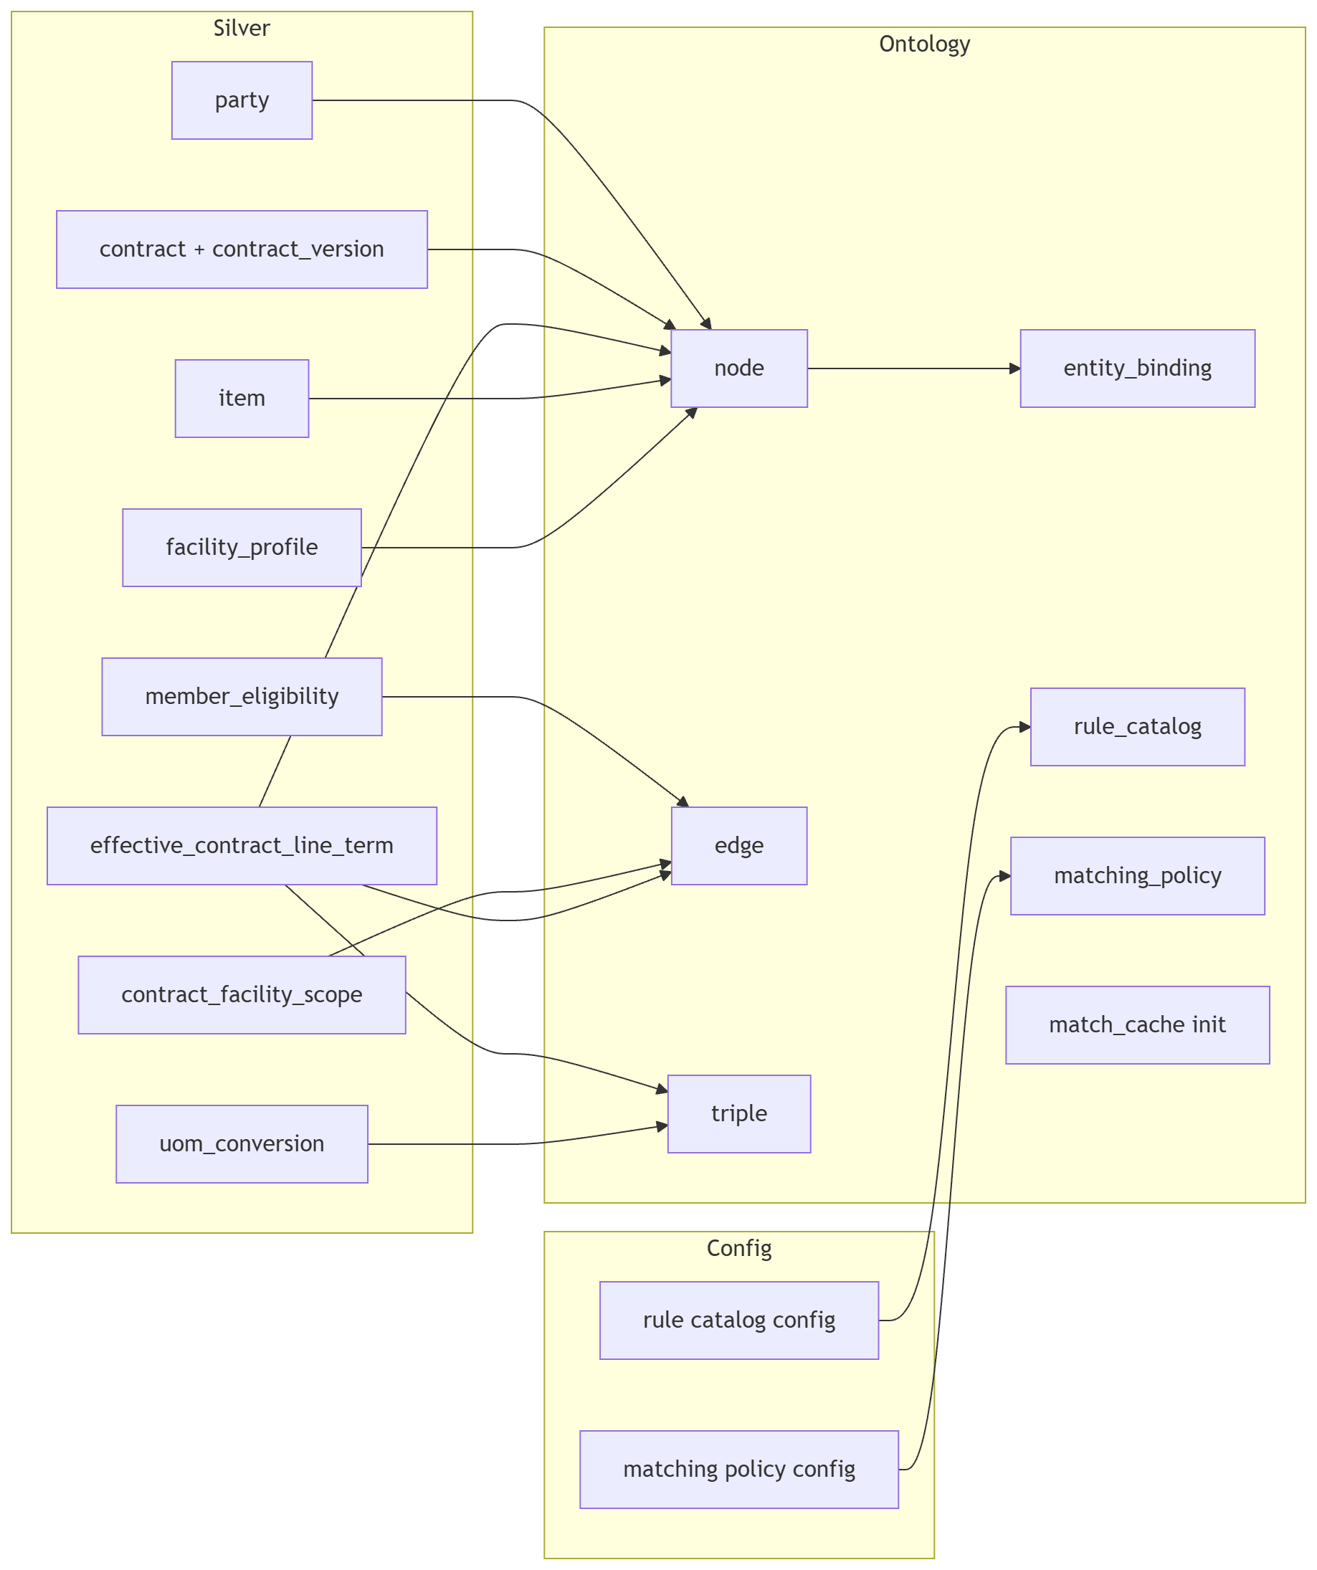
Figure 4: Build Sequence (from Silver to Ontology)

6.2 Ontology Storage Model
Table | Purpose
ontology.node | Semantic object registry
ontology.edge | Relationships between objects
ontology.triple | Optional RDF-style assertions
ontology.entity_binding | Maps graph node to catalog.schema.table row
ontology.rule_catalog | Rule metadata, trigger, severity, action
ontology.matching_policy | Matching weights and thresholds
ontology.match_cache | Fast-path match cache
ontology.audit_event | Semantic audit events and user actions

6.3 Core Ontology Objects
Ontology Object | Backing Table
Health System | silver.party
Facility | silver.party, silver.facility_profile
Supplier | silver.party, silver.supplier_profile
Contract | silver.contract
Contract Version | silver.contract_version
Contract Line Term | silver.contract_line_term
Effective Contract Term | silver.effective_contract_line_term
Contract Clause | silver.contract_clause
Invoice | silver.invoice
Invoice Line | silver.invoice_line
Rule | ontology.rule_catalog
Validation Result | silver.validation_result
Finding | silver.finding
Exception | gold.exception_work_queue
Dispute | gold.dispute_case
User | silver.application_user

6.4 Core Ontology Relationships
Figure 5: Ontology Relationships

6.5 How Ontology Helps Reconciliation
Reconciliation Need | Ontology Support
Match supplier aliases | Supplier HAS_ALIAS Alias
Validate facility-specific contract | Contract SCOPED_TO_FACILITY Facility
Explain price source | ContractLine SUPPORTED_BY_CLAUSE ContractClause
Detect excluded charges | Rule and clause relationship marks prohibited terms
Route soft exceptions | Rule severity and action metadata
Explain finding | Finding links to rule, invoice line, contract line, clause
Create dispute | Exception links to invoice line, supplier, messages
Audit override | User/action edges and audit events

7. Data Flow

7.1 End-to-End Data Flow
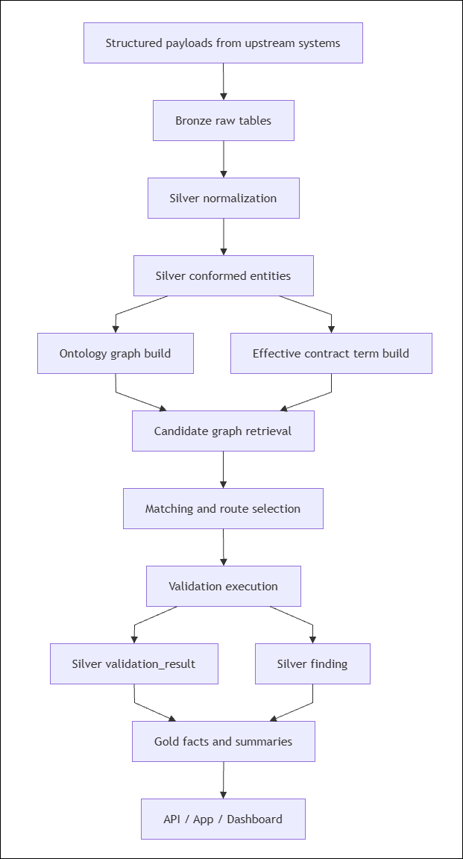
Figure 6: Data Flow

7.2 Data Movement Detail
Step | Input | Output | Layer
1 | Structured source records | Raw payload rows | Bronze
2 | Raw payload rows | Typed, conformed entities | Silver
3 | Contract versions/terms | Effective contract line intervals | Silver
4 | Silver entities | Nodes, edges, bindings | Ontology
5 | Invoice lines + graph | Match candidates | Processing
6 | Match candidates + rules | Validation results | Silver
7 | Validation results | Findings | Silver
8 | Findings/results | Facts, summaries, queues | Gold
9 | Gold + ontology | API/app responses | Serving

8. Processing Flow

8.1 Batch Processing Flow
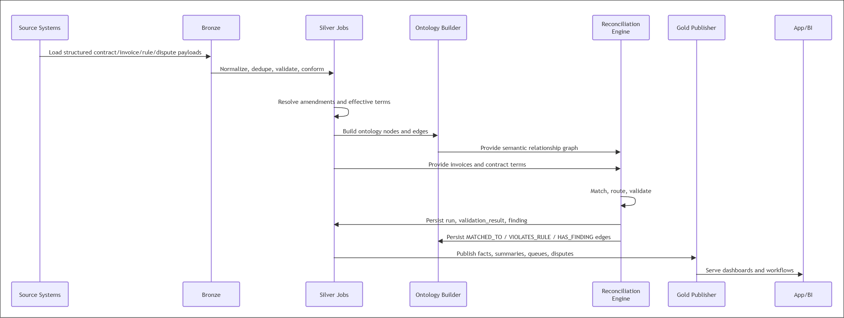
Figure 7: Batch Processing Flow

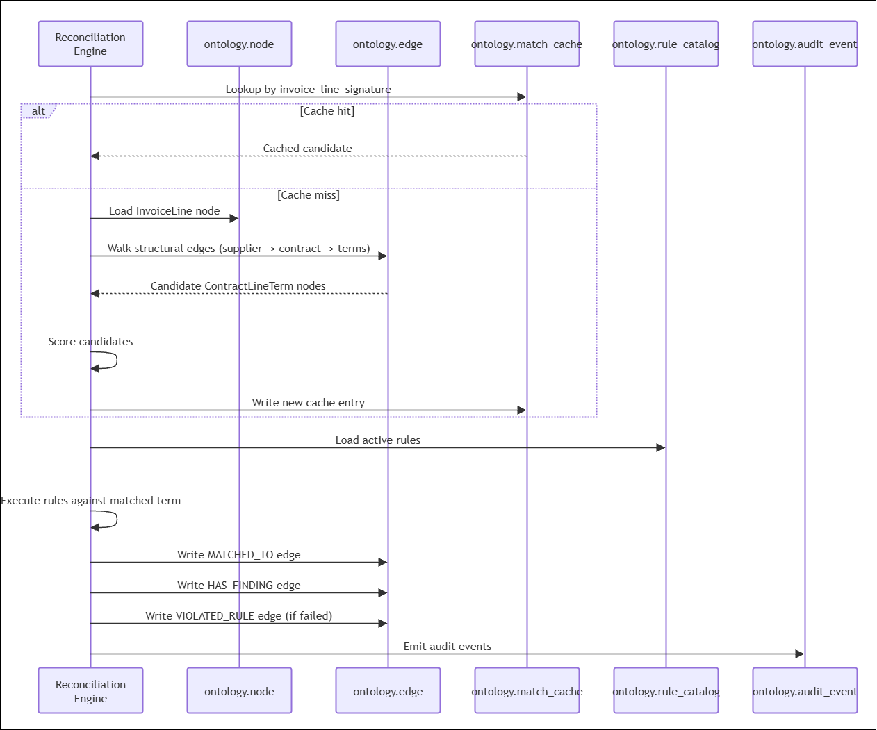
Figure 8: Runtime Data Flow During Reconciliation

8.2 Invoice Line Reconciliation Flow
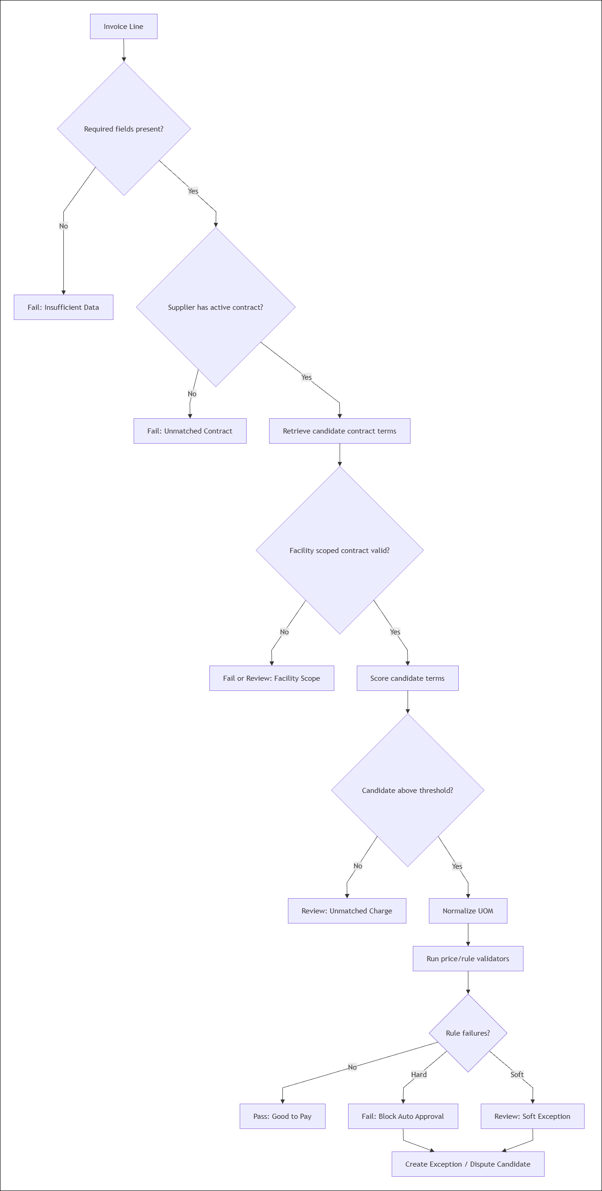

8.3 Rule Processing Flow
Rule | Trigger | Result
Rate Above Contract | billed_price > contracted_rate + tolerance | Hard exception; variance calculated
Unmatched Charge | No contract line match | Hard exception or manual matching queue
Unmatched Contract | Supplier/facility has no active contract | Hard exception; block approval
Unmapped Charge | No category or term mapping | Hard exception; AP review
Insufficient Data | Missing UOM, quantity, price | Hard exception; request corrected invoice
Expedite Fee | Description contains rush/expedite/emergency terms | Soft exception; verify authorization

9. Component Diagram
TBC

10. Deployment Diagram
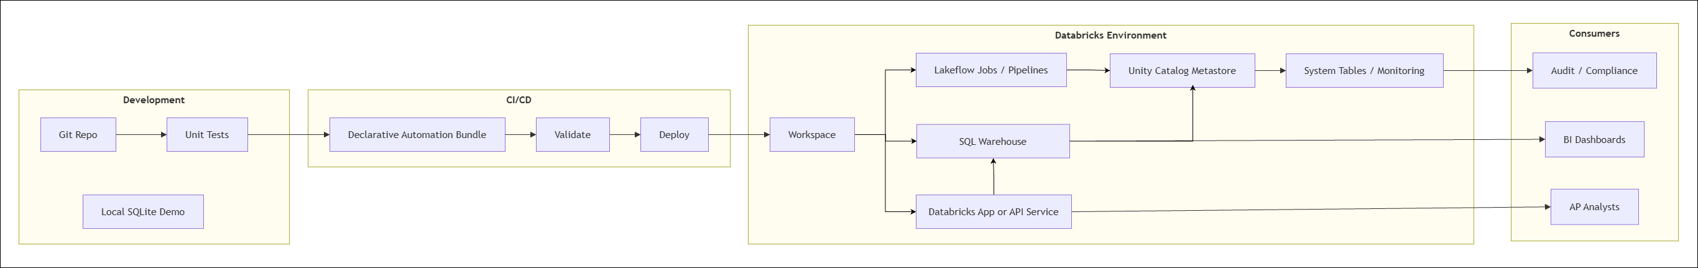
Figure 9: End-to-end Deployment

10.1 Deployment Units
Unit | Deployment Mechanism
SQL schemas/tables | Databricks SQL scripts or bundle resource
Batch jobs | Lakeflow Jobs / Spark jobs
Pipelines | Lakeflow Spark Declarative Pipelines where appropriate
Python engine | Wheel artifact or source deployment
API/app | Databricks App, container service, or external FastAPI
Dashboards | Databricks dashboards or BI tool
Monitoring | System tables, audit logs, custom ops metrics

11. Unity Catalog Design

11.1 Catalog Strategy
Recommended catalog:
Code / configuration
pspa
Alternative enterprise pattern:
Code / configuration
dev_pspa
test_pspa
prod_pspa
For regulated or large enterprise environments, use separate catalogs by environment to simplify isolation, grants, and lifecycle controls.

11.2 Schema Strategy
Schema | Owner | Purpose
bronze | Data engineering | Raw structured payloads
silver | Data engineering + domain data owners | Conformed entities and validation detail
ontology | Platform/data architecture | Graph, rules, policies, cache, semantic audit
gold | Analytics/product owners | Business facts, summaries, exception queues
ops | Platform operations | Metrics, run health, monitoring

11.3 Naming Convention
Code / configuration
<catalog>.<schema>.<object>
Examples:
Code / configuration
pspa.bronze.invoice_raw
pspa.silver.effective_contract_line_term
pspa.ontology.edge
pspa.gold.invoice_line_compliance_fact
pspa.ops.reconciliation_metric

11.4 Securable Object Design
Unity Catalog uses a three-level namespace for tables, views, volumes, functions, models, and services. This solution should use that object model for governance.
Object Type | Recommendation
Catalog | One per environment/domain, for example prod_pspa
Schema | Separate Bronze, Silver, Ontology, Gold, Ops
Table | Delta managed tables for curated data
View | Secure views for analyst-facing subsets
Volume | Optional landing area for structured source payload snapshots
Function | Optional reusable SQL functions for rules or UOM conversion
Model/function serving | Optional semantic scoring or model-based matching

11.5 Managed vs External Storage
Asset | Recommendation
Bronze raw Delta tables | Managed tables unless enterprise policy requires external locations
Silver/Gold Delta tables | Managed tables preferred
External raw payload files | Use external locations and volumes if raw files must remain in cloud storage
Application logs/exports | Use governed volumes or managed tables

11.6 Access Control Model
Persona / Principal | Bronze | Silver | Ontology | Gold | Ops
Data engineering service principal | Read/write | Read/write | Read/write | Read/write | Read/write
Reconciliation job service principal | Read | Read/write validation detail | Read/write graph/cache/audit | Write facts | Write metrics
AP analyst | No direct | Limited read | Limited read via views | Read/update exception workflow | No direct
Sourcing analyst | No direct | Read contracts/suppliers | Read ontology relationships | Read summaries | No direct
Finance leadership | No direct | No direct | No direct | Read dashboards/views | No direct
Compliance/audit | Read via controlled views | Read | Read | Read | Read

11.7 Recommended Groups
Code / configuration
grp_pspa_data_engineers
grp_pspa_reconciliation_jobs
grp_pspa_ap_analysts
grp_pspa_sourcing_analysts
grp_pspa_finance_readers
grp_pspa_auditors
grp_pspa_admins

11.8 Table Classification And Tags
Recommended tags:
Tag | Example Values
domain | price_assurance, supply_chain, ap
layer | bronze, silver, ontology, gold, ops
data_sensitivity | internal, confidential, restricted
contains_pii | true, false
owner | data owner group
retention_class | raw_7_year, audit_7_year, metric_2_year

11.9 Lineage And Audit
Unity Catalog should be used with:
- Lineage from Bronze to Silver to Gold.
- Audit logs for table access.
- Audit events for reconciliation actions.
- Rule and policy version captured on every run.
- Dispute and override action history.

11.10 Retention Guidance
Data | Suggested Retention
Bronze raw payloads | 7 years or enterprise AP audit policy
Silver contracts/invoices | 7 years or contract retention policy
Validation results/findings | 7 years
Gold facts/summaries | 7 years
Dispute messages | 7 years or legal hold policy
Ops metrics | 1-2 years

12. Non-Functional Architecture
Requirement | Design
Scalability | Spark/Databricks jobs for batch reconciliation
Performance | Gold tables optimized for dashboard/query access; match cache for repeated line patterns
Reliability | Idempotent batch IDs, run status, retryable jobs
Auditability | Persist raw payload, validation result, finding, audit event, rule version
Security | Unity Catalog grants, service principals, secure views
Explainability | Ontology edges and clause evidence linked to findings
Maintainability | Repository abstraction, rule catalog, matching policy
Deployment | Declarative Automation Bundles or equivalent CI/CD

13. Interfaces

13.1 Batch Interfaces
Interface | Direction | Description
Structured contract payload | Inbound | Contract headers, terms, clauses, amendments
Structured invoice payload | Inbound | Invoice headers and lines
Supplier/facility master data | Inbound | Supplier profile, aliases, contacts, facility data
Rule/policy config | Inbound | Detection rules and thresholds
Gold facts | Outbound | Compliance facts and leakage summaries
Dispute outcomes | Outbound | Recovery/dispute status to AP workflow

13.2 API Interfaces
Endpoint | Purpose
POST /reconcile | Reconcile invoice or invoice batch
GET /reconciliation-runs/{id} | Retrieve run status
GET /invoices/{id}/findings | Retrieve invoice findings
GET /invoice-lines/{id}/validations | Retrieve rule-level validations
GET /suppliers/{id}/summary | Supplier Price Assurance scorecard
POST /exceptions/{id}/assign | Assign exception
POST /exceptions/{id}/override | Override with audit
POST /disputes | Initiate dispute
POST /disputes/{id}/messages | Add supplier/AP message

14. Risks And Mitigations
Risk | Mitigation
Source systems send changing schemas | Store raw payload as JSON/VARIANT in Bronze; evolve Silver mapping
Supplier aliases cause incorrect matching | Govern aliases in Silver and require confidence/evidence
Contract clauses are ambiguous | Store clause evidence and route low-confidence matches to review
Rule changes affect historical outcomes | Version rules and store rule version on validation results
Cache returns stale contract match | Invalidate cache on contract/amendment/item/UOM/policy changes
Analysts need explainability | Link findings to rules, terms, clauses, and graph paths
Gold dashboards become slow | Optimize Gold tables and aggregate by period/supplier/category

15. Implementation Roadmap
Phase | Scope
1 | Create Unity Catalog schemas and tables
2 | Load Bronze structured payloads
3 | Build Silver normalization for suppliers, facilities, contracts, invoices
4 | Build amendment resolver and effective contract terms
5 | Build ontology graph nodes/edges/entity bindings
6 | Implement reconciliation matching and validators on Databricks repository
7 | Publish Gold facts, summaries, exception queue
8 | Add dispute workflow tables and APIs
9 | Add dashboards and analyst UI
10 | Add monitoring, CI/CD bundles, data quality checks, and production grants

16. Reference Implementation Files
File | Purpose
sql/databricks_medallion_schema.sql | Base Medallion + Ontology schema
sql/databricks_price_assurance_extensions.sql | Price Assurance extensions from seed analysis
docs/MEDALLION_ONTOLOGY_ARCHITECTURE.md | Layering rationale
docs/PRICE_ASSURANCE_SEED_GAP_ANALYSIS.md | Field/entity gap analysis
src/ontology_reconciliation/engine.py | Demo reconciliation orchestrator
src/ontology_reconciliation/matching.py | Demo matching algorithm
src/ontology_reconciliation/validators.py | Demo validation rules

17. External References
- Databricks Medallion Lakehouse Architecture
- Databricks Unity Catalog
- Databricks Declarative Automation Bundles
- Databricks Lakeflow Spark Declarative Pipelines

Appendix
This section provides schematic architecture diagrams for the Price Assurance Contract-Invoice Reconciliation Lakehouse. Diagrams are rendered as images for Word review and presentation use.

1. Enterprise Architecture
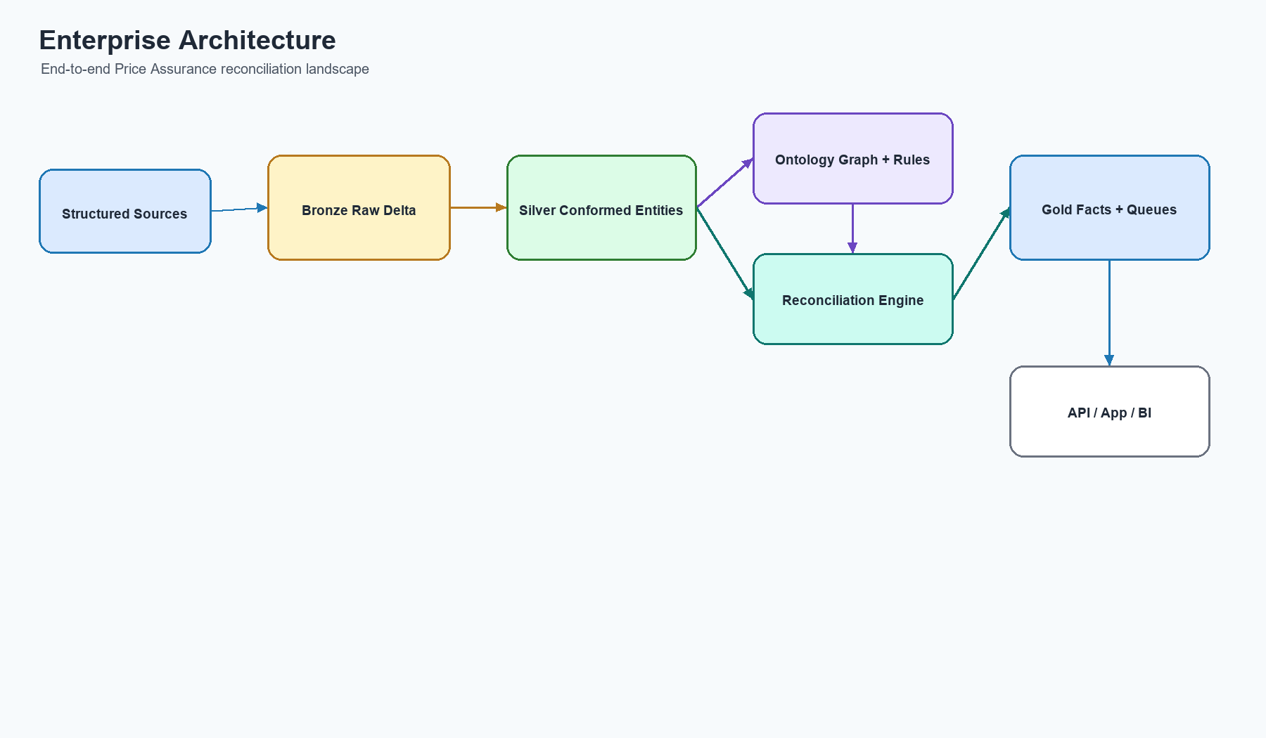
Figure 1: Enterprise Architecture

2. Medallion Architecture
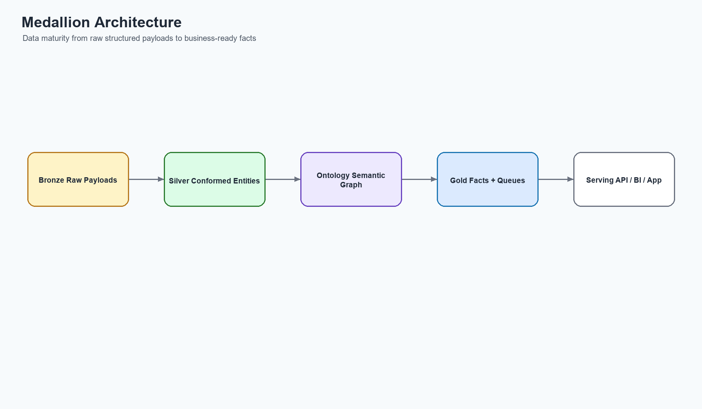
Figure 2: Medallion Architecture

3. Ontology Architecture
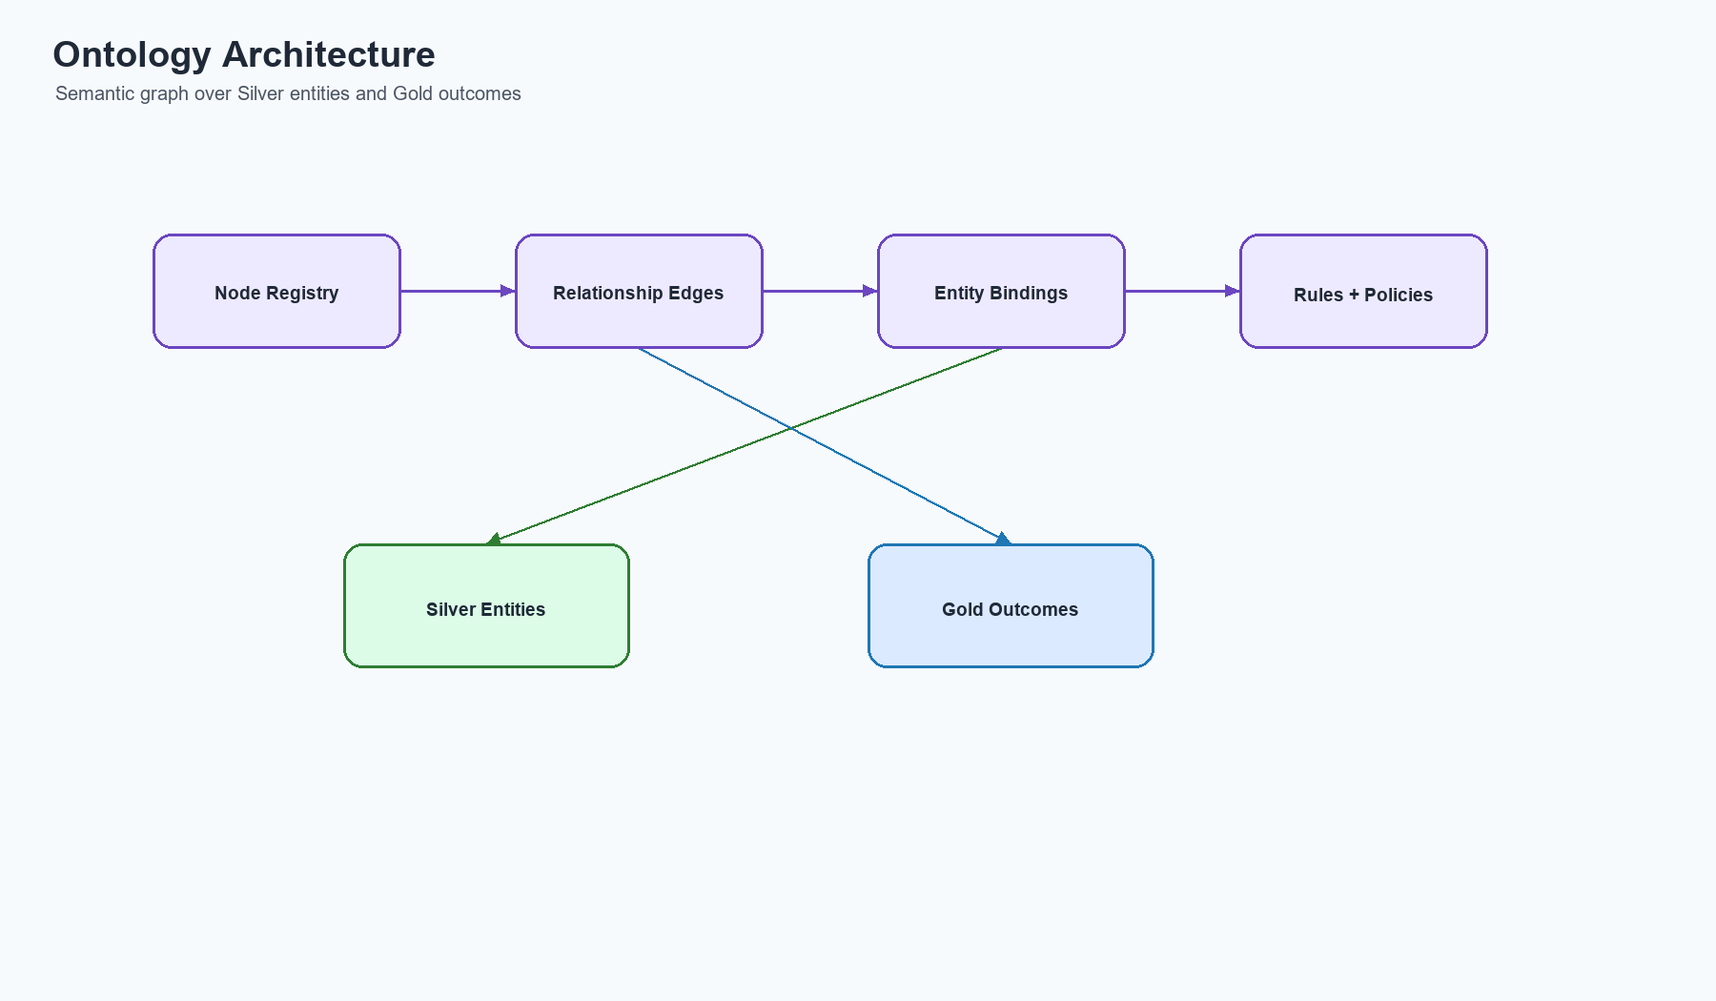
Figure 3: Ontology Architecture

4. Logical Data Model
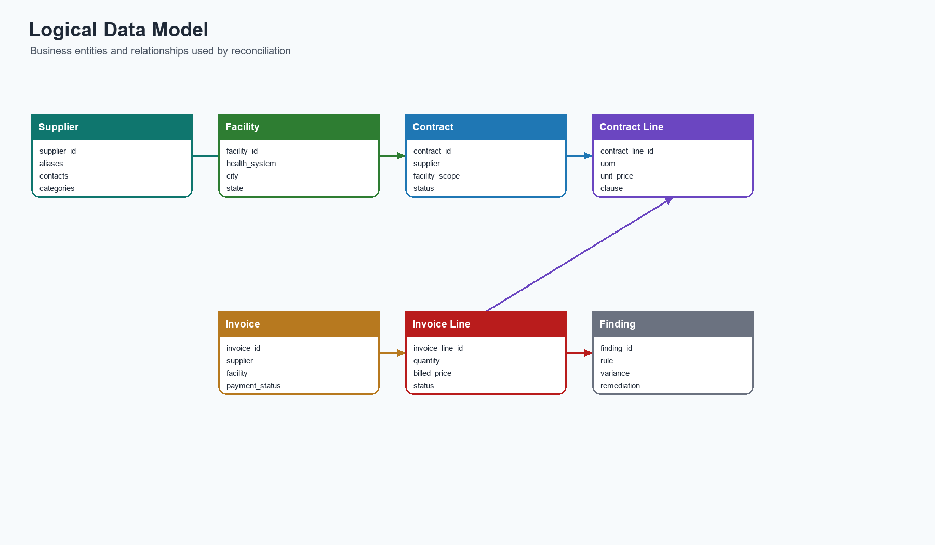
Figure 4: Logical Data Model

5. Physical Data Model
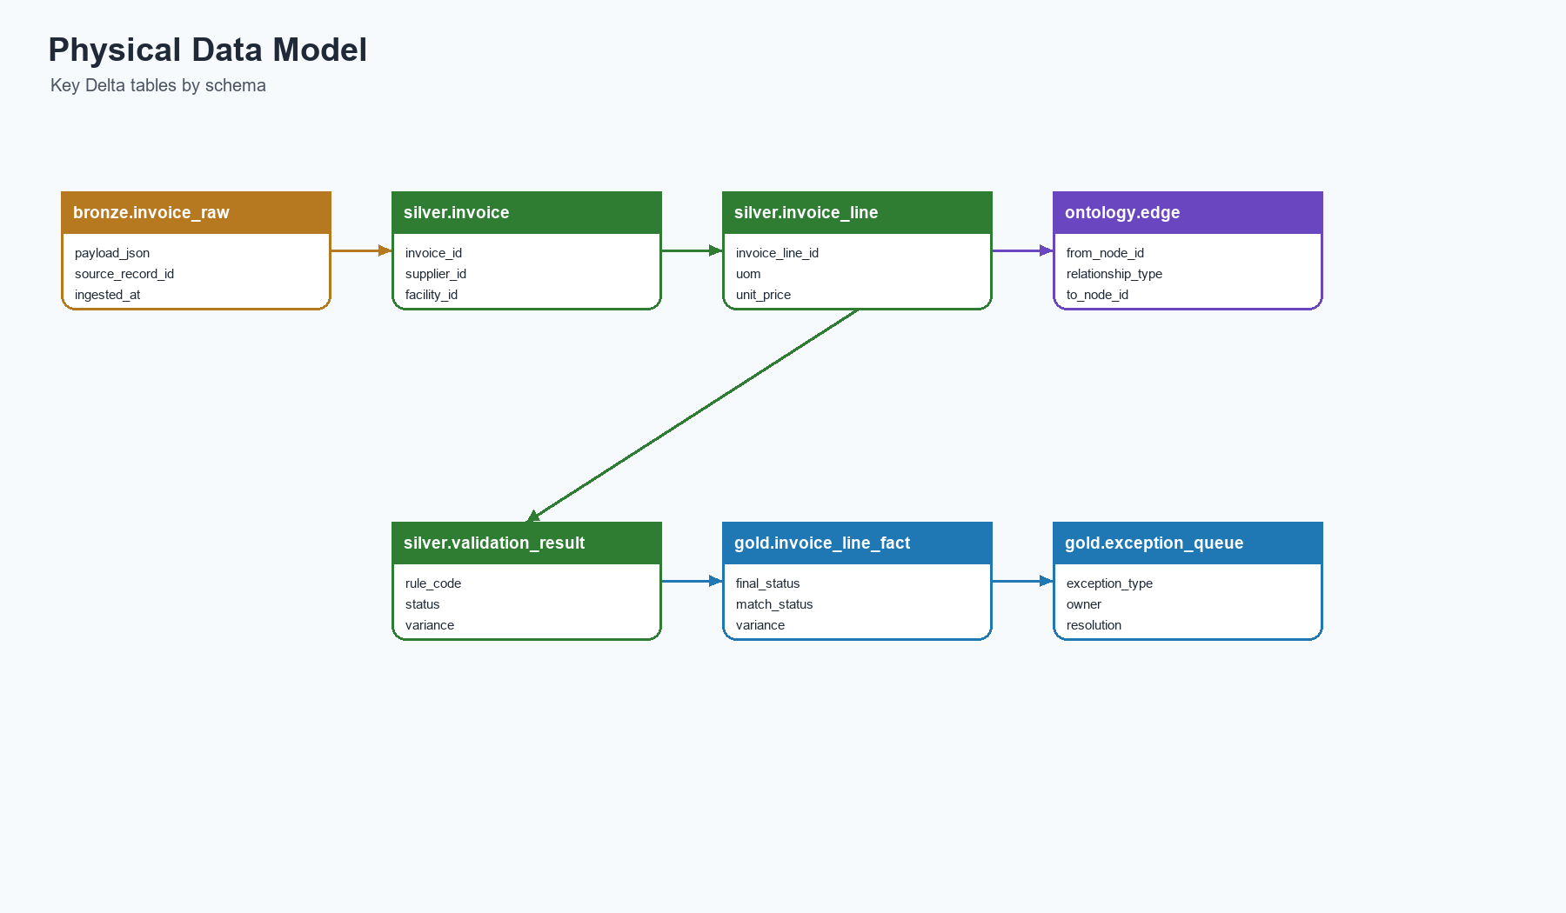
Figure 5: Physical Data Model

6. Entity Relationship Diagram
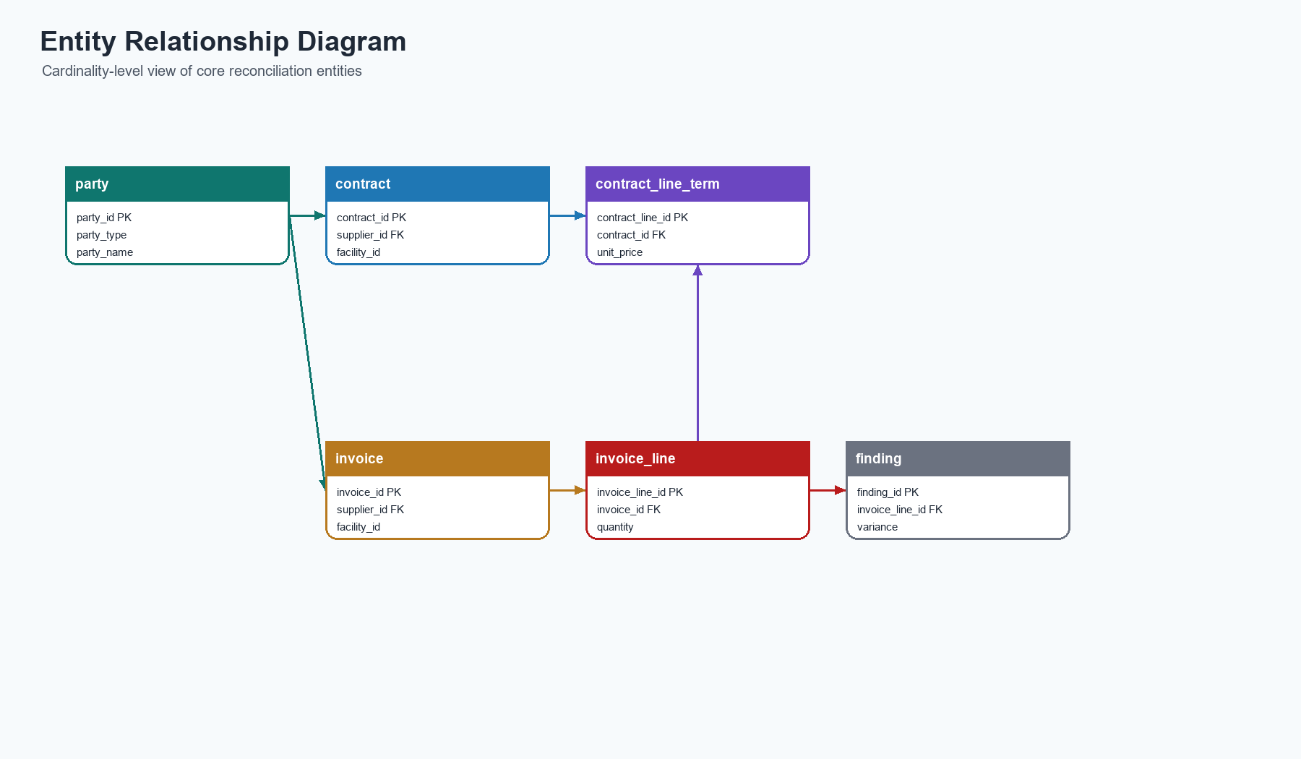
Figure 6: Entity Relationship Diagram

7. Data Flow Diagram
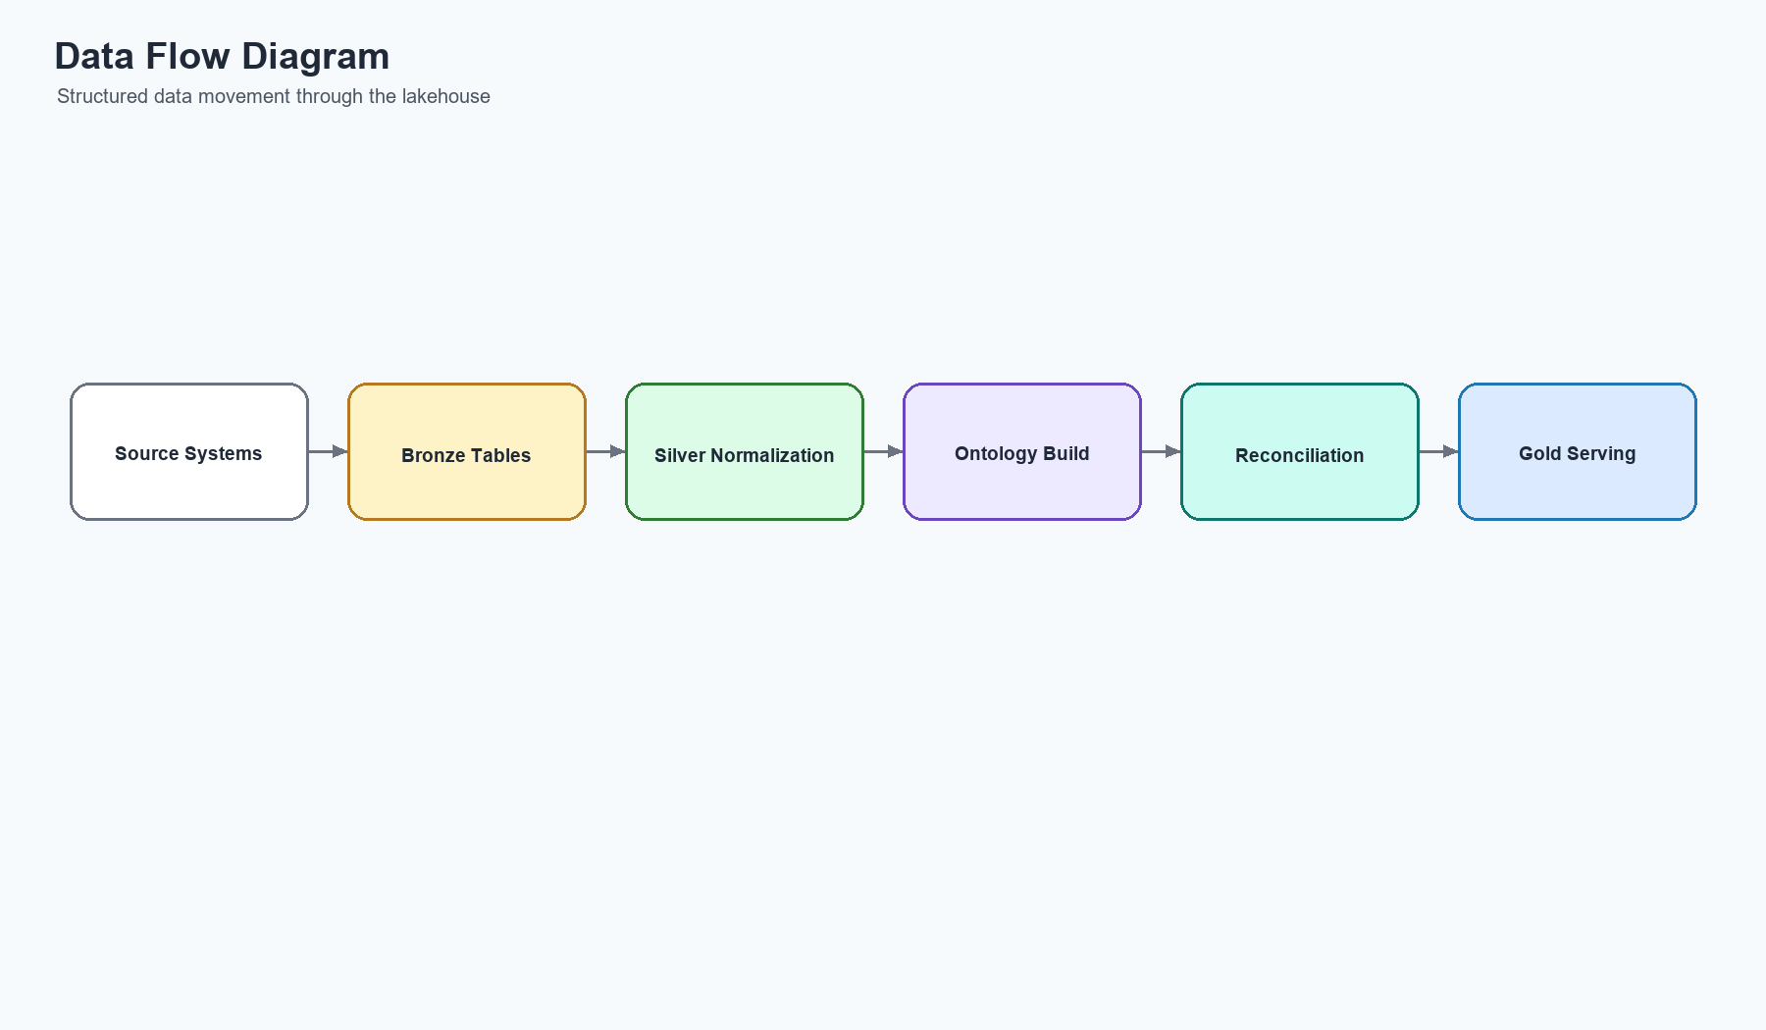
Figure 7: Data Flow Diagram

8. Pipeline Dependency Diagram
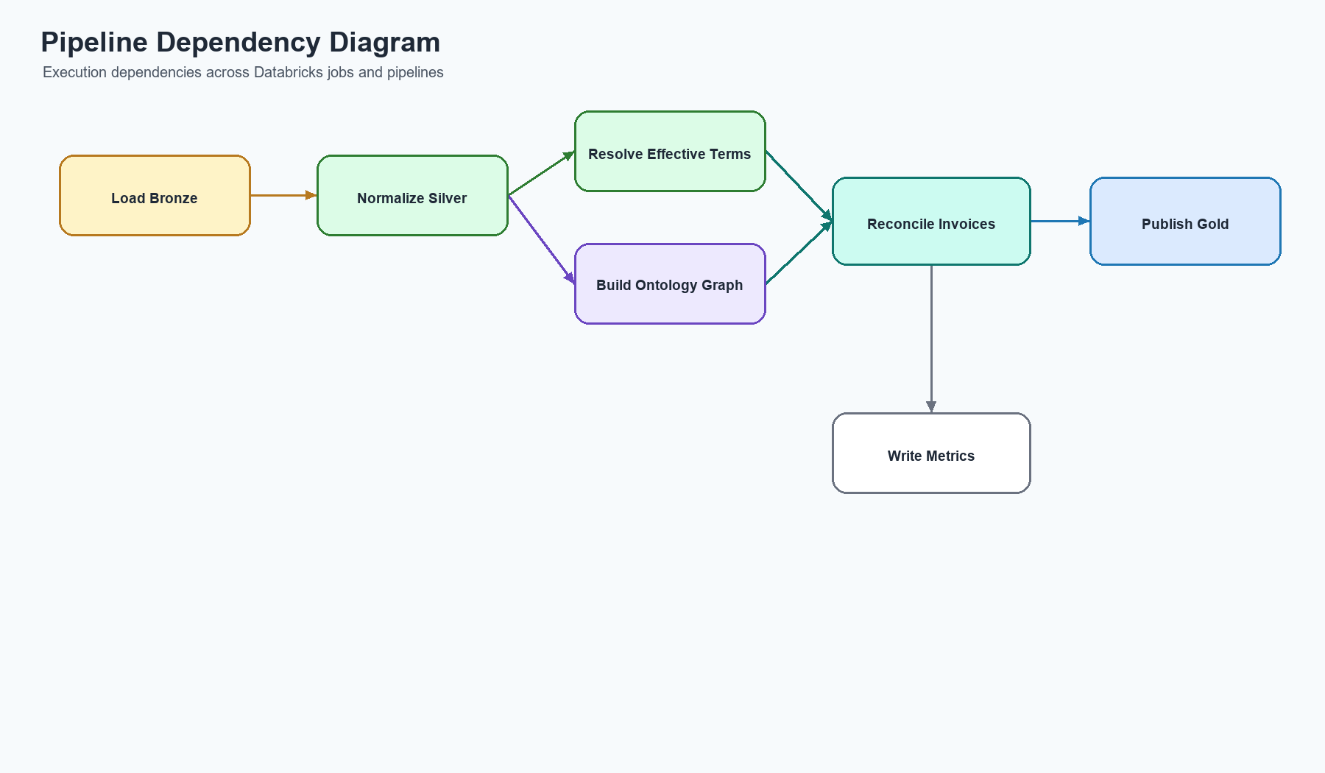
Figure 8: Pipeline Dependency Diagram

9. Workflow Diagram
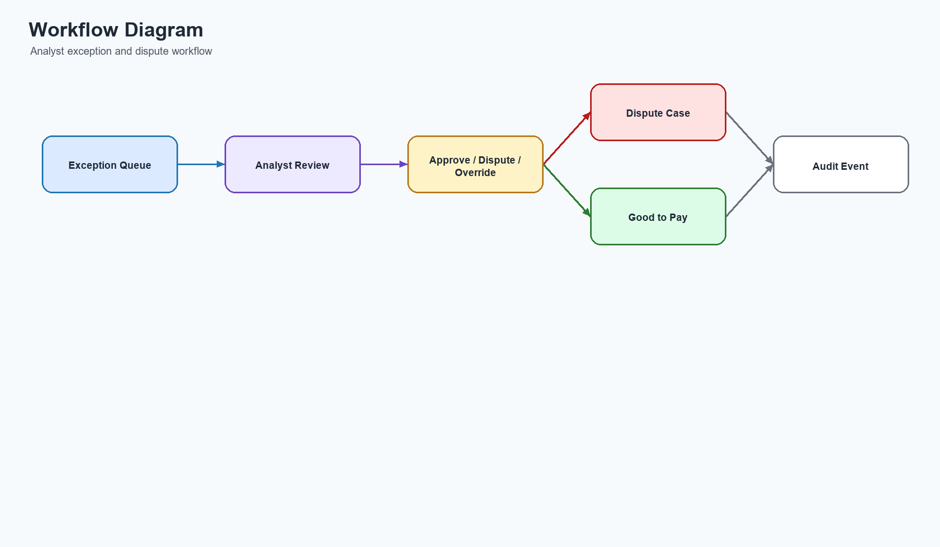
Figure 9: Workflow Diagram

10. Unity Catalog Hierarchy
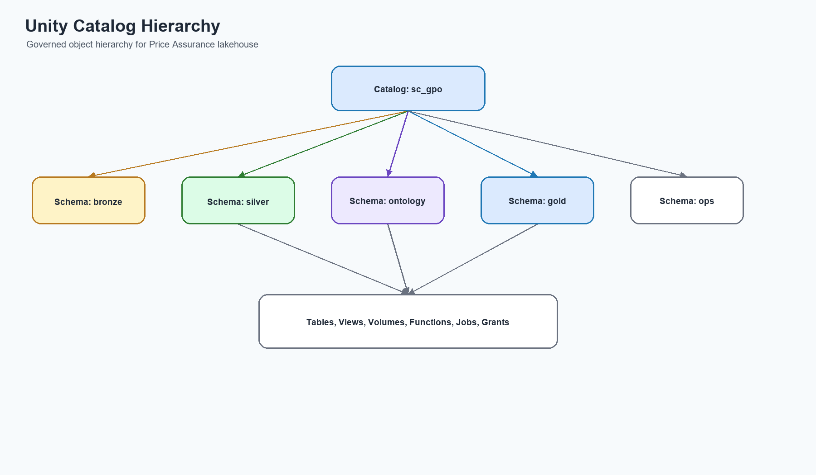
Figure 10: Unity Catalog Hierarchy

11. Security Architecture
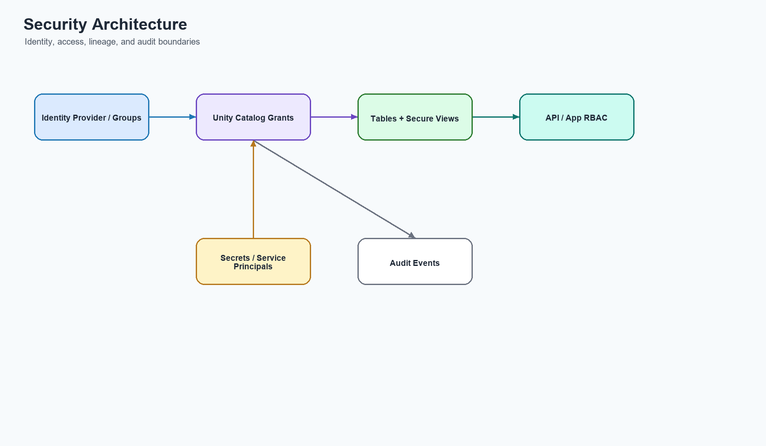
Figure 11: Security Architecture

12. Lakeflow Pipeline Flow
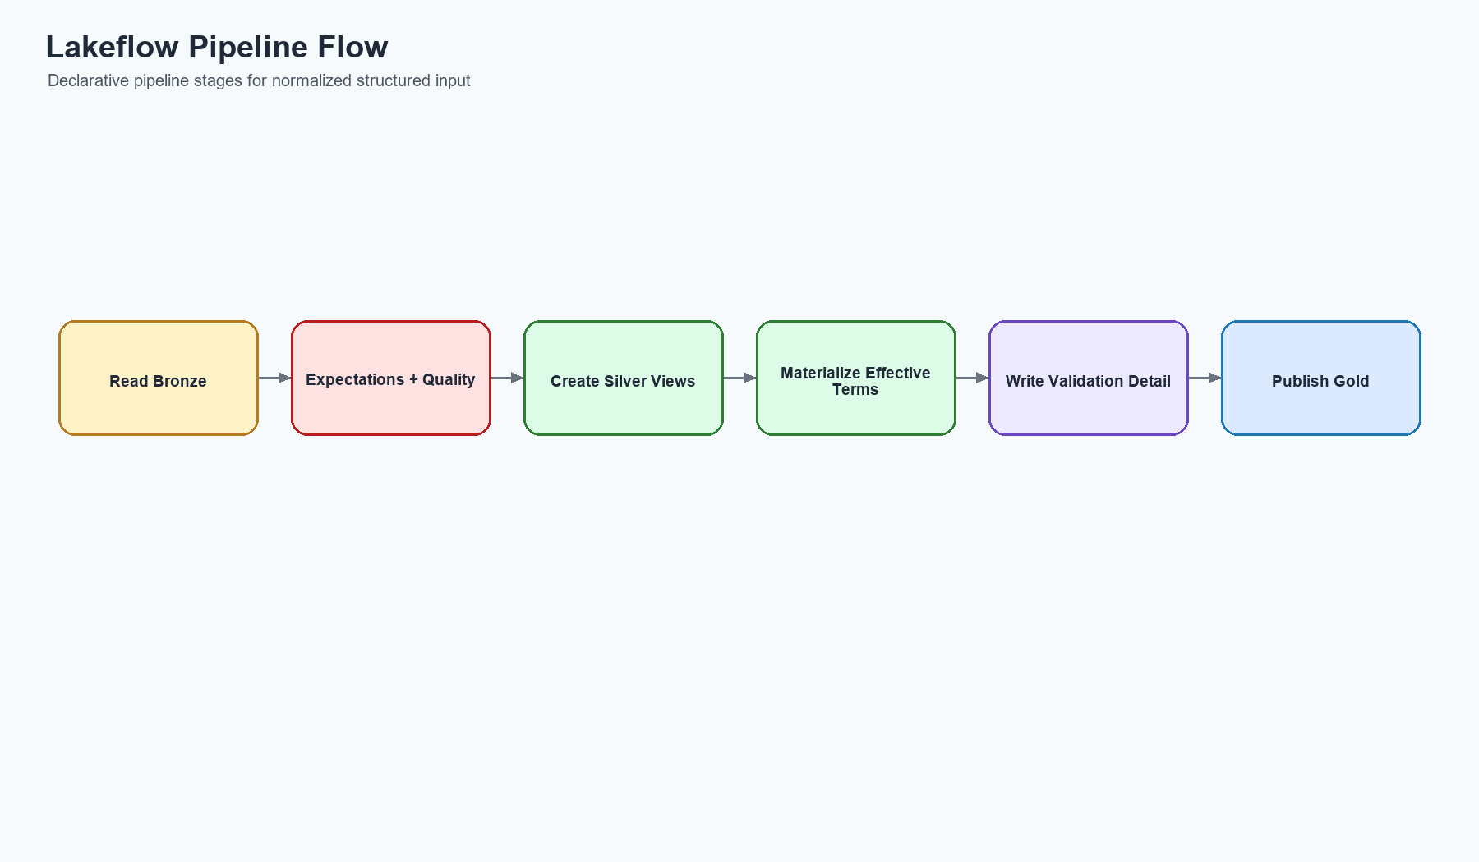
Figure 12: Lakeflow Pipeline Flow

13. Matching Engine Architecture
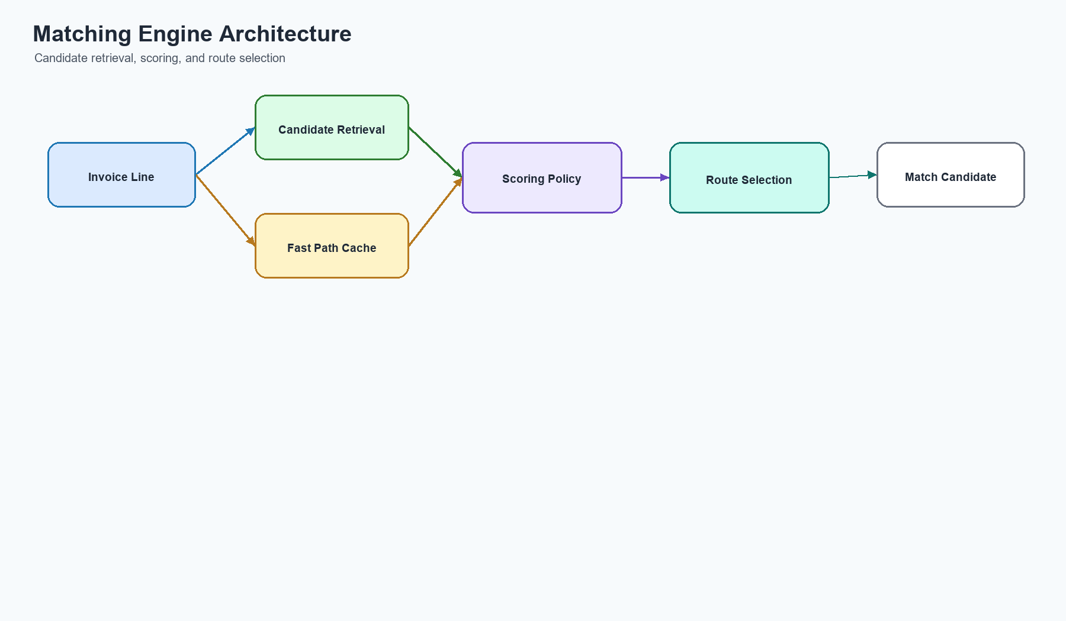
Figure 13: Matching Engine Architecture

14. Validation Engine Architecture
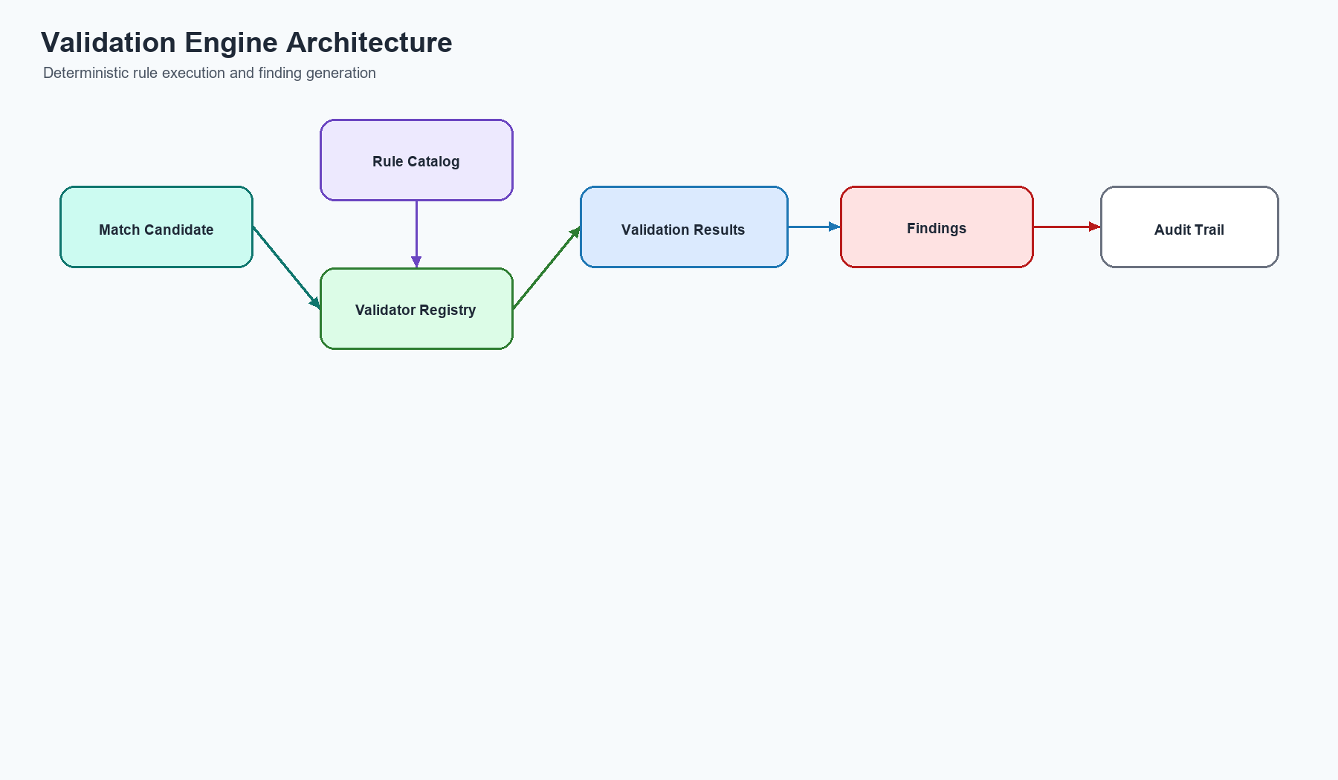
Figure 14: Validation Engine Architecture

15. Gold Analytics Architecture
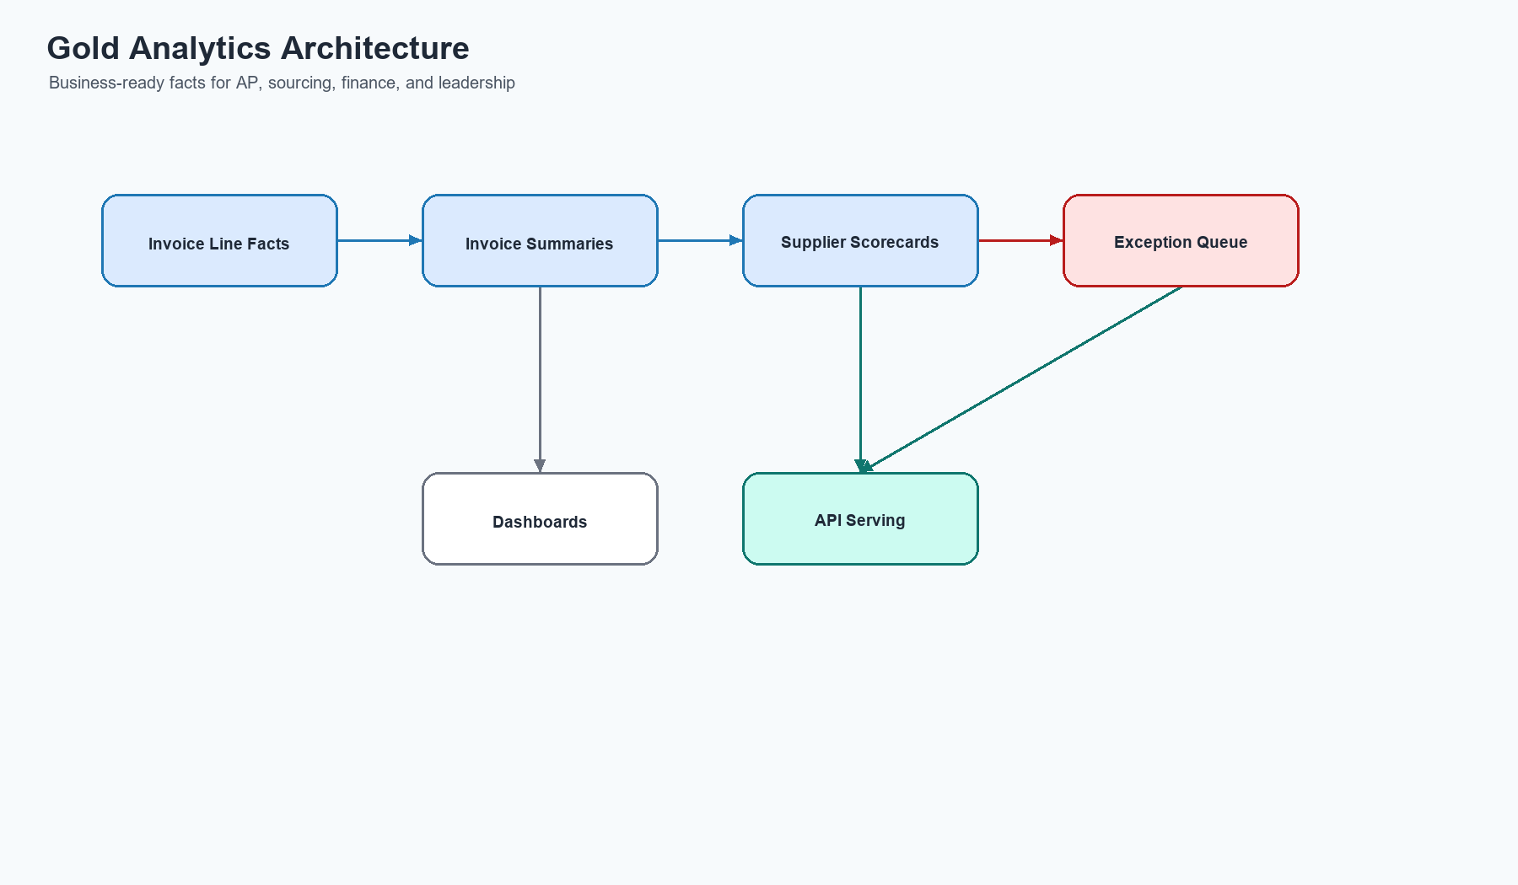
Figure 15: Gold Analytics Architecture

16. Monitoring & Observability
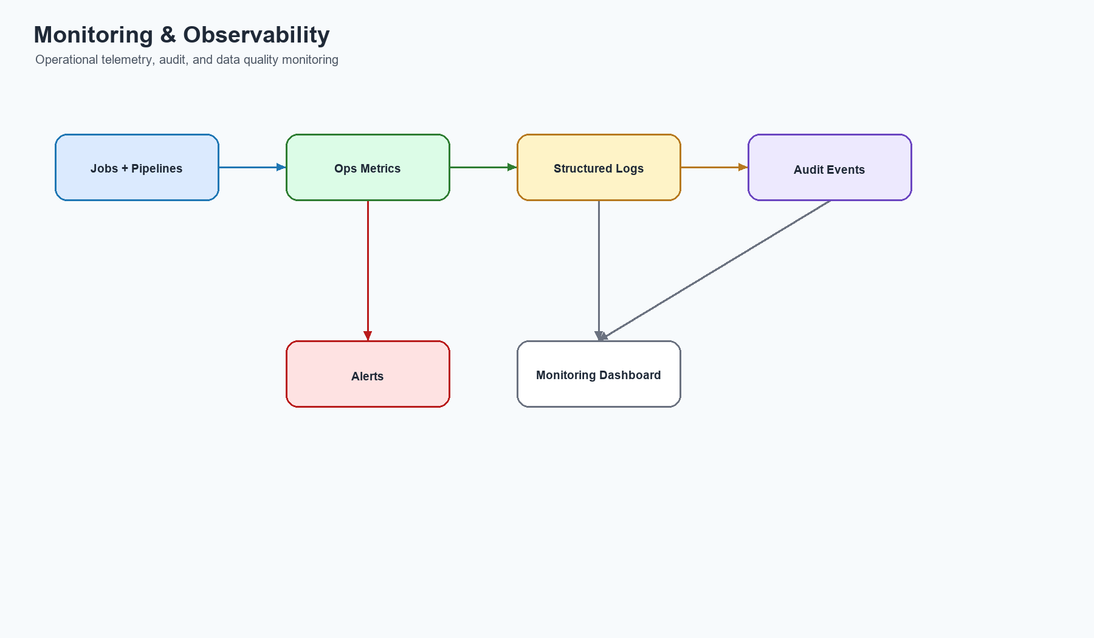
Figure 16: Monitoring & Observability

