**HEART DISEASE ANALYSIS**

**WORKFLOW**

BY:

JIVANSHU KUMAR (2001330130080)

MRIGANKA SAMADDER (2001330130095)

HARSHIT BALODIA (2001330130074)

DAKSH RAJ SINGH (2001330130053)

KHUSHI NARANG (2001330130083)

Under the Supervision

Of:

Dr. Hitesh Singh

Dr. Vivek Kumar

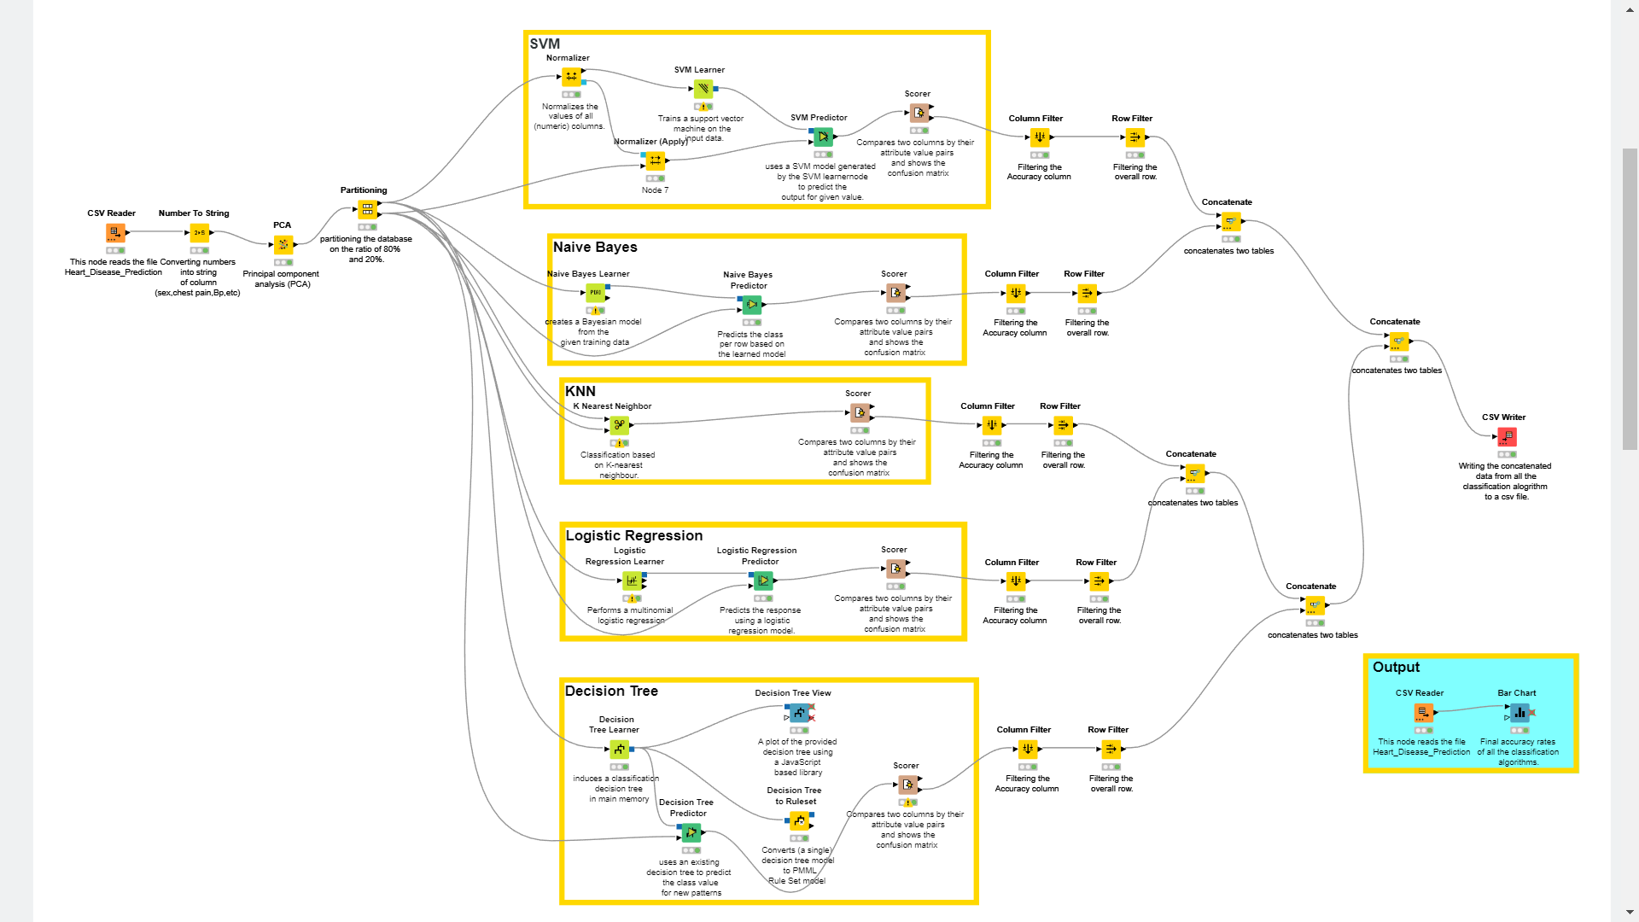

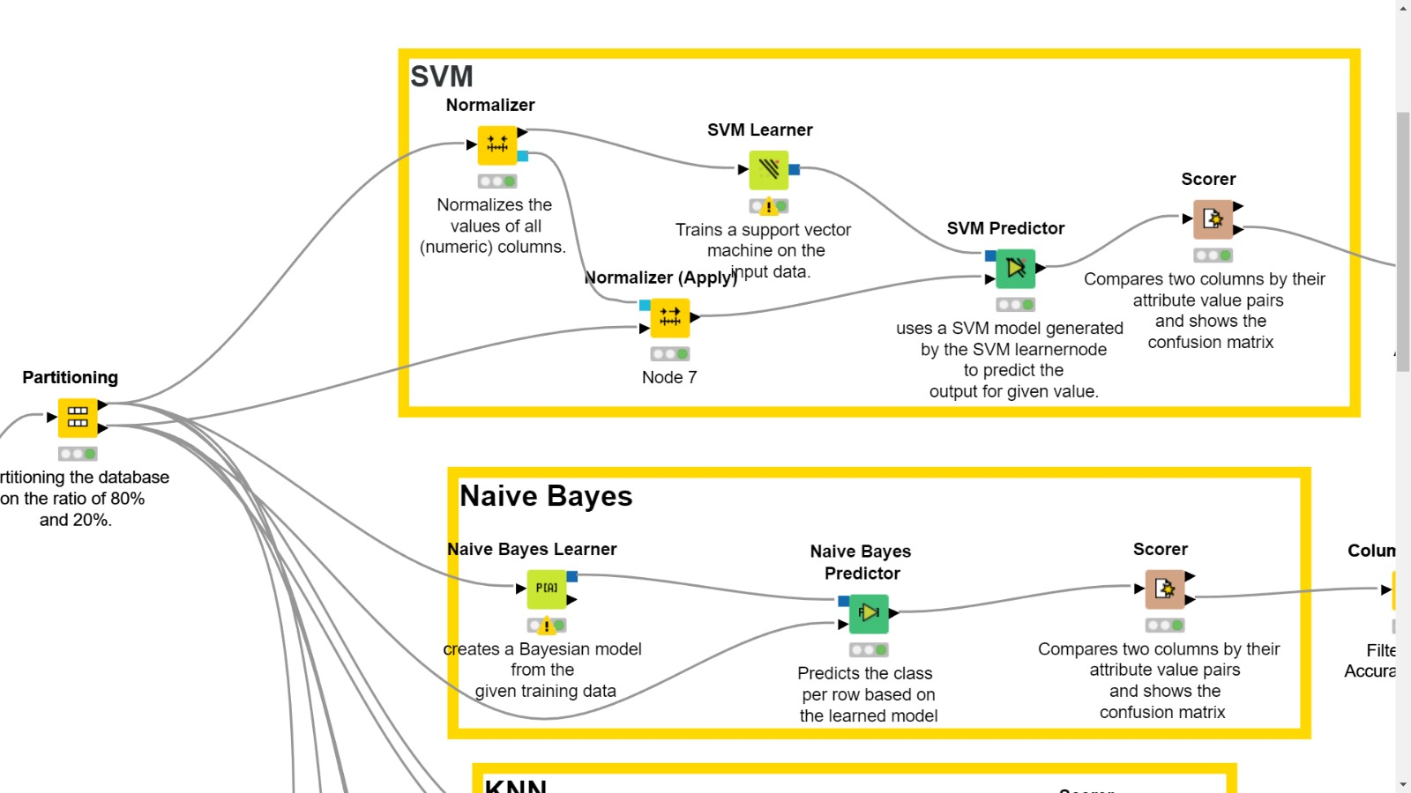

**OUTPUT**

**KNIME HUB LINK FOR THE WORKFLOW**

<https://hub.knime.com/mriganka18/spaces/Public/latest/KNIME_HeartDiseaseFinal>