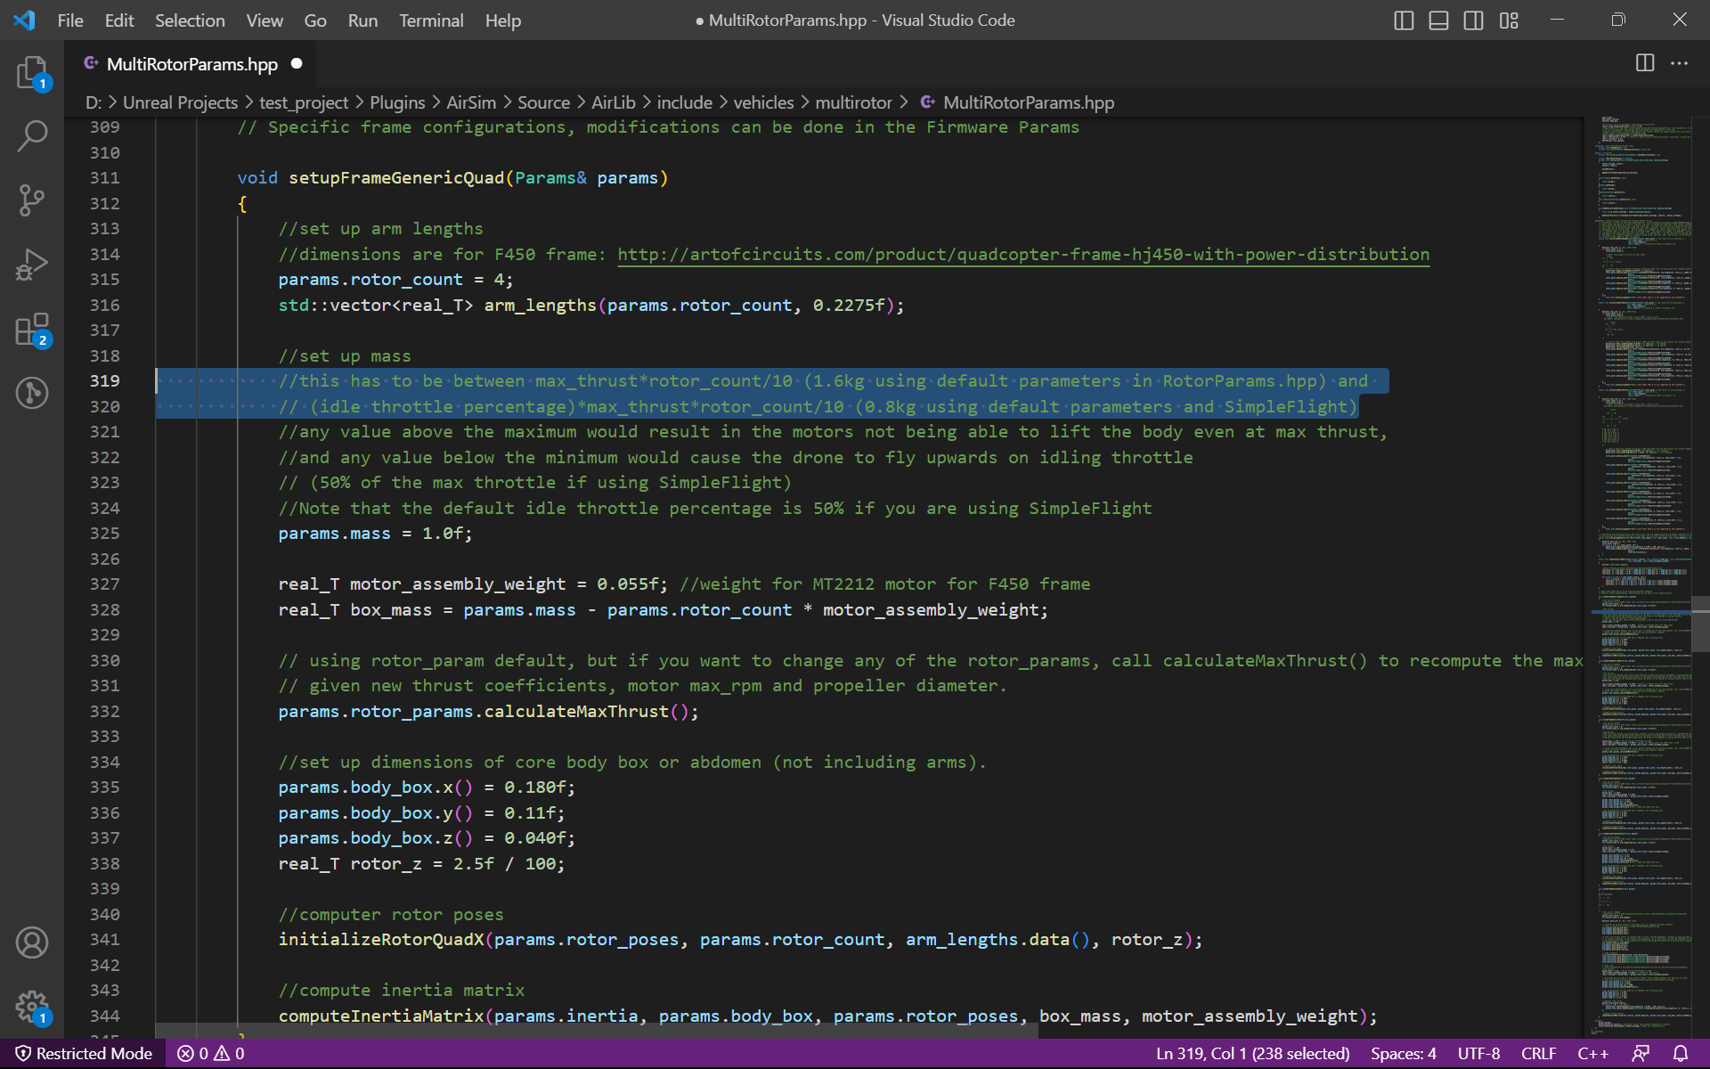



**Mass of Quadrotor** - 1.6kg using default parameters in RotorParams.hpp

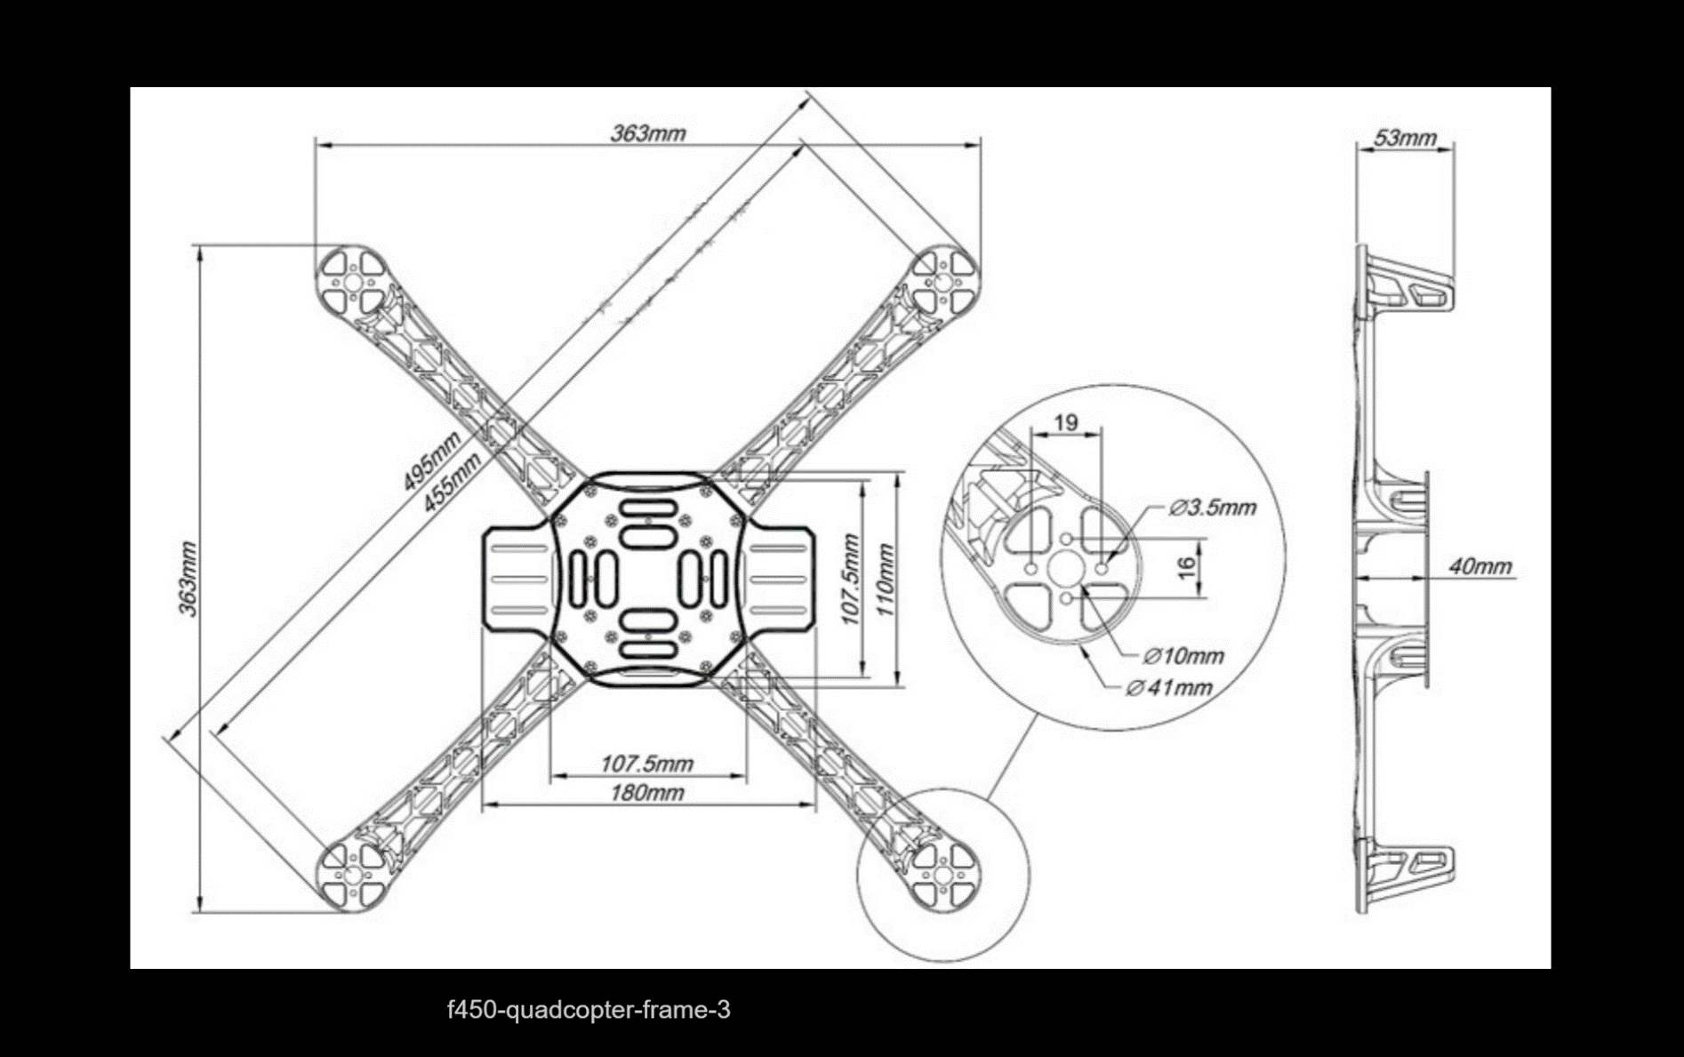**Dimension of Quadrotor**

**Link to client function**

D:\Unreal Projects\test_project\Plugins\AirSim\Source\AirLib\src\vehicles\multirotor\api

**How is the default Multirotor model is selected and what are its parameters?**

1. Launch the visual studio project -> when unreal engine pops up, Select Game Mode as ‘AirSimGameMode’.
2. Hit the play button. By default, the SimMode is “ ”. Which lead to a pop up to choose vehicle type.

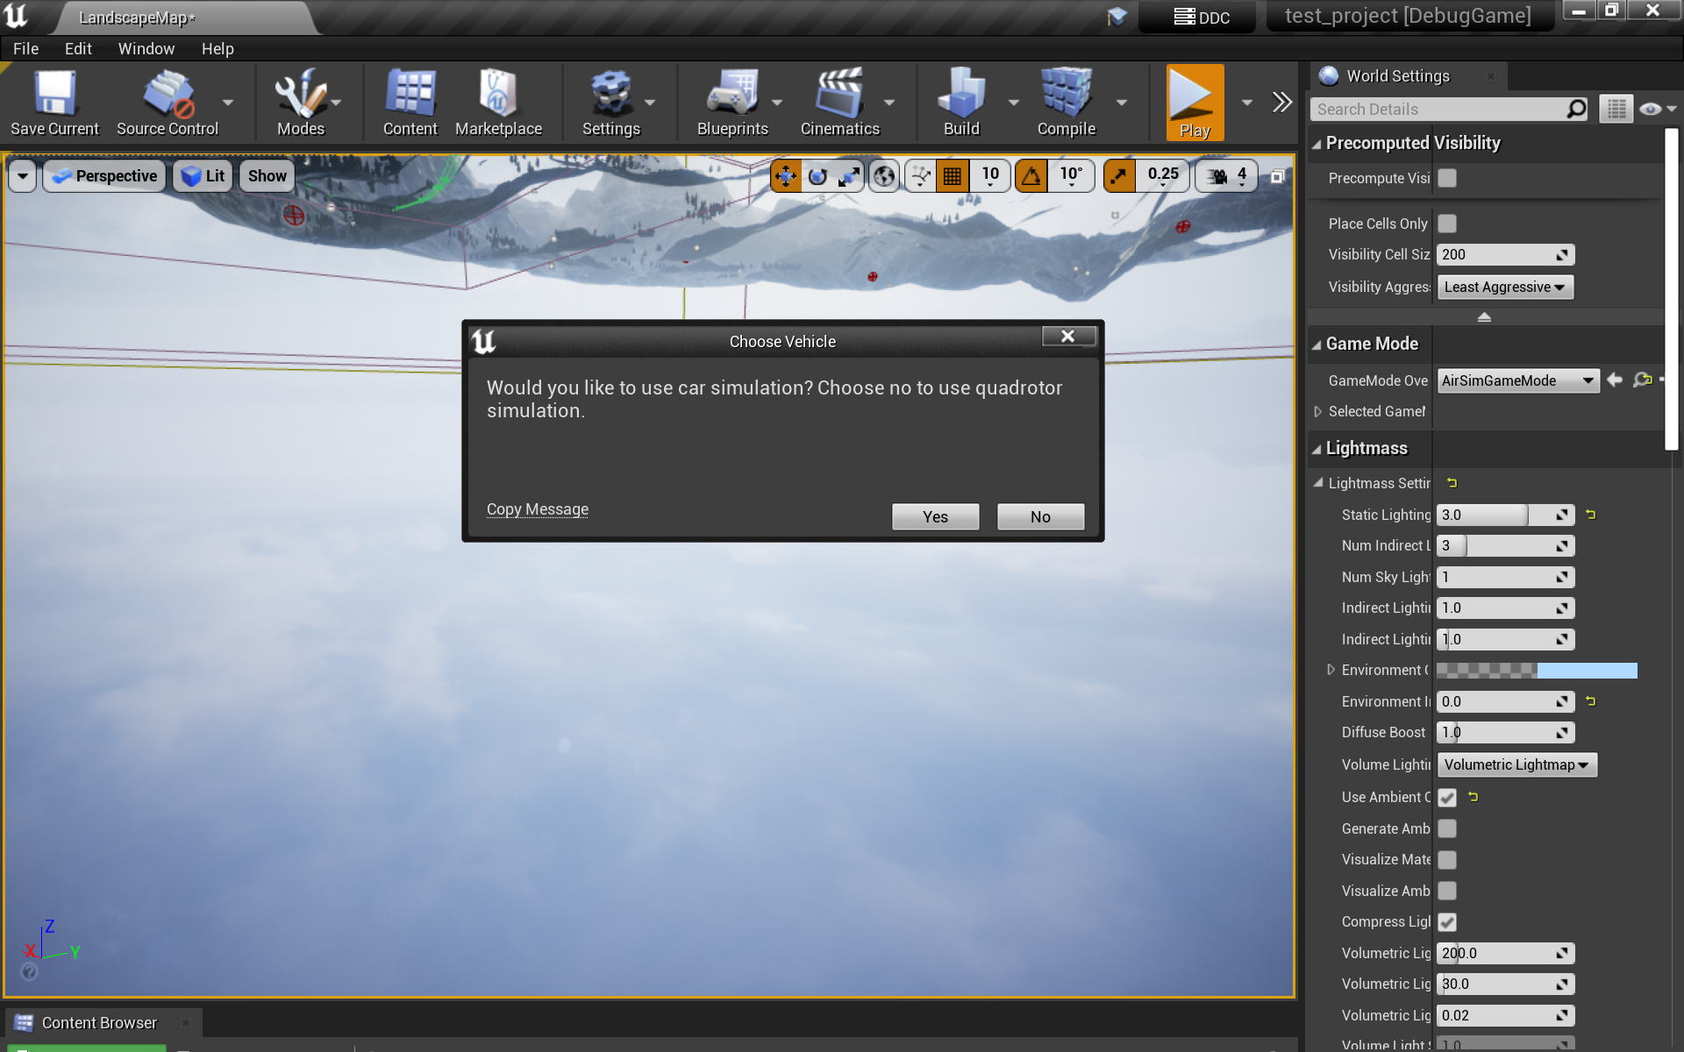

1. The first thing that executes when we start simulation is settings.json file. This file has all the default value to the constraints like vehicle type, clock speed, wind etc. **The default vehicle type is ‘SimpleFlight’**.

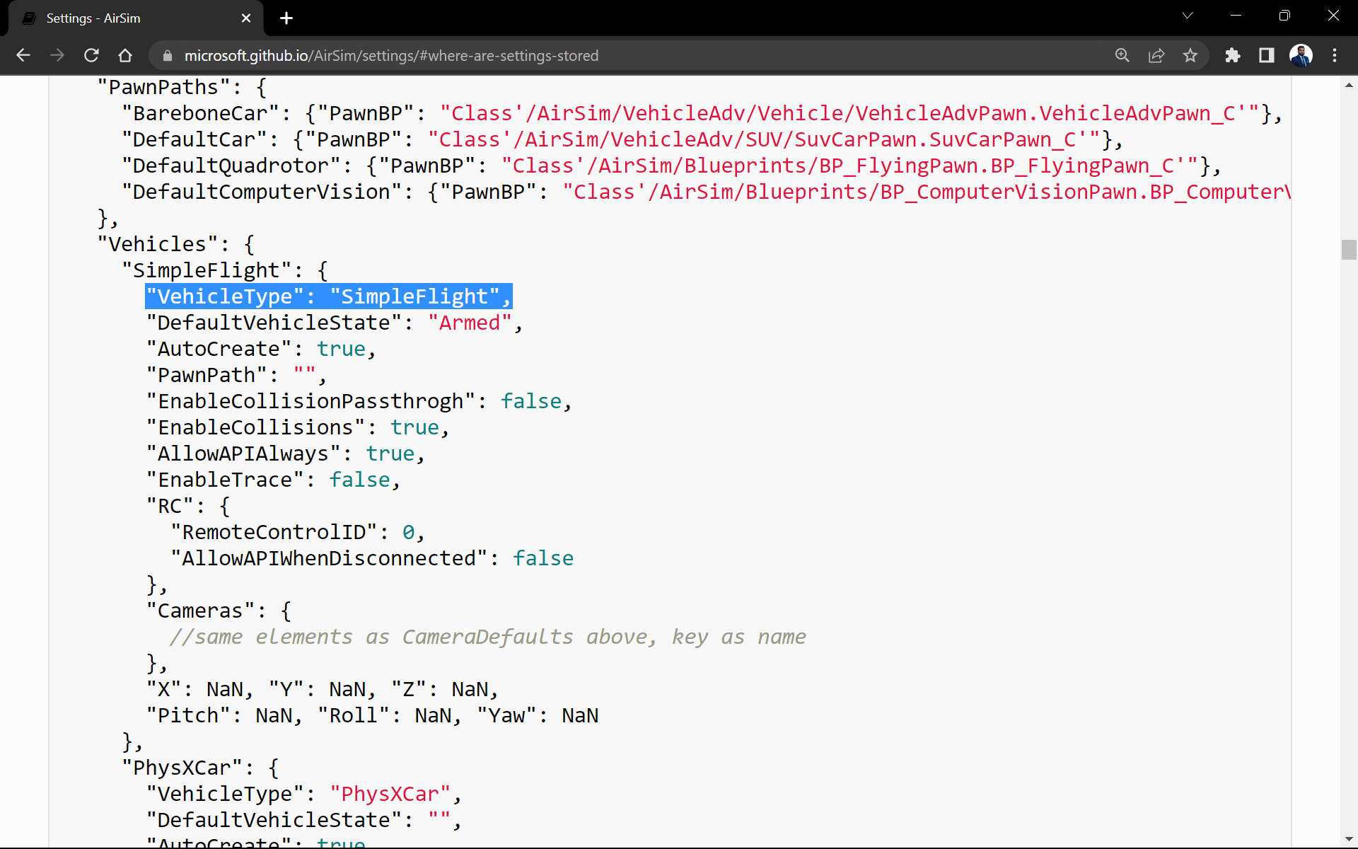

The same can be seen in the plugins folder under sources. Now we know the default vehicle type is SimpleFlight. We can now check the default parameters of the multirotor.

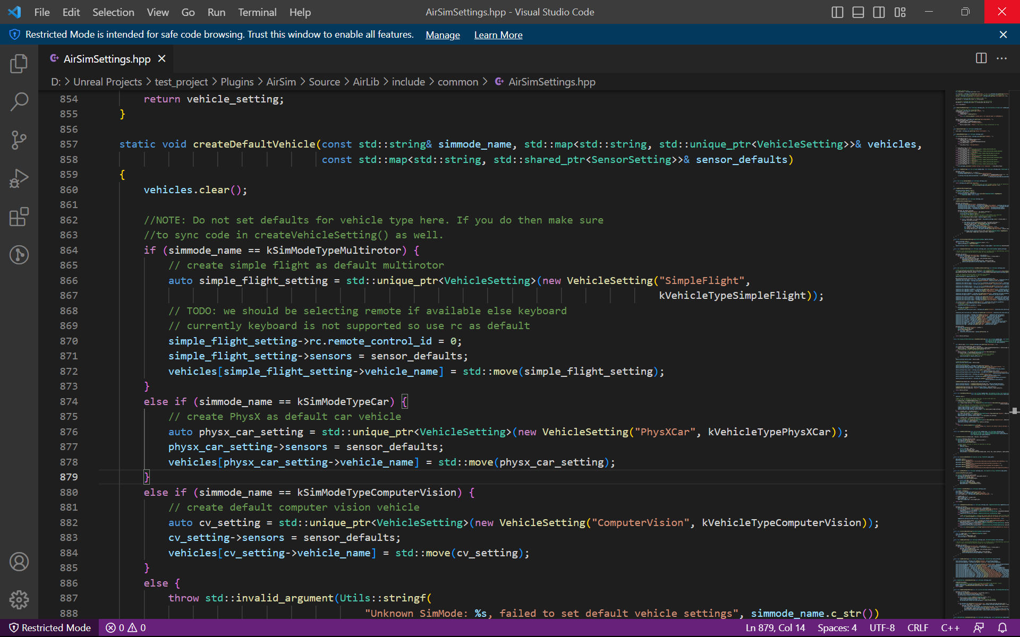

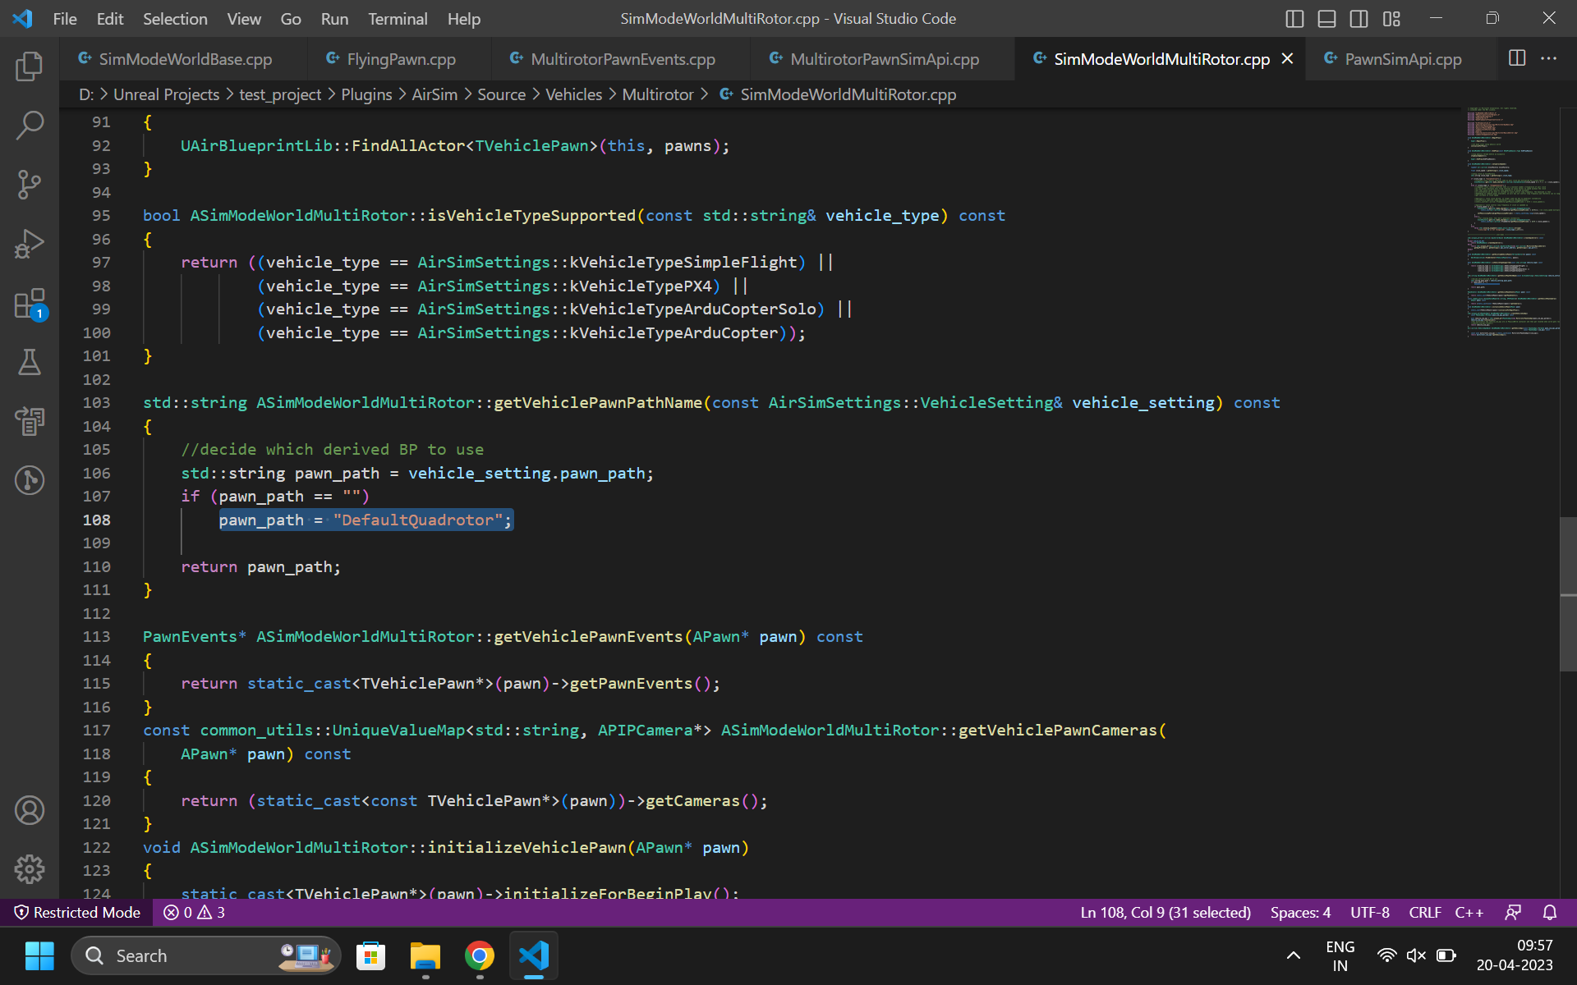

Some connection between this

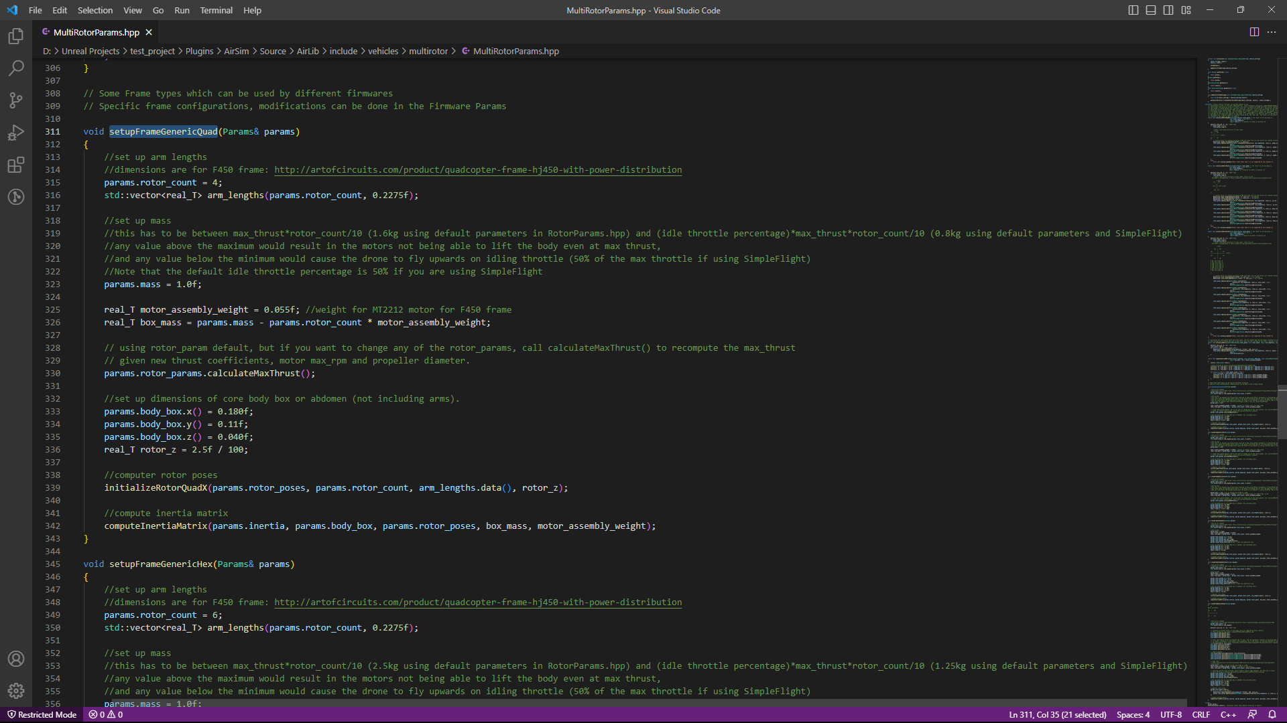

The dynamics of quadrotor

D:\Unreal Projects\test_project\Plugins\AirSim\Source\AirLib\src\vehicles\multirotor\api\MultirotorAPIbase