**Solution of problem – 1**

1 (a)

Table for Golden Section Search method:

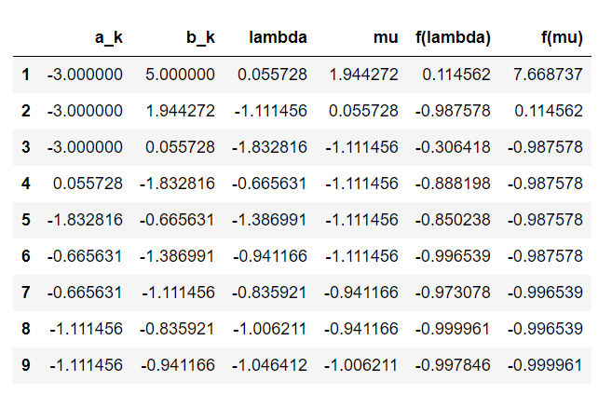

Table for Fibonacci Search Method:

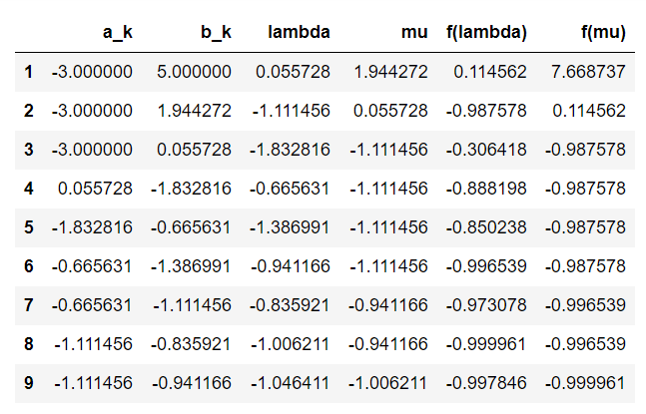

1 (b)

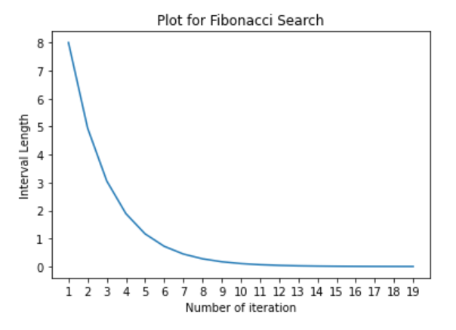

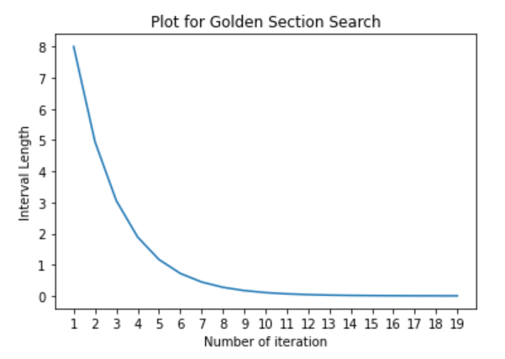

From the above we clearly see that both the search functions are almost equally efficient and asymptotically identical.

1 (c)

Manually we get the optimum value 

By SciPy package optimizer we get the optimum value 

They don’t have any significant difference.

**Solution of problem – 2**

Based on the given Wolfe conditions , we can conclude that the co-ordinates of the optimal solution is (0,1).