**Solution of problem-1**

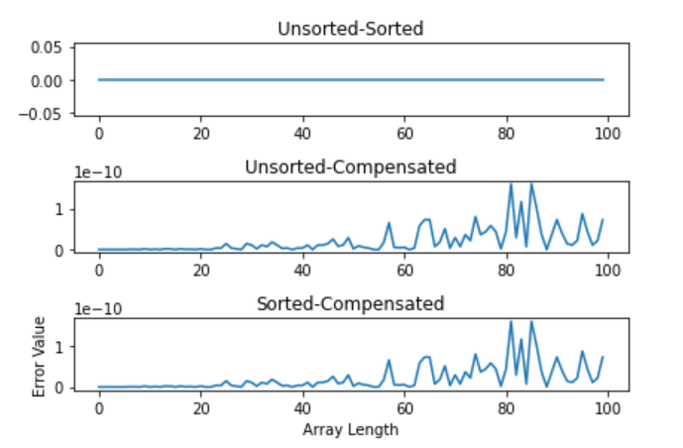

The unsorted sum and sorted sum are same as the error between those values are 0. On the other hand compensated sum is erroneous and error is increasing with the length of the array.

**Solution of problem-2**

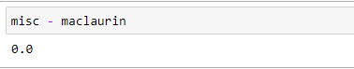

The logarithmic and Maclaurin series approach are numerically equivalent as their difference is 0. Also there are little difference in normal approach and these logarithmic/Maclaurian approaches.