**About Data:**

Used dataset is collected from the UCI Machine Learning repository named *Air Quality Data Set*[(Click Here)](https://archive.ics.uci.edu/ml/datasets/Air+Quality).

Variables are described given below:

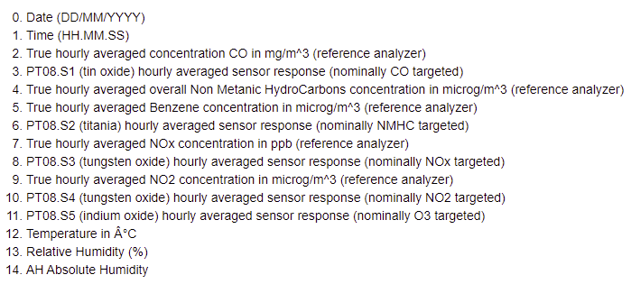

Primarily data cleaning part is done through remove the missing value and remove the date and time column. Then variables are normalized before the analysis. Also, data has portioned into train data (90%) and test data (10%).

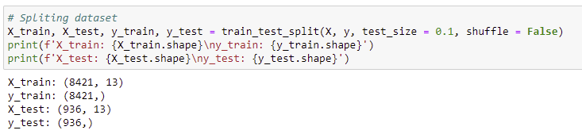

Response variable is temperature (T) and others variables are explanatory variable. The result of OLS model summary is given below:

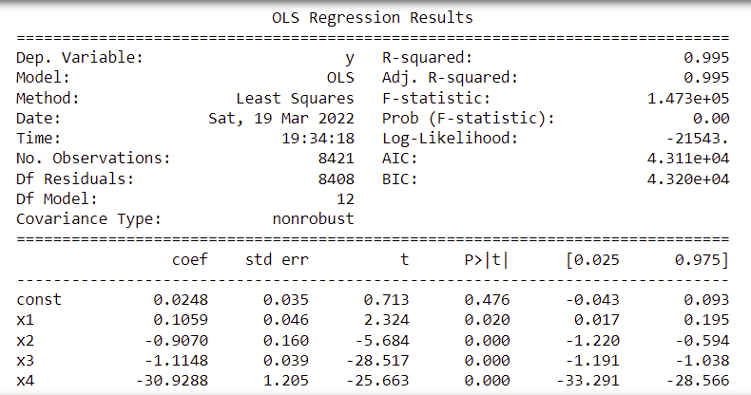

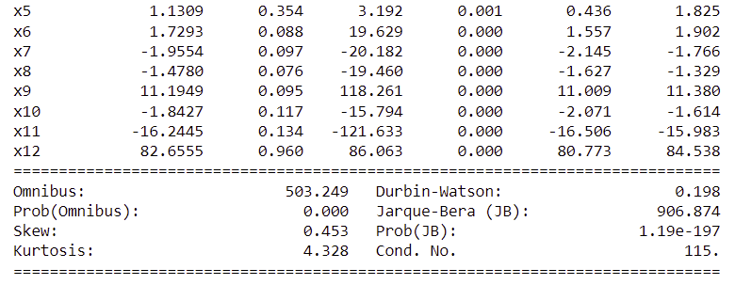

**Analytical Result and Test Accuracy:**

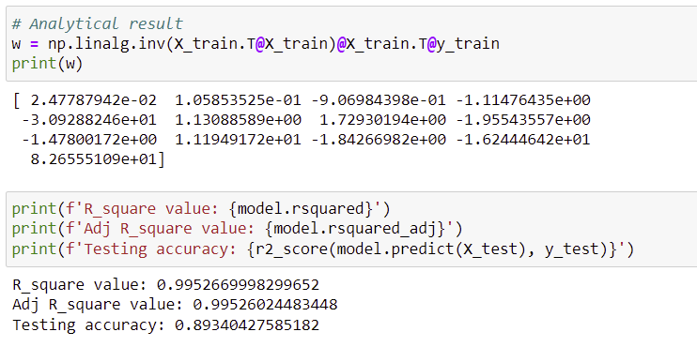

All analytical resulted coefficients are same and OLS model give approximate 90% accuracy.

From the model summary, we can conclude the following:

1. Except intercept all regression coefficients are significant. Also, from the p-value for model is less than 5% significance level, hence the OLS model is statistically significant.
2. Errors are serially uncorrelated from JB test.
3. OLS model give the 90% accuracy, which is quite good.

**Minimization of loss function:**

1. Batch Gradient Descent

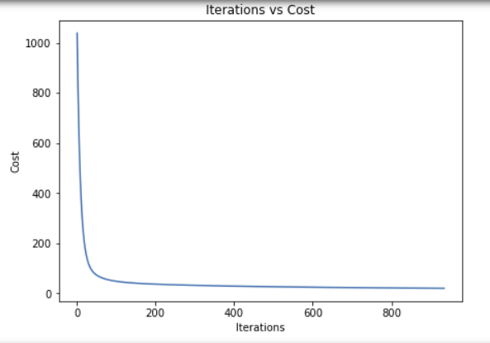 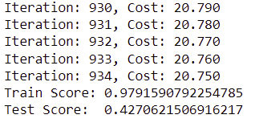

1. Sequential Gradient Descent (Widrow-Hoff Algorithm)

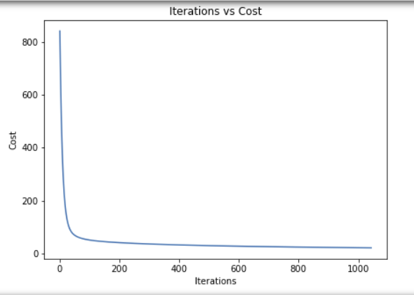 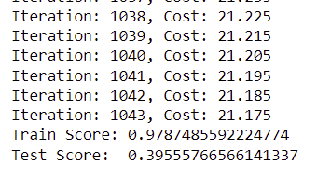

From the above plots we can conclude that sequential batch gradient takes more iteration to minimizes the cost.

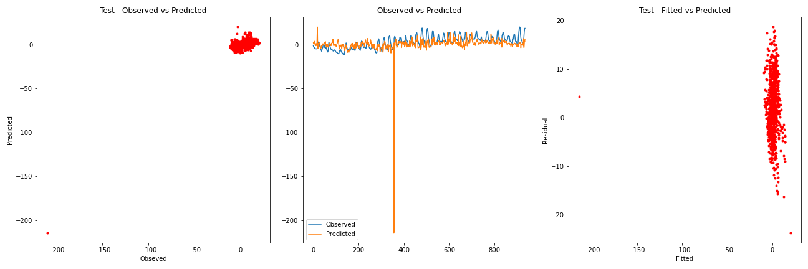

Residual and predicted values is correlated, which suggest there are high multicollinearity in the data.