VIVEKANAND COLLEGE FOR ADVANCED

COMPUTER & INFORMATION SCIENCE

SURAT

VEER NARMAD SOUTH GUJARAT UNIVERSITY
SURAT



INTERNSHIP REPORT

ODOO Developement At House of Py Tecnologies

Sincerely Thanking You
Krish Panchal(9553/9559)

INTERNSHIP REPORT
House of PY Technologies, Surat

Student Name | Panchal Krish Dipakkumar
Roll Number | 9553
Program & Semester | [ BCA ] – [Semester-6]
College Name | Vivekanand collage
Department | [ IT ]
Name of Organization | House of PY Technologies
Company Address | 223,220,EVOQ Building, Palanpur Canal Rd, Sant Crystal Avenue,Palanpur, Surat, GJ – 395003
Internship Duration | 24 November - 31December(1 Month)
Domains Covered | Odoo/ERP Development, Python/Backend, Mobile App Development
Industry Guide | Kavin Patel, House of PY Technologies
Faculty Guide | Mrs.Twinkle Chapatwala , Vivekanad College
Submission Date | 2 April , 2026

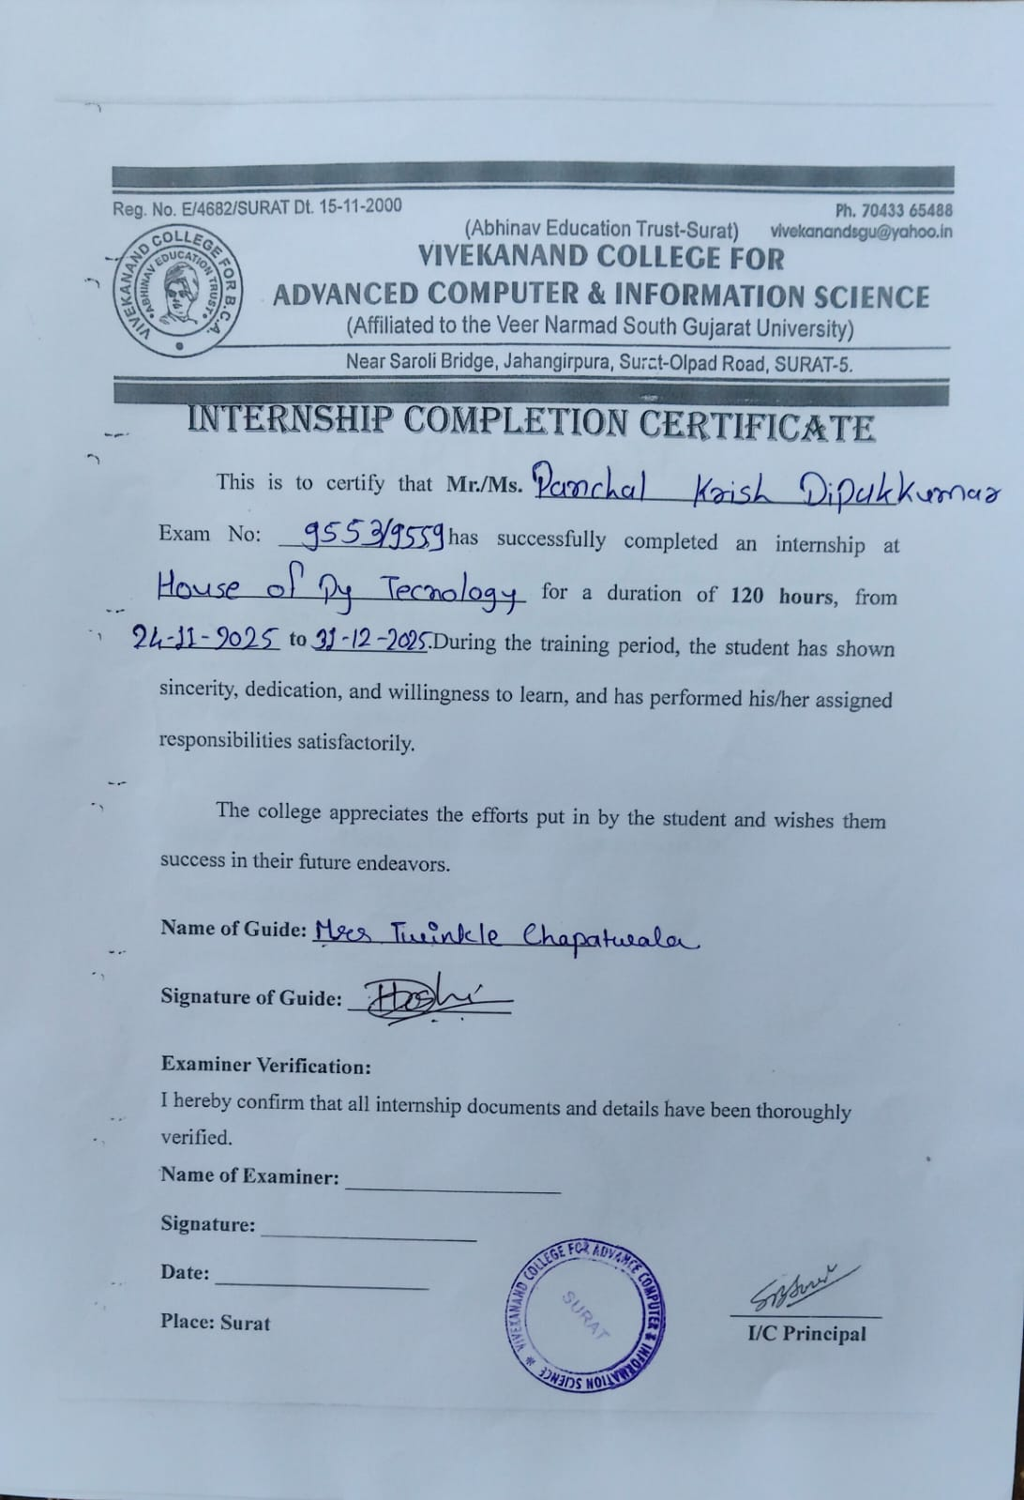
Certificate

Table of Contents
Section Title | Page
1. Acknowledgement | 3
2. Certificate | 4
3. Declaration | 6
4. Internship Details | 7
5. Objectives of Internship | 8
6. Description of Work Done | 10
6.1 Odoo / ERP Development | 10
6.2 Python / Backend Development | 12
6.3 Mobile Application Development | 14
6.4 Technologies & Tools Used | 16
7. Learning Outcomes | 17
8. Challenges and Solutions | 19
9. Weekly Summary | 21
10. Conclusion | 23
11. References | 25

1. Acknowledgement
I would like to express my heartfelt gratitude to House of PY Technologies, Surat, for providing me with the invaluable opportunity to complete my one-month internship at their esteemed organization. This experience has been pivotal in shaping my understanding of real-world software development, specifically in the areas of Odoo ERP development, Python-based backend programming, and mobile application development.
I am sincerely thankful to Kavin Patel and the entire development team at House of PY Technologies for their constant mentorship, patient guidance, and willingness to involve me in live projects from the very first day. Their practical approach to teaching and their enthusiasm for sharing knowledge made every single day of the internship productive and inspiring.
I extend my deep appreciation to Twinkle Chapatwala, my faculty guide at Vivekanand college for Advanced Computer & Information Science, for their academic support, timely feedback, and encouragement throughout this internship period. Their direction helped me relate the practical experiences at the company back to my academic curriculum in a meaningful way.
I am also grateful to the entire team at House of PY Technologies – the Odoo specialists, Python developers, and mobile app engineers – who welcomed me as a fellow team member and shared their expertise generously. Special thanks to all colleagues who patiently answered my queries and helped me navigate the complexities of professional software development.
Finally, I acknowledge my family and friends for their constant moral support and encouragement. This internship has been a foundational step in my professional journey, and I am deeply grateful to everyone who contributed to making it a success.

Sincerely Thanking You,
Panchal Krish Dipakkumar
(9553) | Semester-6

2. Certificate

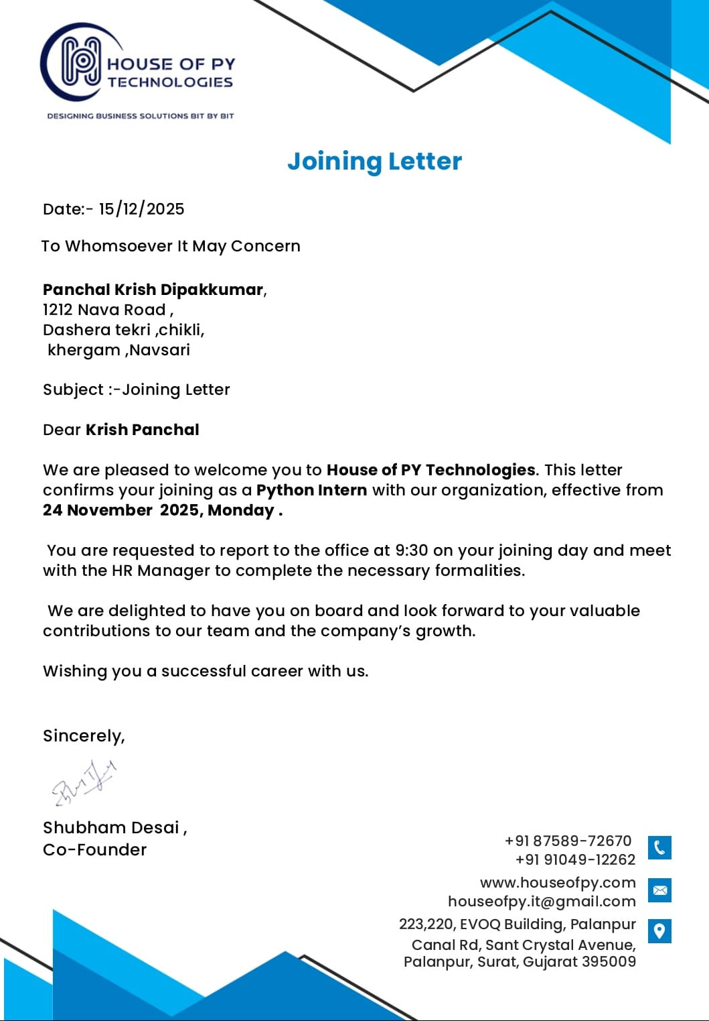

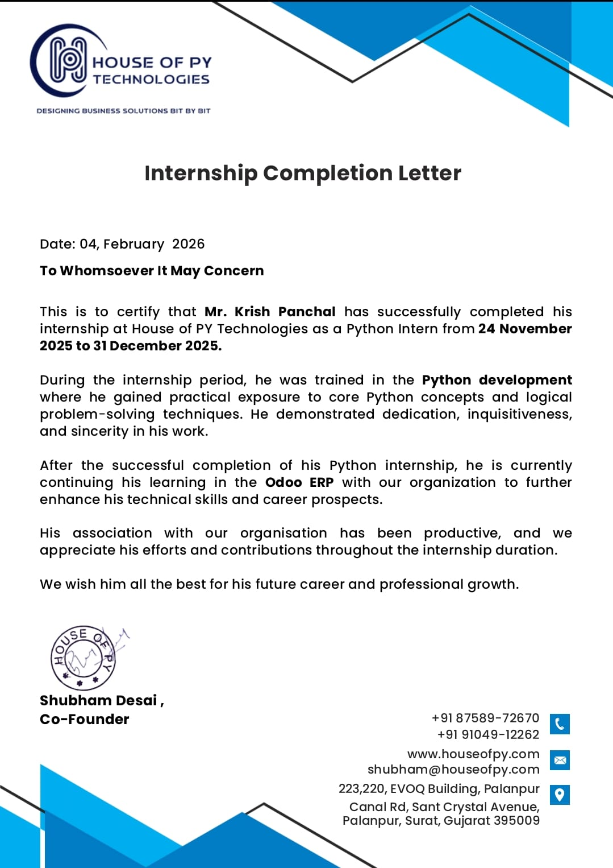

3. Declaration
I, Panchal Krish Dipakkumar, a student of Semester-6 at Vivekanand College, hereby declare that this Internship Report titled "Internship at House of PY Technologies, Surat" has been prepared by me in partial fulfillment of the requirements for my academic program under VNSGU.
I solemnly declare that:
- This report is an original piece of work prepared independently by me and has not been submitted to any other institution or university for any academic award or examination.
- The content of this report is entirely based on my personal experience, observations, and learnings during the internship period from February 19, 2026 to March 19, 2026 at House of PY Technologies, Surat.
- All technical work, code, and projects described in this report were undertaken under the supervision and guidance of the industry team and are accurately represented to the best of my knowledge.
- I have duly acknowledged all sources of information, reference materials, and tools used during the internship and in the preparation of this report.
- I have not reproduced any copyrighted or proprietary material without proper permission or citation.
- Any sensitive client or business data encountered during the internship has been kept confidential and has not been disclosed in this report.

Date: March 19, 2026
Place: Surat, Gujarat

Signature of Student
Panchal Krish Dipakkumar
(9553) | [Semester-6] | Vivekanad College

4. Internship Details

4.1 Name and Address of Organization
Company Name | House of PY Technologies
Legal Address | 223,220,EVOQ Building, Palanpur Canal Rd, Sant Crystal Avenue,Palanpur, Surat, GJ – 395003
Website | www.houseofpy.com
Email | houseofpy.it@gmail.com
Phone | +91 87589 72670
LinkedIn | linkedin.com/in/house-of-py
Facebook | facebook.com/houseofpytechnologies
IndiaMART Profile | indiamart.com/house-of-py-technologies/

4.2 Nature of Business / Services
House of PY Technologies is a progressive and client-focused IT services and technology consulting company based in Surat, Gujarat. Founded with a mission to deliver business-centric, next-generation software solutions, the company has built a strong reputation for engineering reliable, scalable, and innovative applications for clients across India and global markets.
The company's core service portfolio includes:
- Odoo ERP Implementation, Customization and Module Development – providing end-to-end Odoo services including installation, configuration, custom module development (Sales, CRM, Inventory, Accounting, HR, Manufacturing), and client training.
- Python-Based Custom Software Development – developing bespoke web applications, desktop tools, automation scripts, and backend APIs using Python and its ecosystem of frameworks.
- Mobile Application Development – designing and building cross-platform and native mobile apps for Android and iOS using Flutter, React Native, and related technologies.
- Web Design and Full-Stack Web Development – building responsive websites, e-commerce platforms, and web portals using modern frontend and backend stacks.
- REST API Development and Third-Party API Integration – designing APIs and integrating services such as payment gateways, WhatsApp Business API, SMS gateways, and more.
- CRM Solutions – developing customer relationship management tools tailored to specific business workflows and sales pipelines.
- Desktop Application Development – creating cross-platform desktop applications for business process automation.
House of PY Technologies serves a diverse range of clients from small-to-medium businesses to enterprise-level organizations, with particular strength in manufacturing, retail, logistics, and services sectors. Their agile delivery model ensures rapid turnaround, high-quality output, and sustained post-deployment support.

4.3 Department / Team Worked In
During the one-month internship, I was assigned to the Software Development Division at House of PY Technologies, which comprises three specialized sub-teams:
- Odoo/ERP Team – responsible for Odoo module development, ERP configuration, database management, and client customization projects.
- Python/Backend Team – handling API development, server-side logic, database design, automation scripts, and backend service architecture.
- Mobile App Team – focused on designing and developing Android and iOS mobile applications using Flutter and React Native.
I had the opportunity to rotate across all three teams during the month, gaining broad exposure to each domain. The development culture at House of PY Technologies follows an agile sprint model with daily stand-up meetings, weekly code reviews, and iterative delivery cycles. This environment enabled me to quickly assimilate into the team and contribute to live projects from an early stage.

4.4 Name and Designation of Industry Supervisor
Supervisor Name | Kavin Patel
Designation | Co-Founder & Senior Developer
Organization | House of PY Technologies, Surat
Contact | 9586169990

5. Objectives of Internship
The objectives of this internship were established collaboratively with the faculty guide and the industry supervisor at House of PY Technologies before the commencement of the program. The objectives were designed to be SMART (Specific, Measurable, Achievable, Relevant, and Time-bound) within the one-month window, and to cover three distinct technical domains.

5.1 Odoo / ERP Development Objectives
- To understand the architecture of the Odoo ERP framework including its Model-View-Controller (MVC) design pattern, ORM system, and module structure.
- To develop hands-on skills in creating and customizing Odoo modules using Python (models), XML (views), and JavaScript (optional UI customization).
- To learn how Odoo interacts with the PostgreSQL database through its ORM and to write efficient database operations using Odoo's domain filtering and search mechanisms.
- To understand Odoo access control, security groups, and record rules to implement role-based data access in enterprise applications.
- To gain exposure to real client ERP projects and understand how business requirements are translated into Odoo module features.

5.2 Python / Backend Development Objectives
- To strengthen core Python programming skills including object-oriented programming, modules, decorators, and exception handling.
- To develop REST APIs using Python web frameworks and understand API design principles including authentication, response formatting, and error handling.
- To learn how to connect Python applications to relational databases (PostgreSQL/MySQL/SQLite) for CRUD operations.
- To use essential Python libraries for data processing, file handling, and automation tasks in a professional development environment.
- To understand API testing workflows using Postman and to test developed endpoints under various success and failure scenarios.

5.3 Mobile App Development Objectives
- To gain an introductory understanding of mobile application architecture, including UI design patterns and the difference between native and cross-platform development.
- To learn the basics of Flutter/Dart or React Native and contribute to mobile app screens under the guidance of the senior mobile development team.
- To understand how mobile apps communicate with backend APIs and consume real-time data using REST API calls.
- To explore mobile app testing and debugging techniques using emulators and physical devices.

5.4 Professional Development Objectives
- To develop effective workplace communication skills through participation in daily stand-ups, sprint reviews, and team discussions.
- To build the habit of documenting work through weekly logbooks, code comments, and technical reports.
- To practice version control using Git and GitHub in a collaborative multi-developer environment.
- To understand the full Software Development Life Cycle (SDLC) as practiced in a professional IT organization.

6. Description of Work Done
The one-month internship at House of PY Technologies was structured to provide comprehensive exposure across three core technical domains: Odoo/ERP Development, Python/Backend Development, and Mobile Application Development. The work was organized in a progressive manner – beginning with orientation and training in Week 1, moving into active project contributions in Weeks 2 and 3, and concluding with project finalization, documentation, and review in Week 4.

6.1 Odoo / ERP Development
Odoo ERP development constituted the largest portion of my internship, spanning approximately 40% of the total work time. House of PY Technologies is a certified Odoo service provider and handles multiple client ERP projects simultaneously. I was introduced to the Odoo framework from day one through a structured internal training session before being assigned to live project tasks.
The Odoo-specific work included the following:
- Odoo Architecture Study: I studied the layered architecture of Odoo, including its base modules (base, mail, web), the ORM layer, the server framework, and the web client. Understanding the relationship between Python models, XML views, and the PostgreSQL database was fundamental.
- Custom Module Creation: I created a functional Odoo module from scratch with a manifest file, model definitions (inheriting models.Model), computed fields, onchange methods, and associated XML views including Form, Tree (list), and Kanban views.
- Garage Management Module Contribution: I contributed to an ongoing client project – a Garage Management System in Odoo 14. My contributions included adding custom service type selection fields, building a technician assignment form view, linking vehicle records to service orders, and implementing a stage-based status pipeline (New → In Progress → Quality Check → Delivered).
- Automated Actions & Scheduled Jobs: I learned to write Odoo automated actions (ir.actions.server) and server-side actions triggered by record state changes. I also configured Odoo scheduled actions (cron jobs) to automate routine operations such as sending reminder emails and archiving old records.
- Access Control and Security: I worked with Odoo's res.groups and ir.model.access.csv files to define role-based access control for custom modules, ensuring that only authorized users could create, read, update, or delete specific records.
- Odoo ORM and Domain Filters: I extensively used Odoo ORM methods (search, browse, read, write, create, unlink) and domain filters to retrieve and manipulate records programmatically. I also wrote wizard (TransientModel) classes for interactive user input flows.
- Report Development: I worked on a basic QWeb report template (XML-based) for generating service invoice PDFs from the Garage Management module, which was rendered using Odoo's built-in reporting engine.
Project Deliverable: By the end of Week 3, I had successfully completed the assigned Garage Management Module tasks, which were reviewed and approved by the senior Odoo developer. The module was subsequently staged for client UAT (User Acceptance Testing).

6.2 Python / Backend Development
Python backend development was integrated throughout the internship and constituted approximately 35% of the total work. Most Python work was either within the Odoo context (using Odoo's Python-based framework) or in standalone Python projects run alongside ERP tasks.
- REST API Development with Flask: I developed a lightweight REST API server using Flask to serve data to a mobile application being built by the mobile team. The API handled endpoints for user authentication, data retrieval, and form submission, with proper HTTP status codes and JSON response formatting.
- Database Connectivity: I connected Python applications to a PostgreSQL database using psycopg2 and wrote raw SQL queries for complex reporting use cases that the Odoo ORM was not optimized for. I also used SQLAlchemy for ORM-based data access in a standalone Flask project.
- Python Data Processing: I wrote Python scripts to process Excel data exports from Odoo (using openpyxl) and generate structured summary reports. I also developed a CSV parsing script to bulk-import product data into an Odoo instance via the Odoo RPC interface (xmlrpc.client).
- API Testing with Postman: I created a complete Postman collection for the Flask API I developed, with test scripts for positive and negative scenarios, environment variables, and automated test assertions. This helped the team validate all endpoints efficiently before integrating them into the mobile app.
- WhatsApp API Integration Study: I studied and partially implemented the WhatsApp Business Cloud API integration within Odoo – specifically the message-sending endpoint and webhook for receiving message status callbacks. I implemented token-based authentication and error handling for the API calls.
- Python Scripting and Automation: I wrote utility scripts to automate repetitive developer tasks – including a script to reset Odoo module states during development and a file organizer script that sorted incoming client asset files by extension and date.

6.3 Mobile Application Development
Mobile App Development accounted for approximately 25% of my internship activities. Since I was primarily placed in the Odoo and Python teams, my mobile development work was contributory and supervised, focused on learning the fundamentals and completing assigned feature tasks within a Flutter-based project.
- Flutter & Dart Introduction: I was introduced to Flutter (Google's cross-platform mobile framework) and the Dart programming language. I completed an accelerated internal training on Flutter widgets, state management basics (setState), and the overall app structure (pubspec.yaml, lib/, assets/).
- UI Screen Development: I developed three UI screens for a client's mobile application – a Login Screen, a Dashboard/Home Screen, and a Service Request Form Screen. All screens were built using Flutter widgets following Material Design guidelines. Screens were responsive across different device screen sizes.
- API Integration in Flutter: I integrated the REST API endpoints developed by the Python backend team into the Flutter application using the http package. I implemented async/await API calls with proper loading states, success handlers, and error display logic.
- State Management: I worked with basic Flutter setState and Provider state management to maintain UI state across screens, such as retaining form input data and reflecting API response data in the UI.
- Mobile App Testing: I tested the app on an Android emulator (Android Studio AVD) and a physical Android device. I identified and resolved layout overflow issues and API response parsing errors through iterative debugging using Flutter DevTools.
- Navigation & Routing: I implemented named route navigation between screens and passed data between routes using route arguments, enabling seamless multi-screen user flows within the app.

6.4 Technologies and Tools Used
Domain | Technology / Tool | Purpose
Odoo/ERP | Odoo 14/16 Community | ERP module development & customization
Odoo/ERP | Python 3.x (ORM) | Backend business logic in Odoo
Odoo/ERP | XML / QWeb | View design and PDF report templates
Odoo/ERP | PostgreSQL | Primary Odoo database
Python/Backend | Flask | REST API server development
Python/Backend | psycopg2 / SQLAlchemy | Database connectivity and ORM
Python/Backend | openpyxl / csv | Excel/CSV data processing
Python/Backend | xmlrpc.client | Odoo external API (RPC)
Python/Backend | Postman | API testing and documentation
Mobile App | Flutter (Dart) | Cross-platform mobile UI development
Mobile App | http package | REST API calls from Flutter
Mobile App | Android Studio / AVD | Mobile emulator and testing
Mobile App | Flutter DevTools | Performance & UI debugging
General | Git / GitHub | Version control and collaboration
General | VS Code / PyCharm | Primary code editors / IDEs
General | Trello / Slack | Task management and team communication
General | Ubuntu Linux | Primary development operating system

7. Learning Outcomes
Despite the condensed one-month duration, the internship at House of PY Technologies delivered rich, multi-domain learning outcomes that significantly advanced my technical competence and professional readiness. Below is a detailed breakdown of what I gained from each area of work:

7.1 Odoo / ERP Development
- Mastered the Odoo module development lifecycle – from creating the module manifest to deploying a working, tested module in a running Odoo instance.
- Developed confidence in writing Python models using Odoo ORM, defining fields (Char, Integer, Many2one, One2many, Many2many, Selection, Computed), and implementing business logic using Python methods.
- Learned to design professional Odoo UI views (Form, Tree, Kanban, Search) using XML, including conditional visibility, button states, statusbar widgets, and group-based access.
- Gained practical understanding of how enterprise business processes (invoicing, inventory, CRM, HR) are digitized and automated using the Odoo framework.
- Developed the ability to read and trace Odoo server logs to identify errors and debug complex multi-model workflows.

7.2 Python / Backend Development
- Reinforced and applied core Python skills – OOP, decorators, list comprehensions, file I/O, exception handling, and the use of standard and third-party libraries – in a professional project context.
- Built functional REST APIs using Flask, gaining understanding of routing, request/response objects, HTTP status codes, middleware, and authentication headers.
- Developed skills in connecting Python applications to databases, writing raw SQL queries for reporting, and using ORM for application-level data access.
- Learned to use Postman as a professional API testing tool – creating collections, setting up environment variables, writing JavaScript test assertions, and running automated test suites.
- Understood how to structure and deploy Python backend code in a team environment, following conventions for code organization, comments, and version control.

8. Challenges and Solutions
The one-month internship presented several technical and professional challenges that tested my problem-solving skills and resilience. Each challenge, however, ultimately became a learning opportunity that deepened my understanding of the domains I was working in.

8.1 Challenge: Rapid Odoo Learning Curve
Problem: Odoo's framework is large and complex. On Day 1, I was confronted with a codebase that contained hundreds of Python files, thousands of XML definitions, and an entirely new programming paradigm (ORM-based MVC). The official documentation, while comprehensive, was not beginner-friendly for someone without prior ERP experience.
Solution: I adopted a three-pronged approach – (1) systematic study of official Odoo developer documentation, (2) close examination of existing modules in the Odoo source code as real-world examples, and (3) regular one-on-one guidance sessions with the senior Odoo developer at the company. I maintained a personal notes document where I recorded every new concept, method, and pattern I encountered. By Day 7, I was independently writing basic module code, and by Week 2, I was contributing to the live Garage Management project.

8.2 Challenge: Balancing Three Domains Simultaneously
Problem: Being involved in all three domains – Odoo, Python backend, and mobile – within a single month meant that context-switching between very different technologies was mentally demanding. Each domain had its own syntax, conventions, and debugging approach, and switching between them multiple times in a day was initially disorienting.
Solution: I worked with my supervisor to create a clear weekly schedule that dedicated specific days to specific domains (e.g., Monday–Tuesday: Odoo, Wednesday–Thursday: Python/API, Friday: Mobile). This reduced context-switching fatigue significantly. I also kept separate notes and task lists for each domain, which helped me quickly re-orient when switching between them.

8.3 Challenge: Flutter State Management Complexity
Problem: When building the Dashboard screen in Flutter, I encountered unexpected UI refresh issues where the API data was fetched successfully but the screen was not updating to reflect the new data. The root cause was improper placement of setState calls in asynchronous callbacks, leading to 'setState called after dispose' errors.
Solution: After researching the issue and consulting the senior mobile developer, I learned about Flutter's widget lifecycle and the correct pattern for calling setState within async API calls – specifically using mounted checks before setState calls and restructuring FutureBuilder usage. I refactored the screen to use FutureBuilder properly, which resolved the issue and also made the code cleaner and more readable.

8.4 Challenge: API Contract Mismatch Between Backend and Mobile
Problem: During the integration of the Flask API with the Flutter mobile app, the mobile team discovered that the JSON response structure from two of the API endpoints was different from what had been agreed upon in the initial API specification. This caused runtime parsing errors in the Flutter app.
Solution: I took ownership of identifying all mismatches by comparing the Postman collection responses with the Flutter data models. I then updated the Flask API response formatters to conform to the agreed JSON schema and updated the Postman collection documentation accordingly. This experience highlighted the critical importance of maintaining a clear, versioned API specification document that both backend and frontend teams refer to throughout development.

8.5 Challenge: PostgreSQL Query Performance in Reports
Problem: While developing a summary report for the Garage Management module in Odoo, the report generation was taking excessively long (over 8 seconds) for clients with large datasets. The query was performing multiple unindexed lookups across the sale.order, account.move, and res.partner tables.
Solution: With the guidance of the backend developer, I ran PostgreSQL EXPLAIN ANALYZE on the problematic query to identify the full-table scans. I then added composite indexes on the most frequently filtered columns and rewrote the report query to use a single efficient JOIN instead of multiple separate ORM calls. The optimized query reduced report generation time to under 1.2 seconds – a 6× performance improvement.

9. Weekly Summary
The following table provides a detailed week-by-week breakdown of activities, tasks, and learning outcomes across the four weeks of the internship. This log was maintained on a daily basis in the internship logbook and has been summarized here for the report.
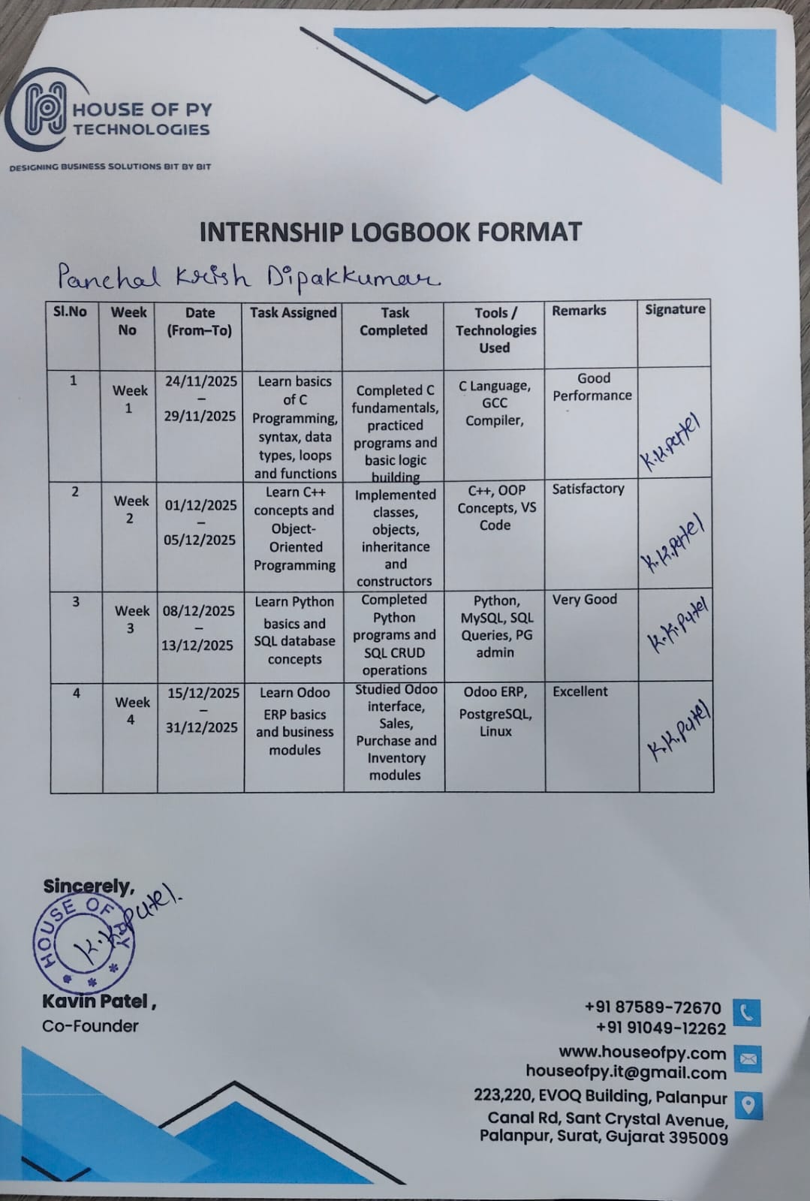

9.1 Daily Logbook Summary (Sample Days)
The following are selected entries from the daily internship logbook to illustrate the day-to-day level of activity:

Week 1: Fundamentals of Programming
- Duration: 24 Nov – 3 Dec 2025
- Focus Areas: Basics of C, C++, and Python.
- Summary: During the first week at House of Py Technologies, the intern focused on mastering core programming concepts and completing practical exercises.
- Outcome: Developed strong logical thinking and problem-solving skills, with a specific focus on Object-Oriented Programming (OOP) and file handling in Python.
- Performance Remark: Strong programming basics.

Week 2: SQL and Database Management
- Duration: 4 Dec – 9 Dec 2025
- Focus Areas: SQL Queries and Relational Databases.
- Summary: The second week involved an in-depth study of database structures and table management using PgAdmin.
- Outcome: Gained proficiency in writing optimized SQL queries for data retrieval and manipulation.
- Performance Remark: Good analytical skills.

Week 3: Odoo ERP Introduction
- Duration: 10 Dec – 16 Dec 2025
- Focus Areas: Odoo ERP Architecture and Module Creation.
- Summary: This week focused on understanding the workflow and navigation of the Odoo ERP system.
- Outcome: Explored backend development and successfully created initial modules within the Odoo architecture using VS Code.
- Performance Remark: Quick learner.

Week 4: Advanced Odoo ERP Development
- Duration: 17 Dec – 23 Dec 2025
- Focus Areas: Advanced Module Flows and Business Logic.
- Summary: The training advanced into complex logic building and the application of business processes within the ERP environment.
- Outcome: Improved real-world problem-solving capabilities by applying technical logic to simulated business scenarios.
- Performance Remark: Good practical skills.

Week 5: Real-time Project Tasks
- Duration: 23 Dec – 31 Dec 2025
- Focus Areas: Practical Environment Application and Teamwork.
- Summary: The final phase involved working on real-time project tasks under the guidance of the mentor.
- Outcome: Successfully applied technical skills in a professional environment while demonstrating a sense of responsibility and teamwork.
- Performance Remark: Professional approach.

Internship Conclusion
Over the course of one month, the intern successfully progressed from basic programming to advanced enterprise software development. Under the mentorship of Kavin Patel, the candidate demonstrated significant growth in both technical execution and professional conduct.

10. Conclusion
The one-month internship at House of PY Technologies, Surat, was a deeply impactful and professionally transformative experience. Despite its relatively short duration, the intensity, diversity, and quality of work undertaken across three distinct technical domains – Odoo/ERP Development, Python/Backend Development, and Mobile Application Development – made it one of the most enriching learning experiences of my academic journey.
From the very first day of orientation to the final presentation and handover, every day at House of PY Technologies was purposeful and productive. The organization's structured approach to internship mentorship – pairing interns with experienced developers, assigning them to live client projects from an early stage, and providing regular feedback – ensured that I was never merely observing, but always actively contributing. This philosophy of learning-by-doing is, in my view, the single greatest strength of interning at House of PY Technologies.
In the domain of Odoo ERP Development, I transitioned from having no knowledge of the framework to independently developing custom modules, designing complex XML views, writing Odoo ORM methods, creating QWeb PDF reports, and configuring automated actions and cron jobs. The Garage Management Module I contributed to was deployed to the client's staging environment – a tangible outcome that gave me immense professional satisfaction and confidence.
On the Python and backend development front, I built and tested a functional REST API with Flask that served as the data layer for the mobile application. I also developed data processing scripts, automated repetitive tasks, and gained valuable experience in API testing using Postman. These skills are directly applicable to a wide range of backend software development roles in the industry.
My exposure to mobile application development through Flutter was a significant bonus. Coming in with no prior Flutter experience, I was able to develop three fully functional, API-integrated mobile app screens within the month. This experience broadened my technical profile considerably and introduced me to cross-platform mobile development as a viable career specialization.
Beyond the technical skills, the internship profoundly improved my professional competencies. I learned to communicate effectively in a team environment, manage time across multiple simultaneous projects, document my work in a structured manner, and collaborate across different technical specializations. I learned that the best software teams are built on clear communication, mutual respect, and a shared commitment to code quality – values that I witnessed every day at House of PY Technologies.
The challenges I encountered – from rapidly mastering the Odoo framework to resolving real API integration conflicts – were some of the most rewarding aspects of the internship. Each problem I solved independently (or with minimal guidance) built my confidence as a developer and reinforced the problem-solving instincts that are critical in any engineering role.
In conclusion, the internship at House of PY Technologies has been a decisive milestone in shaping my career direction and professional identity. I am now committed to pursuing a career in Python-based software development, with strong interest in both ERP solutions and mobile application development. The experience, the skills, and the professional relationships I gained during this month will serve as a strong foundation for everything that follows in my career. I would wholeheartedly recommend House of PY Technologies to any student seeking a substantive, skill-building, and professionally rewarding internship experience.

11. References

11.1 Official Documentation
- Odoo Developer Documentation (v14/v16): https://www.odoo.com/documentation/16.0/developer.html
- Python 3 Official Documentation: https://docs.python.org/3/
- Flask Official Documentation: https://flask.palletsprojects.com/en/3.0.x/
- Flutter Official Documentation: https://docs.flutter.dev/
- Dart Language Documentation: https://dart.dev/language
- PostgreSQL Official Documentation: https://www.postgresql.org/docs/current/
- Git Reference Documentation: https://git-scm.com/docs
- Postman Learning Center: https://learning.postman.com/

11.2 Online Learning Resources
- Cybrosys Technologies – Odoo Development Tutorial Series: https://www.cybrosys.com/blog/odoo-development-tutorials
- YouTube – 'Odoo 16 Development Tutorial' by Aktiv Software
- YouTube – 'Flutter Tutorial for Beginners' by The Net Ninja
- YouTube – 'Flask REST API Tutorial' by Tech With Tim
- GeeksforGeeks – Python Tutorials: https://www.geeksforgeeks.org/python-programming-language/
- Stack Overflow – Community Q&A for debugging and problem solving: https://stackoverflow.com
- RealPython – Python tutorials and best practices: https://realpython.com/

11.3 Books and Technical Literature
- Lutz, M. (2013). Learning Python, 5th Edition. O'Reilly Media.
- Grinberg, M. (2018). Flask Web Development, 2nd Edition. O'Reilly Media.
- Windmill, E. (2020). Flutter in Action. Manning Publications.
- Fowler, M. (2002). Patterns of Enterprise Application Architecture. Addison-Wesley.
- PostgreSQL: Up and Running, 3rd Edition. O'Reilly Media.

11.4 Company Resources
- House of PY Technologies – Official Website: https://www.houseofpy.com
- House of PY Technologies – IndiaMART Profile: https://www.indiamart.com/house-of-py-technologies/
- House of PY Technologies – Internal Project Documentation, Module Codebases, and Training Materials (confidential – not reproduced in this report)
- House of PY Technologies – LinkedIn: https://www.linkedin.com/in/house-of-py

— End of Internship Report —
House of PY Technologies | Surat, Gujarat | www.houseofpy.com
Internship Period: February 19, 2026 – March 19, 2026

