SOC LAB PROJECT
ATTACK 04
DETECTING MALICIOUS COMMANDS
Command Execution Monitoring with Linux auditd and Wazuh

Field | Details
Security Capability | Command execution monitoring and detection
Telemetry Source | Linux auditd
Detection Platform | Wazuh SIEM / XDR
Monitored Commands | bash, curl, nc, nmap, wget (plus python3 rule configured)
Custom Detection Rule | 100300 — Level 12
MITRE ATT&CK Mapping | T1059 — Command and Scripting Interpreter
Result | SUCCESSFUL

1. Executive Summary
This report documents the implementation and validation of command execution monitoring in the SOC lab using Linux auditd and Wazuh. The objective was to collect execution telemetry for selected administrative and dual-use utilities, forward the audit records to Wazuh, and generate a high-severity custom alert when monitored commands were executed.
The lab configured audit watches for wget, curl, nc, nmap, bash, and python3. Five command families—bash, curl, nc, nmap, and wget—were then validated through the available proof-of-concept evidence. auditd captured process execution details, command arguments, executable paths, user context, working directory, and audit keys. Wazuh ingested the audit log and the custom Rule ID 100300 produced Level 12 alerts for the configured malicious-command detection pattern.

2. Objectives
- Install and activate auditd on the Ubuntu endpoint.
- Verify that Linux audit records are written to /var/log/audit/audit.log.
- Configure the Wazuh Agent to ingest auditd telemetry.
- Create persistent audit rules for selected command-line utilities.
- Load and verify the audit rules.
- Generate controlled command execution activity.
- Validate audit records using ausearch.
- Create a custom Wazuh rule for command execution detection.
- Verify high-severity Wazuh alerts and MITRE ATT&CK mapping.

3. Detection Architecture
Ubuntu Endpoint
│
│ command execution
▼
Linux Audit Framework / auditd
│
│ /var/log/audit/audit.log
▼
Wazuh Agent
│
│ audit log forwarding
▼
Wazuh Manager
│
│ decoder + custom Rule 100300
▼
Wazuh Indexer / Dashboard
│
▼
SOC Analyst Investigation

4. Security Context
Utilities such as curl, wget, netcat, nmap, bash, and Python have legitimate administrative uses, but they are also frequently used during adversary activity for payload retrieval, network reconnaissance, command execution, scripting, and network communication. For this reason, execution telemetry for these tools can provide valuable detection context.
The detection implemented in this lab is intentionally broad. Execution of a monitored utility does not automatically prove malicious behavior. The SOC analyst must evaluate the command line, user, parent process, destination, asset role, and surrounding alerts before determining whether the activity is benign, suspicious, or malicious.

5. Install and Start auditd

5.1 Execution Location
Machine: Ubuntu Agent
sudo apt update
sudo apt install auditd audispd-plugins -y
Purpose: Installs the Linux Audit daemon and supporting plugins required to collect security-relevant operating-system audit events.
sudo systemctl enable auditd
sudo systemctl start auditd
sudo systemctl status auditd
Purpose: Enables auditd at startup, starts the service, and verifies that it is active.
sudo tail -f /var/log/audit/audit.log
Purpose: Provides live visibility into raw audit records and confirms that the audit subsystem is producing telemetry.

6. Configure Wazuh Agent to Read auditd Logs
The Wazuh Agent configuration was edited on the Ubuntu endpoint:
sudo nano /var/ossec/etc/ossec.conf
The following localfile block was added before the closing ossec_config tag:
<localfile>
<location>/var/log/audit/audit.log</location>
<log_format>audit</log_format>
</localfile>
Purpose: Instructs the Wazuh Agent to monitor the Linux audit log using the audit log format so that audit events can be decoded and evaluated by Wazuh rules.
sudo systemctl restart wazuh-agent
Purpose: Reloads the Agent configuration and starts forwarding newly collected audit telemetry.

7. Configure Command Execution Audit Rules
Persistent audit rules were added to the endpoint:
sudo nano /etc/audit/rules.d/audit.rules
-w /usr/bin/wget -p x -k wget_execution
-w /usr/bin/curl -p x -k curl_execution
-w /usr/bin/nc -p x -k nc_execution
-w /usr/bin/nmap -p x -k nmap_execution
-w /usr/bin/bash -p x -k bash_execution
-w /usr/bin/python3 -p x -k python_execution
Each rule watches the specified executable for execution activity. The -p x option focuses on execution, while -k assigns a searchable audit key. These keys allow analysts to quickly retrieve related records with ausearch.
Executable | Audit Key | Detection Value
wget | wget_execution | Download or transfer activity
curl | curl_execution | HTTP/API and transfer activity
nc | nc_execution | Network connection/listener activity
nmap | nmap_execution | Network reconnaissance activity
bash | bash_execution | Shell execution activity
python3 | python_execution | Script interpreter execution activity

8. Load and Verify Audit Rules
sudo augenrules --load
Purpose: Compiles and loads persistent rules from the audit rules directory into the active Linux Audit configuration.
sudo auditctl -l
Purpose: Lists active audit rules and confirms that the command execution watches have been loaded.

9. Controlled Activity Generation
The following controlled lab commands were used to validate telemetry collection:
wget http://example.com/test.sh
curl http://example.com
nc -lvnp 4444
nmap localhost
The commands were executed only as controlled SOC-lab validation activity. Their purpose was to produce auditable command execution telemetry and verify the complete detection pipeline.

10. auditd Validation Method
Audit records were validated using key-based searches. This confirms endpoint telemetry before troubleshooting or evaluating the Wazuh detection layer.
sudo ausearch -k wget_execution -i | tail -20
sudo ausearch -k curl_execution -i | tail -20
sudo ausearch -k nc_execution -i | tail -20
sudo ausearch -k nmap_execution -i | tail -20
The -k option filters by the configured audit key. The -i option interprets numeric fields into human-readable values. The resulting records expose fields such as PROCTITLE, PATH, CWD, EXECVE, SYSCALL, executable path, user identity, session, and audit key.

11. Custom Wazuh Detection Rule
The custom rule was created on the Wazuh Manager:
sudo nano /var/ossec/etc/rules/local_rules.xml
<group name="auditd,command_execution">
<rule id="100300" level="12">
<match>wget_execution|curl_execution|nc_execution|nmap_execution</match>
<description>Potential malicious command execution detected via auditd</description>
<mitre>
<id>T1059</id>
</mitre>
</rule>
</group>
Rule ID 100300 assigns Level 12 severity when an ingested audit event matches one of the specified command execution keys. The alert is mapped to MITRE ATT&CK T1059, Command and Scripting Interpreter.
Important implementation note: although bash_execution and python_execution audit watches were configured, the supplied custom match expression explicitly contains wget_execution, curl_execution, nc_execution, and nmap_execution. Therefore, bash and Python execution require additional matching logic if they are expected to trigger Rule 100300 directly.
sudo systemctl restart wazuh-manager
Purpose: Reloads the custom rule configuration so subsequent matching events can generate alerts.

12. Detection Workflow
Monitored command executes
↓
Linux Audit Framework records execution
↓
auditd writes event to audit.log
↓
Wazuh Agent reads audit telemetry
↓
Wazuh Manager decodes event
↓
Custom Rule 100300 evaluates audit key
↓
Level 12 alert generated
↓
MITRE T1059 context attached
↓
SOC analyst investigates command, user and arguments

13. Proof-of-Concept Evidence and Analysis

13.1 Audit Rules Loaded
The first validation stage confirmed that the command execution monitoring rules were loaded into the Linux Audit framework. This establishes the telemetry source required for the remaining detections.
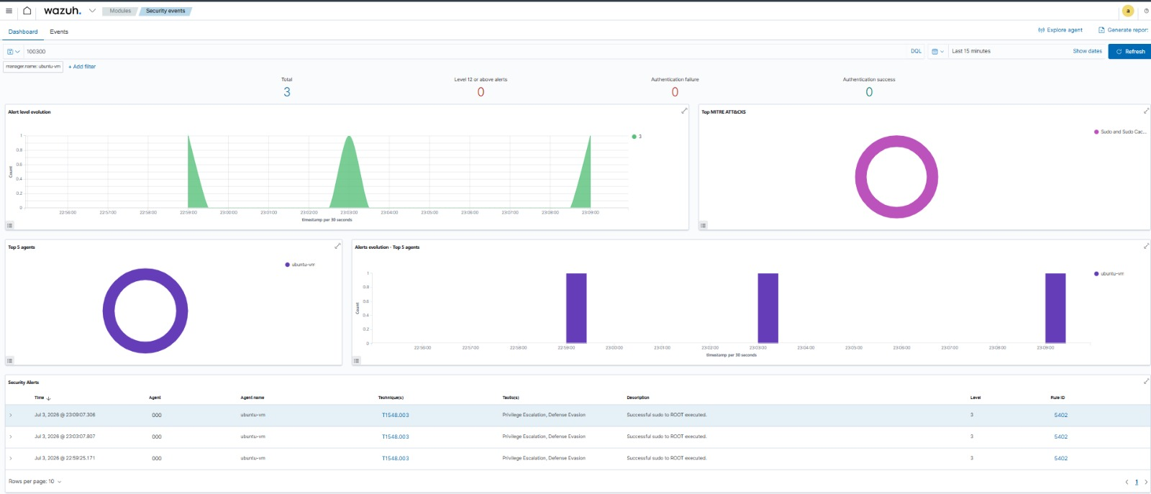

13.2 Bash Execution Monitoring
Bash was included in the endpoint audit configuration through the bash_execution key. The evidence demonstrates shell-related monitoring activity. Shell execution is important context because command interpreters are frequently used to execute scripts and chained commands.
The current custom Rule 100300 match expression does not explicitly include bash_execution. The audit telemetry remains useful, but a dedicated Wazuh rule or an expanded match expression is required if Bash execution should generate the same Level 12 custom alert.

13.3 curl Execution Monitoring and Alert Validation
curl execution was generated on the Ubuntu Agent and verified through the curl_execution audit key. The captured audit output shows command-line context including the executable path and requested destination. This demonstrates that auditd can provide the process-level evidence needed for investigation.
The Wazuh Manager evidence shows Rule ID 100300 processing the curl-related audit event. The alert contains the custom description, Level 12 severity, MITRE T1059 mapping, agent identity, executable path, command, working directory, and audit key.

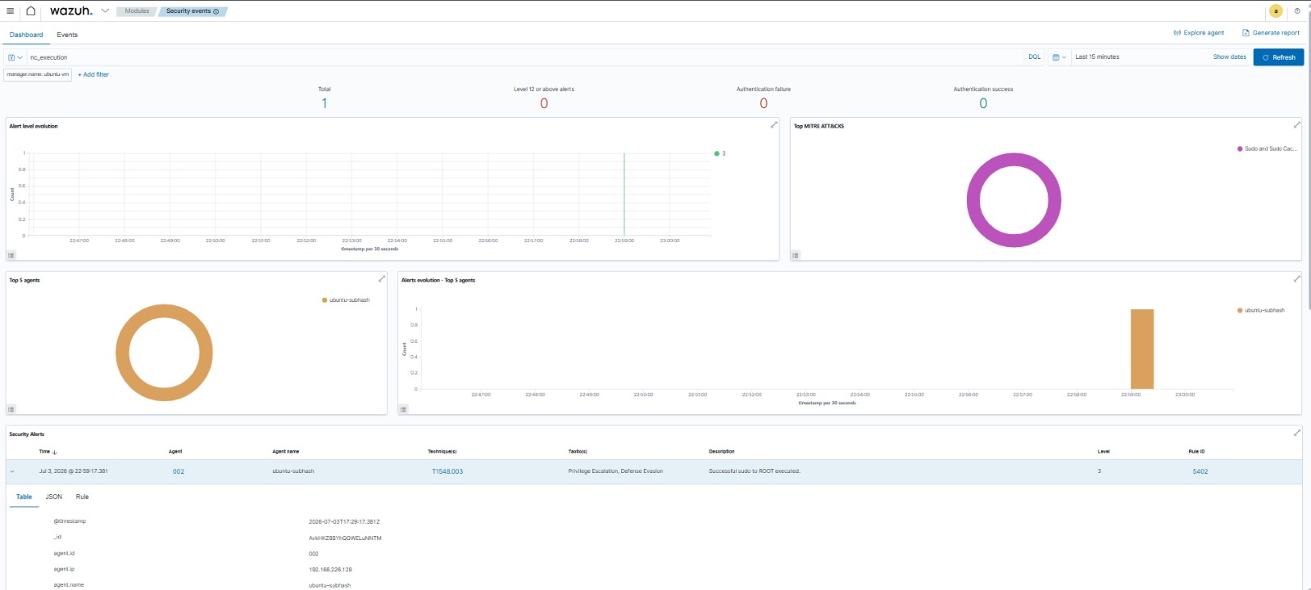

13.4 Netcat (nc) Execution Monitoring
Netcat was monitored with the nc_execution audit key. The lab used a listener command to generate controlled execution telemetry. Netcat is a dual-use networking utility, so its execution can be significant when observed on systems where it is unexpected.
No separate Wazuh Manager terminal screenshot for the nc event was supplied in the evidence set. The report therefore preserves the available endpoint audit evidence without fabricating a server-side screenshot. Because nc_execution is included in the Rule 100300 match expression, matching ingested events are designed to be evaluated by the same custom detection rule.
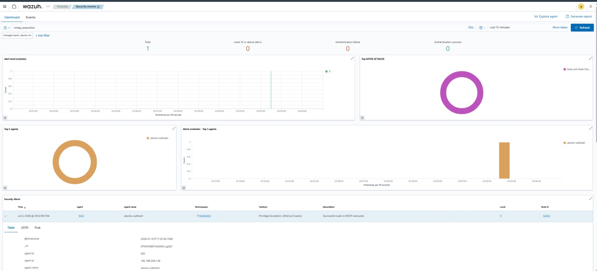

13.5 Nmap Execution Monitoring and Alert Validation
Nmap execution was monitored using the nmap_execution audit key. The controlled command nmap localhost generated audit telemetry showing the executable, command arguments, user context, working directory, and the configured key.
The available Wazuh-side evidence confirms that the command execution detection pipeline received and processed monitored command telemetry.

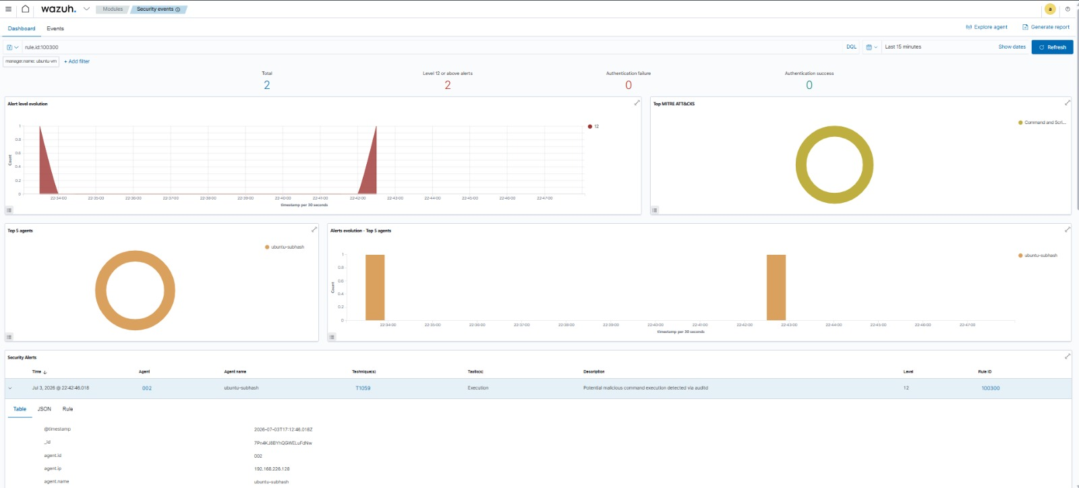

13.6 Wget Execution Monitoring and High-Severity Detection
wget was monitored with the wget_execution audit key. The controlled request attempted to retrieve test.sh from example.com. The remote server returned HTTP 404, meaning the requested resource was not downloaded; however, the execution itself was successfully captured by auditd. This distinction is important: the detection monitors command execution, not successful payload delivery.

Wazuh Manager alert evidence shows the wget command associated with Rule ID 100300, Level 12, MITRE T1059, and the custom description 'Potential malicious command execution detected via auditd'.

14. Detection Results Summary
Command | Endpoint Audit Evidence | Wazuh Evidence | Result
bash | Available | Audit monitoring evidence available; not explicitly matched by Rule 100300 | Telemetry validated
curl | Available | Manager JSON and dashboard evidence available | Detected
nc | Available | No separate Manager terminal screenshot supplied; dashboard-stage evidence available | Telemetry validated
nmap | Available | Wazuh-side evidence available | Detected / validated
wget | Available | Manager JSON confirms Rule 100300 Level 12 | Detected

15. Alert Interpretation
The strongest detection evidence in the lab is the Rule ID 100300 output. The captured Wazuh JSON shows a Level 12 alert with the description 'Potential malicious command execution detected via auditd', MITRE ATT&CK ID T1059, agent ubuntu, and detailed audit data.
For wget and curl, the alert evidence includes command name, executable path, command argument, working directory, audit user identity, and audit key. These fields allow a SOC analyst to answer essential investigation questions: what executed, who executed it, where it ran, what arguments were supplied, and which endpoint generated the event.

16. SOC Analyst Investigation Procedure
High-severity command alert received
↓
Identify endpoint and user
↓
Review command and full arguments
↓
Check parent process and working directory
↓
Evaluate destination IP/domain or listener port
↓
Correlate with authentication, IDS, FIM and process alerts
↓
Determine legitimate administration vs suspicious activity
↓
Contain endpoint if confirmed malicious
↓
Preserve evidence and investigate persistence/lateral movement
↓
Remediate and document incident

17. Observed Outcomes
- auditd installed and active on the Ubuntu endpoint.
- Wazuh Agent configured to ingest /var/log/audit/audit.log.
- Execution watches configured for wget, curl, nc, nmap, bash, and python3.
- Audit keys provided searchable command-specific telemetry.
- curl, nc, nmap, and wget activity produced endpoint audit evidence.
- Custom Wazuh Rule ID 100300 generated Level 12 malicious-command alerts for matching monitored keys.
- Alerts were mapped to MITRE ATT&CK T1059.
- Wazuh alert data provided process, user, command-line, path, and endpoint context.
- The wget test demonstrated that execution detection can succeed even when the requested download itself fails.

18. Limitations and Detection Engineering Notes
The custom rule uses a broad match against audit keys. This is useful for lab validation but may generate false positives in production because tools such as curl, wget, nmap, and netcat can be used legitimately by administrators, automation, monitoring agents, and developers.
The configured audit watches include bash_execution and python_execution, but the supplied Rule 100300 expression does not include those two keys. If high-severity alerts are required for Bash or Python, separate rules or carefully tuned correlation logic should be created.
The nc evidence set did not include a dedicated Wazuh Manager terminal screenshot. This report intentionally does not invent or substitute false evidence. The available endpoint audit and dashboard-stage screenshots are included, and the configured detection logic is documented accurately.

19. Production Hardening Recommendations
- Tune rules by endpoint role, user identity, parent process, command arguments, and destination.
- Create separate severities for reconnaissance, download activity, interpreters, and network listeners.
- Correlate command execution with Suricata alerts, FIM changes, authentication anomalies, and privilege escalation.
- Use allowlists for known automation and approved administrative tooling.
- Alert on suspicious argument patterns rather than tool names alone where practical.
- Monitor execution from unusual directories such as temporary or world-writable locations.
- Preserve raw audit telemetry for forensic investigation and timeline reconstruction.
- Test custom rules with representative benign and malicious-like lab activity before production deployment.

20. Skills Demonstrated
- Linux auditd installation and administration.
- Persistent Linux Audit rule creation.
- Execution telemetry analysis with ausearch.
- Wazuh Agent log-source integration.
- Custom Wazuh detection rule development.
- MITRE ATT&CK technique mapping.
- High-severity alert validation.
- Command-line forensic analysis.
- SOC alert triage and investigation workflow design.
- Evidence-driven security documentation.

21. Security Outcome
STATUS: SUCCESSFUL
The command execution monitoring lab successfully demonstrated an end-to-end detection pipeline from Linux process execution to centralized Wazuh alerting. auditd captured command activity with detailed process and user context, the Wazuh Agent forwarded audit telemetry, and the custom detection rule generated Level 12 alerts for matching command execution keys.
The exercise also demonstrated an important SOC principle: command execution detections require contextual investigation. Dual-use tools are not inherently malicious, but their execution can become high-value evidence when correlated with suspicious destinations, unusual users, privilege escalation, network alerts, or unauthorized system changes.

22. Conclusion
Attack 04 successfully implemented and validated malicious-command detection using auditd and Wazuh. The lab established persistent monitoring for selected command-line utilities, validated audit records with key-based searches, integrated the audit log with Wazuh, and created a custom high-severity detection rule mapped to MITRE ATT&CK T1059.
The supplied evidence demonstrates multiple stages of the detection lifecycle across bash, curl, nc, nmap, and wget activity. Together, these tests show how endpoint audit telemetry can be transformed into centralized, investigation-ready SOC alerts containing command, user, executable, endpoint, and technique context.

