SOC LAB PROJECT
ATTACK 01
FILE INTEGRITY MONITORING (FIM)
Real-Time File Change Detection with Wazuh

Platform | Wazuh SIEM / XDR
Endpoint | Ubuntu Agent
Monitored Path | /root
Result | SUCCESSFUL

1. Executive Summary
This report documents the implementation and validation of File Integrity Monitoring (FIM) in a Wazuh-based SOC lab. The Ubuntu endpoint was configured to monitor the privileged /root directory in real time. Controlled file activity was generated and successfully detected by Wazuh, providing centralized evidence of file addition, integrity checksum changes, and file deletion.
The validated monitoring chain was: endpoint filesystem activity → Wazuh Agent detection → event forwarding → Wazuh Manager analysis → dashboard visibility. This capability later became the foundation for VirusTotal enrichment and n8n SOAR automation.

2. Objectives
- Enable complete event archiving on the Wazuh Manager.
- Configure the Ubuntu Agent to monitor /root in real time.
- Generate controlled filesystem activity.
- Verify file events and rule information in the Wazuh dashboard.
- Establish a reliable FIM event source for later SOC automation.

3. Lab Architecture
Ubuntu Agent (/root)
│ File add / modify / delete
▼
Wazuh Agent — Syscheck / FIM
│ Integrity event
▼
Wazuh Manager
│ Rule analysis
▼
Wazuh Dashboard
│
▼
SOC Analyst Investigation

System Roles
Wazuh Manager (ubuntu-vm): Receives endpoint events, analyzes them with Wazuh rules, archives data, and exposes alerts for investigation.
Ubuntu Agent (ubuntu-agent): Monitors the configured /root directory and forwards detected integrity changes to the Manager.
Wazuh Dashboard: Provides centralized visibility into event time, agent details, file path, event type, hashes, ownership, permissions, and rule information.

4. Security Context
File Integrity Monitoring is important because attackers frequently create, modify, replace, or delete files after gaining access. Examples include malware drops, malicious scripts, persistence artifacts, configuration tampering, unauthorized SSH keys, and evidence removal. The /root directory was selected because it is a privileged location where unexpected file activity can be security-relevant.

5. Wazuh Manager Configuration

5.1 Open the Manager Configuration
Execution location: Wazuh Server / Manager (ubuntu-vm)
sudo nano /var/ossec/etc/ossec.conf
Purpose: Opens the primary Manager configuration file.

5.2 Enable Event Archiving
<logall>yes</logall>
<logall_json>yes</logall_json>
logall enables plain-text archiving of received events. logall_json enables structured JSON archiving, which is useful for investigation, troubleshooting, integrations, and automation.

5.3 Restart the Manager
sudo systemctl restart wazuh-manager
Purpose: Reloads the Manager configuration after the changes.

6. Ubuntu Agent FIM Configuration

6.1 Open the Agent Configuration
Execution location: Ubuntu Agent (ubuntu-agent)
sudo nano /var/ossec/etc/ossec.conf

6.2 Configure /root Monitoring
<syscheck>
<disabled>no</disabled>
<directories check_all="yes" report_changes="yes" realtime="yes">/root</directories>
</syscheck>
- /root — directory selected for monitoring.
- check_all="yes" — enables comprehensive integrity checks.
- report_changes="yes" — enables reporting of detected file changes.
- realtime="yes" — enables near-real-time detection instead of relying only on scheduled scans.

6.3 Restart the Agent
sudo systemctl restart wazuh-agent
Purpose: Loads the updated FIM configuration and activates monitoring for /root.

7. Test Execution
The controlled test was performed on the Ubuntu Agent. The operator switched to root, entered /root, verified the directory, reviewed existing contents, created test.txt, and listed the directory again.
su root
cd /root
pwd
ls
touch test.txt
ls
- su root — switches to the root account for privileged-directory testing.
- cd /root — enters the monitored directory.
- pwd — verifies the current working directory.
- ls — records directory contents before and after the test.
- touch test.txt — creates the controlled test file that triggers FIM.

8. Detection and Analysis

8.1 File Addition Detection
Wazuh successfully detected creation of /root/test.txt. The expanded event shows decoder syscheck_new_entry, location syscheck, rule description 'File added to the system.', rule ID 554, rule level 5, syscheck event 'added', path /root/test.txt, user root, and real-time monitoring mode.
The event also contains integrity metadata such as an MD5 hash and file permission information. These fields support triage, correlation, and threat-intelligence enrichment.

8.2 Security Events Timeline
The Security Events view demonstrates broader FIM coverage. The captured evidence includes file addition, integrity checksum change, and file deletion events. Wazuh displayed rule ID 554 for file addition, rule ID 550 for an integrity checksum change, and rule ID 553 for file deletion.
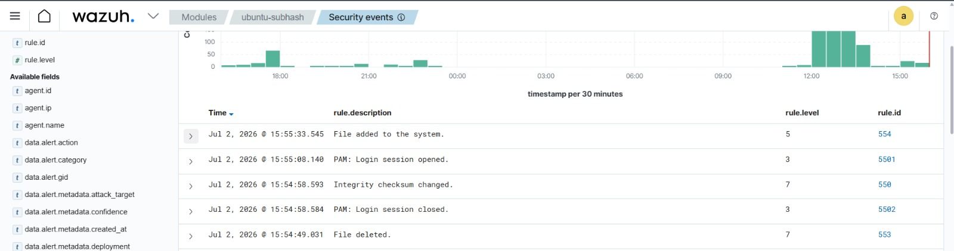

9. Detection Flow
1. test.txt is created inside /root
↓
2. Wazuh Syscheck/FIM detects the new entry
↓
3. Ubuntu Agent forwards the event
↓
4. Wazuh Manager analyzes the event
↓
5. Rule 554 identifies the file-addition event
↓
6. Alert appears in the Wazuh dashboard
↓
7. Analyst reviews path, user, hash, permissions, and timestamp

10. Observed Results
Activity | Description | Rule ID | Level
File added | File added to the system. | 554 | 5
Checksum changed | Integrity checksum changed. | 550 | 7
File deleted | File deleted. | 553 | 7

11. Verification Criteria
- Ubuntu Agent connected to the Wazuh Manager.
- FIM enabled on the Agent.
- /root configured for real-time monitoring.
- test.txt created inside /root.
- Event forwarded to the Manager.
- Wazuh displayed the file-addition event with rule ID 554.
- Expanded event exposed the monitored path and integrity metadata.
- Dashboard also demonstrated checksum-change and deletion visibility.

12. Proof-of-Concept Evidence
POC 1 — Endpoint Activity: Controlled creation of test.txt inside the monitored /root directory.
POC 2 — Expanded Alert: Real-time detection of /root/test.txt with event, rule, hash, ownership, and permission evidence.
POC 3 — Security Events Timeline: Centralized visibility of file addition, checksum change, and file deletion.

13. Security Outcome
STATUS: SUCCESSFUL
The Wazuh FIM implementation successfully detected controlled file activity on the Ubuntu endpoint. Creation of /root/test.txt generated a real-time event that was forwarded to the Manager and displayed in the dashboard. The captured evidence also demonstrates visibility into integrity checksum changes and file deletion events.

14. Defensive Value
- Detection of unauthorized file creation.
- Visibility into malicious script or malware placement.
- Detection of configuration tampering.
- Monitoring of persistence-related file activity.
- Visibility into unexpected privileged-directory changes.
- Detection of file deletion that may indicate evidence removal.
- Hash collection for threat-intelligence enrichment.

15. Production Recommendations
The lab monitored /root for controlled validation. Production deployments should define monitoring scope according to asset criticality and expected change frequency. Candidate paths include /etc, /usr/bin, /usr/sbin, /bin, /sbin, web application directories, SSH configuration locations, and service configuration paths.
Production environments should establish approved baselines, tune noisy paths, prioritize critical files, correlate changes with process and user activity, and test automated response actions before enforcement.

16. Skills Demonstrated
- Wazuh SIEM/XDR configuration.
- Linux endpoint monitoring.
- File Integrity Monitoring implementation.
- Wazuh Agent and Manager configuration.
- Security event generation and validation.
- Rule-based alert investigation.
- Centralized SOC monitoring.
- Linux service management.
- Detection engineering fundamentals.
- POC-driven security documentation.

17. Conclusion
Attack 01 successfully demonstrated real-time File Integrity Monitoring using Wazuh. A controlled file was created in /root, detected by the Ubuntu Agent, analyzed by the Wazuh Manager, and presented through the dashboard. The evidence confirms successful visibility into file addition and broader integrity events, providing a strong foundation for later VirusTotal and SOAR automation stages.

