SOC LAB PROJECT
ATTACK 02
NETWORK INTRUSION DETECTION
Suricata IDS Integration with Wazuh and Nmap Scan Detection

Detection Engine | Suricata IDS
SIEM Platform | Wazuh SIEM / XDR
Monitored Endpoint | Ubuntu Agent
Test Source | Kali Linux
Result | SUCCESSFUL

1. Executive Summary
This report documents the implementation and validation of Network Intrusion Detection in the SOC lab using Suricata integrated with Wazuh. Suricata was installed on the Ubuntu Agent, configured to monitor the active network interface, and set to generate structured EVE JSON telemetry. The Wazuh Agent was configured to collect Suricata's eve.json output and forward events to the Wazuh Manager for centralized analysis and dashboard visibility.
A controlled Nmap SYN scan was launched from the Kali Linux test machine against the Ubuntu Agent. Suricata inspected the traffic and generated scan-related alerts. Wazuh successfully ingested and displayed these events, including signatures associated with suspicious inbound traffic to database and remote-access service ports.

2. Objectives
- Install and validate Suricata on the Ubuntu Agent.
- Update and verify the Suricata detection rules.
- Identify and configure the correct network interface.
- Configure HOME_NET, rule paths, EVE JSON logging, and AF_PACKET capture.
- Integrate Suricata EVE JSON with the Wazuh Agent.
- Generate controlled reconnaissance using Nmap from Kali Linux.
- Verify local Suricata telemetry and centralized Wazuh detection.

3. Lab Architecture
Kali Linux — Scan Source
│ Nmap SYN scan
▼
Ubuntu Agent — Target
│ Traffic on ens33
▼
Suricata IDS
│ eve.json alerts
▼
Wazuh Agent Logcollector
│ JSON forwarding
▼
Wazuh Manager
│ Analysis and indexing
▼
Wazuh Dashboard
▼
SOC Analyst Investigation

System Roles
Kali Linux: Controlled reconnaissance source used to generate network scan traffic.
Ubuntu Agent: Monitored target endpoint hosting the Wazuh Agent and Suricata IDS.
Suricata: Inspects network traffic, matches patterns against detection rules, and writes structured events to /var/log/suricata/eve.json.
Wazuh: Collects, forwards, analyzes, indexes, and presents Suricata security events for centralized investigation.

4. Security Context
Network reconnaissance is commonly performed before exploitation. An attacker may scan a target to identify reachable hosts, open ports, exposed services, database listeners, and remote-access services. Detecting reconnaissance gives defenders an opportunity to investigate activity before it progresses to exploitation.
In this lab, Suricata provided network-level visibility while Wazuh provided centralized event collection and investigation, demonstrating how IDS telemetry can be incorporated into a SIEM workflow.

5. Suricata Installation
Execution location: Ubuntu Agent (ubuntu-agent)

5.1 Add Stable Repository
sudo add-apt-repository ppa:oisf/suricata-stable -y
Purpose: Adds the stable Suricata package repository.

5.2 Update Package Metadata
sudo apt update
Purpose: Refreshes package metadata after adding the repository.

5.3 Install Suricata
sudo apt install suricata suricata-update -y
Purpose: Installs the IDS engine and its rule-management utility.

5.4 Verify Installation
sudo suricata -V
Purpose: Confirms installation and displays the installed Suricata version.

6. Rule Update and Verification
sudo suricata-update
Purpose: Downloads and prepares the active Suricata detection rule set.
ls -lh /var/lib/suricata/rules/
Purpose: Confirms that the rules directory contains the required rule files.

7. Network Interface Identification
ifconfig
Purpose: Identifies the active interface and IP addressing used by the Ubuntu Agent. In the implemented lab configuration, Suricata monitored ens33. Selecting the correct interface is essential because traffic on an unmonitored interface will not be inspected.

8. Suricata Configuration
sudo nano /etc/suricata/suricata.yaml
Purpose: Opens the primary Suricata configuration file.

8.1 Protected Network
HOME_NET: "[192.168.43.142/24]"
EXTERNAL_NET: "any"
HOME_NET defines the protected network range for rule evaluation. EXTERNAL_NET was set to any for the lab.

8.2 Rule Loading
default-rule-path: /var/lib/suricata/rules
rule-files:
- suricata.rules
Purpose: Directs Suricata to load the generated rule file from the configured rules directory.

8.3 EVE JSON Logging
outputs:
- eve-log:
enabled: yes
filetype: regular
filename: /var/log/suricata/eve.json
types:
- alert
- http
- dns
- tls
- flow
Purpose: Enables structured JSON telemetry for alerts, HTTP, DNS, TLS, and flow activity. This format is suitable for SIEM ingestion.

8.4 Packet Capture Interface
af-packet:
- interface: ens33
Purpose: Configures Suricata to inspect traffic captured from ens33.

9. Validation and Service Startup
sudo suricata -T -c /etc/suricata/suricata.yaml
Purpose: Tests configuration syntax and rule loading before service restart.
sudo systemctl enable suricata
sudo systemctl restart suricata
sudo systemctl status suricata
These commands enable automatic startup, restart the service with the active configuration, and verify service health.

10. Local Suricata Event Verification
sudo tail -f /var/log/suricata/eve.json
Purpose: Follows the EVE JSON file in real time and confirms that Suricata is producing structured network telemetry..

11. Wazuh Agent Integration
sudo nano /var/ossec/etc/ossec.conf
Execution location: Ubuntu Agent.
<localfile>
<log_format>json</log_format>
<location>/var/log/suricata/eve.json</location>
</localfile>
Purpose: Instructs the Wazuh Agent to collect Suricata EVE JSON as structured input.
sudo systemctl restart wazuh-agent
sudo systemctl status wazuh-agent
Purpose: Reloads the Agent configuration and confirms that the service remains operational.

12. Controlled Network Scan
Execution location: Kali Linux test machine.
nmap -sS -Pn TARGET_IP
- nmap — invokes the network scanning utility.
- -sS — performs a TCP SYN scan to identify port states.
- -Pn — skips host discovery and proceeds directly with scanning.
- TARGET_IP — represents the Ubuntu Agent address used in the authorized SOC lab.
The captured POC shows the controlled scan against the Ubuntu Agent. The target was reachable, SSH on TCP port 22 was reported open, and the remaining scanned ports were closed or reset.
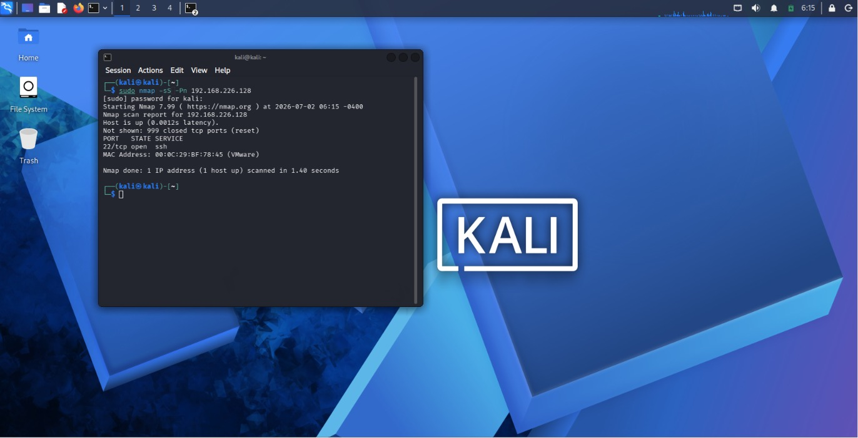

13. Detection and Analysis

13.1 Expanded Suricata Alert
The expanded Wazuh event confirms successful Suricata telemetry ingestion. The alert contains the Ubuntu Agent identity, alert category, signature, destination IP and port, source IP and port, direction, interface, and flow metadata.
The displayed event includes the signature 'ET SCAN Suspicious inbound to Oracle SQL port 1521'. The event identifies the monitored Ubuntu Agent as destination and the Kali Linux system as source, demonstrating successful correlation from scan traffic to IDS detection and SIEM visibility.
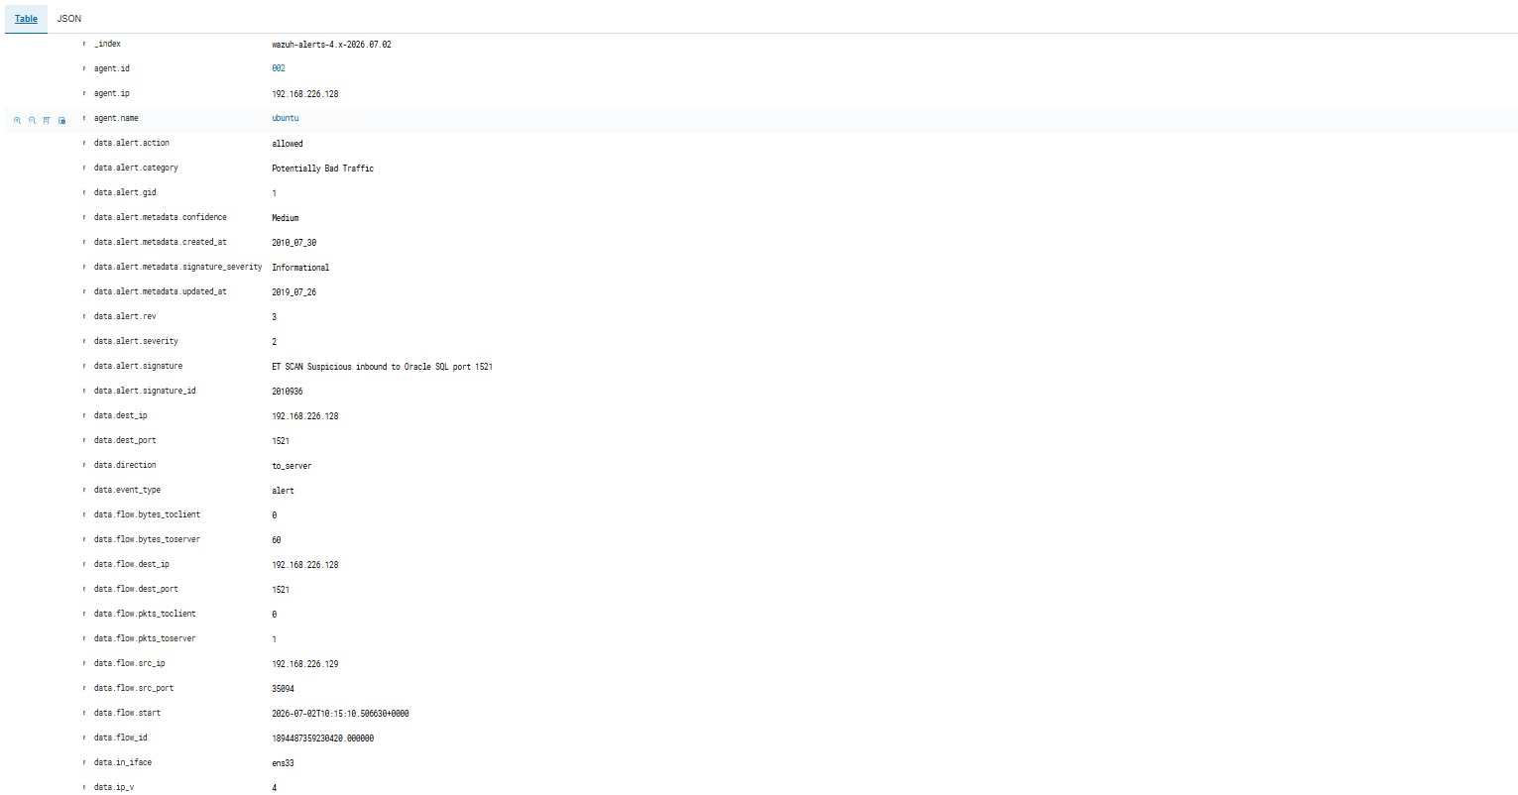

13.2 Multiple Scan Signatures
The Wazuh Security Events view shows multiple Suricata alerts generated during reconnaissance. The captured events include suspicious inbound activity associated with Oracle SQL port 1521, VNC ports 5800–5820, PostgreSQL port 5432, MSSQL port 1433, and MySQL port 3306.
These alerts demonstrate that the reconnaissance produced a pattern of network security signals rather than a single isolated event, providing broader context for analyst investigation.
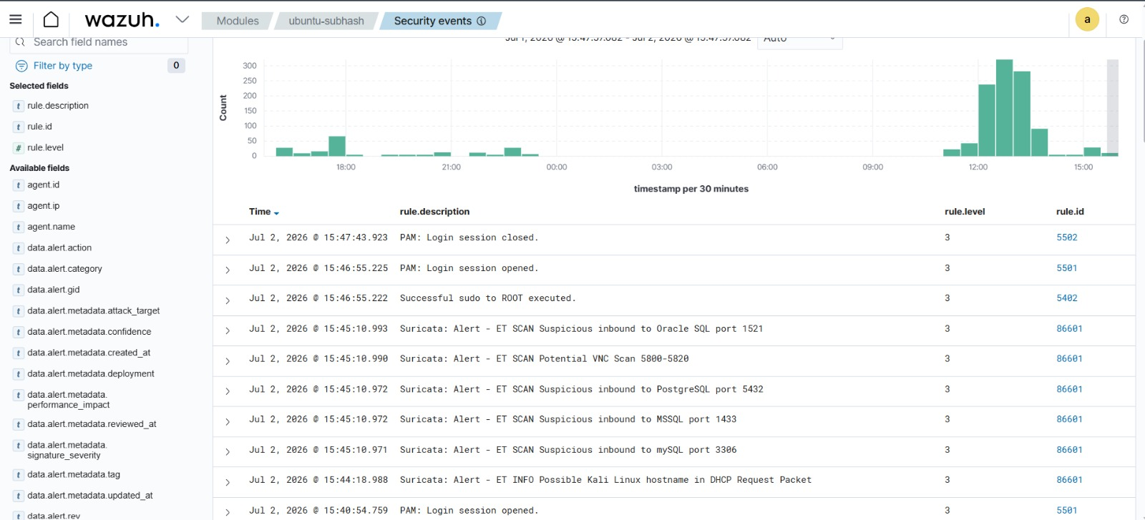

14. End-to-End Detection Flow
1. Kali Linux launches Nmap SYN scan
↓
2. Packets reach Ubuntu Agent interface
↓
3. Suricata inspects traffic on ens33
↓
4. Detection rules identify scan patterns
↓
5. Events are written to eve.json
↓
6. Wazuh Agent reads JSON events
↓
7. Events reach Wazuh Manager
↓
8. Wazuh analyzes and indexes alerts
↓
9. SOC analyst investigates in dashboard

15. Observed Results
Observed Detection | Evidence Source | Outcome
Suricata telemetry generation | eve.json | Successful
Controlled Nmap SYN scan | Kali terminal | Successful
Oracle SQL port 1521 scan alert | Expanded Wazuh event | Detected
VNC 5800–5820 scan alert | Wazuh Security Events | Detected
PostgreSQL 5432 scan alert | Wazuh Security Events | Detected
MSSQL 1433 scan alert | Wazuh Security Events | Detected
MySQL 3306 scan alert | Wazuh Security Events | Detected

16. Verification Criteria
- Suricata installed successfully.
- Rules updated and available.
- Correct interface configured.
- Configuration validation completed.
- Suricata service operational.
- eve.json generated structured telemetry.
- Wazuh Agent collected EVE JSON.
- Controlled Nmap scan generated from Kali Linux.
- Suricata scan alerts appeared in Wazuh.
- Expanded events contained source, destination, port, signature, and flow context.

17. Troubleshooting Commands
sudo apt --fix-broken install -y
sudo apt remove suricata-update -y
sudo apt install suricata -y
suricata -V
sudo suricata-update
which suricata
which suricata-update
sudo systemctl status suricata
These commands repair broken dependencies, reinstall Suricata if necessary, verify the IDS version, refresh rules, confirm executable paths, and check service health.

18. Proof-of-Concept Evidence
POC 1 — Suricata Event Generation: Demonstrates active EVE JSON telemetry generation on the Ubuntu Agent.
POC 2 — Controlled Scan Execution: Demonstrates the Nmap SYN scan from Kali Linux against the lab target.
POC 3 — Expanded IDS Alert: Demonstrates Wazuh ingestion of a Suricata alert with detailed network and signature metadata.
POC 4 — Multiple Scan Detections: Demonstrates centralized visibility of multiple Suricata scan signatures in Wazuh.

19. Security Outcome
STATUS: SUCCESSFUL
The Suricata and Wazuh network intrusion detection pipeline was successfully implemented and validated. Suricata inspected traffic on the Ubuntu Agent, generated EVE JSON events, and Wazuh collected and displayed the resulting IDS alerts. Controlled Nmap reconnaissance from Kali Linux produced multiple scan-related detections, confirming end-to-end monitoring and centralized SOC visibility.

20. Defensive Value
- Early detection of reconnaissance and service discovery.
- Visibility into suspicious inbound connection attempts.
- Identification of scans targeting database and remote-access ports.
- Structured network metadata for investigation.
- Centralized correlation of endpoint and network telemetry.
- Ability to identify broader scan patterns.
- Foundation for automated enrichment and response workflows.

21. Production Recommendations
For production deployment, HOME_NET should accurately represent protected network ranges and the monitored interface should be verified after network or virtualization changes. Detection rules should be updated on a controlled schedule, and noisy signatures should be tuned against environment baselines.
Suricata telemetry should be correlated with authentication logs, endpoint events, vulnerability information, and asset criticality. High-confidence detections may be routed into SOAR workflows, but automated containment should be carefully tested before enforcement.

22. Skills Demonstrated
- Suricata IDS installation and configuration.
- Network interface and packet inspection configuration.
- Suricata rule management.
- EVE JSON telemetry analysis.
- Wazuh Agent log integration.
- SIEM-based IDS alert investigation.
- Controlled Nmap reconnaissance testing.
- Network intrusion detection validation.
- SOC detection engineering fundamentals.
- POC-driven technical documentation.

23. Conclusion
Attack 02 successfully demonstrated network intrusion detection using Suricata integrated with Wazuh. The Ubuntu Agent generated structured IDS telemetry, the Wazuh Agent forwarded the events, and Wazuh presented scan-related alerts for investigation. The controlled Nmap SYN scan produced multiple Suricata detections, validating the complete network-monitoring pipeline from packet inspection to centralized SIEM visibility.

