SOC LAB PROJECT
ATTACK 07
PHISHING EMAIL IDENTIFICATION
Email Security Monitoring, Rspamd Analysis and Wazuh Detection Engineering
Field | Details
Scenario | Phishing and suspicious email identification
Endpoint | Ubuntu Agent
Log source | /var/log/phishing-mails.log and email-security telemetry
Detection platform | Wazuh
Email analysis evidence | Rspamd
Primary custom rule | 100500
Observed alert level | 10
MITRE ATT&CK | T1566 — Phishing
Status | SUCCESSFUL

1. Executive Summary
This report documents a phishing-email identification use case built in a controlled SOC lab using Wazuh and email-security analysis telemetry. The objective was to ingest email-related logs, create custom detection logic for common phishing indicators, generate controlled suspicious-email events, and investigate the resulting alerts in Wazuh.
The detection logic covers lookalike sender domains, shortened URLs, executable attachments and urgency language. The supplied evidence also demonstrates Rspamd-based email analysis and Wazuh alerts for suspicious spam/phishing behavior, missing Message-ID headers and invalid DKIM authentication information.
The expanded Wazuh event confirms a Level 10 alert with Rule ID 100500, rule group email_security/rspamd, and MITRE ATT&CK mapping T1566 under Initial Access. The scenario therefore demonstrates both indicator-based phishing detection and email-authentication/context analysis.

2. Objectives
- Create a dedicated phishing-email log source on the Ubuntu Agent.
- Configure the Wazuh Agent to ingest the email-security log.
- Create custom rules for common phishing indicators.
- Trigger a controlled suspicious-email event.
- Review phishing-related alerts in Wazuh Security Events.
- Analyze sender, URL, attachment and urgency indicators.
- Validate Rspamd spam classification and email-authentication findings.
- Map the detection to MITRE ATT&CK phishing behavior.

3. Detection Architecture
Suspicious Email / Test Event
↓
Email analysis and log generation
↓
Ubuntu Agent log source
↓
Wazuh Agent log collection
↓
Wazuh Manager decoding and rule matching
↓
Custom phishing / email-security rules
↓
Security Event generated
↓
SOC analyst investigates:
sender → authentication → URL → attachment → language

4. Threat Scenario
Phishing remains a common Initial Access technique because attackers can combine social engineering with technical indicators such as lookalike domains, shortened links, suspicious attachments and urgent language. No single indicator is always conclusive, so SOC analysis should correlate message content, authentication results, sender infrastructure and attachment or URL reputation.
This lab demonstrates layered email detection. Custom Wazuh rules identify explicit phishing indicators, while the supplied Rspamd evidence provides additional signals such as DMARC policy rejection, missing Message-ID, missing date and unknown sending hostname.

5. Create the Phishing Log File
On the Ubuntu Agent, a dedicated log file was created:
sudo touch /var/log/phishing-mails.log
This file acts as a controlled log source for generating and testing phishing detection rules.

6. Add the Log Source to the Wazuh Agent
sudo nano /var/ossec/etc/ossec.conf
The following block was added before the closing ossec_config tag:
<localfile>
<log_format>syslog</log_format>
<location>/var/log/phishing-mails.log</location>
</localfile>
This configuration instructs the Agent to monitor the phishing-mail log and forward matching log entries to the Wazuh Manager for analysis.

7. Restart the Agent
sudo systemctl restart wazuh-agent
Restarting the Agent applies the new localfile configuration. Agent connectivity should be verified before rule testing.

8. Create Custom Phishing Rules
Custom detection rules were added in local_rules.xml through Wazuh rule management:
<group name="phishing_detection,email_security">
<rule id="100500" level="10">
<match>paypa1.com</match>
<description>Possible phishing sender domain detected</description>
<mitre><id>T1566</id></mitre>
</rule>
<rule id="100501" level="12">
<match>bit.ly</match>
<description>Suspicious shortened phishing URL detected</description>
<mitre><id>T1566</id></mitre>
</rule>
<rule id="100502" level="14">
<match>invoice.exe</match>
<description>Suspicious executable attachment detected</description>
<mitre><id>T1204</id></mitre>
</rule>
<rule id="100503" level="8">
<match>account suspended</match>
<description>Phishing urgency language detected</description>
<mitre><id>T1566</id></mitre>
</rule>
</group>

9. Rule Logic and Severity
Rule | Indicator | Level | Purpose
100500 | Lookalike sender domain | 10 | Detect suspicious sender-domain impersonation
100501 | Shortened URL | 12 | Detect potentially concealed phishing destinations
100502 | Executable attachment | 14 | Detect high-risk executable attachment reference
100503 | Urgency language | 8 | Detect social-engineering pressure language
The rule levels reflect increasing investigative priority in this lab. In production, severity should be tuned using organizational context, allowlists, mail-gateway telemetry and correlation with other indicators.

10. Restart the Wazuh Manager
sudo systemctl restart wazuh-manager
The Manager restart loads the new custom rules. Rule syntax should be validated if the service fails to restart or alerts do not appear.

11. Trigger the Controlled Phishing Event
A synthetic phishing-style log entry was appended on the Ubuntu Agent:
echo "From: support@paypa1.com Subject: Verify account now http://bit.ly/login Attachment: invoice.exe" | sudo tee -a /var/log/phishing-mails.log
The test message combines multiple suspicious characteristics: a lookalike sender domain, an account-verification lure, a shortened URL and an executable attachment reference.

12. Rspamd Analysis Evidence
The supplied Rspamd output classified the analyzed message as spam. The visible result shows Spam: true and a score of 7.90/15.00. Important contributing indicators include DMARC_POLICY_REJECT, HFILTER_HOSTNAME_UNKNOWN, MISSING_DATE and MISSING_MID.
The DMARC result is especially useful because the output states that the example domain had no valid SPF and no valid DKIM under a reject policy. Missing Message-ID and date headers, while not independently proving phishing, add useful anomaly context.
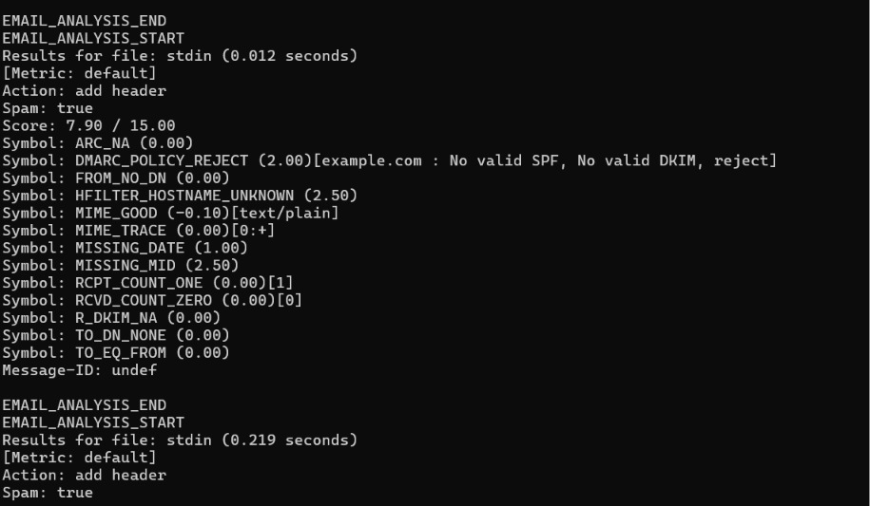

13. Wazuh Security Event Evidence
The Wazuh Security Events view shows multiple email-security detections. Visible events include a suspicious spam or phishing email alert at Level 10, an email received without a Message-ID header at Level 8, and an email received without valid DKIM authentication information at Level 8.
This demonstrates a stronger detection model than relying on a single keyword: content indicators and authentication/header anomalies can be reviewed together during triage.
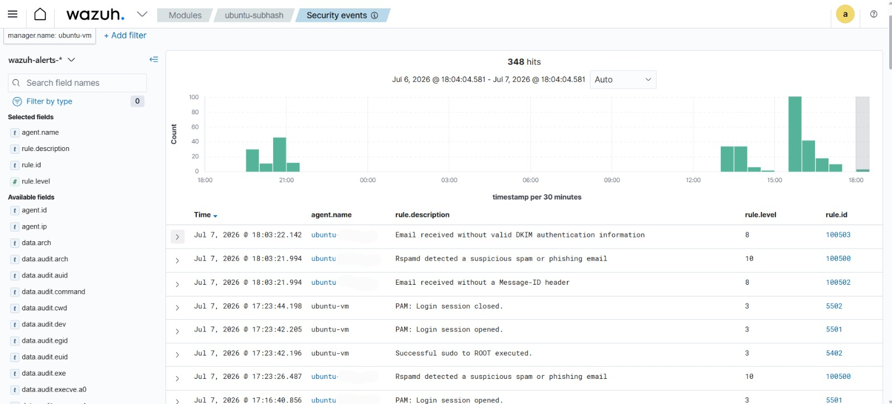

14. Detailed Alert Investigation
The expanded Wazuh event provides the following key fields:
Field | Observed Value
agent.id | 002
agent.ip | 192.168.226.130
agent.name | ubuntu-subhash
full_log | Spam: true
location | /var/log/email-security.log
manager.name | ubuntu-vm
rule.description | Rspamd detected a suspicious spam or phishing email
rule.groups | email_security, rspamd
rule.id | 100500
rule.level | 10
rule.mitre.id | T1566
rule.mitre.tactic | Initial Access
rule.mitre.technique | Phishing
The event confirms that Wazuh received the email-security result, classified it with the custom phishing detection logic and mapped it to MITRE ATT&CK T1566.
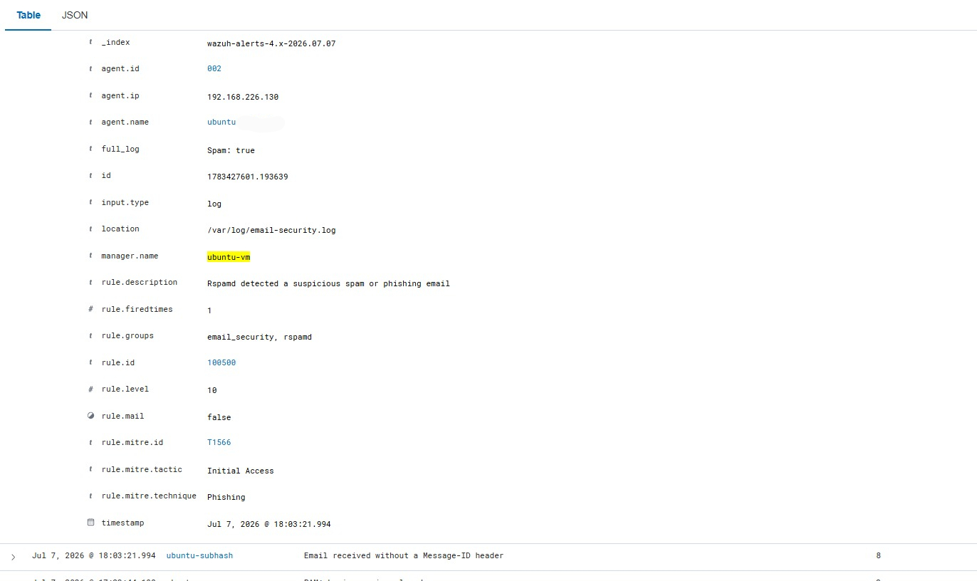

15. SOC Analyst Investigation Workflow
Phishing alert received
↓
Validate sender and display-name mismatch
↓
Check SPF / DKIM / DMARC results
↓
Inspect Message-ID and mail headers
↓
Expand shortened URLs safely
↓
Check URL/domain reputation
↓
Inspect attachment type and hash
↓
Review urgency and credential-harvesting language
↓
Search for same campaign across other mailboxes
↓
Contain, block, quarantine and escalate as appropriate

16. Real SOC Analysis Points
- Sender domain spoofing or lookalike-domain behavior.
- SPF, DKIM and DMARC authentication failures.
- Suspicious or shortened URLs.
- Executable or unusual attachment types.
- Urgency, fear or account-suspension language.
- Missing or malformed email headers.
- Unknown or suspicious sending infrastructure.
- Repeated delivery attempts across users.
- Related endpoint or browser activity after message delivery.

17. Detection Results
Validation Area | Observed Evidence | Result
Email analysis | Rspamd Spam: true | Successful
Spam score | 7.90 / 15.00 | Observed
Authentication anomaly | DMARC reject context; no valid SPF/DKIM shown | Detected
Header anomaly | Missing Message-ID alert | Detected
DKIM anomaly | Invalid/missing valid DKIM alert | Detected
Wazuh phishing alert | Rule 100500, Level 10 | Successful
MITRE mapping | T1566 — Phishing | Successful

18. Optional Detection Enhancements
The lab can be extended with additional correlation and content-analysis logic.
<rule id="100504" level="10">
<regex>[A-Za-z0-9+/]{100,}={0,2}</regex>
<description>Possible Base64 encoded phishing content</description>
</rule>
<rule id="100505" level="15" frequency="5" timeframe="60">
<if_matched_sid>100500</if_matched_sid>
<description>Multiple phishing attempts detected</description>
</rule>
These enhancements can help detect long encoded content and repeated campaign activity. They should be tuned carefully because generic Base64 patterns can produce false positives in legitimate email content.

19. Response Opportunities
- Block confirmed malicious sender IPs or domains at approved controls.
- Quarantine confirmed malicious attachments.
- Block confirmed malicious URLs using web or DNS security controls.
- Reset credentials when credential theft is confirmed or strongly suspected.
- Disable a user account only under an approved incident-response process.
- Search for and remove matching campaign messages from other mailboxes.
- Notify affected users with clear incident guidance.
- Preserve message headers and artifacts for investigation.

20. Troubleshooting Checklist
- Confirm the Agent is connected.
- Confirm the monitored log file exists and is readable.
- Verify the localfile block is inside the correct ossec_config structure.
- Restart wazuh-agent after log-source changes.
- Confirm new log lines are appended after the Agent restart.
- Validate local_rules.xml syntax.
- Restart wazuh-manager after rule changes.
- Search the correct time range and Agent in Security Events.
- Verify exact match strings and case behavior.
- Check Manager and Agent logs if expected alerts are absent.

21. Security Engineering Notes
Keyword rules are useful for lab validation but should not be the only phishing defense in production. Legitimate emails can contain shortened links or urgent language, while sophisticated phishing messages may avoid obvious keywords. Production detection should combine authentication results, domain age and reputation, URL analysis, attachment sandboxing, user reports and behavioral correlation.
The supplied evidence demonstrates the value of layered telemetry: Rspamd provides a scored analysis with individual symbols, while Wazuh centralizes and maps the resulting security events for SOC investigation.

22. Skills Demonstrated
- Wazuh log-source configuration.
- Custom phishing rule creation.
- Email-security log analysis.
- Rspamd result interpretation.
- SPF, DKIM and DMARC investigation concepts.
- Phishing indicator analysis.
- MITRE ATT&CK mapping.
- SOC triage workflow design.
- Alert severity interpretation.
- Detection engineering and documentation.

23. Security Outcome
STATUS: SUCCESSFUL
The phishing-email identification workflow successfully generated and displayed email-security alerts in Wazuh. The supplied evidence shows Rspamd classifying a message as spam, Wazuh surfacing authentication and header anomalies, and a detailed Level 10 phishing alert mapped to MITRE ATT&CK T1566.
The scenario demonstrates how content indicators, sender/authentication anomalies and centralized SIEM alerting can be combined to support practical phishing triage.

24. Conclusion
Attack 07 successfully demonstrated phishing-email identification using Wazuh detection engineering and Rspamd email-analysis evidence. The workflow covered log ingestion, custom rule creation, controlled event generation, alert review and detailed event investigation.
The strongest aspect of the lab is the layered approach: suspicious content indicators are complemented by email-authentication and header anomalies. This gives a SOC analyst better context than a single keyword match and provides a useful foundation for future URL reputation checks, attachment analysis, campaign correlation and controlled automated response.

