SOC LAB PROJECT
ATTACK 05
SSH BRUTE FORCE DETECTION AND BLOCKING
Wazuh Detection, Correlation and Active Response

Field | Details
Attack Scenario | Repeated SSH authentication attempts
Attacker System | Kali Linux
Target System | Ubuntu Agent
Detection Platform | Wazuh SIEM / XDR
Response Mechanism | firewall-drop Active Response
Primary Rules Observed | 5760 and 5763
Outcome | Brute-force activity detected and automated response validated
Status | SUCCESSFUL

1. Executive Summary
This report documents the controlled simulation, detection, correlation, and automated response workflow for an SSH brute-force attack in the SOC lab. A Kali Linux attacker system generated repeated SSH login attempts against the monitored Ubuntu endpoint. The Ubuntu Agent recorded failed authentication events in /var/log/auth.log and forwarded them to the Wazuh Manager.
Wazuh detected individual SSH authentication failures and correlated repeated attempts into a higher-severity brute-force alert. The Active Response framework was configured to invoke firewall-drop for selected SSH rules, providing an automated containment layer. The supplied evidence shows the Hydra attack activity, Wazuh authentication-failure alerts, a correlated brute-force alert, detailed SSH event fields, and firewall-drop Active Response logging.

2. Objectives
- Verify that the Ubuntu Agent monitors SSH authentication logs.
- Confirm that Wazuh SSH detection and correlation rules are available.
- Configure Manager-side Active Response for relevant SSH rules.
- Confirm that the endpoint supports the firewall-drop response script.
- Generate controlled repeated SSH authentication attempts from Kali Linux.
- Observe individual failed-authentication alerts and brute-force correlation.
- Validate Active Response execution logging.
- Document the full detection-to-response workflow as professional SOC evidence.

3. Lab Architecture
Kali Linux Attacker
│
│ repeated SSH login attempts
▼
Ubuntu Agent / SSH Service
│
│ /var/log/auth.log
▼
Wazuh Agent
│
│ forwards authentication telemetry
▼
Wazuh Manager
│
│ SSH decoding + rule correlation
▼
Brute-Force Detection
│
│ Active Response instruction
▼
Ubuntu Agent
│
│ firewall-drop response
▼
Automated Source-IP Containment

4. Attack Background
SSH brute-force activity consists of repeated authentication attempts against an SSH service in an effort to discover valid credentials. A single failed login can be caused by normal user error, but a rapid sequence of failures from the same source can indicate password guessing or automated credential attacks.
In this lab, Hydra was used only inside the controlled environment to generate repeated SSH authentication attempts. Wazuh analyzed the resulting authentication logs and provided both event-level visibility and correlated brute-force detection.

5. Verify SSH Log Monitoring on the Ubuntu Agent
The Wazuh Agent configuration was checked on the Ubuntu endpoint:
sudo nano /var/ossec/etc/ossec.conf
The following localfile configuration was verified:
<localfile>
<log_format>syslog</log_format>
<location>/var/log/auth.log</location>
</localfile>
Purpose: This configuration instructs the Wazuh Agent to read Linux authentication events from /var/log/auth.log. SSH failures, successful logins, PAM events, source IP addresses, source ports, and target usernames can then be forwarded for centralized analysis.

6. Verify SSH Detection Rules
The Wazuh rules interface was used to confirm that SSH-related detection logic was available. The lab checked relevant SSH rules, including the rules referenced in the Active Response configuration.
Rule ID | Role in Lab
5710 | SSH-related detection rule included in response configuration
5712 | SSH-related detection rule included in response configuration
5715 | SSH authentication success-related rule included in response configuration
5760 | sshd authentication failed event observed in evidence
5763 | Correlated SSH brute-force authentication-failure event observed in evidence
The supplied dashboard evidence clearly shows repeated Rule 5760 alerts at Level 5 and a Rule 5763 alert at Level 10 with the description indicating brute-force attempts and authentication failure.

7. Configure Wazuh Active Response
The Active Response configuration was added on the Wazuh Manager before the closing ossec_config tag:
sudo nano /var/ossec/etc/ossec.conf
<active-response>
<command>firewall-drop</command>
<location>all</location>
<rules_id>5710,5712,5715,5760,5763</rules_id>
<timeout>600</timeout>
</active-response>
Configuration meaning: firewall-drop is the response action; location all allows execution on the relevant managed endpoint context; rules_id defines the triggering rules; and timeout 600 defines a temporary response duration of 600 seconds where supported by the response workflow.
Detection-engineering note: including broad or success-related SSH rules in an automated blocking policy can create unwanted blocking in a production environment. Production deployments should tune the triggering conditions carefully, usually focusing on correlated brute-force detections and validated source-IP context.

8. Verify Active Response Components
The lab procedure included verification of the Active Response configuration and endpoint response binaries.
sudo ls /var/ossec/etc/shared/ar.conf
sudo ls /var/ossec/active-response/bin/
The response directory should contain the firewall-drop implementation required by the endpoint to execute the blocking action.
If the Manager configuration does not already define the command, the command definition is:
<command>
<name>firewall-drop</name>
<executable>firewall-drop</executable>
<timeout_allowed>yes</timeout_allowed>
</command>

9. Enable Active Response on the Agent
The Ubuntu Agent configuration was checked to ensure Active Response was not disabled:
<active-response>
<disabled>no</disabled>
</active-response>
After configuration validation, the services were restarted on their respective systems:
# Wazuh Manager
sudo systemctl restart wazuh-manager
# Ubuntu Agent
sudo systemctl restart wazuh-agent
Purpose: Restarting the services loads the updated Manager response policy and Agent-side configuration.

10. Controlled SSH Brute-Force Simulation
The attack simulation was executed from the Kali Linux lab machine against the Ubuntu Agent SSH service. A small controlled password list was used for the test.
hydra -l root -P pass.txt ssh://192.168.226.130
Command interpretation: -l root specifies the test username, -P pass.txt supplies the controlled password list, and the SSH URI identifies the target service. The evidence shows the attack completing with zero valid passwords found. A successful credential compromise was not required because the objective was to generate repeated failed-authentication telemetry for detection and response validation.
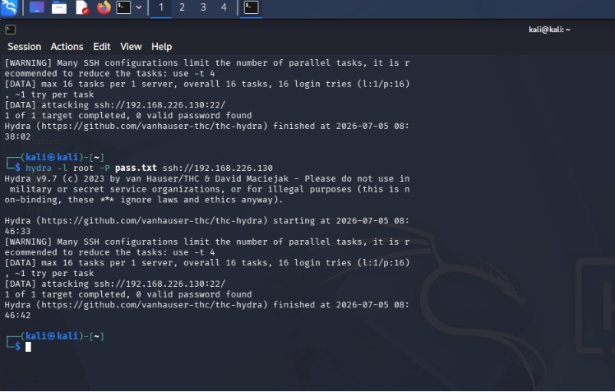

11. Wazuh Detection Evidence
The Wazuh Security Events dashboard recorded repeated SSH authentication failures for the monitored endpoint. Multiple Rule ID 5760 events were generated at Level 5 with the description 'sshd: authentication failed.'
The same evidence also shows Rule ID 5763 at Level 10 with a brute-force correlation description. This demonstrates the difference between atomic event detection and correlation: individual failures are recorded first, and repeated related activity is elevated into a more serious brute-force alert.
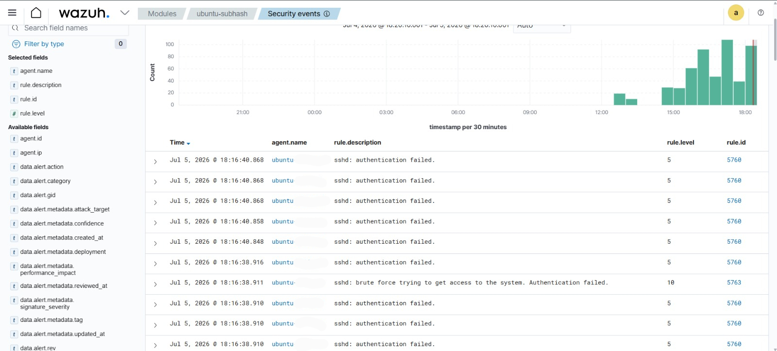

12. Detailed SSH Event Analysis
The expanded Wazuh event evidence provides investigation-ready context for an SSH authentication failure. The event identifies Agent ID 002, Agent IP 192.168.226.130, Agent name ubuntu-subhash, destination user root, source IP 192.168.226.129, source port 48890, sshd decoder context, /var/log/auth.log as the source location, Rule ID 5760, Rule Level 5, and repeated firing count.
The full log records a failed password attempt for root from the source IP. These fields allow an analyst to identify the targeted account, attack origin, affected endpoint, log source, and detection rule without relying only on the alert title.
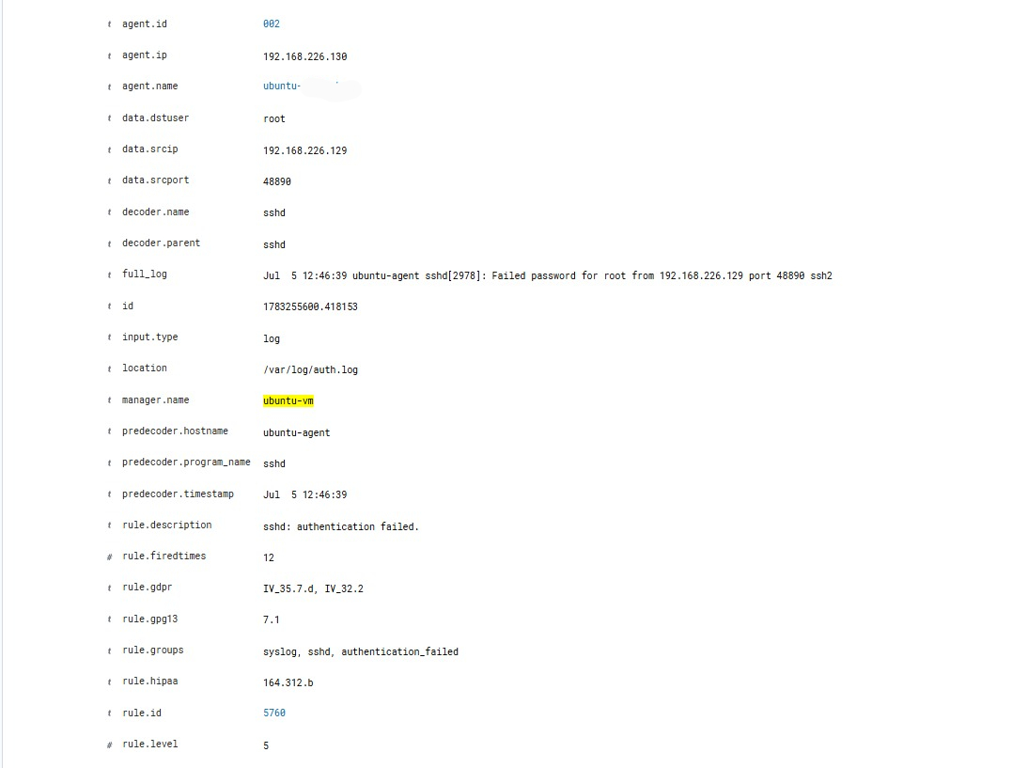

13. Active Response Evidence
The Active Response log was monitored to validate response execution:
sudo tail -f /var/ossec/logs/active-responses.log
The supplied evidence shows firewall-drop Active Response processing and lifecycle information. The log includes the response program, Wazuh execution module, alert context, agent details, SSH event information, and an 'Ended' entry.
This evidence confirms that the Active Response mechanism was invoked and logged. The captured log excerpt shown here is associated with an SSH event context; therefore, the report treats it as proof of Active Response workflow execution rather than claiming more than the screenshot directly demonstrates.

14. Detection and Response Workflow
1. Hydra generates repeated SSH attempts
↓
2. sshd writes failures to /var/log/auth.log
↓
3. Wazuh Agent collects authentication logs
↓
4. Wazuh Manager decodes SSH events
↓
5. Rule 5760 records authentication failures
↓
6. Repeated activity correlates into Rule 5763
↓
7. Active Response policy evaluates triggering rule
↓
8. firewall-drop is invoked on the endpoint
↓
9. Response activity is recorded in active-responses.log
↓
10. SOC analyst validates detection and containment

15. Verification Commands
The following commands were part of the validation and troubleshooting workflow:
# Review firewall-drop configuration on Manager
sudo grep firewall-drop /var/ossec/etc/ossec.conf
# Watch Active Response events
sudo tail -f /var/ossec/logs/active-responses.log
# Review current packet-filter rules where applicable
sudo iptables -L
# Test SSH connectivity from the controlled lab system
ssh user@UBUNTU_IP
A manual removal command was documented for controlled lab cleanup when a specific test source address had been blocked:
sudo iptables -D INPUT -s TEST_SOURCE_IP -j DROP
This cleanup action should only be used for the exact test rule and source address that were intentionally introduced in the lab.

16. Results Summary
Validation Area | Evidence | Result
Attack generation | Hydra screenshot | Successful
Individual SSH failure detection | Rule 5760 events visible | Successful
Brute-force correlation | Rule 5763 Level 10 visible | Successful
Event enrichment | Source IP, user, port, agent and raw log visible | Successful
Active Response workflow | firewall-drop log evidence available | Validated
Credential compromise | 0 valid passwords found | Not required / no compromise

17. SOC Analyst Interpretation
The evidence demonstrates a layered detection model. Rule 5760 provides visibility into individual failed SSH authentication attempts, while Rule 5763 raises the severity when the behavior matches a brute-force pattern. This reduces the need for an analyst to manually count every failed login.
For triage, the analyst should review the source IP, destination account, number and timing of failures, whether the source is internal or external, successful logins occurring after the failures, privilege escalation events, and other correlated network or endpoint alerts.
A sequence of repeated failures followed by a successful login should receive higher investigation priority because it can indicate credential compromise. Conversely, a small number of failures from a known administrator may be benign.

18. Incident Response Procedure
Brute-force alert received
↓
Validate source IP and target account
↓
Review failure count and time window
↓
Check for successful login after failures
↓
Correlate with Suricata and endpoint alerts
↓
Confirm Active Response execution
↓
Determine whether source is legitimate
↓
Contain confirmed malicious activity
↓
Reset exposed credentials if compromise suspected
↓
Review persistence and lateral movement
↓
Document evidence and close/escalate incident

19. Observed Outcomes
- The Ubuntu Agent successfully generated SSH authentication telemetry.
- Wazuh displayed repeated sshd authentication failure events.
- Rule ID 5760 generated Level 5 alerts for individual failures.
- Rule ID 5763 generated a Level 10 brute-force correlation alert.
- The expanded event exposed source IP, source port, destination user, agent details and raw log context.
- Hydra completed the controlled password test with zero valid passwords found.
- The firewall-drop Active Response workflow produced response log evidence.
- The exercise demonstrated an end-to-end detection and automated-response architecture.

20. Limitations and Engineering Notes
Automated blocking must be tuned carefully. Blocking on every individual authentication failure can create false positives and may lock out legitimate administrators. A production design should generally use correlated brute-force rules, thresholds, trusted-source allowlists, and asset-specific policies.
The response location and trigger list should be tested against the exact Wazuh deployment architecture. SOC teams should also verify which endpoint executes the response and confirm the blocking state independently using the host's active packet-filtering framework.
The supplied Hydra evidence shows zero valid passwords found. This is a successful defensive test outcome: the attack generated sufficient telemetry for detection without demonstrating account compromise.

21. Production Hardening Recommendations
- Disable direct root SSH login where operationally possible.
- Use SSH keys and strong authentication controls instead of password-only access.
- Restrict SSH exposure using network segmentation and access-control policies.
- Tune automated blocking around correlated brute-force detections rather than isolated user mistakes.
- Maintain allowlists for trusted administrative infrastructure where appropriate.
- Alert on successful authentication following a burst of failed attempts.
- Correlate SSH brute-force alerts with Suricata network detections and privilege-escalation events.
- Monitor authentication attempts against disabled, privileged, and non-existent accounts.
- Review Active Response logs and maintain a safe recovery procedure for accidental blocks.

22. Skills Demonstrated
- Wazuh SSH log monitoring.
- Authentication-event analysis.
- Wazuh rule verification and correlation analysis.
- Active Response configuration.
- Automated firewall-drop response validation.
- Controlled SSH brute-force simulation.
- SOC alert triage and evidence interpretation.
- MITRE-aware security investigation.
- Incident response workflow design.
- Professional proof-of-concept documentation.

23. Security Outcome
STATUS: SUCCESSFUL
The lab successfully demonstrated detection of repeated SSH authentication failures, correlation into a higher-severity brute-force alert, and execution of the Wazuh Active Response workflow. The collected evidence provides a clear chain from attack simulation through endpoint logging, Wazuh detection, event enrichment, correlation, and response logging.
No valid password was discovered during the controlled Hydra test. The security objective was detection and containment validation rather than credential compromise.

24. Conclusion
Attack 05 successfully validated the SOC lab's ability to detect and respond to SSH brute-force behavior. Repeated login attempts generated authentication telemetry on the Ubuntu endpoint, Wazuh detected individual failures through Rule 5760, and correlated behavior was elevated through Rule 5763 at Level 10.
The exercise demonstrates the operational value of combining centralized log collection, behavioral correlation, and Active Response. Instead of only displaying failed logins, the architecture can identify attack patterns, provide investigation context, and initiate a containment workflow while preserving evidence for SOC analysis.

