SOC LAB PROJECT
ATTACK 06
VIRUSTOTAL INTEGRATION WITH WAZUH
File Integrity Monitoring, Threat Intelligence Enrichment and Malware Reputation Detection
Field | Details
Scenario | Malicious-file reputation detection
Endpoint | Ubuntu Agent
Monitored path | /root
Detection | Wazuh File Integrity Monitoring
Enrichment | VirusTotal
Test artifact | EICAR anti-malware test file
Custom rules | 100200 and 100201
Observed result | 65 positives out of 67 engines
Status | SUCCESSFUL

1. Executive Summary
This report documents the integration of Wazuh File Integrity Monitoring (FIM) with VirusTotal threat intelligence in a controlled SOC lab. The objective was to detect a file addition or modification inside a monitored directory, trigger custom Wazuh rules, perform hash-based reputation enrichment, and present the resulting intelligence in Wazuh.
The Ubuntu Agent monitored /root in real time. Custom Rules 100200 and 100201 represented file modification and file addition events. The Wazuh Manager integration was configured to trigger on these rules. A standard EICAR anti-malware test file was then placed in /root to validate the workflow safely without deploying real malware.
The supplied Wazuh evidence shows data.integration=virustotal, found=1, malicious=1, positives=65, total=67, and source.file=/root/eicar.com. This confirms successful end-to-end detection and enrichment.

2. Objectives
- Enable real-time FIM for /root.
- Verify file creation and modification visibility in Wazuh.
- Create custom rules for /root file additions and modifications.
- Configure VirusTotal integration on the Wazuh Manager.
- Use a safe standardized anti-malware test artifact.
- Validate reputation enrichment in the Wazuh alert.
- Document the full endpoint-to-intelligence workflow.

3. Architecture
Ubuntu Agent (/root monitored)
↓
Wazuh FIM detects file activity
↓
Wazuh Manager receives syscheck event
↓
Custom Rule 100200 or 100201 matches
↓
VirusTotal integration is triggered
↓
File hash reputation is checked
↓
Enriched malicious-file alert is generated

4. About the Scenario
File Integrity Monitoring can establish that a file was added, modified, or deleted, but a filesystem change alone does not determine maliciousness. Threat-intelligence enrichment adds reputation context by checking a cryptographic hash against an external intelligence service.
This lab combines Wazuh FIM as the detection trigger with VirusTotal as the reputation-enrichment layer. The result is a practical SOC workflow that detects change, enriches the event automatically, and gives the analyst stronger context for triage.

5. VirusTotal Account and API Preparation
A VirusTotal account was created and an API key was obtained from the account profile. The key was configured only on the Wazuh Manager.
Security note: API keys are secrets. They should not be committed to GitHub or exposed in public screenshots. The configuration screenshot included in this report has been redacted. Any key that has been publicly exposed should be rotated.

6. Enable FIM on the Ubuntu Agent
sudo nano /var/ossec/etc/ossec.conf
Inside the syscheck section, the monitored directory was configured as follows:
<syscheck>
<disabled>no</disabled>
<directories check_all="yes" report_changes="yes" realtime="yes">/root</directories>
</syscheck>
check_all enables integrity checks, report_changes records change information where supported, and realtime enables immediate monitoring of filesystem activity.

7. Restart and Verify the Agent
sudo systemctl restart wazuh-agent
sudo touch /root/testfile
After restarting the Agent, a test file was created to confirm that ordinary FIM events reached Wazuh. The Security Events or Discover view can be searched for syscheck activity to verify file-added and file-modified events before configuring external enrichment.

8. Add Custom Wazuh Rules
The custom rules were added to local_rules.xml through Wazuh rule management:
<group name="root_monitoring,syscheck">
<rule id="100200" level="7">
<if_sid>550</if_sid>
<field name="file">/root</field>
<description>File Modified in /root Directory.</description>
</rule>
<rule id="100201" level="7">
<if_sid>554</if_sid>
<field name="file">/root</field>
<description>File added to /root Directory.</description>
</rule>
</group>
Rule 100200 handles modification events under /root, while Rule 100201 handles additions. Both are Level 7 in this lab and become the trigger IDs for the VirusTotal integration.
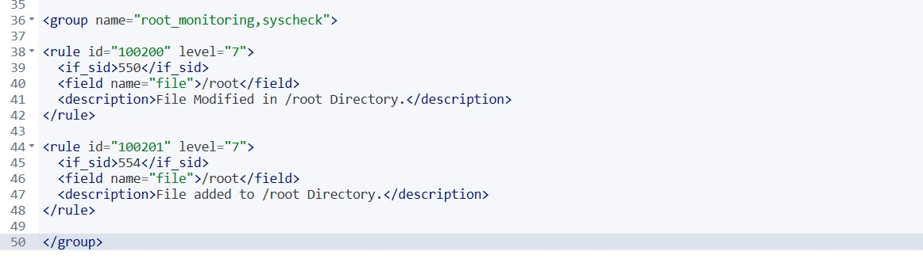

9. Configure VirusTotal Integration
On the Wazuh Manager, ossec.conf was edited:
sudo nano /var/ossec/etc/ossec.conf
The integration block was added before the closing ossec_config tag:
<integration>
<name>virustotal</name>
<api_key>YOUR_VIRUSTOTAL_API_KEY</api_key>
<rule_id>100200,100201</rule_id>
<alert_format>json</alert_format>
</integration>
The integration name selects VirusTotal, the API key authenticates the lookup, rule_id limits invocation to the two custom FIM rules, and JSON preserves structured alert data for processing.
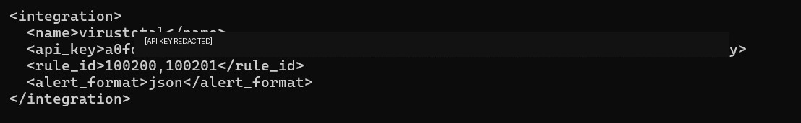

10. Restart the Wazuh Manager
sudo systemctl restart wazuh-manager
Restarting the Manager loads the integration configuration. The Manager service and Agent connectivity should be verified before generating a new test event.

11. Generate the Controlled Test Event
The EICAR anti-malware test file was used as the validation artifact. EICAR is a standardized security-testing artifact and is not real malware.
sudo curl -Lo /root/eicar.com <EICAR_TEST_FILE_URL> && sudo ls -lah /root/eicar.com
Writing the file into /root triggers the real-time FIM pipeline. The listing verifies that the test artifact was created at the monitored path.

12. Detection and Enrichment Flow
1. Test artifact written to /root
↓
2. Wazuh FIM detects file addition
↓
3. Syscheck event reaches Manager
↓
4. Rule 100201 matches
↓
5. VirusTotal integration runs
↓
6. File hash reputation is checked
↓
7. Reputation metadata returns to Wazuh
↓
8. Analyst receives enriched security event

13. Alert Evidence
The expanded Wazuh event confirms that VirusTotal enrichment executed successfully. Important observed fields are summarized below.
Field | Observed value / meaning
agent.id | 002
agent.ip | 192.168.226.130
agent.name | ubuntu-subhash
data.integration | virustotal
data.virustotal.found | 1
data.virustotal.malicious | 1
data.virustotal.positives | 65
data.virustotal.total | 67
data.virustotal.source.file | /root/eicar.com
decoder.name | json
The event demonstrates that the reputation lookup found the hash and returned a malicious result. In the supplied evidence, 65 of 67 represented engines reported a positive detection for the test artifact.

14. Evidence Interpretation
The key result is not only that a file appeared in /root. The FIM event was enriched with external reputation context. found=1 shows that reputation data existed, malicious=1 indicates a malicious classification in the integration result, and positives=65 with total=67 provides the observed detection ratio for this event.
The source.file value links the intelligence result directly to /root/eicar.com on the monitored endpoint, giving the analyst a clear relationship between endpoint activity and reputation intelligence.

15. SOC Analyst Triage Workflow
Enriched alert received
↓
Confirm endpoint and file path
↓
Review malicious flag and detection ratio
↓
Validate hash and event timeline
↓
Identify user/process that created the file
↓
Correlate FIM, auditd and network telemetry
↓
Determine test / benign / malicious context
↓
Contain if genuine malicious activity exists
↓
Search for same hash on other endpoints
↓
Document and close or escalate

16. Results Summary
Validation Area | Evidence | Result
Real-time FIM | /root monitoring configured | Successful
Custom rules | Rules 100200 and 100201 shown | Successful
Integration | VirusTotal block configured | Successful
Test event | EICAR file created under /root | Successful
Threat-intelligence lookup | data.integration=virustotal | Successful
Reputation result | malicious=1; 65/67 positives | Successful
End-to-end enrichment | Expanded event populated | Successful

17. Observed Outcomes
- Real-time monitoring was configured for /root.
- Custom rules were created for file modifications and additions.
- VirusTotal enrichment was tied to Rules 100200 and 100201.
- The EICAR test artifact generated the required FIM workflow.
- Wazuh produced a VirusTotal-enriched event.
- The event identified /root/eicar.com as the source file.
- The alert showed malicious=1 and 65 positives out of 67 total engines.
- The lab demonstrated automatic enrichment of endpoint file events with threat intelligence.

18. Troubleshooting Checklist
- Confirm the Agent is connected to the Manager.
- Verify /root is in the active syscheck configuration.
- Restart wazuh-agent after Agent configuration changes.
- Validate ordinary FIM events before troubleshooting enrichment.
- Check local_rules.xml syntax and confirm custom rules fire.
- Confirm integration rule IDs exactly match the custom rule IDs.
- Restart wazuh-manager after changing the integration block.
- Review Manager logs for integration or authentication errors.
- Check API quota and key validity without exposing the key.
- Generate a fresh controlled test event after configuration changes.

19. Security Engineering Notes
Threat-intelligence enrichment supports analyst investigation but should not replace it. Reputation services can have false positives, false negatives, delayed detections, and disagreement between engines. Analysts should combine reputation with process ancestry, user context, network connections, persistence evidence, and related endpoint alerts.
Monitoring /root provides high-value visibility but can also create noise. Production deployments should tune paths, exclusions, rule levels, and enrichment triggers to balance detection coverage, API quota, and alert quality.
API credentials must be treated as secrets. Public repositories should use placeholders and documentation screenshots should be redacted.

20. Production Hardening Recommendations
- Rotate any API key that has been exposed.
- Never commit live integration secrets to GitHub.
- Tune FIM to critical directories and high-value files.
- Use enrichment selectively to manage API usage.
- Correlate malicious-file alerts with auditd command-execution events.
- Investigate the process and user responsible for file creation.
- Search enterprise-wide for matching hashes after confirmed malicious detections.
- Integrate confirmed detections with approved containment workflows.
- Document exceptions for legitimate security test artifacts.
- Retain timestamps and evidence for incident-response timelines.

21. Skills Demonstrated
- Wazuh File Integrity Monitoring configuration.
- Custom Wazuh rule creation.
- Wazuh Manager integration configuration.
- Threat-intelligence enrichment.
- Hash-based malware reputation analysis.
- Safe validation using a standard test artifact.
- SOC alert investigation and evidence interpretation.
- Detection-engineering trigger design.
- Secret-handling awareness.
- Professional proof-of-concept documentation.

22. Security Outcome
STATUS: SUCCESSFUL
The lab successfully detected a file event in a real-time monitored directory, triggered custom Wazuh rules, invoked VirusTotal enrichment, and generated a structured alert containing malicious reputation information.
The supplied evidence shows a complete chain from controlled file creation on the Ubuntu Agent to enriched telemetry in Wazuh. The observed event reported the artifact as found and malicious, with 65 positives among 67 total engines represented in that result.

23. Conclusion
Attack 06 successfully validated the integration of endpoint File Integrity Monitoring with external threat intelligence. Wazuh FIM provided immediate visibility into file activity under /root, custom rules converted that activity into clear detection logic, and VirusTotal enrichment added reputation metadata.
This exercise demonstrates an important SOC pattern: detection identifies that something changed, while enrichment helps determine whether the change deserves urgent investigation. The workflow improves triage context and provides a foundation for future automated response and case-management workflows.

