n8n SOAR Setup with Wazuh FIM,
VirusTotal Enrichment and Telegram Alerting
Detailed SOC Automation Lab Implementation Guide
This document explains the complete setup of an n8n-based SOAR workflow that receives Wazuh File Integrity Monitoring (FIM) alerts, extracts useful endpoint and file metadata, enriches the file hash through VirusTotal, and sends a structured alert to Telegram. The workflow provides a practical example of SIEM-to-SOAR integration and automated alert enrichment.

1. Objective
The objective is to automate the handling of selected Wazuh alerts. When a monitored file is created in the Ubuntu agent's /root directory, Wazuh generates a custom FIM alert. The Wazuh Manager forwards the JSON alert to an n8n production webhook. n8n normalizes the alert fields, queries VirusTotal using the SHA-256 hash, and sends the endpoint, file and reputation details to a Telegram chat.

2. Architecture and Data Flow
Ubuntu Agent (/root directory monitored by FIM)
↓
Wazuh Agent detects file creation/change
↓
Wazuh Manager correlates event with Rule ID 100201
↓
Custom Wazuh integration sends JSON to n8n Webhook
↓
n8n Edit Fields node normalizes alert data
↓
HTTP Request node queries VirusTotal by SHA-256
↓
Telegram node sends enriched SOC alert
↓
SOC analyst receives actionable notification

3. Lab Components
- Wazuh Manager: central SIEM component that receives, correlates and forwards selected alerts.
- Ubuntu Agent: monitored endpoint where FIM watches the /root directory.
- WSL Ubuntu: hosts Docker and the n8n container.
- n8n: workflow automation platform used as the SOAR orchestration layer.
- VirusTotal API: enriches the alert with file reputation statistics.
- Telegram Bot: delivers the final enriched security alert to the analyst.

4. Prerequisites
- A working Wazuh Server and an enrolled Ubuntu Wazuh Agent.
- Windows Subsystem for Linux (WSL) available on the Windows host.
- Docker and Docker Compose support inside the selected WSL environment.
- A VirusTotal account and API key.
- A Telegram bot token and target chat ID.
- Network reachability from the Wazuh Manager to the n8n webhook address.

5. Prepare Ubuntu in WSL
If a clean WSL environment is required, the following commands can be run from Windows PowerShell or Command Prompt. Unregistering a distribution permanently removes that WSL distribution and its data, so back up anything important first.
wsl --unregister Ubuntu
wsl -l -v
wsl --install -d Ubuntu
After installation, launch Ubuntu and create the requested Linux username and password.

6. Install Docker and Docker Compose in WSL
sudo apt update
sudo apt install docker.io docker-compose-v2 -y
sudo systemctl enable docker
sudo systemctl start docker
sudo usermod -aG docker $USER
After adding the current user to the docker group, log out and back in, or restart the WSL session, so the new group membership is applied.
docker --version
docker compose version
docker ps

7. Deploy n8n with Docker Compose
mkdir -p ~/n8n
cd ~/n8n
nano docker-compose.yml
Use the following Compose configuration. Replace placeholder secrets with strong values and avoid committing real credentials to Git repositories.
services:
n8n:
image: docker.n8n.io/n8nio/n8n
container_name: n8n
ports:
- "5678:5678"
environment:
- TZ=Asia/Kolkata
- GENERIC_TIMEZONE=Asia/Kolkata
- N8N_BASIC_AUTH_ACTIVE=true
- N8N_BASIC_AUTH_USER=admin
- N8N_BASIC_AUTH_PASSWORD=REPLACE_WITH_STRONG_PASSWORD
volumes:
- n8n_data:/home/node/.n8n
restart: always
volumes:
n8n_data:
cd ~/n8n
docker compose up -d
docker ps
docker compose logs --tail=50
Open n8n from the Windows host browser at localhost on port 5678 and complete the initial owner-account setup. The instance is then ready for workflow creation.

8. n8n Service Operations
# Stop the n8n container
cd ~/n8n
docker compose down
# Stop Docker
sudo systemctl stop docker
# Start Docker
sudo systemctl start docker
# Start n8n again
cd ~/n8n
docker compose up -d

9. Verify Wazuh FIM Before SOAR Integration
The automation should only be configured after confirming that Wazuh is already detecting the intended FIM event.

9.1 Wazuh Manager Logging
On the Wazuh Manager, edit the main configuration:
sudo nano /var/ossec/etc/ossec.conf
Inside the existing <global> section, verify that JSON archiving/logging is enabled as required by the lab:
<logall>yes</logall>
<logall_json>yes</logall_json>
sudo systemctl restart wazuh-manager

9.2 Ubuntu Agent FIM Monitoring
sudo nano /var/ossec/etc/ossec.conf
Inside the existing syscheck configuration, ensure FIM is enabled and add the monitored directory:
<directories check_all="yes" report_changes="yes" realtime="yes">/root</directories>
sudo systemctl restart wazuh-agent
Create a test file under /root and confirm that a Wazuh FIM event is generated before continuing.

10. Wazuh-to-n8n Integration

10.1 Create the Webhook Node
- Open the n8n editor and create a new workflow.
- Add the Webhook trigger node.
- Set HTTP Method to POST.
- Use a path such as wazuh-agent or wazuh-alert.
- Set Authentication to None only for the isolated lab. For production, protect the endpoint through authentication, a reverse proxy, TLS and network restrictions.
- Set response behavior to return after the final node finishes, with no response data if that matches the lab requirement.
- Activate or publish the workflow and copy the production webhook URL.

10.2 Configure the Wazuh Manager Integration
sudo nano /var/ossec/etc/ossec.conf
Add the custom integration before the closing </ossec_config> tag. Replace WSL_IP with the reachable address and ensure the webhook path exactly matches the production webhook configured in n8n.
<integration>
<name>custom-n8n</name>
<hook_url>http://WSL_IP:5678/webhook/wazuh-agent</hook_url>
<rule_id>100201</rule_id>
<alert_format>json</alert_format>
</integration>
sudo systemctl restart wazuh-manager
In this lab, Rule ID 100201 represents the custom FIM rule for a file added under /root. When that rule fires, the integration forwards the alert JSON to n8n.

11. Build the n8n SOAR Workflow
The workflow contains four main nodes: Webhook → Edit Fields → HTTP Request → Telegram.

11.1 Node 1 — Webhook
The Webhook node receives the Wazuh alert using HTTP POST. Confirm that the workflow uses the production webhook URL when active. Test URLs are intended for manual test-listening sessions and should not be used for the permanent Wazuh integration.

11.2 Node 2 — Edit Fields
Add an Edit Fields node and map the relevant Wazuh JSON values into simple field names:
hostname = {{$json.body.agent.name}}
agent_ip = {{$json.body.agent.ip}}
filename = {{$json.body.syscheck.path}}
username = {{$json.body.syscheck.uname_after}}
md5 = {{$json.body.syscheck.md5_after}}
sha256 = {{$json.body.syscheck.sha256_after}}
event_type = {{$json.body.syscheck.event}}
This normalization step makes later nodes easier to configure and reduces dependence on deeply nested JSON paths.

11.3 Node 3 — VirusTotal HTTP Request
- Add an HTTP Request node.
- Set Method to GET.
- Set the request URL to the VirusTotal v3 file endpoint followed by the SHA-256 expression.
- Enable Send Headers.
- Add the header name x-apikey and store the API key securely in n8n credentials or another secret-management mechanism where possible.
https://www.virustotal.com/api/v3/files/{{$json.sha256}}
The response is used by the Telegram node to display malicious, suspicious, harmless and undetected engine counts. If a hash is unknown to VirusTotal or the API returns an error, consider adding error handling so the notification still reaches the analyst.

11.4 Node 4 — Telegram Alert
Create a Telegram bot, obtain the bot token and determine the destination chat ID. In n8n, add the Telegram node, configure credentials, select Message as the resource and Send Message as the operation, then enter the chat ID.
Suggested message template:
🚨 *WAZUH FIM ALERT* 🚨
━━━━━━━━━━━━━━
🖥️ *System Information*
━━━━━━━━━━━━━━
🔹 *Hostname:* {{$node["Edit Fields"].json["hostname"]}}
🔹 *Agent IP:* {{$node["Edit Fields"].json["agent_ip"]}}
🔹 *User:* {{$node["Edit Fields"].json["username"]}}
━━━━━━━━━━━━━━
📁 *File Information*
━━━━━━━━━━━━━━
🔹 *Filename:* {{$node["Edit Fields"].json["filename"]}}
🔹 *Event Type:* {{$node["Edit Fields"].json["event_type"]}}
━━━━━━━━━━━━━━
🔐 *File Hashes*
━━━━━━━━━━━━━━
🔹 *SHA256:* {{$node["Edit Fields"].json["sha256"]}}
🔹 *MD5:* {{$node["Edit Fields"].json["md5"]}}
━━━━━━━━━━━━━━
🛡️ *VirusTotal Analysis*
━━━━━━━━━━━━━━
🚨 *Malicious:* {{$json.data?.attributes?.last_analysis_stats?.malicious || 0}}
⚠️ *Suspicious:* {{$json.data?.attributes?.last_analysis_stats?.suspicious || 0}}
✅ *Harmless:* {{$json.data?.attributes?.last_analysis_stats?.harmless || 0}}
❔ *Undetected:* {{$json.data?.attributes?.last_analysis_stats?.undetected || 0}}
━━━━━━━━━━━━━━
⚡ *Generated by Wazuh + n8n SOAR Workflow*
━━━━━━━━━━━━━━

12. Workflow Implementation Evidence
The completed workflow below shows the four-node automation chain used in the lab.
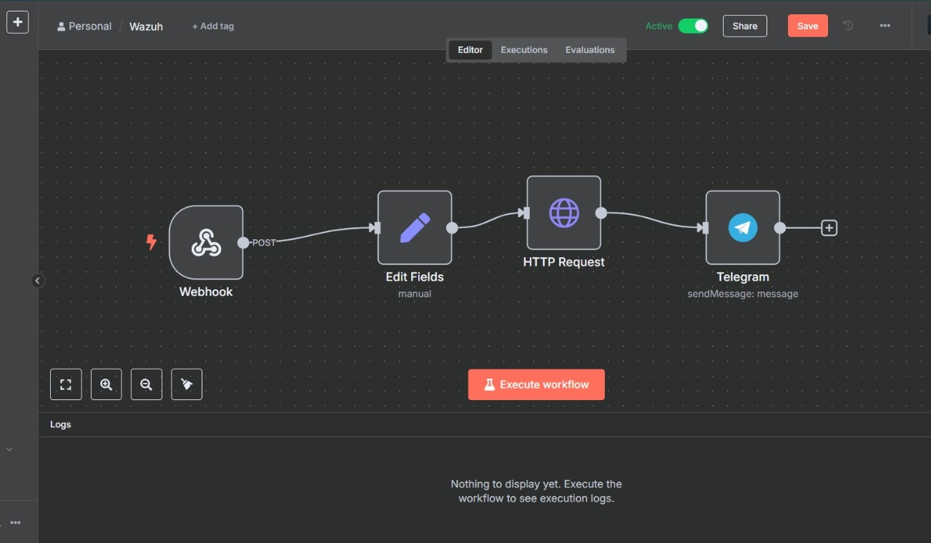
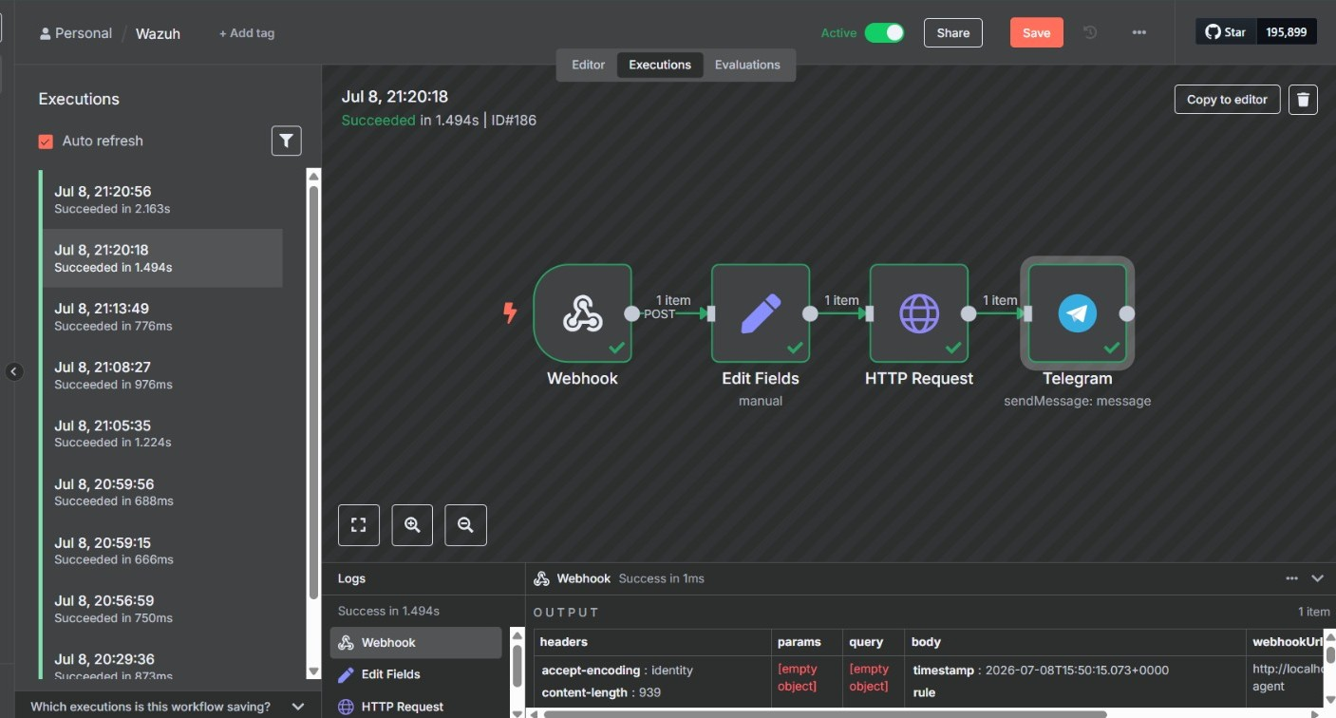
The execution view confirms that the event passed successfully through every node in the workflow.

13. Publish and Activate the Workflow
- Save the workflow configuration.
- Publish or activate the workflow according to the n8n version in use.
- Confirm that the workflow status is Active.
- Verify that Wazuh is configured with the production webhook URL, not the temporary test URL.
- Review the Executions page to confirm that incoming alerts are being processed.

14. End-to-End Testing Procedure
Perform the final test from the Ubuntu agent:
sudo -i
cd /root
touch soar-test-file.txt
Expected validation sequence:
- The Ubuntu Wazuh Agent detects the new file through FIM.
- The Wazuh Manager receives and correlates the event.
- Custom Rule ID 100201 is triggered for the file-added event.
- The custom integration POSTs the alert JSON to the n8n webhook.
- The Webhook node receives one item.
- Edit Fields extracts endpoint and file information.
- The HTTP Request node queries VirusTotal using the SHA-256 value.
- The Telegram node sends the enriched alert.
- The n8n Executions page shows a successful run across all four nodes.

15. Troubleshooting Guide
Issue | Likely Cause | Check / Resolution
Webhook receives nothing | Wrong URL, test URL used, workflow inactive or routing issue | Use production URL, activate workflow, verify WSL IP and test connectivity from the manager.
FIM event missing | syscheck disabled or directory not monitored | Verify the /root directories entry and restart wazuh-agent.
Wazuh alert exists but n8n does not run | Integration rule ID or hook path mismatch | Verify rule 100201, custom integration configuration and manager logs.
VirusTotal node fails | Invalid API key, quota limit or unknown hash | Check HTTP status, credentials, API quota and add error handling.
Telegram node fails | Invalid bot token, chat ID or bot permissions | Recheck credentials and confirm the bot can message the target chat.
Docker permission denied | User group membership not refreshed | Log out/in or restart WSL after usermod, then retry docker ps.
n8n unavailable | Container or Docker service stopped | Check systemctl status docker, docker ps and docker compose logs.

16. Security Considerations
- Do not place real passwords, VirusTotal API keys or Telegram bot tokens in screenshots, public reports or Git repositories.
- Use strong authentication and HTTPS for n8n when the service is exposed beyond an isolated lab.
- Restrict access to port 5678 using firewall rules or a reverse proxy.
- Prefer n8n credentials or secret storage over hard-coded API keys.
- Rotate any credential that has been accidentally exposed.
- Validate incoming webhook requests before using this design in a production SOC.
- Apply least privilege to the n8n host, Docker access and Telegram bot permissions.
- Add retry, timeout and error-handling branches for external API failures.

17. SOC Value of the Automation
This workflow demonstrates a practical SOAR use case. Wazuh performs endpoint monitoring and alert generation, while n8n orchestrates enrichment and notification. The analyst receives more context without manually copying file hashes into external reputation services. This reduces repetitive triage work, improves notification speed and provides a foundation for future response actions such as quarantine, ticket creation, case management, host isolation or approval-based containment.

18. Skills Demonstrated
- SIEM monitoring and custom Wazuh rule integration.
- File Integrity Monitoring on a Linux endpoint.
- SOAR workflow design using n8n.
- Webhook-based event forwarding and JSON field mapping.
- Threat-intelligence enrichment using the VirusTotal API.
- Telegram-based security alert notification.
- Dockerized service deployment inside WSL.
- End-to-end SOC workflow testing and troubleshooting.

19. Final Outcome
The completed lab successfully connects Wazuh with n8n to automate FIM alert processing. A file event generated on the Ubuntu agent is detected by Wazuh, forwarded to n8n, enriched with VirusTotal analysis and delivered to Telegram. The successful execution evidence confirms that the four workflow stages—ingestion, normalization, enrichment and notification—operate as one end-to-end SOAR pipeline.

