**Laptop Tracking System**

**Submitted by:**

**Neha Nafisha Das**

**EmpId:201249**

**Introduction:**

Currently in iNautix , whenever laptop is brought by any resource ,the security officials has to make any entry into a register with various details and whenever that resource takes it out of the floor , he has to sign against the same row where he entered in register. So this application will help to keep track of this. The application is done in angularjs and Spring MVC format. There are different modules for different operations.

**REQUIREMENTS**:

1. Functional Requirements
2. All the employees should have an employee ID and a password so that he/she can login to the application to see the details.
3. Every security guards must have the credentials to enter the details of the employee’s laptop entry and exit timing into the application.
4. If any new employee is appointed, then he first has to sign up and enter their details.
5. Non-Functional Requirements
6. Security: Only authorized users can access the application with username and password.
7. Performance: Easy tracking of records and updation of employee’s laptop can be done.
8. User-friendly: The application is very interactive.
9. Maintainability: Backups for database are available.

**DIAGRAMS:**

1. Use Case

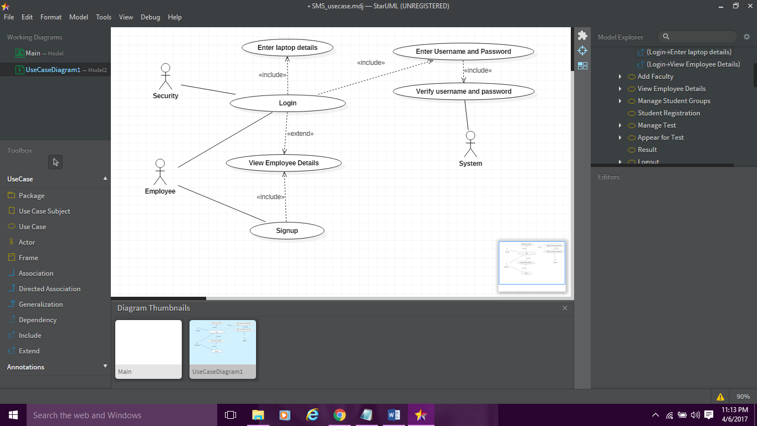

1. Employee Activity Diagram

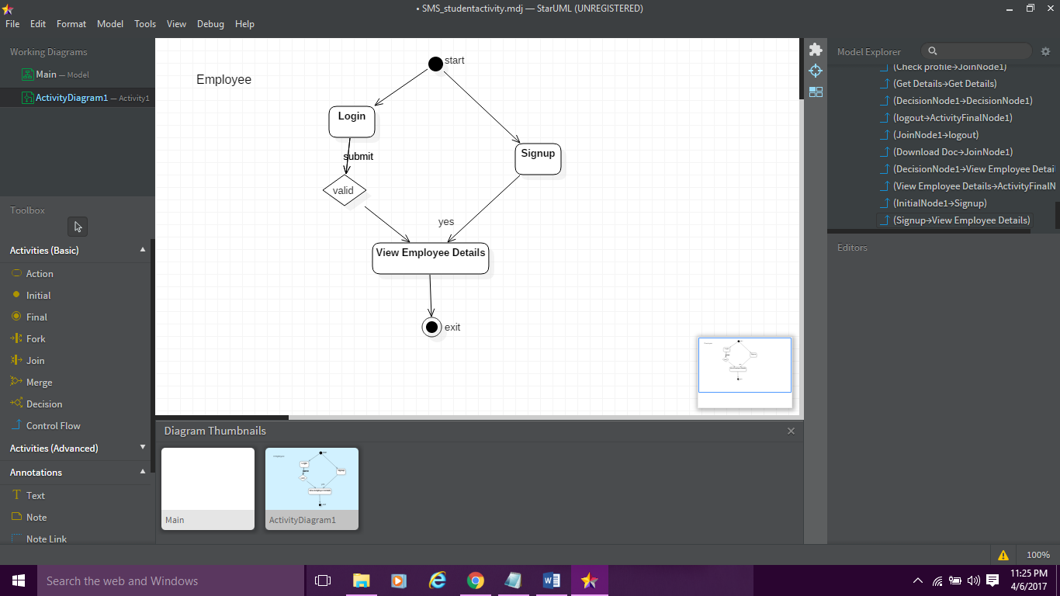

1. Security Activity Diagram

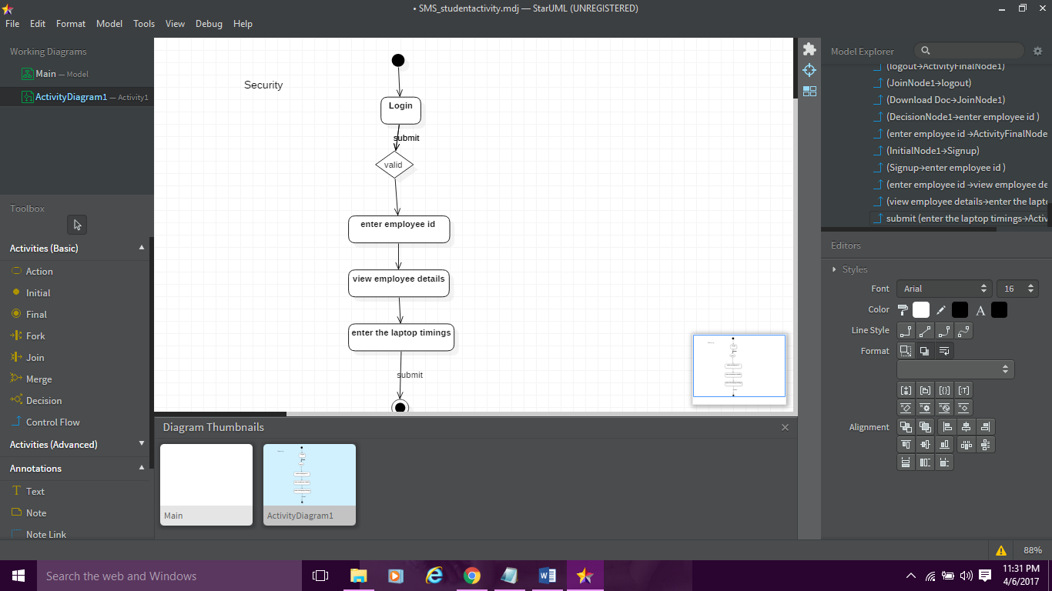

**TECHNOLOGY USED:**

1. Operating System: Windows 7
2. Server: apache tomcat server 7.0
3. Scripting: angularjs scripting
4. IDE: JAVA neon 2.0
5. Backend: Spring MVC Framework

**CLASSES CREATED:**

* 1. Model classes:-
     1. EmployeeDetails: Stores all the details of the Employee.
     2. LaptopDetails: Stores all the details of the Employee’s laptop.
     3. LoginDetails: Stores all the authentication details.
  2. Controller classes:-
     1. EmployeeController: Calls the register function in the EmployeeDao layer.
     2. LoginController: Calls the authenticate function in the LoginDao layer.
     3. ViewController: Calls the display function in the ViewDao layer.
     4. TrackingController: Calls the track function in the TrackingDao layer.
  3. Dao classes:-
     1. DBUtil: Gets connected to the database.
     2. EmployeeDao: Consists a function of getting registered a new employee.
     3. LoginDao: Contains a function which authenticates username and password entered and returns the role of the user.
     4. ViewDao: Basically contains the function which will retrieve the data from the database and display it on the screen.
     5. TrackingDao: Contains the function which helps the security to enter the entry and exit timings of the laptop.

**Conclusion:**

Simplicity is never simple. As we have seen in this project, the process of creating a user-friendly and straightforward platform that facilitates the security’s job is one filled with complexity. From understanding user requirements to system design and finally system prototype and finalization, every step requires in-depth understanding and commitment towards achieving the objectives of the project.

Although the employee’s laptop tracking module is not fully integrated to the system and used on real time, the system prototype demonstrates easy navigation and data are stored in a systematic way. Overall, efficiency has improved and work processes simplified. Although all the objectives have been met, the system still has room for improvement. The system is robust and flexible enough for future upgrade using advanced technology and devices.