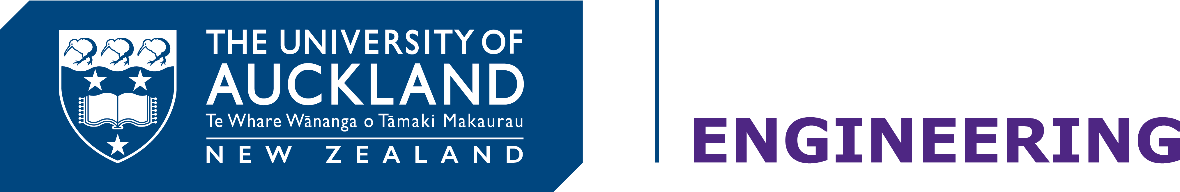

Department of Electrical and Computer Engineering

**ELECTENG 209: Analogue and Digital Design**

**Project Submission**

**Declaration of Originality**

We have read and understood the Engineering Policy on cheating in the Handbook, and hereby declare that all parts of this project are our own work. In particular, we have not received any excessive help from anyone and we have not given any excessive help to anyone. We understand that if all or part of our hand-in is found to be suspiciously similar to anyone else’s then all of us will be suspected of cheating and will be interviewed by a disciplinary committee.

|  |  |  |  |  |
| --- | --- | --- | --- | --- |
|  | Student 1 | Student 2 | Student 3 | Student 4 |
| ID | 253196568 | 317284058 | 343577241 | 822635375 |
| Full Name | Dhairya Trivedi | Prashanthi Balakeyan | Kunal Bhatia | Salina Dhungel |
| Signature | ……………………………… | ……………………………… | ……………………………… | ……………………………… |
| Date | 26/10/17 | 26/10/17 | 26/10/17 | 26/10/17 |