Beer Game Report for Factory

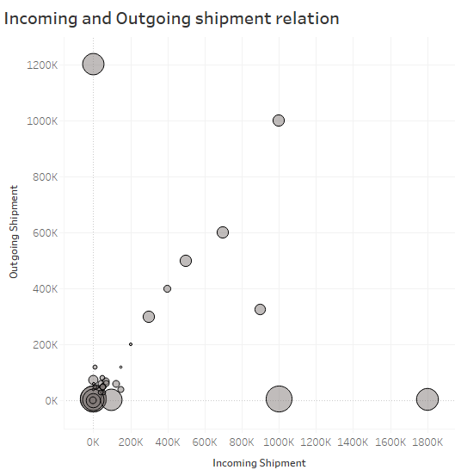

The scatter plot shows that relation between outgoing shipment and incoming shipment is not linear. For few week, the demand and supply were not equal. The size of circle denotes the total cost of a week.

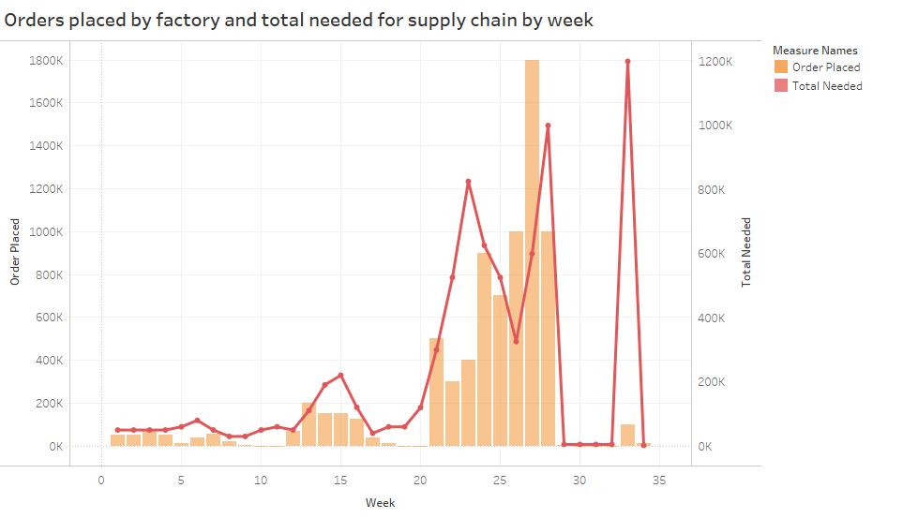

Orders placed by factory increased steeply from 20th week. Total orders needed by distributor and number of orders placed were not in same direction from 20th to 25th week. This was due to Bull whip effect and less safety stock.

The weekly cost for each week was stable till 20th week. But after that , the cost of increased because of Backlog cost. Orders placed by Factory were 10 for two weeks and it caused less inventory. The safety stock was no there. Due to high demand , it caused bull whip effect. The cost from 29th week increased very high due to high inventory cost. In those weeks, demand was very less. 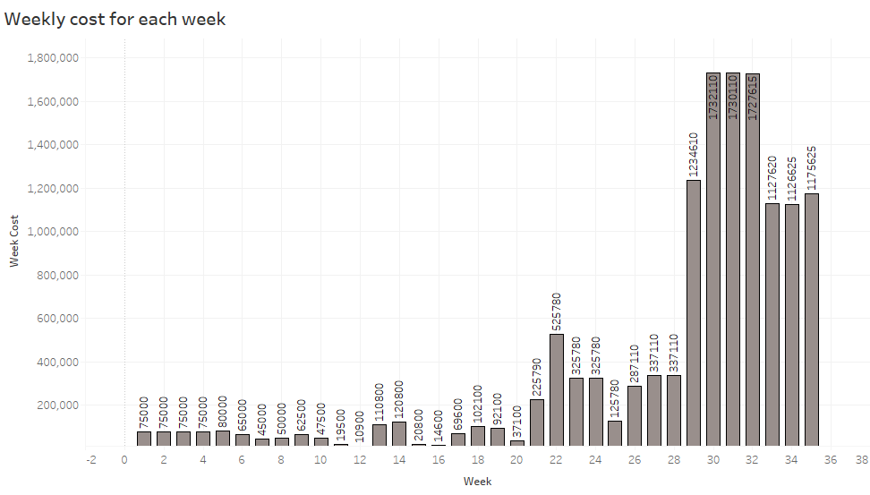

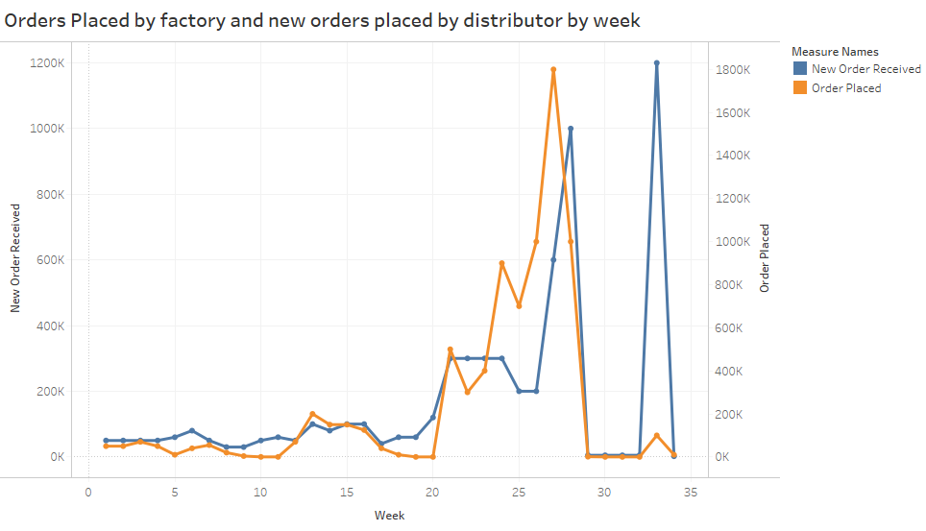

From below chart, the Backlog cost increased rapidly from 20th week and it was due to bull-whip effect.

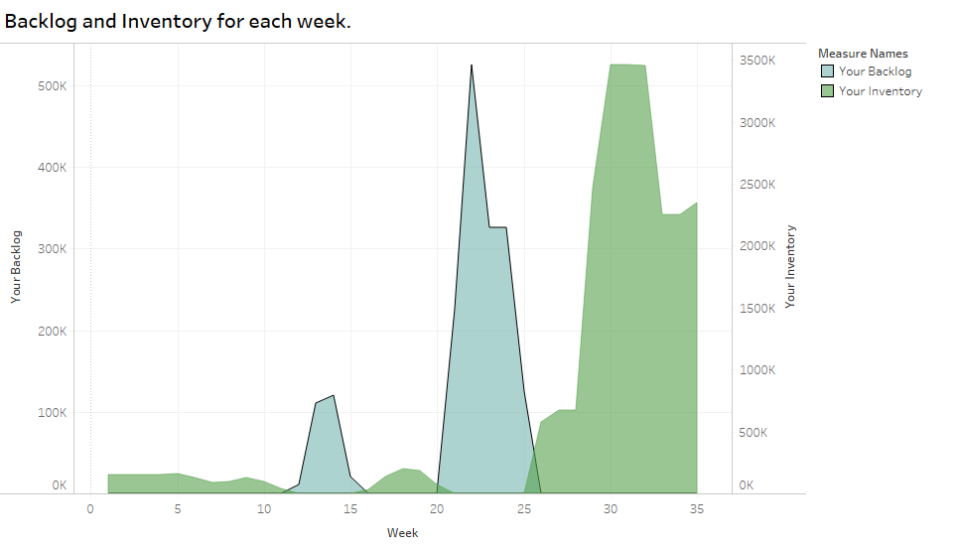

Strategy for Beer game:

Measures that could have improved the situation:

The inventory should not be reduced to zero.

The orders placed by factory should be in sync with the expected demand.