## CBA Tutorials

## Simulation

### Maya Ganesh

### 16 Sep 2018

**Example 1** - The number of cars arriving at Anderson Quick Oil and Lube during the last 250 hours of operations , which uses a single waiting line, is observed to be the following:

|  |  |
| --- | --- |
| Number of cars arriving | Frequency |
| 3 | 10 |
| 4 | 30 |
| 5 | 40 |
| 6 | 50 |
| 7 | 40 |
| 8 | 60 |
| 9 | 20 |

Estimated revenue for cars arrivals per hour is given in the following table:

|  |  |
| --- | --- |
| Number of cars arriving | Revenue |
| 3 | 75 |
| 4 | 100 |
| 5 | 125 |
| 6 | 150 |
| 7 | 175 |
| 8 | 200 |
| 9 | 225 |

1. Determine the probability distribution of car arrivals
2. Use Excel and simulate 10 hours of car arrivals and compute the average number of arrivals per hour
3. Based on the simulated 10 hours of car arrivals, determine the estimated average revenue for the Anderson Quick Oil and Lube.

Excel file

**Example-2**

1) Conley Fisheries has one boat and it costs 10000$ to operate the boat. The boat has a capacity of 3500 pounds and they are able to always fill that capacity.

2) Everyday they can take their boat to exactly one of the two ports – Gloucester or Rockport.

3) Gloucester always accepts the entire quantity of 3500 pounds and always offers the price of 3.25 per pound.

4) Rockport’s demand is variable and follows a given distribution. Further, the price offered at Rockport is also variable-normally distributed with a mean μ = $ 3.65/lb. and with a standard deviation of $0.20/lb.

**Exercise:**

1. **What is the expected daily earnings from using Rockport?**
2. **What is the standard deviation of daily earnings from using Rockport?**
3. **On any given day, what is the probability that Conley fisheries would earn more money using Rockport instead of Gloucester?**

**Solution**



Price is a normally distributed random variable with mean 3.65 and standard deviation 0.2

From demand distribution (empirical and discrete)

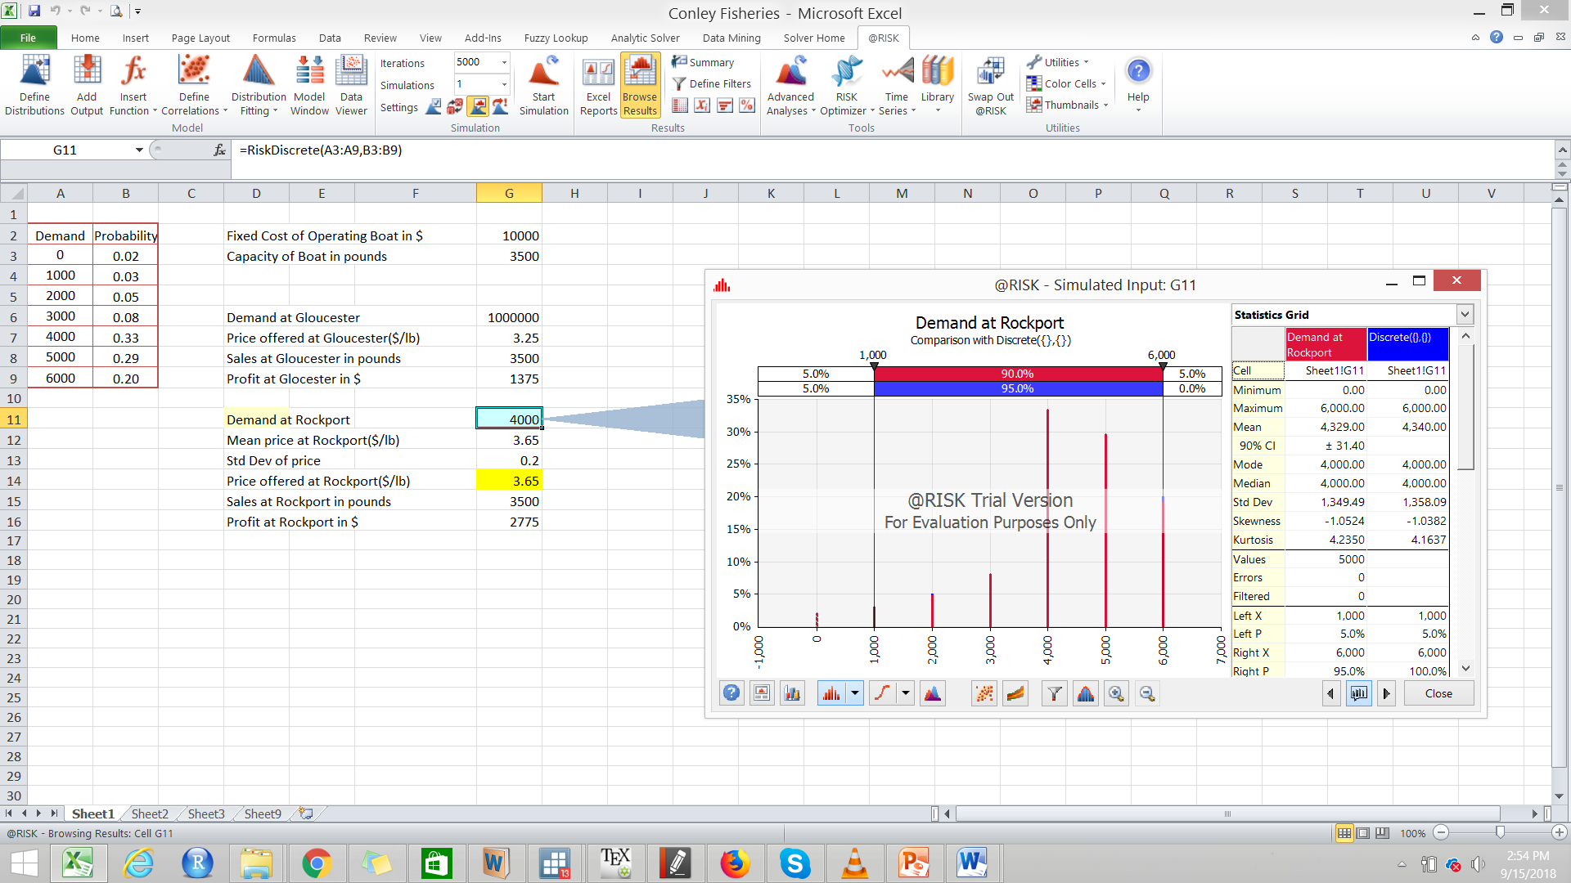

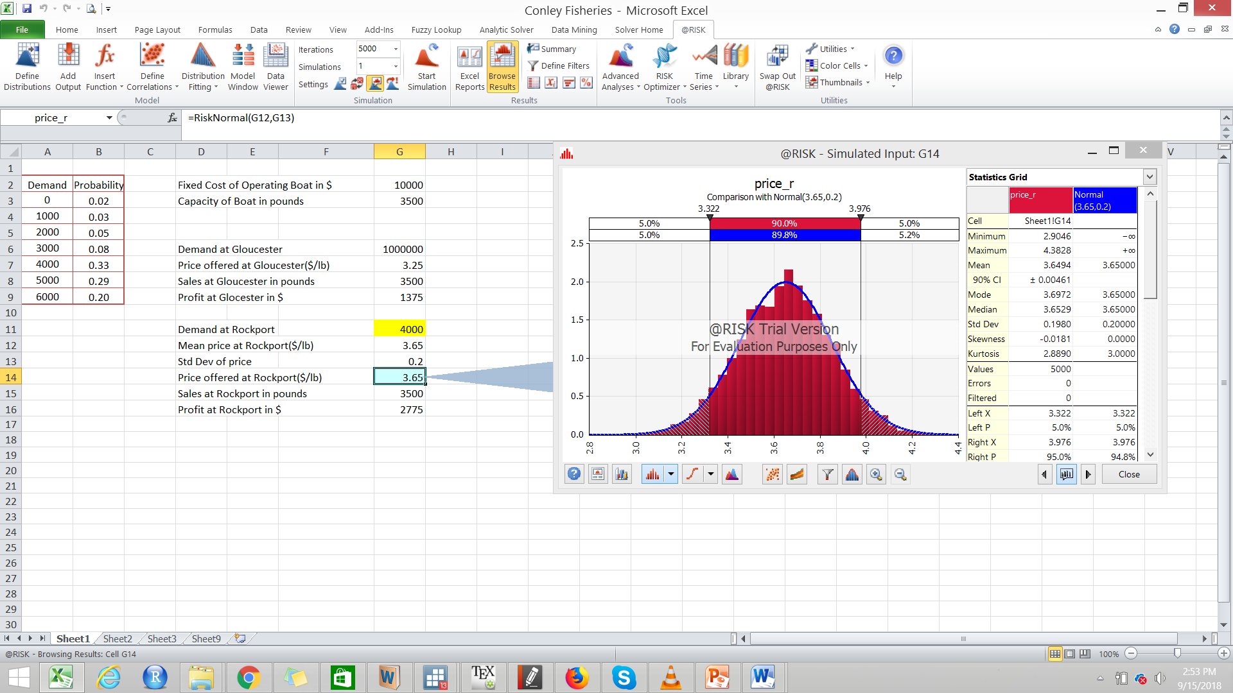

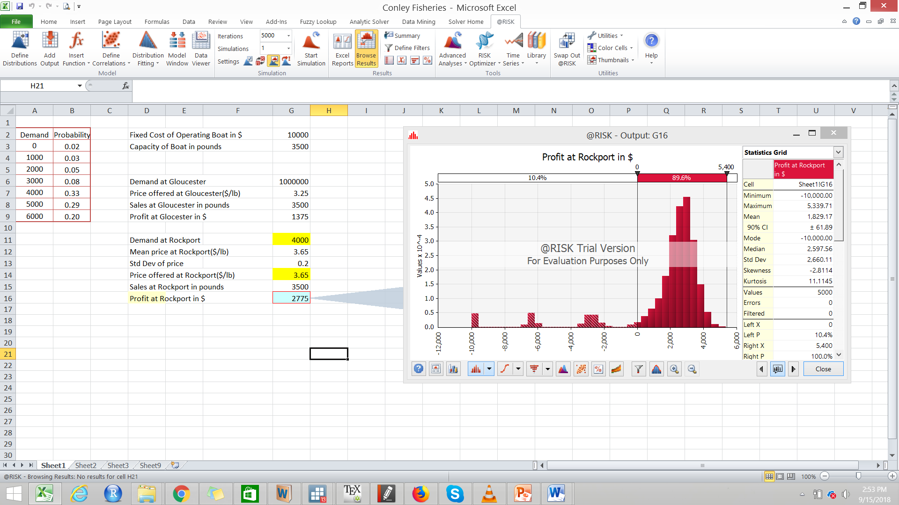

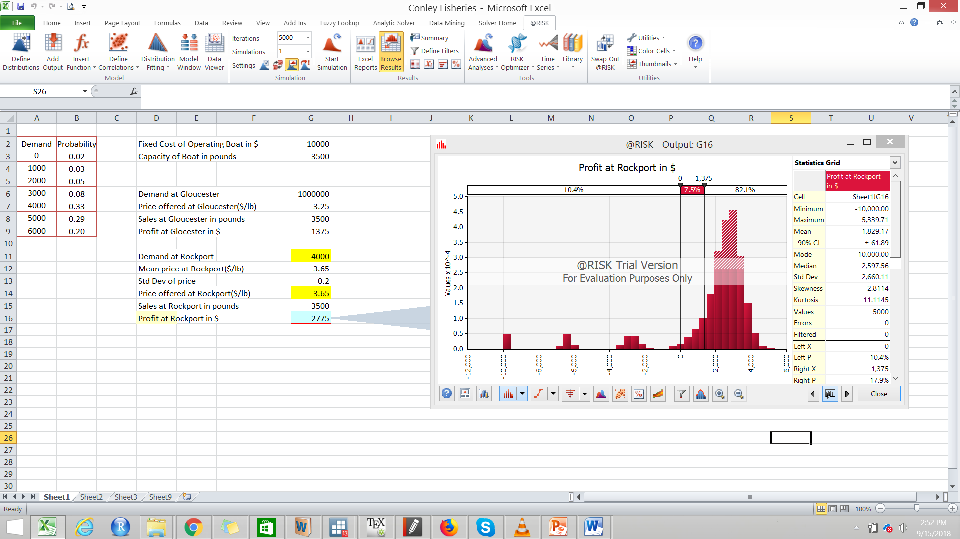

**Example 3 -** A robot is used to install the doors on automobiles along an assembly line. A sample of 20 installation times was automatically taken by the robot, with the following results, where the values are in seconds:

|  |
| --- |
| **Time taken in seconds** |
| 99.79 |
| 100.26 |
| 100.23 |
| 99.55 |
| 99.96 |
| 99.56 |
| 100.41 |
| 100.27 |
| 99.62 |
| 99.9 |
| 100.17 |
| 99.98 |
| 100.02 |
| 99.65 |
| 100.06 |
| 100.33 |
| 99.83 |
| 100.47 |
| 99.82 |
| 99.85 |

|  |  |
| --- | --- |
| **Sample mean** | **99.9865** |
| **Variance** | **0.080182** |
| **Standard deviation** | **0.283164** |
|  |  |

**Normal- QQ plot**

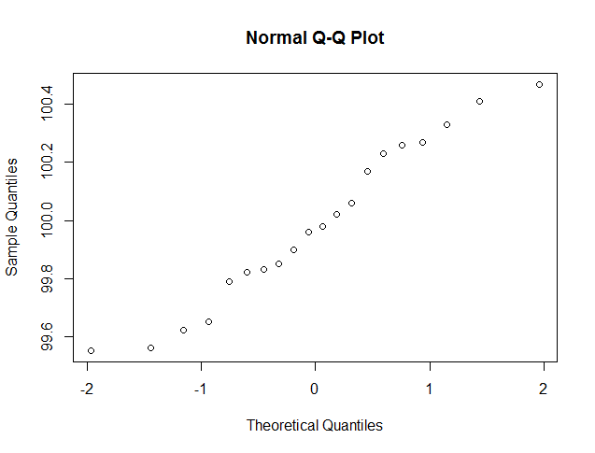

**Exponential QQ-plot**

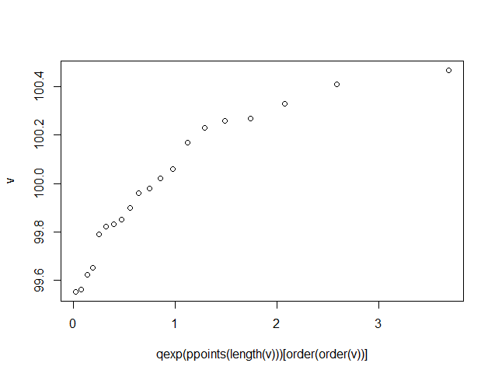

**In Analytical solver – add on**

**Fit distribution function**

**Normal**

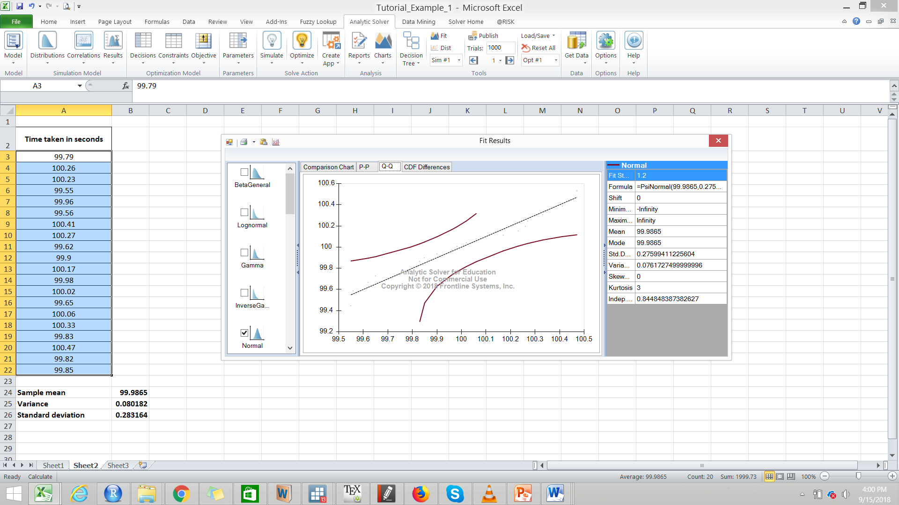

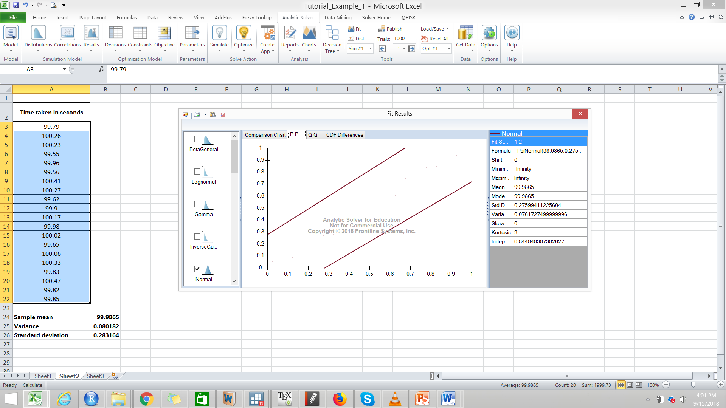

**The Chisquare test statistic – 1.2**

**Critical value of Chisquare = Chisqinv(0.95,19) = 30.14**

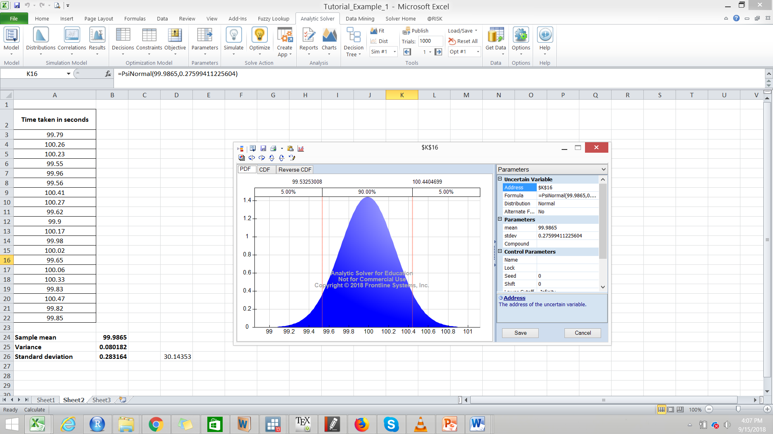

**Example 4 – KDK**

KDK Glass Industries specializes in heat tempered glass. They generally maintain a large inventory of annealed glass. The main reason is that, when the customers place the orders, they expect a committed delivery within 24 hours. If such immediate delivery is assured, they tend to take their business to some other supplier. Consequently, a stock out can lead to loss of not only the present order, it will give the customer an opportunity to try out a new supplier.

On the other hand, maintaining large inventory of annealed glass leads to increased inventory carrying costs. The supply of annealed glass is also fraught with uncertainties. Their current supplier requires a lead time of 1 to 3 days. These lead time uncertainties coupled with stochastic demand is turning inventory management into a major concern.

At present, KDK follows a simple inventory policy. They have a fixed re-order quantity. At present it is 1000 kgs (10 quintals). Their internal system is designed to rise an order when the inventory position (Stock at hand + Stock in Order) goes below a predetermined quantity (it is called the “order point”) at the end of the day. At present the order point is 500 kgs.

**Cost Structure**

The inventory carrying cost is estimated at Rs. 50 per quintal of annealed glass per day. The ordering cost is Rs. 2,000 per order. This includes the logistics cost which has to be borne by KDK. The accounts felt that this cost can be considered as cost per order , irrespective of the quantity ordered. The stock-out cost is Rs. 800 for 100 kgs of annealed glass.

**Exercise**

1. Carry out the simulation for 30 days.
2. It should allow changing the **demand pattern** without re-doing the entire simulation.
3. It should allow changing the **lead time** (we should be able to change the min and max of lead time without re-doing the entire simulation
4. It should allow changing the re-order quantity (currently fixed at 1000 kgs) and order point (currently fixed at 500 kgs).
5. Provide the probability distribution as well as mean, standard deviation, minimum and maximum for the following:

* Holding cost
* Order cost
* Stock-out cost
* Total cost

**Appendix 1**

**Frequency Distribution of Quantity Demanded (daily) of Annealed Glass**

|  |  |  |  |  |  |  |
| --- | --- | --- | --- | --- | --- | --- |
| Quantity (quintals) | 0 | 1 | 2 | 3 | 4 | 5 |
| Frequency (No. of days) | 10 | 20 | 40 | 80 | 30 | 20 |

The opening inventory of annealed glass on the first day of the month was 7 quintals and nothing was delivered on the first day.

**Summarise the problem:**

1) KDK is currently following an inventory policy. It will check the inventory position at the end of every day. If the inventory position (stock in hand+ stock in pipeline) is less than or equal to 5 quintals, it will place an order of 10 quintals .This order will get delivered after a “lead time” which varies from 1 to 3 days

2) The demand for the product is also uncertain with the given distribution

3) There will be three types of inventory related costs: Order cost, Holding/Carrying Cost and Stock out cost.

4) We have to simulate the entire situation for 30 days and analyze or costs

How do we simulate the entire system?

What is random/ uncertain here?

To simulate let us understand the entire day’s process

The beginning of the day :

1) We have an opening inventory which is basically last day’s closing inventory.

2) Some order that was placed on an earlier date gets delivered

1+2 will give us the stock available to meet the demand

The end of the day.We analyze our inventory position and decide to order or not.

Inventory position= Closing Inventory + Orders in pipeline

Inventory position today= Inventory position yesterday + Order placed yesterday-Demand Filled today.

If Inventory position today <= 5 Quintals , we place an order 10 Quintals and incur an **Order cost**

We get a Demand .This demand varies from day to day as per the given distribution.

How much demand can we satisfy? Minimum (Stock Available, Demand)

What happens when demand is more than stock available? We incur **Stock Out Cost**

What happens when the stock available is more than the demand? We incur **Holding Cost**

**Example 5 : Hungry Dawg Restaurants**

* Hungry Dawg is a growing restaurant chain with a self-insured employee health plan.
* Covered employees contribute $125 per month to the plan, Hungry Dawg pays the rest.
* The number of covered employees changes from month to month.
* The number of covered employees was 18,533 last month and this is expected to increase by 2% per month.
* The average claim per employee was $250 last month and is expected to increase at a rate of 1% per month.

Will the number of covered employees really increase by exactly 2% each month?

Will the average health claim per employee really increase by exactly 1% each month?

Excel file

* Suppose we analyzed historical data and found that:
  + The change in the number of covered employees each month is uniformly distributed between a 3% decrease and a 7% increase.
  + The average claim per employee follows a normal distribution with mean increasing by 1% per month and a standard deviation of $3.

**Questions:**

* How likely is it that the total company cost will be exactly $36,125,850 in the coming year?
* What is the probability that the total company cost will exceed, say, $38,000,000?

**Number of employees covered each month**

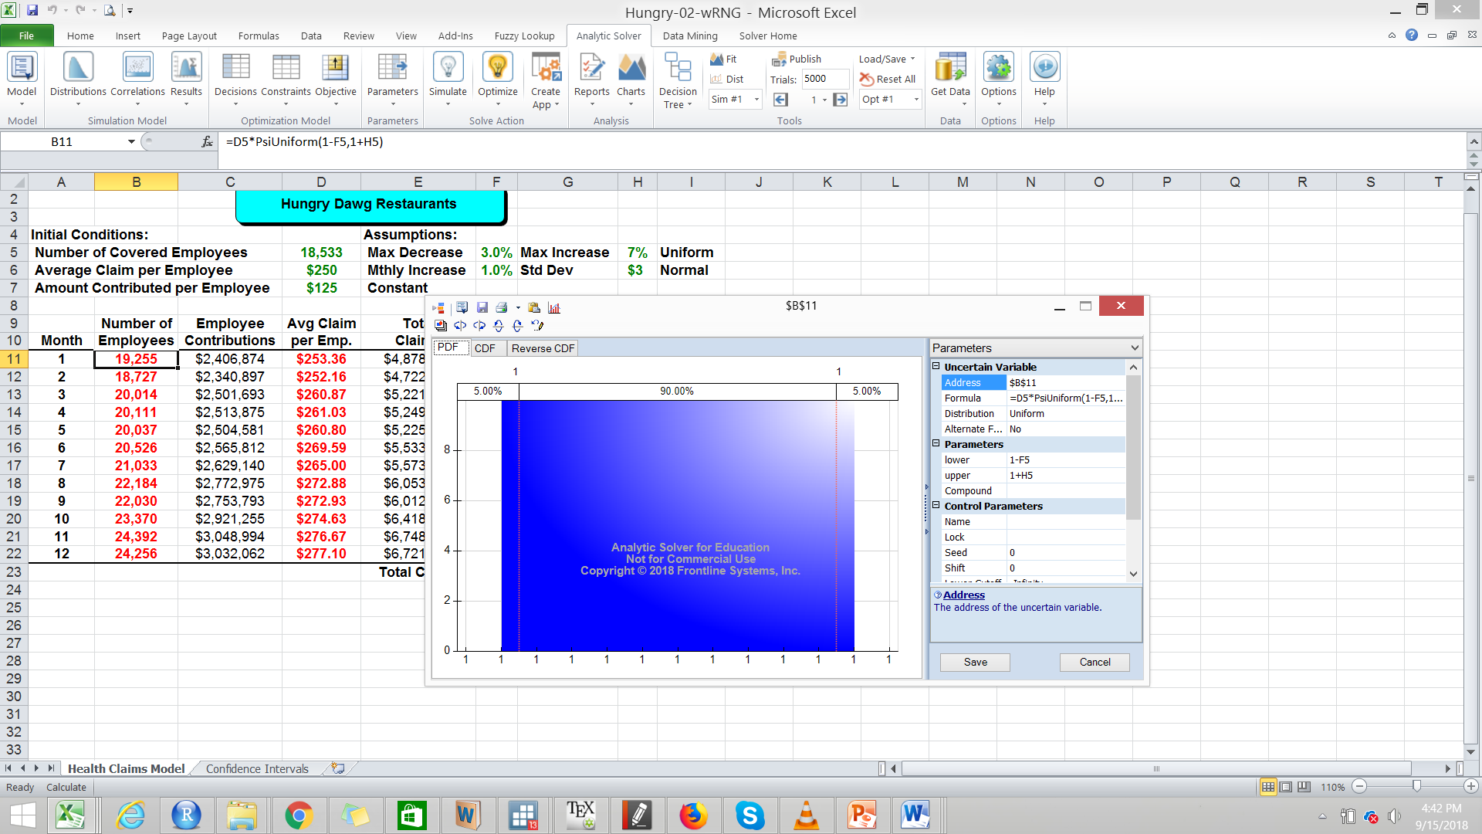

**Average claim per employee**

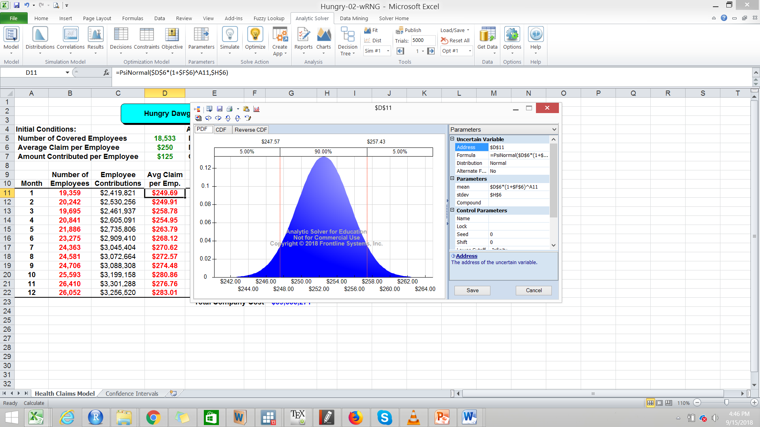

**Output**

