> c

Loadings:

Comp.1 Comp.2 Comp.3

Age -0.143 0.989

Height -0.698 -0.134 -0.704

Weight -0.702 0.709

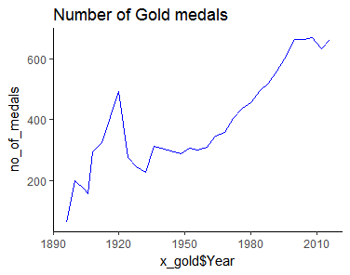

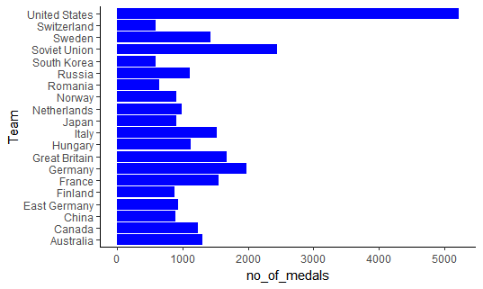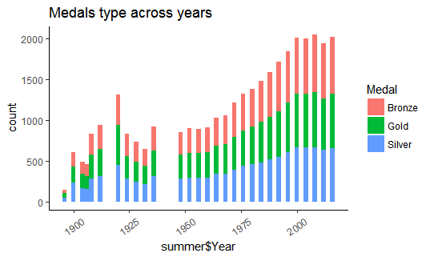

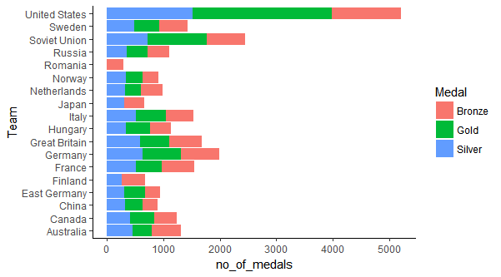

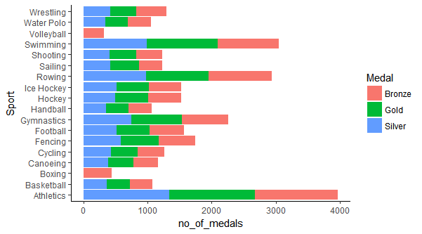

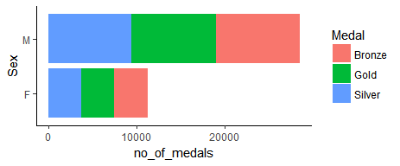

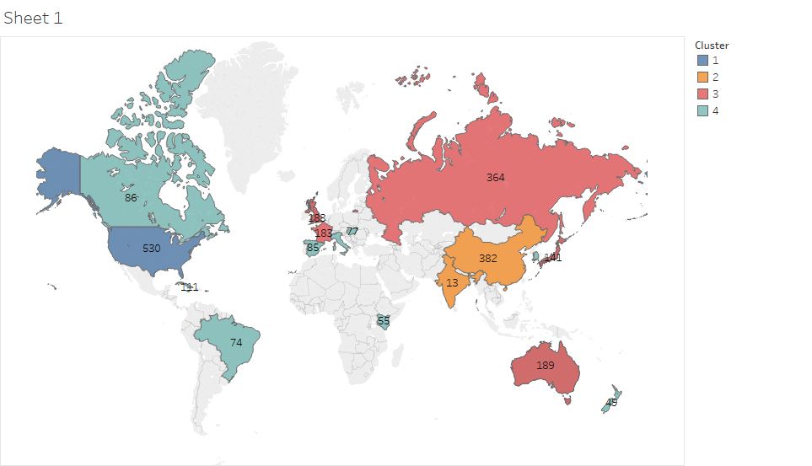

A close up of text on a black background

Description generated with very high confidenceA screenshot of a cell phone

Description generated with very high confidenceA screenshot of a social media post with text and a blue sky

Description generated with high confidenceA screenshot of a cell phone

Description generated with very high confidence

