**MINI PROJECT**

**(2020-2021)**

# Medical-Based Web Application

# SYNOPSIS



**Institute of Engineering & Technology**

**Team Members**

Kartik Agrawal (181500310)

Kush Mittal (181500342)

Mukund Agrawal (181500401)

Vinay Kumar Sharma (181500794)

Ashish Agarwal (181500137)

## Supervised By

**Mr. Akash Kumar Choudhary Sir**

**Department of Computer Engineering & Applications**

**Name / Title of the project:**

Medical-Based Web Application

**The problem statement:**

* Some of the Medical Store owners can't be able to keep track of his stock details which leads to an untimely shortage/loss of medicines or expiry of medicines.
* Some Medical Store owners won't give proper bills because they lack in time to make a handwritten bill for customers.
* Difficulty in managing a lot of medicines data/details.

**Reason for selecting the topic:**

* Difficulty in keeping track of medicines.
* Customers can't get a legal option if the exchange/return of the purchased medicine is not made by the store owner saying there is no bill.

**Objectives of the project:**

In this project, we are going to make a website where medical store owners can log in to our site through their respective mobile numbers and can manage their database of products.

Also, they can generate e-bills and print them.

**Literature Survey / Feasibility Study:**

Yes, this project is feasible by the help of Web Development & Database Management System.

**Future Scope:**

In the future, we can expand this website for general store owners as well by which they can manage their products database and along with that they can also generate a bill.

**Methodology (including a summary of the project):**

* Firstly, we will make a log-in page for the user, the user can sign-up on our website through his mobile number & then log-in after completing the sign-up process.
* After log-in into his account, he can get the option of adding medicine details into stock including details like quantity, price, expiry date, etc.
* He can also view the data of the stocks he has in his store so that there will be no untimely shortage/expiry of any medicine.
* He can also get a feature where he can type medicine name, quantity and can generate the bill for the customer.

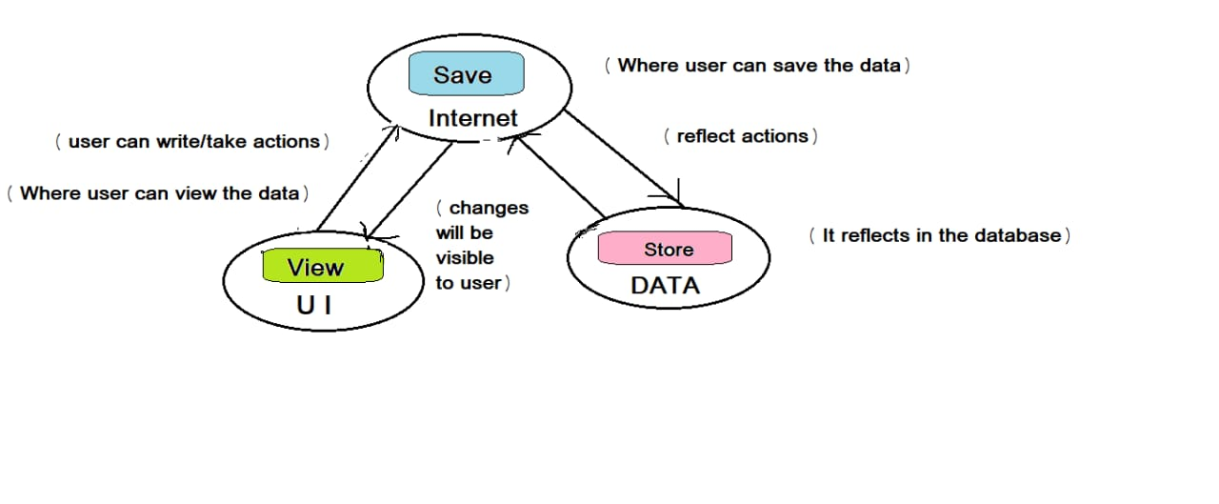

**Requirements:**

***Hardware:-***

* Processor: i3 or above
* RAM: 4 GB or above
* Disc space: 20 GB (3 GB for database files + enough GB for shared documents, individual)
* Network card required

***Software:-***

* Git package
* Visual Studio Code as IDE
* OPERATING SYSTEM: Windows 7
* DATABASE: MySQL or PostgreSQL
* FRONT-END: HTML, CSS, JAVASCRIPT, BOOTSTRAP4
* BACK-END: Java

**Testing technologies to be used:**

* Functionality Testing
* Usability testing
* Database Testing
* Compatibility testing
* Performance Testing
* Security testing
* Crowd Testing

**What contribution would the project make and where?**

It will help medical store owners to manage/arrange their database of products/medicines so that they can keep track of the items they have & also can generate bills.

**Scope for extension into a major project:**

Yes, we can expand it into a major project as an application for general store owners as well.

**Conclusion:**

We made a website where medical store owners can log in to our site through their respective mobile numbers and can manage their database of products.

Also, they can generate e-bills and print them.

**References:**

[**https://hackr.io/tutorials/learn-bootstrap**](https://hackr.io/tutorials/learn-bootstrap)

[**https://www.learn-html.org/**](https://www.learn-html.org/)

[**https://bootstrapbay.com/blog/learn-bootstrap/**](https://bootstrapbay.com/blog/learn-bootstrap/)

[**https://www.w3schools.com/html**](https://www.w3schools.com/html)

[**https://www.udemy.com/html-css-bootstrap/**](https://www.udemy.com/html-css-bootstrap/)