Text Mining Project Report
Market sentiment classification from financial tweets

GROUP 15
Antônio Ramos | 20240561
Tahiya Laboni | 20240943

Table of Contents
- Introduction
- Dataset Description and Exploratory Data Analysis
- Data Preprocessing
- Experimental Design
- Classical Machine Learning Results
- Word2Vec-Based Models
- Deep Learning and Transformer Results
- Agentic AI Extra Challenge
- Final Model Selection
- Conclusion
Appendix

1. Introduction

Financial sentiment analysis presents challenges that are not commonly found in general-purpose sentiment classification tasks. Financial tweets are short, highly contextual and frequently contain domain-specific vocabulary, including stock tickers, analyst recommendations, earnings announcements and market jargon. In many cases, sentiment is implied rather than explicitly expressed, which increases the complexity of the classification task.
The objective of this project was to evaluate multiple text representation and classification strategies for the prediction of financial sentiment in tweets. Rather than assuming that a particular modelling approach would dominate the others, the project was designed as a comparative experimental study involving traditional machine-learning models, dense word embeddings, recurrent neural networks and Transformer-based architectures.
A secondary objective was the implementation of an Agentic AI workflow capable of selecting an already trained model according to characteristics of an input tweet and then executing the corresponding prediction process.
The work was divided into two notebooks. The first notebook contains the complete experimentation workflow, including exploratory analysis, preprocessing, feature engineering, model training and comparison. The second notebook implements the final production-oriented pipeline using only the selected model.
This report documents the experimental workflow implemented in tm_tests_99.ipynb and the final ready-to-run solution implemented in tm_final_99.ipynb. The task is a three-class NLP classification problem: Bearish (0), Bullish (1), and Neutral (2). The final prediction file is pred_99.csv.

2. Dataset Description and Exploratory Data Analysis

The training set contains 9543 tweets and the test set contains 2388 tweets. There are no missing values in the relevant columns and no duplicated rows in the training data. The class distribution is imbalanced: Neutral is the majority class, followed by Bullish and Bearish.
Class | Count | Percentage
Neutral | 6178 | 64.7400
Bullish | 1923 | 20.1500
Bearish | 1442 | 15.1100
One of the first findings obtained during exploratory analysis was the existence of significant class imbalance. The Neutral class represented approximately two thirds of the observations, while Bullish and Bearish tweets appeared considerably less frequently. This result is consistent with the nature of financial social media, where many messages simply report events, news or market movements without expressing a strong directional opinion.
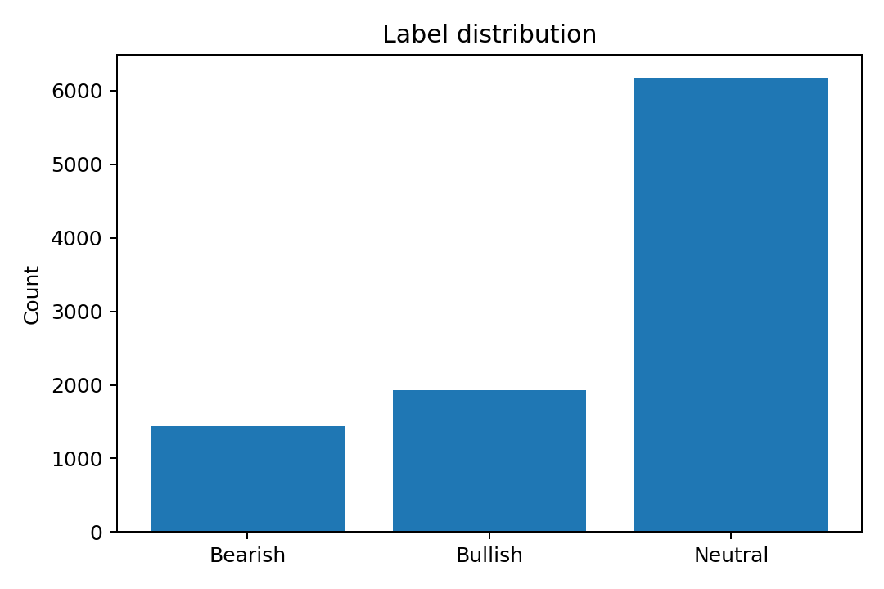
Figure 1 - Label distribution in the training corpus.
One of the first findings obtained during exploratory analysis was the existence of significant class imbalance. The Neutral class represented approximately two thirds of the observations, while Bullish and Bearish tweets appeared considerably less frequently. This result is consistent with the nature of financial social media, where many messages simply report events, news or market movements without expressing a strong directional opinion.
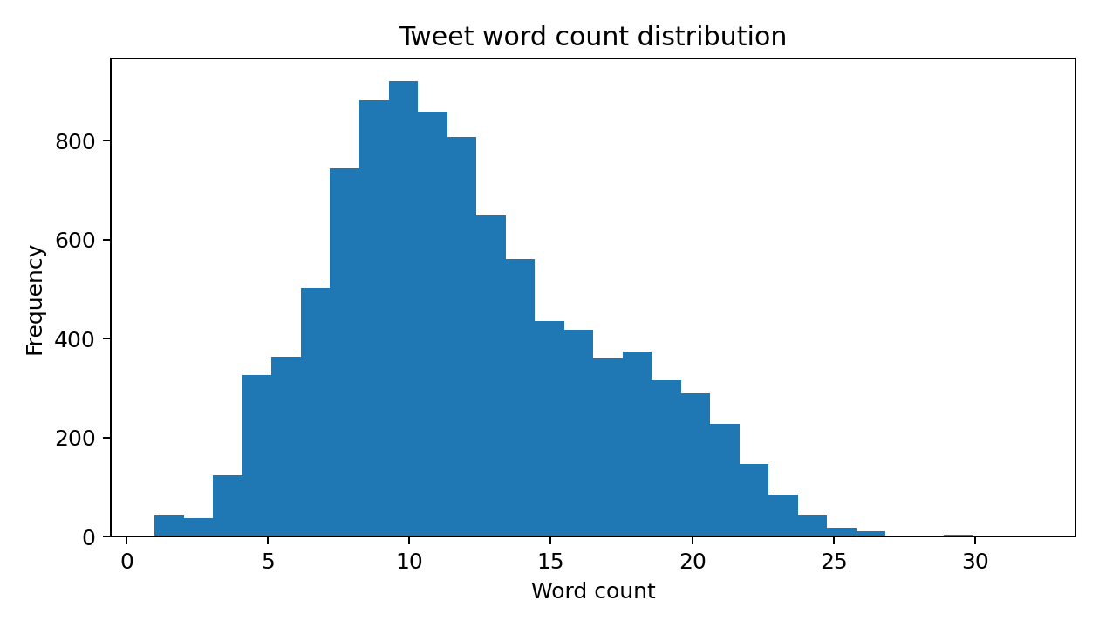
Figure 2 - Distribution of tweet length in words.
The analysis of tweet length revealed another important characteristic of the dataset. Most tweets were relatively short, with a concentration around ten to fifteen words. This observation influenced several design decisions throughout the project. Short texts tend to favour sparse n-gram representations, but they may also benefit from contextual embeddings capable of capturing meaning from limited textual evidence.
The vocabulary analysis performed after preprocessing confirmed the strong financial nature of the corpus. Terms associated with stocks, earnings, prices, analyst actions and market movements appeared frequently. This result suggested that domain-specific language understanding could potentially provide an advantage over general-purpose language models.
.

3. Data preprocessing

The analysis of tweet length revealed another important characteristic of the dataset. Most tweets were relatively short, with a concentration around ten to fifteen words. This observation influenced several design decisions throughout the project. Short texts tend to favour sparse n-gram representations, but they may also benefit from contextual embeddings capable of capturing meaning from limited textual evidence.
The vocabulary analysis performed after preprocessing confirmed the strong financial nature of the corpus. Terms associated with stocks, earnings, prices, analyst actions and market movements appeared frequently. This result suggested that domain-specific language understanding could potentially provide an advantage over general-purpose language models.
Stop-word removal, lemmatization and text normalization were evaluated as part of the workflow. The resulting vocabulary became significantly cleaner while preserving the financial terminology that characterizes the dataset.
The most important observation during preprocessing was that preserving financial context produced better downstream representations than aggressively simplifying the text. This was particularly visible in models designed to exploit domain-specific vocabulary.

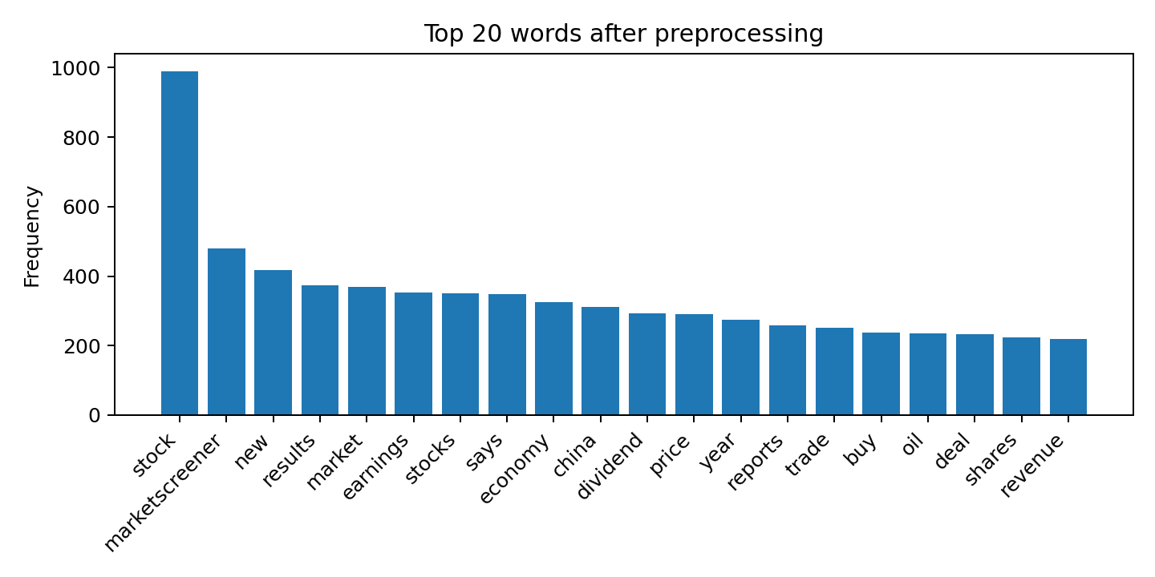
Figure 3 - Most frequent terms after preprocessing.
The top words show a clear financial vocabulary, including stock, market, price, earnings, shares, buy, trade and beat. This confirms that both general sentiment and finance-domain signals are present. The final modeling text uses the lemmatized version because it is cleaner than raw text while retaining the most relevant domain terms.

4. Feature engineering
Four feature families are implemented in the experimental notebook. First, Bag-of-Words uses CountVectorizer with word unigrams and bigrams, min_df=2 and max_features=50,000. Second, TF-IDF uses word unigrams/bigrams with sublinear term frequency and the same vocabulary cap. Third, a combined word+character TF-IDF representation joins word n-grams (1,2) and character n-grams (2,3), which is useful for short tweets, cashtags and ticker-like tokens. Fourth, Word2Vec uses skip-gram embeddings trained on the training split, vector_size=80, window=5, min_count=2 and epochs=10; tweet vectors are computed by averaging token embeddings.
Transformer encoder features are produced by fine-tuning sequence-classification models directly on raw tweets. The tested encoder list in tm_tests_99 is: distilbert-base-uncased, bert-base-uncased, ProsusAI/finbert and roberta-base. They use max_length=96, batch size=16, epochs=3, learning rate=2e-5, weight_decay=0.01 and best model selection by validation Macro F1.

5. Classification models and hyperparameters

The experimental design was intentionally broad. Multiple modelling families were evaluated in order to understand how different text representations behaved in the financial sentiment domain.
The experiments included:
- Bag-of-Words representations;
- TF-IDF representations;
- Combined word and character TF-IDF features;
- Word2Vec embeddings;
- BiLSTM neural networks;
- Transformer-based encoders;
- Domain-specific Transformer models.
All experiments used the same stratified validation split, allowing direct comparison across modelling approaches.
Several hyperparameter configurations were evaluated throughout the development process. Instead of focusing on a single configuration, the goal was to understand how different modelling choices affected validation performance.

6. Evaluation and results
Models are evaluated on a stratified 80/20 validation split using Accuracy, Macro Precision, Macro Recall, Macro F1 and Weighted F1. Macro F1 is the selection criterion because the classes are imbalanced and the minority Bearish/Bullish classes are important for the problem.
The classical machine-learning experiments produced surprisingly competitive results.
Bag-of-Words models established a strong baseline and demonstrated that a substantial portion of the sentiment signal could already be captured through simple frequency-based representations. Logistic Regression and LinearSVC consistently produced stronger results than Naive Bayes, suggesting that linear decision boundaries were sufficient to exploit a large portion of the available information.
The transition from Bag-of-Words to TF-IDF produced measurable improvements, although the magnitude of those improvements was smaller than initially expected. This result indicates that the presence of certain terms was already highly informative and that frequency reweighting served primarily as a refinement mechanism rather than a transformational improvement.
The strongest classical baseline emerged from the combination of word-level and character-level TF-IDF features. Character n-grams appeared particularly useful for financial text because they captured patterns associated with tickers, abbreviations and short market expressions that might not be fully represented by word-level features alone.
Although classical approaches did not achieve the highest scores in the study, they remained remarkably competitive while requiring significantly lower computational cost.

Model | Accuracy | Macro Precision | Macro Recall | Macro F1 | Weighted F1
Transformer: distilbert-base-uncased | 0.8649 | 0.8328 | 0.8120 | 0.8219 | 0.8636
TF-IDF word+char + LinearSVC | 0.7994 | 0.7427 | 0.7278 | 0.7349 | 0.7977
TF-IDF + LinearSVC | 0.7994 | 0.7383 | 0.7222 | 0.7298 | 0.7974
BoW + MultinomialNB | 0.7988 | 0.7375 | 0.7106 | 0.7229 | 0.7954
BoW + LogisticRegression | 0.7915 | 0.7251 | 0.7187 | 0.7216 | 0.7908
TF-IDF + LogisticRegression | 0.7894 | 0.7192 | 0.7236 | 0.7214 | 0.7900
TF-IDF + SGDClassifier | 0.7700 | 0.7027 | 0.6851 | 0.6931 | 0.7675
Word2Vec avg + RandomForestClassifier | 0.7365 |  |  | 0.5794 | 0.7083
Word2Vec avg + LogisticRegression | 0.6564 |  |  | 0.5741 | 0.6706
BiLSTM Embedding | 0.7810
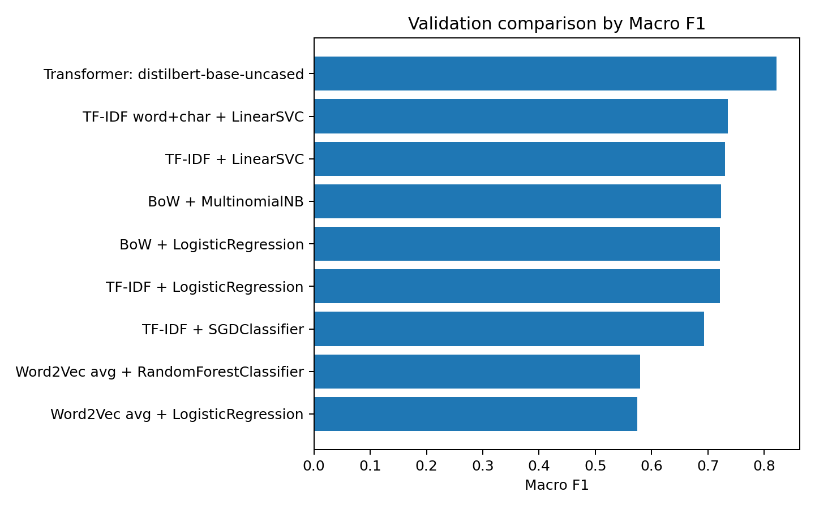
Figure 4 - Model comparison by validation Macro F1.

5. Classical Machine Learning Results

The classical machine-learning experiments produced surprisingly competitive results.
Bag-of-Words models established a strong baseline and demonstrated that a substantial portion of the sentiment signal could already be captured through simple frequency-based representations. Logistic Regression and LinearSVC consistently produced stronger results than Naive Bayes, suggesting that linear decision boundaries were sufficient to exploit a large portion of the available information.
The transition from Bag-of-Words to TF-IDF produced measurable improvements, although the magnitude of those improvements was smaller than initially expected. This result indicates that the presence of certain terms was already highly informative and that frequency reweighting served primarily as a refinement mechanism rather than a transformational improvement.
The strongest classical baseline emerged from the combination of word-level and character-level TF-IDF features. Character n-grams appeared particularly useful for financial text because they captured patterns associated with tickers, abbreviations and short market expressions that might not be fully represented by word-level features alone.
Although classical approaches did not achieve the highest scores in the study, they remained remarkably competitive while requiring significantly lower computational cost.

6. Word2Vec-Based Models

The Word2Vec experiments generated results that were weaker than the strongest sparse-feature baselines.
The most likely explanation is related to the representation strategy adopted in the experiment. Tweet embeddings were generated through averaging operations, which inevitably compress all token information into a single vector. While computationally efficient, this process removes positional information and reduces the influence of important local phrases.
This limitation appears particularly relevant in short financial tweets, where a small number of words can completely alter sentiment. As a consequence, Word2Vec models struggled to match the discriminative power achieved by TF-IDF-based approaches.
Even though the results were not among the strongest obtained in the project, these experiments provided an important comparison point between sparse and dense representations.

7. Deep Learning and Transformer Results

The BiLSTM model represented the first deep-learning architecture evaluated during the project. Training curves showed rapid reductions in training loss, but validation performance stabilized early and eventually exhibited signs of overfitting.
This behaviour suggests that the model successfully learned patterns from the training set but encountered difficulties generalizing those patterns to unseen examples. Early stopping reduced the severity of the problem, although the final performance remained below the strongest Transformer-based alternatives.
The Transformer experiments produced the strongest results observed throughout the study. DistilBERT and BERT both generated substantial improvements over classical baselines, confirming the value of contextual representations for financial sentiment classification.
The most significant finding emerged from the evaluation of FinBERT. Unlike the general-purpose Transformer models, FinBERT was pre-trained on financial language. The validation results demonstrated a consistent advantage over the remaining candidates, particularly in the identification of Bullish and Bearish sentiment.
The final validation results identified FinBERT as the strongest model evaluated in the project, achieving approximately 87% accuracy and a Macro-F1 score close to 0.83. These results justified its selection as the final production model.
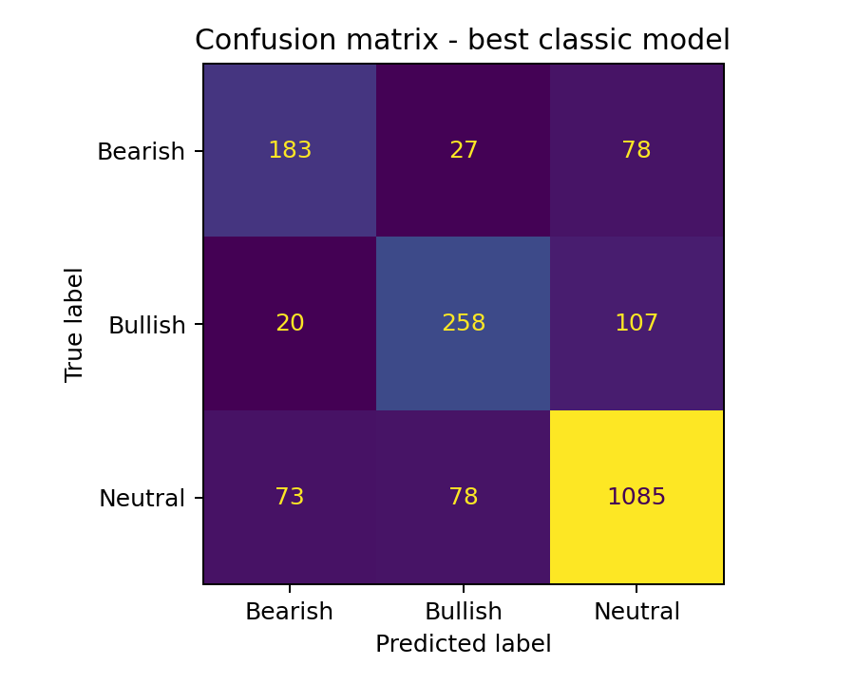
Figure 5 - Confusion matrix for the best classic baseline.
The confusion matrix shows that Neutral is easier to detect, while Bearish and Bullish are more frequently confused with Neutral. This is consistent with the class distribution and with financial tweets whose sentiment may be implied by verbs such as cut, beat, miss, upgrade or downgrade rather than by ordinary sentiment words.
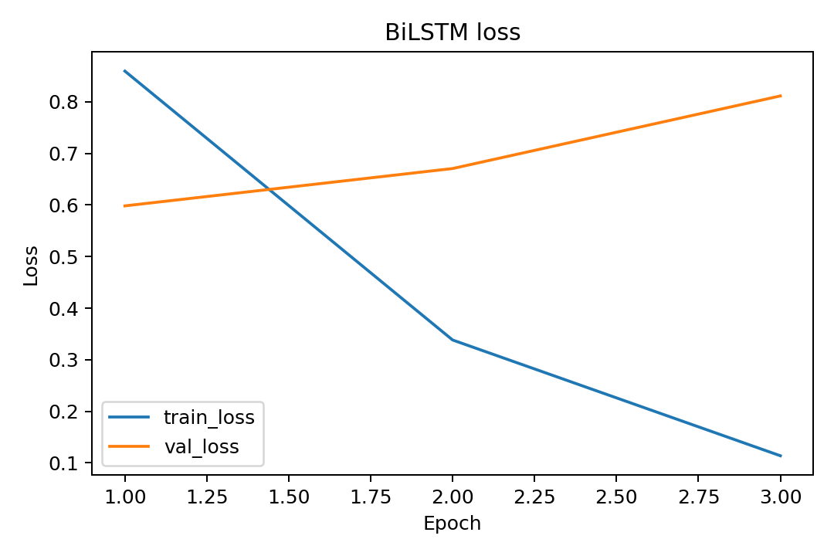
Figure 6 - BiLSTM training and validation loss.
The BiLSTM displayed overfitting: training loss decreased quickly while validation loss increased after the first epoch. This suggests that the neural recurrent model memorized patterns in the training set without improving generalization. The transformer encoder performed better because it starts from pretrained contextual representations.

8. Final Pipeline
The final model selection process was based primarily on Macro-F1 and supported by Accuracy, Precision and Recall.
Among all evaluated candidates, FinBERT produced the strongest overall validation performance. The improvement over classical baselines was significant, while the improvement over generic Transformer encoders, although smaller, remained consistent across evaluation metrics.
Because the objective of the final notebook is prediction rather than experimentation, only the FinBERT pipeline was retained in the production workflow. This decision simplifies execution while preserving the strongest observed performance.

9. Extra Challenge - Agentic AI

The Agentic AI component was implemented as a routing layer positioned above the trained classifiers.
Rather than directly performing sentiment classification, the agent first evaluates characteristics of the input tweet and then decides which previously trained model should be used for inference. This architecture separates decision-making from prediction and demonstrates a simple but effective orchestration workflow.
The routing mechanism considers factors such as tweet length, financial vocabulary and ticker presence. Based on these signals, the agent selects the most appropriate available model and then executes the corresponding prediction process.
An important characteristic of this implementation is that the agent does not retrain any model. Instead, it leverages the models already produced during experimentation, turning them into reusable tools that can be dynamically selected according to the context of the input.

10. Conclusion
This project investigated multiple approaches for financial sentiment classification using a common experimental framework. The results demonstrated that classical machine-learning techniques remain strong baselines, especially when combined with carefully engineered sparse features. However, the best overall performance was achieved by Transformer-based models.
The experiments also highlighted the importance of domain specialization. While generic language models performed well, the financial specialization incorporated into FinBERT provided the strongest and most consistent validation results.
The Agentic AI component demonstrated that model orchestration can be incorporated into sentiment-analysis workflows without requiring additional training. By selecting among existing models, the agent adds a decision-making layer capable of adapting inference strategies to the characteristics of the input text.
Future work could investigate larger financial language models, ensemble strategies and more sophisticated routing mechanisms within the agentic framework.

Appendix - Delivery mapping

- tm_tests_15.ipynb: complete experiments with BoW, TF-IDF, Word2Vec, BiLSTM and all configured Transformer encoders.
- tm_final_15.ipynb: final FinBERT pipeline.
- pred_15.csv: test predictions.
- report_15.pdf: this report. Group number: 99.

