JusticeBot Infrastructure Metrics
Timestamp: 2026-04-09 23:11:01
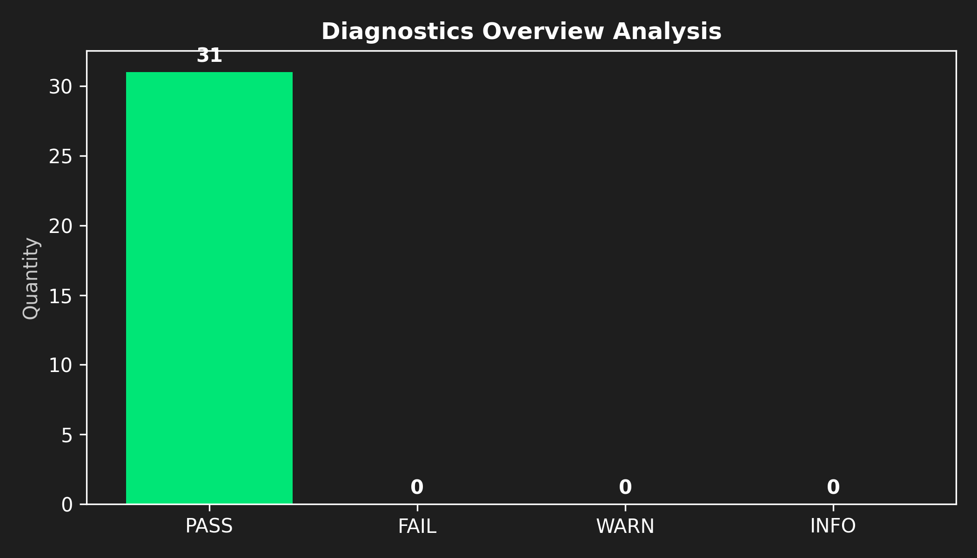
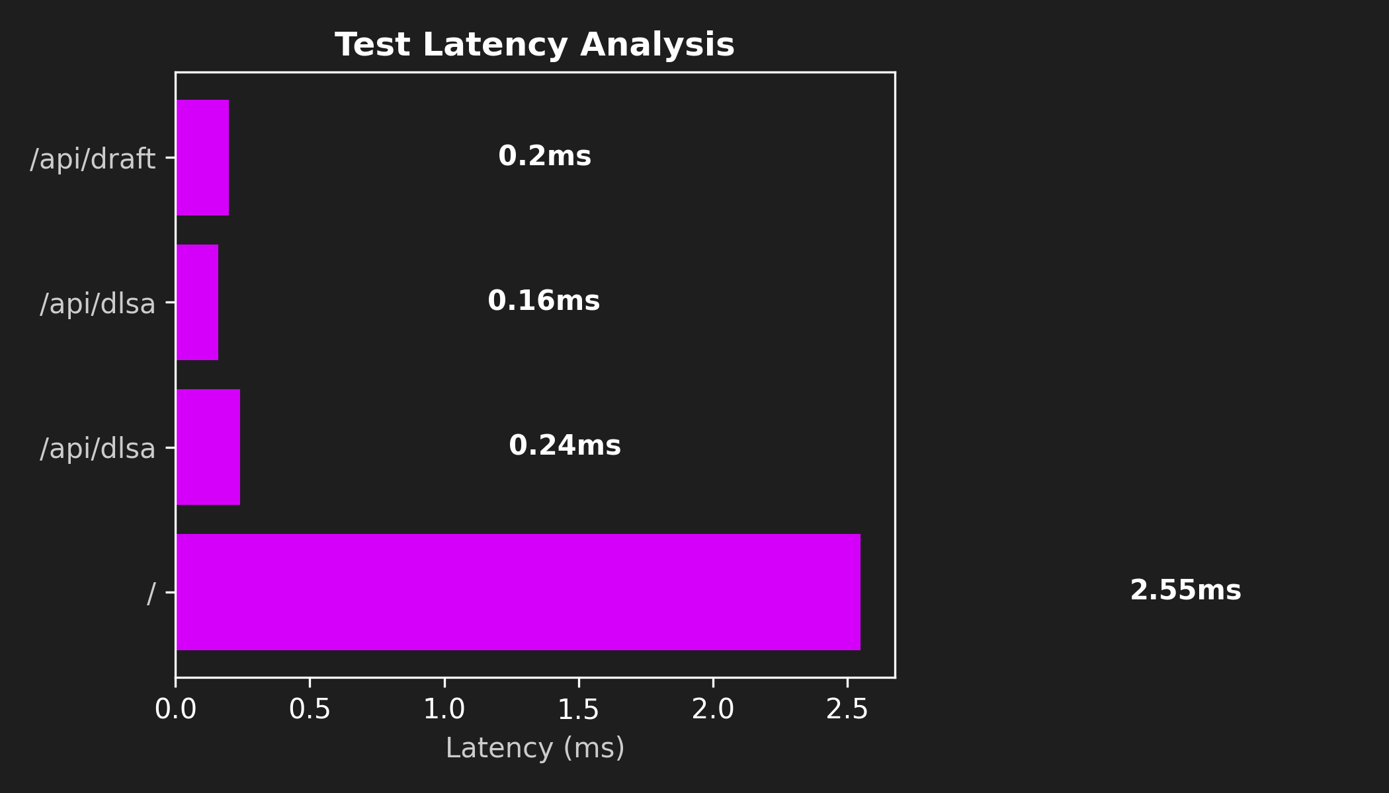

Test Execution Log
Module | Test Executed | State
Env | Python 3.14 | PASS
Env | Dependency flask loaded | PASS
Env | Dependency dotenv loaded | PASS
Env | Dependency groq loaded | PASS
Env | Dependency fitz loaded | PASS
Env | Dependency docx loaded | PASS
Env | Dependency fpdf loaded | PASS
Env | Dependency matplotlib loaded | PASS
Env | Dependency reportlab loaded | PASS
Config | config.py loaded | PASS
Config | GROQ_API_KEY present | PASS
Config | MODELS present | PASS
Config | TEMPERATURE present | PASS
Config | APP_TITLE present | PASS
Modules | Module memory.session built correctly | PASS
Modules | Module data.dlsa_offices built correctly | PASS
Modules | Module utils.dlsa built correctly | PASS
Modules | Module utils.doc_parser built correctly | PASS
Modules | Module utils.pdf_export built correctly | PASS
Modules | Module agents.router built correctly | PASS
Modules | Module agents.legal_advisor built correctly | PASS
Modules | Module agents.doc_analyzer built correctly | PASS
Modules | Module agents.drafter built correctly | PASS
Modules | Module prompts.legal_prompts built correctly | PASS
Modules | Module prompts.draft_prompts built correctly | PASS
Utils | Session created successfully | PASS
Utils | DLSA Lookup works (Delhi) | PASS
Routes | GET / returns 200 OK | PASS
Routes | GET /api/dlsa valid for Punjab | PASS
Routes | GET /api/dlsa handles 404 cleanly | PASS
Routes | POST /api/draft handles missing context properly | PASS

