Bharat AI-SoC Student Challenge

Project Report
Problem statement 2: Touchless HCI for Media Control Using Hand Gestures on NVIDIA Jetson Nano
Team members:
1)Madava Venkat J
2)Jason Arputharaj A

Abstract:
In this project, a real-time gesture-controlled media playback system running on an NVIDIA Jetson Orin Nano edge AI platform is designed and implemented. Users can use pre-programmed hand gestures recorded by a camera to control video playback functions like play, pause, and stop. The main goal of this project is to develop a contactless and user-friendly interaction mechanism to replace conventional input devices like keyboards, remote controls, and touchscreens.
The system uses MediaPipe-powered computer vision techniques to recognize gestures and detect hand landmarks in real time. While the MPV media player is controlled by Inter-Process Communication (IPC) to effectively carry out playback commands, OpenCV is utilized for video capture and processing. The Jetson device runs the entire system locally, guaranteeing minimal latency and data privacy
The project shows that implementing edge-based AI systems for real-time human-computer interaction without depending on cloud processing is feasible. According to experimental results, the system can detect gestures with minimal latency and stability, which makes it appropriate for use in smart classrooms, assistive technology, and environments where hygiene is a concern. The application demonstrates efficient software optimization and hardware utilization strategies for embedded AI deployment.
Introduction:
Over time, human-computer interaction (HCI) has changed dramatically, progressing from command-line interfaces to graphical interfaces and, more recently, toward natural interaction systems. One such new paradigm for interaction is gesture-based control, which allows people and machines to communicate intuitively without making physical contact.
Conventional media control systems are based on touch interfaces, keyboards, or hardware remote controls. These techniques, however, are problematic in settings where touch-based interaction is unsanitary, inconvenient, or inaccessible. Sterile conditions restrict physical contact in healthcare settings. In a similar vein, people with physical disabilities might have trouble utilizing standard input devices.
In order to overcome these obstacles, this project creates a computer vision-powered touchless media control system. The device records live video from a camera, uses MediaPipe to identify hand landmarks, decodes preset gestures, and instructs a media player with the appropriate control commands. The NVIDIA Jetson platform was chosen because it supports edge AI deployment and has embedded GPU capabilities.
The suggested system offers a scalable and effective solution for next-generation interactive systems by showcasing the real-world integration of gesture recognition with real-time multimedia control.
Methodology:
The system architecture follows a modular pipeline consisting of video acquisition, gesture detection, gesture classification, command generation, and media control execution.
First, a USB camera connected to the Jetson device captures live video frames using OpenCV. Each frame is processed and converted to RGB format before being passed to MediaPipe Hands for landmark detection. MediaPipe identifies 21 hand landmarks per detected hand and provides normalized coordinate outputs.
Next, gesture recognition is implemented using a rule-based approach. The system determines whether each finger is in an extended or folded position by comparing the relative positions of fingertip and joint landmarks. A smoothing mechanism using a moving average over multiple frames is implemented to reduce noise and prevent false triggers.
Once a gesture is classified (e.g., five fingers = play/pause, one finger = volume up), a corresponding command is generated. These commands are transmitted to the MPV media player through an IPC socket. MPV interprets the commands and executes playback actions in real time.
Dynamic delay mechanisms are implemented to avoid repeated command triggering from sustained gestures. The methodology ensures low latency, modular design, and robustness under varying lighting conditions.

Gesture | Operation
✋ | Pause/play
✊ | stop
☝ | Volume up
✌️ | Volume down

Hardware Utilization:
The NVIDIA Jetson Nano / Orin Nano development board, intended for edge AI applications, was used to implement the project. The board's integrated GPU and ARM-based CPU are tuned for parallel processing applications.Hardware components used include:
- NVIDIA Jetson development board
- USB camera for real-time video capture
- HDMI display for output
The Jetson platform provides sufficient computational power to run MediaPipe and OpenCV simultaneously without significant performance degradation. Although GPU acceleration is available, the system was optimized to ensure stable CPU-based processing to avoid multimedia pipeline conflicts.
Efficient memory utilization was maintained by processing frames at moderate resolution (640×480), which balances detection accuracy and processing speed.
Optimization Techniques:
To guarantee reliable and effective system performance on the embedded platform, a number of optimization techniques were put into practice.
In order to decrease false positives and enhance tracking stability, MediaPipe detection confidence thresholds were first raised. Frame averaging over several consecutive frames was used as part of a temporal smoothing mechanism to stabilize gesture recognition.
Second, when a gesture is held for long periods of time, a dynamic action delay system was added to avoid repetitive command execution. This decreased unexpected behavior and enhanced usability.
Third, because MPV is more compatible with Jetson's multimedia pipeline, it was chosen over VLC. By properly configuring MPV, hardware decoding conflicts were prevented, guaranteeing steady video playback.
Additionally, frame skipping techniques can be optionally enabled to reduce CPU load when running on resource-constrained configurations. Efficient socket communication was implemented for IPC control, ensuring low-latency interaction between the gesture recognition module and the media player.
These optimization techniques collectively enhanced accuracy, stability, and responsiveness.

Results:
Several optimization strategies were implemented to ensure stable and efficient system performance on the embedded platform.
First, MediaPipe detection confidence thresholds were increased to reduce false positives and improve tracking stability. A temporal smoothing mechanism was implemented using frame averaging across multiple consecutive frames to stabilize gesture recognition.
Second, a dynamic action delay system was introduced to prevent repetitive command execution when a gesture is held for extended periods. This improved usability and reduced unintended behavior.
Third, MPV was selected instead of VLC due to better compatibility with Jetson’s multimedia pipeline. Hardware decoding conflicts were avoided by configuring MPV appropriately, ensuring stable video playback.
Additionally, frame skipping techniques can be optionally enabled to reduce CPU load when running on resource-constrained configurations. Efficient socket communication was implemented for IPC control, ensuring low-latency interaction between the gesture recognition module and the media player.
These optimization techniques collectively enhanced accuracy, stability, and responsiveness.

Applications:
The developed system can be used in a wide range of fields.
With assistive technology, people with restricted mobility can operate digital media without making physical contact. It enables medical practitioners to navigate content in healthcare settings without jeopardizing sterility.
Teachers can manage video playback and presentations in smart classrooms without interfering with instruction. Additionally, the system can be used to control multimedia centers or televisions in smart home settings.
Furthermore, the project provides a fundamental framework for sophisticated gesture-based interaction systems, such as multimodal AI interfaces and sign language recognition.

Output:
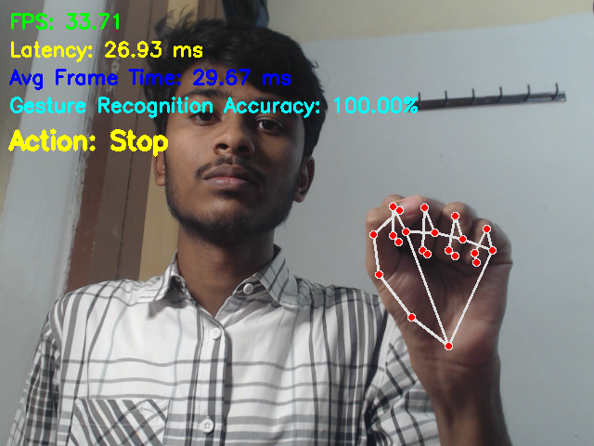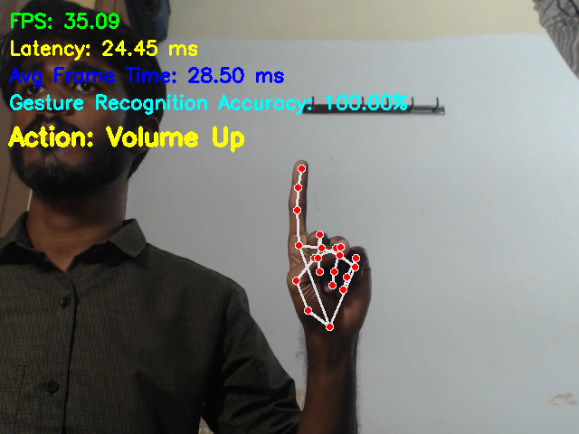
Figure 1(Stop) Figure 2(volume up)

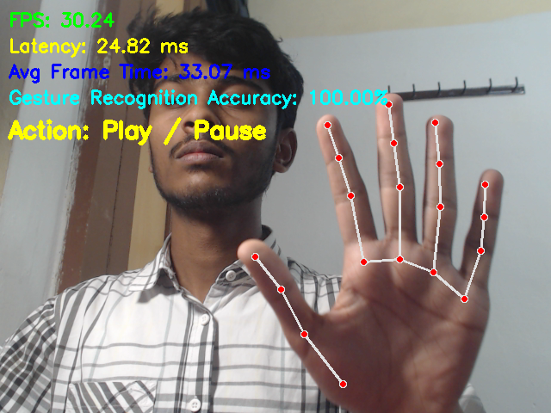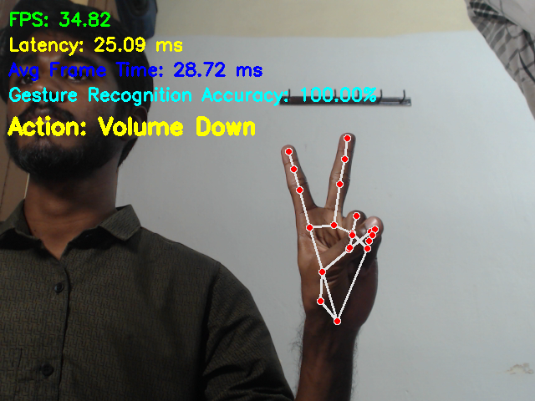
Figure 3(play/pause) Figure 4(volume Down)

Conclusion:
The developed system has broad applicability across multiple domains.
In assistive technology, it enables individuals with limited mobility to control digital media without physical contact. In healthcare environments, it allows medical professionals to navigate content without compromising sterility.
In smart classrooms, instructors can control presentations and video playback without interrupting teaching flow. The system can also be integrated into smart home environments for controlling televisions or multimedia centers.
Additionally, the project serves as a foundational framework for advanced gesture-based interaction systems, including sign language recognition and multimodal AI interfaces.

