Security guard User stroy
Apartment Building Management System

Purpose. This section defines the Security Guard user class, needs, user stories confirmations, risks, and non-functional requirements. It follows the scope and terminology used in the Resident and Building Manager SRS documents.

1.5 Risk Definitions (Security Guard)

Risk | What could go wrong | How we handle it
Invalid, expired, or cancelled guest pass | A visitor might try to enter with an incorrect pass code or use a pass that has expired, been cancelled, or is outside its approved arrival time. | Before allowing entry, the system checks the pass code, validity period, arrival time, cancellation status, and remaining guest allowance (SG-02; NFR-SG-02).
Guest pass reused or guest limit exceeded | More visitors might enter than the resident has approved, particularly if a pass is reused after its allowed guest count has been reached. | The system keeps track of successful check-ins and updates the pass status to Partly used or Fully used based on the remaining guest allowance. Once the limit is reached, further check-ins are blocked (SG-02; NFR-SG-03).
Exposure of resident information | Since the guard may use a shared device, displaying unnecessary resident information could compromise privacy. | The guard interface displays only the information needed for gate duties, including the guest's name, destination flat, pass validity, and check-in status. Resident phone numbers and other private records remain inaccessible to the guard (NFR-SG-04).
Inaccurate visitor records | If a visitor's arrival or departure is not recorded correctly, the system may show an incorrect list of people currently inside the building. | The system records the date and time of each successful entry and exit. The current visitor list is updated according to these records so the guard can identify which visitors are still inside (SG-03, SG-04; NFR-SG-05).
Uncovered or unclear guard shifts | A guard might miss a scheduled shift or be unsure about their assigned working hours if duty information is not communicated clearly. | The guard can check their assigned shift and duty times through the system. The Building Manager remains responsible for creating and updating shift assignments (SG-05; BM-09).
Delay in contacting emergency personnel | During an urgent incident, the guard might lose valuable time searching for the manager's or guard desk's emergency contact number. | The system provides a clearly accessible emergency contact section containing the available contact numbers maintained by the Building Manager (SG-06; BM-10; NFR-SG-06).
Misuse of an unattended shared device | If a guard leaves the gate device unattended while logged in, another person might gain access to restricted guard functions. | Each guard must use an authenticated account to access guard functions. The system automatically ends an inactive session after the agreed timeout period to reduce the risk of unauthorized access (SG-01; NFR-SG-01).

2.1 User Class: Security Guard
The Security Guard is a building staff member responsible for gate security, checking approved guest passes, recording visitor entry and exit, and responding to routine gate enquiries. Guards work in shifts. Their technical skill and English typing ability may be limited (system may approve banglish), so the interface should be simple, clear, and quick to use.
The Building Manager creates or manages the guard account and assigns shifts. The guard can view their assigned duty information but cannot create staff accounts or change shift assignments. The guard checks resident-created guest passes; the resident's phone number must not be displayed. For walk-in visitors, the existing intercom process remains in use where digital approval is outside this release. (as there are intercom in every building now a days, we will take only advance pass)

Action | Security Guard
Log in to the guard interface | Yes
View today's assigned shift | Yes
Check a resident-created guest pass | Yes
Record approved guest entry and guest count | Yes
Record visitor exit | Yes
View visitors currently inside the building | Yes
View the guest's name and destination flat | Yes
View a resident's phone number or another flat's private records | No
Create resident accounts or assign guard shifts | No
Change guest-pass validity or approve a cancelled/expired pass | No
Set or edit emergency contact numbers | No

2.2 User Needs

Area | How it works now / current situation | Problem | What the guard needs
Expected guests | The guard may need to call a flat using the intercom. | The intercom may be broken or nobody answers, causing delays and uncertainty. | Check a resident-created guest pass using its code and see whether it is valid.
Entry and exit records | Visitor details may be written in a paper register. | Handwritten records can be incomplete, difficult to search, or missing departure times. | Record visitor check-in and exit with timestamps and view who is currently inside.
Guest allowance | The guard may not have a reliable way to confirm how many guests were approved or already checked in. | More guests than approved may enter, or a pass may be reused. | See the allowed guest count and how many check-ins remain.
Privacy | The guard may rely on phone calls or contact details shared informally. | Unnecessary resident contact details may be exposed on a shared device. | See only the information needed to verify the pass and direct the guest to the correct flat.
Shift information | Shift details may be shared verbally or kept on paper. | The guard may be uncertain about their assigned duty time. | View today's assigned shift by manager and relevant duty information.
Emergencies | Emergency numbers may be stored separately or may be hard to find. | Searching for the right contact can delay communication. | Open a clear emergency-contact with manager screen quickly.
Ease of use | The gate desk is busy and the device may be shared. | Long forms, small controls, or complex English labels slow down work. | Use a simple interface with clear labels and minimal typing.

3.1 User Stories and Confirmation
Each story uses the format As a / I want / so that. Confirmation criteria are written as Given / When / Then. Priority is Must, Should, or Could. Stories are aligned with RES-03, BM-02, BM-09, and BM-10.

SG-01 · Log in to the guard interface · Must
As a security guard, I want to log in with my own guard account, so that only authorized staff can use the guard functions.
Confirmation criteria
- Given I enter the correct credentials for an active guard account, when I log in, then I see the guard dashboard.
- Given I enter an incorrect password, when I submit the form, then access is refused and a clear error message is shown.
- Given I am logged out or my session has expired, when I open a guard-only page, then I must log in before using it.
- Given I am logged in as a resident or another role, when I try to open a guard-only page, then access is refused.
N:B: Building Manager (creates/manages guard accounts).

SG-02 · Check a guest pass · Must
As a security guard, I want to enter or scan a resident-created guest-pass code, so that I can verify whether the guest is approved to enter.
Confirmation criteria
- Given a valid code is entered within its approved date and arrival window, when I check it, then the system shows the guest name, destination flat, approved guest count, and remaining allowance.
- Given the code is invalid, expired, cancelled, or outside its allowed time window, when I check it, then the system refuses check-in and explains that the pass is not valid.
- Given the pass has already reached its guest allowance, when I check it, then the system shows Fully used and does not allow another check-in.
- Given I view a guest pass, then the resident's phone number is not displayed.
N:B: Resident (RES-03 creates and shares the pass); Building Manager (BM-02 manages accounts).

SG-03 · Record guest entry · Must
As a security guard, I want to check in guests using a valid guest pass, so that the system records who entered the building and when.
Confirmation criteria
- Given a guest has a valid pass with remaining allowance, when I confirm check-in, then the system records the entry date and time.
- Given a guest is checked in, when the record is saved, then the pass usage is updated and the resident receives the notification described in RES-03.
- Given the check-in would exceed the approved guest count, when I try to confirm it, then the system refuses the check-in.
- Given the entry record is saved, when I view the visitor list, then the guest appears as currently inside.
N:B: Resident (RES-03); Building Manager (visitor/security operations).

SG-04 · Record visitor exit · Must
As a security guard, I want to record when a checked-in visitor leaves, so that the building's current visitor list remains accurate.
Confirmation criteria
- Given a visitor is currently marked as inside, when I record their exit, then the system saves the exit date and time.
- Given the exit is saved, when I view current visitors, then that visitor no longer appears as inside.
- Given a visitor has no active entry record, when I try to record an exit, then the system asks me to verify the record and does not create a duplicate exit.
N:B: SG-03 (entry record); Resident (guest-pass workflow).

SG-05 · View assigned shift · Should
As a security guard, I want to view my assigned shift and duty time, so that I know when I am scheduled to work.
Confirmation criteria
- Given the manager has assigned me a shift, when I open Duty, then I see the shift date and start and end times.
- Given no shift has been assigned to me for today, when I open Duty, then the system clearly shows that no shift is listed.
- Given I am a guard, when I view Duty, then I cannot create, edit, or reassign shifts.
N:B: Building Manager (BM-09 assigns shifts).

SG-06 · Access emergency contacts · Must
As a security guard, I want to access the building's emergency contact numbers quickly, so that I can contact the responsible person during an urgent incident. (Manager)
Confirmation criteria
- Given I open Emergency contacts, when the screen loads, then the current guard-desk and manager contact numbers are clearly displayed.
- Given the manager updates an emergency number, when I reopen or refresh the screen, then the updated number is shown.
- Given a contact number is missing, when I open the screen, then the missing information is clearly indicated rather than showing a misleading number.
N:B: Building Manager (BM-10 maintains emergency numbers).

SG-07 · View current visitors · Should
As a security guard, I want to view the list of visitors currently inside the building, so that I can answer gate enquiries and monitor visitor movement.
Confirmation criteria
- Given visitor entries have been recorded and exits have not yet been recorded, when I open Current visitors, then I see those active visitor records.
- Given a visitor's exit has been recorded, when I refresh the list, then that visitor is no longer shown as currently inside.
- Given I open a visitor record, then I see only the details required for gate duties and not a resident's phone number.
N:B: SG-03 and SG-04 (entry and exit records).
3.2 Non-Functional Requirements

ID | Category | Requirement | Story
NFR-SG-01 | Security | The system must allow access to guard-specific pages and actions only to authenticated Security Guard accounts that are active. Users with other roles must be denied access. Automated tests must verify that these restrictions work correctly. | SG-01
NFR-SG-02 | Security | Before approving a check-in, the system must verify the guest-pass code, validity dates, permitted arrival time, cancellation status, and remaining guest allowance. Passes that are invalid, expired, cancelled, outside the approved time window, or fully used must not be accepted. | SG-02, SG-03
NFR-SG-03 | Accuracy | Each successful check-in must be recorded only once, and the remaining guest allowance must be updated correctly. The system must prevent additional check-ins once the approved guest limit has been reached. | SG-02, SG-03
NFR-SG-04 | Privacy | The guard interface and any API responses accessible to guards must not reveal residents' phone numbers or other private information restricted to residents. Automated tests must verify that this information is not exposed. | SG-02, SG-07
NFR-SG-05 | Accuracy | Every successfully recorded visitor entry and exit must include the relevant date and time. The current visitor list must accurately reflect the saved records so that visitors who have left are no longer shown as being inside the building. | SG-03, SG-04, SG-07
NFR-SG-06 | Safety | Guards must be able to access emergency contact information from the dashboard within two actions. The displayed contact numbers must reflect the latest information maintained by the Building Manager. | SG-06, BM-10
NFR-SG-07 | Performance | Under the agreed test conditions and on a 4G connection, the guard dashboard, guest-pass check results, and current visitor list must load within 3 seconds for at least 95% of requests. | SG-01, SG-02, SG-07
NFR-SG-08 | Usability | The interface must remain usable on screens as narrow as 360 pixels, with clear labels and touch-friendly controls. It must support both Bangla and English. From the guard dashboard, checking a guest pass must require no more than four taps, excluding the taps or input needed to enter the pass code. | SG-02, SG-06, SG-07
NFR-SG-09 | Availability | Guest-pass checking must be available at least 99% of the time between 6:00 a.m. and midnight, in line with the availability requirement defined for the resident guest-pass feature. | SG-02, SG-03
NFR-SG-10 | Auditability | For every successful visitor check-in and exit, the system must store the account of the guard who performed the action, along with its date and time. These records must allow authorized users to trace visitor-log activities when needed. | SG-03, SG-04

Scope notes and cross-references
- The resident creates, shares, and cancels guest passes. The guard checks passes and records visitor movement; the guard does not create or extend a resident's pass.
- The Building Manager creates and manages staff accounts, assigns shifts, and maintains emergency contact numbers.
- Walk-in visitor approval and delivery approval through the guard's phone are not added as new features in this draft, because the Resident document lists those items as outside the current release. Existing intercom handling remains available where needed.
- The exact inactivity timeout for shared devices and the detailed offline behavior should be agreed by the team before finalizing the SRS. The system should not falsely confirm a check-in if it cannot save the record.

Review note: The IDs and numeric targets in this draft are proposed to align the Security Guard requirements with the supplied Resident and Building Manager documents. The group should confirm them together before merging this section into the final SRS.

UML Use Case Diagram:
- Actor: Security Guard — the person who interacts with the guard interface.
- System boundary: BariBondhu System — all seven functions belong to the application.
- <<include>>: A required use case that another use case invokes. Recording guest entry includes checking the guest pass.
- Login relationships: Protected functions require an authenticated guard session, following the Resident SRS's diagram convention.
- Notes: Clarify the validation and recording rules without overcrowding the diagram with extra use cases.
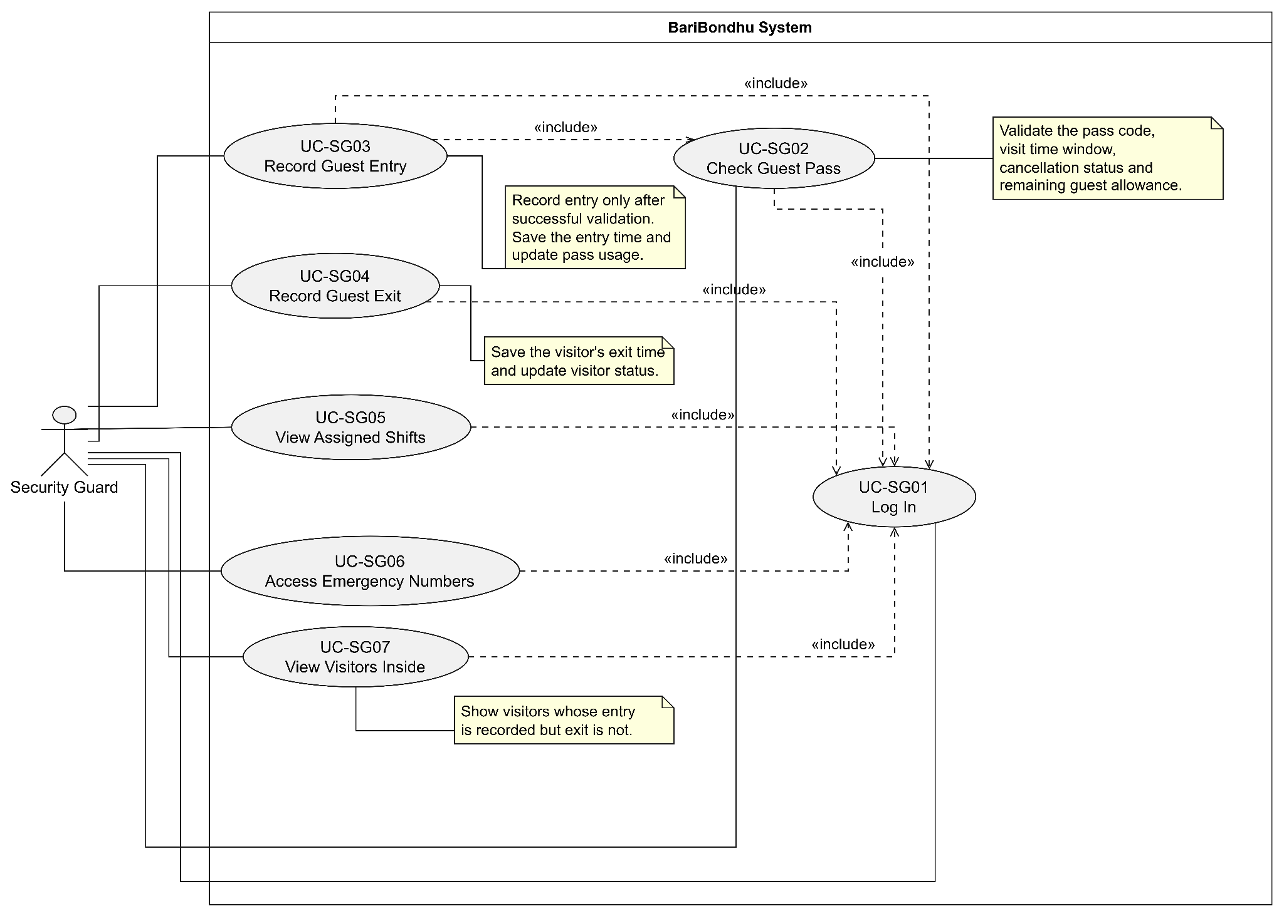
Figure: Use case diagram of Security Guard User

Use Case Narrative

1. UC-SG01 — Log In
Field | Description
Use case | UC-SG01 Log In
Actors | Primary: Security Guard
Precondition | The guard has an account created or enabled by the authorised building manager.
Trigger | The guard opens the guard interface while logged out.
Main success scenario | 1. The guard enters their username and password. 2. The system validates the credentials and account status. 3. The system opens the guard home screen.
Alternate flows | 2a. Incorrect credentials: the system displays an error and allows another attempt. 2b. The account is inactive: the system refuses access. 3a. The guard attempts to access a resident, manager or committee-only page: the system denies access.
Postcondition | The guard is authenticated and can access only the functions permitted to the Security Guard role.
Non-functional requirements | Passwords must be securely stored; access permissions must be enforced by the backend, not just hidden in the interface.

2. UC-SG02 — Check Guest Pass
Field | Description
Use case | UC-SG02 Check Guest Pass
Actors | Primary: Security Guard
Precondition | The guard is logged in, and a guest presents a pass code or matching QR code.
Trigger | The guard enters the six-digit code or scans the guest's QR code.
Main success scenario | 1. The guard enters or scans the pass. 2. The system validates the pass code, validity period, cancellation status and remaining guest allowance. 3. The system confirms that the pass is valid. 4. The system displays the guest's name, flat number and remaining guest allowance.
Alternate flows | 2a. The code is invalid: the system displays an invalid-pass message. 2b. The pass is not yet valid or has expired: entry is not authorised. 2c. The pass has been cancelled or fully used: the system refuses entry using that pass. 2d. The server cannot be reached: the system reports that validation could not be completed and does not show a false success.
Postcondition | The pass validation result is displayed. Checking a pass alone does not record guest entry.
Non-functional requirements | Pass validation must enforce the pass's time window and usage allowance. The guard must not see the resident's phone number.

3. UC-SG03 — Record Guest Entry
Field | Description
Use case | UC-SG03 Record Guest Entry
Actors | Primary: Security Guard
Precondition | The guard is logged in, and the guest has a valid pass with remaining allowance.
Trigger | The guard chooses to record the arrival of a guest after checking the pass.
Main success scenario | 1. The guard checks the guest pass. 2. The system confirms that the pass is valid and has sufficient remaining allowance. 3. The guard records the guest's entry. 4. The system saves the entry time and updates the pass usage. 5. The system updates the active visitor list and notifies the resident of the recorded arrival.
Alternate flows | 2a. Pass validation fails: the system does not record entry. 3a. The guest allowance has already been reached: the system refuses to record additional entry under that pass. 4a. The server is unavailable or saving fails: the system clearly reports that the entry has not been confirmed as saved.
Postcondition | The successful entry is recorded, pass usage is updated and the visitor appears in the active visitor list.
Non-functional requirements | Entry records must be saved reliably, and successful entry actions must be included in the audit log. The resident's phone number must not appear on the guard interface.

4. UC-SG04 — Record Guest Exit
Field | Description
Use case | UC-SG04 Record Guest Exit
Actors | Primary: Security Guard
Precondition | The guard is logged in, and the visitor has an existing recorded entry without a recorded exit.
Trigger | The guard selects a visitor who is leaving the building and records the exit.
Main success scenario | 1. The guard opens the active visitor list. 2. The system displays visitors whose entry is recorded but exit is not. 3. The guard selects the visitor and records the exit. 4. The system saves the exit timestamp. 5. The system removes the visitor from the active visitor list.
Alternate flows | 2a. No active visitors are recorded: the system displays an appropriate empty-state message. 3a. The visitor has already been marked as exited: the system prevents a duplicate exit record. 4a. The server cannot save the exit: the system reports the failure instead of claiming success.
Postcondition | The visitor's exit time is recorded, and the visitor no longer appears in the active visitor list.
Non-functional requirements | Exit records must be saved reliably and successful exit actions must be logged for auditing.

5. UC-SG05 — View Assigned Shifts
Field | Description
Use case | UC-SG05 View Assigned Shifts
Actors | Primary: Security Guard
Precondition | The guard is logged in.
Trigger | The guard opens the Assigned Shifts section.
Main success scenario | 1. The guard opens Assigned Shifts. 2. The system retrieves the shifts assigned to that guard. 3. The system displays the available shift information. 4. The guard reviews the schedule.
Alternate flows | 2a. No shifts are assigned: the system displays a message that no shifts are currently available. 2b. The shift information cannot be retrieved: the system displays an error and allows the guard to try again.
Postcondition | The guard has viewed their assigned shifts. No shift assignment is changed.
Non-functional requirements | The guard must only be able to view their permitted shift information and must not be able to modify shift assignments through this use case.

6. UC-SG06 — Access Emergency Numbers
Field | Description
Use case | UC-SG06 Access Emergency Numbers
Actors | Primary: Security Guard
Precondition | The guard is logged in and can access the guard interface.
Trigger | The guard opens the Emergency Numbers section.
Main success scenario | 1. The guard opens Emergency Numbers. 2. The system displays 999 first, followed by the guard-desk and building-manager phone numbers. 3. The guard selects the appropriate number when needed.
Alternate flows | 2a. The emergency contact information cannot be retrieved: the system displays an error rather than showing incorrect contact details. 2b. A building contact number is missing: the system must not silently save or present an empty number as a valid contact.
Postcondition | The emergency contact information is displayed to the guard. No visitor, bill or shift records are changed.
Non-functional requirements | The emergency screen must prioritise 999. Building emergency contacts must be maintained so that the required contact numbers are available.

7. UC-SG07 — View Visitors Inside
Field | Description
Use case | UC-SG07 View Visitors Inside
Actors | Primary: Security Guard
Precondition | The guard is logged in.
Trigger | The guard opens the Visitors Inside section.
Main success scenario | 1. The guard opens Visitors Inside. 2. The system retrieves visitors with recorded entries and no recorded exits. 3. The system displays the relevant visitor information, including the guest's name and flat number. 4. The guard reviews the list.
Alternate flows | 2a. No visitors are currently recorded inside: the system displays an empty-state message. 2b. Visitor information cannot be retrieved: the system displays an error and does not present stale information as confirmed current data.
Postcondition | The guard has viewed the active visitor list. No visitor entry or exit is recorded by merely viewing the list.
Non-functional requirements | Only information required for gate operations should be shown. The guard must not see residents' phone numbers or access another role's restricted data.

1. State Diagram — Guest Pass
Scheduled: the pass exists but its valid time window has not started.
Active: the pass is currently valid and unused.
PartlyUsed: some guests have entered, but allowance remains.
FullyUsed: all permitted guests have entered.
Cancelled: the resident cancelled the pass.
Expired: the pass's validity period ended.

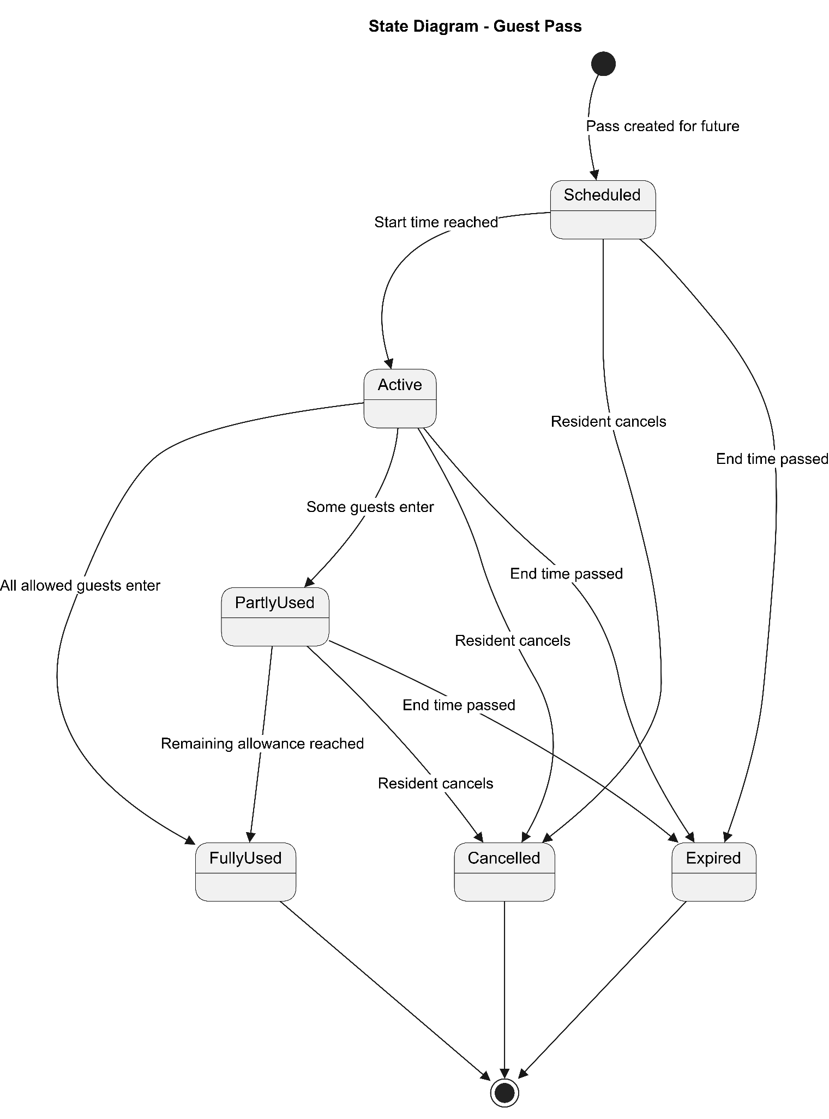
Figure: State Diagram of a Guest Pass

2. State Diagram — Visitor Entry/Exit Record
EntryPending: the entry process has started but is not confirmed.
Inside: the visitor's entry is saved and no exit has been recorded.
EntryFailed: entry validation or saving failed.
ExitPending: the guard has started recording the visitor's departure.
Exited: the exit timestamp has been saved.
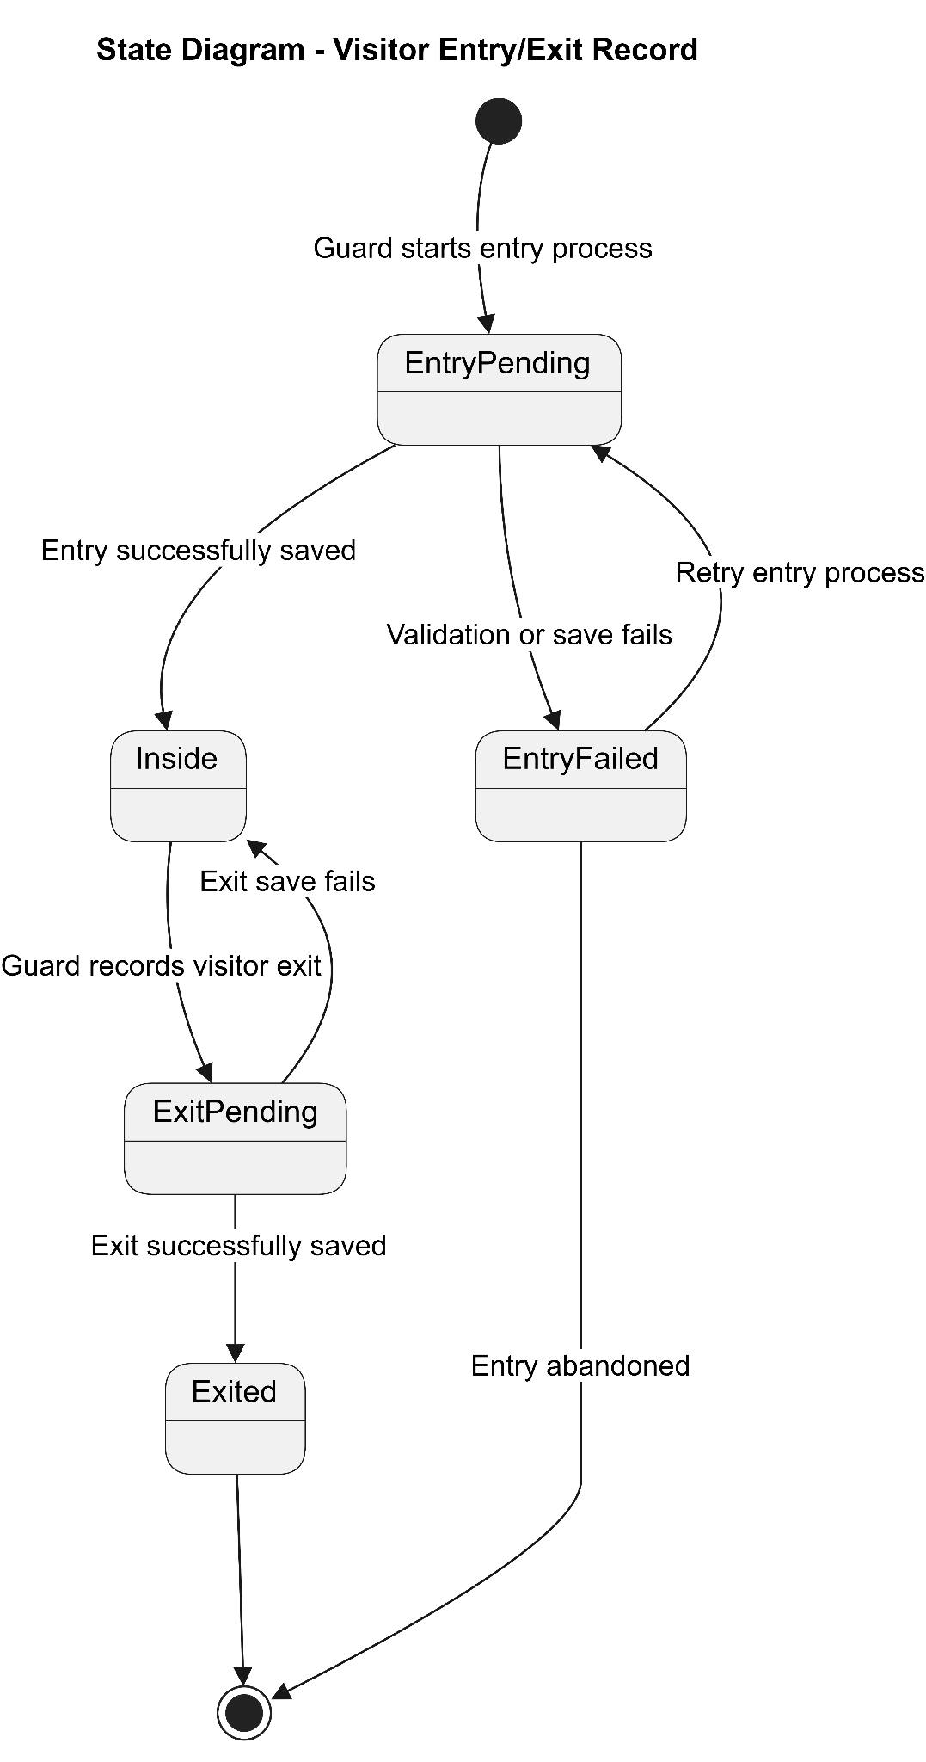
Figure: State Diagram of Visitor Entry/Exit Record

3. State Diagram — Guard Account
Inactive: the account cannot be used to access the guard interface.
Active: the account is enabled for authentication.
An authorised account-management action changes the account between active and inactive states.
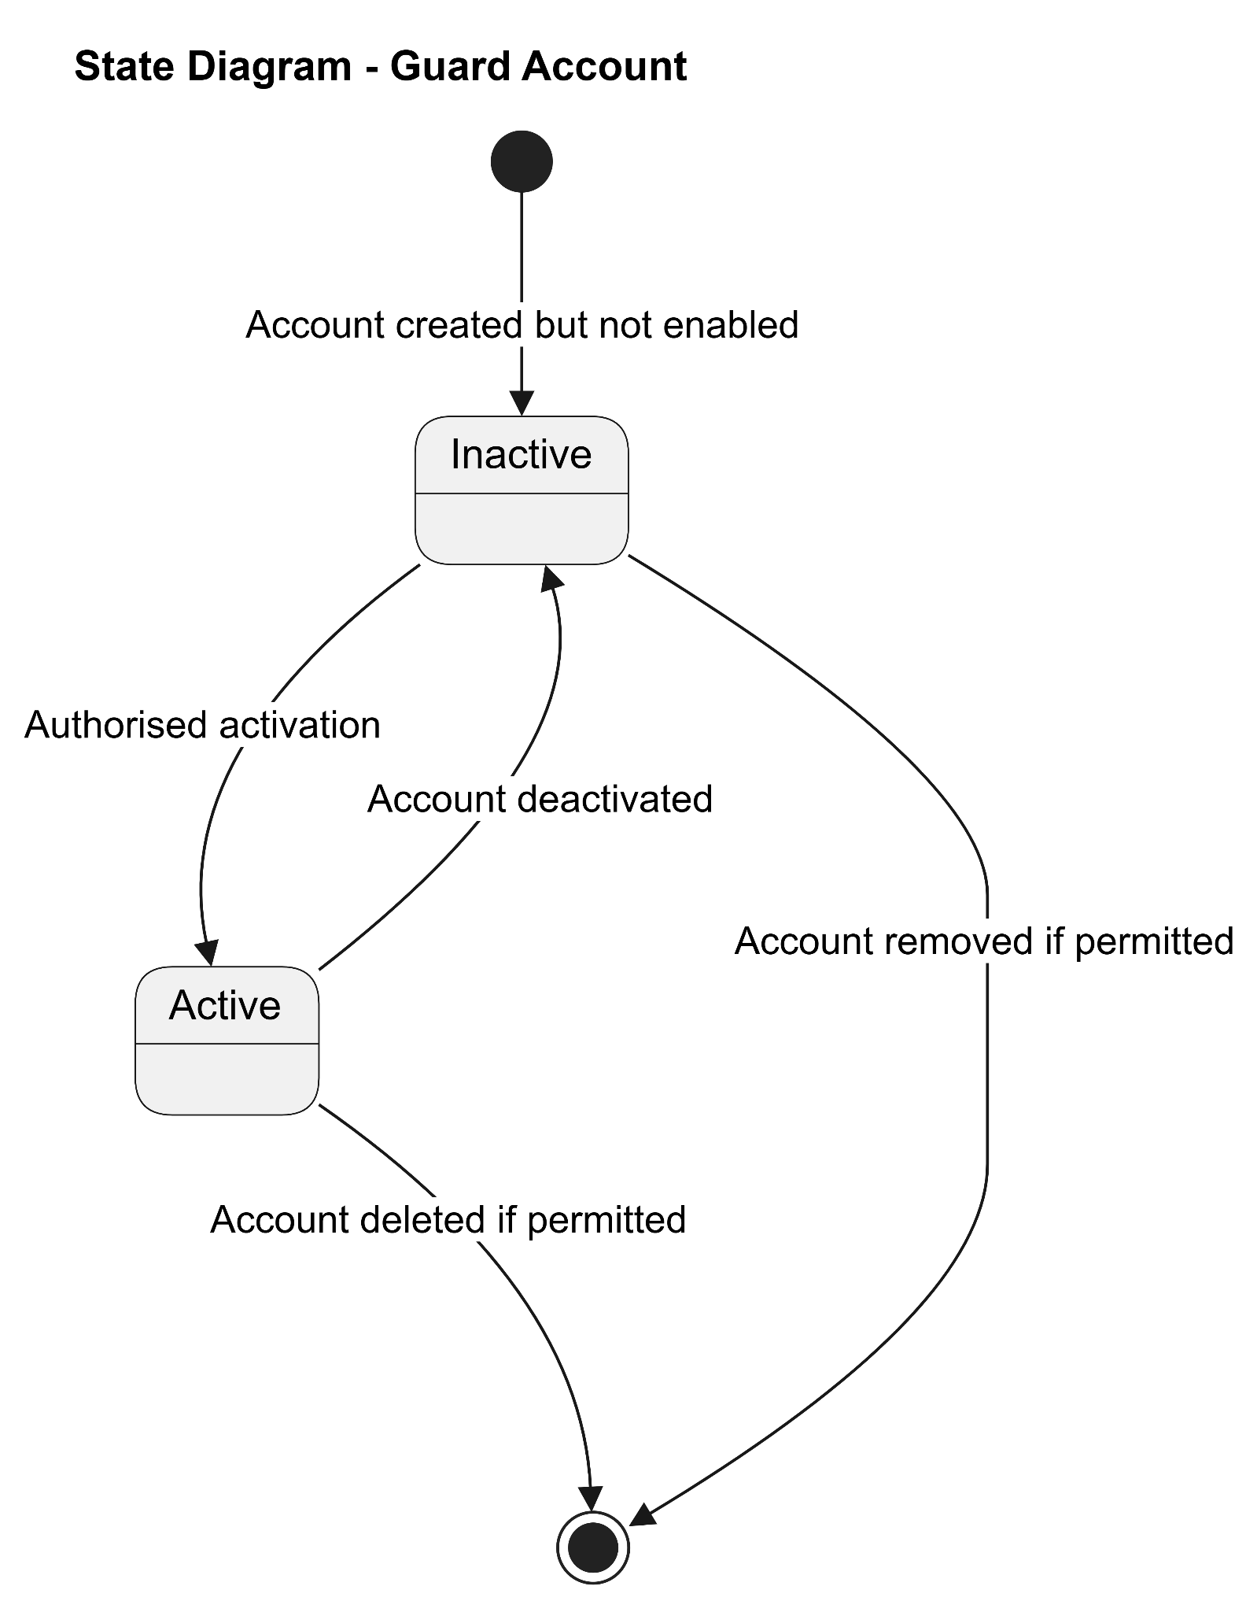
Figure: State Diagram of Guard Account

4. State Diagram — Shift Assignment
Assigned: a shift has been allocated to a guard.
InProgress: the shift's scheduled working period has started.
Completed: the scheduled shift has ended.
Cancelled: an authorised user cancelled the shift.

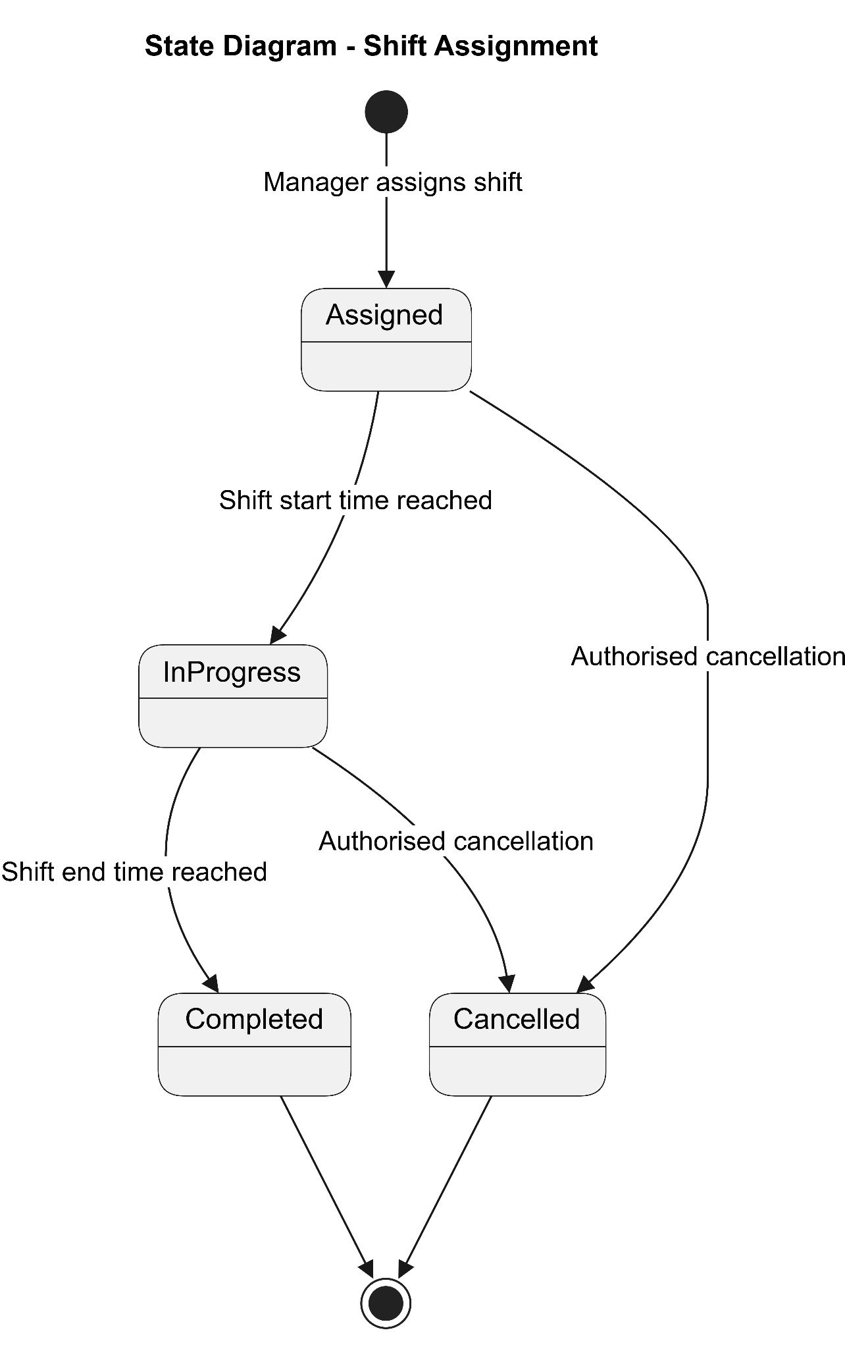

Figure: State Diagram of Shift Assignment

Data Flow Diagram Level 0
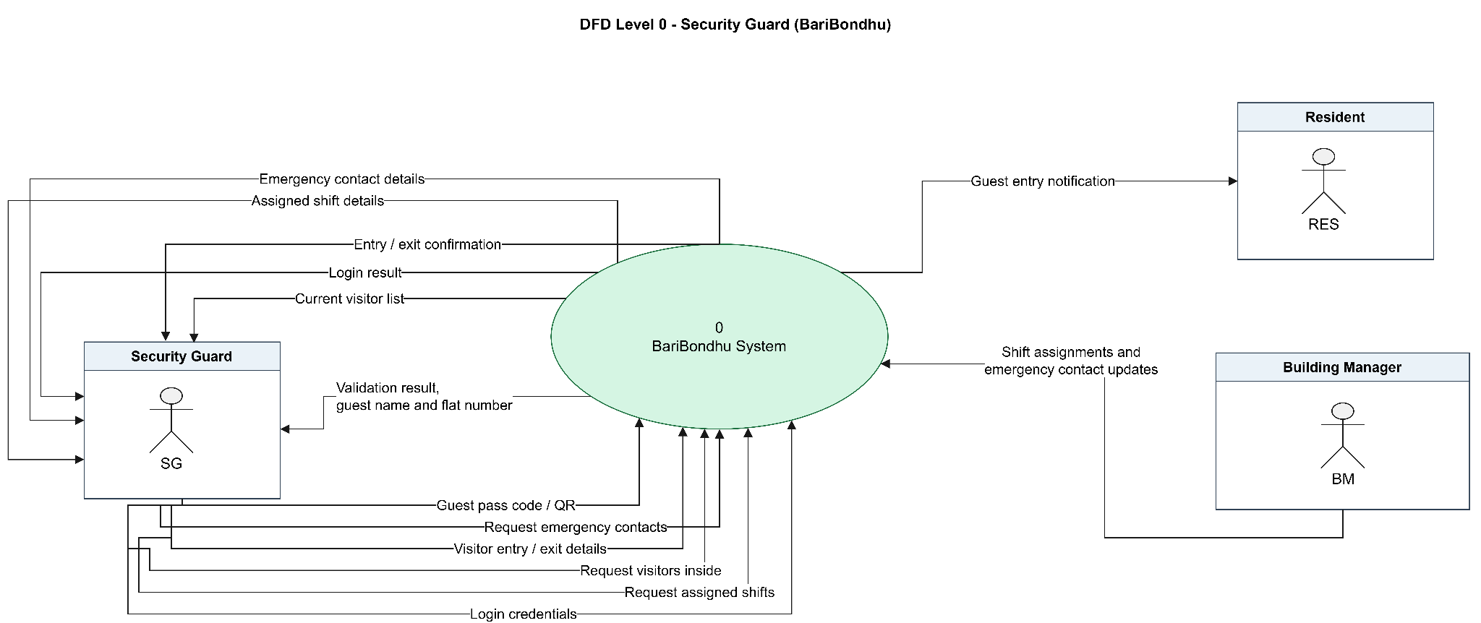
Fiure: DFD level 0 for security guard

Description: The diagram illustrates the interaction between the Security Guard and the BariBondhu system. The guard authenticates, validates guest passes, records visitor entry and exit, views visitors currently inside, checks assigned shifts, and accesses emergency contacts. The system sends a notification to the relevant resident after a guest entry is recorded.

