SRS – Building Manager User Stories

Proposal: Building Manager Part
Project: Apartment Building Management System
My part: Building Manager user class
The problem. In most apartment buildings the manager runs everything on a paper register, a phone and a group chat. Cash dues are written by hand, so receipts are missing and people argue about who paid. Residents phone again and again about the same fault, and nobody can see its status. Staff and emergency phone numbers are out of date, and the committee sees the accounts once a year, if that.
What I propose. I will write the Building Manager part of the SRS. It describes one system where the manager can make bills, check payments, assign and follow fault tickets, plan guard shifts, record expenses, keep emergency numbers up to date and send announcements. The manager is the link between all the other users, so my stories connect to the Resident, Guard, Maintenance and Committee stories.
Goals for the manager
• Every payment, online or cash, ends with a receipt and a record the manager can see.
• Every fault has one ticket with a clear status, from report to close.
• The manager can show the committee and residents where the service charge goes.
• Nothing is app-only: flats that pay cash are still handled.
What is in this part
Area | What the manager does | Stories
Accounts | Logs in, creates and manages flat, staff and committee accounts | BM-01, BM-02
Billing and payments | Makes monthly bills, checks and records payments, sends reminders | BM-03 to BM-05
Faults and repairs | Assigns tickets and follows them until closed | BM-06, BM-07
Building fund | Records expenses and publishes the monthly summary | BM-08, BM-12
Staff and safety | Plans guard shifts and sets emergency numbers | BM-09, BM-10
Communication | Sends announcements | BM-11

1.5 Risk Definitions (Building Manager)
Risk | What could go wrong | How we handle it
Wrong bill or wrong payment record | The manager enters a wrong amount or accepts a payment that never came. A resident then sees a wrong balance, or "Paid" when no money arrived. | Bills can only be corrected with a reason (BM-03). The manager checks every cash claim (BM-04). A bill turns Paid only after the gateway or the manager confirms it (NFR-BM-04).
Fault not handled in time | A fault request, or a problem found by maintenance staff, sits with nobody assigned. A broken lift or water cut stays unfixed and people could be in danger. | Tickets with nobody assigned after 24 hours are highlighted (BM-06). Staff-found problems appear in the same list (BM-06). Emergency numbers are always visible (BM-10, NFR-BM-05).

2.1 User Class: Building Manager
The building manager is paid staff who runs the building every day. The manager logs in many times a day, mostly on a phone and sometimes on a laptop, and prefers Bangla or English. Technical skill is average.
The manager is the link between all the other users. The manager creates the accounts for flats, guards, maintenance staff and committee members, makes the monthly bills from the committee's rates, checks cash payments, gives fault tickets to maintenance staff, plans guard shifts, records expenses for the committee to approve, keeps the emergency numbers up to date, and sends announcements. The manager does not set charge rates or approve expenses. Those belong to the committee.
Action | Building manager
Create and manage flat, guard, maintenance and committee accounts | Yes
Make bills and check cash or bank payments | Yes
See every flat's bills, payments and tickets | Yes
Assign fault tickets, follow them and close them | Yes
Record building expenses and publish the monthly summary | Yes
Plan guard shifts and set emergency numbers | Yes
Send announcements | Yes
See a resident's phone number | Yes (guards and maintenance staff cannot)
Set charge rates and approve expenses | No (committee only)

2.2 User Needs
Area | How it works now | Problem | What the manager needs
Dues | Collects cash and writes it in a paper register | Receipts are handwritten or missing. People argue about who paid. It is hard to see who still owes. | Make bills with a breakdown, check payment claims, and see unpaid flats quickly
Faults | Residents phone again and again, and the manager passes the message on by phone. Staff mention extra problems only by word of mouth. | No record and no status. One water outage can bring 20 calls. Extra problems are forgotten. | One list of tickets, including problems found by staff, assign each one and see progress without phoning around
Accounts and staff | Phone numbers on paper and in the manager's phone | The list is out of date. It is not clear who is on duty at the gate. | One place for flat, staff and committee accounts and for guard shifts
Money reports | The committee sees the accounts once a year, if that | The manager cannot easily show where the service charge goes | Record each expense by category and make a monthly summary
Emergencies | Phone calls and word of mouth | Residents and guards do not know who to call | Keep the guard desk and manager numbers up to date in the app
Announcements | Notice on the board or a message in a group chat | Some residents never see it | Send one announcement to all residents or to one block or floor

3.1 Functional Requirements: User Stories and Confirmation
Each story has its confirmation written as Given / When / Then. Priority is Must, Should or Could. "Touches" shows which other user's story depends on it.
BM-01 · Log in · Must
As a building manager, I want to log in with my own account, so that only I can use the manager pages.
• Given I enter the right username and password, when I log in, then I see the manager dashboard.
• Given I enter a wrong password 5 times in a row, when I try again, then my account is locked for 15 minutes and I see why.
• Given I am a resident, guard, maintenance or committee user, when I try to open a manager page, then I am refused.
Touches: all users (same login pattern as RES-06, SG-01, MNT-01 and CM-05).
BM-02 · Manage accounts · Must
As a building manager, I want to add, edit and deactivate flat, guard, maintenance and committee accounts, so that every person has the right access and I always have correct contact details.
• Given I enter a flat number, floor and contact details, when I save, then one account is created for that flat and it shows in the flat list.
• Given I enter a name, phone number and role (guard, maintenance or committee), when I save, then that staff or committee account is created.
• Given the flat number already exists, when I try to add it again, then I see an error and nothing is created.
• Given I update a resident's phone number or flat details, when I save, then the new details show straight away.
• Given a user has forgotten the password and has no email address, when I reset it, then a temporary password is issued and must be changed at the next login.
• If I deactivate an account, when that person opens the app, then they cannot log in, but their old bills, tickets and decisions are kept.
Touches: Resident (RES-06, one account for each flat), Guard (SG-01), Maintenance (MNT-01), Committee (CM-05).
BM-03 · Make monthly bills · Must
As a building manager, I want to make each flat's monthly bill from the committee's charge rates, so that residents can see what they owe and why.
• Given the committee has set the rates, when I make the bills for a month, then each flat gets a bill with every charge (service, generator, water) and its rate.
• Given a flat has an unpaid amount from an earlier month, when the new bill is made, then that amount is shown as its own line and added to the total.
• Given I set a due date, when the bill is made, then the resident sees the same total and due date in their app.
• Given the committee changes a rate after the bills are made, when I open those bills, then they keep their old rates.
• Given a bill is already made, when I need to change it, then I must give a reason and the resident is notified. I cannot delete it.
Touches: Resident (RES-01), Committee (CM-01, sets rates).
BM-04 · Check and record payments · Must
As a building manager, I want to accept or reject a payment a resident has recorded, and to record payments handed to me directly, so that a bill shows Paid only when I really got the money.
• Given a resident records a cash or bank payment, when I open Claims, then I see the amount, date, method and slip photo, and the bill shows Awaiting verification.
• Given I accept the claim, when I confirm, then the bill shows Paid and the resident can download a receipt.
• Given I reject the claim, when I write a reason, then the bill goes back to Unpaid and the resident sees the reason.
• Given I reject a claim with no reason, when I submit, then I see "Write a reason" and nothing changes.
• Given a flat pays me in cash and has not used the app, when I record the payment, then the bill shows Paid and a receipt is available to that flat.
Touches: Resident (RES-04).
BM-05 · See unpaid dues and send reminders · Should
As a building manager, I want to see which flats have not been paid and send them a reminder, so that I do not have to phone each one.
• Given the due date has passed, when I open Dues, then I see every flat with an unpaid bill and how many days it is late.
• Given a bill is Awaiting verification or Payment pending, when the due date passes, then that flat is not on the defaulters list until the payment is decided.
• Given I select some late flats, when I send a reminder, then each of them gets an in-app notification.
Touches: Resident (RES-01 and RES-04).
BM-06 · Assign fault tickets · Must
As a building manager, I want to see all fault tickets in one list and give each one to a maintenance staff member, so that the right person fixes it on time.
• Given residents have reported faults, when I open tickets, then I see each ticket with its category, place (inside a flat or common area), description, photo and status. Common-area tickets also show how many residents tapped "Me too".
• Given a maintenance staff member reported an additional problem, when I open the tickets, then I see it marked Found by staff with its description and place, and I can assign it like any other ticket.
• Given I choose a staff member, a priority and a due date, when I assign, then the status becomes Assigned and the staff member, the resident and anyone following it get a notification.
• Given a ticket has nobody assigned after 24 hours, when I open the list, then it is highlighted as late.
Touches: Resident (RES-02), Maintenance (MNT-01, MNT-05), Committee (CM-04 sees how many tickets are late).
BM-07 · Follow and close tickets · Must
As a building manager, I want to see updates and work notes from maintenance staff and close finished tickets, so that I know the work is really done.
• If a staff member changes a ticket to In progress or Fixed, when I open it, then I see the new status, the time and any work notes.
• Given a ticket is Fixed, when I confirm, then it becomes Closed and the resident and anyone following it are notified.
• Given the repair did not work, when I reopen the ticket and write a reason, then it goes back to Assigned and the staff member is notified.
Touches: Resident (RES-02, notified at every change), Maintenance (MNT-03 and MNT-04; only the manager closes or reopens tickets).
BM-08 · Record building expenses · Must
As a building manager, I want to record each expense with a category and receipt, so that the committee can approve it and residents can see where the money goes.
• Given I enter the amount, date, category (repair, salary, utility or other) and an optional receipt photo, when I save, then the expense is saved as Waiting for approval.
• Given the committee rejects an expense, when I open it, then I see the reason and can send a corrected version, which goes back to Waiting for approval.
• Given an expense is Approved, when I need to fix it, then I cannot edit or delete it. I add a correcting expense with a note, and the committee approves it.
Touches: Committee (CM-02, approves expenses), Resident (RES-05).
BM-09 · Plan guard shifts · Should
As a building manager, I want to give each security guard a shift, so that the gate desk is always covered and I know who is on duty.
• Given I pick a guard, a date and a shift time, when I save, then it shows in today's duty list and on that guard's Duty screen.
• Given two shifts for the same guard overlap, when I try to save, then I see a warning and nothing is saved.
Touches: Guard (SG-05).
BM-10 · Keep emergency numbers up to date · Must
As a building manager, I want to set the emergency phone numbers (guard desk and manager), so that residents and guards can call straight away in a lift emergency, fire or gas smell.
• If I add or change a number, when I save, then residents and guards see the new number the next time they open or refresh the emergency screen.
• Given I leave a number empty, when I save, then I see a warning and nothing is saved.
Touches: Resident (RES-02), Guard (SG-06).
BM-11 · Send announcements · Should
As a building manager, I want to send announcements, so that residents and committee members know about building events and water or electricity cuts.
• Given I write a title and message in English or Bangla and choose all residents or one block or floor, when I send it, then it shows in their app and they get an in-app and email notification.
• Given I mark an announcement as Urgent (for example a water or power cut), when I send it, then it stays at the top of the resident's screen until it expires.
• Given I made a mistake, when I edit or remove the announcement, then residents see the new version or it disappears.
• Given the title or message is empty, when I try to send, then I see "Write a message" and nothing is sent.
Touches: Resident (read only; confirming that they read it is not in this release), Committee (can read announcements). There is no SMS, only in-app and email.
BM-12 · Publish the monthly summary · Should
As a building manager, I want to publish a monthly summary of money collected and spent, so that the committee and residents can see where the service charge goes.
• Given a month has records, when I publish the summary, then it shows total collected, total spent for each category and the balance.
• Given an expense is Waiting for approval or Rejected, when I publish the summary, then it is left out, and the summary shows how many expenses are still waiting.
• Given some flats have not been paid, when residents or the committee see the summary, then they see only the total outstanding, not which flats owe it.
• Given I also want members who never log in to see it, when I send the summary as an announcement (BM-11), then they can read it there.
Touches: Resident (RES-05), Committee (CM-04, CM-02).

3.2 Non-Functional Requirements
ID | Category | Requirement | Story
NFR-BM-01 | Performance | The dashboard, Dues list and Tickets list shall load within 3 seconds for 95% of requests on a 4G connection, with 200 flats of data. | BM-03, BM-05, BM-06
NFR-BM-02 | Security | Only a logged-in manager can use manager pages. All other users are refused. Automated tests check this on every manager page and API. | All
NFR-BM-03 | Auditability | Every change to a bill, payment claim, expense or account is saved with who made it, when, and the old and new value. These records cannot be edited or deleted and are kept for at least 5 years. | BM-02, BM-03, BM-04, BM-08
NFR-BM-04 | Safety | A bill changes to Paid only when the payment gateway confirms it or the manager accepts or records the payment. Confirmed payments are never lost, and records are backed up every day. | BM-03, BM-04
NFR-BM-05 | Safety | The late-ticket highlight and the emergency numbers are always visible and cannot be switched off. | BM-06, BM-10
NFR-BM-06 | Usability | Assigning a ticket and accepting a payment claim take no more than 4 taps from the dashboard. Screens work at 360 px width and are in Bangla and English. | BM-04, BM-06
NFR-BM-07 | Accuracy | Bill totals, balances and the monthly summary always match the saved records. Each payment and each expense is counted once. | BM-03, BM-04, BM-08, BM-12
NFR-BM-08 | Privacy | Residents' phone numbers are shown only to the manager and to the resident. Guards, maintenance staff and the committee never see them, on screen or in any API they can call. | BM-02, BM-06
NFR-BM-09 | Reliability | If a save fails because of a connection or system error, the app shows an error within 5 seconds and never shows the change as saved. | All

4. UML Use Case Diagram
The Building Manager is the main actor. Residents, guards, maintenance staff and committee members are the other actors who take part in a use case. Every use case from UC-02 to UC-12 includes UC-01 Log in. The use cases are shown in five modules, in the same way as the earlier project report.
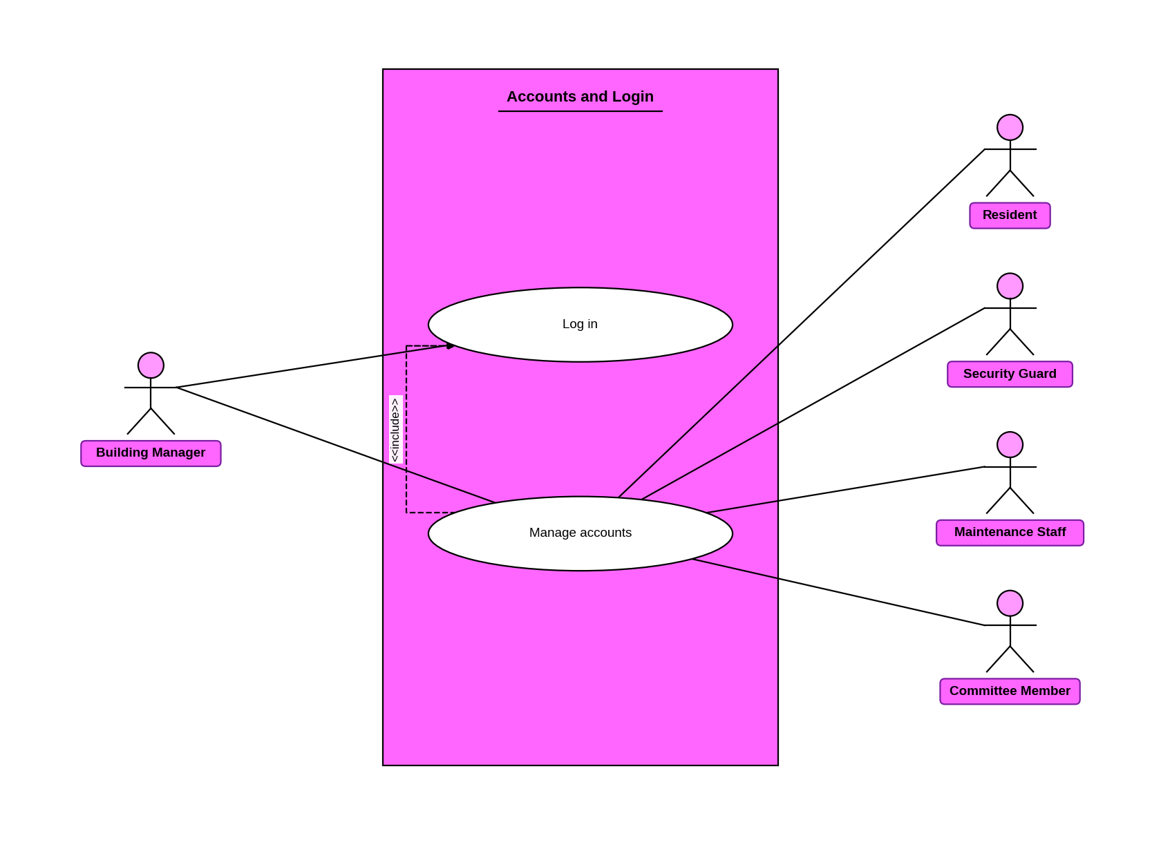
Figure 4.1: Accounts and Login
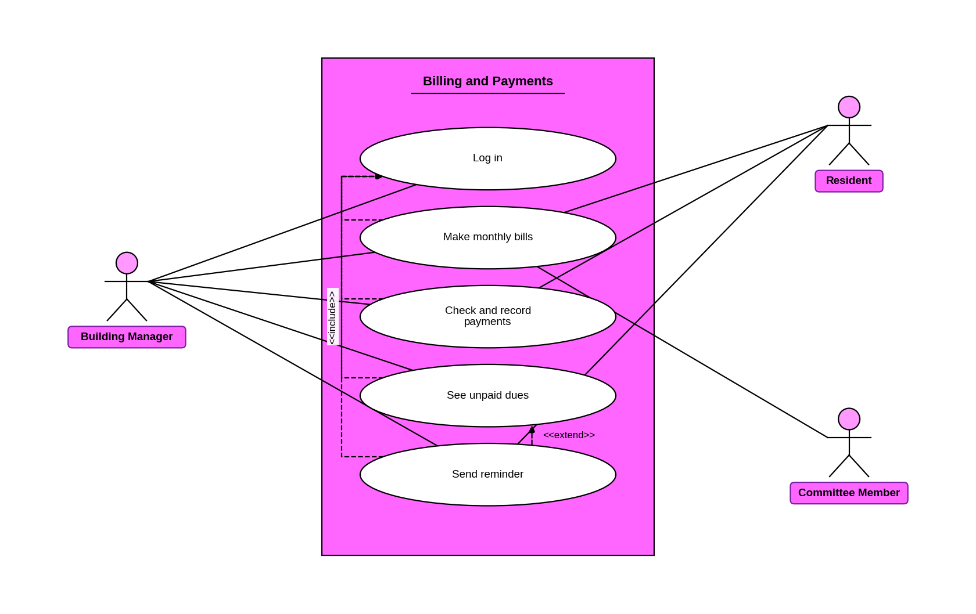
Figure 4.2: Billing and Payments
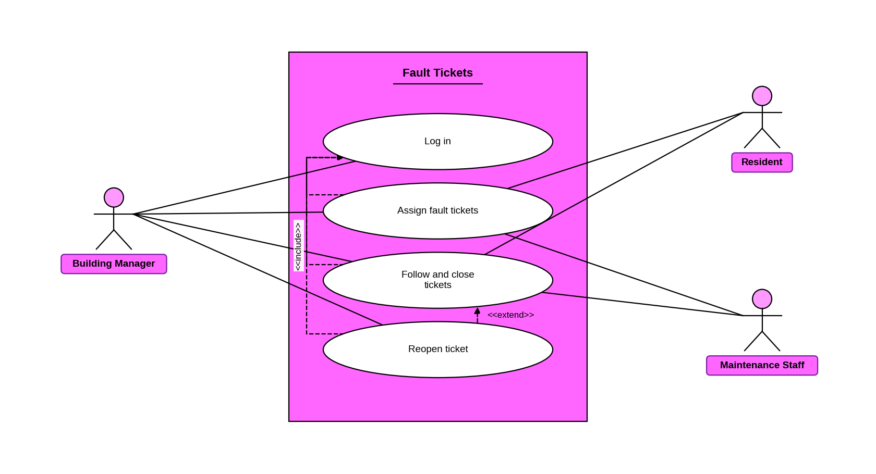
Figure 4.3: Fault Tickets
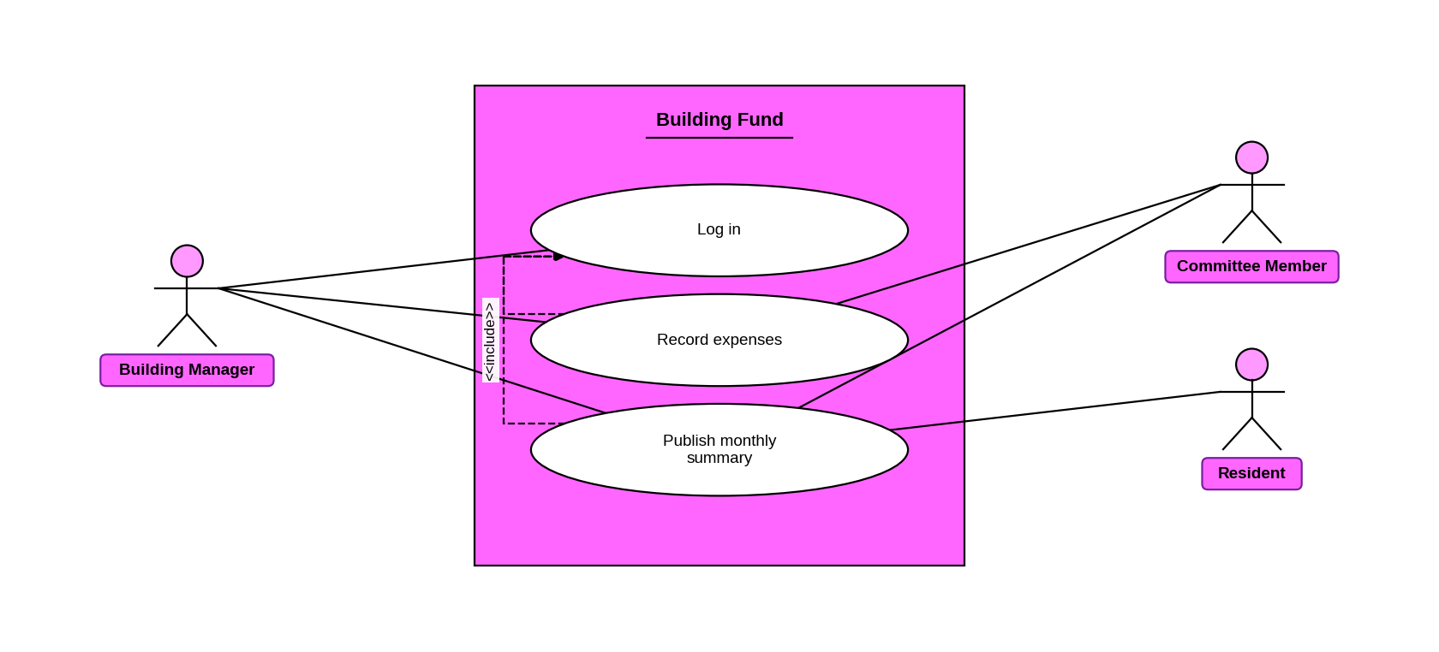
Figure 4.4: Building Fund
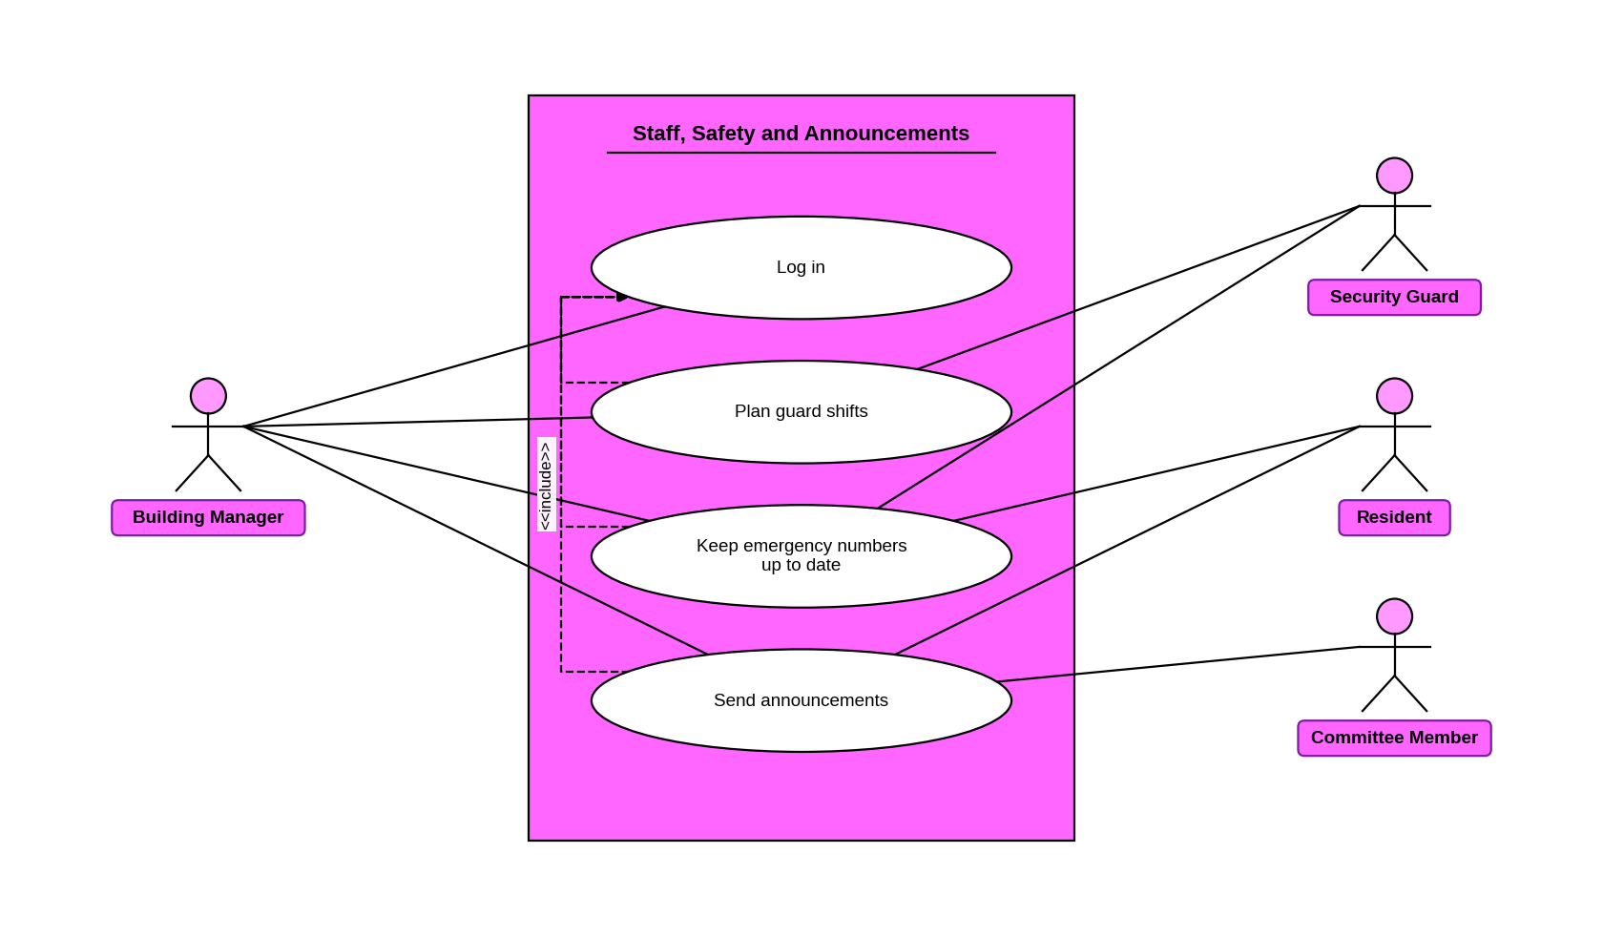
Figure 4.5: Staff, Safety and Announcements

5. Use Case Narratives

Each use case has its own narrative in table format. An alternate flow is numbered after the step it branches from, so 2a branches from step 2. The manager is the primary actor in all of them. «include» and «extend» show how use cases connect.

UC-01 Log in
Field | Description
Use case | UC-01 Log in (BM-01)
Actors | Primary: Building Manager
Precondition | The manager has an active account.
Trigger | The manager opens the app while logged out.
Main success scenario | 1. The manager enters the username and password.  2. The system checks them.  3. The system opens the manager dashboard.
Alternate flows | 2a. Wrong username or password → error shown, return to step 1. After 5 wrong passwords in a row the account is locked for 15 minutes and the screen shows why.  3a. A resident, guard, maintenance or committee user tries to open a manager page → access refused.
Postcondition | The manager is logged in and can use the manager pages.
Non-functional | Only a logged-in manager can use manager pages (NFR-BM-02).

UC-02 Manage accounts
Field | Description
Use case | UC-02 Manage accounts (BM-02)
Actors | Primary: Building Manager · Secondary: Resident, Guard, Maintenance Staff, Committee Member (the account owners)
Precondition | The manager is logged in («include» Log in).
Trigger | The manager opens Accounts and taps Add, or opens an existing account.
Main success scenario | 1. The manager chooses the account type: flat, guard, maintenance or committee.  2. The manager enters the details (flat number, floor and contact details, or name, phone number and role).  3. The system checks the details.  4. The system saves the account and shows it in the list.
Alternate flows | 1a. The manager edits a resident's phone number or flat details → the new details show straight away.  1b. A user forgot the password and has no email address → manager resets it, a temporary password is issued and must be changed at the next login.  1c. Manager deactivates an account → that person cannot log in, but old bills, tickets and decisions are kept.  3a. The flat number already exists → error shown, nothing is created.
Postcondition | The account is created, changed or deactivated, and the change is saved.
Non-functional | Every change is saved with who made it and when (NFR-BM-03). Phone numbers are shown only to the manager and the resident (NFR-BM-08).

UC-03 Make monthly bills
Field | Description
Use case | UC-03 Make monthly bills (BM-03)
Actors | Primary: Building Manager · Secondary: Committee Member (sets the rates), Resident (receives the bill)
Precondition | The manager is logged in («include» Log in). The committee has set the charge rates.
Trigger | The manager opens Bills and chooses a month.
Main success scenario | 1. The manager chooses the month and sets a due date.  2. The system makes a bill for each flat with every charge (service, generator, water) and its rate.  3. The system adds any unpaid amount from an earlier month as its own line and includes it in the total.  4. Residents see the same total and due date in their app.
Alternate flows | 1a. The manager corrects a bill that is already made → a reason is required and the resident is notified.  1b. Manager tries to delete a bill → refused. A bill can only be corrected.  2a. The committee changes a rate after the bills are made → those bills keep their old rates.
Postcondition | Every flat has a bill for the month. Each change is saved.
Non-functional | The Dues list loads within 3 s for 95% of requests on a 4G connection (NFR-BM-01). Totals always equal the saved records (NFR-BM-07).

UC-04 Check and record payments
Field | Description
Use case | UC-04 Check and record payments (BM-04)
Actors | Primary: Building Manager · Secondary: Resident
Precondition | The manager is logged in («include» Log in). A resident recorded a cash or bank payment and the bill is Awaiting verification, or a flat paid the manager directly.
Trigger | The manager opens Claims.
Main success scenario | 1. The manager sees the amount, date, method and slip photo of the claim.  2. The manager accepts the claim.  3. The system sets the bill to Paid.  4. Residents can download a receipt.
Alternate flows | 1a. A flat pays the manager in cash and has not used the app → manager records the payment for the full bill total, and the bill shows Paid with a receipt.  2a. The manager rejects the claim and writes a reason → the bill goes back to Unpaid and the resident sees the reason.  2b. The manager rejects the claim with no reason → "Write a reason" is shown and nothing changes.
Postcondition | The bill is Paid, or Unpaid again with a reason. Each change is saved.
Non-functional | A bill becomes Paid only on gateway confirmation or when the manager accepts or records the payment (NFR-BM-04). Changes are saved with who and when (NFR-BM-03).

UC-05 See unpaid dues
Field | Description
Use case | UC-05 See unpaid dues (BM-05)
Actors | Primary: Building Manager · Secondary: Resident
Precondition | The manager is logged in («include» Log in). Bills exist and some due dates have passed.
Trigger | The manager opens Dues.
Main success scenario | 1. The system finds the bills that are Unpaid and past their due date.  2. The system lists each flat with its unpaid amount and how many days it is late.  3. The manager reads the list.
Alternate flows | 2a. A bill is Awaiting verification or Payment pending → that flat is not on the list until the payment is decided.  3a. Manager selects late flats → «extend» Send reminder (UC-13).
Postcondition | Nothing changes.
Non-functional | The Dues list loads within 3 s for 95% of requests on a 4G connection (NFR-BM-01).

UC-13 Send reminder
Field | Description
Use case | UC-13 Send reminder (BM-05)
Actors | Primary: Building Manager · Secondary: Resident
Precondition | The manager has opened the list of unpaid dues.
Trigger | The manager selects late flats and taps Send reminder (extends See unpaid dues at step 3).
Main success scenario | 1. Manager selects one or more late flats.  2. Manager taps Send reminder.  3. The system sends an in-app notification to each selected resident.
Alternate flows | 1a. No flat is selected → the system asks the manager to select at least one.
Postcondition | The selected residents have been reminded.
Non-functional | If sending fails, an error is shown within 5 s and the reminder is never shown as sent (NFR-BM-09).

UC-06 Assign fault tickets
Field | Description
Use case | UC-06 Assign fault tickets (BM-06)
Actors | Primary: Building Manager · Secondary: Resident, Maintenance Staff
Precondition | The manager is logged in («include» Log in). A resident reported a fault, or a staff member reported an additional problem.
Trigger | The manager opens the tickets.
Main success scenario | 1. The system lists the tickets with category, place (inside a flat or common area), description, photo and status.  2. Manager opens a ticket.  3. The manager chooses a staff member, a priority and a due date.  4. The system sets the ticket to Assigned and notifies the staff member, the resident and anyone following it.
Alternate flows | 1a. A common-area ticket → the number of residents who tapped "Me too" is shown.  1b. A problem reported by staff → it is marked Found by staff and is assigned the same way.  1c. A ticket has nobody assigned after 24 hours → it is highlighted as late.
Postcondition | The ticket is assigned to one staff member.
Non-functional | The Tickets list loads within 3 s for 95% of requests (NFR-BM-01). The late highlight cannot be switched off (NFR-BM-05). Staff never see the resident's phone number (NFR-BM-08).

UC-07 Follow and close tickets
Field | Description
Use case | UC-07 Follow and close tickets (BM-07)
Actors | Primary: Building Manager · Secondary: Maintenance Staff, Resident
Precondition | The manager is logged in («include» Log in). The ticket is Assigned.
Trigger | A staff member changes the ticket status, or the manager opens the ticket.
Main success scenario | 1. The staff member changes the ticket to In progress, then to Fixed, and adds work notes.  2. The manager opens the ticket and sees the status, the time and the notes.  3. The manager confirms the repair and closes the ticket.  4. The system sets the ticket to Closed and notifies the resident and anyone following it.
Alternate flows | 3a. The repair did not work → «extend» Reopen ticket (UC-14).
Postcondition | The ticket is Closed. Only the manager closes or reopens a ticket.
Non-functional | Each status change is saved with the account, date and time (NFR-BM-03). A failed save is never shown as saved (NFR-BM-09).

UC-14 Reopen ticket
Field | Description
Use case | UC-14 Reopen ticket (BM-07)
Actors | Primary: Building Manager · Secondary: Maintenance Staff
Precondition | The ticket is Fixed but the problem is still there.
Trigger | The manager taps Reopen (extends Follow and closes tickets at step 3).
Main success scenario | 1. The manager writes the reason.  2. The system sets the ticket back to Assigned.  3. The system notifies the staff member.
Alternate flows | 1a. No reason is written → the system asks for one and nothing changes.
Postcondition | The ticket is assigned again.
Non-functional | The change is saved with the account, date and time (NFR-BM-03).

UC-08 Record expenses
Field | Description
Use case | UC-08 Record expenses (BM-08)
Actors | Primary: Building Manager · Secondary: Committee Member (approves)
Precondition | The manager is logged in («include» Log in).
Trigger | The manager opens Expenses and taps Add.
Main success scenario | 1. The manager enters the amount, date, category (repair, salary, utility or other) and an optional receipt photo.  2. The system saves the expense as Waiting for approval.  3. Committee approves the expense (CM-02).
Alternate flows | 3a. The committee rejects the expense → the manager sees the reason and can send a corrected version, which goes back to Waiting for approval.  3b. The expense is already Approved → it cannot be edited or deleted. The manager adds a correcting expense with a note, and the committee approves it.
Postcondition | The expense is Waiting for approval, Approved or Rejected.
Non-functional | Every change is saved with who and when (NFR-BM-03). Each expense is counted once (NFR-BM-07).

UC-09 Plan guard shifts
Field | Description
Use case | UC-09 Plan guard shifts (BM-09)
Actors | Primary: Building Manager · Secondary: Security Guard
Precondition | The manager is logged in («include» Log in). A guard account exists.
Trigger | The manager opens Shifts.
Main success scenario | 1. The manager picks a guard, a date, a start time and an end time.  2. System checks that the shift does not overlap another shift of that guard.  3. The system saves the shift, and it shows in today's duty list and on the guard's Duty screen.
Alternate flows | 2a. The shift overlaps another shift of the same guard → a warning is shown and nothing is saved.
Postcondition | The guard has an assigned shift.
Non-functional | If the save fails, an error is shown within 5 s and the shift is never shown as saved (NFR-BM-09).

UC-10 Keep emergency numbers up to date
Field | Description
Use case | UC-10 Keep emergency numbers up to date (BM-10)
Actors | Primary: Building Manager · Secondary: Resident, Security Guard (they read the numbers)
Precondition | The manager is logged in («include» Log in).
Trigger | The manager opens Emergency numbers.
Main success scenario | 1. Manager adds or changes the guard desk and manager numbers.  2. The system saves them.  3. Residents and guards see the new numbers the next time they open or refresh the emergency screen.
Alternate flows | 1a. A number is left empty → a warning is shown and nothing is saved.
Postcondition | The emergency screen shows the current numbers.
Non-functional | The emergency numbers are always visible and cannot be switched off (NFR-BM-05).

UC-11 Send announcements
Field | Description
Use case | UC-11 Send announcements (BM-11)
Actors | Primary: Building Manager · Secondary: Resident, Committee Member (readers), Email Service
Precondition | The manager is logged in («include» Log in).
Trigger | The manager opens Announcements and taps New.
Main success scenario | 1. The manager writes a title and a message in English or Bangla.  2. The manager chooses all residents, one block or one floor.  3. The system shows the announcement in their app and sends in-app and email notifications.
Alternate flows | 1a. Manager marks it Urgent (for example a water or power cut) → it stays at the top of the resident's screen until it expires.  3a. The title or message is empty → "Write a message" is shown and nothing is sent.  3b. Manager edits or removes the announcement → residents see the new version, or it disappears.
Postcondition | The chosen residents have the announcement. There is no SMS, only in-app and email.
Non-functional | A failed send is never shown as sent (NFR-BM-09). Screens are in Bangla and English (NFR-BM-06).

UC-12 Publish monthly summary
Field | Description
Use case | UC-12 Publish monthly summary (BM-12)
Actors | Primary: Building Manager · Secondary: Committee Member, Resident (readers)
Precondition | The manager is logged in («include» Log in). The month has payment and expense records.
Trigger | The manager opens a monthly summary.
Main success scenario | 1. The manager chooses the month and publishes the summary.  2. The system works out the total collected, the total spent for each category and the balance, leaving out expenses that are Waiting for approval or Rejected, and shows how many are waiting.  3. Residents and committee members see the totals.
Alternate flows | 3a. Some flats have not paid → only the total outstanding is shown, not which flats owe it.  3b. Manager also wants members who never log in to see it → manager sends the summary as an announcement (UC-11).
Postcondition | The monthly summary is visible to residents and the committee.
Non-functional | Totals always match the saved records and each payment and expense is counted once (NFR-BM-07).

6. State Diagrams
These are the five objects the manager changes or follows: Bill, Fault ticket, Expense, Account and Announcement.

6.1 Bill
The bill turns Paid only when the payment gateway confirms it or the manager accepts or records the payment (NFR-BM-04).
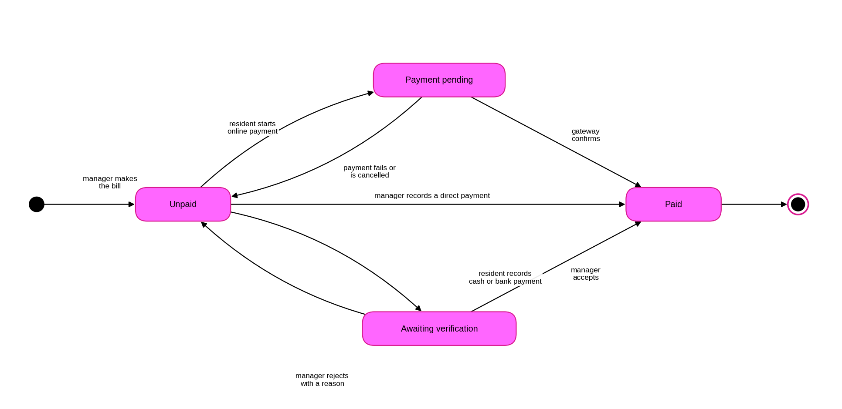
Figure 6.1: State diagram of a Bill

6.2 Fault ticket
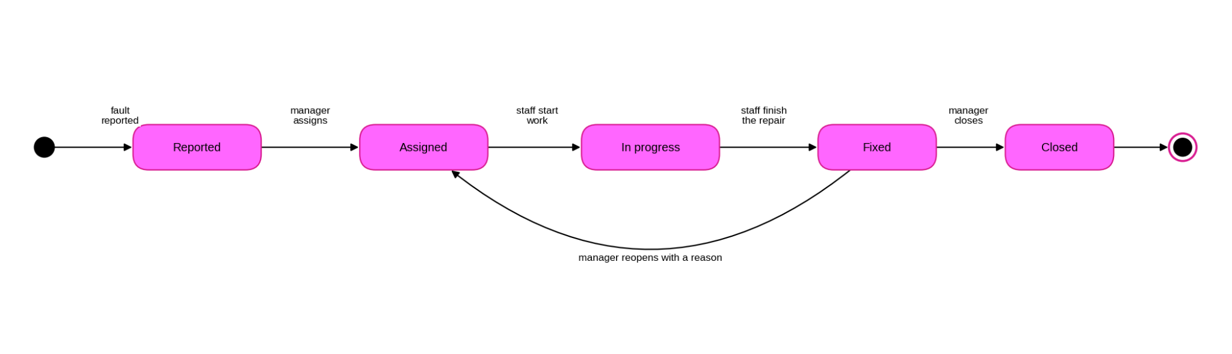
Figure 6.2: State diagram of a Fault ticket

6.3 Expense
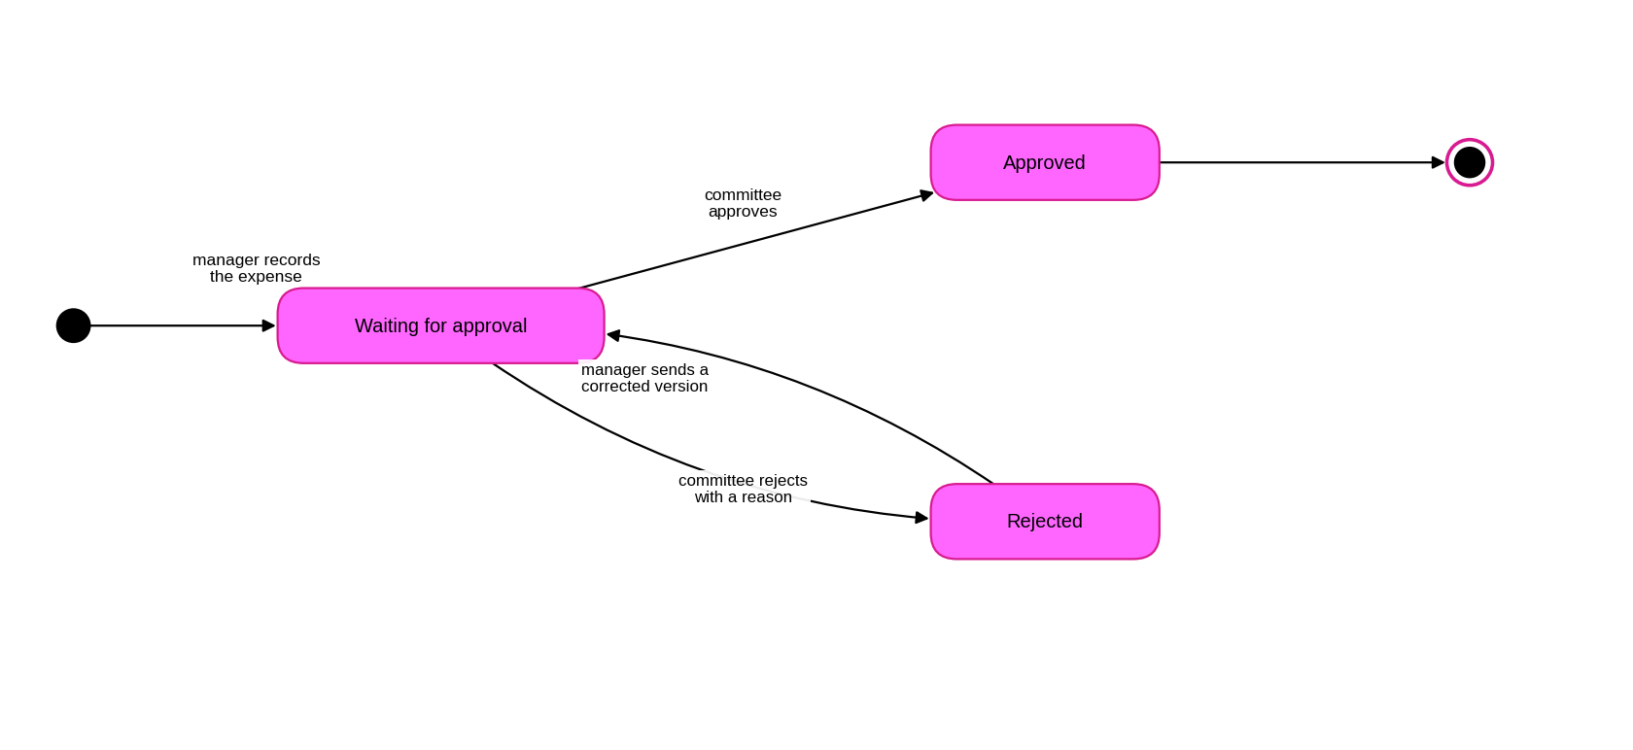
Figure 6.3: State diagram of an Expense
An Approved expense never changes. A mistake is fixed by adding a correcting expense, which starts at Waiting for approval.

6.4 Account
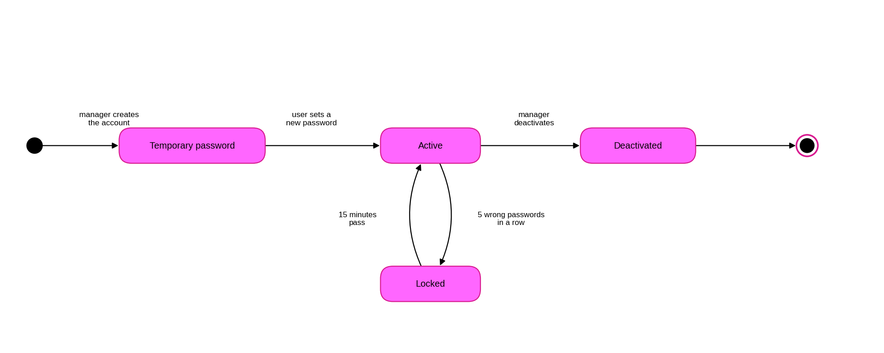
Figure 6.4: State diagram of an Account
A Deactivated account keeps its old bills, tickets and decisions.

6.5 Announcement
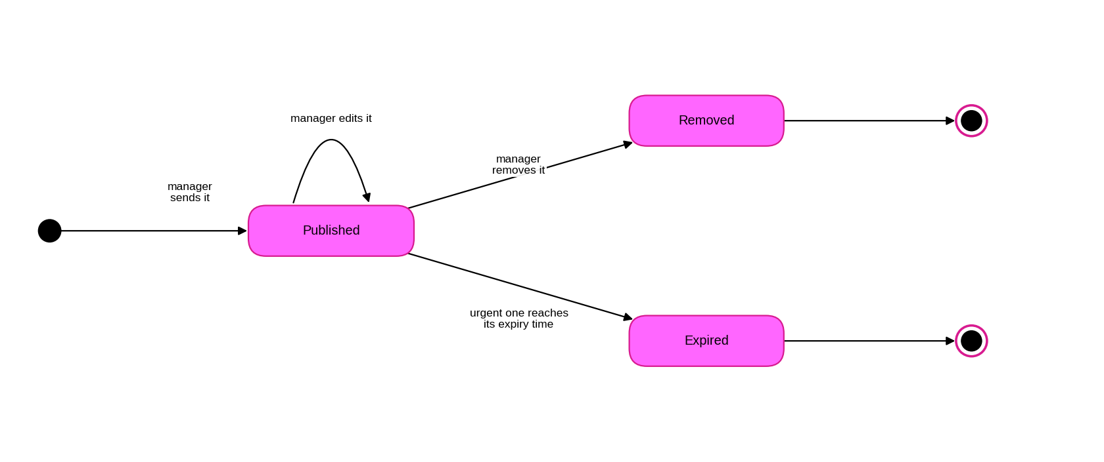
Figure 6.5: State diagram of an Announcement

7. Data Flow Diagrams
Circles are processes, rectangles are people or outside services, and cylinders are data stores. Level 0 shows the whole system. Level 1 splits it into six main processes. Level 2 opens up the two processes the manager uses most: 2.0 Billing and payments, and 3.0 Fault tickets. On level 1, Resident and Committee Members are drawn more than once to keep the lines apart.

7.1 Level 0 (context diagram)
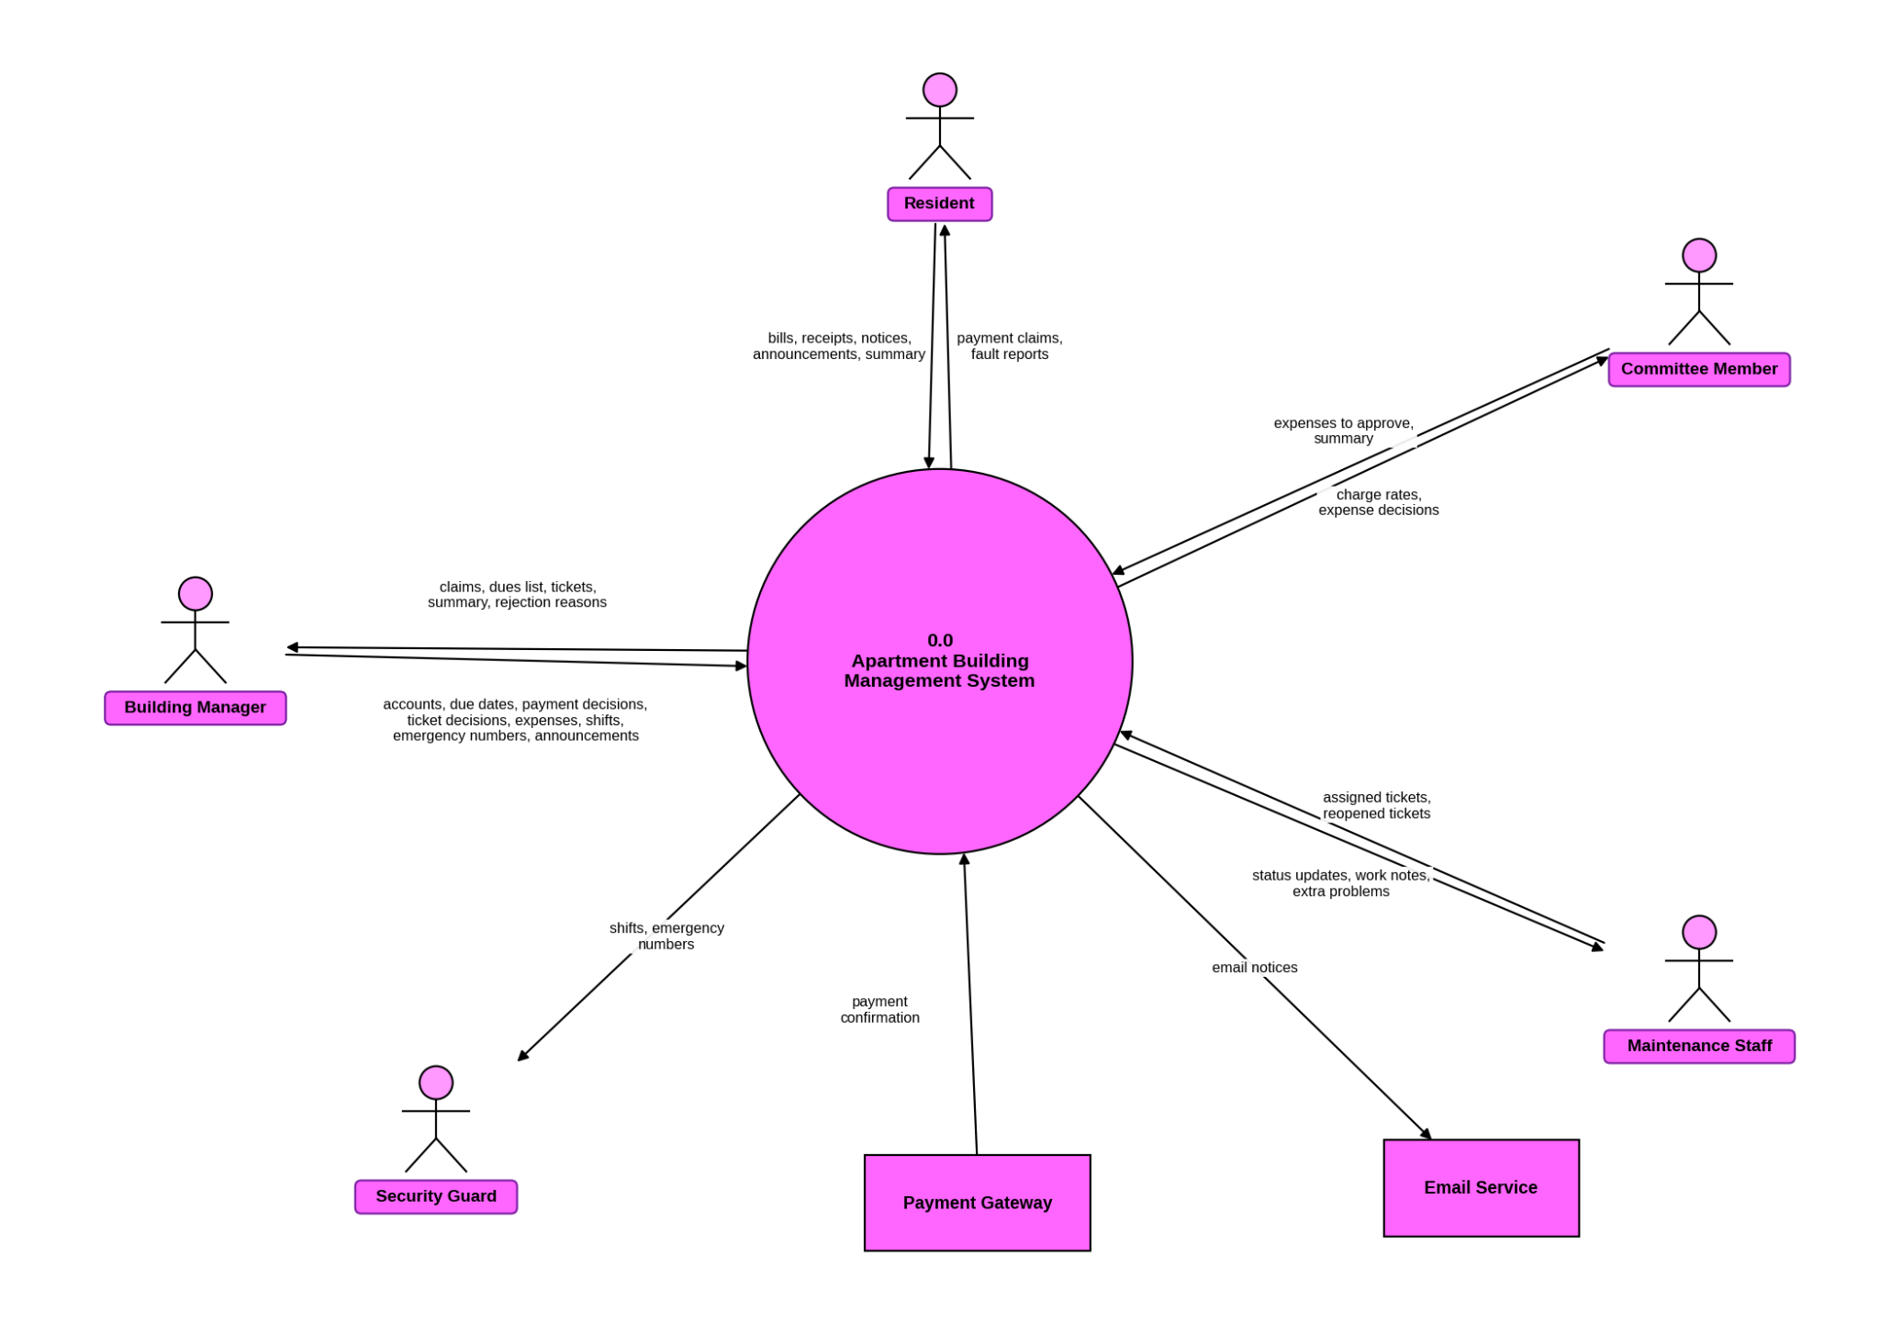
Figure 7.1: Context level diagram (Level 0)

7.2 Level 1
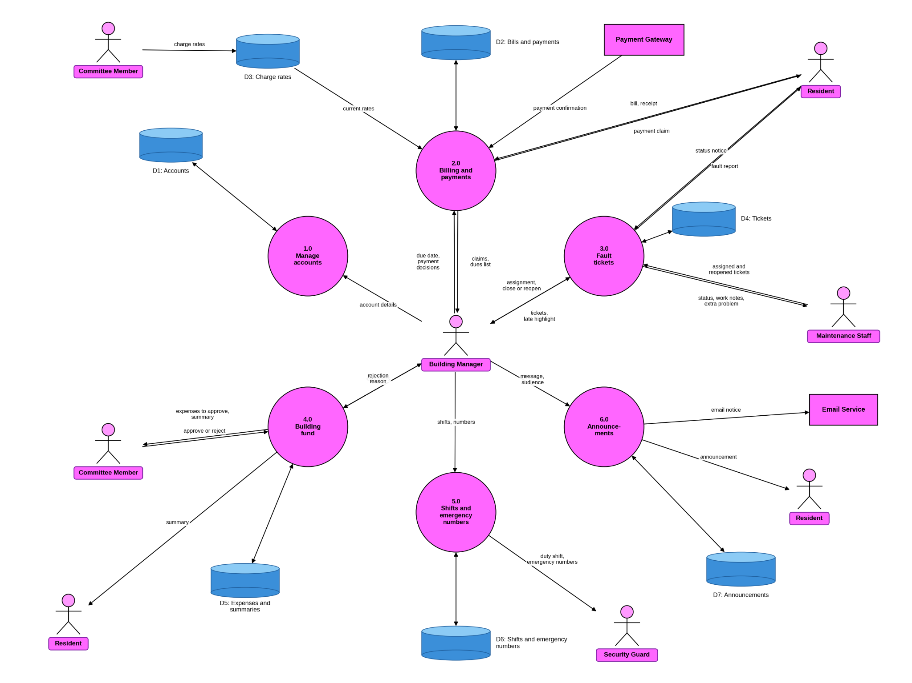
Figure 7.2: Level 1 data flow diagram

