SRS – Maintenance Staff User Class
Apartment Building Management System
1.5 Risk Definitions (Maintenance Staff)
Risk | What could go wrong | How we handle it
A ticket is missed or delayed | A ticket may remain unassigned or staff may not notice a new assignment. | The staff member sees assigned tickets in one list, with priority, location and current status (MNT-01; NFR-MNT-01). The Building Manager remains responsible for assignment.
Wrong ticket is updated | A staff member may change a ticket that belongs to another staff account. | Only the assigned staff member can view and update that ticket. The system refuses unauthorized access and updates (MNT-01, MNT-03; NFR-MNT-02).
Ticket status is inaccurate | A ticket may show Fixed before the repair is completed, or the latest status may not be saved. | Only valid status changes are allowed. The system confirms successful saves and displays the latest saved status (MNT-03; NFR-MNT-03).
Repair information is lost | Work notes may not be saved, making it difficult for the manager to understand what was done. | The system confirms when a note is saved and keeps it attached to the ticket for authorized review (MNT-04; NFR-MNT-04).
Additional problem is not followed up | A new fault found during repair may be forgotten or communicated only verbally. | Staff can submit an additional problem with a description and location for the Building Manager to review and arrange follow-up (MNT-05).
Emergency waits in the normal ticket queue | A dangerous situation may be treated like an ordinary repair. | Emergency faults such as fire, gas smell or someone trapped in a lift must use the emergency contact process described by the Resident and Building Manager requirements, not a normal maintenance ticket.

2.1 User Class: Maintenance Staff
Maintenance Staff are building workers, such as electricians, plumbers and lift technicians, who carry out repairs for reported faults in flats and common areas. They receive tickets assigned by the Building Manager and update each ticket as the work progresses.
Maintenance Staff may have basic smartphone skills and may use their own smartphone or a shared device. The interface should therefore be simple, mobile-friendly and quick to use, with clear labels and minimal typing. Staff can view and update only tickets assigned to their own account. They cannot assign tickets to other staff, close tickets, manage resident accounts or change building settings.
Action | Maintenance Staff
Log in to the maintenance interface | Yes
View tickets assigned to them | Yes
View ticket description, location, category, priority and status | Yes
Change an assigned ticket to In progress | Yes
Change an assigned ticket to Fixed after completing the repair | Yes
Record and view work notes on an assigned ticket | Yes
Report an additional problem discovered during repair | Yes
View or update a ticket assigned to another staff member | No
Assign tickets to staff or change ticket priority/due date | No; Building Manager responsibility
Move a ticket from Fixed to Closed or reopen it | No; Building Manager responsibility
Create resident/staff accounts or edit emergency numbers | No; Building Manager responsibility

2.2 User Needs
Area | How it works now / current situation | Problem | What Maintenance Staff needs
Ticket assignments | The Building Manager receives reports and passes repair details to staff. | Details may be spread across phone calls or messages, and staff may miss a job. | One list showing all tickets assigned to the logged-in staff member.
Understanding a fault | Staff may need to call the manager or resident to clarify the problem. | Important details, location or priority may be unclear before visiting the site. | A ticket details page with description, location, category, priority and any repair instructions.
Repair progress | Staff may tell the manager verbally when work starts or finishes. | Residents and the manager may not know the latest status. | Update the ticket to In progress when work starts and Fixed when the repair is complete.
Work records | Repair details may be remembered or written separately. | The manager may not have a reliable record of what was done. | Save work notes against the ticket so authorized users can review them.
Additional faults | A second problem found during a repair may be reported verbally. | The additional problem can be forgotten or may not have a clear location. | Submit an additional problem with its description and location for the Building Manager to review.
Ease of use | Staff may use a phone while moving around the building. | Long forms and complex screens slow down repair work. | A simple mobile interface with clear status names and short forms.

3.1 Functional Requirements: User Stories and Confirmation
Each story follows the As a / I want / so that format. Confirmation criteria use Given / When / Then. Priority is Must, Should or Could. “Touches” identifies related stories owned by other user classes.

MNT-01 · View assigned tickets · Must
As a maintenance staff member, I want to view the tickets assigned to me, so that I know which repair work I need to complete.
· Given I log in with my active Maintenance Staff account, when I open Tickets, then I see the list of tickets assigned to me.
· Given I have assigned tickets, when the ticket list loads, then each ticket shows its title or short description, location, priority and current status.
· Given I have no assigned tickets, when I open Tickets, then I see a message saying that no tickets are currently assigned.
· Given I try to open a ticket that is not assigned to me, when I select it, then access is refused.
Touches: Building Manager (assigns tickets, BM-06); Resident (reports faults, RES-02).

MNT-02 · View ticket details · Must
As a maintenance staff member, I want to view the details of an assigned ticket, so that I can understand the reported problem before starting the repair.
· Given a ticket is assigned to me, when I select it, then I see its description, location, category, priority and current status.
· Given the ticket contains repair instructions or additional information, when I open its details, then I can read that information.
· Given the ticket does not exist, when I try to open it, then I see a clear error message.
· Given the ticket is not assigned to my account, when I try to view its details, then access is refused.
Touches: Building Manager (provides ticket details and assignment, BM-06); Resident (reports faults, RES-02).

MNT-03 · Update ticket status · Must
As a maintenance staff member, I want to update the status of an assigned ticket, so that the repair progress can be tracked by the Building Manager and the resident.
· Given a ticket is assigned to me, when I start working on it and save the update, then its status changes to In progress.
· Given a ticket is In progress, when I finish the repair and save the update, then its status changes to Fixed.
· Given I select a valid status and the system saves the change, when the update completes, then the new status and update time are displayed.
· Given I reopen the ticket after updating it, when its details load, then the latest saved status is displayed.
· Given I try to update a ticket that is not assigned to me, when I submit the change, then the system refuses the update.
· Given a ticket is Fixed, when I view its status options, then I cannot change it to Closed; closing the ticket is the Building Manager's responsibility.
Touches: Building Manager (tracks progress and closes tickets, BM-07); Resident (receives ticket status updates, RES-02).

MNT-04 · Record work notes · Should
As a maintenance staff member, I want to record notes about the repair work I perform, so that there is a record of the work carried out.
· Given I open an assigned ticket, when I enter a work note and save it, then the system stores the note with that ticket.
· Given I enter a non-empty work note and the save is successful, when the system responds, then I see a confirmation message.
· Given I submit an empty work note, when I try to save it, then I see a message asking me to enter a note and nothing is saved.
· Given I have saved a work note, when I reopen the ticket, then I can view the saved note.
· Given the Building Manager opens the same ticket, when they review its details, then the saved work note is available to them.
Touches: Building Manager (reviews ticket progress and work records, BM-07).

MNT-05 · Report an additional problem · Could
As a maintenance staff member, I want to report an additional problem discovered during repair work, so that the Building Manager can arrange any necessary follow-up.
· Given I am working on an assigned ticket, when I discover another problem, then I can open a form to report the additional problem.
· Given I enter a description and location, when I submit the report, then the system saves it and confirms successful submission.
· Given the description or location is empty, when I submit the report, then I see a clear validation message and the report is not saved.
· Given the report is submitted successfully, when the Building Manager views it, then the additional problem and its location are displayed.
Touches: Building Manager (reviews and arranges follow-up); Resident (may report the same building problem, RES-02).

MNT-06 · Log in to the maintenance screens · Must
As a maintenance staff member, I want to log in with my own account, so that only I can see and update the tickets assigned to me.
- Given I enter the right username and password for an active maintenance account, when I log in, then I see my tickets.
- Given 5 wrong passwords in a row from one device, when I try again, then that device must wait 15 minutes (BR-14).
- Given I have been idle for 15 minutes, when I touch the app, then I must log in again.
- Given I am logged in as any other role, when I try to open a maintenance page, then access is refused.
Touches: BM-02 (creates the account).

3.2 Non-Functional Requirements
ID | Category | Requirement | Story
NFR-MNT-01 | Performance | The Tickets list and ticket details shall load within 3 seconds for 95% of requests on a 4G connection under the agreed test load. | MNT-01, MNT-02
NFR-MNT-02 | Security | Only an authenticated, active Maintenance Staff account shall access maintenance-only pages. Staff shall view or update only tickets assigned to their account. Automated tests shall verify these restrictions. | All
NFR-MNT-03 | Accuracy | A ticket status shall change only after the system successfully saves the update. The latest saved status and update time shall be displayed consistently to authorized users. | MNT-03
NFR-MNT-04 | Auditability | Each ticket status change and saved work note shall be associated with the ticket, the acting staff account, and the date and time of the action. | MNT-03, MNT-04
NFR-MNT-05 | Usability | Maintenance screens shall work at a 360-pixel screen width, use clear labels, and support Bangla and English. Viewing an assigned ticket's details shall take no more than 3 actions from the dashboard, excluding login. | MNT-01, MNT-02
NFR-MNT-06 | Reliability | If a ticket update or work note cannot be saved because of a connection or system error, the system shall show an error and shall not display the unsaved change as successful. | MNT-03, MNT-04, MNT-05
NFR-MNT-07 | Privacy | Maintenance Staff shall not be able to access resident bills, payment records, guest-pass information, or tickets assigned to other staff unless explicitly authorized for that ticket. | MNT-01, MNT-02, MNT-03
NFR-MNT-08 | Data integrity | A work note shall remain linked to its ticket after the user leaves the page or logs in again, and it shall be available to authorized Building Manager users. | MNT-04

4. UML Use Case Diagram
The Maintenance Staff member is the primary actor. The module supports login, viewing assigned tickets and their details, updating repair status, saving work notes, and reporting an additional problem found during repair. The Building Manager assigns tickets and reviews staff updates. The Maintenance Staff member cannot assign, close or reopen tickets.
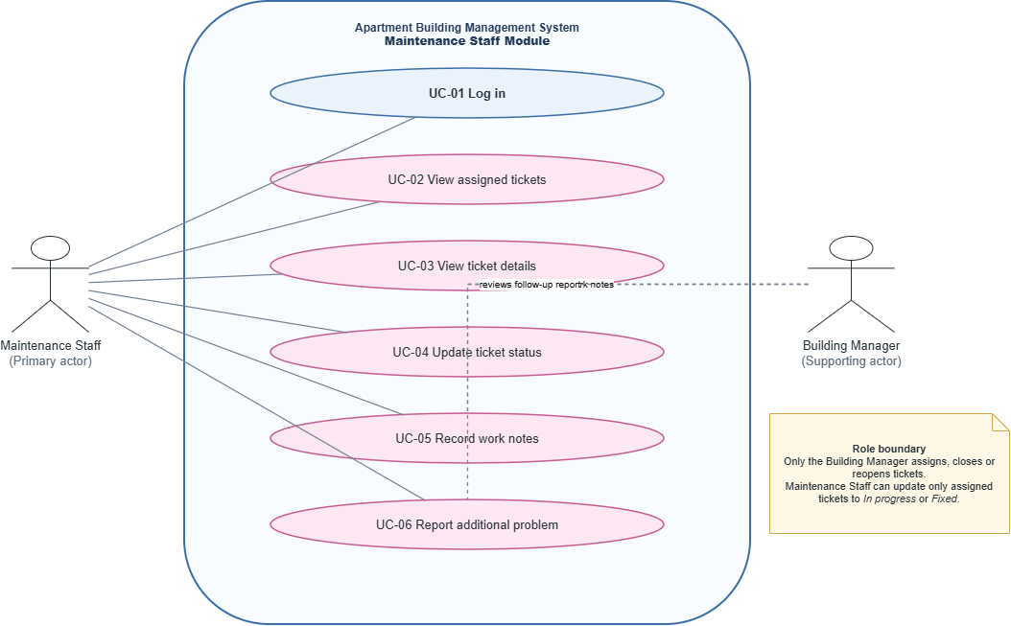

Figure 4.1: UML Use Case Diagram — Maintenance Staff

5. Use Case Narratives
Each narrative lists the actor, the condition before it starts, the main steps, other paths, and the result. UC-02 to UC-06 require the Maintenance Staff member to be logged in with an active account (UC-01).

UC-01 Log in (MNT-06)
Actor: Maintenance Staff
Before: The staff member has an active Maintenance Staff account.
Main steps:
1. The staff member opens the app and enters username and password.
2. The system checks the credentials and account status.
3. The system opens the Maintenance Staff ticket screen.
Other paths:
· Wrong credentials: the system shows an error. After five wrong passwords in a row, access is temporarily locked for 15 minutes.
· An inactive account or a user with another role cannot open maintenance pages.
After: The staff member is logged in and can access maintenance pages.

UC-02 View assigned tickets (MNT-01)
Actor: Maintenance Staff
Before: The staff member is logged in and the Building Manager has assigned at least one ticket, or the staff member has no current assignments.
Main steps:
4. The staff member opens Tickets.
5. The system lists only tickets assigned to that staff account.
6. Each ticket shows its short description, location, priority and current status.
7. The staff member selects a ticket if more information is needed.
Other paths:
· No tickets are assigned: the system displays a message that no tickets are currently assigned.
· The staff member tries to access a ticket assigned to another person: access is refused.
After: The staff member can see their current repair workload.

UC-03 View ticket details (MNT-02)
Actor: Maintenance Staff
Before: The staff member is logged in and the selected ticket is assigned to their account.
Main steps:
8. The staff member selects a ticket from the list.
9. The system displays the description, location, category, priority and current status.
10. The system displays any repair instructions or additional information saved with the ticket.
Other paths:
· The ticket does not exist: the system displays a clear error.
· The ticket is assigned to another staff member: access is refused.
After: The staff member has the information needed to understand the repair request.

UC-04 Update ticket status (MNT-03)
Actor: Maintenance Staff
Before: The staff member is logged in and the ticket is assigned to their account.
Main steps:
11. When repair work starts, the staff member changes the status to In progress and saves it.
12. When the repair is completed, the staff member changes the status to Fixed and saves it.
13. The system saves the new status and update time.
14. The Building Manager and resident can view the latest saved status through their permitted screens.
Other paths:
· The ticket is not assigned to this staff member: the update is refused.
· The save fails: the system displays an error and does not show the unsaved status as successful.
· The ticket is Fixed: the staff member cannot change it to Closed; only the Building Manager closes it.
After: The ticket shows the latest successfully saved status and update time.

UC-05 Record work notes (MNT-04)
Actor: Maintenance Staff
Before: The staff member is logged in and has opened a ticket assigned to their account.
Main steps:
15. The staff member enters a non-empty note describing the repair work.
16. The staff member selects Save.
17. The system stores the note with the ticket and confirms the save.
18. The Building Manager can review the saved note when viewing the ticket.
Other paths:
· The note is empty: the system asks the staff member to enter a note and saves nothing.
· The save fails: the system displays an error and does not claim the note was saved.
After: The work note is stored against the ticket and is available to authorized users.

UC-06 Report an additional problem (MNT-05)
Actor: Maintenance Staff
Before: The staff member is logged in and is working on an assigned ticket.
Main steps:
19. The staff member discovers another problem during repair work.
20. The staff member opens the additional-problem form.
21. The staff member enters the problem description and location.
22. The staff member submits the report and the system confirms successful submission.
23. The Building Manager can view the reported problem and arrange follow-up.
Other paths:
· Description or location is empty: the system shows a validation message and does not save the report.
· The save fails: the system displays an error and does not show the report as submitted.
After: The additional problem is recorded for the Building Manager to review.

6. State Diagrams
These are the four objects the manager changes or follows.Maintenance Staff updates a ticket to In progress and Fixed.
6.1 Fault Ticket
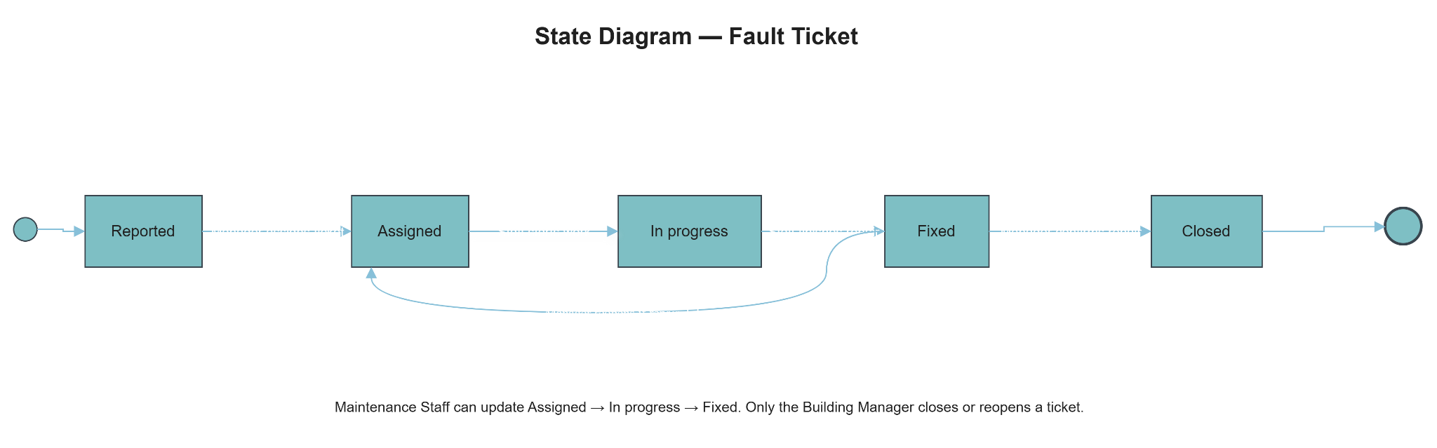
Figure 6.1: State diagram of a fault ticket

6.2 Maintenance Staff Account

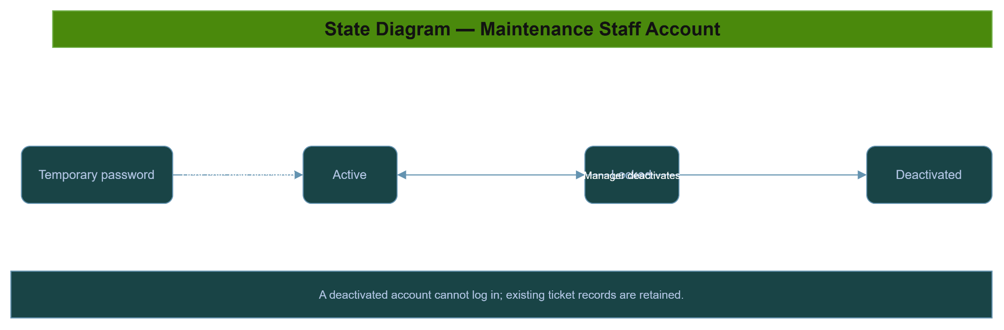

Figure 6.2: State diagram of a Maintenance Staff account

6.3 Work Note

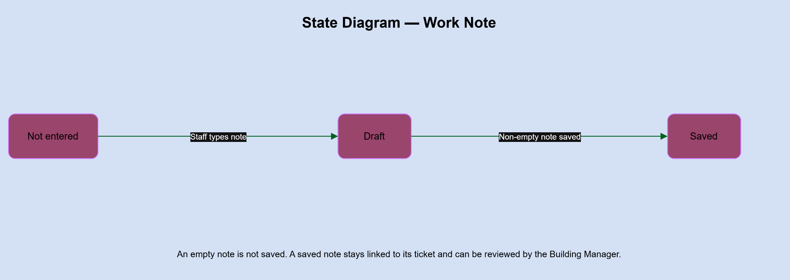

Figure 6.3: State diagram of a work note

6.4 Additional Problem Report
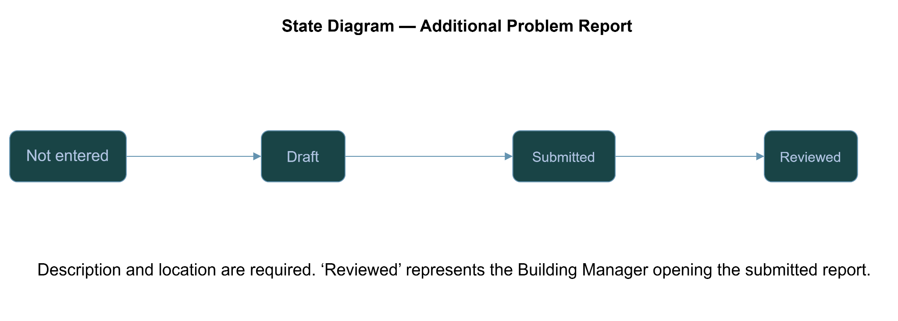

Figure 6.4: State diagram of an additional problem report
Note: The SRS explicitly defines ticket status changes, account access restrictions, saving work notes and submitting additional-problem reports. The Work Note and Additional Problem Report diagrams use simple lifecycle states to represent those documented actions; they do not add new staff permissions.

7. Data Flow Diagram

7.1 Level 0 (Context Diagram)
Level 0 treats the Apartment Building Management System as one process. It shows the main external actors and the information exchanged with the Maintenance Staff module. Internal data stores are not shown at this level.

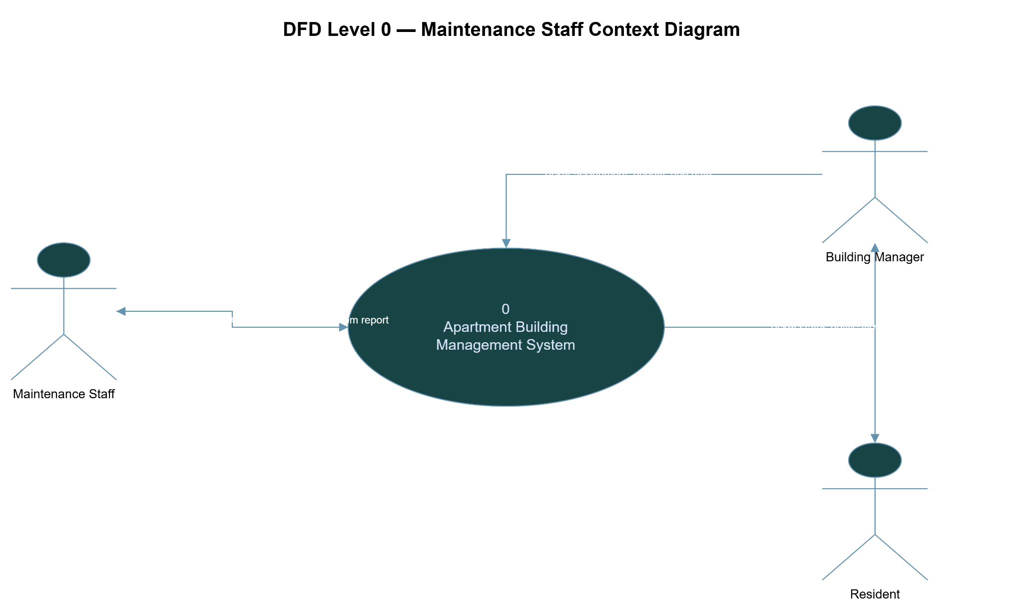
Figure 7.1: Context level diagram (DFD Level 0)

