Resident user class (RES)
My part for the SRS: the Resident class. There are 7 stories (4 Must, 1 Should, 2 Could), plus what the other sections need from the resident side. Section 10 says which SRS section each part goes into, so whoever writes that section can lift it from here.
Please check the stories that touch your class (marked "Touches" under each one). All the numbers are suggestions, so change them if they clash with your stories.

1. Who the resident is (SRS 2.1)
Residents are the people living in the flats: owner-occupiers, and tenants renting from an owner. Both pay the service charge, so the app treats them the same for these stories. Tenants care more about receipts, though, because they often have to show the landlord they've paid.
For this release there's one account per flat, created by the manager. Family members share it. Separate logins for each family member are on the later list (section 5).
What a resident can do:
Action | Resident
See and pay their own flat's bill | Yes
Record a cash or bank payment | Yes
Report and follow faults | Yes
Create and cancel guest passes (the guard checks them at the gate) | Yes
See the building fund summary (totals only) | Yes
Read building announcements | Yes
Give feedback on building services | Yes
See any other flat's bills, payments or tickets | No

What matters for the design:
- Skill levels are all over the place. A student will figure anything out. Somebody's 70-year-old father who only uses WhatsApp won't, and he should still be able to pay a bill.
- Residents will mostly use their own Android phones. Load-shedding kills the Wi-Fi, so the app has to work on slow mobile data.
- A lot of residents, older ones especially, would rather read Bangla.
- Bills come monthly, guests weekly or more, faults now and then.
- Some flats won't use the app at all. Nothing can be app-only: cash payment and the intercom still have to work for them.
Operating environment (SRS 2.3): the resident's own smartphone browser (mostly Android), on mobile data or home Wi-Fi.

2. What's wrong today (SRS 2.2)
Area | How it works now | Problem
Dues | The manager collects cash and writes it in a register | Handwritten receipts or none. "I paid" vs "the register says you didn't". Nobody knows what the charge covers
Guests | The guard calls the flat on the intercom | The intercom is broken or nobody answers, so guests wait at the gate or the guard just guesses
Faults | The resident phones the manager, then phones again | No record, no status. One water outage means 20 calls
Building fund | The committee shows the accounts once a year, if that | Residents don't know where their service charge goes

So residents need to: pay without chasing the manager and get proof; let guests in without the intercom; report a fault once and see what happens to it; and see how the money is spent.

3. Main journeys
- Monthly dues. The bill appears, I check the breakdown, then pay online or pay cash and record it. I get a receipt either way.
- Expected guest. I create a pass and send the code or QR code. The guest shows it at the gate, the guard types or scans it, and I get a notification.
- Fault. I report it (in my flat or a common area), get updates as it moves along, and it gets fixed.
- Fund. I open the monthly summary and see what came in and what went out.

4. User stories (SRS 3.1)

RES-01 · See and pay my monthly bill · Must
As a resident, I want to see my monthly bill broken down by charge and pay it online, so that I know what I'm paying for and have proof without handing cash to anyone.
- Given my flat has a bill for the month, when I open Dues, then I see each charge (service, generator, water) with its rate, any unpaid amount from earlier months, the total and the due date.
- Given I've started a payment, when the gateway hasn't confirmed it yet, then the bill shows Payment pending and I can't pay it again.
- Given the gateway confirms the payment, when I open Dues (even if I closed the app halfway through), then the bill shows Paid and I can download a receipt with a receipt number and transaction ID.
- Given the payment fails or I cancel it, when I come back to the app, then the bill stays Unpaid and I see why.
- Given I'm a resident of flat 5B, when I try to open another flat's bill, then access is refused.
The bill only turns Paid when the gateway confirms it, which rules out wrong Paid statuses and double charges.
Touches: Manager (generates bills, BM-03), Committee (sets charge rates).

RES-02 · Report a fault · Must
As a resident, I want to report a fault and say whether it's inside my flat or in a common area, so that the right person fixes it without me calling the manager five times.
- Given I pick Common area (say, the lift), when there's already an open ticket for it, then I can tap "Me too" and follow that ticket instead of making a duplicate.
- Given I pick Inside my flat, when I submit a category, description, optional photo and the times someone is home, then a ticket is created as Reported and the manager is notified.
- Given I pick an emergency (someone stuck in the lift, fire, gas smell), when I select it, then the app shows the guard desk and manager numbers to call right away and doesn't create a normal ticket.
- Given my ticket's status changes, when it's updated, then I get a notification.
- Given the description is empty, when I submit, then I see "Describe the problem" and nothing is created.
"Me too" is there so one water outage doesn't turn into 20 tickets.
Touches: Manager (assigns tickets, BM-06; closes them, BM-07), Maintenance (works on them and marks them Fixed, MNT-03).

RES-03 · Pre-approve guests · Must
As a resident, I want to create a pass for guests I'm expecting and share it with them, so that the guard lets them in without calling me on the intercom.
- Given I enter the guest's name, how many people are coming, the date and an arrival window (e.g. 6–10 pm), when I save, then I get a random 6-digit code and a matching QR code that only work in that window, and I can share either one from my phone.
- Given the pass is for 4 people, when the guard has checked in 4, then the code shows Fully used.
- Given my plans change, when I cancel the pass, then the code stops working at the gate straight away.
- Given my guests are checked in, when the guard records it, then I get a notification.
The guard can type the code or scan the QR. Either way they see the guest's name and flat number only, never my phone number.
Touches: Guard (checks the code or QR and records the entry, SG-02, SG-03).

RES-04 · Record a cash payment · Should
As a resident, I want to record that I paid cash or by bank transfer, so that my bill doesn't show as unpaid while the manager checks it.
- Given I have an unpaid bill, when I enter the amount, date, method and an optional photo of the slip, then the bill shows Awaiting verification and the manager is notified.
- Given the manager accepts it, when they confirm, then the bill shows Paid and I can download a receipt.
- Given the manager rejects it, when they give a reason, then the bill goes back to Unpaid and I see the reason.
- Given my bill is Awaiting verification, when the due date passes, then my flat isn't put on the defaulters list until the manager decides.
Plenty of people will keep paying cash, and they shouldn't end up marked as defaulters for it.
Touches: Manager (verifies the payment, BM-04; defaulters list, BM-05).

RES-05 · See how the building fund is spent · Could
As a resident, I want a monthly summary of what the building collected and spent, so that I can see where my service charge goes.
- Given a month has records, when I open Building fund, then I see total collected, total spent by category (repair, salary, utility, other) and the balance.
- Given an expense is still waiting for committee approval, when I view the summary, then it isn't counted.
- Given some flats haven't paid, when I view the summary, then I only see the total outstanding, not which flats owe it.
Touches: Manager (records expenses, BM-08; monthly summary, BM-12), Committee (approves expenses).

RES-06 · Log in · Must
As a resident, I want to log in with my flat's account, so that only my household can see our bills, guest passes and tickets.
- Given the manager has created my flat's account, when I enter the right username and password, then I see the resident home screen.
- Given I enter a wrong password 5 times in a row, when I try again, then the account is locked for 15 minutes and I see why.
- Given I've forgotten my password, when I tap Forgot password, then a reset link goes to my flat's registered email.
- Given the manager has deactivated my flat's account, when I try to log in, then I'm refused, but my old bills and receipts are kept.
- Given I'm logged in as a resident, when I try to open a manager, guard or maintenance page, then access is refused.
Everyone in the flat shares this login for now. Separate logins are on the later list (section 5).
Touches: Manager (creates and deactivates flat accounts, BM-02).

RES-07 · Give feedback on building services · Could
As a resident, I want to rate the building's services and leave a comment, so that the committee knows what's working and what isn't.
- Given I've picked a service (cleaning, security, maintenance, lift or other) and a rating from 1 to 5, with an optional comment, when I submit, then it's saved and I see a thank-you message.
- Given I tick Send anonymously, when the committee reads my feedback, then they don't see my flat number.
- Given I already gave feedback on the same service this month, when I submit again, then my earlier feedback is replaced instead of a second one being added.
- Given I haven't picked a rating, when I submit, then I see "Pick a rating" and nothing is saved.
This is for general services. A specific fault still goes through RES-02.
Touches: Committee (reviews feedback, US-CM-09).

5. Not in this release (SRS 1.4, out of scope)
I thought about these and left them out:
- Separate logins for family members, and registering maids, drivers and tutors with the hours they're allowed in
- Approving walk-in visitors and deliveries from the phone (the guard keeps using the intercom)
- Parcel notifications and deciding who's allowed to collect them
- Acknowledging notices
- The resident confirming or rejecting a fix (the manager closes a ticket once it's Fixed, see BM-07)
- Querying a charge on a bill
- Voting in building polls
- Booking move-in and move-out slots
- Partial or advance payments
- An SOS or panic button, plus SMS notifications

6. Non-functional requirements (SRS 3.2)
ID | Category | Requirement | Story
NFR-RES-01 | Performance | The Dues page shall load within 3 s for 95% of requests on a 4G connection. | RES-01
NFR-RES-02 | Security | A resident shall only be able to read or change their own flat's data. Every request for another flat's data shall be refused, and automated tests shall check this on every resident page and API. | All
NFR-RES-03 | Security | Guest pass codes and QR codes shall be random, tied to one flat and valid only within their time window. Residents' phone numbers shall never appear on guard screens. | RES-03
NFR-RES-04 | Safety | A bill shall change to Paid only on payment-gateway confirmation or manager verification, never on the resident's action alone. | RES-01, RES-04
NFR-RES-05 | Safety | Bill and payment records shall be backed up daily, and no confirmed payment shall be lost on restore. | RES-01, RES-04
NFR-RES-06 | Usability | Paying the current bill and creating a guest pass shall each take no more than 4 taps from the home screen. | RES-01, RES-03
NFR-RES-07 | Usability | Resident screens shall be available in Bangla and English, work at 360 px screen width, and stay usable with the phone's text size at 150%. | All
NFR-RES-08 | Availability | Guest pass creation and checking shall be available 99% of the time between 6 am and midnight. | RES-03
NFR-RES-09 | Security | Passwords shall be stored hashed, never as plain text. After 5 wrong passwords in a row, the account shall lock for 15 minutes. | RES-06
NFR-RES-10 | Privacy | Feedback sent anonymously shall never show the flat number or account to the committee or manager, on screen or in exports. | RES-07

7. Risks (SRS 1.5)
Risk | How we handle it
A bill shows Paid but the money never arrived | Gateway confirmation and the pending state (RES-01); manager verification (RES-04); NFR-RES-04
A resident gets charged twice | Pay is disabled while a payment is pending (RES-01)
A pass code gets forwarded to strangers | Time window, guest count and cancel (RES-03)
Residents see each other's bills or phone numbers | Own-flat access only, totals-only fund summary (RES-01, RES-05); NFR-RES-02, NFR-RES-03
Someone in real danger waits in a ticket queue | Emergency categories show phone numbers instead (RES-02)
Flats that pay cash get marked as defaulters | Recorded cash payments (RES-04)
Someone guesses a resident's password | Lockout after 5 wrong tries (RES-06); NFR-RES-09

8. Assumptions and constraints (SRS 2.4, 2.5)
Assumptions (any of these could turn out wrong):
- Every flat has at least one person with a smartphone and internet.
- Bills are per flat, and whoever lives there pays. The app doesn't care what the lease says.
- The manager creates each flat's account.
- The building has emergency numbers (guard desk, manager) that we can show in the app.
Constraints:
- Payments go through a sandbox only. No real money moves.
- No SMS. Notifications are in-app and email only.
- Text has to be kept up to date in both Bangla and English.

9. For the SDS
State diagrams these stories need:
- Bill: Unpaid → Payment pending → Paid; Payment pending → Unpaid (failed); Unpaid → Awaiting verification → Paid, or back to Unpaid if rejected.
- Guest pass: Active → Partly used → Fully used; Active → Cancelled; Active → Expired.
- Fault ticket: Reported → Assigned → In progress → Fixed → Closed. The manager moves it from Fixed to Closed, or back to Assigned with a reason if the repair didn't work (BM-07).
Use case relationships:
- Pay bill «include» Log in
- Download receipt «extend» Pay bill
- Follow existing ticket «extend» Report fault (only when a matching open ticket exists)
- Show emergency numbers «extend» Report fault (only for emergency categories)
Entities: Flat, Resident, Bill, BillLine, Payment, PaymentClaim, GuestPass, Ticket, TicketFollower, Expense, Feedback.

10. Where this goes in the SRS
SRS section | Section here
1.4 Product Scope | 4 (in scope) and 5 (out of scope)
1.5 Risk Definitions | 7
2.1 User Classes and Characteristics | 1
2.2 User Needs | 2
2.3 Operating Environment | 1
2.4 Constraints, 2.5 Assumptions | 8
3.1 Functional Requirements | 4
3.2 Non-Functional Requirements | 6

Resident: use cases, state diagrams and DFD
This part covers the Resident user class. Story IDs (RES), business rules (BR) and non-functional requirements (NFR) refer to the SRS.

1. UML use case diagrams
The Resident is the primary actor. The Payment Gateway, the Email Service and the Building Manager join in as secondary actors. There are four diagrams, one per subsystem. Apart from Reset password, every use case needs the resident to be logged in, which the diagrams show as «include» Log in. Pay bill is drawn in italics because it is abstract: a resident never just "pays", they pay online or record a cash or bank payment. The condition for each «extend» is written on its arrow.
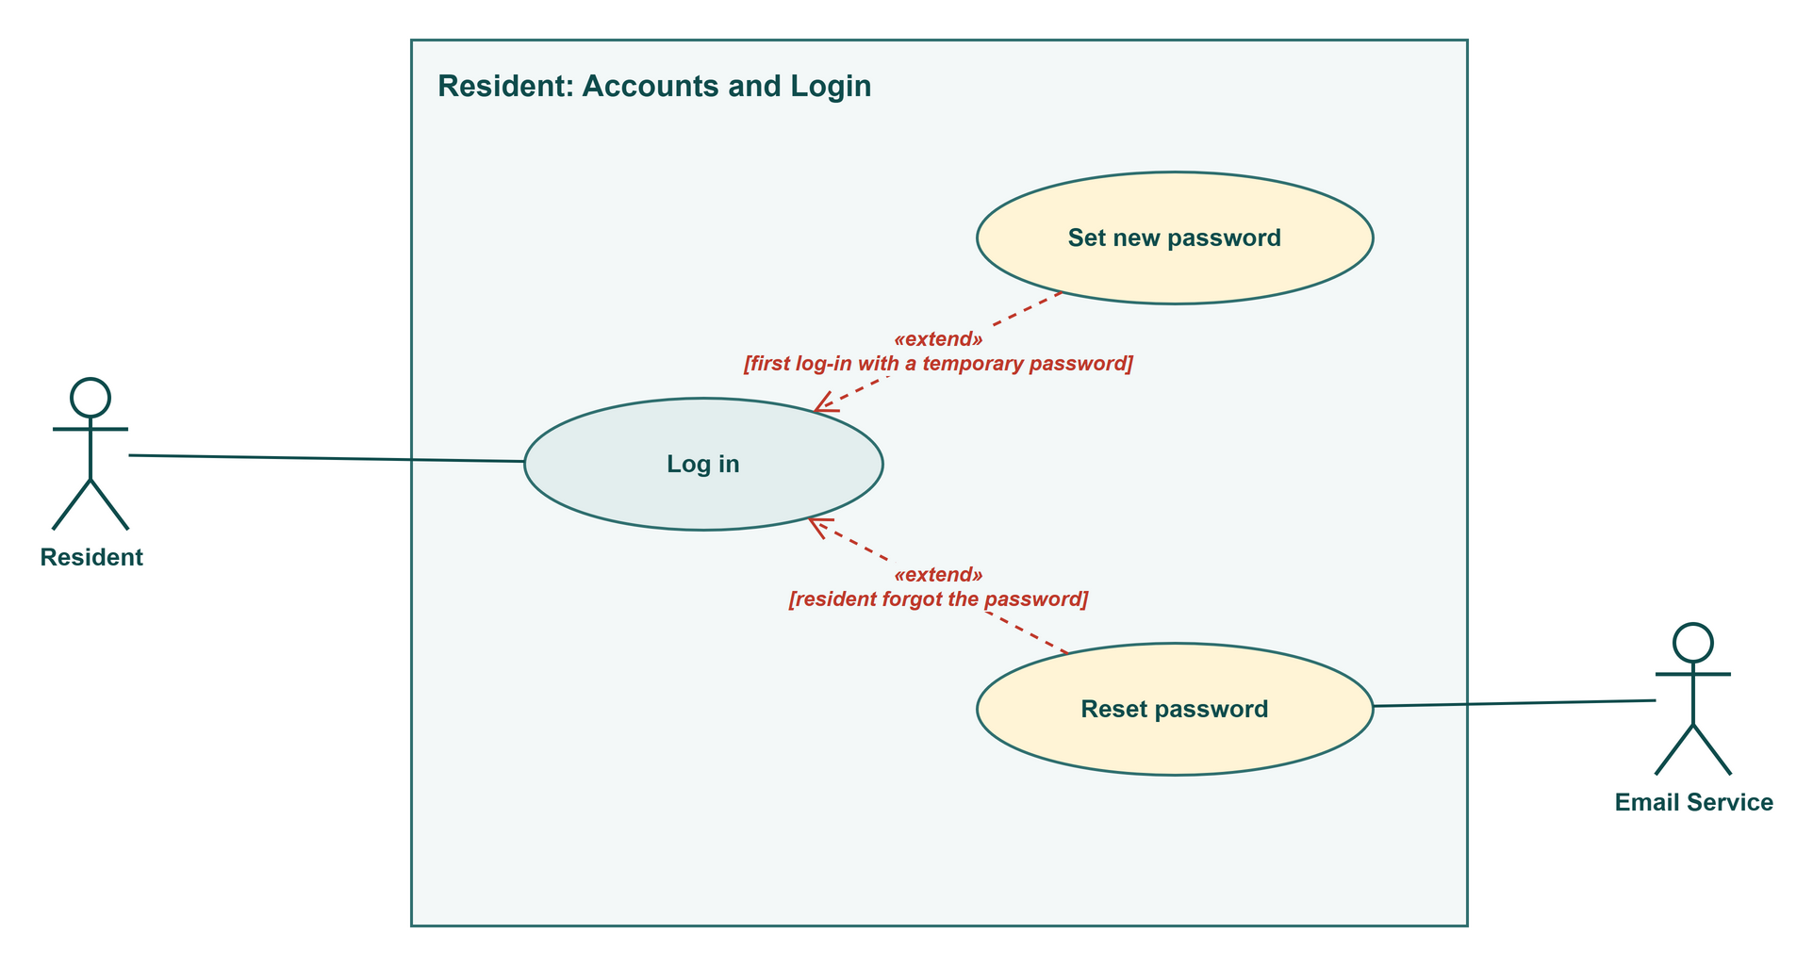
Figure R1: Resident use cases: Accounts and Login
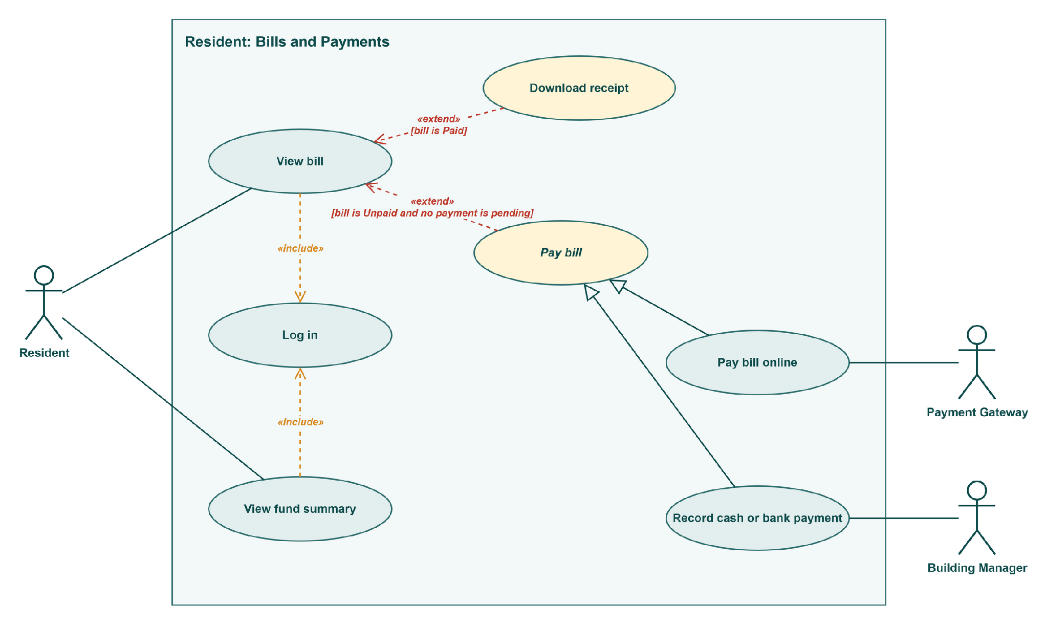
Figure R2: Resident use cases: Bills and Payments
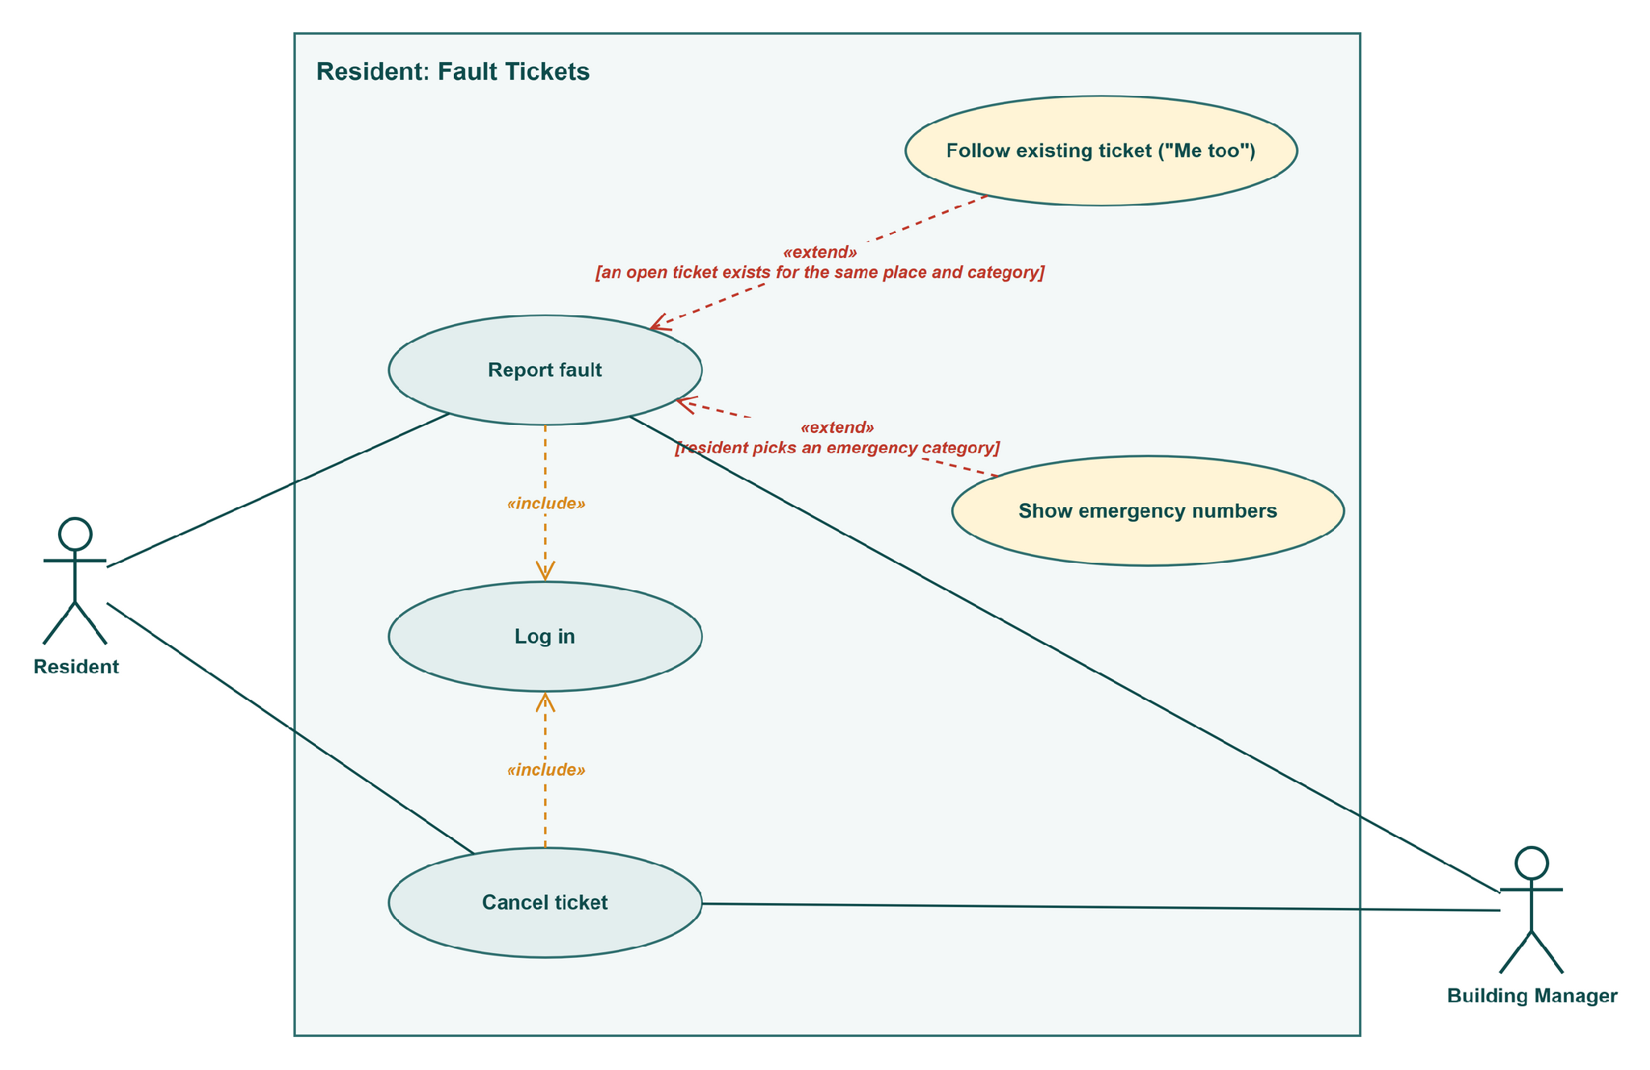
Figure R3: Resident use cases: Fault Tickets
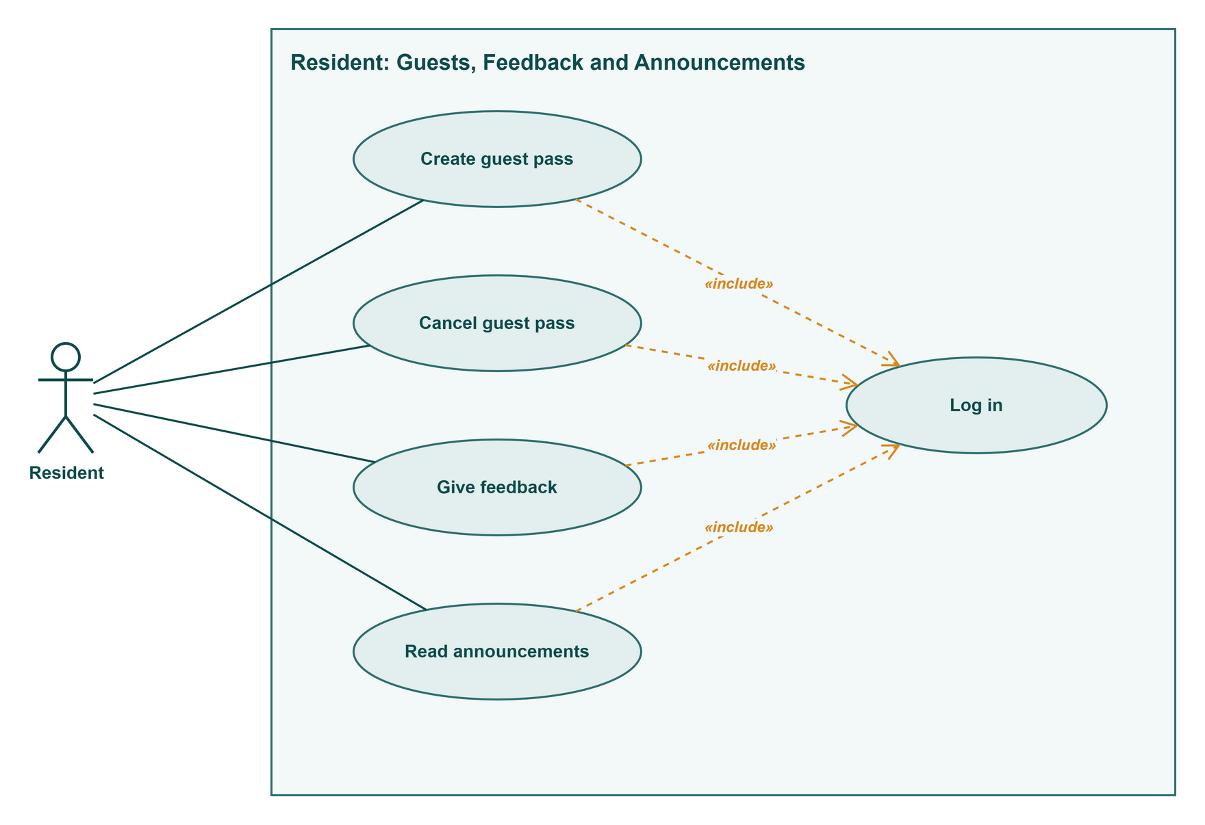
Figure R4: Resident use cases: Guests, Feedback and Announcements

2. Use case narratives
Each use case has its own narrative in the Lecture 3 table format. An alternate flow is numbered after the step it branches from, so 2a branches from step 2.

UC-R01 Log in
Field | Description
Use case | UC-R01 Log in (RES-06)
Actors | Primary: Resident
Precondition | The manager has created the household account (BM-02) and the occupancy is active.
Trigger | The resident opens BariBondhu while logged out.
Main success scenario | 1. Resident enters the username and password.  2. System checks them and checks that the occupancy is active.  3. System opens the resident home screen.
Alternate flows | 1a. Resident taps Forgot password → «extend» Reset password (UC-R03).  2a. First log-in with a temporary password → «extend» Set new password (UC-R02), then step 3.  2b. Wrong username or password → error shown, return to step 1. After 5 wrong passwords in a row, this device must wait 15 minutes and the screen shows the time left (BR-14).  2c. The occupancy has ended → log-in refused. The records are kept but the next household can't see them (BR-09).  3a. Resident tries to open a manager, guard, maintenance, committee or administrator page → access refused.
Postcondition | The resident is logged in and can see only their own household's data.
Non-functional | HTTPS only (NFR-03). Passwords stored only as salted hashes (NFR-04). Wrong-password limit per device (NFR-05). Session ends after 7 days idle (NFR-07).

UC-R02 Set new password
Field | Description
Use case | UC-R02 Set new password (RES-06)
Actors | Primary: Resident
Precondition | The account has a temporary password from the manager that is less than 7 days old.
Trigger | The resident logs in with the temporary password (extends Log in at step 2).
Main success scenario | 1. System asks for a new password.  2. Resident enters the new password twice.  3. System checks that it has at least 8 characters and that both entries match.  4. System saves the password and Log in continues at step 3.
Alternate flows | 3a. Too short, or the two entries differ → System says what is wrong, return to step 2.  Temporary password older than 7 days → log-in refused, and the resident is told to ask the manager for a new one.
Postcondition | The temporary password no longer works. The account is Active.
Non-functional | At least 8 characters, stored only as a salted hash, never sent by email (NFR-04).

UC-R03 Reset password
Field | Description
Use case | UC-R03 Reset password (RES-06)
Actors | Primary: Resident · Secondary: Email Service
Precondition | The resident is not logged in.
Trigger | The resident taps Forgot password on the log-in screen (extends Log in at step 1).
Main success scenario | 1. Resident enters the username.  2. System finds the email address on the account.  3. System sends a reset link, valid for 30 minutes, through the Email Service.  4. Resident opens the link and enters a new password of at least 8 characters.  5. System saves the password and the resident logs in (UC-R01).
Alternate flows | 2a. The account has no email address → the screen tells the resident to ask the manager to reset it. The use case ends.  4a. The link is older than 30 minutes or was already used → "This link has expired", return to step 1.
Postcondition | The new password works and the old one does not.
Non-functional | The reset link expires after 30 minutes. The password itself is never emailed (NFR-04).

UC-R04 View bill
Field | Description
Use case | UC-R04 View bill (RES-01)
Actors | Primary: Resident
Precondition | The resident is logged in («include» Log in).
Trigger | The resident opens Dues or taps a bill reminder notification.
Main success scenario | 1. System finds the household's current bill.  2. System shows each charge (service, generator, water) with its rate, any Carried forward or adjustment line, the total, the due date and the status.  3. Resident reads the bill.
Alternate flows | 2a. The bill is Unpaid and no payment is pending → Pay is offered: «extend» Pay bill (UC-R05).  2b. The bill is Paid → «extend» Download receipt (UC-R08).  2c. The bill is Payment pending or Awaiting verification → the status is shown and both payment options are disabled (BR-03).  3a. Resident tries to open another flat's bill → access refused.
Postcondition | Nothing changes.
Non-functional | Dues loads within 3 s for 95% of requests on Fast 3G (NFR-01). A resident reaches only their own occupancy's data (NFR-06). Totals always equal the saved records (NFR-26).

UC-R05 Pay bill (abstract)
Field | Description
Use case | UC-R05 Pay bill (abstract) (RES-01, RES-04)
Actors | Primary: Resident · Secondary: depends on the payment method
Precondition | The bill is Unpaid and no payment is pending (the extend condition on View bill).
Trigger | The resident taps Pay on the bill.
Main success scenario | 1. System shows the bill total and the two ways to pay.  2. Resident chooses Pay online, which continues as Pay bill online (UC-R06), or Record cash or bank payment, which continues as UC-R07.
Alternate flows | 1a. The bill changed in the meantime, for example the manager recorded a payment → System shows the new status and offers no payment.
Postcondition | Set by the chosen method (UC-R06 or UC-R07).
Non-functional | Paying the current bill takes at most 4 taps from the home screen (NFR-24). A bill becomes Paid only as set out in BR-02 (NFR-15).

UC-R06 Pay bill online
Field | Description
Use case | UC-R06 Pay bill online (RES-01)
Actors | Primary: Resident · Secondary: Payment Gateway
Precondition | The bill is Unpaid and no payment is pending.
Trigger | The resident chooses Pay online (specialises Pay bill).
Main success scenario | 1. System sets the bill to Payment pending and disables Record cash or bank payment (BR-03).  2. System sends a payment request for the bill total to the Payment Gateway and opens its payment page.  3. Resident pays on the gateway's page.  4. Payment Gateway confirms the payment to the system server to server.  5. System sets the bill to Paid, creates a receipt with a receipt number and the gateway's transaction ID, and notifies the resident.
Alternate flows | 3a. The payment fails or the resident cancels → the bill returns to Unpaid and the gateway's reason is shown.  3b. The resident closes the app halfway → steps 4 and 5 still happen when the gateway confirms.  4a. No confirmation after 30 minutes → System asks the gateway for the status. If there is no successful payment, the bill returns to Unpaid (BR-04). A confirmation that arrives later still makes the bill Paid.
Postcondition | The bill is Paid with a receipt, or Unpaid again with nothing charged. Each change is logged (NFR-27).
Non-functional | Only the gateway's confirmation makes the bill Paid (BR-02, NFR-15). No confirmed payment is lost after a restore (NFR-20). Sandbox gateway only, no real money (constraint 2.4).

UC-R07 Record cash or bank payment
Field | Description
Use case | UC-R07 Record cash or bank payment (RES-04)
Actors | Primary: Resident · Secondary: Building Manager
Precondition | The bill is Unpaid and no online payment is pending.
Trigger | The resident chooses Record cash or bank payment (specialises Pay bill).
Main success scenario | 1. Resident enters the amount, the date, the method (cash or bank transfer) and, optionally, a photo of the slip.  2. System checks that the amount equals the bill total.  3. System saves the claim, sets the bill to Awaiting verification and notifies the manager.  4. Manager accepts the claim (BM-04). The bill becomes Paid and the resident can download a receipt.
Alternate flows | 1a. The photo is not a JPG or PNG, or is over 5 MB → refused with a message (NFR-09).  2a. The amount is not the bill total → "The amount must match the bill total (৳ total). Partial payments aren't supported." Nothing is saved (BR-06).  4a. Manager rejects the claim with a reason → the bill returns to Unpaid and the resident sees the reason.  4b. The due date passes while the bill is Awaiting verification → the flat stays off the defaulters list until the manager decides (BR-08).
Postcondition | The claim is recorded. The bill is Awaiting verification, then Paid or Unpaid.
Non-functional | Slip photos are visible only to the manager and the flat that uploaded them (NFR-14). A bill becomes Paid only as set out in BR-02 (NFR-15).

UC-R08 Download receipt
Field | Description
Use case | UC-R08 Download receipt (RES-01, RES-04)
Actors | Primary: Resident
Precondition | The bill is Paid (the extend condition on View bill).
Trigger | The resident taps Download receipt.
Main success scenario | 1. System creates the receipt: receipt number, flat, month, each charge, total, payment date, method and, for online payments, the gateway's transaction ID.  2. The receipt downloads to the resident's device.
Alternate flows | 2a. The download fails because of the connection → an error is shown within 5 s and the resident can try again (NFR-17).
Postcondition | The resident has a copy of the receipt. Nothing else changes.
Non-functional | Amounts in BDT (৳) with two decimals and times in Asia/Dhaka (BR-01).

UC-R09 View fund summary
Field | Description
Use case | UC-R09 View fund summary (RES-05)
Actors | Primary: Resident
Precondition | The resident is logged in («include» Log in).
Trigger | The resident opens Building fund.
Main success scenario | 1. System finds the latest month the manager has published.  2. System shows the opening balance, total collected, total spent by category (repair, salary, utility, other), the closing balance and the total outstanding.  3. Resident can pick an earlier published month.
Alternate flows | 1a. This month's summary isn't published yet → System shows the last published month and a note that this month isn't ready.
Postcondition | Nothing changes.
Non-functional | Only Approved expenses are counted (BR-10). Totals only, never which flats owe money (NFR-12). Loads within 3 s (NFR-01).

UC-R10 Report fault
Field | Description
Use case | UC-R10 Report fault (RES-02)
Actors | Primary: Resident · Secondary: Building Manager
Precondition | The resident is logged in («include» Log in).
Trigger | The resident taps Report a fault.
Main success scenario | 1. Resident chooses Inside my flat, or Common area and a place from the list (BR-13).  2. Resident picks a category.  3. Resident enters a short title, a description, an optional photo and the times someone is home.  4. System creates the ticket as Reported.  5. System notifies the manager and shows the ticket under My tickets.
Alternate flows | 1a. Common area, and an open ticket already exists for that place and category → «extend» Follow existing ticket (UC-R11).  2a. Emergency category (fire, gas smell, someone stuck in a lift) → «extend» Show emergency numbers (UC-R12). If the resident then taps Log it for repair, the ticket is created as Urgent at step 4.  3a. The description is empty → "Describe the problem", nothing is created.  3b. The photo is not a JPG or PNG, or is over 5 MB → refused with a message (NFR-09).
Postcondition | The ticket is Reported, and the resident is notified each time its status changes.
Non-functional | Notifications arrive within 1 minute (NFR-29). The maintenance worker sees the flat number, photo and home times, never the resident's phone number (NFR-10).

UC-R11 Follow existing ticket ("Me too")
Field | Description
Use case | UC-R11 Follow existing ticket ("Me too") (RES-02)
Actors | Primary: Resident
Precondition | A common-area fault, with an open ticket for the same place and category (BR-13).
Trigger | System finds the matching ticket while the resident reports a fault (extends Report fault at step 1).
Main success scenario | 1. System shows the open ticket with its title, status and number of followers.  2. Resident taps Me too.  3. System adds the resident as a follower and raises the count the manager sees.
Alternate flows | 2a. The resident's problem is different → Report fault continues at step 2 and a new ticket is created.
Postcondition | The resident follows the ticket and gets its status changes. No duplicate ticket is created.
Non-functional | Status notifications arrive within 1 minute (NFR-29).

UC-R12 Show emergency numbers
Field | Description
Use case | UC-R12 Show emergency numbers (RES-02)
Actors | Primary: Resident
Precondition | The resident picked an emergency category.
Trigger | Selecting the emergency category (extends Report fault at step 2).
Main success scenario | 1. System shows 999 first, then the guard-desk and manager numbers, each with a one-tap Call button, before anything else.  2. Resident calls the number they need.  3. Resident taps Log it for repair, and Report fault continues at step 4 with an Urgent ticket.
Alternate flows | 3a. The resident leaves without tapping Log it for repair → no ticket is created.
Postcondition | The resident has seen the emergency numbers. If they tapped Log it for repair, an Urgent ticket exists.
Non-functional | 999 is always first and the building numbers are never empty (BR-12). The emergency screen is at most 2 taps from the home screen (NFR-16).

UC-R13 Cancel ticket
Field | Description
Use case | UC-R13 Cancel ticket (RES-02)
Actors | Primary: Resident · Secondary: Building Manager
Precondition | The resident's own ticket is still Reported («include» Log in).
Trigger | The resident opens the ticket and taps Cancel.
Main success scenario | 1. System asks the resident to confirm.  2. Resident confirms.  3. System sets the ticket to Cancelled and notifies the manager.
Alternate flows | The ticket is already Assigned → Cancel isn't offered. Only the manager can close it.  2a. The resident doesn't confirm → nothing changes.
Postcondition | The ticket is Cancelled.
Non-functional | The change is logged with the account, date and time (NFR-27).

UC-R14 Create guest pass
Field | Description
Use case | UC-R14 Create guest pass (RES-03)
Actors | Primary: Resident
Precondition | The resident is logged in («include» Log in).
Trigger | The resident taps New guest pass.
Main success scenario | 1. Resident enters the guest's name, the number of people (1 to 20) and a start and end date-time.  2. System checks that the end is after the start and no more than 24 hours later.  3. System creates a 6-digit code and a matching QR code (BR-11) and saves the pass.  4. Resident shares the code or the QR code from the phone.
Alternate flows | 2a. The end is before the start, or more than 24 hours after it → "Check the visit times", no pass is created.  2b. The number of people is outside 1 to 20 → refused with a message.  After step 4, when the guard checks the guests in (SG-03), the resident gets a notification with the number who arrived.
Postcondition | The pass is Scheduled, or Active if it starts now. The guard can check it during its time window.
Non-functional | Codes come from a secure random source and are tied to one flat and one pass (NFR-08). At most 4 taps (NFR-24). Pass checking is available 99.5% of the time (NFR-18). The guard never sees the resident's phone number (NFR-10).

UC-R15 Cancel guest pass
Field | Description
Use case | UC-R15 Cancel guest pass (RES-03)
Actors | Primary: Resident
Precondition | The pass is Scheduled, Active or Partly used («include» Log in).
Trigger | The resident opens the pass and taps Cancel.
Main success scenario | 1. System asks the resident to confirm.  2. Resident confirms.  3. System sets the pass to Cancelled. The code and QR code stop working at the gate straight away.
Alternate flows | The pass is Fully used or Expired → Cancel isn't offered.  2a. The resident doesn't confirm → nothing changes.
Postcondition | The pass is Cancelled. Guests already checked in stay in the visitor log.
Non-functional | A gate check returns within 2 s and shows the pass as cancelled (NFR-02). The change is logged (NFR-27).

UC-R16 Give feedback
Field | Description
Use case | UC-R16 Give feedback (RES-07)
Actors | Primary: Resident
Precondition | The resident is logged in («include» Log in).
Trigger | The resident opens Feedback.
Main success scenario | 1. Resident picks a service: cleaning, security, maintenance, lift or other.  2. Resident picks a rating from 1 to 5, can add a comment of up to 500 characters, and can tick Send anonymously.  3. Resident submits.  4. System saves the feedback and shows a thank-you message.
Alternate flows | 3a. No rating picked → "Pick a rating", nothing is saved.  4a. The household already rated this service this month → the new feedback replaces the earlier one.
Postcondition | The feedback is saved for this month and the committee can read it (CM-03).
Non-functional | Anonymous feedback never shows the flat or the account to any reader, on screen or in exports (NFR-11).

UC-R17 Read announcements
Field | Description
Use case | UC-R17 Read announcements (RES-08)
Actors | Primary: Resident
Precondition | The resident is logged in («include» Log in).
Trigger | The resident opens Announcements or taps an announcement notification.
Main success scenario | 1. System lists the announcements sent to all residents or to the resident's block or floor, newest first.  2. Resident opens one and reads the title, message and date.
Alternate flows | 1a. An announcement is Urgent and hasn't expired → it is also pinned at the top of the home screen until its expiry time.  1b. The manager edited an announcement → the latest version is shown. A removed announcement is no longer listed.  1c. An announcement was sent only to another block or floor → it isn't shown.
Postcondition | Nothing changes.
Non-functional | In-app notification within 1 minute, plus email when the account has one (NFR-29). Bangla and English (NFR-22).

3. State diagrams

Bill
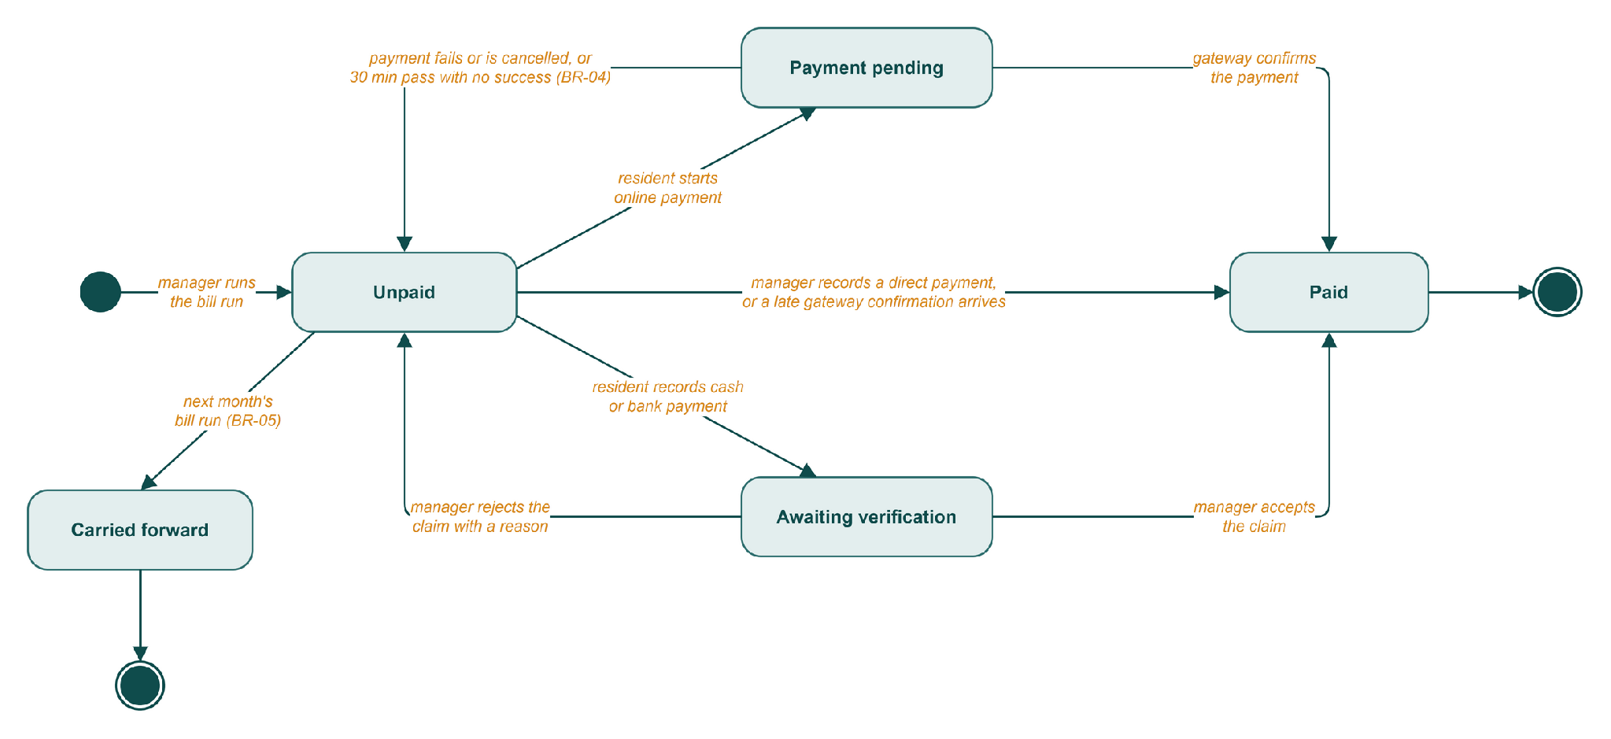
Figure R5: State diagram of a Bill
A bill is in one payment flow at a time (BR-03), and only the gateway's confirmation or the manager's decision can make it Paid (BR-02). Paid and Carried forward are final. To fix a mistake on a Paid bill, the manager adds an adjustment line to next month's bill (BR-07).

Guest pass
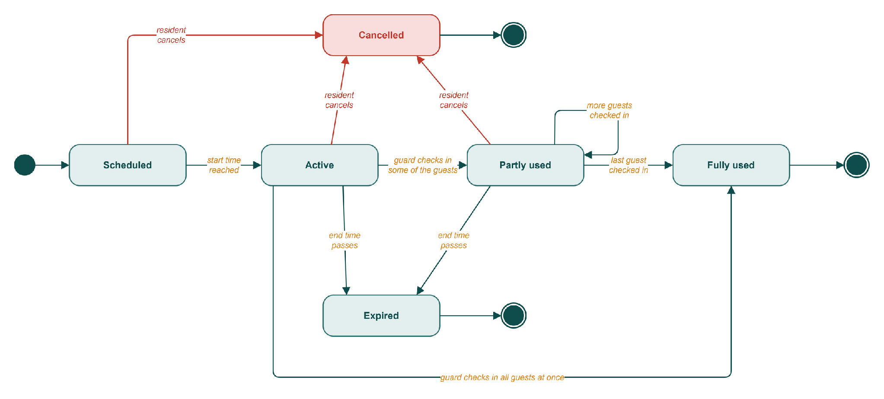
Figure R6: State diagram of a Guest pass
A pass works from its start date-time to its end date-time, 24 hours at most (BR-11). Once it is Fully used, Cancelled or Expired, it stays that way.

Fault ticket
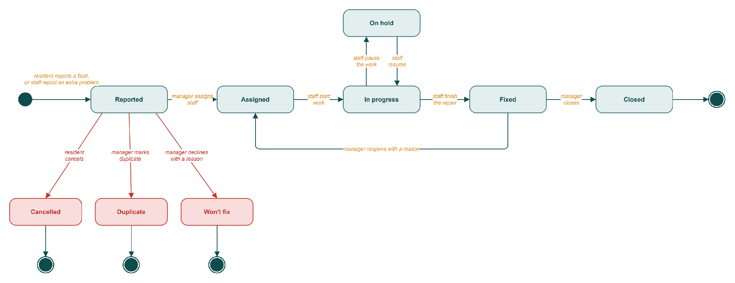
Figure R7: State diagram of a Fault ticket
Residents can cancel a ticket only while it is still Reported. After the manager assigns it, closing or reopening it is the manager's call. Tapping "Me too" adds a follower and leaves the state alone.

Payment claim
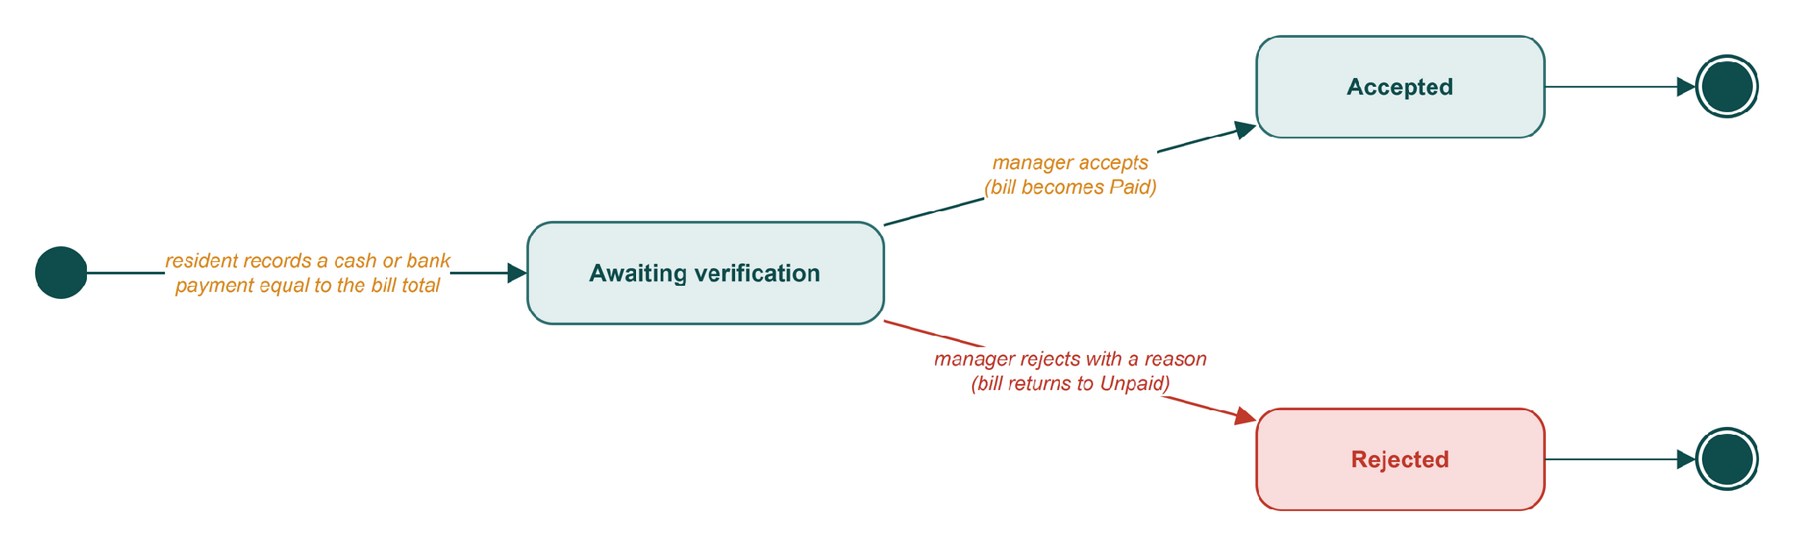
Figure R8: State diagram of a Payment claim
A claim starts when the resident records a cash or bank payment, and the amount has to match the bill total (BR-06). Whatever the manager decides also moves the bill; see the Bill diagram.

Household account
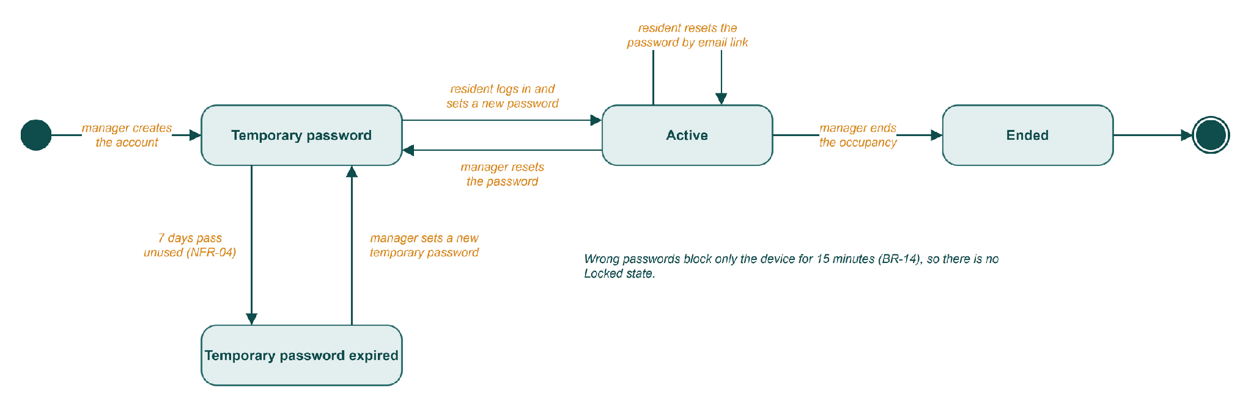
Figure R9: State diagram of a Household account
In Release 1 the whole household shares one account. Too many wrong passwords block the device for 15 minutes (BR-14), not the account, so there is no Locked state.

4. Data flow diagram (Level 0)
Level 0 draws the whole system as a single process, numbered 0. Rectangles are external entities, and each arrow carries data one way. The diagram keeps to the Resident's data: what residents send in, what they get back, and which other people or services that data reaches.
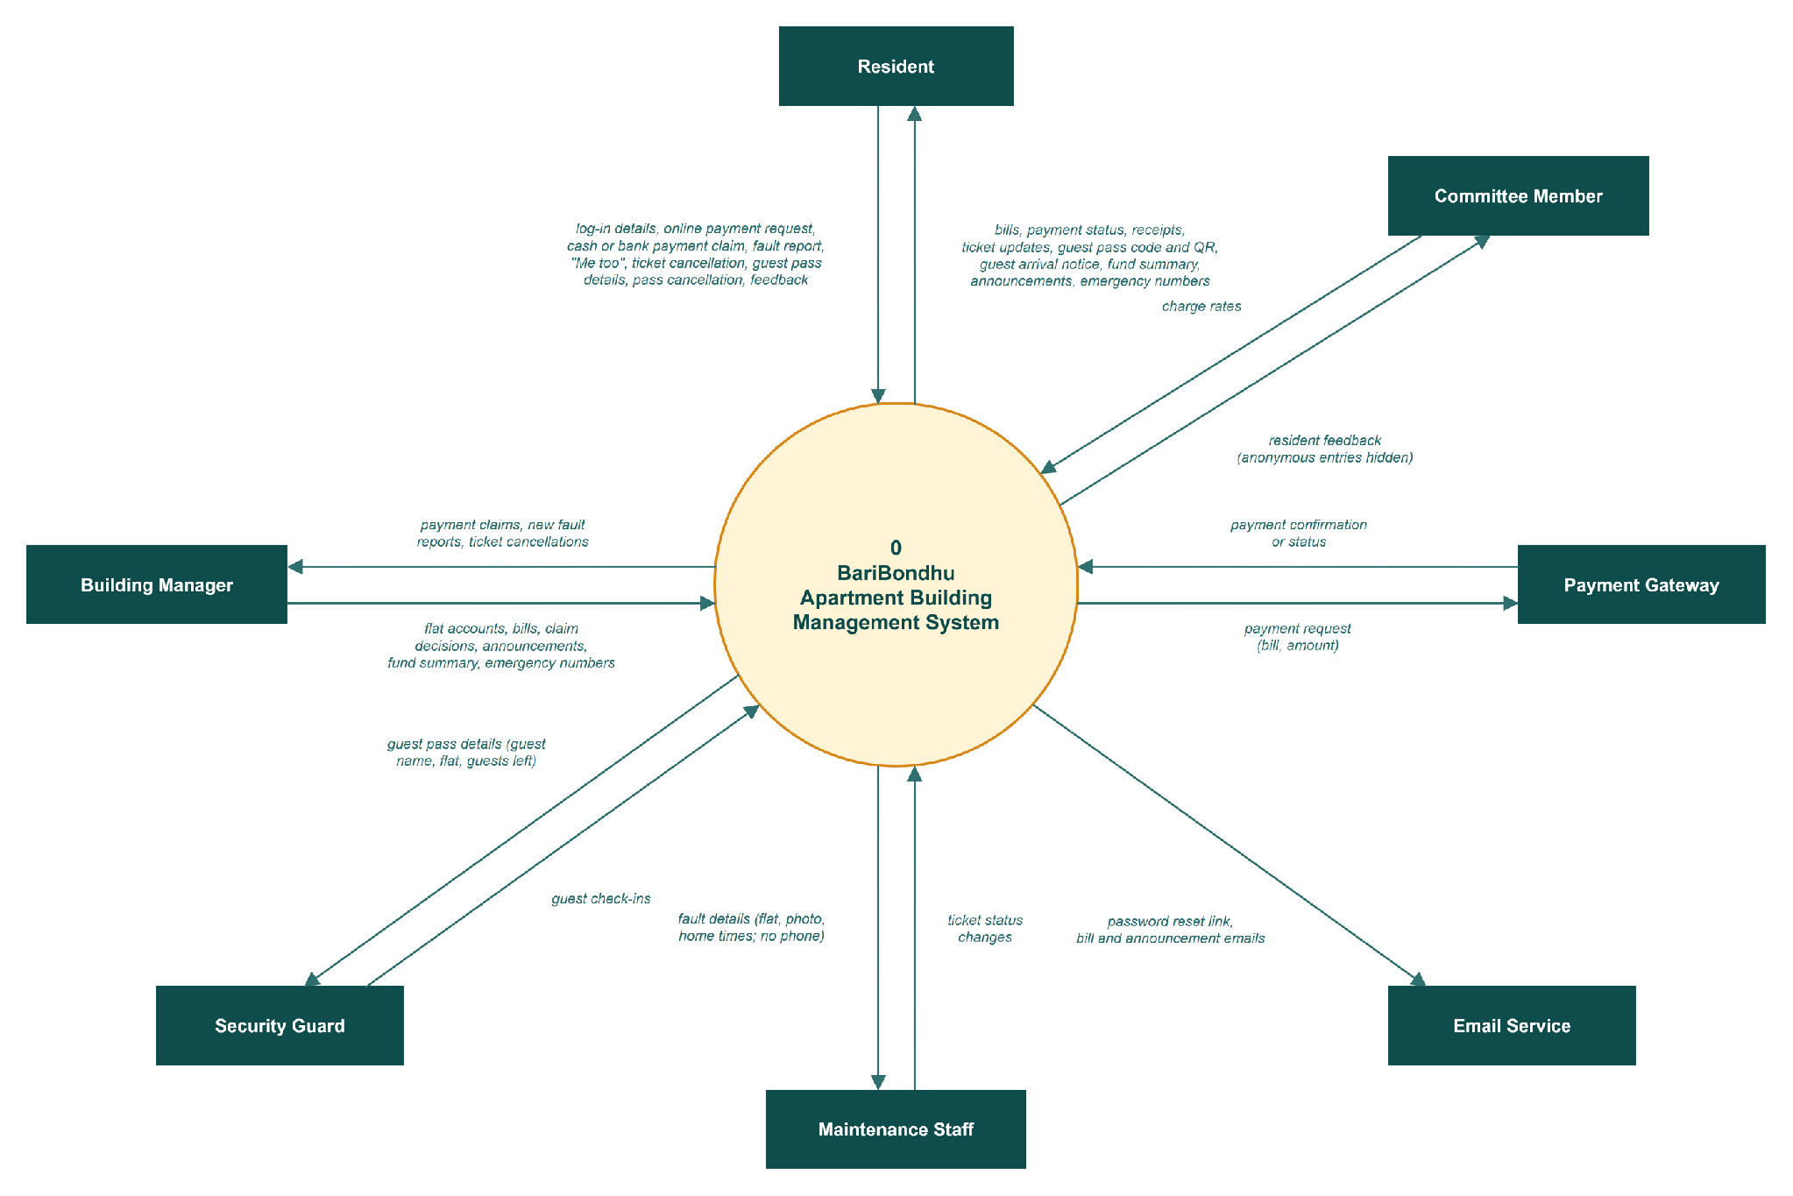
Figure R10: DFD Level 0 (context diagram) for the Resident

