- Jenkins-02
Mohammed Mujahed-16
Configure 2 slave machines in Jenkins master.
- Configure webhooks to Jenkins job.
- Configure poll scm and build periodical options in Jenkins job.
- Take backup of Jenkins server by using bash script.
- Take backup of Jenkins using rethin backup plugin.

Setup a new Jenkins server and dump the backup taken in task4.
🧩 Task Overview (What & Why)
Task | Purpose
1. Configure 2 slave (agent) machines | Distribute load, faster builds, scalability
2. Configure Webhooks | Auto-trigger Jenkins when code changes
3. Poll SCM & Build Periodically | Scheduled and SCM-based automation
4. Backup Jenkins using Bash script | Disaster recovery (manual method)
5. Backup Jenkins using ThinBackup plugin | Automated plugin-based backup
6. Restore backup on new Jenkins server | Real DR (Disaster Recovery) simulation

1:Configure 2 slave machines in Jenkins master.
Purpose
To distribute build load from Jenkins master to agent nodes and run jobs in parallel.

📌 Prerequisites
- Jenkins Master running
- 2 Linux servers (Agent-1, Agent-2)
- Java installed on all servers

SSH access from master → agents
creating slave 1 and slave 2 instances
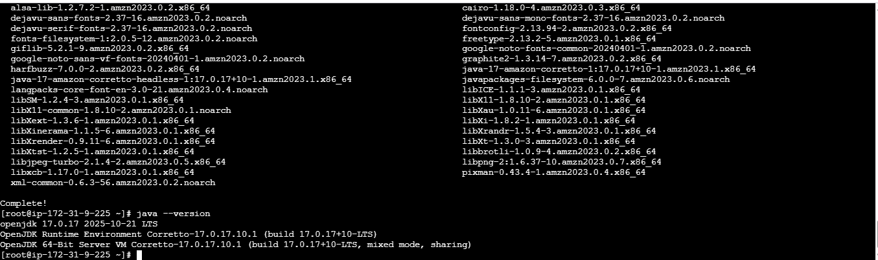
>install java 17* version in both slave instances.
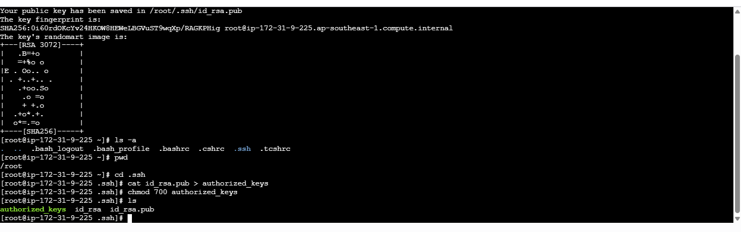
generate ssh-keygen and copy to authorized keys in .ssh folder and allow chmod 700 to authorized keys.
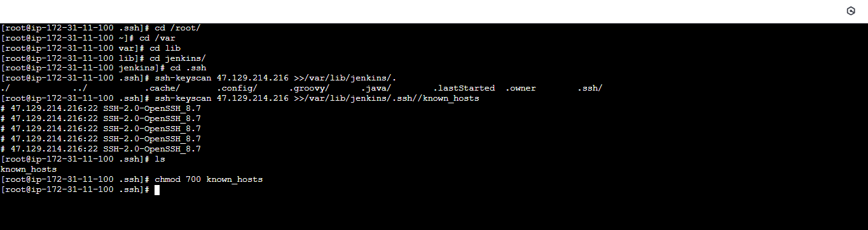
switch to master instance-
#then create a .ssh directory in /var/lib/Jenkins/.ssh
#then i used this command to add the slave 1 ssh key in master instance to build the connection.
#ssh-keyscan –H <slave-01-ip> >>/var/lib/Jenkins/.ssh/known_hosts
#then it will generate one known_hosts file
#chmod 700 known_hosts.
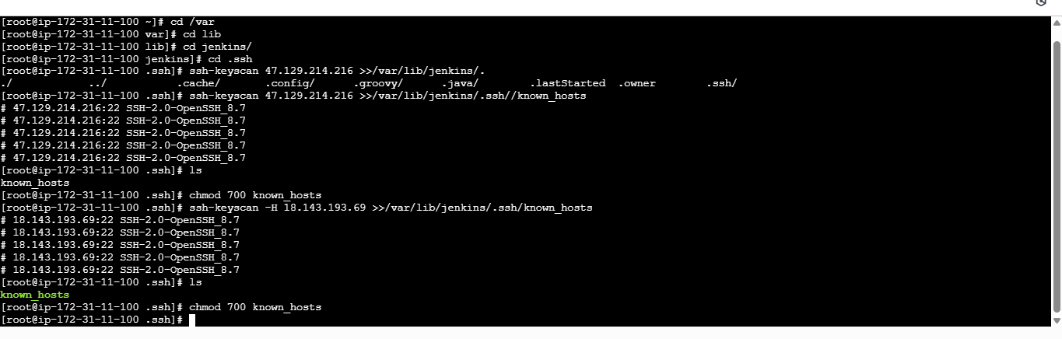
#add another slave instance ssh keygen in master machine by using same command.
#ssh-keyscan –H <ip of slave 2> >>/var/lib/Jenkins/,.ssh/known_hosts
#then move to Jenkins GUI for further process.
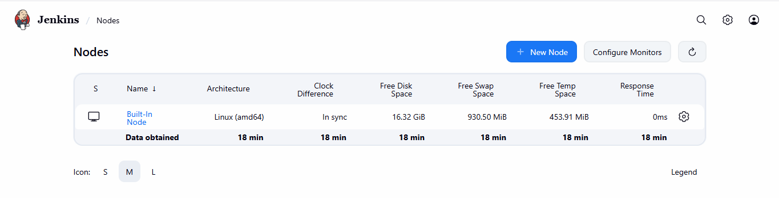
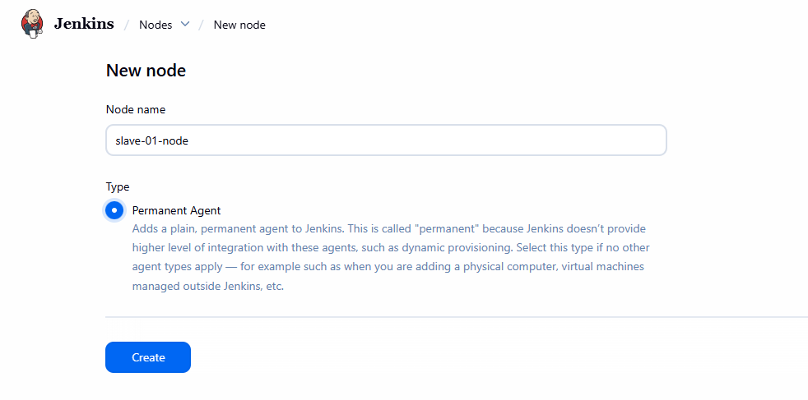
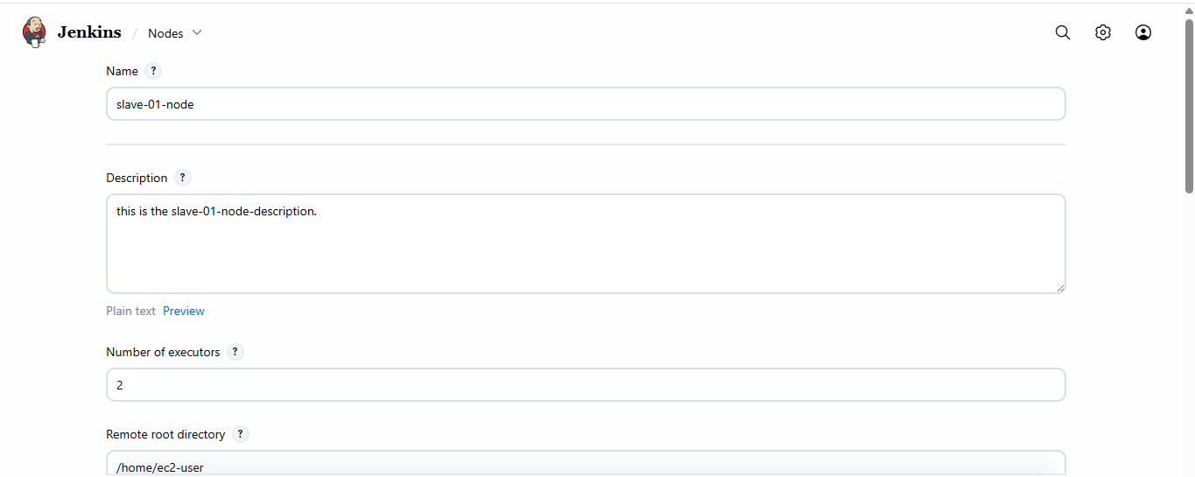
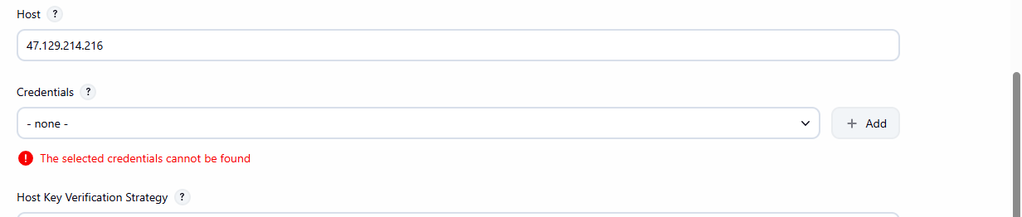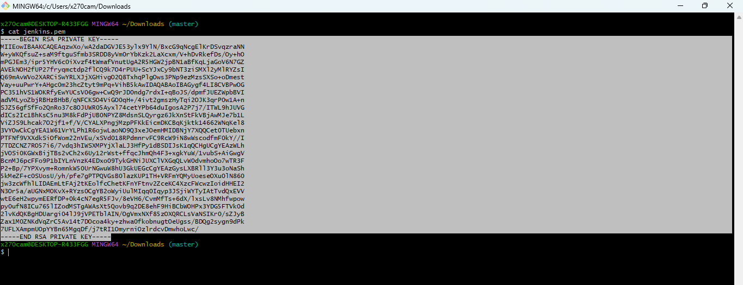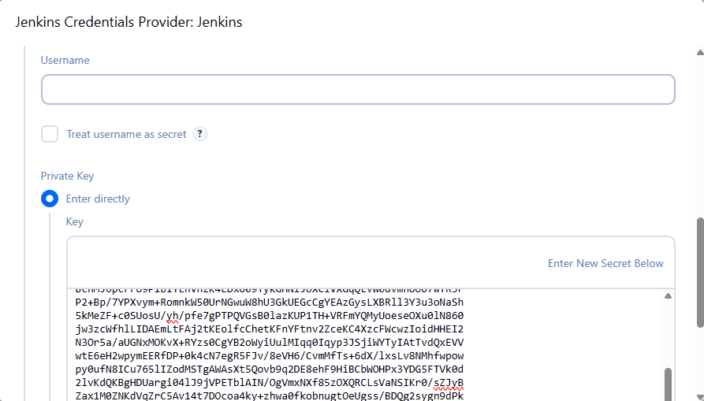
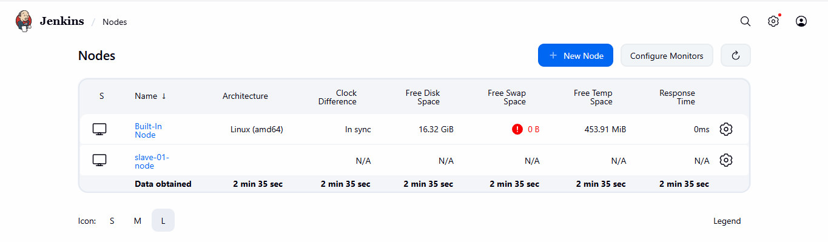
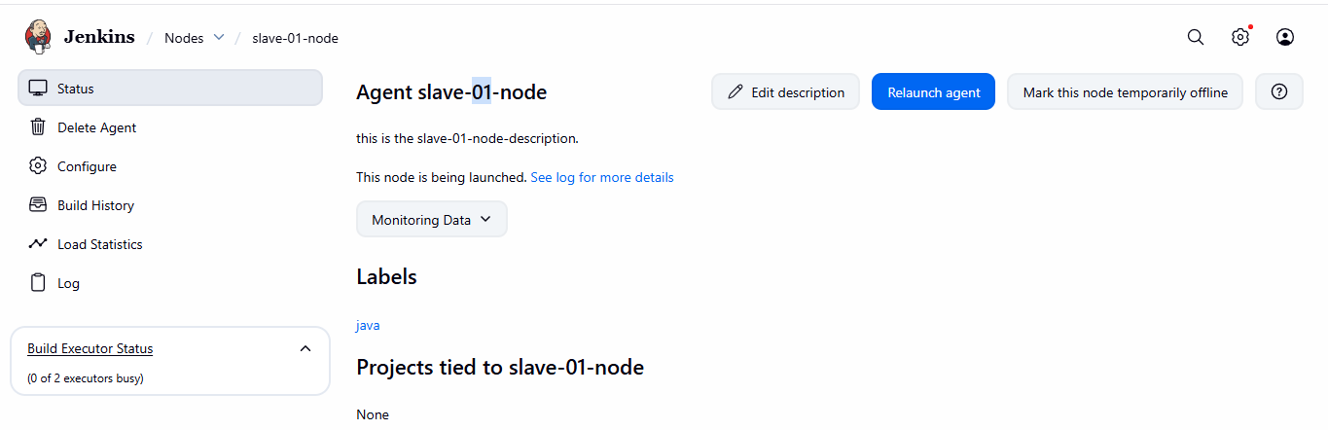
🔧 Step 1: Prepare Slave Machines

On both slave servers
sudo yum install java-11-openjdk -y
java -version
Create Jenkins user:
sudo useradd jenkins
sudo passwd jenkins

🔑 Step 2: Enable Passwordless SSH (Master → Slaves)

On Jenkins Master
sudo su - jenkins
ssh-keygen
(Press Enter for all)
Copy key to both slaves:
ssh-copy-id jenkins@SLAVE1_PRIVATE_IP
ssh-copy-id jenkins@SLAVE2_PRIVATE_IP
Test:
ssh jenkins@SLAVE1_PRIVATE_IP

⚙ Step 3: Configure Node in Jenkins UI
- Jenkins → Manage Jenkins
- Manage Nodes and Clouds
- New Node
- Enter:
  - Node name: agent-1
  - Type: Permanent Agent

Configuration
Field | Value
Remote root dir | /home/jenkins
Launch method | Launch via SSH
Host | Slave private IP
Credentials | jenkins user
Labels | linux-agent
Usage | Only build jobs with label
✔ Save → Node should become Connected
Repeat same for agent-2

🧪 Test Agent
Create job → restrict where project can run → linux-agent

2:Configure webhooks to Jenkins job.
🎯 Purpose
- Trigger Jenkins automatically when code changes
- No manual builds

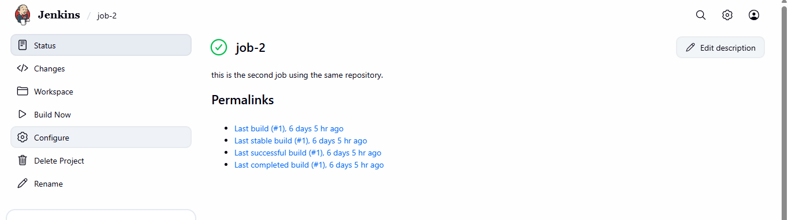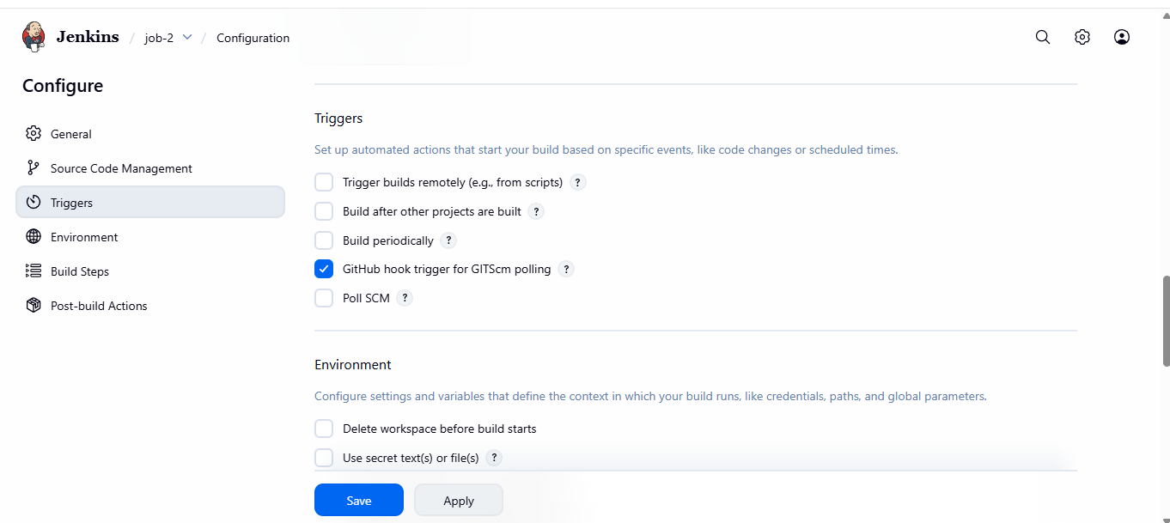
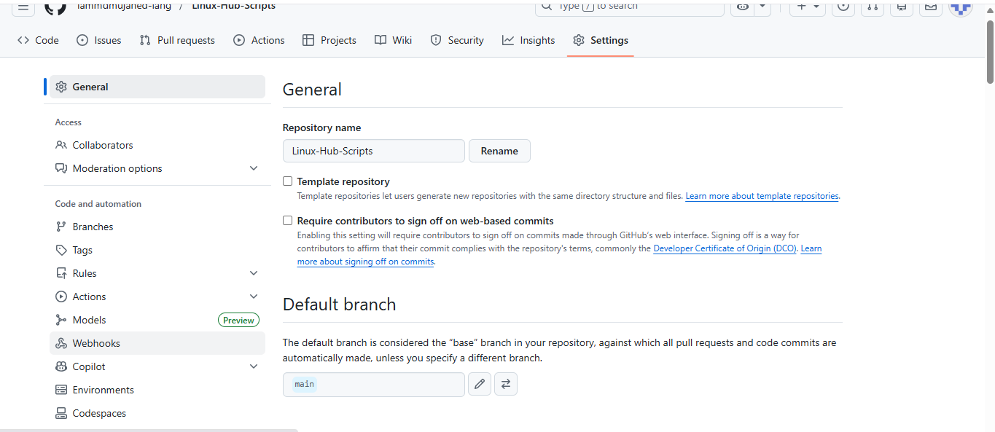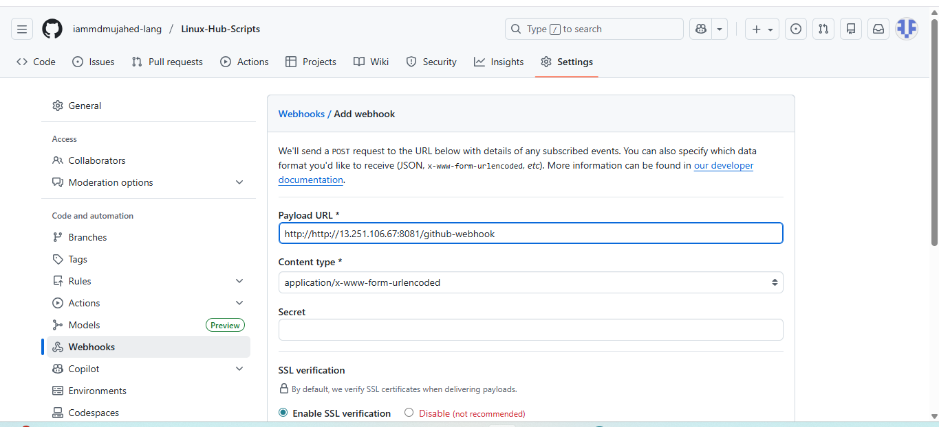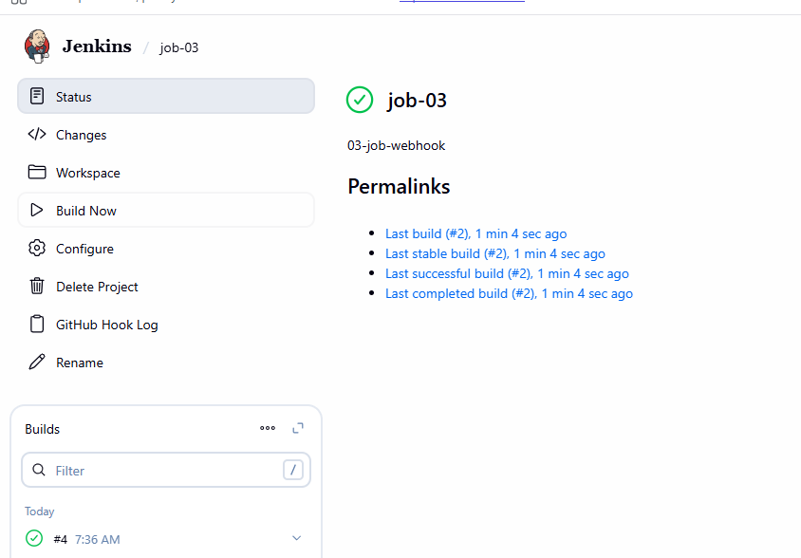
🔗 Step 1: Install GitHub Plugin
Jenkins → Manage Jenkins → Plugins → Install:
- GitHub Plugin
- Git Plugin

🔑 Step 2: Generate Jenkins Webhook URL
http://JENKINS_PUBLIC_IP:8080/github-webhook/

🧩 Step 3: Configure GitHub Webhook
GitHub Repo → Settings → Webhooks
- Payload URL: Jenkins webhook URL
- Content type: application/json
- Event: Just push event
- Save

⚙ Step 4: Jenkins Job Configuration
Job → Configure:
✔ GitHub hook trigger for GITScm polling
Save
🧪 Push code → Jenkins auto build starts

3:Configure poll scm and build periodical options in Jenkins job.
🎯 Purpose
Option | Why
Poll SCM | Check SCM for changes
Build Periodically | Time-based builds

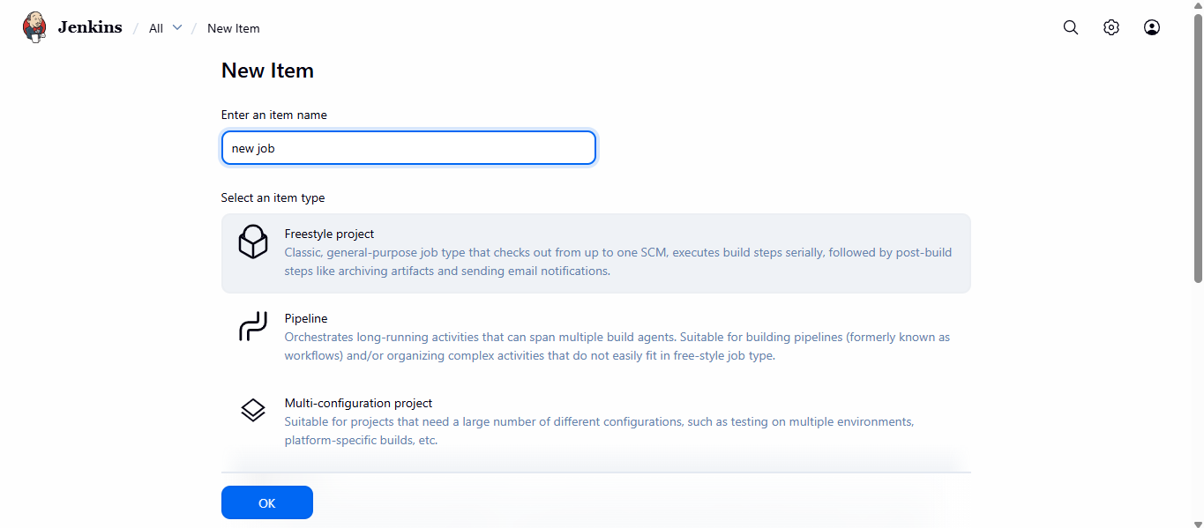
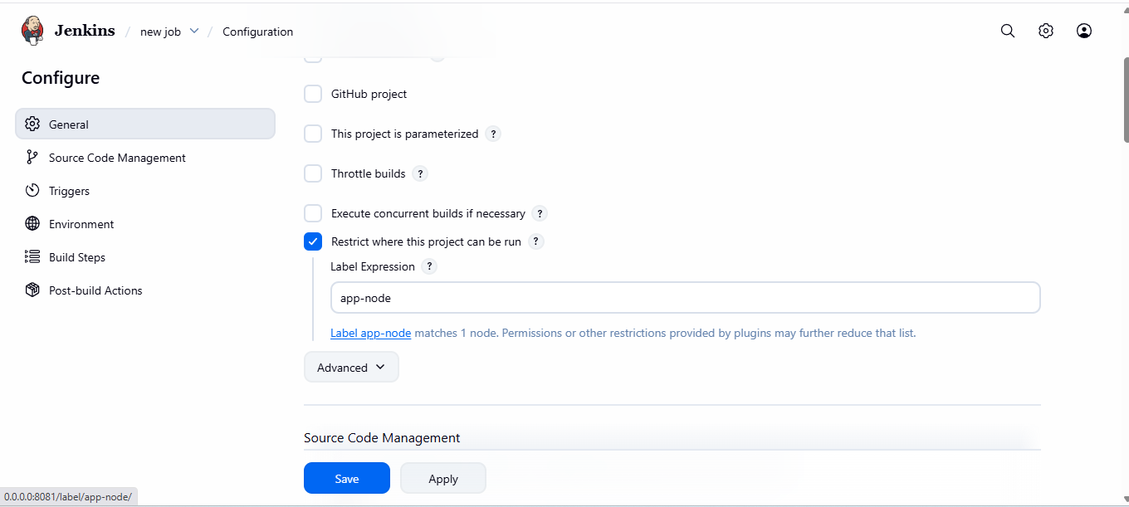
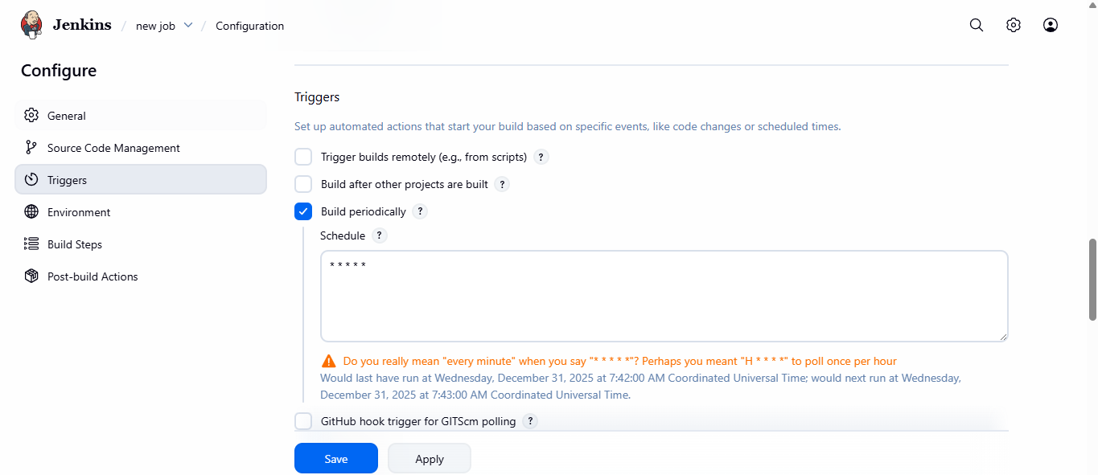
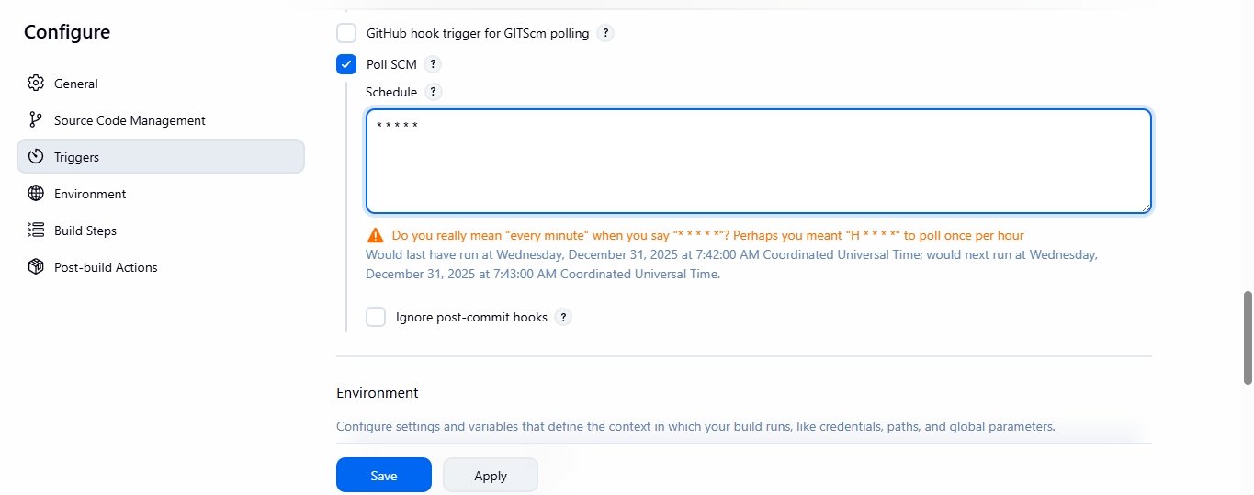
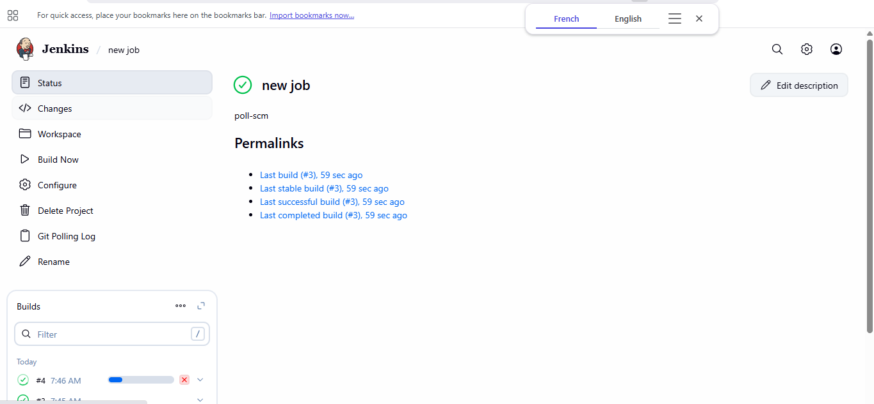
🔄 Poll SCM
H/5 * * * *
👉 Jenkins checks Git every 5 minutes
✔ Build only if code changed

⏰ Build Periodically
0 2 * * *
👉 Build daily at 2 AM

🕒 CRON Quick Guide
Field | Meaning
Minute | 0–59
Hour | 0–23
Day | 1–31
Month | 1–12
Weekday | 0–7

4:Take backup of Jenkins server by using bash script.
🎯 Purpose
- Manual full backup
- Useful when plugins fail

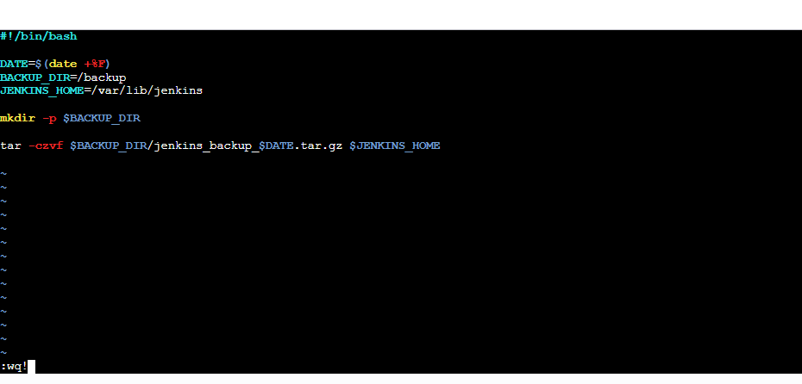
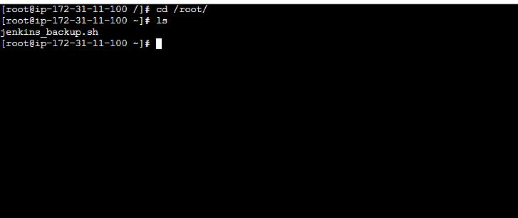
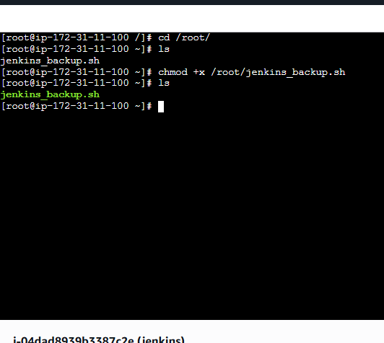
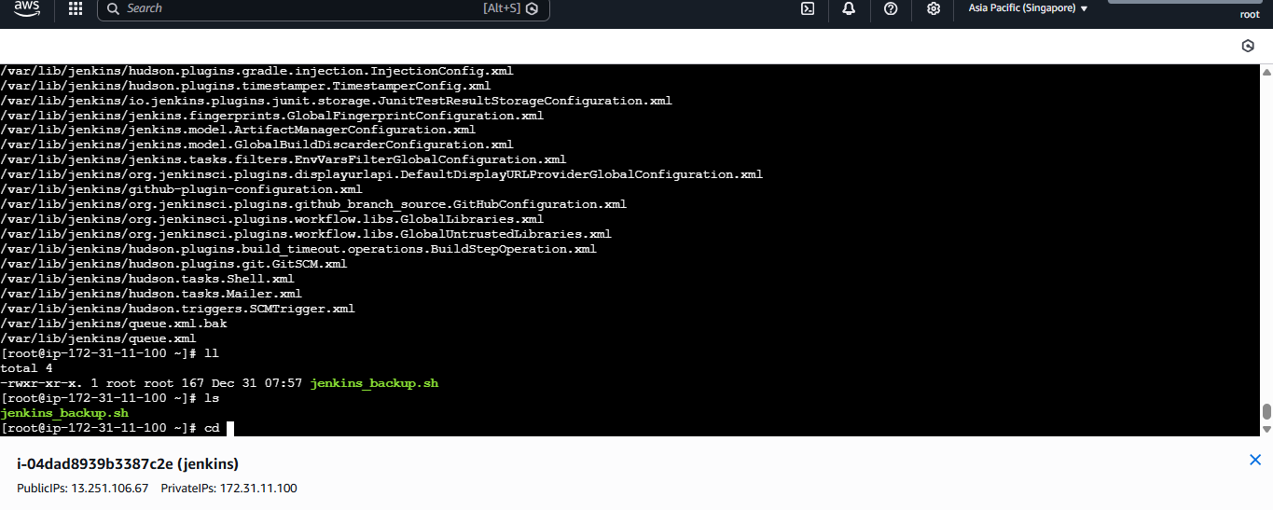
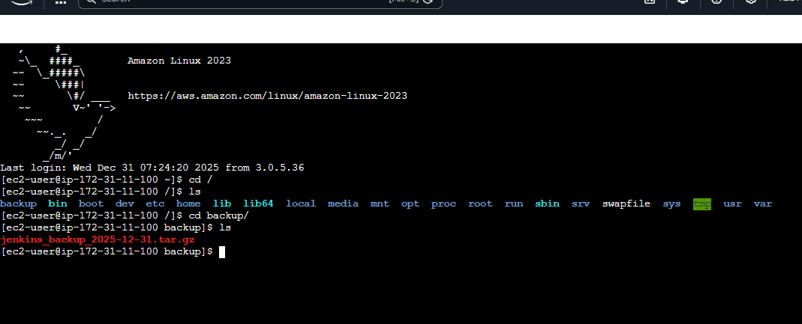
📝 Step 1: Create Backup Script
On Jenkins Master
sudo vi /opt/jenkins_backup.sh
#!/bin/bash
DATE=$(date +%F)
BACKUP_DIR="/backup/jenkins_$DATE"

mkdir -p $BACKUP_DIR

tar -czvf $BACKUP_DIR/jenkins_backup.tar.gz /var/lib/jenkins

echo "Backup completed on $DATE"

▶ Step 2: Permissions
sudo chmod +x /opt/jenkins_backup.sh
Run:
sudo /opt/jenkins_backup.sh

⏲ Step 3: Automate via Cron (Optional)
sudo crontab -e
0 1 * * * /opt/jenkins_backup.sh

5:Take backup of Jenkins using rethin backup plugin.
🎯 Purpose
- Plugin-managed backups
- Easy restore

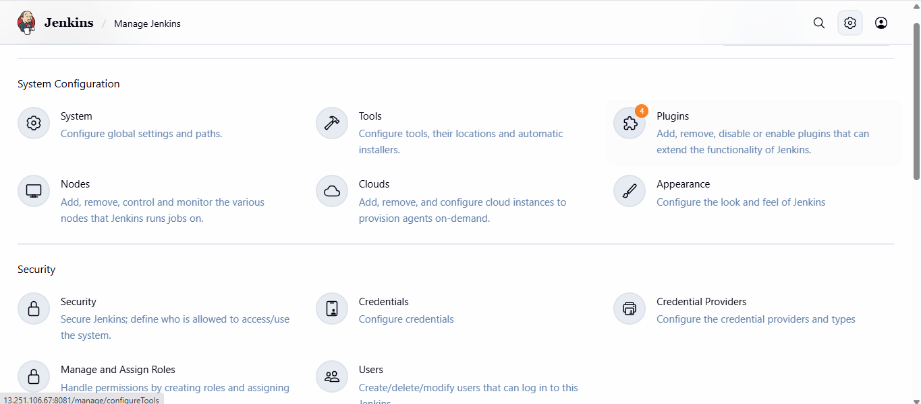
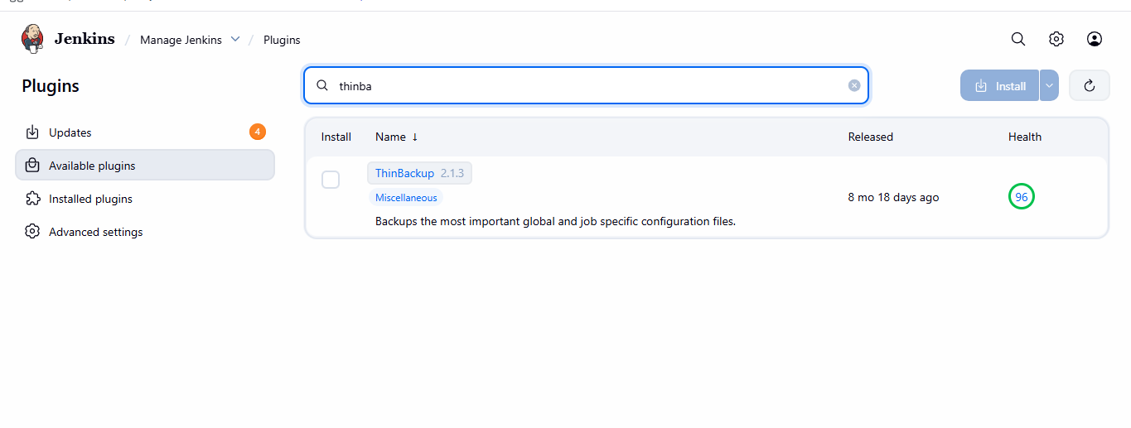
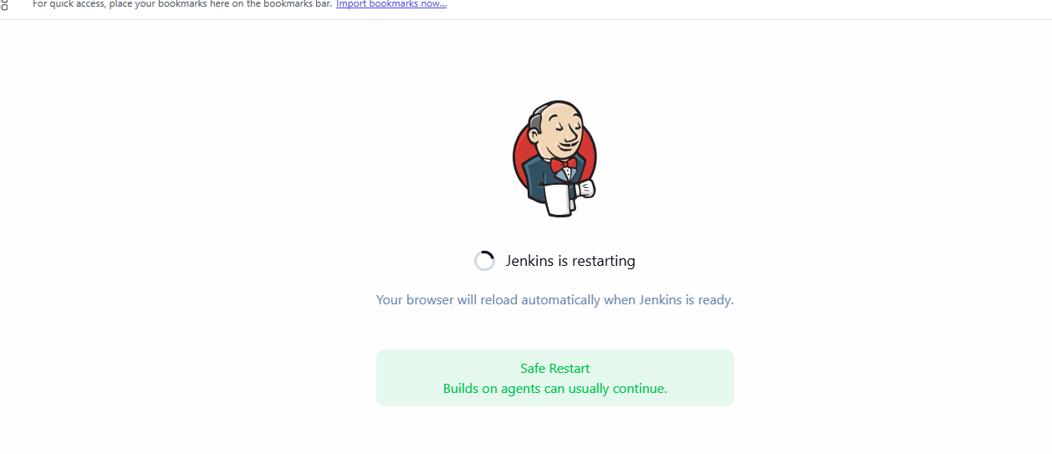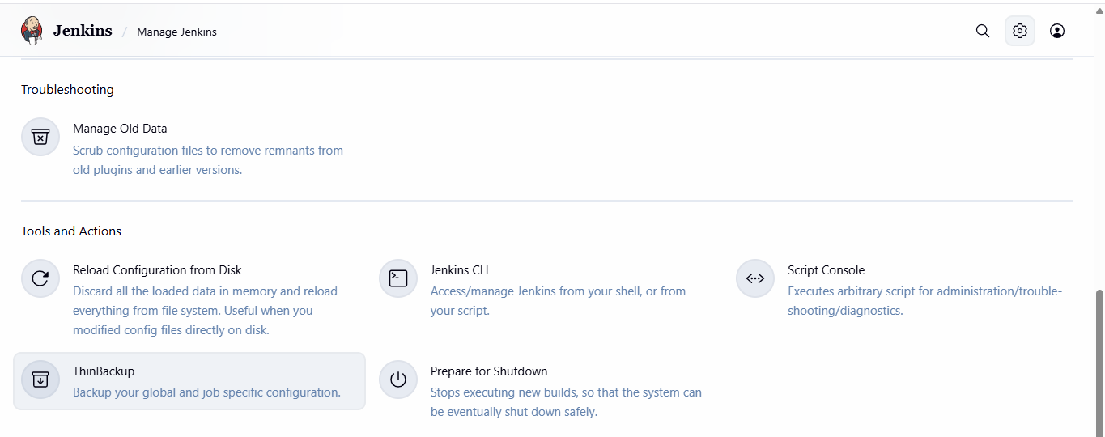
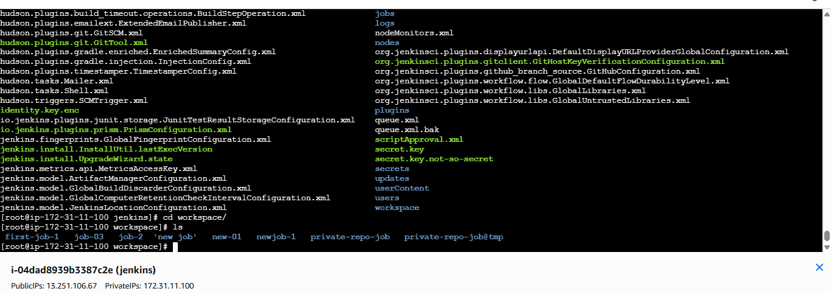
🔌 Step 1: Install Plugin
Manage Jenkins → Plugins → Install:
✔ ThinBackup

⚙ Step 2: Configure Backup
Manage Jenkins → ThinBackup → Settings
Option | Value
Backup Directory | /backup/thinbackup
Backup build results | ✔
Backup config | ✔
Save

▶ Step 3: Run Backup
Manage Jenkins → ThinBackup → Backup Now
✔ Backup stored safely

6:Setup a new Jenkins server and dump the backup taken in task4.

🎯 Purpose
- Disaster recovery
- Server migration
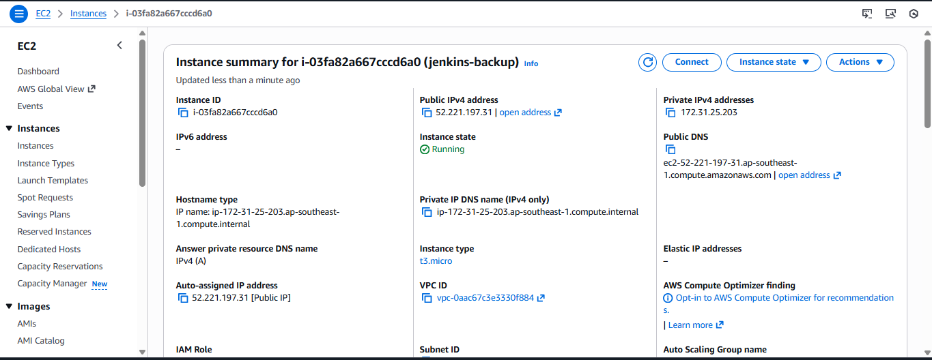
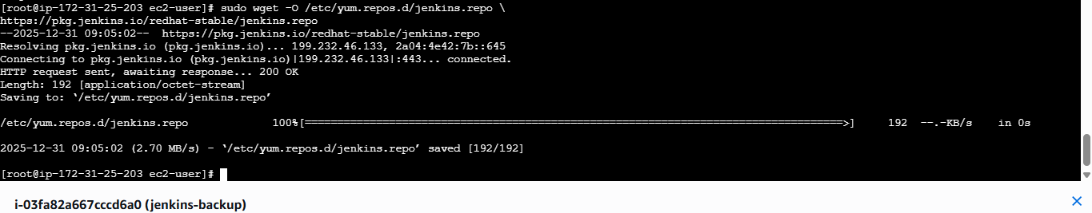
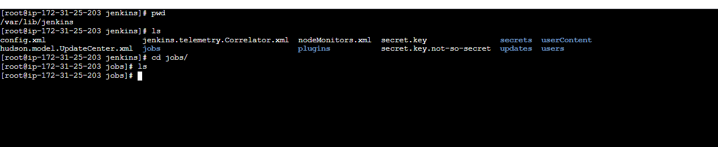
STEP-1: Launch a New Jenkins Server 1. 2. Launch a new EC2 instance
◦ OS: Amazon Linux
◦ Open ports: ▪ 22 (SSH) ▪ 8080 (Jenkins) Login to the new server
STEP-2:
Install Jenkins on New Server Install Java dnf install -y java-17-amazon-corretto
1. Add Jenkins Repository sudo wget -O /etc/yum.repos.d/jenkins.repo h ps://pkg.jenkins.io/redhat-stable/jenkins.repo sudo rpm --import h ps://pkg.jenkins.io/redhat-stable/jenkins.io-2023.key
STEP-3:
2. Install Jenkins sudo yum install jenkins –y
systemctl enable jenkins
systemctl start Jenkins
systemctl status Jenkins
Now open your master server of Jenkins —>
Step 4: Copy Your Backup to New Server Login into your old main server you took backup Create an test.pem file where you copy your pemkey of new-server and and paste in the oldserver
—> On old Jenkins server: jenkins-backups
—> is the folder were we placed backup file scp /root/jenkins-backups/jenkins_backup_2025-12-24.tar.gz \ ec2-user@:/tmp
Step 5: Login in to new server and check the file in /tmp jenkins_backup_2025-12-24.tar.gz —> is backup file

