Jenkins-03.
Task 1
Create one Jenkins job using the below code and create three stages:
stage1: Git clone to download the source code.
stage2: Sonarqube Integration to check the quality of code.
stage3: Slack Integration to send the alerts to slack.
URL: https://github.com/betawins/VProfile-1.git
Step 1: Create a New Job
1. Click on “New Item”
2. Enter a job name → e.g. - VProfile.
3. Select “Freestyle project”.
4. Click OK.
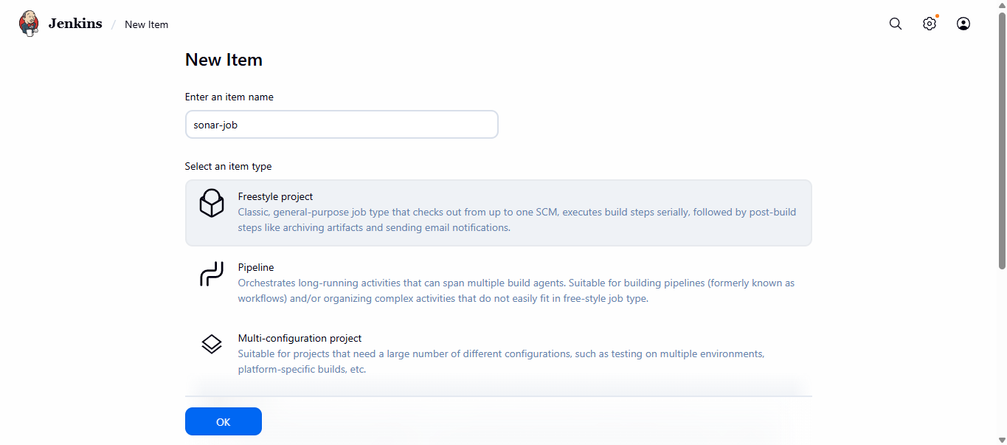
Step 2: Configure Git Repository
1. In the job configuration page:
o Scroll to Source Code Management.
o Select Git.
o In Repository URL, enter your Git repo link: https://github.com/betawins/VProfile-1.git
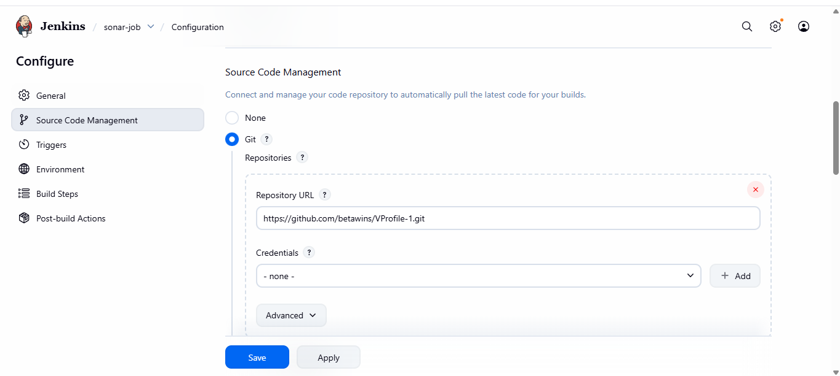
In Branches to build, specify the branch (default: */master).
Step 4: Save and Build
• Click Save.
• Click Build Now.
• Check the Console Output → It should show Jenkins cloning the repository.
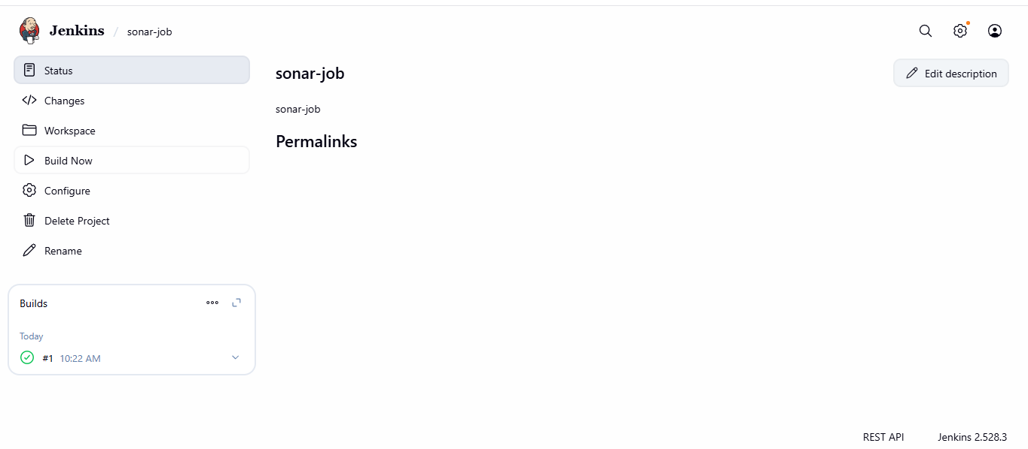
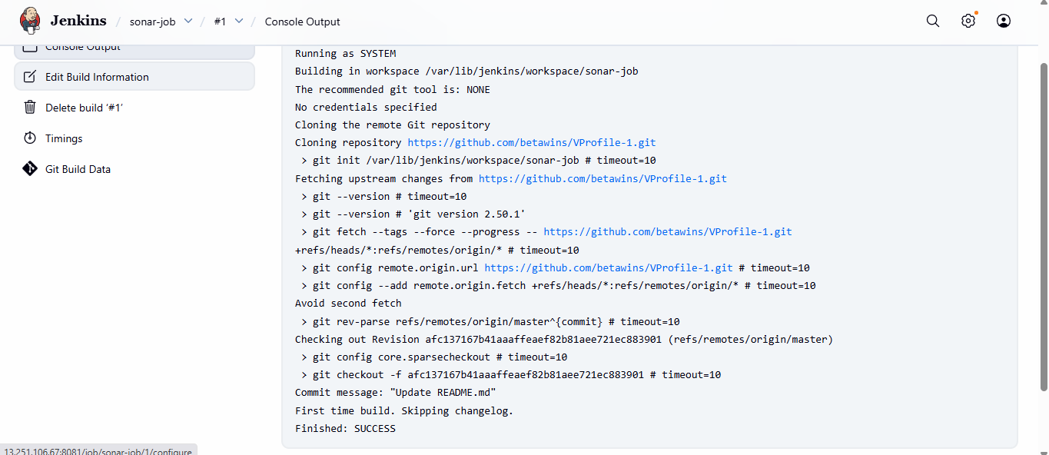
#we have successfully Git clone to download the source code.
# From url https://github.com/betawins/VProfile-1.git
#for checking the info of the cloned repo We can check by login to your ssh.
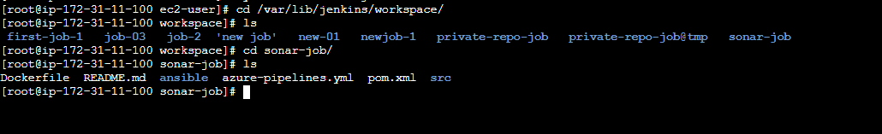
—>stage2: Sonarqube Integration to check the quality of code.
launching new sonar Instance: for quality check of the code.
Prerequsities for sonarqube:
Prerequisites
• EC2 instance with Java installed
• Use t2.large with atleast 20gb memory to run sonarqube.
1.Step-by-Step SonarQube Installation on EC2
• Launch EC2 Instance
• Instance type: t2.large
• Storage: 20 GB (minimum)
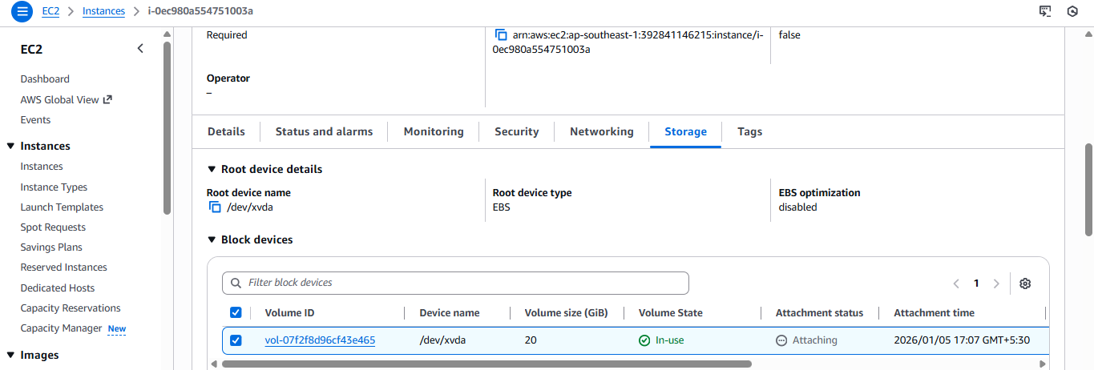
#then need to install docker.
yum install docker.
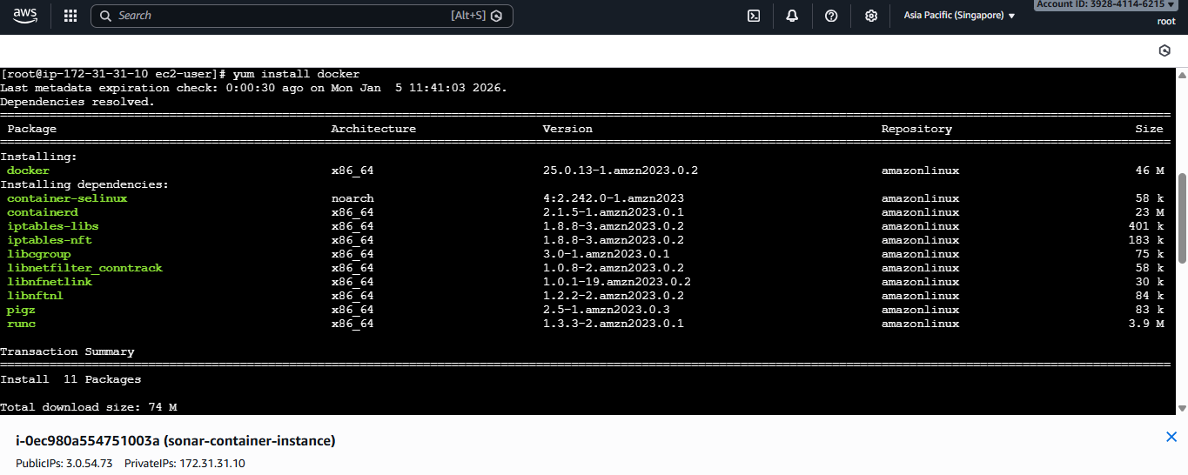
#then need to run docker and pull sonarqube.
>systemctl start docker
>docker pull sonarqube.
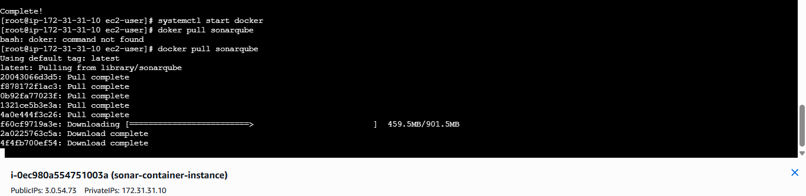
#then see docker images.
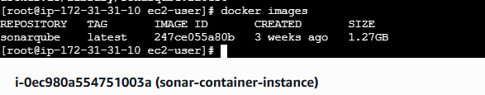
#then check the passwd.
docker run -itd -p 9000:9000 sonarqube
#then ps docker
#Then login to sonarqube by using ip address and:9000
#check for the security group 9000 is allowed.
#login with username: admin and passwd: admin then change.
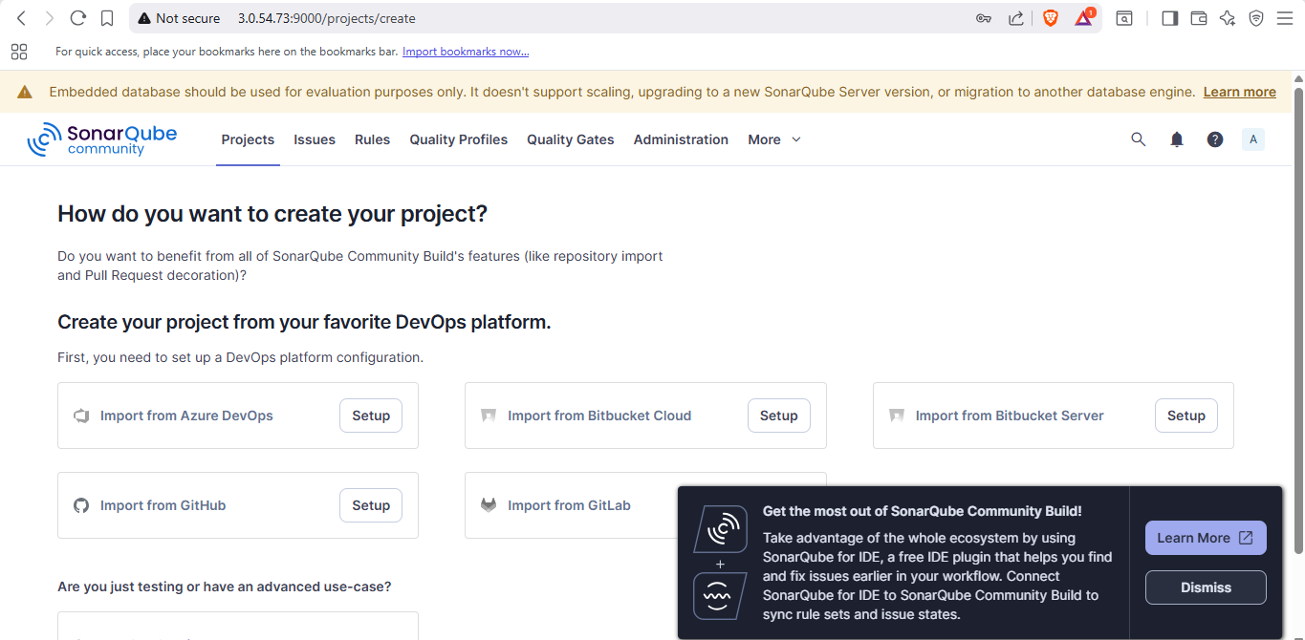
#after login go to profile > securities> generate token.
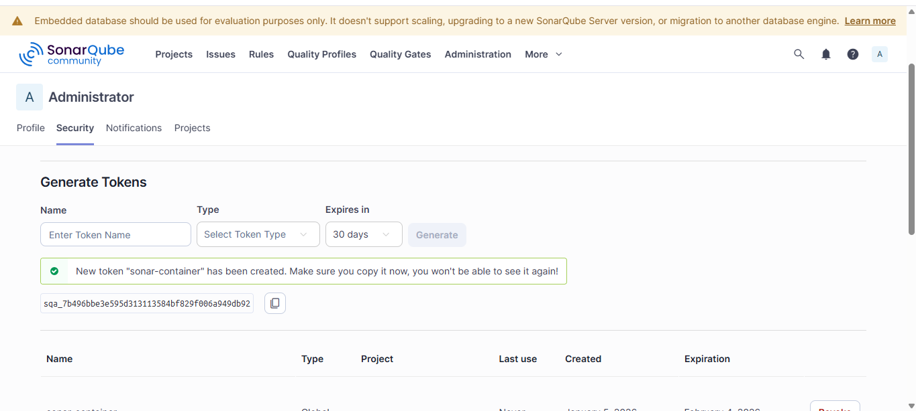
#copy the token and go to Jenkins GUI.
#then go to credential in setting.
#then click on add creadentials.
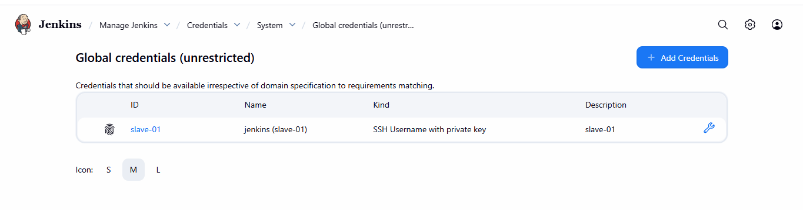
—-> now go to your Jenkins master
—-> create new credentials
—-> select the secret text
—> in side secret paste the token from sonarqube
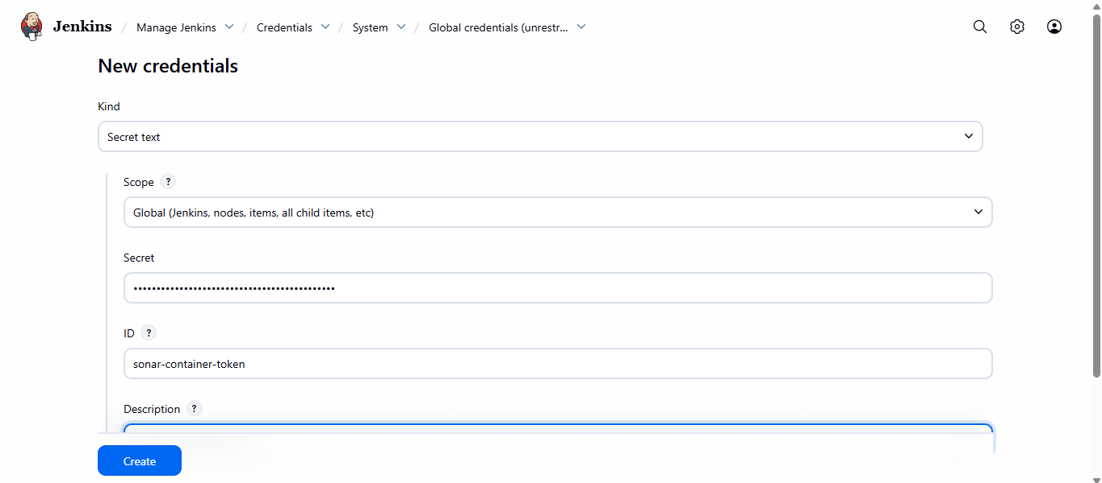
#click on create.
—-> after creating the credential
—> go to Jenkins
—> manage Jenkins
—> plugins
—>available plugins
—> search sonarqube scanner
—> and install it
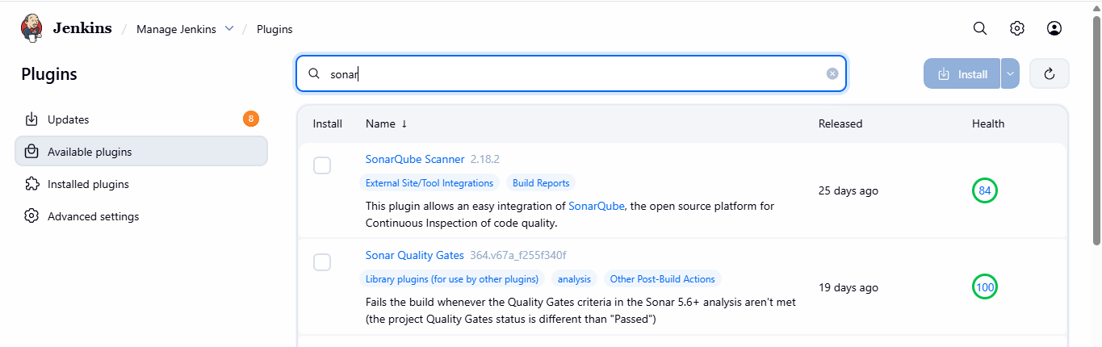
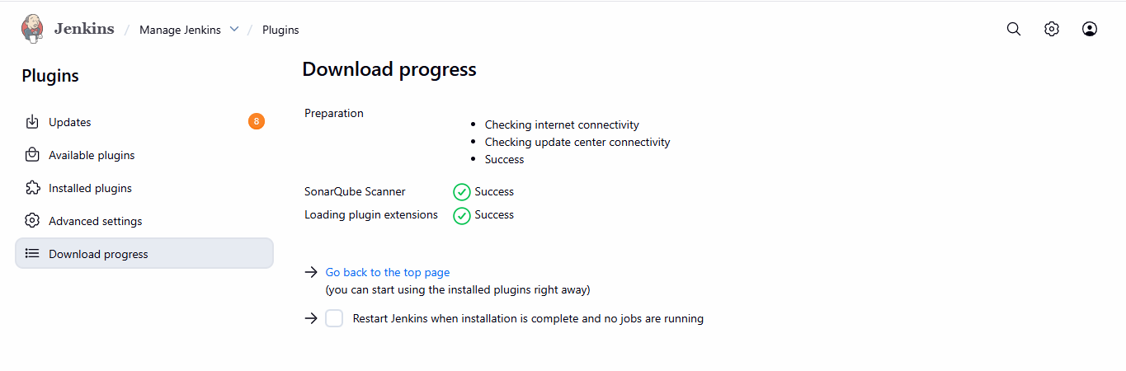
STEP 4 — Configure SonarQube Server in Jenkins Manage Jenkins
➡ System
➡ Scroll to SonarQube servers
➡ Add SonarQube
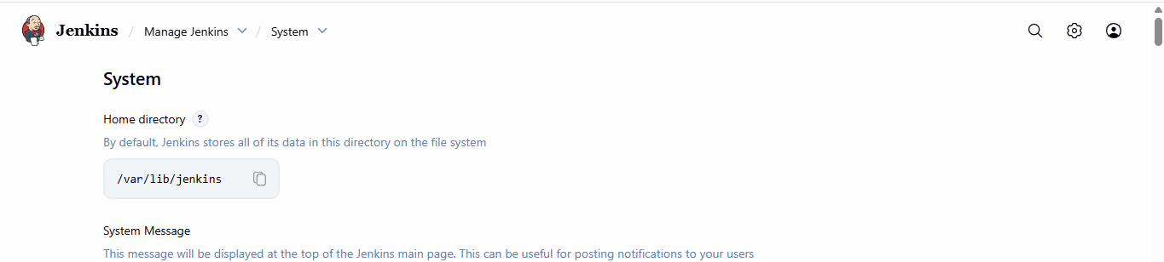
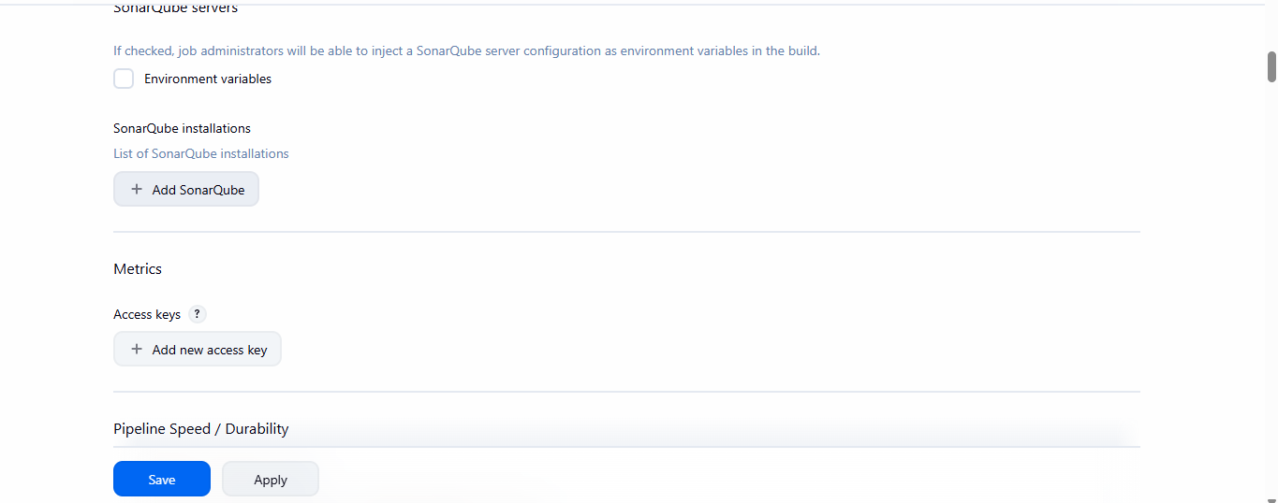
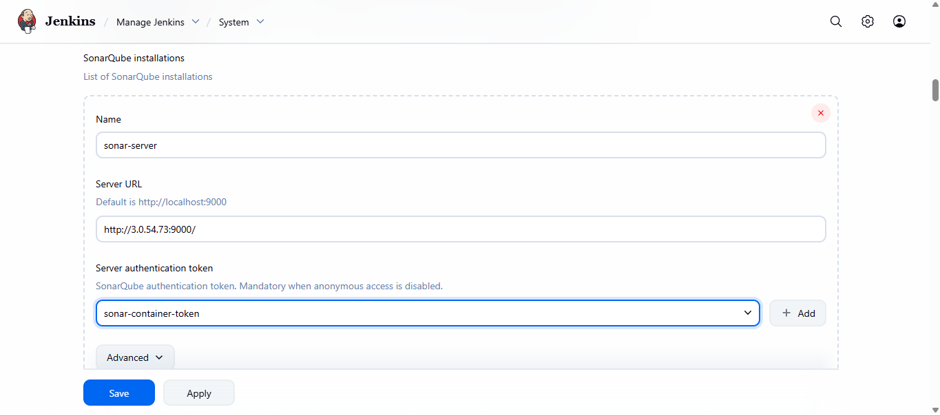
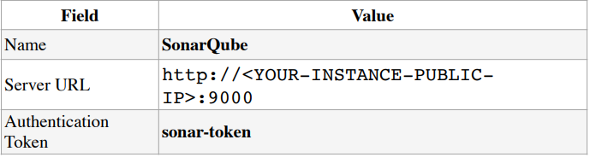
#after saving the sonarqube in configuration of node.
#go to created job.
Step-5: Configure Project for Sonar Analysis Edit your Jenkins job where VProfile Git repo is configured.➡ Configure Job
➡ Add a new build step:
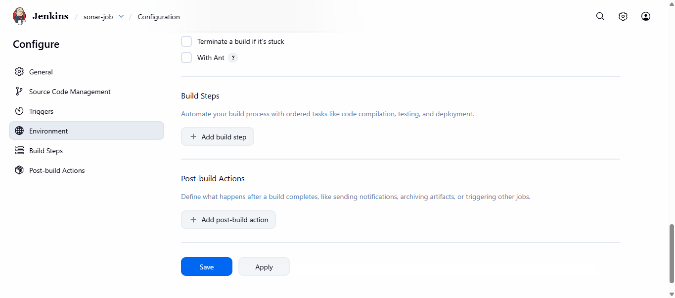
sonar.projectKey=Sabear sonar.projectName=Sabear sonar.projectVersion=1.0 sonar.sources=/var/lib/jenkins/workspace/$JOB_NAME/src/ sonar.binaries=target/classes/com/visualpathit/account/controller/ sonar.junit.reportsPath=target/surefire-reports sonar.jacoco.reportPath=target/jacoco.exec sonar.java.binaries=src/main/java/com/visualpathit/account/
#click on save.
check on sonarqube.
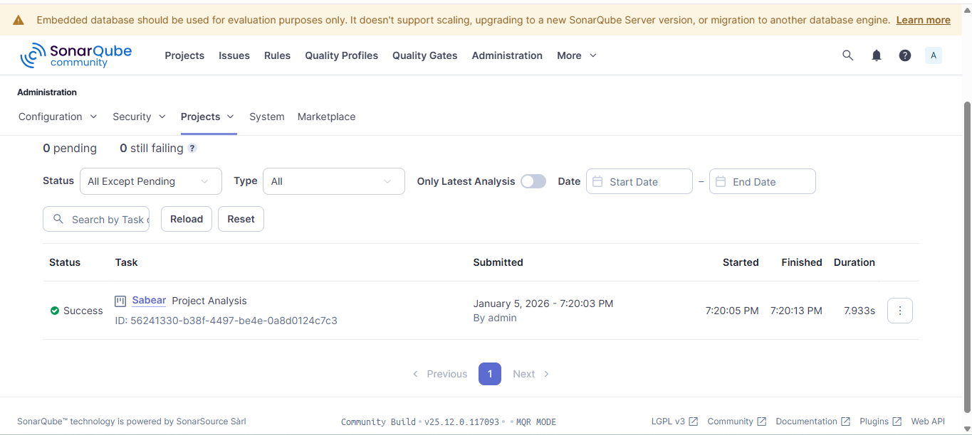
# the status is success
Stage-3: Slack Integration to Send Alerts Objective Send Jenkins build notifications (success/failure) to a Slack channel.
Prerequisites Configuration Steps
Step1. —> Install Slack Notification Plugin in Jenkins
Go to: Manage Jenkins → Manage Plugins
→ Available Search for: ✔ Slack Notification Plugin Click → Install and Restart Jenkins if required Requirement Details Slack App installed With webhook/ token access Slack Workspace Already created
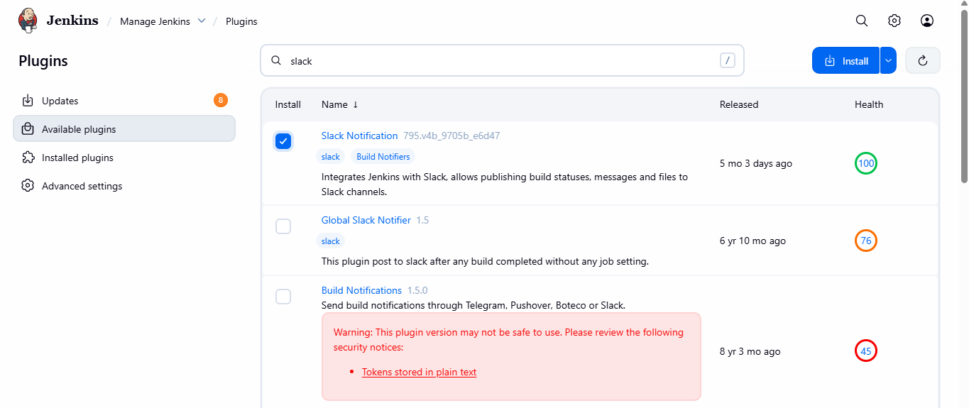
#open slack application.
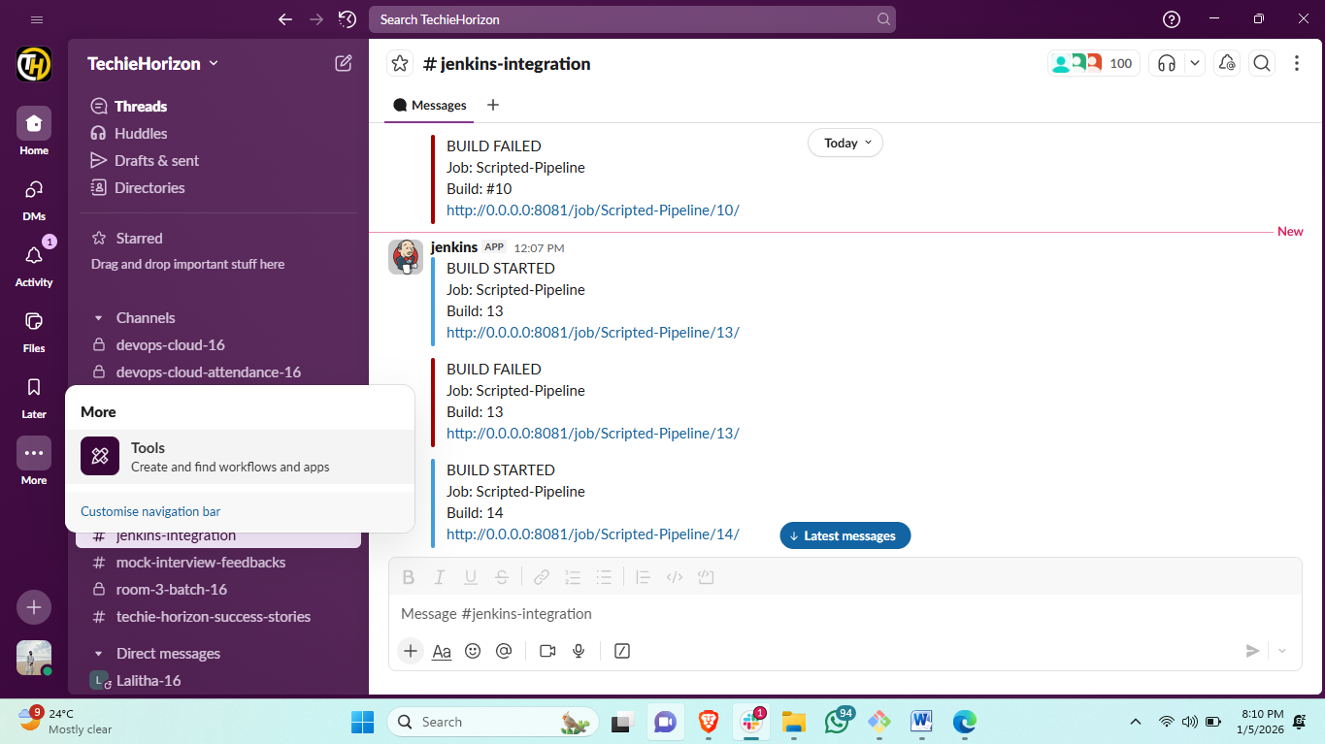
Step2.
Jenkins + Slack Integration
▶ Go to Slack: Go to slack open apps Select Jenkins cli
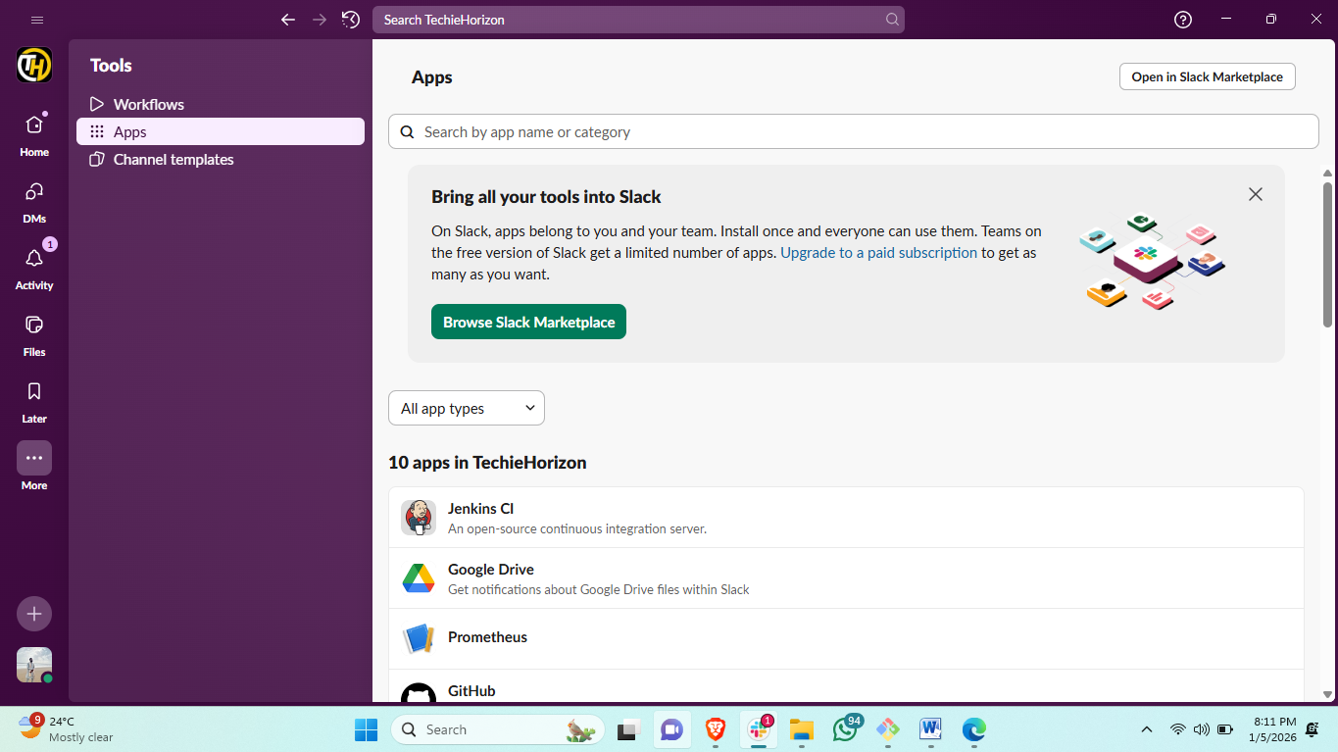
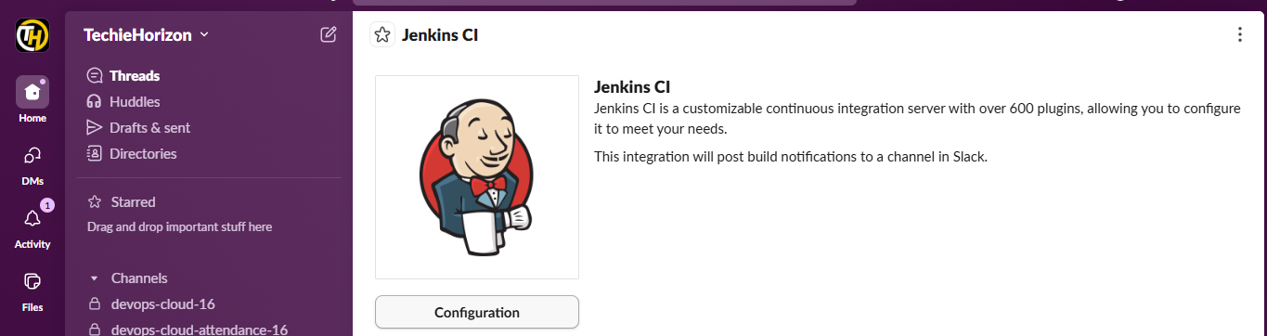
Step 3. Configure Slack in Jenkins
• Workspace: your Slack team domain (e.g., myworkspace.slack.com).
• Integration Token Credential ID: Add a new credential → Kind = “Secret Text” → Paste URL.
• Default Channel: #jenkins-integration
• Save
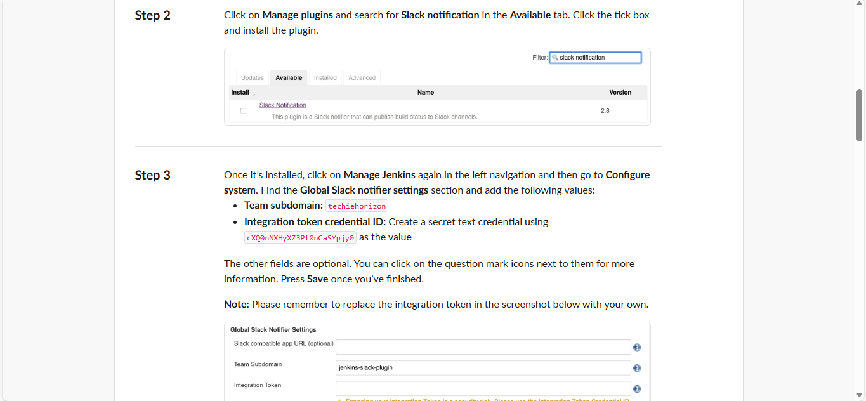

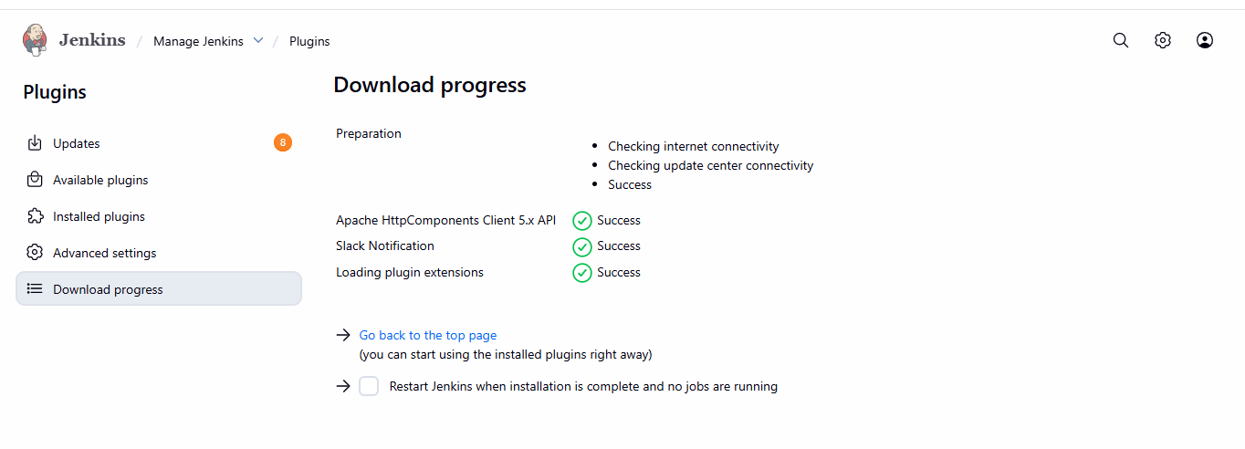
#then go to Jenkins.
jenkins manage Jenkins system
click on credential for slack.
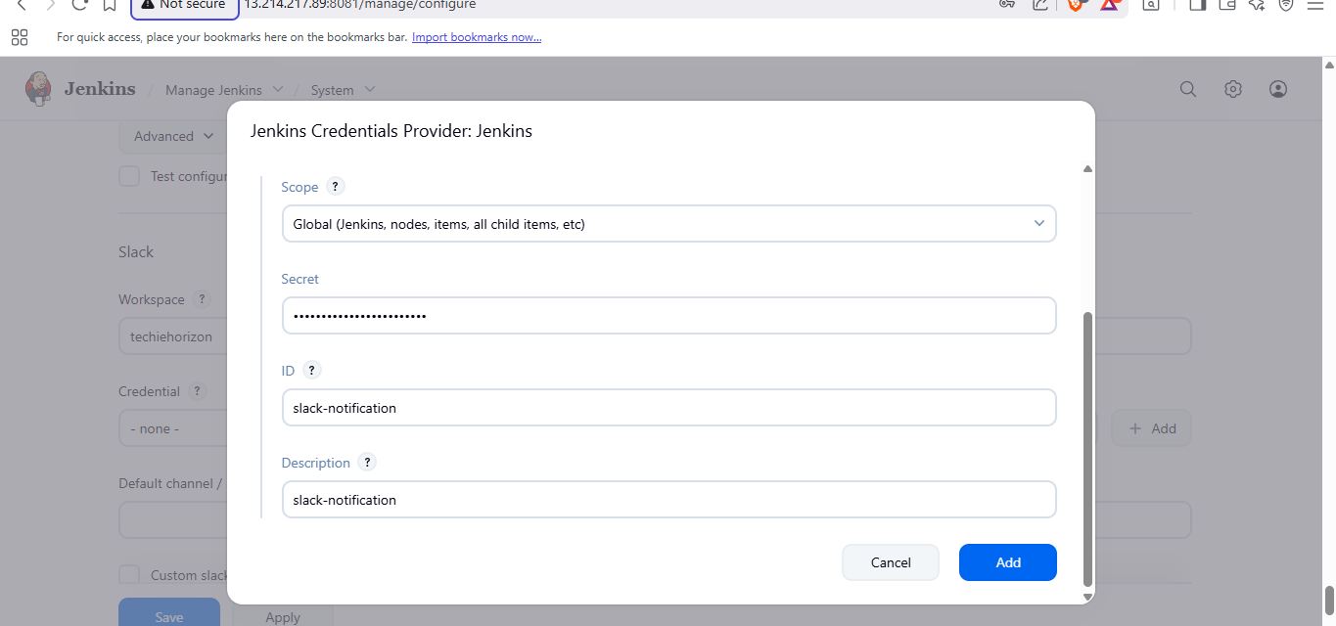
from Jenkins cli copy the token and paste in credentials secret
and save
now go to Jenkins configuration and add scroll down to slack conf.
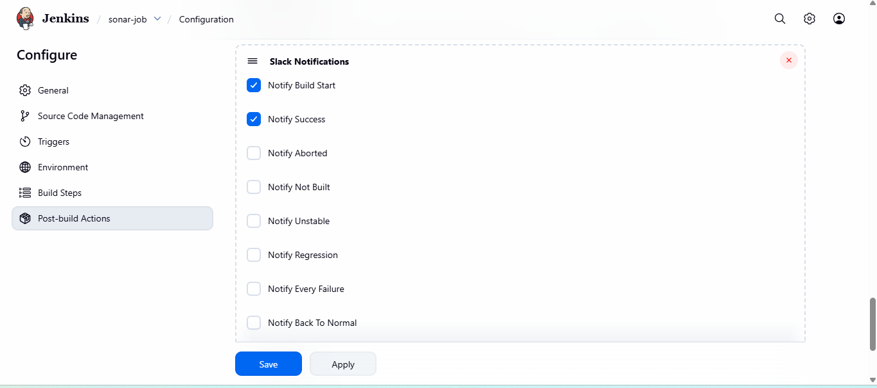
Step 4 :Add Slack Notifications to Jenkins Job
Add Slack Notifications in Jenkins Job Open your same Jenkins job
Configure: Scroll to Post-Build Actions Click: ➡ Add post-build action
Slack Notifications Select notifications: ✔ Notify Success ✔ Notify Failure ✔ Notify Always (optional) Save job
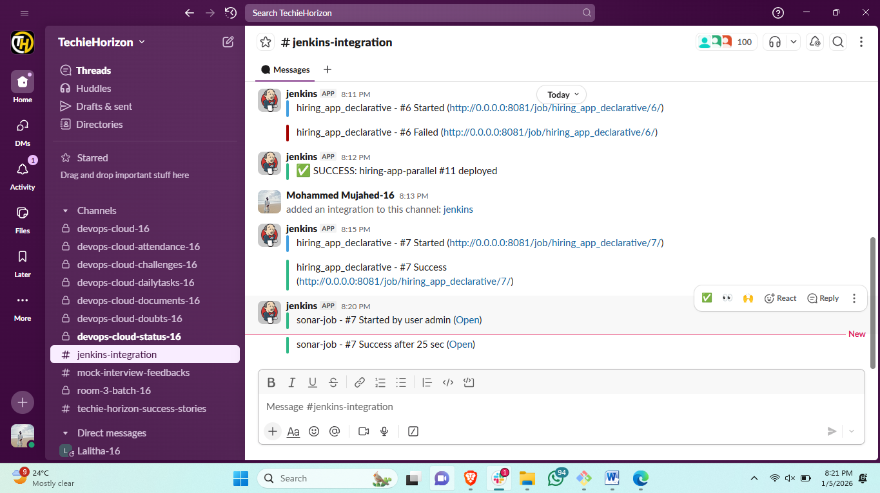
Result:
you can see in Jenkins integration channel your job is success.
Task 2
Create one Jenkins job using the below code and create three stages:
stage1: Git clone to download the source code.
stage2: Sonarqube Integration to check the quality of code.
stage3: Slack Integration to send the alerts to slack.
URL: https://github.com/betawins/hiring-app.git
Stage1-: Git clone to downloaded the source code.
Step1: first creaing a new job.
#click on new item.
#assign name for job.
#select freestyle project.
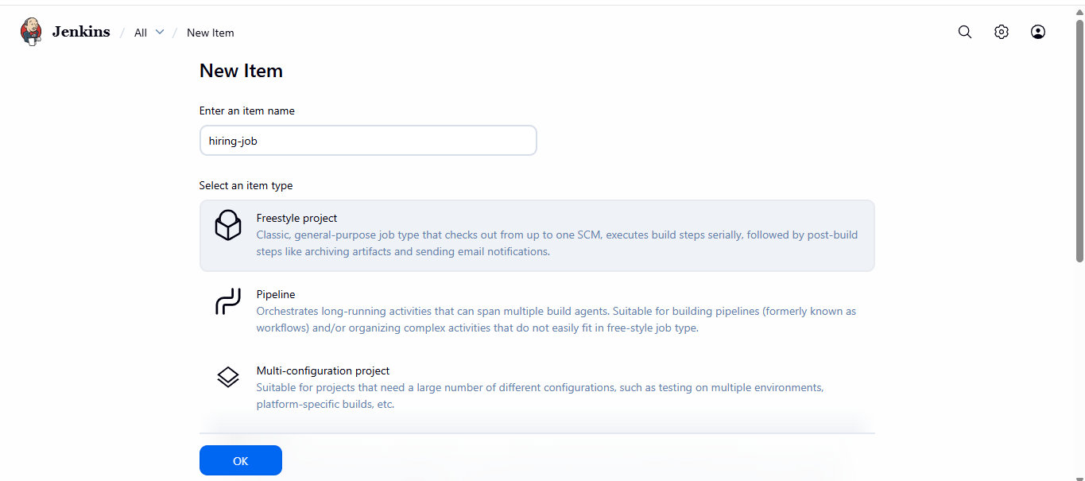
step2: configureing general information.
#add description.
#right the label name. in which machine you are trigerrin job.
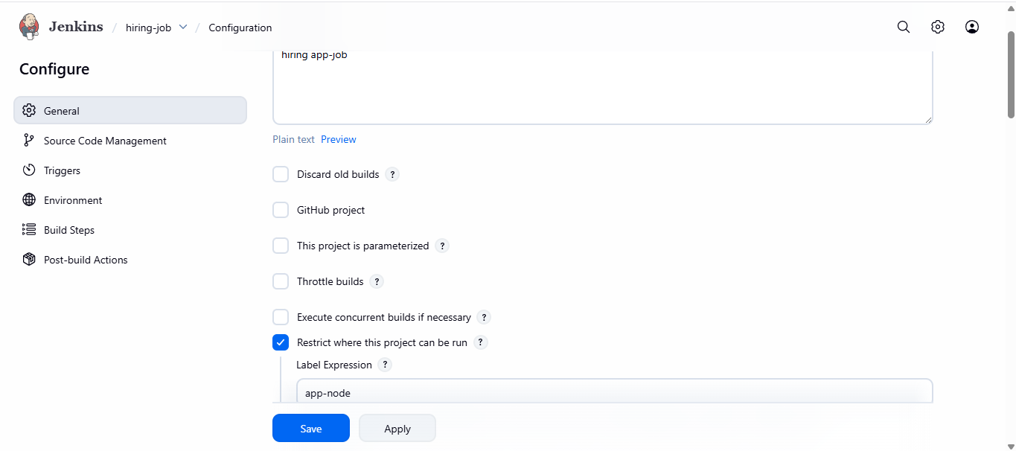
step3: setuping the source code management.
#click on git
#add your github URL
#make sure in which branch yor repo is available.
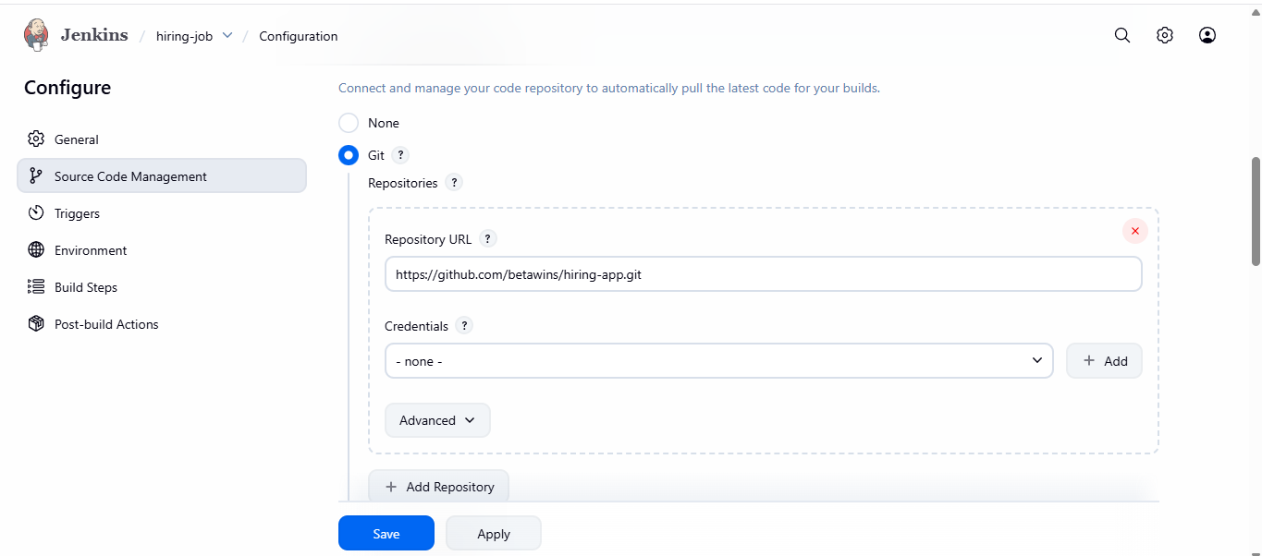
step5: scroll down to build steps.
#click on add build step
#select execute sonarcube-scanner
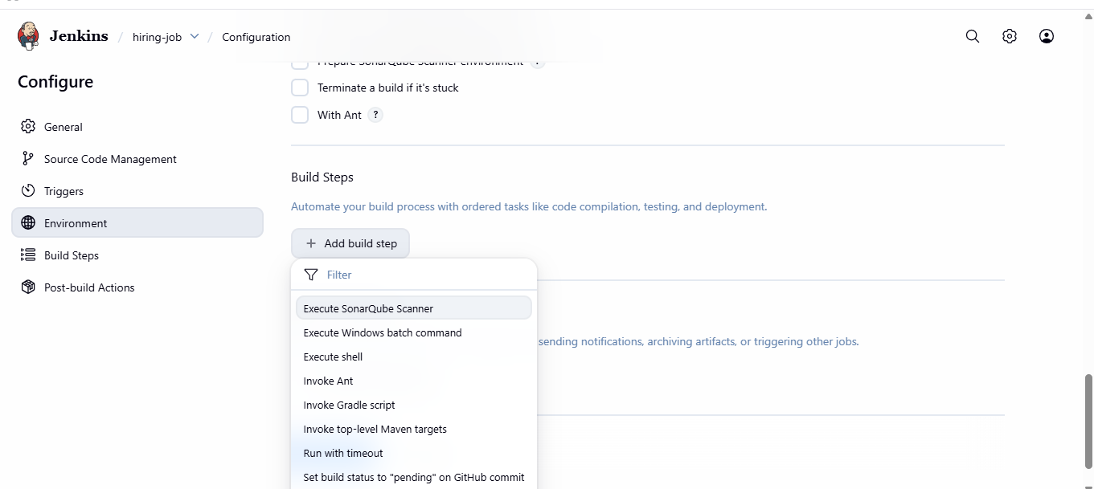
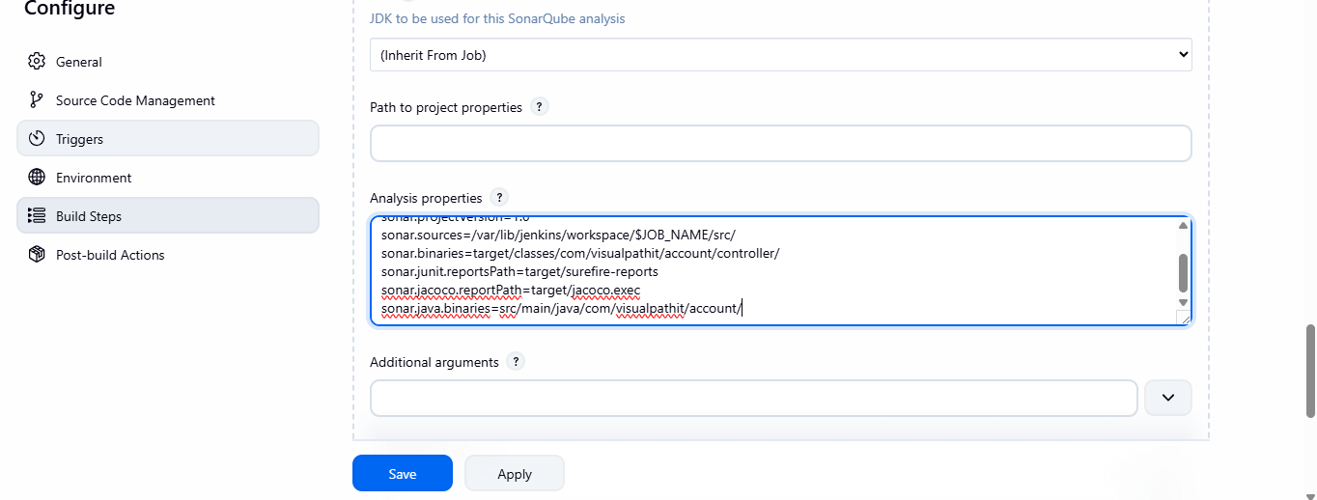
>add the analysis properties.
sonar.projectKey=Sabear sonar.projectName=Sabear sonar.projectVersion=1.0 sonar.sources=/var/lib/jenkins/workspace/$JOB_NAME/src/ sonar.binaries=target/classes/com/visualpathit/account/controller/ sonar.junit.reportsPath=target/surefire-reports sonar.jacoco.reportPath=target/jacoco.exec sonar.java.binaries=src/main/java/com/visualpathit/account/
step6: setup the slack notification.
#click on add post-build action.
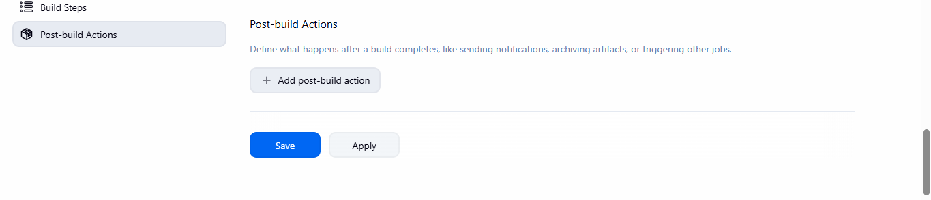
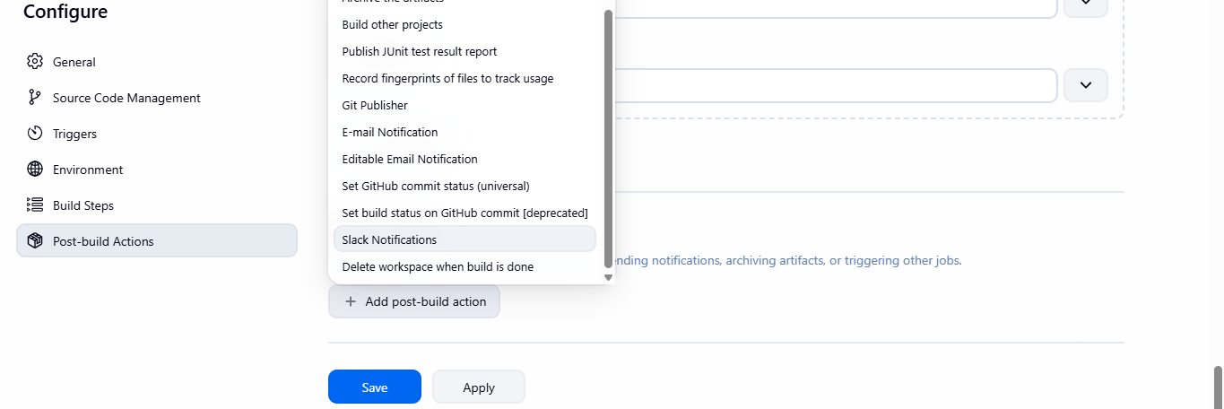
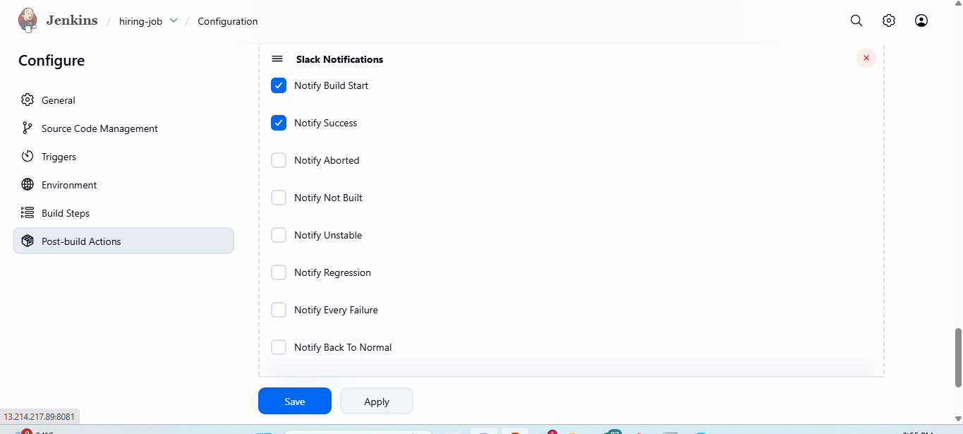
#save the configuration of job and save.
#then click on build now to trigger the job.
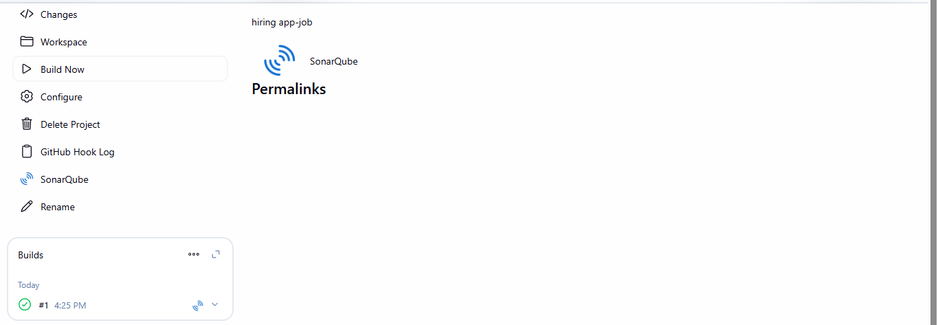
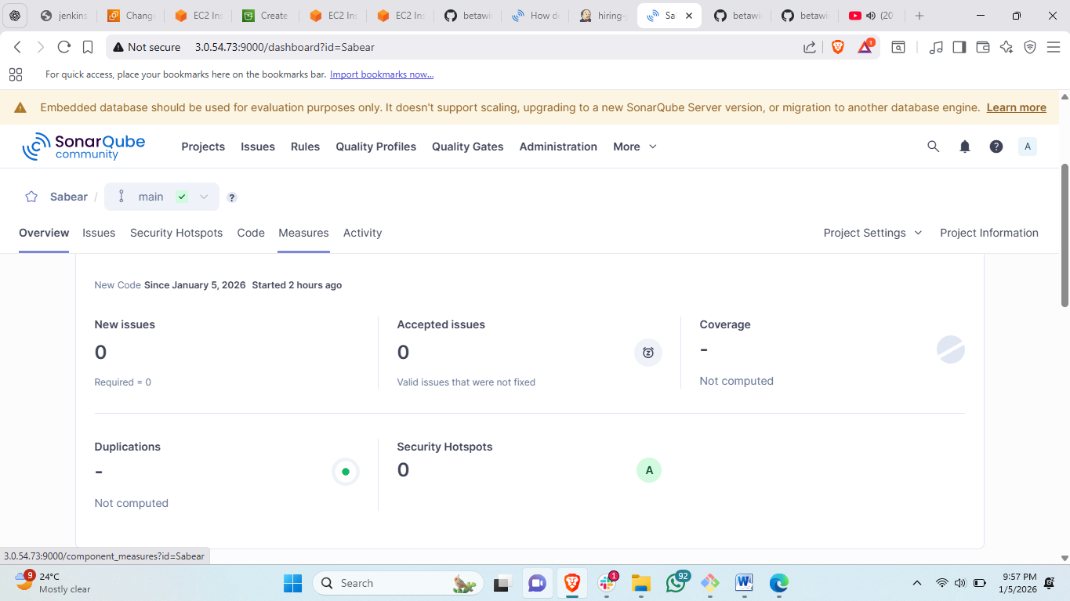

#then check the status of sonarqube to make sure the quality check of source code.
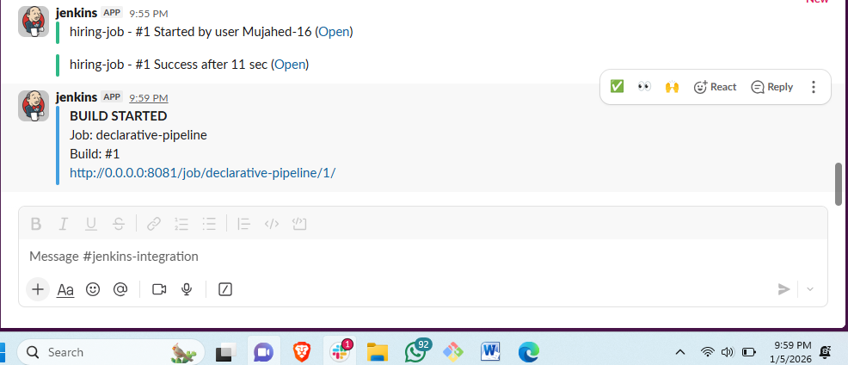
#check the status of slack channel as well.

